

Date: 13 August 2021

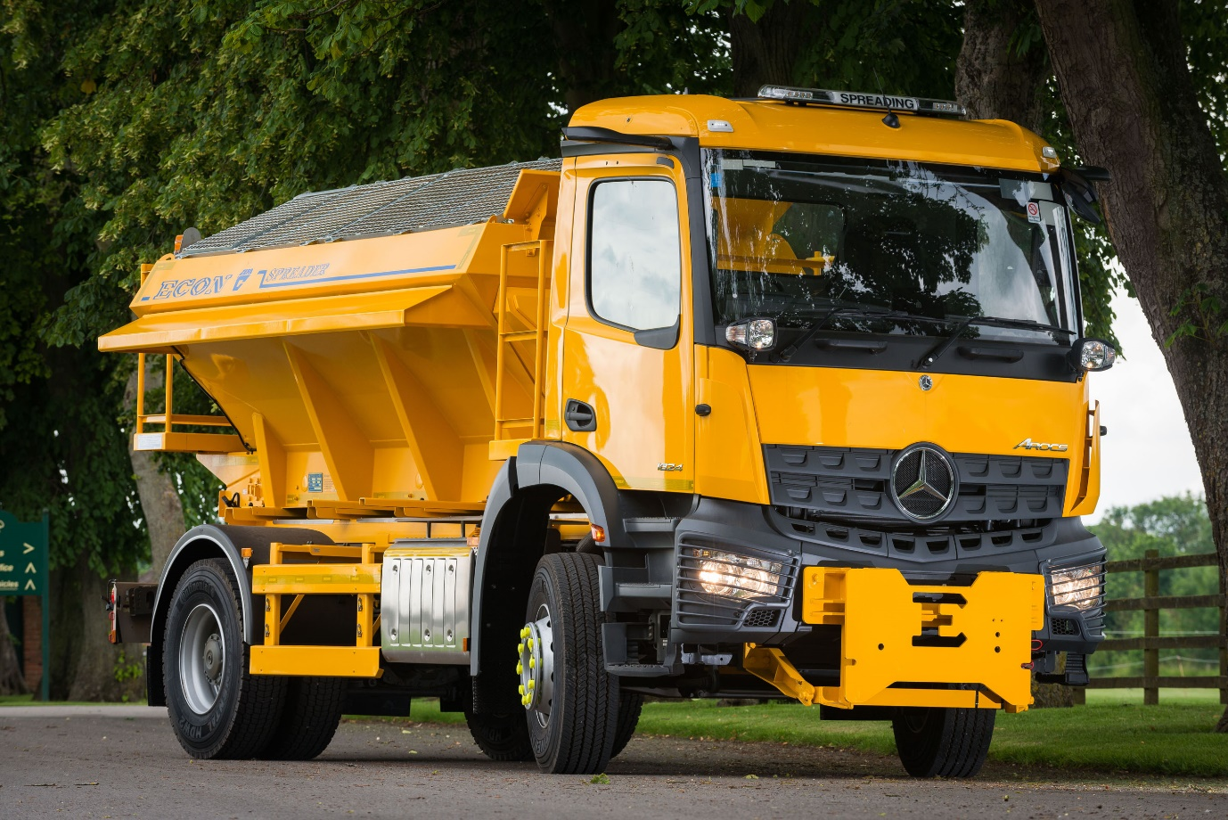

Econ Engineering spreads the word on the benefits of MirrorCam technology from Mercedes-Benz Trucks

Winter maintenance equipment specialist Econ Engineering has added the first MirrorCam-equipped Mercedes-Benz to the fleet of gritters that local authorities and others will once again be relying upon to keep roads open when the weather takes a turn for the worse.

The 4x2 Arocs chassis arrived via Dealer Northside Truck & Van, a trusted supplier to the Ripon-based manufacturer for the last 14 years. An 18-tonne 1824 variant, it has a ClassicSpace S-cab and is powered by a 7.7-litre, 175 kW (238 hp) in-line six-cylinder engine.

MirrorCam is Mercedes-Benz Trucks’ acclaimed alternative to door mirrors. The system employs roof-mounted, rear-facing cameras, which relay their images to screens mounted inside the cab, on the A-pillars. Not only does MirrorCam provide much-enhanced rear visibility, but it also eliminates the large, forward-facing blind spots created by mirror housings. As a result, Econ’s MirrorCam-equipped Arocs merits two Direct Vision stars from Transport for London, one more than it would if fitted with conventional mirrors.

Econ Managing Director Jonathan Lupton believes this ground-breaking technology offers specific advantages for gritter drivers who can find themselves working on dark nights and in blizzard conditions.

“In addition to the improved visibility which promises to be a big help, MirrorCam should be much less susceptible to the typical problems of dirt, rain and icing up that can be a real issue for those undertaking gritting operations,” he explained.

“Also, as the cameras are relatively compact and mounted that bit higher, they are not as vulnerable as mirrors to accidental damage from overhanging trees and hedges, so there are potential savings in repair costs too.

“We have high hopes for MirrorCam’s effectiveness and suitability for winter maintenance applications,” he confirmed. “We’re looking forward to seeing how the system performs in active service. I’m confident that MirrorCam will prove a real winner, and we expect it to be very popular with our customers.”

As well as building trucks with gritting bodies and other specialised equipment for acquisition by customers, Econ operates its own fleet of more than 800 vehicles, more than half of which are based on Mercedes-Benz Actros, Arocs and Atego models. These are available for spot-hire, short-term rentals for a single winter season, or longer contracts lasting up to 10 years.

Econ’s mobile engineers carry out on-site inspections and maintenance, minimising downtime for operators. The company also provides summer storage services at its headquarters and other locations in Alloa, Cardiff and Halesworth, Suffolk, where vehicles are fully prepared for work in the next winter season.

Designed from the ground up for the most demanding applications, the Mercedes-Benz Arocs is now a mainstay of the Econ fleet – a further 46 are currently in build at its production facility, while Northside Truck & Van will be delivering another 40 chassis later this year.

“With gross weights from 18-32 tonnes and 4x2, 4x4, 6x4, 6x6 and 8x4 configurations available, or even 8x6 or 8x8 options for extreme applications, the Arocs range offers everything we need in a medium-to-heavy truck,” said Mr Lupton.

“The chassis is very versatile and an excellent base for our bodies, with front frame adaptations for ploughs and live-drive PTOs to power the hydraulics for salt beds and spinners. The truck’s inherent fuel efficiency, coupled with the fact that some of our equipment can be electrically powered, means we help customers to reduce their carbon footprints.”

Truck Sales Executive Martin Tordoff manages Northside Truck & Van’s relationship with Econ. “Martin’s customer service and attention to detail are second to none,” continued Mr Lupton. “We know we can rely on him to ensure that our chassis are always perfectly specified for the arduous nature of winter work.

“Northside’s aftersales team also play a key role in helping us to restrict downtime for our customers, by supporting us with competitively priced parts, expert technical advice when we need it, and speedy and efficient turnarounds if any warranty work is required.”

He added: “Econ Engineering has worked closely with Northside for a long time now. We value our suppliers in the same way we do our customers – without the Dealer’s unstinting support we would not be able to offer the first-class service of which we are so proud.”

Established more than 50 years ago, Econ Engineering is a second-generation family business. It serves 88% of the UK’s local authorities and claims to be the country’s number one manufacturer of winter maintenance and road repair bodywork used by councils and contractors.

The Econ range includes gritting bodies with capacities of 0.7 to 12 cubic metres, capable of administering dry, pre-wet and liquid treatments. The company also manufactures Multipurpose QCB, Multispread and Unibody products that allow customers to undertake different tasks using just one vehicle, saving on both capital and operational costs.

Econ’s offering extends to more than just winter maintenance equipment. Soaring demand for its market-leading Hotboxes, designed to keep asphalt at its optimum operating temperature using thermostatically controlled gas burners, has prompted an increase in manufacturing capacity to ensure availability.

www.econ.uk.com

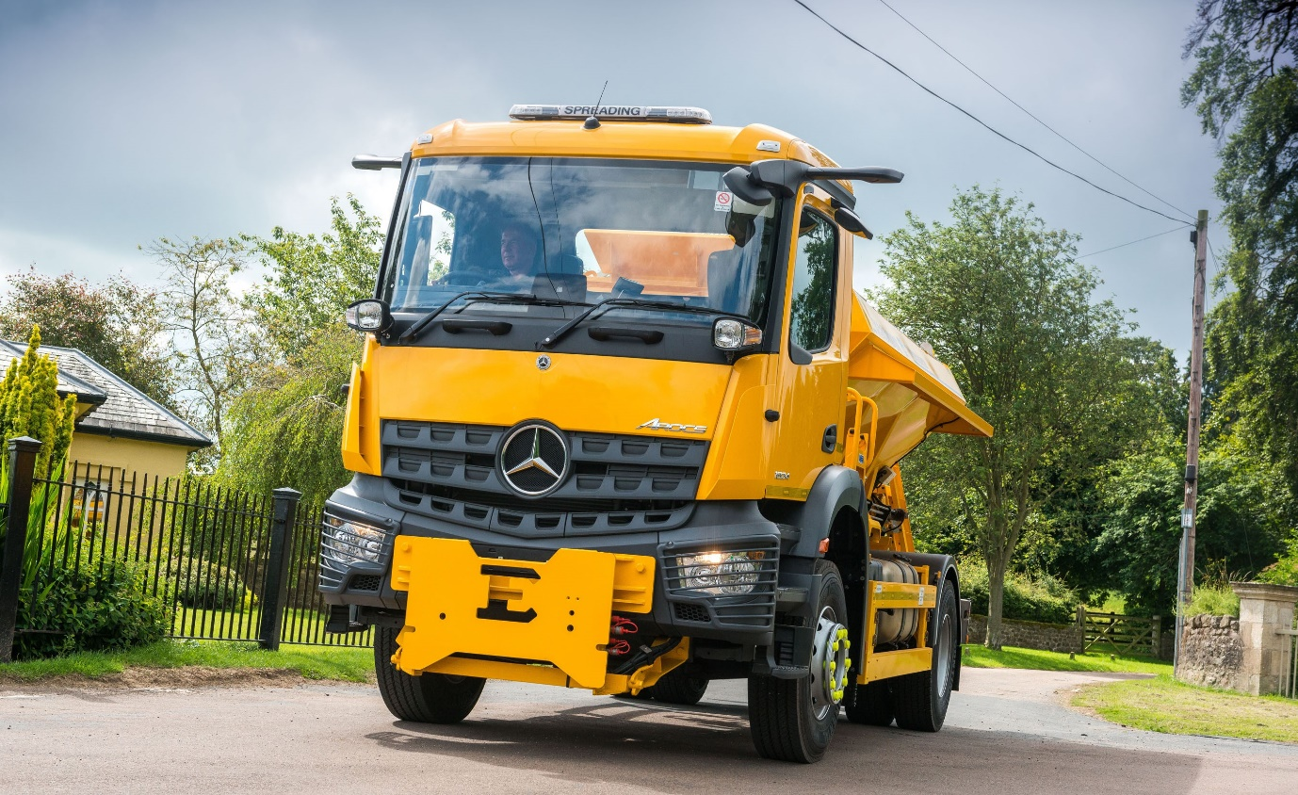

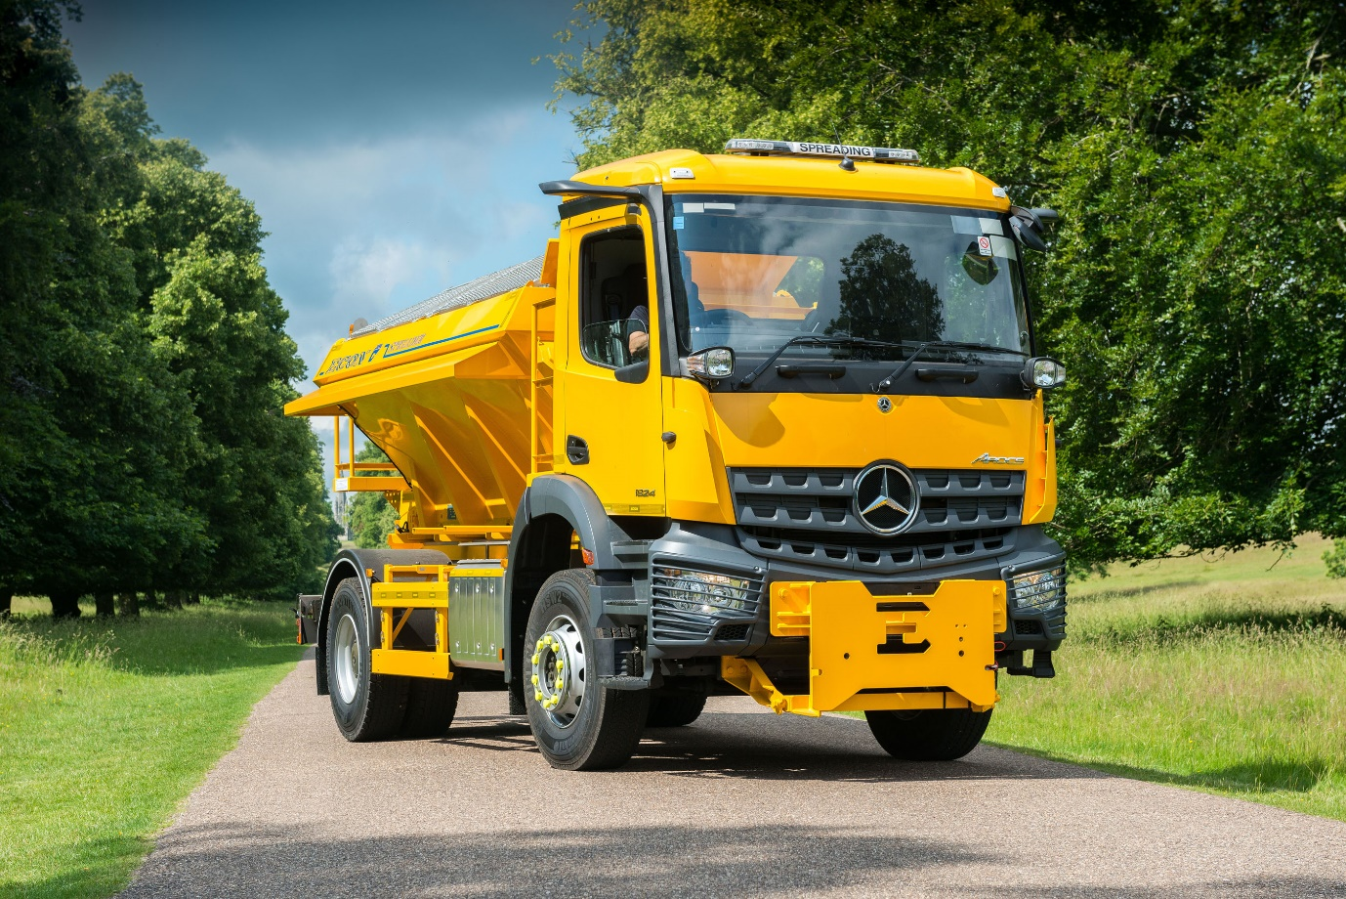

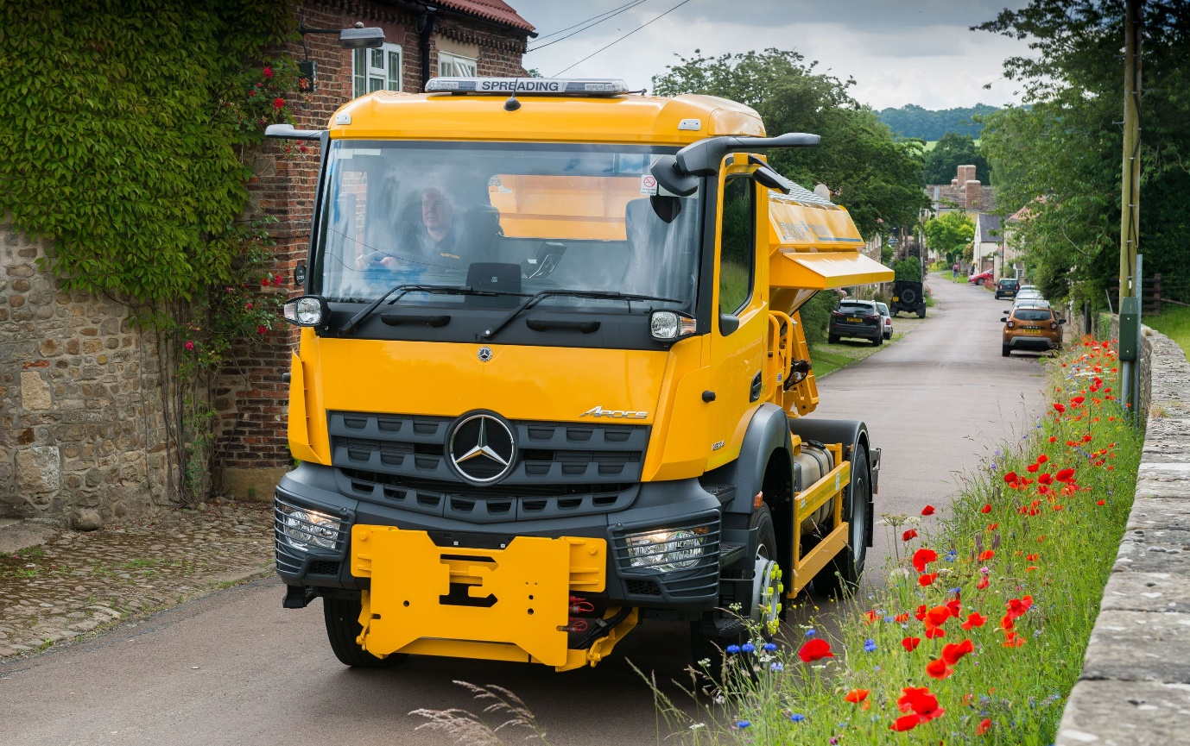

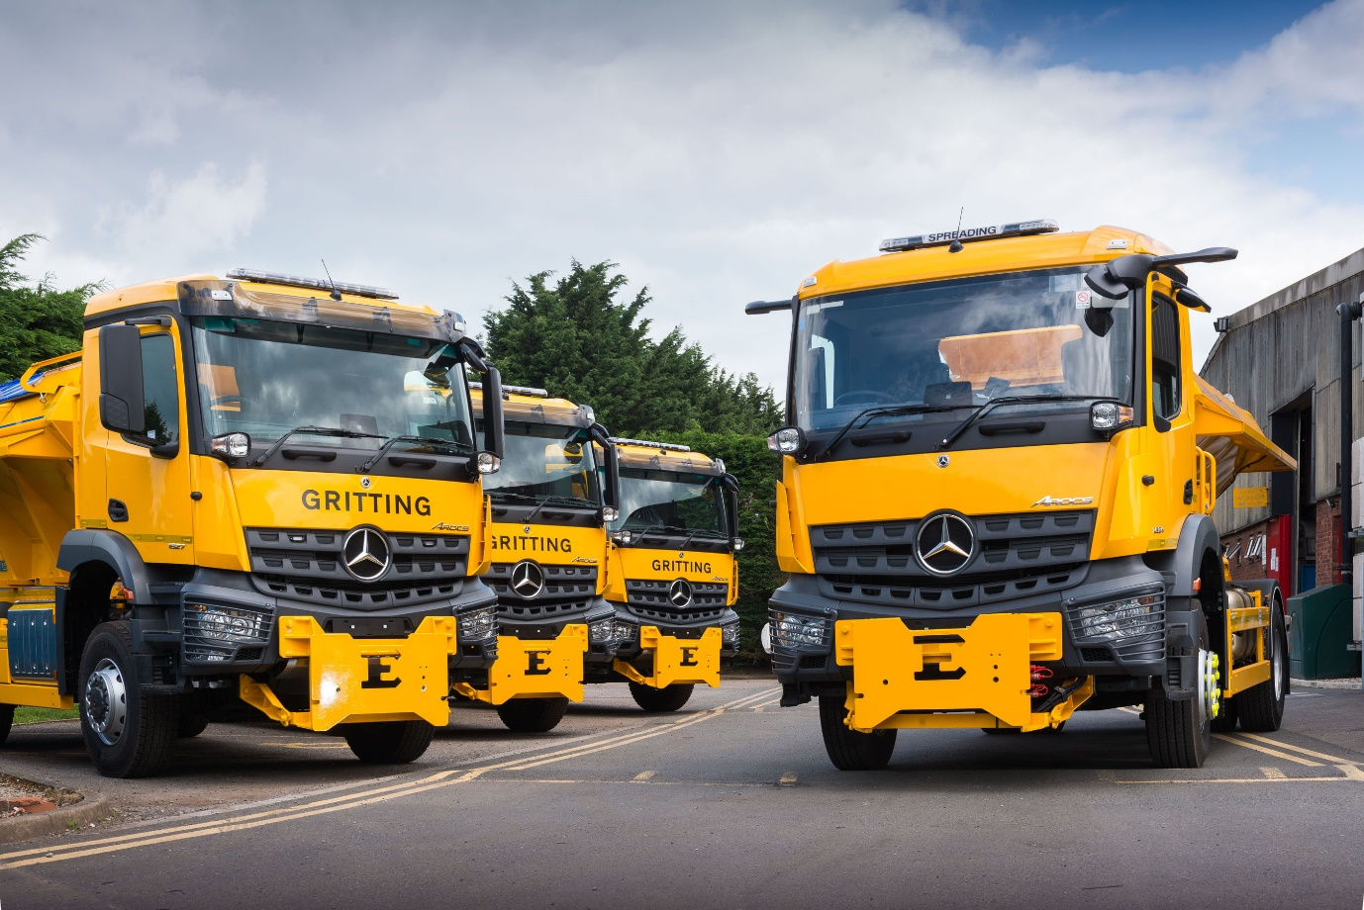



Looking to the future: Econ Engineering Fleet Hire Manager Paul Wigby with the company’s first MirrorCam-equipped Mercedes-Benz Arocs, right

ends

For more information, or to request bigger/higher-res image files, please contact:
John Ripley or Steve Warren
Impact Communications, 01926 842126
John: 07771 484595, john@impactcom.co.uk
Steve: 07770 470251, steve@impactcom.co.uk

