

Date: 19 November 2020

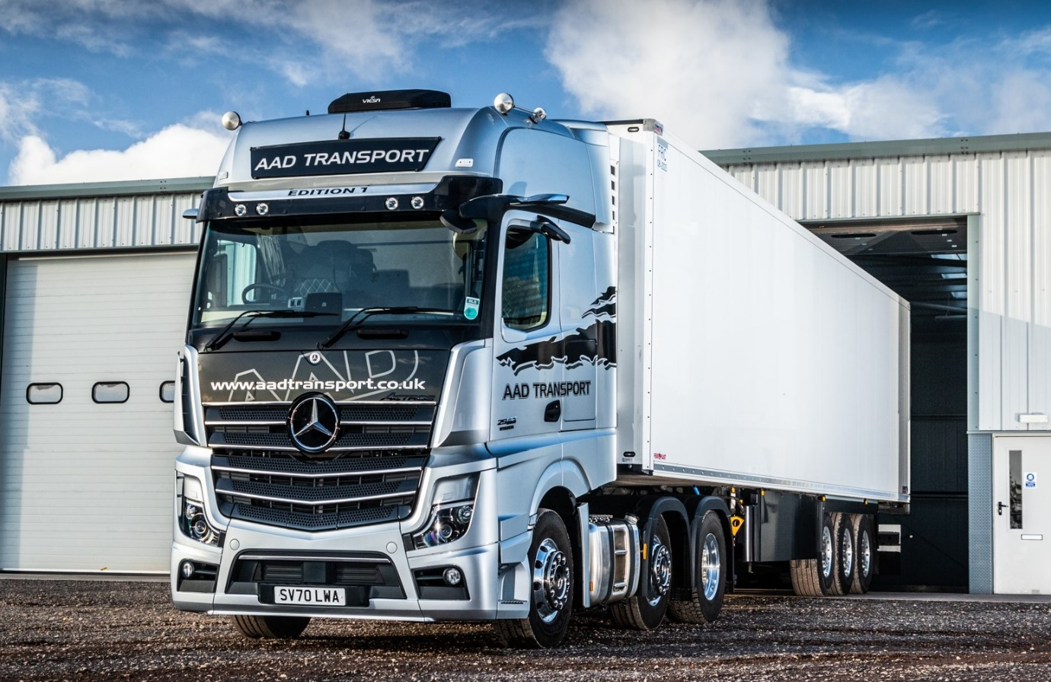

Exclusive Mercedes-Benz Actros Edition 1 flagship is a winner on all fronts for AAD Transport

His boss describes him as “an old-school guy”, but AAD Transport driver Gordon Taylor was quick to embrace the innovative technology as well as the sumptuous comfort and eye-catching appearance of his very special Mercedes-Benz Actros Edition 1.

“Gordon is a highly experienced driver,” said owner and Managing Director Alan Davie. “Like every member of our team, he’s also a valued employee with a ‘can-do’ approach, who will turn his hand to anything the transport game throws at him.”

A general haulier, AAD Transport is based in Kirriemuir, near Dundee, and runs a fleet of 33 tractor units. Its new, limited edition flagship arrived via North of Scotland Dealer BLS Truck & Van and is the only Mercedes-Benz truck on the fleet at present, although the operator has run tractors from previous Actros model generations in the past.

The Edition 1 is a stunning showcase for the latest Actros range, International Truck of the Year 2020. Just 400 examples have been built and of these only 35 were made available to UK customers.

Its imposing GigaSpace cab is instantly recognisable thanks to the gloss black grille, darkened headlamp covers and rims, and branded sun visor incorporating four extra LED main-beam headlamps. Like most Edition 1s, AAD’s truck is powered by a range-topping 15.6-litre in-line six-cylinder engine that produces a potent 460 kW (625 hp).

“Our drivers are all multi-taskers, with a flexible approach to the job,” continued Mr Davie. “They could be pulling a refrigerated trailer one day, and a step-framed low-loader the next, and are often away from home, be it in the UK or Europe, for a week or more at a time.

“For this reason we choose highly specified vehicles that are great not only to drive, but also to live in. The Actros Edition 1 fits the bill perfectly. Gordon told me he wanted ‘something different’ this time, and with all of its amazing technology his new truck certainly delivers on that score.

“It’s a fantastic vehicle but we pushed the specification even further by adding an optional coffee maker, microwave oven, home cinema system and Viesa cab cooler, which provides air-conditioning at night without the need to run the engine.”

The latest Mercedes-Benz Actros breaks new ground in several respects but the most talked-about development is its MirrorCam system, which replaces traditional mirrors with rear-facing cameras that relay their images to screens mounted inside the cab, on the A-pillars.

As well as enhancing safety by providing much-enhanced all-round visibility, not least through the elimination of forward-facing blind spots caused by conventional mirrors, the system cuts diesel costs by an estimated 1.5% because the cameras’ compact, streamlined housings create far less aerodynamic drag.

“If I’m honest I wasn’t sure how Gordon would take to MirrorCam, because it’s quite a culture change,” recalled Mr Davie. “As it turned out, I needn’t have feared.”

Gordon Taylor, who has worked for AAD Transport since 2015, said that while he loved the luxury touches and effortless power of his new Actros, MirrorCam was one of his favourite features.

“I’ve found the system very natural and easy to get along from the first day I sat in the truck,” he revealed. “The more I use it, the more I like it. The cameras and screens provide a very clear view of what I need to see, particularly when reversing or making tight turns with a trailer.”

The new truck’s black leather-trimmed cab interior features door handles with contrasting topstitching and a polished and brushed aluminium dashboard badge that confirms his truck as ‘One of 400’ Edition 1s. Mr Taylor can choose from no fewer than eight colours of ambient ceiling lighting, while his bed is an industry-leading 900 mm wide.

The latest Actros also comes with a radical new dashboard, which replaces traditional switchgear with twin screens, one with touch functionality. Naturally, Edition 1 drivers benefit from the upgraded Multimedia Cockpit, interactive version, which incorporates a larger, 12in instrument panel and offers additional functionality.

“My Edition 1 looks fantastic and is a great truck in which to work and spend time away from home,” enthused Gordon Taylor. “I always get a great night’s sleep and couldn’t be happier with it.”

Alan Davie added: “BLS Truck & Van Sales Executive Chris Dyer was admirably persistent in convincing me the truck would deliver the fuel economy and reliability we need. The Mercedes-Benz Finance contract hire package he put together is very competitive, while I’ve also been given all the right promises about the level of back-up we can expect.

“The manufacturer’s Zero Tolerance on Downtime commitment certainly provides reassurance, as it means that if our truck is ever off the road for more than 24 hours we’ll be supplied with a replacement or equivalent contribution towards a rented vehicle. All told, it’s an excellent proposition.”

Like other new Actros models, the Edition 1 is equipped with the latest, enhanced version of Mercedes-Benz Trucks’ fuel-saving Predictive Powertrain Control (PPC) system, and a potential life saver in the form of Active Brake Assist 5, which, unlike the previous version of he manufacturer’s emergency braking technology, relies on camera as well as radar.

The exclusive model’s lengthy list of optional equipment includes a Sight Package, which provides for ‘best possible’ lighting and visibility by adding a rain sensor, bi-xenon headlamps, fog lamps, LED daytime running lights, cornering lights and LED tail lights. Other additional specification is bundled within the Driving, Comfort, Media and Stowage Packages.
aadtransport.co.uk

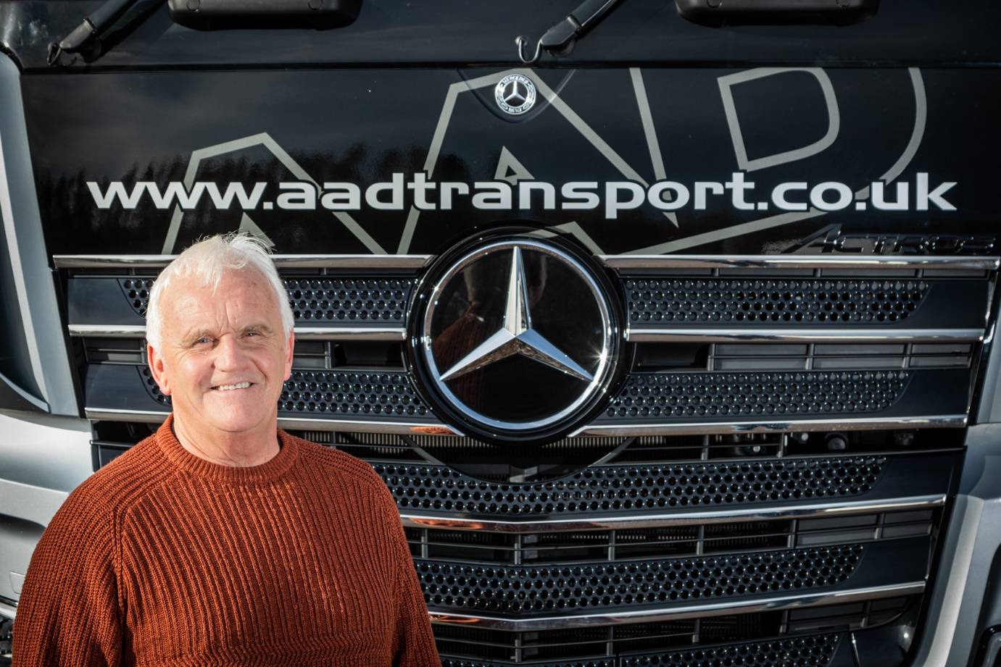

A clear improvement: Driver Gordon Taylor is impressed by the view provided by the MirrorCam cameras and screens in his new Mercedes-Benz Actros Edition 1

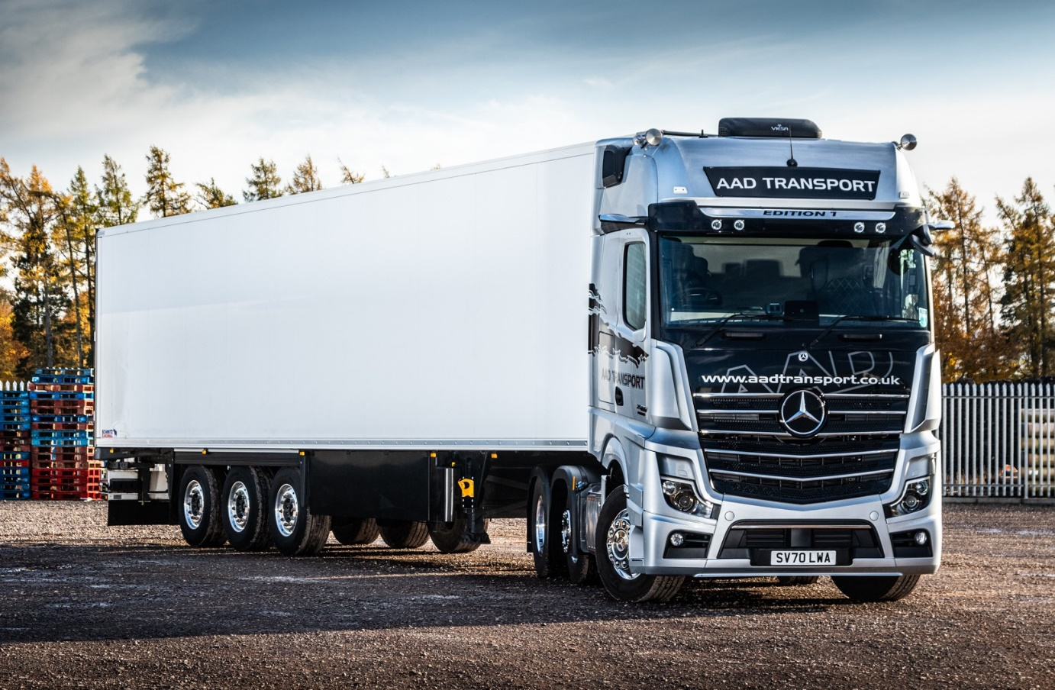

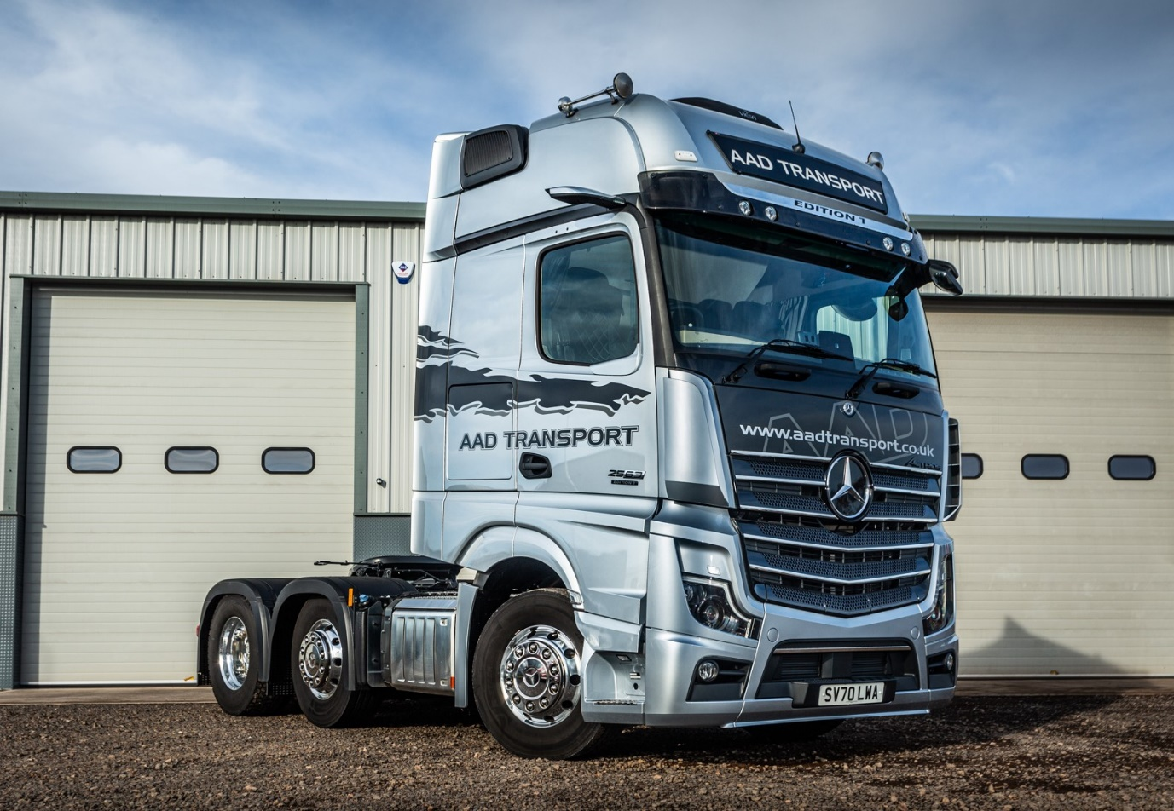

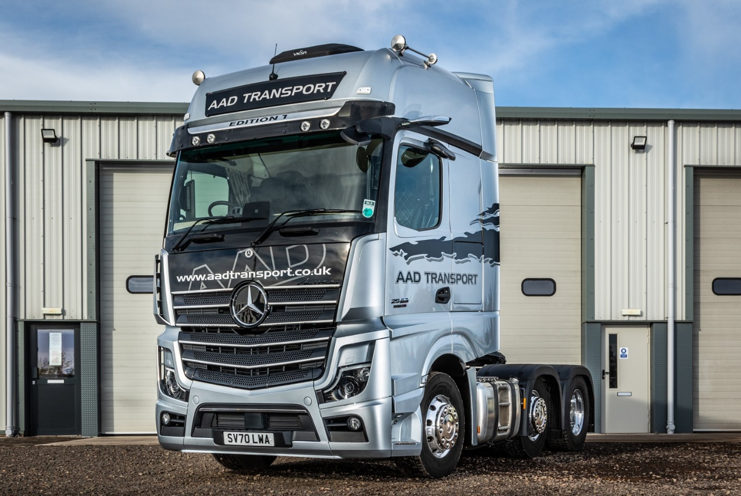

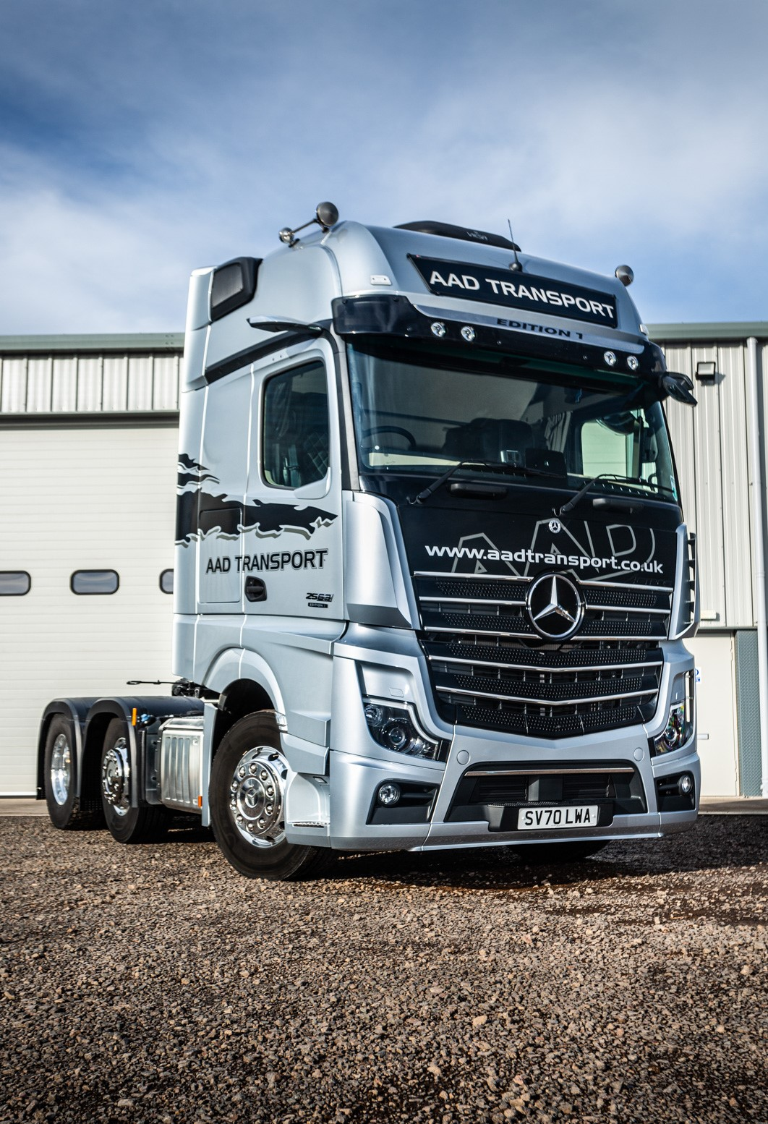

ends

For more information, or to request bigger versions of image files, please contact:
John Ripley or Steve Warren
Impact Communications, 01926 842126
John: 07771 484595, john@impactcom.co.uk
Steve: 07770 470251, steve@impactcom.co.uk



