

Date: 7 May 2019

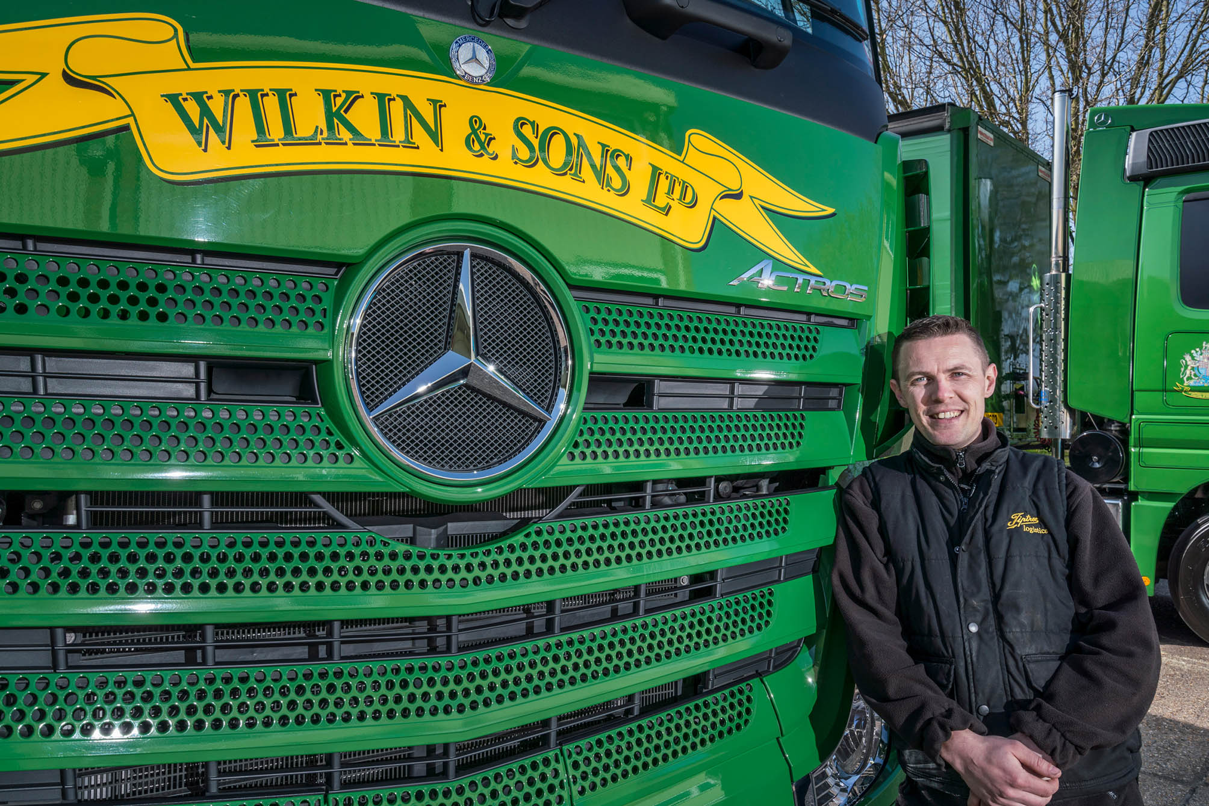

Accident averted: Driver Tim Sharp was ‘blown away” by the speed with which his new truck’s Active Brake Assist 4 system responded when a pedestrian stepped into his path

Mercedes-Benz Trucks’ emergency braking system proves its life-saving potential for Wilkin & Sons driver

Tim Sharp was at the wheel of his new Mercedes-Benz Actros when a woman stepped off the kerb in front of him – and the truck’s Active Brake Assist 4 emergency braking system intervened instantly to prevent an accident.

“I was on my way out of London,” he recalled. “A lady was on her phone and decided to take a short cut to a zebra crossing. The vehicle picked up on her before I could, and brought me safely to a halt in good time. I didn’t touch anything; the truck did it all. And the speed with which it did so... I was just blown away. Fantastic!”

A 26-tonne Actros 2536L model with aerodynamic, flat-floored StreamSpace cab and tag axle, Wilkin & Sons’ latest truck arrived via the Ipswich headquarters of East Anglia Dealer Orwell Truck & Van, and has a curtainside body by another long-established supplier, Colliers Truck Builders, of Witham.

It wears the distinctive green and gold colours of a world-renowned company which has been producing Tiptree conserves in north Essex since 1885, and is the proud holder of a Royal Warrant from Her Majesty The Queen.

The rigid’s advanced, 265 kW (360 hp) straight-six engine is paired with a Mercedes PowerShift 3 automated transmission. Active Brake Assist 4 is incorporated within the optional Mercedes-Benz Safety Pack (standard equipment on road-going Actros tractor units), which also includes Proximity Control Assist and a driver’s airbag.

Wilkin & Sons has also specified the vehicle with fuel-saving Predictive Powertrain Control technology, and alloy wheels, while Tim’s stylishly personalised cab interior features a factory-fitted fridge and a sunroof surround with LED lighting.

Tim uses his Actros to make nationwide deliveries of Wilkin & Sons’ products to the regional distribution centres of major supermarkets, wholesalers, hotels, restaurants, garden centres, and even private homes. As well as the jams and marmalades for which it is best known, the company’s portfolio now includes everything from savouries, sauces and steamed puddings, to fruit-flavoured gins and teas.

The six-wheeler has also been quick to impress in terms of fuel-efficiency. “I was coming back from Derbyshire last week, with it set to Economy at 52 mph, and achieved 14.2 mpg,” explained Tim. “I was empty at the time, but given exactly the same scenario with my previous 26-tonner, I’d have hit 11.5 mpg if I was lucky.”

The new Actros has lined-up alongside Wilkin & Sons’ seven other trucks. With a single exception, all wear three-pointed stars and were supplied by Orwell Truck & Van – in addition to rigids at 26, 18 and 7.5 tonnes GVW, the line-up includes an Actros 2546 MegaSpace tractor unit which has been on the road since 2006.

A serial winner of truck show awards, this vehicle is affectionately known as ‘The Star’ by the Wilkin & Sons distribution team. Lovingly tended by driver Bradley Scott, the truck is a real-head turner with its traditional, hand-painted signwriting, and highly polished chrome chassis infills, vertical exhausts and other features.

Working with a curtainsided trailer, Bradley’s Actros shunts the five miles between Wilkin & Sons’ production facility in Tiptree and warehouse at Maldon two or three days a week, and is also used to make deliveries.

“I was at a truck stop in Chippenham not so long ago and a chap started taking photographs of my unit,” said Bradley. “He couldn’t believe it when I told him it was 12 years old, but that kind of thing happens all the time. She’s now clocked-up 950,000 km, and is still fresh as a daisy, starting first time, and never missing a beat. She’s my baby, and I love her.”

The Actros tractor unit was allocated from new to Kevin King, who drove it until he took on the role of Transport Assistant in 2013, prior to his promotion three years later to Transport Manager. He said: “That truck’s been a fantastic tool, but it’s only what we’ve come to expect from Mercedes-Benz.

“We were running them when I joined this company 28 years ago, and we’ve remained loyal to the brand ever since. Mercedes-Benz trucks have always been reliable and cost-effective to operate, of course, and over the years the manufacturer has also raised its game in terms of driver appeal.

“Wilkin & Sons is a high-profile company, so image is very important to us, too. A dirty-looking truck sends out all the wrong messages, which is why we actively encourage our drivers to take care of their vehicles, and participate in truck shows. Lads like Tim and Bradley are great ambassadors for our business, and their fantastic looking trucks are a credit to them, as well as to Mercedes-Benz.”

Commenting on the decision to specify its latest vehicle with the optional Safety Pack, Kevin King continued: “We’re delivering to busy high streets and areas where there are lots of pedestrians, so we’ll seize any opportunity to maximise safety.

“Tim’s is the first new vehicle we’ve bought since Active Brake Assist 4 was introduced. His report on the incident when the woman stepped out in front of him is very reassuring, and emphatically justifies our investment in this ground-breaking technology.”

Active Brake Assist 4 employs multi-mode radar to monitor moving and stationary objects in front of the vehicle and sounds an audible warning when it senses potential for a collision. If the driver takes no action, it will apply staged braking followed by full braking power to prevent a crash, or dramatically reduce the effects of an impact. The system is looking for moving pedestrians from a standstill, even one stepping into the truck’s path from behind a parked car.

Wilkin & Sons’ new Actros is the subject of a seven-year Complete Service Contract and, like the company’s other Mercedes-Benz trucks, is inspected and maintained by Orwell Truck & Van. “My Transport Assistant Lawrence Cook has a particularly good relationship with the team at Orwell’s Colchester depot, who are very responsive and provide an excellent service,” added Mr King.

www.tiptree.com

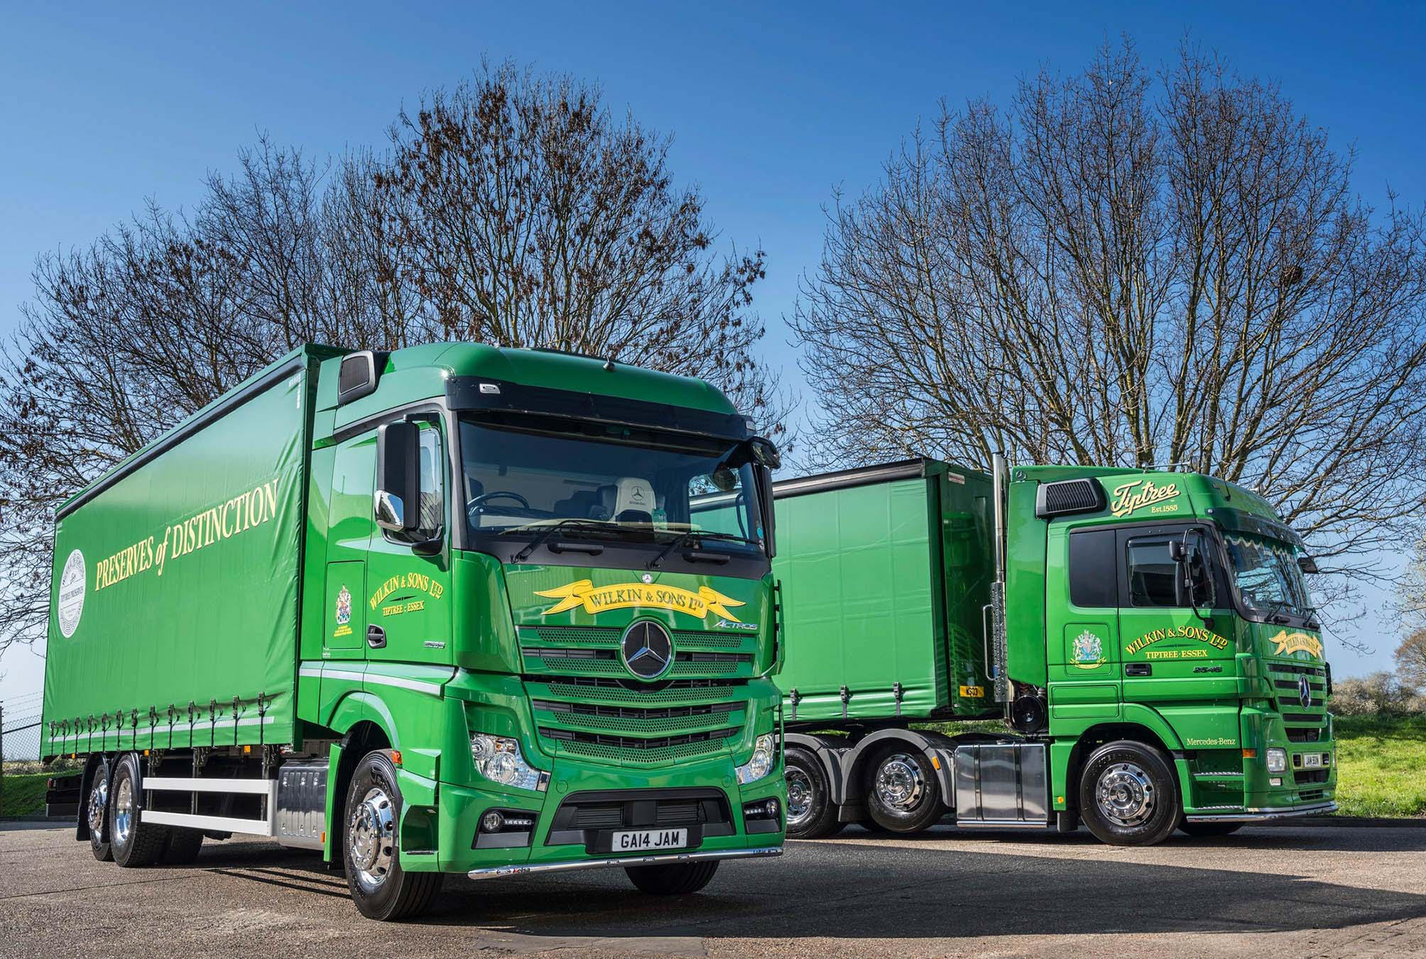

Jam today, and every other day too: There are more than 12 years between them, but Wilkin & Sons’ newest and oldest trucks share the Mercedes-Benz DNA and passionate devotion of their drivers which ensures they turn heads wherever they go

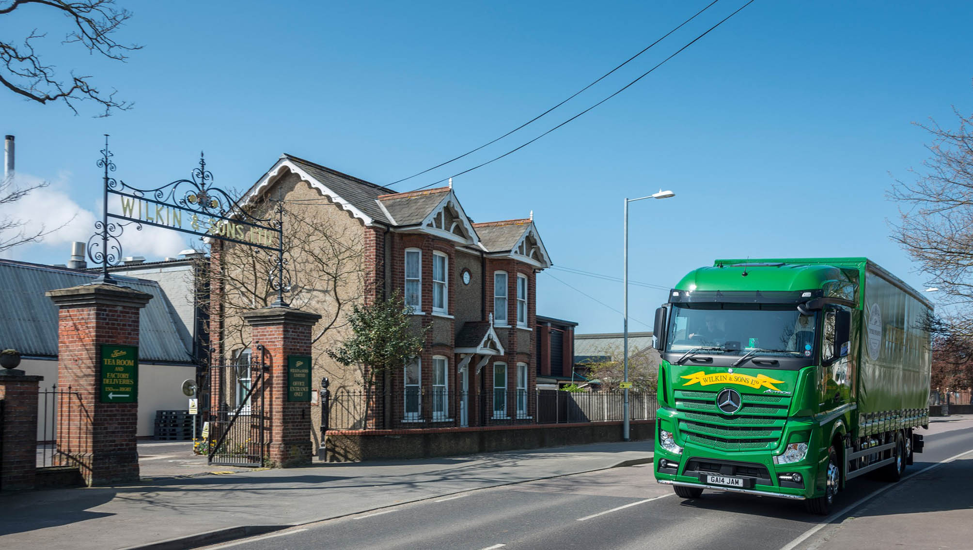

Drive past: The new Actros outside Wilkin & Sons iconic factory gates in Tiptree

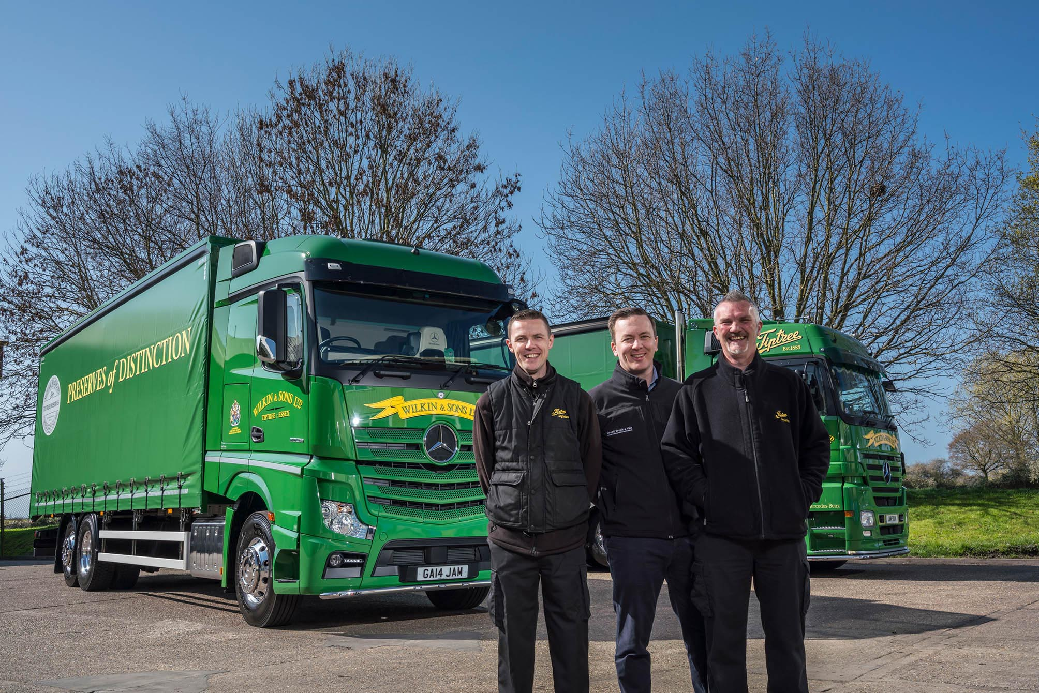

Three-pointed stars in their eyes: Wilkin & Sons’ drivers Tim Sharp, left, and Bradley Scott, right, are pictured with Orwell Truck & Van Sales Executive Ben Sheldrake, and their stunning Mercedes-Benz Actros

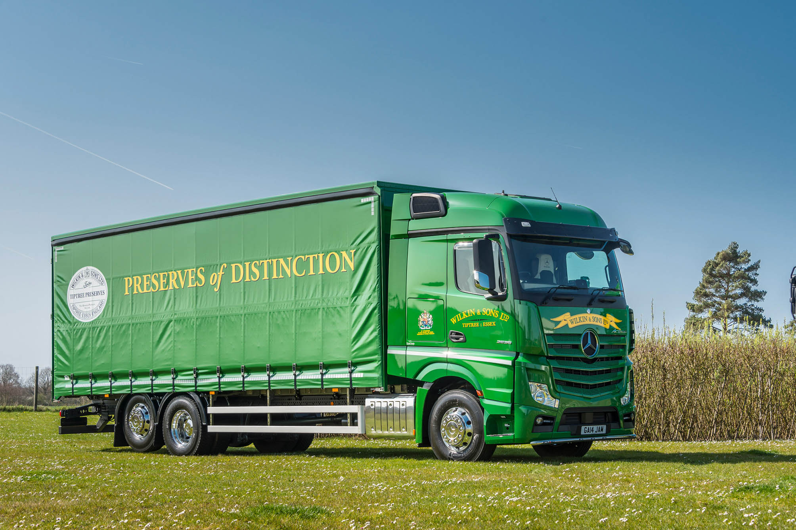

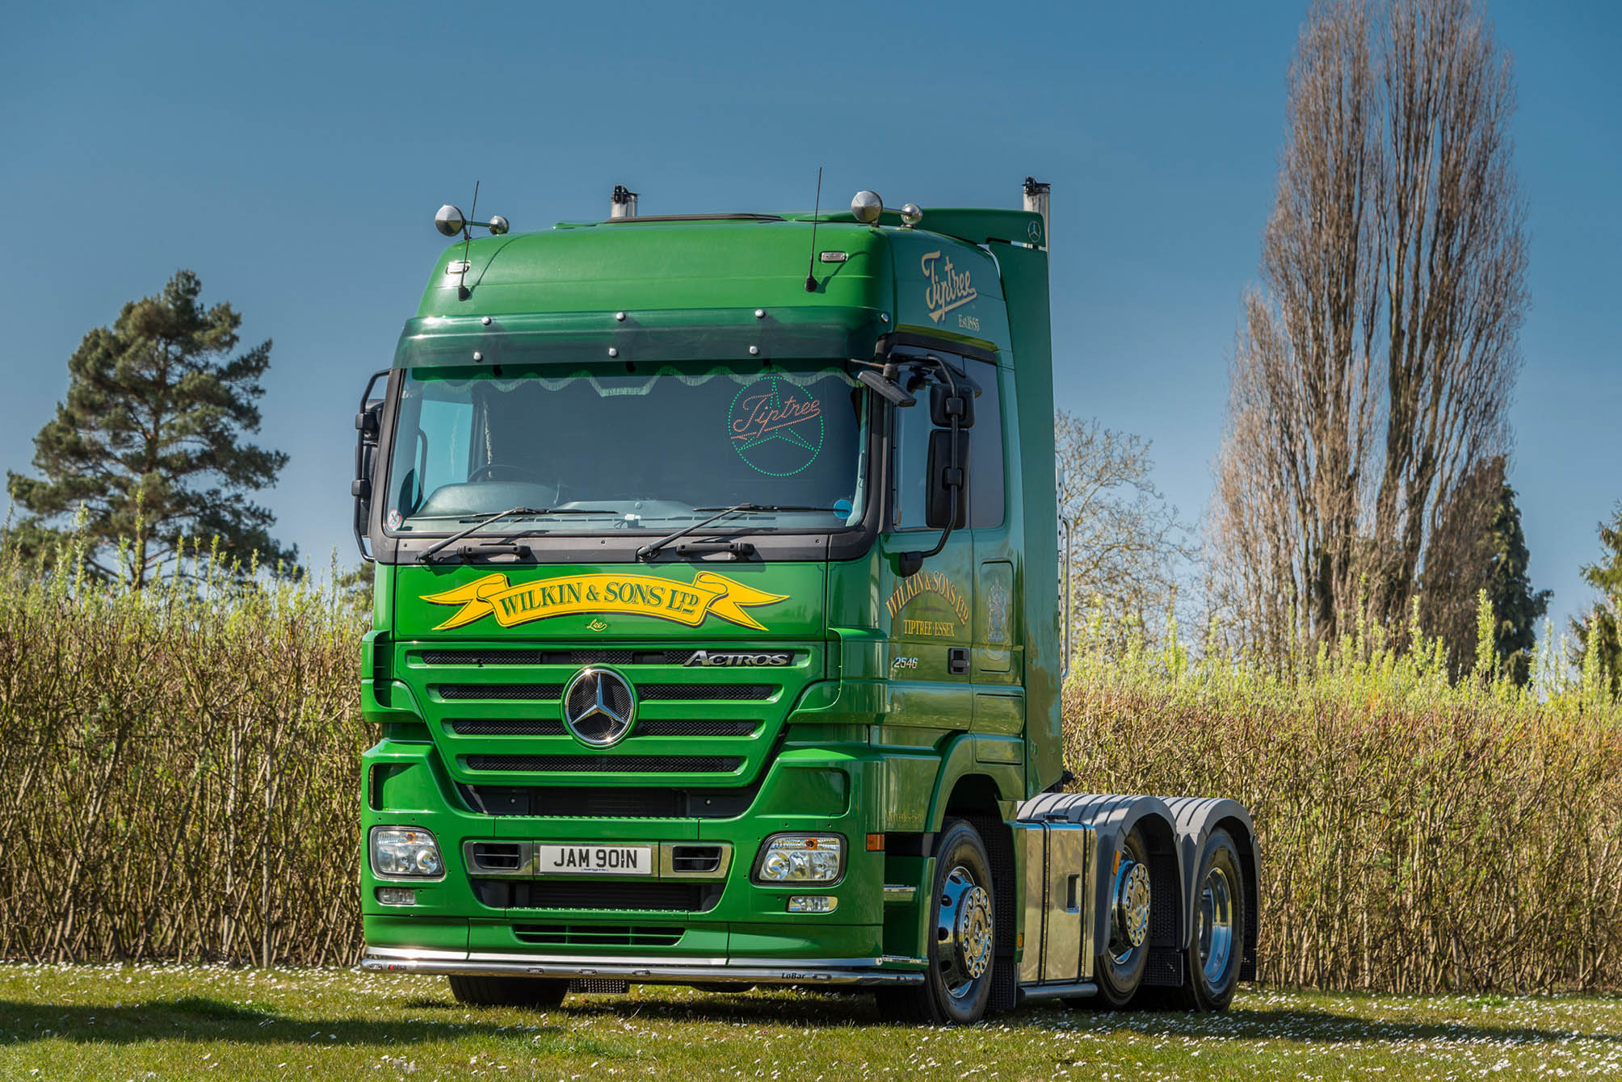

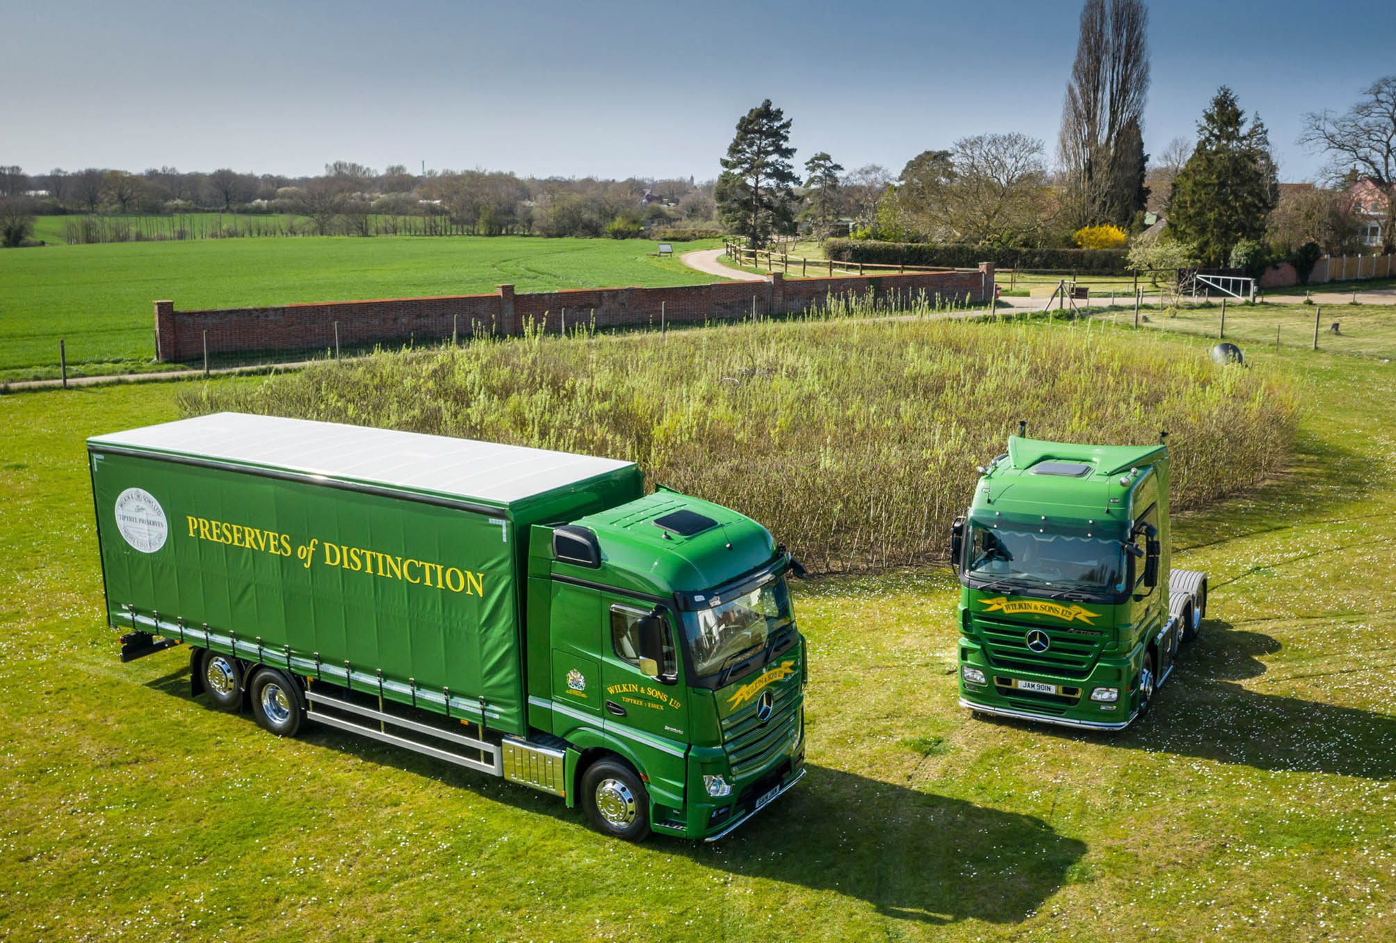

ends

For more information, or to request bigger/higher-res image files, please contact:
Steve Warren or John Ripley
Impact Communications, 01926 842126
John: 07771 484595, john@impactcom.co.uk
Steve: 07770 470251, steve@impactcom.co.uk

