

Date: 22 June 2021

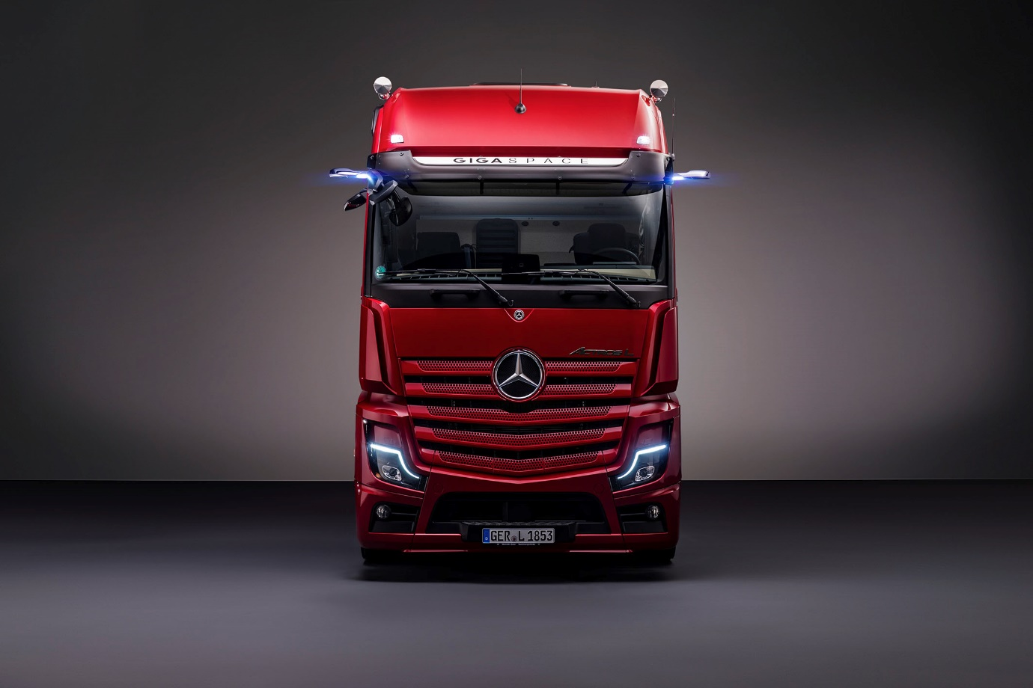

The Actros L: Mercedes-Benz Trucks sets new standards in the premium segment for long-distance haulage trucks

The Actros L – the largest and most luxurious production model in the series – offers a host of features and equipment details for relaxed driving, comfortable living and efficient working

Active Drive Assist 2 features an emergency stop function which can automatically brake the vehicle to a complete halt in an emergency

- Quieter cabs with improved heat insulation

- Lower seating position for more comfort and improved visibility

- New high-intensity LED headlamps

Whether in terms of efficiency, safety or comfort, the Mercedes-Benz Actros has been setting a high standard for trucks in the long-distance haulage and heavy-duty distribution haulage sectors since 1996. The latest Actros generation, from 2018 onward, has continually set new milestones with a multitude of innovations in the fields of digitalisation, networking and safety. Innovations such as the Multimedia Cockpit, MirrorCam, partially automated driving functions and enhanced safety systems ensure that the Actros admirably fulfils the increasing demands of the road haulage sector while sustainably supporting the driver in completing his or her tasks. Following on from the launch in 2021 of the limited edition Actros Edition 2, Mercedes-Benz Trucks is now introducing the Actros L, the largest and most luxurious of this successful model series. The heavy-duty truck with conventional diesel powertrain can be ordered Europe-wide from 1 July 2021 and goes into production in November 2021.

“When developing the Actros L we placed particular focus on driver comfort, safety, connectivity and Total Cost of Ownership to create further benefits in these aspects for our customers and their drivers,” says Andreas von Wallfeld, Head of Marketing, Sales and Services at Mercedes-Benz Trucks. Thanks to close dialogue with customers there is clear knowledge of what they want from a premium truck for both their company and their drivers. “It’s precisely these requirements that we have addressed with the Actros L,” von Wallfeld emphasises.

Exceptional spaciousness and high-quality equipment for enhanced driver comfort

It begins with the driver’s cab, which on the StreamSpace, BigSpace and GigaSpace variants is 2.5 metres wide and makes for an exceptionally spacious interior. The lack of engine tunnel means that the cab has a flat floor, creating a really comfortable ambience. Enhanced cab noise insulation has resulted in a quieter environment for the driver, assisting with relaxation, particularly at break times.

The seating position has been lowered by 40 mm for more relaxed driving and a comfortable view of the road. On a related note, the optionally available, newly designed LED main headlamps have a higher light intensity than xenon headlamps and provide excellent illumination of the road – a huge plus when it comes to safety, especially when it’s dark. And there’s a cost-effectiveness benefit too: compared to conventional bulbs, LED headlamps are more energy efficient and have a longer service life.

Aiming to enhance driver comfort and convenience are various equipment details, including stylish seat covers, new door trim, a comfortable mattress with 45 mm thick topper and a pleasantly tactile cab rear panel in the bed area. The sense of well-being can be further boosted with the numerous Interior Line accessories from Mercedes-Benz Trucks. Von Wallfeld is firmly convinced: “For transport companies, the Actros L is a really strong asset, especially in light of the acute shortage of drivers.”

Excellent safety features

With the Actros L too, Mercedes-Benz Trucks is systematically pursuing its goal of helping to make road traffic as safe as possible by utilising active safety assistance systems, and in doing so is taking another step closer to realising its vision of accident-free driving. This is evidenced not only by Lane Keeping Assist, Proximity Control Assist and MirrorCam, which replaces the main and wide-angle mirrors, but also by a host of other safety features.

Another equipment option for the Actros L is the second generation Active Drive Assist (ADA 2), which is available for 4x2 and 6x2 tractor units with tag axles, but not – currently – those with mid-lifts. Under certain preconditions the system actively assists the driver with longitudinal and lateral guidance of the truck and can automatically maintain the distance to the vehicle ahead, accelerate and also steer if the necessary system conditions such as sufficient curve radius or clearly visible road markings are met. In addition, ADA 2 includes the Emergency Stop Assist sub-function which is able to initiate an emergency stop if, despite visual and audible warnings, the driver is no longer controlling the steering wheel. If the truck comes to a standstill, the system can automatically engage the new electronic parking brake. In addition, the doors are unlocked so that paramedics and other first responders can directly reach the driver in case of a medical emergency.

The Actros L is also equipped as standard with Active Brake Assist 5 (ABA 5), which features a pedestrian recognition function. This system can help to avoid accidents where, due to the driver being distracted, the following distance being too short, or an inappropriate speed, the truck is at risk of colliding with a vehicle ahead or a stationary vehicle, or there is a risk of a frontal collision with a pedestrian. ABA 5 works using a combined radar and camera system. If the system detects the risk of an accident with a vehicle driving in front, a stationary obstacle or a person (crossing the vehicle’s path, coming towards the vehicle, walking in the same lane as the vehicle or suddenly coming to a stop in fright), the system initially emits a visual and audible warning to the driver. If the driver fails to respond appropriately, the system can then initiate partial braking in a second stage. If the threat of a collision continues, ABA 5 can perform automated maximum full-stop braking – at vehicle speeds of up to 50 km/h when responding to moving persons.

In addition, the Actros L is equipped with Sideguard Assist, which supports the driver when making left turns and changing lanes in busy environments where visibility may be restricted. Within the system limits, it is designed to reduce the possibility of accidents involving vulnerable road users. Two short-range radar sensors mounted on the passenger side of the vehicle monitor up to a lane’s width, and deliver optical and acoustic warnings which alert the driver to the presence of cyclists, pedestrians or other vehicles.

With all assistance systems, Mercedes-Benz Trucks aims to support the driver as much as possible within the system limits. However, as the law prescribes, the driver remains fully responsible for driving the vehicle safely at all times.

Greater efficiency through made-to-measure connectivity

In conjunction with these assistance systems, the intelligent cruise and transmission control system Predictive Powertrain Control (PPC) is also impressive. The system can take into account the topography, the course of a road and traffic signs in certain situations. This means that unnecessary braking, accelerating and gear shifting can be avoided. With the help of PPC, the latest Actros generation consumes up to 3% less diesel on expressways and motorways than vehicles not equipped with the system, while on rural roads it can even be as much as 5% less. On the subject of fuel efficiency, the new Eco-Support display in the Multimedia Cockpit, Interactive helps the driver to adopt a driving style that’s as economical as possible.

The driver is shown the activities and functions of assistance systems such as ABA 5, ADA 2 or PPC in the standard user-friendly Multimedia Cockpit, with its two colour displays forming the centrepiece of the Human-Machine Interface (HMI). In the Actros L, this also includes as an optional feature displays for the total weight of the towing vehicle and trailer and for the front axle load, even for tractor units with only partial air suspension. This helps the driver to keep an eye on the weight and prevent overloading.

Mercedes-Benz Truck App Portal features a host of tried-and-tested and new applications offering immense added value

If you decide to purchase the Multimedia Cockpit, Interactive as an upgrade to the standard version, you also receive access to the Mercedes-Benz Truck App Portal. This enables haulage companies to harness the new opportunities of connectivity and equip their vehicles with efficiency- and comfort-enhancing apps such as telematics services from Fleetboard. The individually-combinable services enable the intelligent networking of drivers, fleets and trucks. All of them help to optimise consumption, reduce wear and increase vehicle utilisation. The Fleetboard Performance Analysis app, for example, enables driving behaviour to be evaluated and optimised, Fleetboard Time Management provides a detailed insight into driving hours and break times, while Fleetboard Mapping displays the status and position of vehicles. And with Fleetboard Driver Card and Mass Memory Download, it is possible to read, transmit and save all relevant data remotely.

Also new to the Mercedes-Benz Truck App Portal is ContiConnect – an innovative tyre pressure monitoring system solution developed in cooperation with Continental, allowing the operator to wirelessly connect their trailer to the truck, vastly improving safety and the ability of the driver to monitor trailer tyre pressures and temperatures. Further applications, offering benefit to the driver and operator, are in development with releases scheduled this year.

Mercedes-Benz Uptime is a digital protective safety shield also for the Actros L

The Truck Data Centre is the centrepiece of Fleetboard and serves as the basis for other vehicle connectivity solutions. The connectivity module receives the data from the sensors, cameras and steering devices in the truck and analyses these for a range of applications. The Truck Data Center not only forms the basis for Fleetboard’s numerous services, but also for Mercedes-Benz Uptime, the service for consistent increases in vehicle availability.

Mercedes-Benz Uptime combines intelligent vehicle networking with intensive customer support, providing Mercedes-Benz truck operators with an innovative service product. The objective is to assist customers to fulfil their transport orders reliably by ensuring that the trucks spend as much time out on the road as possible. Workshop appointments need to be kept to a minimum and planned more efficiently. To reduce breakdowns, any repairs needed are identified as early as possible and customers are given assistance with arranging the necessary work at short notice – at all times with due consideration of their operational planning requirements. The results: better planning of workshop visits, greater vehicle availability and increased road safety.

Individually configurable service packages as well as tailor-made leasing and financing solutions complete the range of services for the Actros L and ensure greater planning security in these areas.

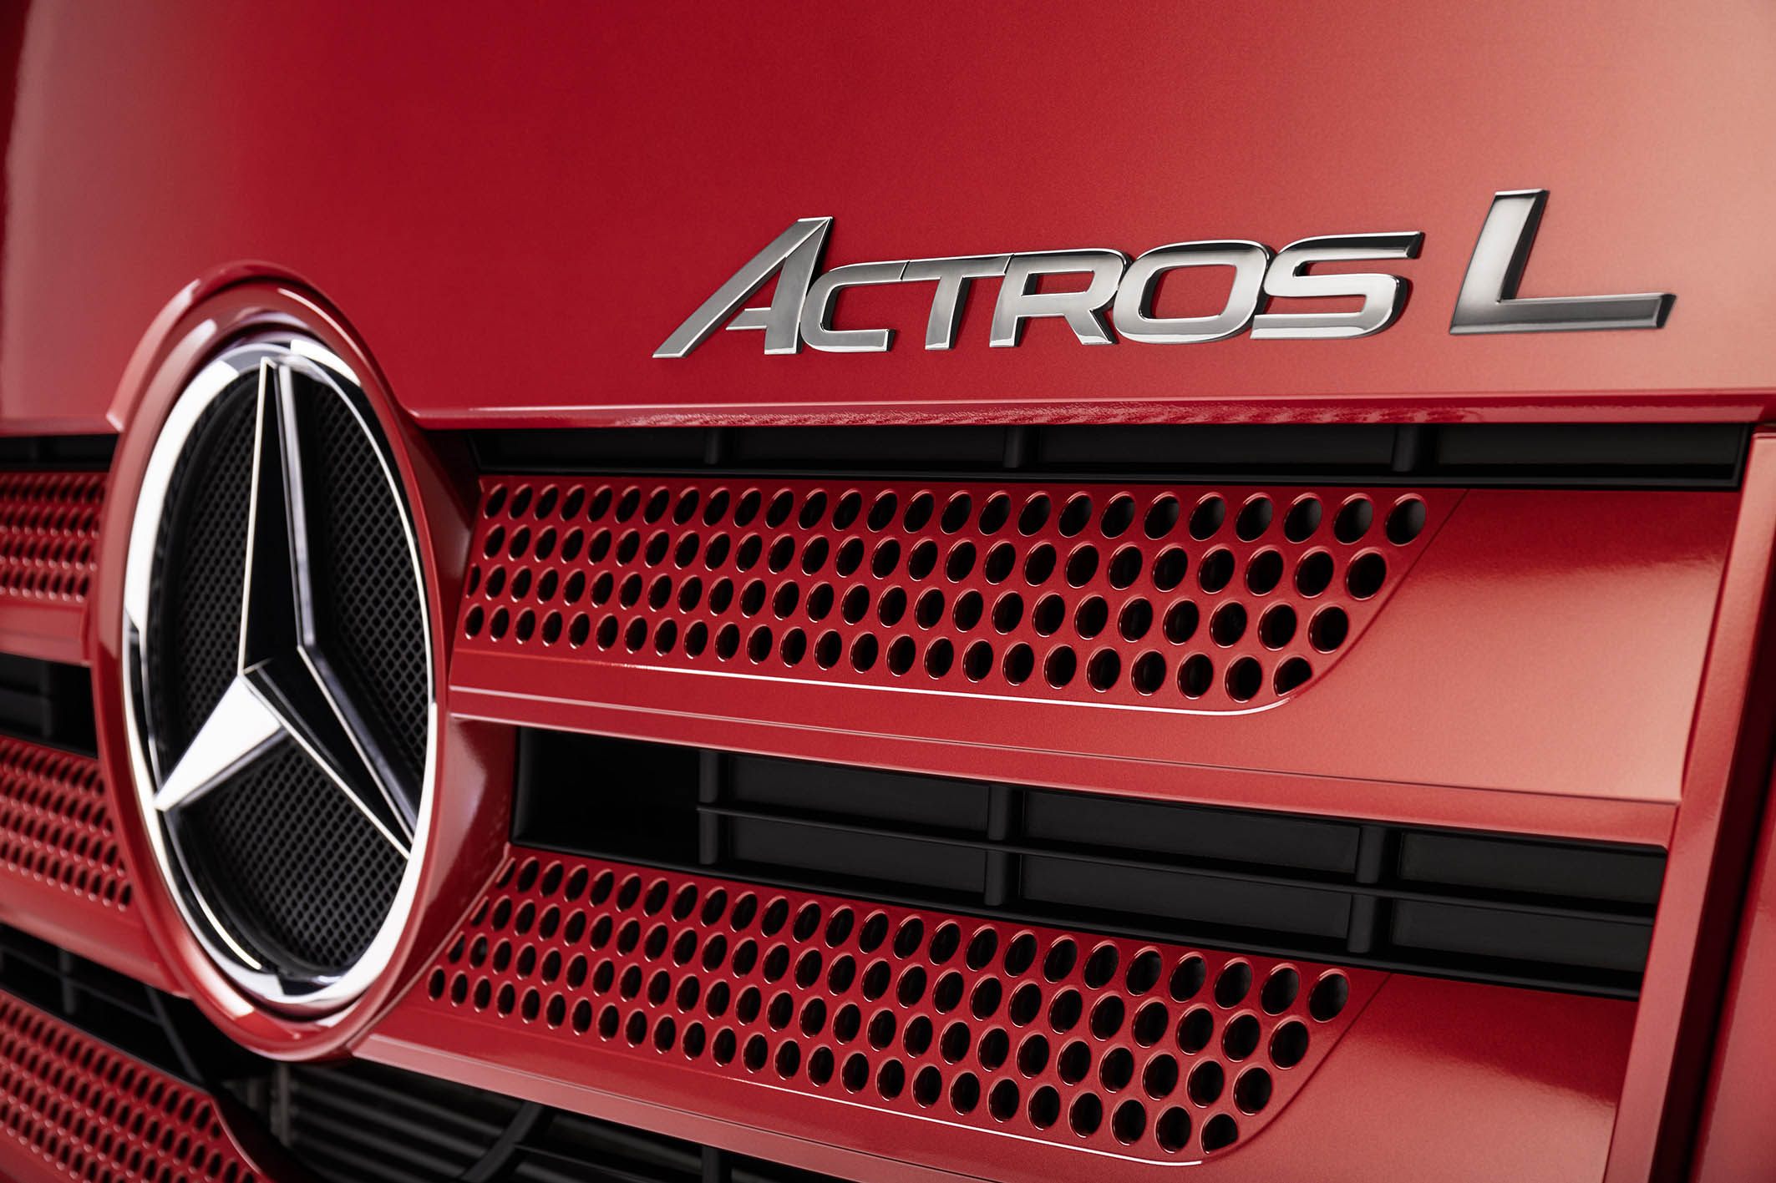

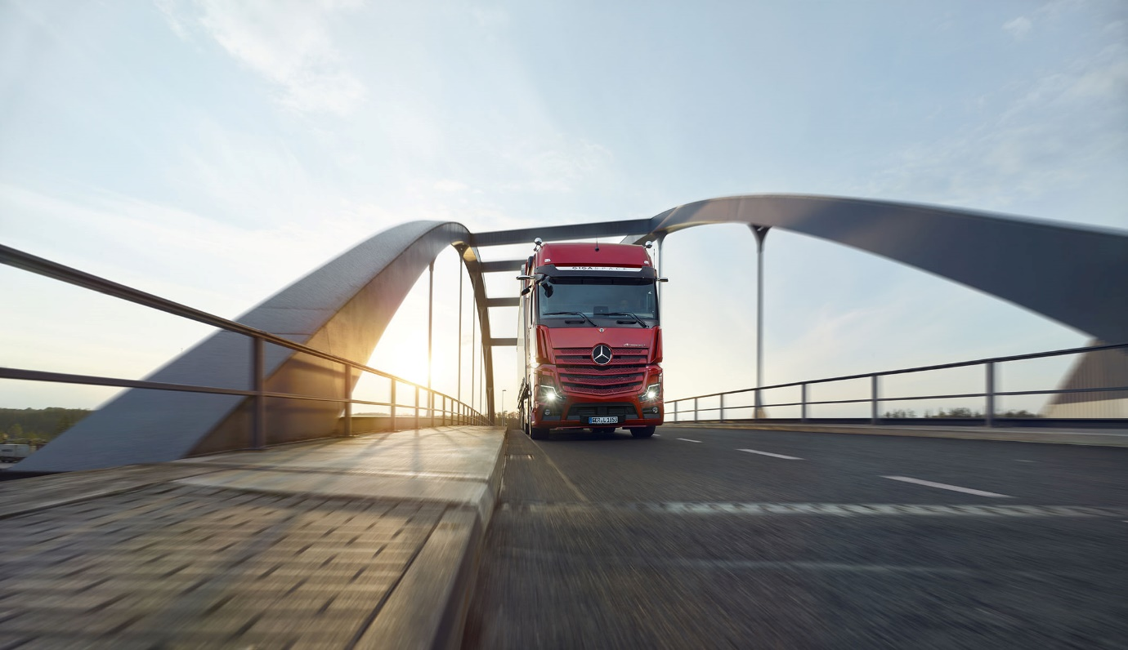

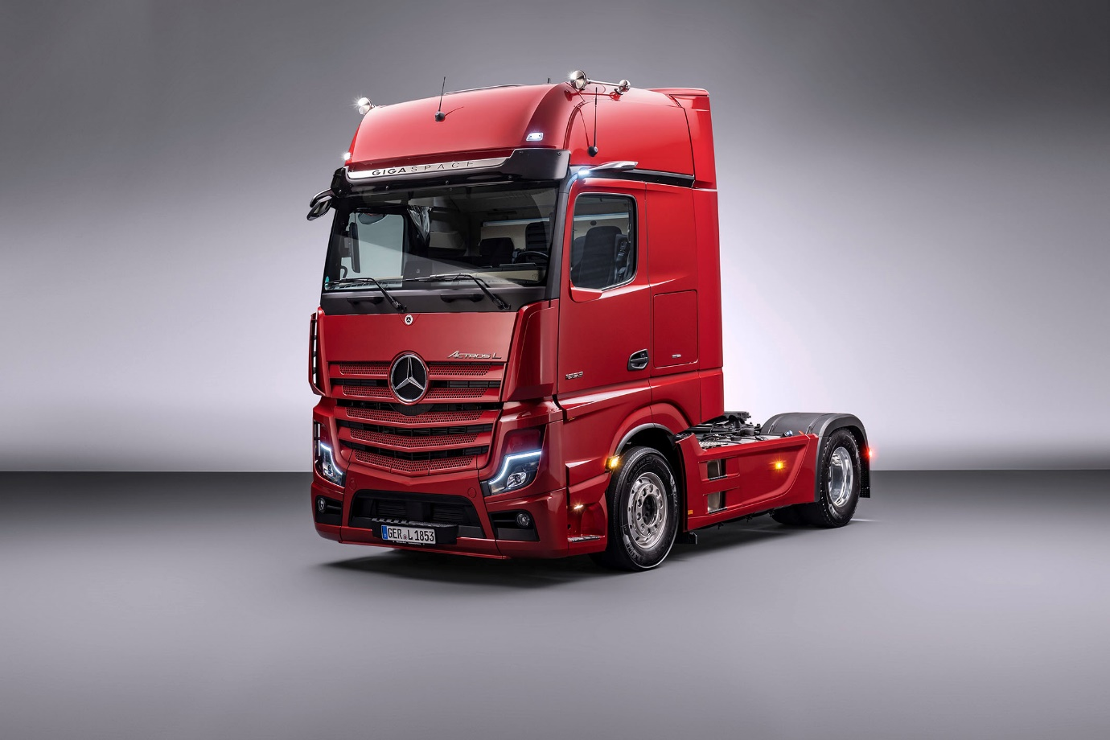

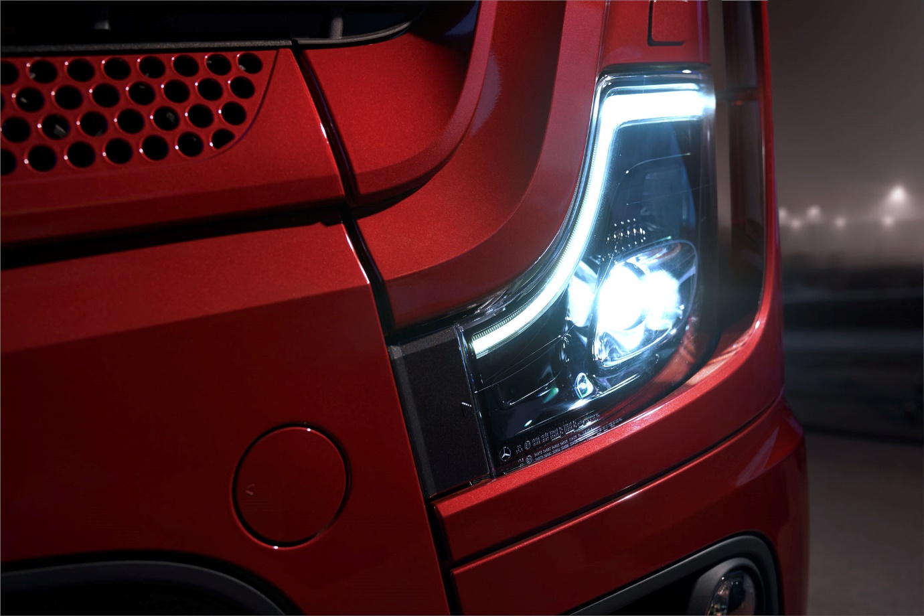

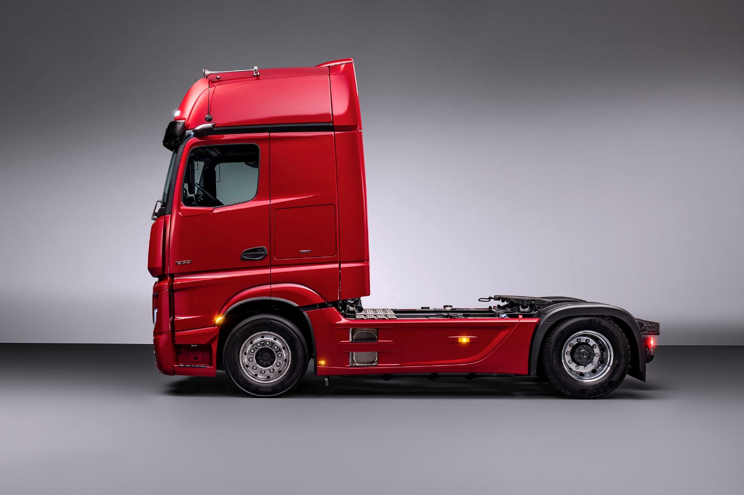

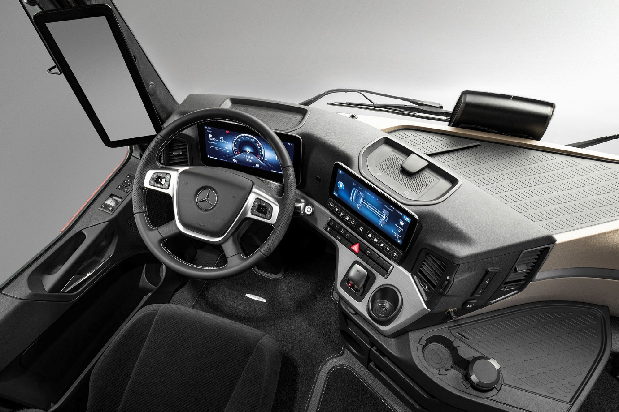

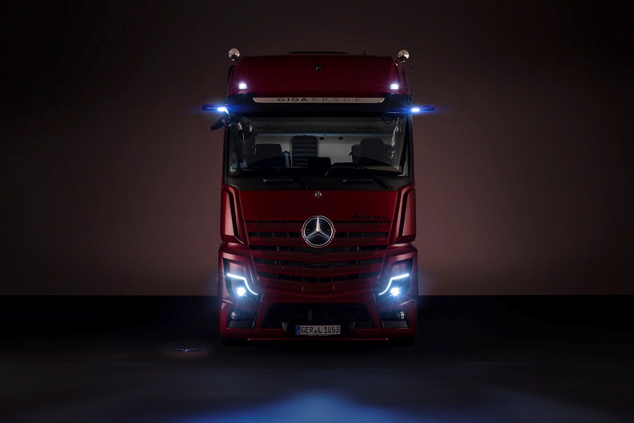

For more information, or to request higher-res image files, please contact:

Jamie Fretwell at Mercedes-Benz Trucks UK Ltd
07712 519230, jamie.fretwell@daimler.com

or

Carola Pfeifle, +49 (0)711 17-53551, carola.pfeifle@daimler.com

Ulrike Burkhart, +49 (0)711 17-58774, ulrike.burkhart@daimler.com

Further information from Mercedes-Benz is available online:
www.media.daimler.com, www.mercedes-benz.com and www.daimler-truck.com

Forward-looking statements:
This document contains forward-looking statements that reflect our current views about future events. The words “anticipate,” “assume,” “believe,” “estimate,” “expect,” “intend,” “may,” ”can,” “could,” “plan,” “project,” “should” and similar expressions are used to identify forward-looking statements. These statements are subject to many risks and uncertainties, including an adverse development of global economic conditions, in particular a decline of demand in our most important markets; a deterioration of our refinancing possibilities on the credit and financial markets; events of force majeure including natural disasters, pandemics, acts of terrorism, political unrest, armed conflicts, industrial accidents and their effects on our sales, purchasing, production or financial services activities; changes in currency exchange rates, customs and foreign trade provisions; a shift in consumer preferences towards smaller, lower-margin vehicles; a possible lack of acceptance of our products or services which limits our ability to achieve prices and adequately utilize our production capacities; price increases for fuel or raw materials; disruption of production due to shortages of materials, labor strikes or supplier insolvencies; a decline in resale prices of used vehicles; the effective implementation of cost-reduction and efficiency-optimization measures; the business outlook for companies in which we hold a significant equity interest; the successful implementation of strategic cooperations and joint ventures; changes in laws, regulations and government policies, particularly those relating to vehicle emissions, fuel economy and safety; the resolution of pending government investigations or of investigations requested by governments and the conclusion of pending or threatened future legal proceedings; and other risks and uncertainties, some of which are described under the heading “Risk and Opportunity Report” in this Annual Report. If any of these risks and uncertainties materializes or if the assumptions underlying any of our forward-looking statements prove to be incorrect, the actual results may be materially different from those we express or imply by such statements. We do not intend or assume any obligation to update these forward-looking statements since they are based solely on the circumstances at the date of publication.

Daimler Truck at a Glance
The Daimler Truck AG is one of the worldʼs largest commercial vehicle manufacturers, with more than 35 primary locations around the world and approximately 100,000 employees. The company brings together seven vehicle brands under one roof: Mercedes-Benz (light, medium and heavy trucks as well as city, intercity and touring coaches) and Setra (intercity, long-distance and premium coaches) are our traditional European brands; our U.S. brands Freightliner Trucks (trucks in weight classes 5 to 8 for a wide range of commercial vehicle applications), Western Star (heavy trucks for specialized and long-haul transports) and Thomas Built Buses (light to medium-duty buses); and our Asian brands Bharat Benz, based in Chennai, India (trucks in the weight classes 10 to 55 t and medium and heavy-duty buses) and FUSO with its headquarters in Japan (trucks and buses for Asia, the Middle East, Africa, Europe and Latin America). This allows the Daimler Truck AG to offer its customers around the globe a broad spectrum of commercial vehicles, ranging from minibuses to heavy-duty trucks for special-purpose transport applications – in short: products and solutions for everyone who keeps the world moving. Gottlieb Daimler and Carl Benz laid the foundation for the modern transport industry 125 years ago. Over the past decades, Daimlerʼs truck and bus divisions have consistently set standards for the entire transportation industry – in terms of safety, fuel efficiency and driver and passenger comfort. It is now time for the next evolutionary step: emission-free, automated and connected driving.
Daimler Trucks & Buses is working to bring these important technologies to high-volume series production, across brands, divisions and regions. In this way the company intends to take a major step closer to realizing its vision of CO2-neutral transport and accident-free driving whilst also contributing to the sustainability of global goods and passenger transport. In 2020, a total of 378,500 trucks and buses were delivered. In 2020 the revenue of the individual areas of business amounted to € 35 billion for the Daimler Truck AG. The adjusted EBIT was € 678 million for the Daimler Truck AG.

