

Date: 4 April 2024

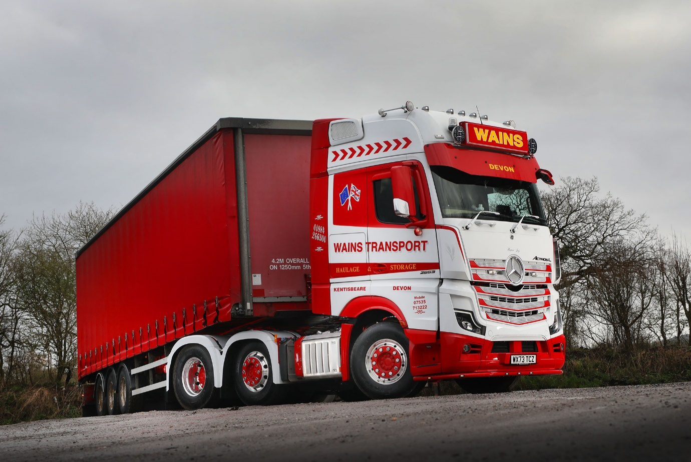

Wains gains economy advantage with Mercedes-Benz Actros L

Devon haulier Wains Transport is enjoying a welcome boost in fuel efficiency from its latest Mercedes-Benz Actros L tractor unit.

The truck has joined another Actros at Wains and both are comfortably ahead of any other vehicles on the operator’s 25-strong fleet.

“We don’t measure mpg obsessively, because there’s a lot of variation in the work our trucks do, but the Actros are consistently better than any other tractor in our line-up by a noticeable margin,” said Managing Director Aaron Wain.

The new arrival is a highly specified and stunningly liveried Actros L 2553, delivered by Dealer City West Commercials. It has a range-topping, flat-floored GigaSpace cab and is powered by a muscular 390 kW (530 hp), 12.8-litre in-line six-cylinder engine.

“We always specify our trucks to be as comfortable as possible,” continued Mr Wain. “Our drivers are typically out on the road all week, so it’s only fair we try to make them as comfortable as possible. The Actros L is as close as you can get to a home-from-home, and is well liked by our driver Chris Bolt.

“His last truck was from another manufacturer, but he drove Mercedes-Benz vehicles in his previous employment and asked for an Actros L when it was time for a replacement. Given that we know they’re so good on fuel, and we also have an excellent relationship with City West Commercials and their Retail Sales Manager Simon Johnson-Taylor, we were more than happy to agree.”

Like most of Wains’ fleet, the new tractor also displays some superb airbrush artwork on its back wall, as a counterpoint to the firm’s eye-catching red and white colours.

“We choose a wide variety of themes, often related to favourite movies or to boats – previous subjects have included everything from Sir Francis Drake’s ‘Golden Hind’ galleon to Spiderman,” said Mr Wain. “This time though we wanted to pay tribute to the indomitable bulldog spirit of Sir Winston Churchill, so we opted for a portrait of his famous ‘V for Victory’ salute.

“We also name our vehicles – usually after female family members – so this one is called Harper Joy after my niece.”

The Actros L range sets new standards in the segments for long-distance haulage and heavy-duty distribution. In addition to a full complement of well-proven Mercedes-Benz technology, it comes with a host of new features that deliver further improvements in efficiency, safety and comfort.
Highlights include sophisticated aerodynamics, quieter cabs with improved heat insulation, and a lower, more comfortable seating position that also provides improved visibility. Wains’ truck also features safety equipment including Active Brake Assist 5 autonomous braking with pedestrian recognition, as well as Attention Assist, Traffic Sign Assist and Proximity Control Assist systems.

The Actros L badge now applies to all four- and six-wheeled tractor units with single or double drive axles, and 18- and 26-tonne rigid chassis, that have flat-floored GigaSpace, BigSpace or Stream Space cabs in the wider (2.5m) of the two widths available.

Wains Transport specialises in bulk tipper and low-loader work as well as general haulage, with vehicles running across the UK from its base at Kingsford Rural Business Centre, situated minutes from the M5 near Cullompton. Now in the third generation of family ownership, the business also includes a fully equipped workshop with facilities including diagnostic equipment and a brake roller tester.

www.wainstransport.co.uk

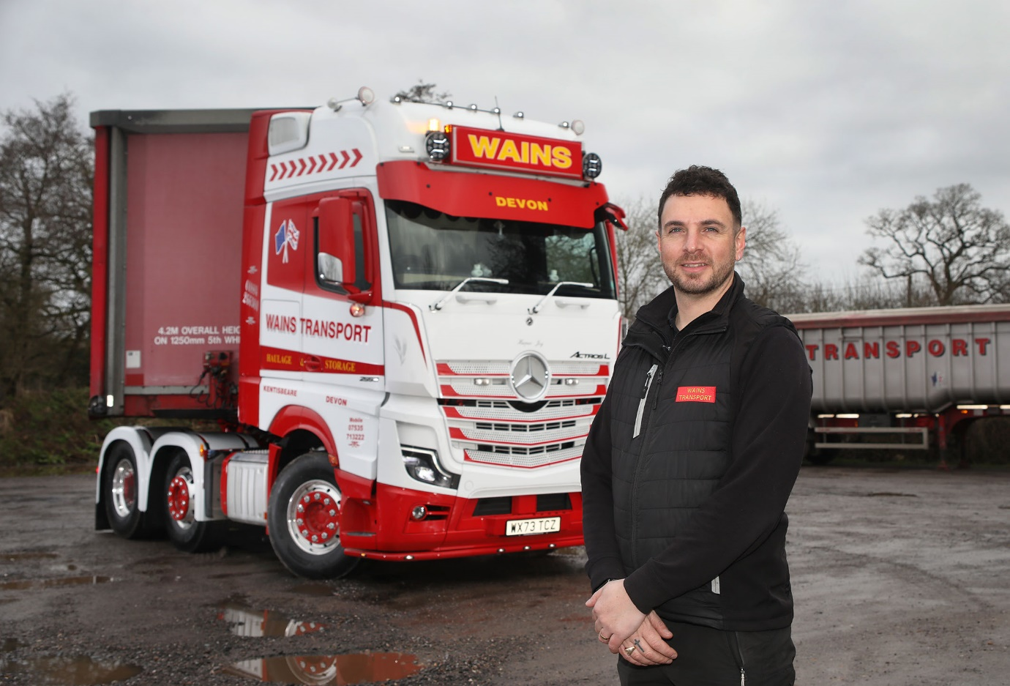

Star performer: Aaron Wain with the new Mercedes-Benz Actros L that is leading the way on fuel

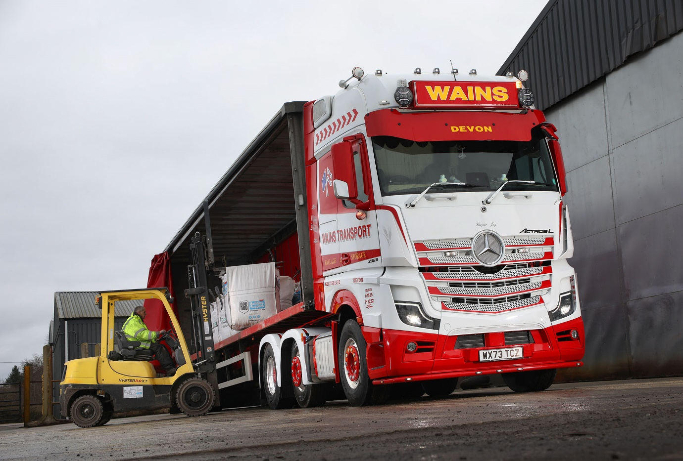

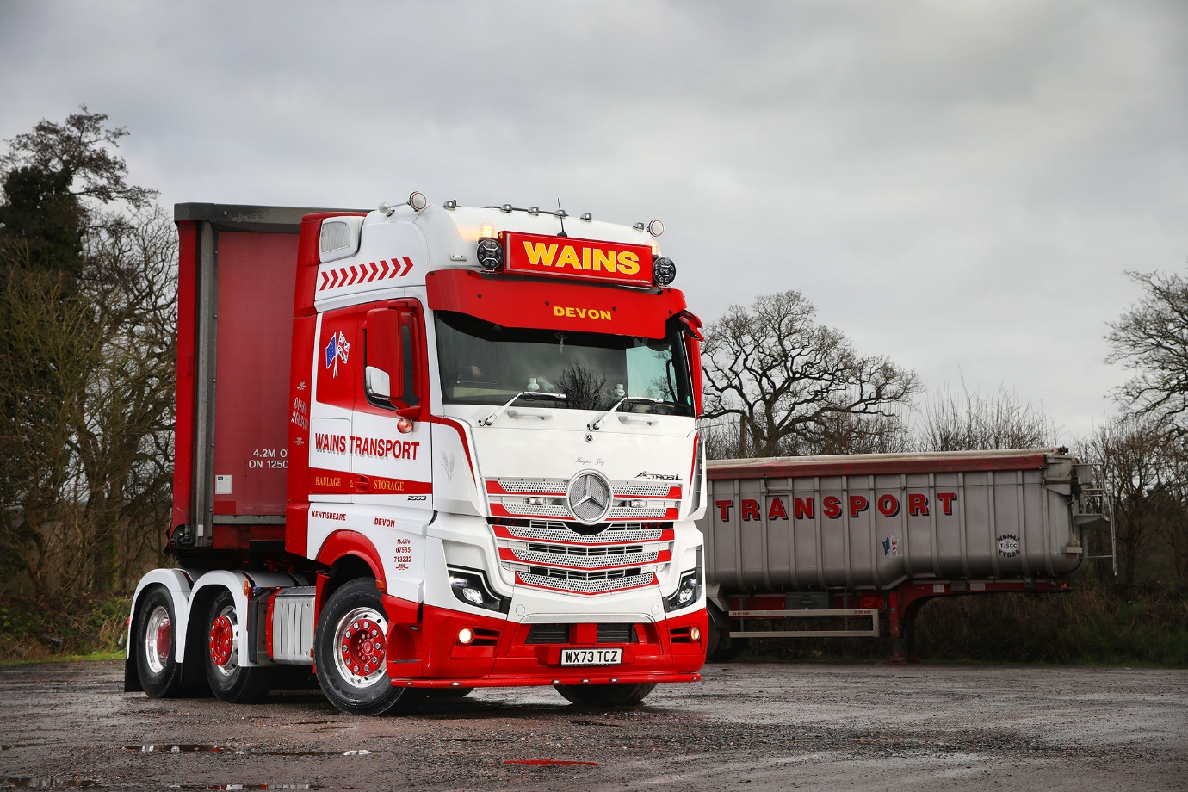

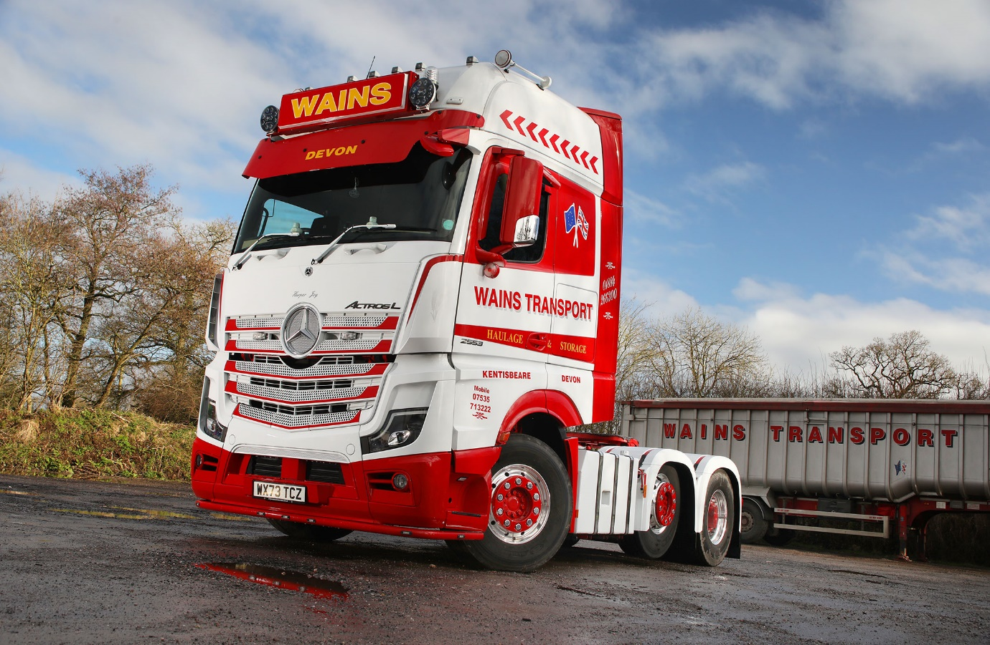

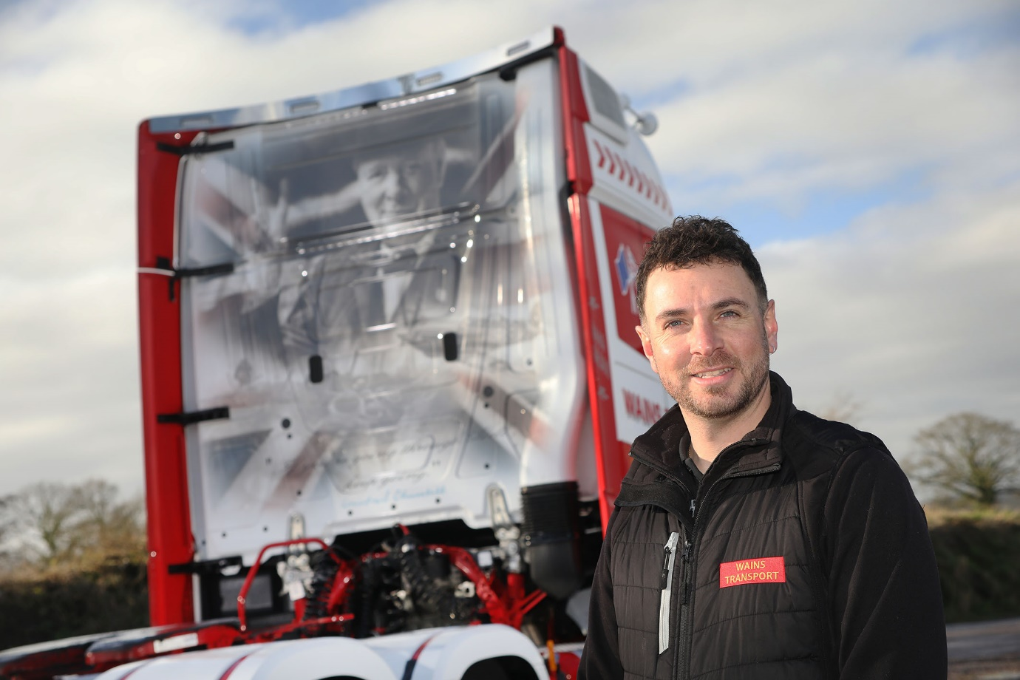

Back to the wall: Wains Transport’s Actros L shows off its Winston Churchill artwork

ends

For more information, or to request bigger/higher-res image files, please contact:
John Ripley: 07771 484595, john.ripley@loopagency.co.uk

