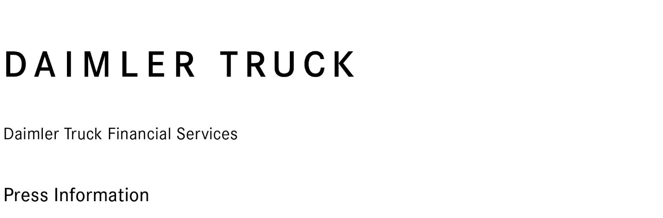

8 March 2023

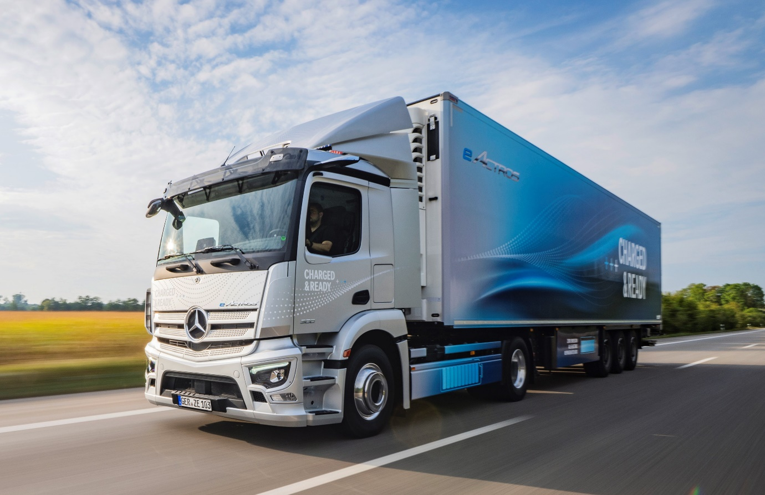

Focused on the future: Its new insurance offer reflects Daimler Truck Financial Services’ commitment to support operators of Mercedes-Benz and FUSO vehicles

Daimler Truck Financial Services collaborates with insurance leader Marsh to deliver peace of mind for UK transport operators

Truck and bus customers of Daimler Truck Financial Services throughout the UK will now have access to commercial insurance and risk advisory services under a new co-operation agreement signed with Marsh, the world’s leading insurance broker and risk adviser.
The service offering includes a holistic reassessment and realignment for Daimler Truck Financial Services’ customers, and incorporates motor insurance, commercial general liability, goods in transit and commercial business insurance.

Daimler Truck Financial Services UK opened for business in August. James Hubbard, its Director, Strategy & Marketing, said: “The co-operation agreement on insurance that we have entered into with Marsh reflects our commitment to provide a truly comprehensive portfolio of services for our customers.

“We look forward to making further, exciting announcements in 2023, particularly in relation to eMobility and the role that we can play in helping operators and indeed Dealers as they embark on their transitions to a zero-emission future.

“As well as financing their acquisitions of battery-electric and, further down the line, hydrogen fuel cell-powered vehicles, Daimler Truck Financial Services will also be well placed to provide support in other areas, such as charging infrastructure.”

Chris Barclay, Affinity Leader, Marsh UK, commented: “We are excited to launch the UK phase of our collaboration with Daimler Truck Financial Services, building on our European co-operation agreement. We have colleagues across more than 50 locations throughout the UK. This aligns with the wide geographic spread of Daimler Truck Financial Services dealer partner locations. We look forward to providing insurance and risk advisory support and advice to Daimler Truck Financial Services customers, whatever their size and location.”

In addition to the UK, the new insurance service has already been rolled out in Spain with other European markets planned to follow shortly.

Daimler Truck Financial Services today operates in Argentina, Australia, Belgium, Brazil, Canada, Germany, Italy, the Netherlands, Japan, Mexico, South Africa, Spain, Turkey, United Kingdom and the USA. Its contract portfolio with leasing, financing and insurance is around 24 billion euros (Q3 2022). Daimler Truck Financial Services is part of Daimler Truck AG.



Exciting times ahead: Director, Strategy & Marketing, James Hubbard, said Daimler Truck Financial Services UK would be further extending its portfolio of support services in 2023

ends

For more information on Daimler Truck Financial Services, or to request higher-res image files, please contact:

Gill Jockel, Marketing & Communications Manager, Daimler Truck Financial Services UK Ltd
07731 985771, gillian.jockel@daimlertruck.com

Forward-looking statements:
This document contains forward-looking statements that reflect our current views about future events. The words “aim”, “ambition”, “anticipate,” “assume,” “believe,” “estimate,” “expect,” “intend,” “may,” ”can,” “could,” “plan,” “project,” “should” and similar expressions are used to identify forward-looking statements. These statements are subject to many risks and uncertainties, including an adverse development of global economic conditions, in particular a decline of demand in our most important markets; a deterioration of our refinancing possibilities on the credit and financial markets; events of force majeure including natural disasters, pandemics, acts of terrorism, political unrest, armed conflicts, industrial accidents and their effects on our sales, purchasing, production or financial services activities; changes in currency exchange rates, customs and foreign trade provisions; a shift in consumer preferences; a possible lack of acceptance of our products or services which limits our ability to achieve prices and adequately utilise our production capacities; price increases for fuel or raw materials; disruption of production due to shortages of materials, labour strikes or supplier insolvencies; a decline in resale prices of used vehicles; the effective implementation of cost-reduction and efficiency-optimization measures; the business outlook for companies in which we hold a significant equity interest; the successful implementation of strategic cooperations and joint ventures; changes in laws, regulations and government policies, particularly those relating to vehicle emissions, fuel economy and safety; the resolution of pending government investigations or of investigations requested by governments and the conclusion of pending or threatened future legal proceedings; and other risks and uncertainties, some of which are described under the heading “Risk and Opportunity Report” in the current Annual Report. If any of these risks and uncertainties materializes, or if the assumptions underlying any of our forward-looking statements prove to be incorrect, the actual results may be materially different from those we express or imply by such statements. We do not intend or assume any obligation to update these forward-looking statements since they are based solely on the circumstances at the date of publication.

Daimler Truck at a Glance
Daimler Truck Holding AG ("Daimler Truck") is one of the world's largest commercial vehicle manufacturers, with over 40 main locations and more than 100,000 employees around the globe. The founders of Daimler Truck have invented the modern transportation industry with their trucks and buses a good 125 years ago. Unchanged to this day, the company's aspirations are dedicated to one purpose: Daimler Truck works for all who keep the world moving. Its customers enable people to be mobile and get goods to their destinations reliably, on time, and safely. Daimler Truck provides the technologies, products, and services for them to do so. This also applies to the transformation to CO2-neutral driving. The company is striving to make sustainable transport a success, with profound technological knowledge and a clear view of its customers' needs. Daimler Truck's business activities are structured in five reporting segments: Trucks North America (TN) with the truck brands Freightliner and Western Star and the school bus brand Thomas Built Buses. Trucks Asia (TA) with the FUSO and BharatBenz commercial vehicle brands. Mercedes-Benz (MB) with the truck brand of the same name. Daimler Buses (DB) with the Mercedes-Benz and Setra bus brands. Daimler Truck's new Financial Services business (DTFS) constitutes the fifth segment, the product range in the truck segments includes light, medium and heavy trucks for long-distance, distribution and construction traffic and special-purpose vehicles used mainly in the municipal and vocational sector. The product range of the bus segment includes city buses, school buses and intercity buses, coaches and bus chassis. In addition to the sale of new and used commercial vehicles, the company also offers aftersales services and connectivity solutions.

Daimler Truck Financial Services at a Glance
Daimler Truck Financial Services is one of the world’s largest captive financial services providers in the commercial vehicle sector. As part of the Daimler Truck Group, it supports the Group’s truck and bus brands with tailored financial services, which include leasing, financing, insurance and rental solutions. The clear objective of Daimler Truck Financial Services is to build and maintain the loyalty of the Group’s customer base as well as contributing to the Group’s financial success. Daimler Truck Financial Services will have around 1,900 employees by the beginning of 2023 and is expected to operate in 16 markets worldwide. Financial services play a vital role for the Daimler Truck Group’s customers, enabling them to use and maintain their vehicles on flexible and reasonable terms.

