

Date: 16 December 2021
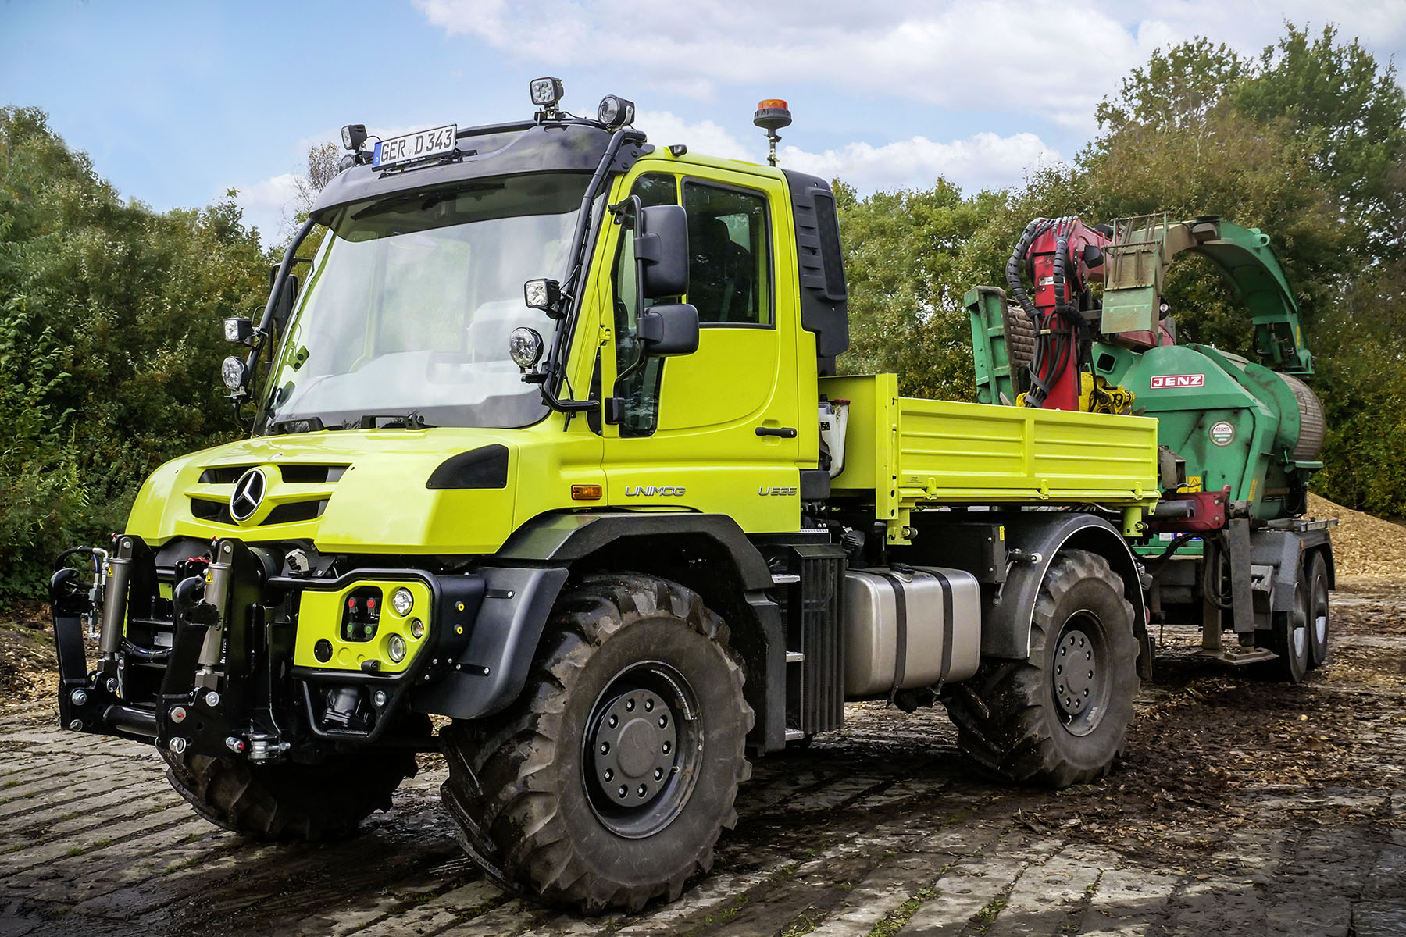

Mercedes-Benz Unimog puts on more muscle where it matters for UK customers

Mercedes-Benz Trucks has responded to customer feedback by introducing more powerful versions of its 4x4 Unimog UGE implement carrier.

Now available for order by UK operators, the U435 and U535 produce 260 kW (354 hp). This represents an increase of 40 kW (54 hp) on the highest output previously available from the Euro VI Step E 7.7-litre in-line six-cylinder engine. Maximum torque is up by 180 Nm to 1,380 Nm, which is available from 1,800 rpm.

Daimler Truck engineers have also purpose-designed and built an automated manual transmission to manage the higher outputs of the U435/U535. The Opti-drive system’s improved gear change co-ordination and clutch control produces quicker shifts that translate into a smoother ride and improved fuel-efficiency. As a result, it is expected to prove popular with UK operators as an alternative to the standard-fit manual gearbox.

In other developments, the Unimog implement carrier can now be specified for the first time with self-levelling suspension for the rear axle. This new set-up, which employs gas storage tanks and hydraulic cylinders, instead of the usual coil springs, offers benefits in terms of comfort and operational efficiency.

As well as providing a constant driving level irrespective of load status or any rear attachments that may be fitted, the hydropneumatic system contributes to handling stability and assists operators when coupling and uncoupling implements.

A new Comfort steering option, meanwhile, makes it easier for drivers to turn the wheel at low, manoeuvring speeds, or when stationary, and is particularly helpful when the vehicle is fitted with large-volume tyres or heavy front implements such as mowers. The electrohydraulic steering delivers a ‘feel’ that adapts to the driving situation.

The U435 and U535 have maximum gross weights (with relevant special equipment) of 14 tonnes and 16.5 tonnes respectively. The first examples are expected to reach the UK next month (January).

The latest round of product enhancements cap a memorable 75th anniversary year for the Mercedes-Benz Unimog. Although it offers many of the attributes of both, this unique vehicle is neither a truck, nor a tractor. It enjoys an unrivalled reputation as the ultimate off-roader, but also achieves impressive on-road speeds of up to 56 mph (where applicable).

Unimogs are chosen for the most arduous applications by a broad spectrum of operators, particularly those engaged in the agriculture and arboriculture, utilities, municipal and emergency services sectors. They are also engaged in highly specialised roles such as railway infrastructure maintenance– the vehicle can even be adapted to run on rails.

Head of Special Trucks Ross Paterson commented: “Mercedes-Benz Trucks is committed to the continuous improvement of its range. This, of course, applies every bit as much to the Unimog – a vehicle first seen in 1946 and that now enjoys legendary status – as it does to other, more mainstream products.

“Many of the innovations and developments we’ve introduced have been in direct response to feedback from those, here in the UK, who buy and operate our vehicles. We listen to what they tell us, and wherever possible we deliver what they need.

“That’s certainly been the case where the U435 and U535 are concerned. Farmers and arboriculturalists in particular, wanted that little bit more power and torque at the wheels for in-field operations, as well as for trailer work.”

Ross continued: “We’ve taken that feedback on board and delivered what they asked for – a Unimog with comparable outputs to some of the bigger agricultural tractors, but which leaves those same tractors standing when it comes to on-road performance.”

The Mercedes-Benz Unimog team will be exhibiting at the LAMMA 2022 agricultural machinery, equipment and technology show, which takes place from 11-12 January. On its stand at the NEC, Birmingham, will be a U530 and a U430, as well as a UHE extreme off-roader with crane.

The Mercedes-Benz Unimog range encompasses vehicles with gross weights from 7.5 to 16.5 tonnes. All have single rear wheels that follow the track created by the front wheels.

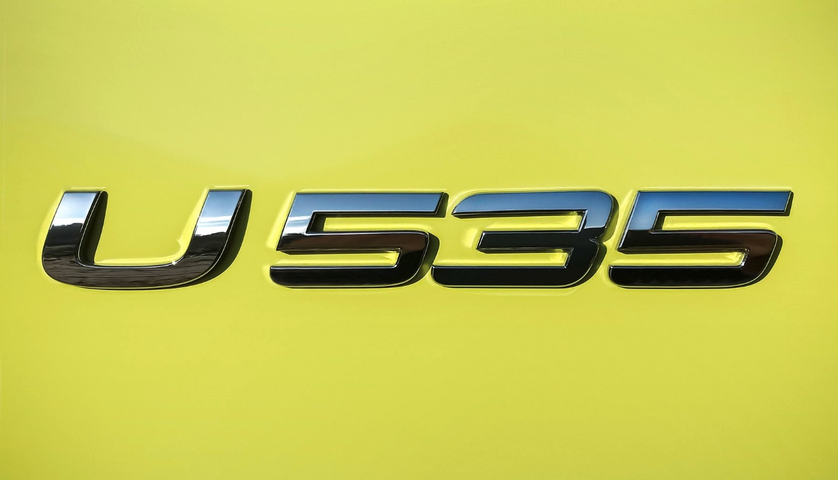

www.mbtrucks.co.uk/unimog-part-of-a-legend

To find out more about what makes the Mercedes-Benz Unimog so special, visit:
youtube.com/watch?v=mAWvMURpRcQ

 facebook.com/UnimogOfficialUK/

 instagram.com/UnimogOfficialUK/

 twitter.com/unimoguk

ends

For more information, or to request higher-res image files, please contact:

Jamie Fretwell at Mercedes-Benz Trucks UK Ltd
07712 519230, jamie.fretwell@daimler.com

or

Steve Warren or John Ripley
Impact Communications
Steve: 07770 470251, steve@impactcom.co.uk
John: 07771 484595, john@impactcom.co.uk

