

Date: 15 April 2021

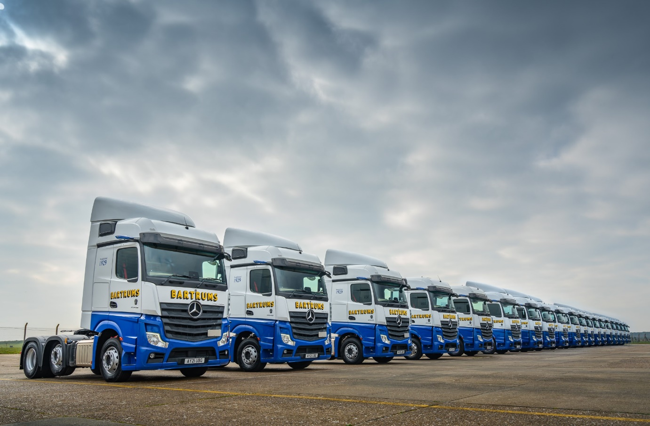

Loyal customer Bartrums looks to the future and embraces the latest Mercedes-Benz truck technology

The Suffolk-based Bartrum Group has underlined the strength of its long-standing partnership with local Mercedes-Benz Dealer Orwell Truck & Van by adding a further 20 tractor units from the latest fifth-generation Actros range to the 11 it commissioned late last year.

These major investments in new equipment reflect the strong position in which the family-owned haulier is emerging from the pandemic, and its determination to “future-proof” its fleet.

Standard features include MirrorCam, the ground-breaking replacement for conventional mirrors, the Active Brake Assist 5 emergency braking system with its enhanced pedestrian recognition capability, and updated Predictive Powertrain Control with more functionality for improved fuel economy.

All 31 trucks were also specified with the optional, interactive version of Mercedes-Benz Trucks’ radical, twin-screen Multimedia Cockpit. In addition to an upgraded 12in central display, this offers extra functionality.

Features include the Mercedes-Benz Truck App Portal, an open platform that enables fleet managers easily to assign apps to individual vehicles, which drivers can then see and use to increase efficiency and comfort.

Bartrums has also relied on Daimler Fleetboard telematics technology for more than a decade. It uses Fleetboard’s performance analysis data to encourage and incentivise drivers to adopt a safe and fuel-efficient style at the wheel, and identify shortcomings that can then be addressed through training.

Delivery of its latest trucks coincides with the launch by Bartrums of a pilot of Fleetboard’s automatic tachograph mass memory and driver card download services. These offer significant time and cost savings, not least because data from vehicles can be accessed remotely, without them having to return to base.

Operations Director Tremayne Johnson commented: “The Bartrum Group is committed to new technology, and the benefits it offers in terms of increased efficiency, environmental compatibility and safety. We’re keen, therefore, to explore the potential benefits of innovative features such as the Truck App Portal and automatic tachograph downloads.”

He continued: “Today’s Actros is clearly the most advanced truck on the road, and the feedback we’ve received from drivers since we set our first on the road last year has been resoundingly positive.

“MirrorCam is a big step forward and hasn’t provoked a single negative comment. All round visibility is so much better. When reversing, you never lose sight of the rear corner of the trailer on the screens mounted inside the cab. Plus, of course, you don’t have a big slab of mirror housing blocking your forward view.”

Last year’s consignment of Actros had StreamSpace cabs, but this time Bartrums has chosen the larger, flat-floored BigSpace cab. Mr Johnson explained: “Driver retention has never been more important to the success of our business, so we made a concerted effort to further increase the appeal of our latest trucks by specifying the bigger cabs and fitting them with microwaves and fridges.”

A fourth-generation family business with headquarters in the market town of Eye, the Bartrum Group provides an extensive portfolio of transport solutions encompassing dedicated logistics, general haulage and pallet distribution, as well as storage and warehousing, and driver training.

It runs a fleet of approximately 150 trucks, two-thirds of them tractor units. With a single exception, every one of these tractors is a Mercedes-Benz supplied by Orwell Truck & Van, a Dealer with which the operator has been working for more than 30 years.

The Actros purchased by Bartrums over the last six months are powered by 12.8-litre, in-line six-cylinder engines that produce 330 kW (450 hp). Most are 2545 models and now in service with two business units: one is Bartrums Haulage & Storage (BHS), the other Bartrums Road Services (BRS), which is the Group’s dedicated palletised distribution arm – its tractor units make collections and deliveries during the day, then trunk nightly to the Pallet-Track hub in Wolverhampton.

However, nine of the new trucks, including eight from the latest batch, are 2544 variants with small-wheeled mid-lift axles. These are working for Bartrums Bulk Haulage (BBH) and engaged primarily in the movement of more than 500,000 tonnes of malt and grain annually for customers from the brewing, food and beverage sectors.

Not only do the 17.5in wheels on the middle axle save around 300 kg compared to the standard version with 22.5in wheels, but they also free up valuable space on the chassis for the hydraulic and other equipment required by the bulk tipping trailer.

Like the rest of its fleet, the new tractor units are now being inspected and serviced by Trumbar Truck Care, the Bartrum Group’s in-house maintenance facility. Orwell Truck & Van supports its customer’s workshop team with an efficient and timely parts delivery service.

Tremayne Johnson added: “We value our partnerships with Mercedes-Benz Trucks and Orwell Truck & Van very highly. The support received throughout this most challenging of years has certainly confirmed that our trust in both is well placed.

“The Dealer’s Fleet Sales Manager Rob Dale and Fleetboard’s National Account Manager Mark Sach are our key contacts, and each provides an excellent service. In truth, though, we’ve been impressed by the way the entire Mercedes-Benz organisation has responded to the Covid crisis, and remained fully focused on keeping operators like us on the road.”

bartrums.com

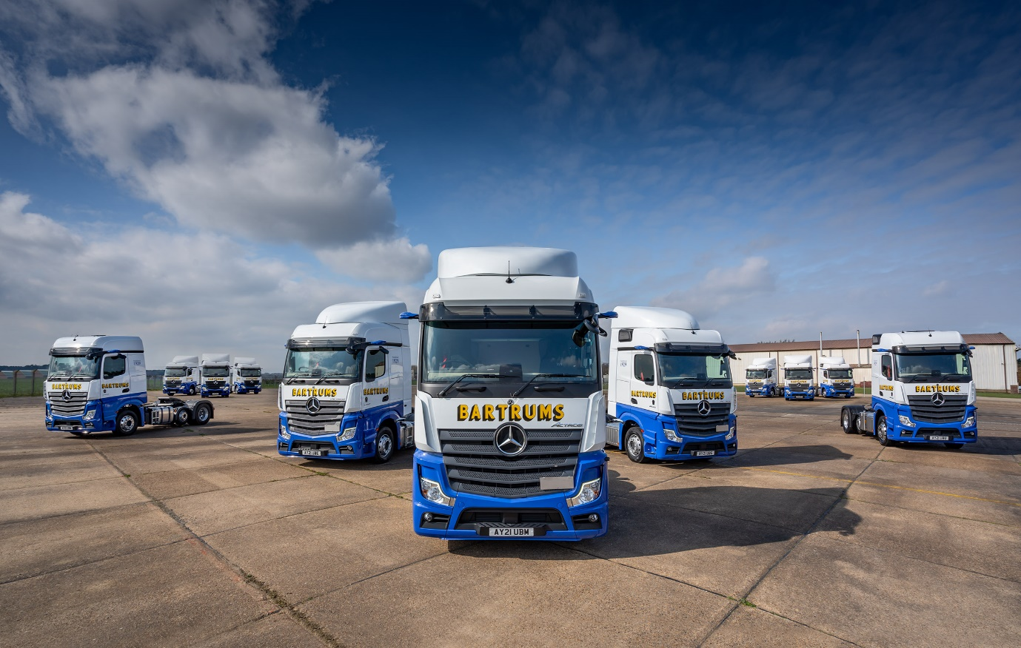

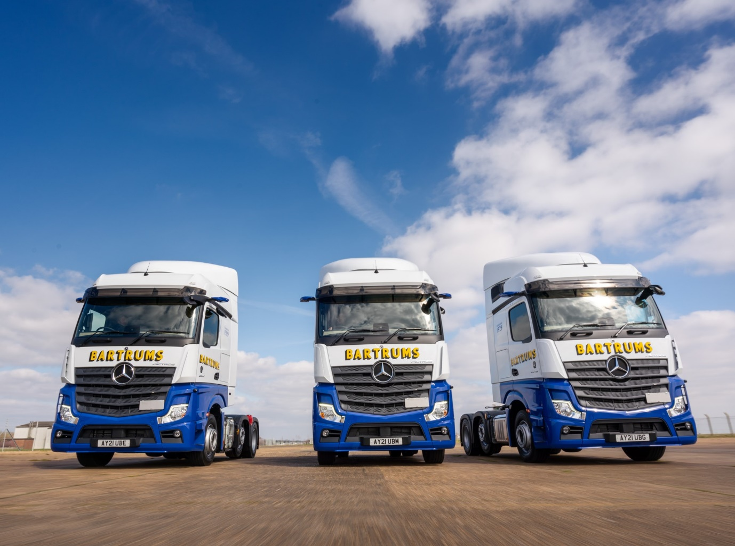

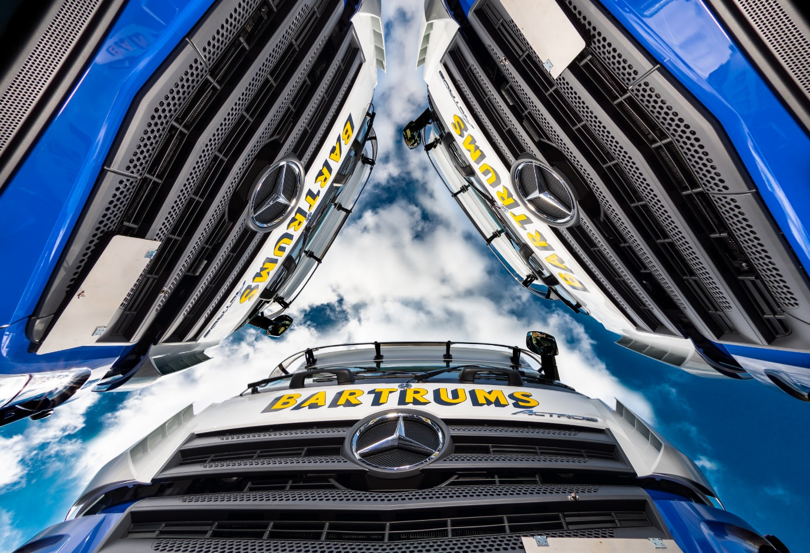

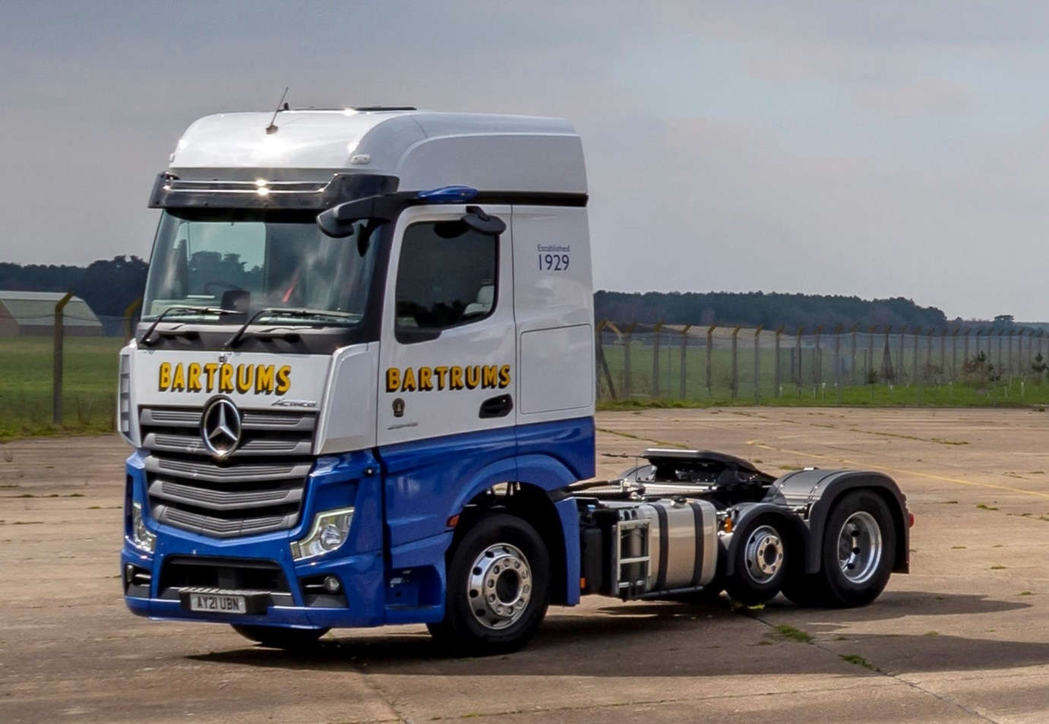

Saving weight and space: The nine Actros units ordered for Bartrums Bulk Haulage have small-wheeled mid-lift axles

ends

For more information, or to request higher-res image files, please contact:

Jamie Fretwell at Mercedes-Benz Trucks UK Ltd
07712 519230, jamie.fretwell@daimler.com

or

Steve Warren or John Ripley
Impact Communications, 01926 842126
Steve: 07770 470251, steve@impactcom.co.uk
John: 07771 484595, john@impactcom.co.uk

About Mercedes-Benz Trucks UK Ltd
Mercedes-Benz Trucks UK Ltd is the sales and marketing organisation responsible for all Daimler truck products in the UK, including FUSO Canter. In 2019, the company registered 6,963 new trucks. Mercedes-Benz accounted for 6,188 new trucks registered in 2019, making it the third-biggest truck brand in the UK. Meanwhile, FUSO registrations hit 775 – including 580 new trucks over 6.0-tonnes. The flagship new Mercedes-Benz Actros which won the 2020 International Truck of the Year award, features seven core innovations including MirrorCam, Multimedia Cockpit and Active Brake Assist 5. Our premium range of innovative trucks – Actros, Arocs, Atego, Econic and Unimog – draw upon more than 125 years of exceptionally high standards of quality, backed up by our promise of Trucks You Can Trust.
www.mbtrucks.co.uk

