

Date: 21 September 2021

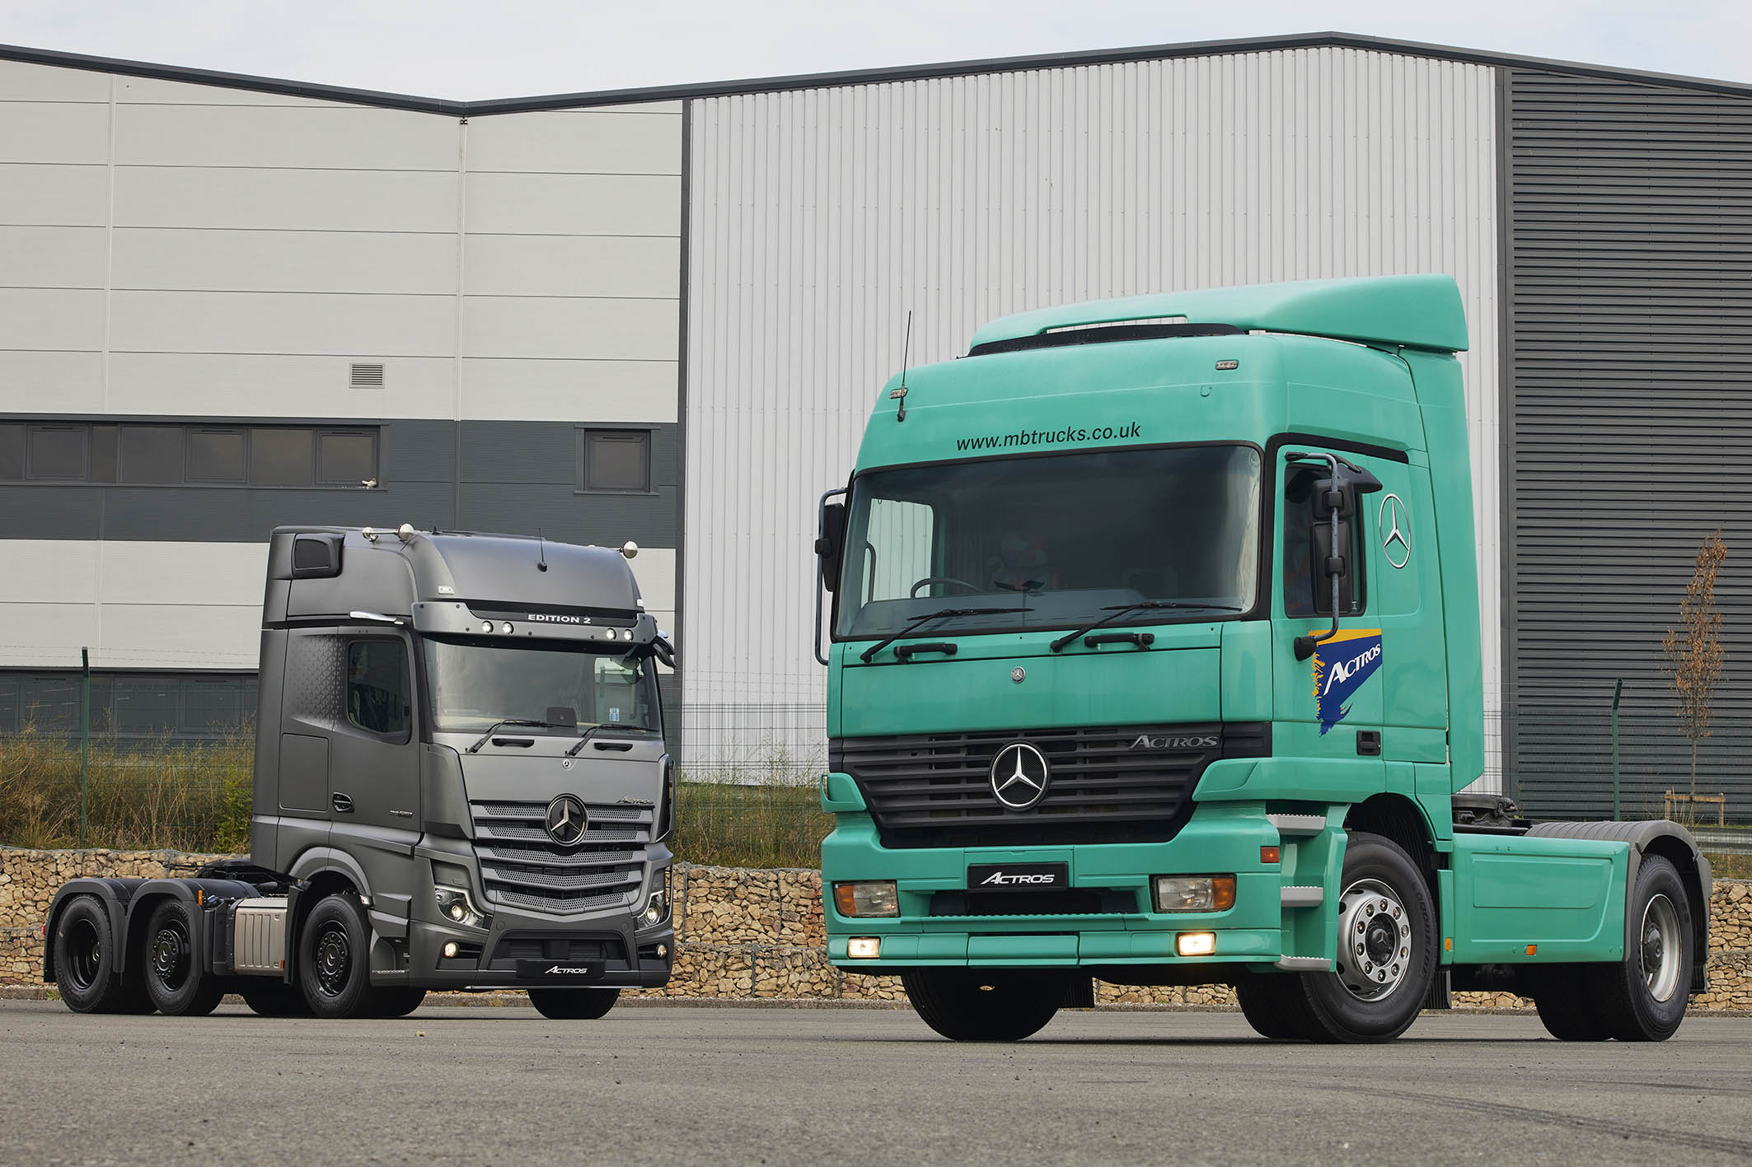

Always ahead of the game: Just as its illustrious predecessor did a quarter of a century ago, so today’s exclusive Actros Edition 2 leaves the competition trailing in its wake

Evolution of an icon: Mercedes-Benz Trucks celebrates 25 years of the Actros in the UK

The commercial vehicle world had never seen anything like it. Unveiled at the IAA show in Hanover on 21 September 1996, the Mercedes-Benz Actros marked the dawn of a new era in truck design, efficiency, safety and comfort.

To widespread acclaim, the world’s first and foremost automotive manufacturer had done it again, by producing the most sophisticated truck ever built, one that instantly became a byword for innovation. A quarter of a century and five model generations later, this remarkable vehicle continues to set the standards to which others aspire.

The original Actros employed a network of Telligent on-board systems to monitor and control the all-new V6 and V8 engines, transmission and suspension, as well as the world’s first standard-fit braking system with discs all round. There were new, more aerodynamic cabs too, including a flat-floored MegaSpace version.

All of which translated into dramatically improved fuel-efficiency, increased safety – stopping distances were slashed by 25%! – and an unprecedented advance in service intervals, which were now up to between 100,000 and 120,000 km.

“The Actros takes truck technology into the 21st Century,” declared George Bennett, the UK’s representative on the jury that named the newcomer International Truck of the Year 1997. The Actros would go on to win the industry’s most coveted accolade on a further four occasions, most recently in 2020.

The last 25 years have confirmed that Mercedes-Benz was wise to be so radical and courageous in tearing up the truck rule book and starting afresh with a clean sheet of paper. The new truck was a sales success from the outset, while competitors have jostled to develop their own versions of technology first deployed in the Actros. Imitation, of course, being the most sincere form of flattery.

It was ever thus for Mercedes-Benz, a company with an unrivalled track record for leading where others have followed. And so it remains to this day. Together with its Arocs stablemate, the fifth-generation Actros range that reached UK roads in 2019 incorporated no fewer than 60 innovations. MirrorCam replaced conventional mirrors, greatly improving visibility and contributing to fuel economy, while Active Drive Assist has made partially automated driving – braking, accelerating, and steering – a reality.

Drivers of all ages have been ‘wowed’ by the state-of-the-art Multimedia Cockpit, while the latest Active Brake Assist 5 emergency braking, fuel-saving Predictive Powertrain Control, and Uptime maintenance systems all make major contributions towards Mercedes-Benz Trucks’ RoadEfficiency goals of Greater safety, Low total costs and Maximised use.

“We are immensely proud to be celebrating the 25th anniversary of the Actros,” commented Katie Purcell, Head of Marketing for Mercedes-Benz Trucks UK. “Few, if any, trucks generate such loyalty and passion among customers, plenty of whom have been running Actros through all five model generations. We love hearing and sharing their positive stories about our flagship product.”

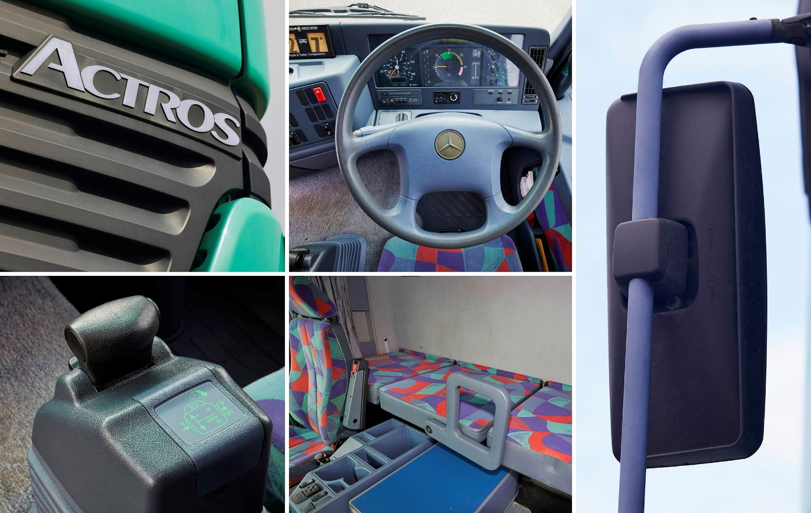

That was then: The gaudy colour scheme might offend modern sensibilities, but with its Telligent electronic controls the original Actros delivered cutting-edge technology in 1996

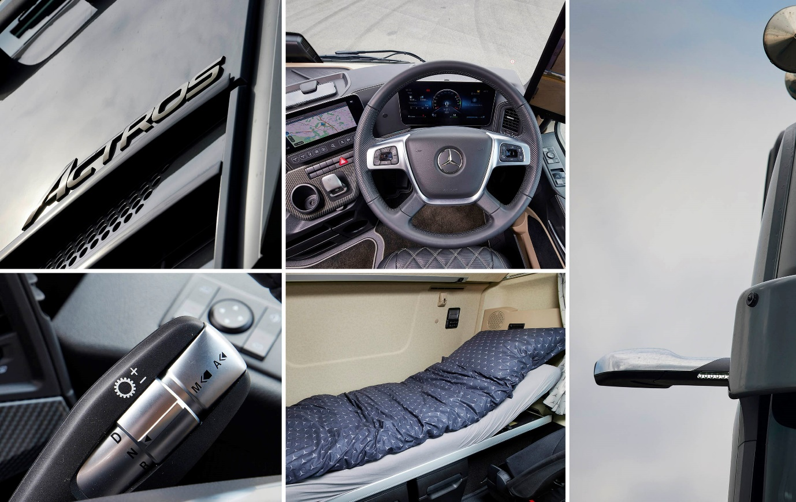

But this is now: Every driver’s dream machine, the exclusive 2021 Actros Edition 2 represents the ultimate in style, comfort, safety and efficiency from Mercedes-Benz Trucks

View from the front line…

Mercedes-Benz Actros Generation 1: Massey Wilcox

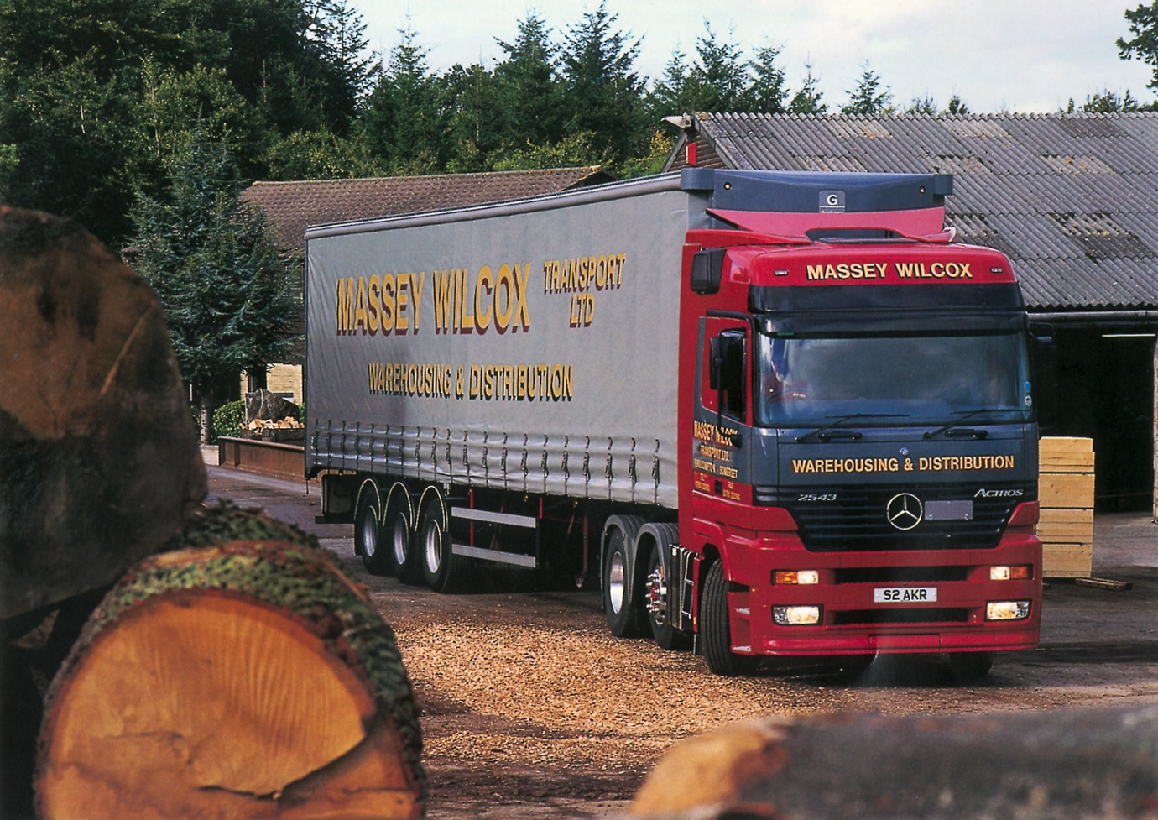

Warehousing and distribution specialist Massey Wilcox, of Chilcompton, near Bath, had already been operating Mercedes-Benz trucks for more than 20 years when it became one of the UK’s first Actros customers in 1997. Delivery the following year of four new tractor units coincided with the decision by Managing Director Robert Wilcox to pass responsibility for the staffing and running of his workshop to his local Mercedes-Benz Dealer – although the franchisee has long since changed, the arrangement proved highly successful and continues to this day. Commenting at the time, Mr Wilcox observed: “Although our Mercedes-Benz trucks have always been reliable, they weren’t particularly exciting. Now, with the new cabs and technology of the Actros, that’s all changed and driver acceptance is extremely good.”

Fast forward to 2021 and with a single exception every one of Massey Wilcox’s 64 trucks wears a three-pointed star. The line-up includes 10 tractor units from the latest Actros range, and there are more on order. Robert Wilcox, who remains at the helm, recalled: “We committed fully to Mercedes-Benz in 1998 and have never wavered since. We’ve run trucks from all five Actros model generations, among them a high-spec unit that we bought in 2004 and painted gold to mark our 50th anniversary and another a decade later with a scheme that featured a diamond, to celebrate 60 years in business. In three years’ time it will be our 70th anniversary, so watch this space!” He added: “The Actros has been the backbone of our business for 25 years – that says it all.”

masseywilcox.com

Mercedes-Benz Actros Generation 2: Pulleyn Transport

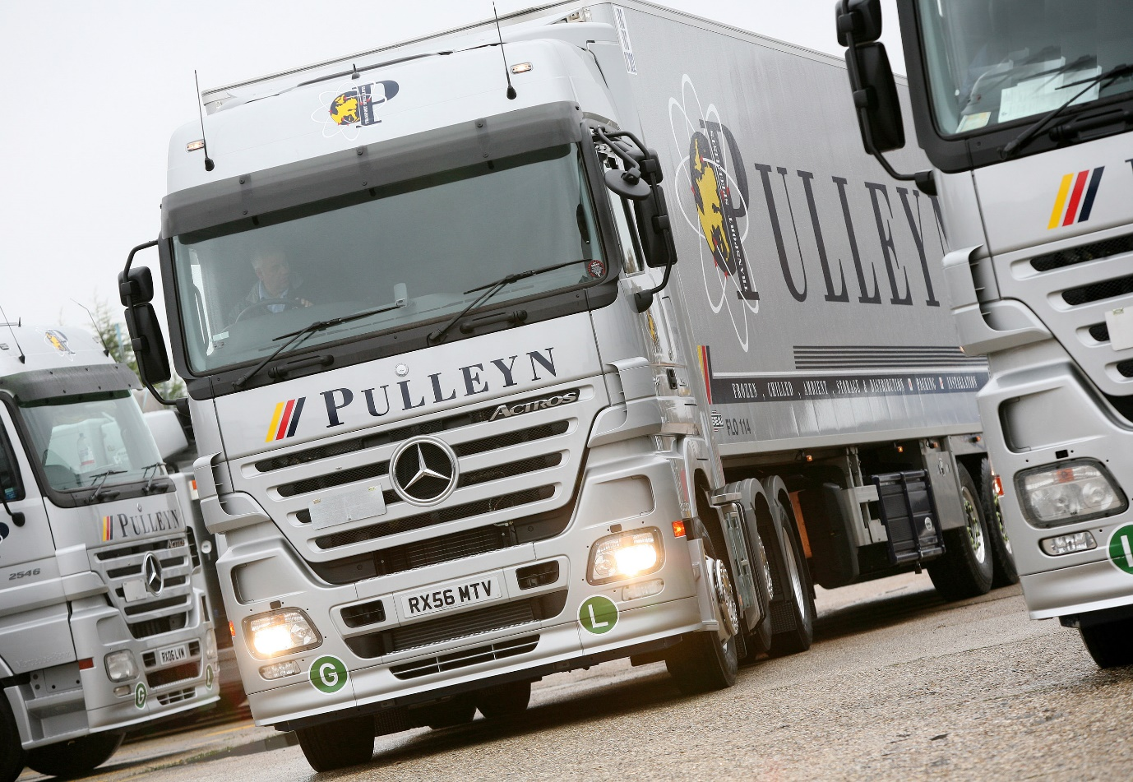

The second-generation Actros was launched in 2003 with a facelift and an upgraded interior. Shortly afterwards Reading-based Pulleyn Transport, one of Europe’s leading carriers of temperature-controlled pharmaceuticals and other sensitive goods, purchased a quartet of 4x2 Executive variants. Those vehicles complied with Euro 3 emissions regulations but a couple of years later Pulleyn returned with an order for 14 6x2 tractors (pictured) that met the Euro 5 standard nearly three years before it came into force. These, too, were range-topping Executive specification models with MegaSpace cabs but unlike their predecessors they were equipped with PowerShift automated manual transmissions, which had just been introduced. Its fleet of more than 50 trucks was now dominated by Mercedes-Benz. Speaking in 2006, Managing Director Adrian Pulleyn said: “We bought our first Actros three years ago and have not looked back since – they’ve been brilliant. The drivers really appreciate their big, comfortable cabs while the fuel returns are excellent too.”

Fifteen years down the line and Pulleyn Transport still relies every bit as heavily on its Mercedes-Benz trucks, the Actros accounting for all of the tractor units and bigger rigid vehicles on its 50-strong fleet. “We started with Mercedes-Benz in 1978 and as the truck industry has consolidated I’ve never regretted aligning ourselves to a manufacturer that was always going to be here for the long-term,” explained Adrian Pulleyn. “Whatever the model generation, we’ve chosen highly specified Actros with big cabs and they’ve invariably represented great value for money. The Actros has always been top of the pile… for me, there’s nothing to touch it.”

pulleyn.co.uk

Mercedes-Benz Actros Generation 3: Maritime Transport

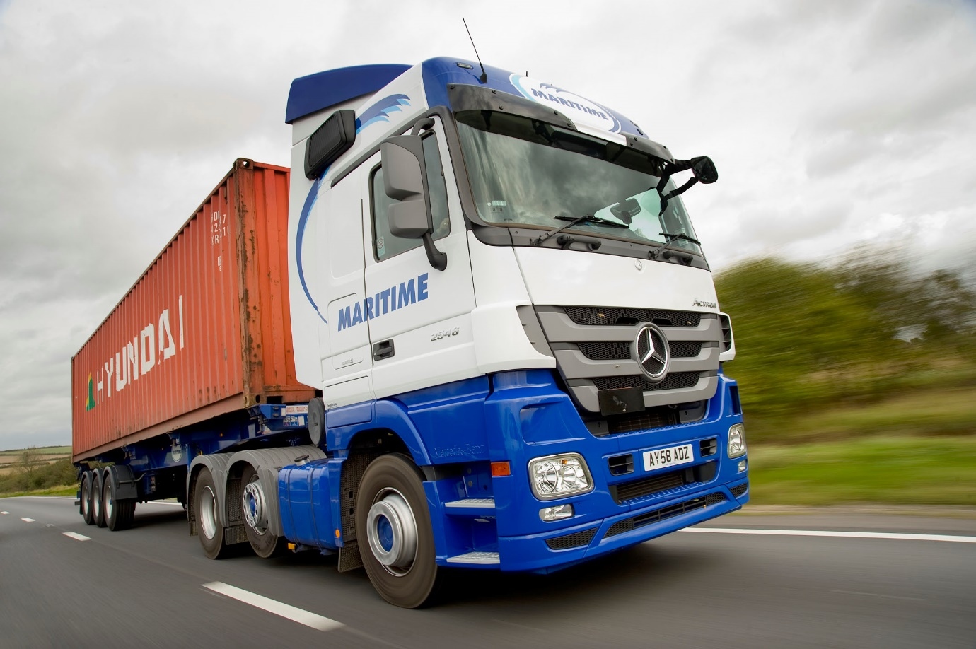

The third-generation Actros arrived in 2008 wearing another new face and with BlueTec® 5 Euro 5 engines and exhaust systems as standard, together with the latest Mercedes PowerShift 2 automated transmissions. The UK’s first eight examples entered service towards the end of that year in the colours of Felixstowe-based Maritime Transport. Britain’s largest privately-owned container haulier was already an established Actros operator and the new model quickly won plaudits from drivers and management alike. “We already know the Actros to be reliable, cost-effective and a driver-friendly, with good back-up from the manufacturer’s Dealer network,” reported former Fleet Director Derek Daly. “Over the years we’ve found that Mercedes-Benz trucks tend to achieve good fuel consumption figures from day one, but then don’t change a great deal – unlike some vehicles that start poorly and then improve as they run in. Based on that knowledge we anticipated our new Actros would be economical ‘straight out of the box’, but they’re even better than we’d hoped.” He added: “The improvements to the cab interior have made what was already a good working environment even better.”

Maritime Transport has diversified over the years to provide complete supply chain coverage through a wide range of services, that now includes curtainsided distribution, intermodal transport, container storage and repair, freight management, and cargo handling and warehousing. The Actros continues to feature prominently on its fleet of more than 1,200 trucks, with the operator commissioning another 100 tractor units this year. Fleet Director Paul Heyhoe praised the latest model’s fuel-efficiency: “The Actros is right up there with the very best on the fleet in terms of economy,” he said. “Maritime welcomes the innovation that Mercedes-Benz continues to bring to the market; we particularly like the Multimedia Cockpit, while given our commitment to safety the new electronic parking brake gets a big tick too.”

maritimetransport.com

Mercedes-Benz Actros Generation 4: Arthur Spriggs & Sons

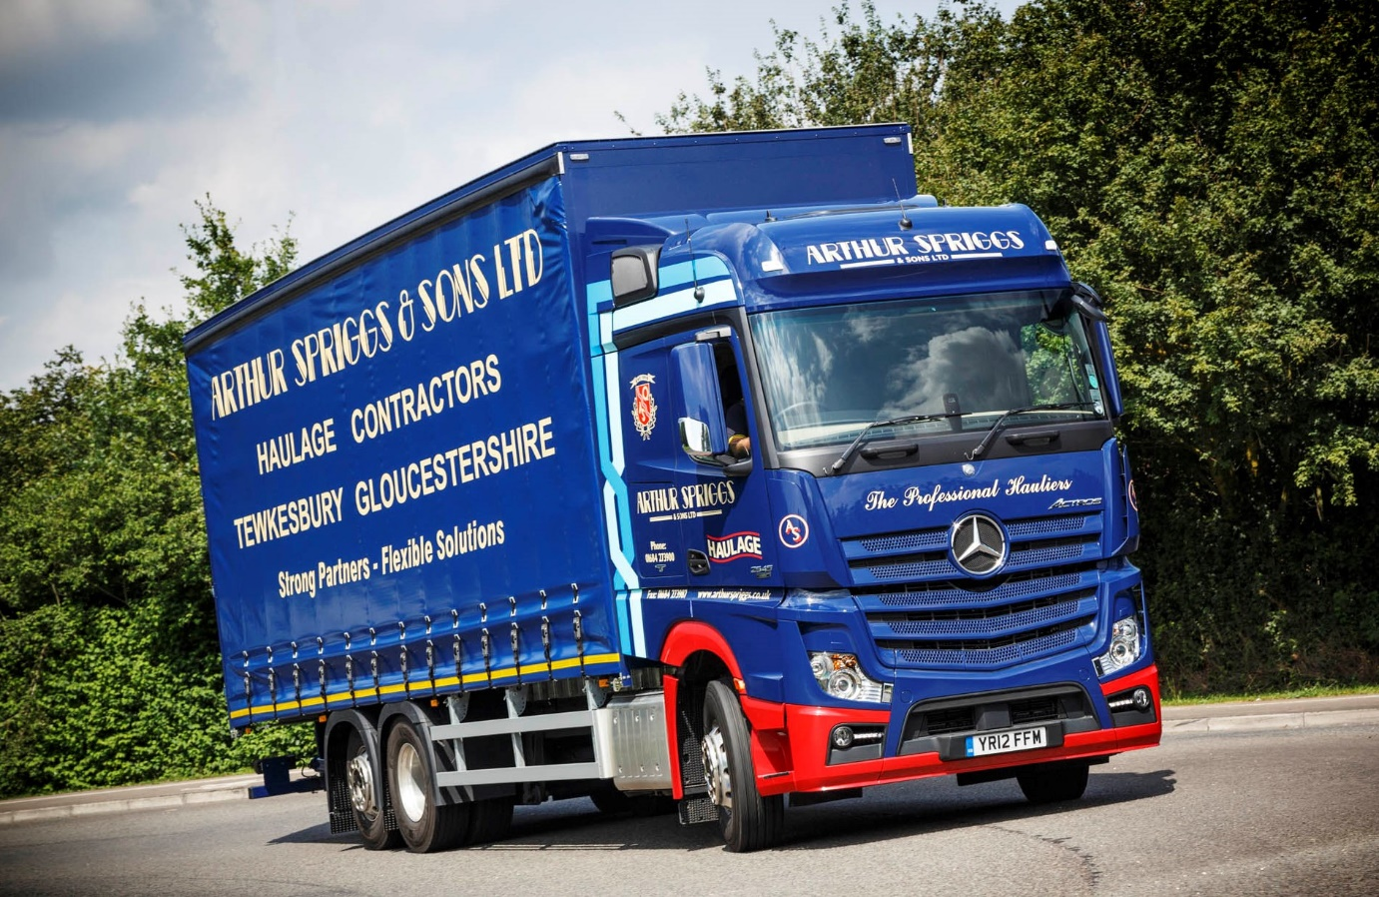

Hailed by Mercedes-Benz as “A new dimension” in truck technology, the fourth-generation Actros was developed from a blank sheet of paper and designed to deliver the best possible productivity, driving dynamics and safety. Economy was dramatically improved – new engines and the Mercedes PowerShift 3 transmission combined to produce fuel savings of 7% at Euro V and 4% at Euro VI – while a sweeping array of all-new cabs, output ratings and options allowed customers to tailor vehicles perfectly for any application. Family-owned haulier Arthur Spriggs & Sons, of Tewkesbury, became the first UK customer for a rigid vehicle from the new range when it took delivery in 2012 of a 26-tonne BigSpace ENA variant with single-wheeled tag axle. The curtainsider joined a fleet that also included nine new Actros tractor units, all but one of them 4x2 models. “Our new six-wheeler is marvellous,” declared Director of Operations Chris Spriggs. “The fuel returns are already good and getting better by the week, the driver loves it to bits, and it looks fantastic too.” He added: “Our new Actros are everything we hoped they would be. We were looking for an improvement in mpg returns and they’ve delivered from day one.”

Today, Arthur Spriggs & Sons operates an all-Mercedes-Benz and FUSO fleet of 60 trucks of various sizes, as well as a number of vans that also wear three-pointed stars. The 26-tonner from 2012 continues to serve – “It’s still a brilliant workhorse,” confirmed Chris Spriggs, who is now Managing Director. “We’ve not suffered a single breakdown with that truck, so it’s certainly lived up to the Mercedes-Benz promise of reliability”. Arthur Spriggs’ fleet also includes the UK’s first exclusive Actros Edition 1 tractor unit, a stunning showcase for the fifth-generation range, which has been on the road for nearly two years. “Our Euro VI Actros have always been fantastically reliable and extremely cost-effective to operate,” reported Chris Spriggs.

arthurspriggs.co.uk

Mercedes-Benz Actros Generation 5: Wrings Transport

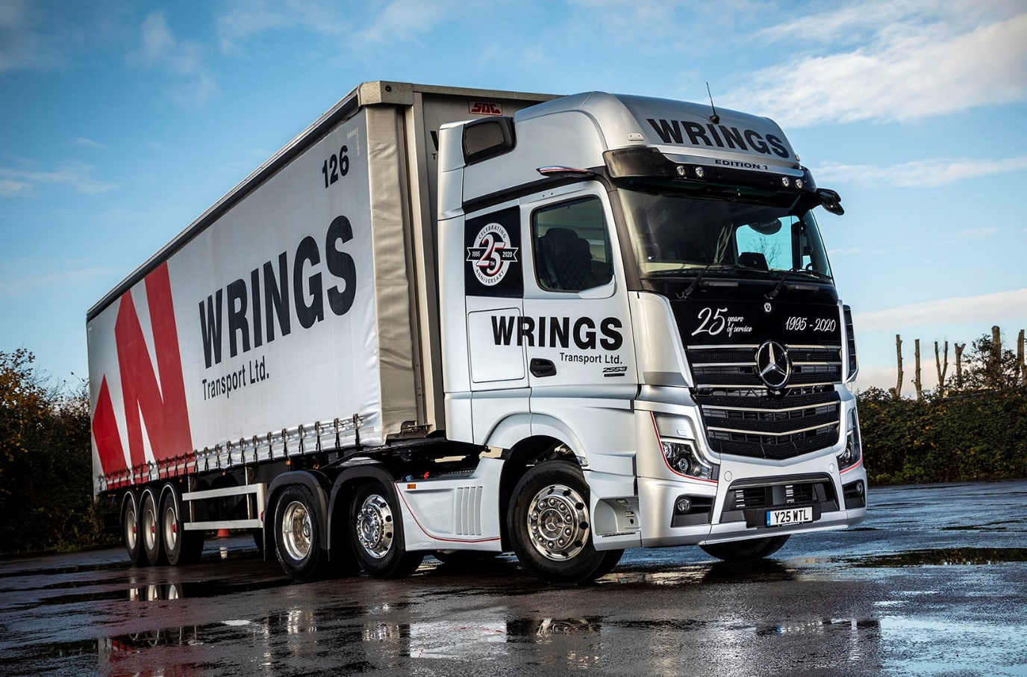

What better way to tell the world it’s your Silver Anniversary than by announcing the fact on an awesome, limited-edition flagship bearing the silver star of Mercedes-Benz. That’s what Wrings Transport did in 2019, when it commissioned a stunning Actros Edition 1. A message across the top of the GigaSpace cab’s distinctive gloss black grille proclaimed ‘25 years of service 1995-2020’. The decision by the largest privately-owned haulier in the Avonmouth area to highlight its quarter of a century in business on an Actros was entirely fitting. The company bought its first Mercedes-Benz truck, a 7.5-tonner, a couple of years after it started out, and the first of a long and unbroken line of Actros a year later, in 1998. “In my opinion Mercedes-Benz has long been the market-leader when it comes to research and development,” said Managing Director Stuart Wring. “Its trucks are reliable, very good on fuel, exceptionally safe, and the build quality’s great.”

Mercedes-Benz continues to claim the lion’s share of the Wrings Transport fleet. The Actros now accounts for 23 of the operator’s 36 tractors units, while all but one of its rigid trucks wear three-pointed stars. “We’ve run Actros from every model generation, including a unit that we bought in 2011 and finally sold to a buyer in Africa earlier this year,” said Stuart Wring. “Looking back over the years there are lots of thing I’d have done differently. We’ve made plenty of mistakes along the way but I’d like to think we’ve learned from them, and haven’t made the same one twice. One decision we definitely got right, though, was to align ourselves so closely to Mercedes-Benz and the Actros.”

wrings.co.uk

ends

For more information on Mercedes-Benz Trucks, or to request higher-res image files, please contact:

Jamie Fretwell, Mercedes-Benz Trucks UK Ltd
07712 519230, jamie.fretwell@daimler.com

or

Steve Warren or John Ripley
Impact Communications, 01926 842126
Steve: 07770 470251, steve@impactcom.co.uk
John: 07771 484595, john@impactcom.co.uk

