

Date: 23 September 2020

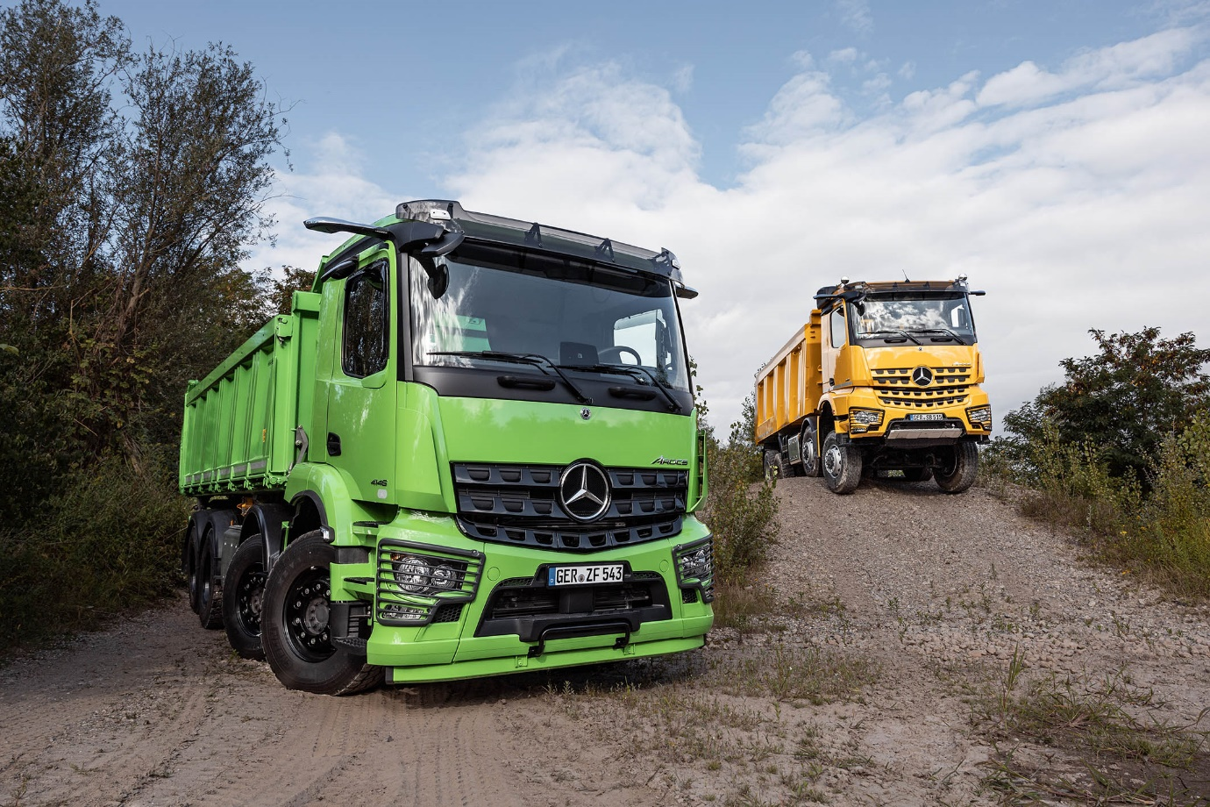

Innovating the construction industry with the new Mercedes-Benz Arocs

- Safe like no other: only the latest generations of assistance systems in the Arocs

- User-friendly: ground-breaking operability of the Multimedia Cockpit

- Superb savings: advanced Predictive Powertrain Control optimises fuel consumption, particularly on interurban routes

- Always on: networking provides for maximum availability

- Extensive range: configurations to suit every application

Construction calls for a hands-on approach. It’s a tough job that requires hardy workers. The new Mercedes-Benz Arocs has all the qualities required to be the perfect partner for construction-related transport: powerful engines, varied drive configurations and a robust chassis for the sustainable development of industry-appropriate vehicle bodies. The Arocs has an extensive programme allowing customers to design their own transport solutions that cater to individual requirements. Construction haulage today, however, requires more than that. Operations represent logistical masterpieces, often completed under extreme conditions and which call for state-of-the-art-technology. Exactly the type of innovation brought to the construction site by the new Arocs. Boasting the latest generation of technological developments such as Predictive Powertrain Control (PPC), Sideguard Assist, Active Brake Assist and market ‘firsts’ such as MirrorCam and the Multimedia Cockpit, not to mention the Truck Data Center (TDC) connectivity platform, the Arocs is setting the standard for efficiency, digitalisation, safety and connectivity.

Maximum safety thanks to MirrorCam and innovative assistance systems

MirrorCam camera technology provides advantages when it comes to the handling and primarily safety of the truck. This replaces the conventional main and wide-angle mirrors in the new Arocs. The optional system comprises two cameras aimed at the rear whose images appear on two large 15-inch displays on the A-pillar in the cab. The Arocs is the first construction truck to include this system. It makes work easier, both on and off the beaten track, for drivers in construction supplier traffic where there are numerous unloading points.

The absence of the mirrors has, on the one hand, considerably improved all-round visibility. The driver has excellent visibility even diagonally in front of the truck, an angle which would otherwise have been concealed by the mirror housing. And it is no longer possible for the driver to incorrectly adjust the mirror. Because from any perspective, the camera shows the same complete image.

Furthermore, MirrorCam provides the driver with a series of auxiliary functions. For example, the display for the inside of the bend swivels in such a way that the driver always has the optimal view of the semitrailer. When manoeuvring or changing lanes, the projection of distance lines on the display helps the driver estimate the distance to the vehicles following behind. “The displays on the A-pillars are placed in the field of view in a way that allows you to better perceive what's going on around the vehicle. You just travel more safely with MirrorCam!,” says Meichle + Mohr driver, Felix Amann.

MirrorCam also works hand-in-hand with the Mercedes-Benz Sideguard Assist. The assistance system can help to avoid accidents on the co-driver's side when the vehicle turns to the right due to it can warn the driver both visually and audibly before a collision occurs. Sideguard Assist in the new Mercedes-Benz Arocs is able to recognise and warn of obstacles to the right of the vehicle along the entire length of the vehicle. To do this, it calculates the sweep curve of the trailer. If MirrorCam is installed, Sideguard Assist warnings are displayed on the right-hand display. Thus keeping all relevant information consolidated in the one place. Daimler Trucks is currently the only manufacturer offering such a driver assistance system fully integrated in the vehicle architecture.

The now fifth generation of Active Brake Assist (ABA) should also contribute to even greater safety. The system can now better react to people within speeds of up to 50 km/h thanks to the combination of radar and camera system. This can be a safety advantage, especially when driving in built-up areas. Regardless of whether it’s a stationary vehicle or travelling ahead, or an unprotected road user such as a cyclist or pedestrian: ABA 5 can help to avoid a rear-end collision. If necessary, the safety system can initiate an automatic full-stop braking within the system limits until the vehicle comes to a complete standstill. Important to note here: ABA 5 is an assistance system. It is the driver who continues to have full responsibility for driving the truck safely. In addition to other things, this responsibility includes the driver having full control of the truck at all times and follows the traffic closely.

Mercedes-Benz Trucks is the first manufacturer with a fully-integrated and networked Multimedia Cockpit

The warning of dangers and other important information in a way that did not overly burden the driver was another important aspect during development of the new Arocs. The Multimedia Cockpit plays an important role here, replacing the classic instrument cluster. It gives the driver a clear overview of all relevant driving and operating conditions. This also includes the information about all assistance systems. Further advantages of the Multimedia Cockpit: predominantly glare-free thanks to a special filter, as well as a modern retina resolution. The Multimedia Cockpit is available in two designs and always includes a radio infotainment system. The optional Multimedia Cockpit Interactive has a 12-inch instrument cluster instead of a 10-inch display. Furthermore, there are two display options ('Classic' and 'Advanced'), a truck-specific navigation system, Remote Online, as well as traffic sign recognition. Another important aspect was closely linking the Multimedia Cockpit with the vehicle body.

There is now no need, for example, to take the instrument cluster apart in order to satisfy bodybuilder requirements, e.g. displaying their preferred symbols. The symbols can be very easily configured from a vehicle library by a service partner, using so-called XENTRY diagnosis. Up to five virtual switches can be freely selected for the primary display of the Multimedia Cockpit. In this case, the switches with integrated indicator lamp show the operating status of the vehicle body – for example, whether the body-mounted headlamps are switched on, or the support legs for a crane have been extended.

The Multimedia Cockpit includes a second screen, in addition to the usual switch panel to the right of the steering wheel. This secondary screen has been designed as a multimedia touch display. The driver can control several functions intuitively and conveniently at the touch of a finger, provided the traffic situation allows it. For example, up to five virtual switches can be used to operate body functions not relevant to safety. Heating, air conditioning and telephony for example are also controlled via the secondary display. Also, the touchscreen can be used to access apps from the Mercedes-Benz Truck App Portal, which serve to optimise transport and vehicle management, amongst other things. The multimedia touchscreen also provides the driver with information about tyre pressure and axle load, while the digital display is able to provide images from up to four cameras. Thus allowing for the vehicle’s radius of action to be monitored.

There is also a control panel with classic switches located immediately below the secondary screen. Should the number of connectors provided here prove insufficient, an additional control panel in the cup holder can be ordered as special equipment. Both displays can also be operated using the touch control buttons, or “finger navigation pads”, in the new multifunction steering wheel.

Innovative and efficient thanks to the advanced Predictive Powertrain Control

The Mercedes-Benz Arocs now also benefits from the advanced cruise and transmission control Predictive Powertrain Control. PPC has thus also found its purpose in inter-urban traffic and the Arocs, which frequently navigates rural roads, is now set to see major progress in the reduction of fuel consumption. In addition to a GPS-based positioning system, the new generation of PPC uses digital road maps that contain data on topography, road bends, the geometry of intersections and roundabouts, as well as traffic signs. Not only is the Arocs always able to find the right gear and appropriate speed for consumption when travelling up- and downhill, but also when navigating the winding roads between cities and towns. This is what makes it so fuel-efficient and as comfortable as possible out on the road.

Even seasoned professionals have confirmed this is the case. Such as Meichle + Mohr driver, Felix Amann. He's already had a chance to sound out the new Arocs on the rural roads around Lake Constance and is pleased about the support of the new system. “Thanks to the new Predictive Powertrain Control, I can now also drive more comfortable overland using cruise control.” Roland Maier, Fleet Manager at Meichle + Mohr, adds: “Even a highly skilled driver with excellent knowledge of the route doesn't achieve fuel consumption rates in interurban traffic like those of the new Arocs with improved Predictive Powertrain Control.” Out on the road, the Arocs is up to five percent more fuel-efficient when compared to models without the intelligent cruise and transmission control. Fuel savings are even better thanks to the optimised aerodynamics of the streamlined MirrorCam camera housing mounted on the side of the cab roof frame.

Truck Data Center installed as standard facilitates intelligent service and telematics services

The Mercedes Arocs is always online. This offers companies considerable advantages. The Truck Data Center Module (TDC) is at the heart of this online vehicle networking. It receives data, for example from sensors and cameras in the truck, and uses this information as a basis for communication between the vehicle and external systems, such as Mercedes-Benz Uptime service and maintenance management and Fleetboard.

The Uptime service continuously checks status messages from the vehicle systems, which are fitted with sensors. Even the condition of operating fluids and wearing parts is included here. If a repair or maintenance is flagged, this is immediately reported to Mercedes-Benz Service by the truck. The data is analysed in real time and passed on to the service organisation with a recommended course of action. If there is a risk of breakdown, contact is made with the customer and a workshop appointment made along the planned route. Furthermore, the repair and maintenance requirements are automatically communicated to the Mercedes-Benz service partner designated by the customer. The necessary work is then consolidated and a date is agreed with the customer in coordination with their schedule. For the customer, facilitating the planning of workshop appointments means greater vehicle availability.

Vehicle networking opens up even further possibilities for improving transport efficiency. Daimler Trucks offers the corresponding apps via the Truck App Portal. Using these apps, fleet managers and dispatchers can optimise the efficiency of the new Arocs using all kinds of digital tools.

Bulk goods, building materials, quarry stone - a truck as individual as the jobs on site

The Mercedes-Benz Arocs is as individual as the jobs carried out by those in the construction industry. Thanks to the large selection of cabs, efficient engines – closely graded with an output of 175 kW (238 hp) to 460 kW (625 hp) – along with drive variants and wheel configurations, it fulfils different requirement profiles. Whether bulk goods, building material supply, ready-mixed concrete or transport of the heaviest construction machinery – the Arocs is equipped to deal with all these tasks and more. The Arocs test vehicles on-site are prime examples of the comprehensive programme available for construction traffic.

A literally groundbreaking speciality for arduous tasks is the fluid coupling. A combination of hydraulic start-off clutch and retarder in one shared component, it allows for precise driving and manoeuvring under heavy load and at the lowest of speeds. As a primary retarder, it develops a braking power of 350 kW (476 hp). Together with the up to 475 kW (646 hp) output of the powerful High Performance Engine Brake, the fluid coupling ensures high efficiency. "The automated manual transmission in combination with the fluid coupling makes driving considerably easier," reports driver David Ewan from Scottish company McIntosh Heavy Logistics.

Nothing is impossible is the thinking behind the Arocs. The extensive Arocs programme comprises wheel configurations from 4x2 and 4x4 to the three-axle vehicles in 6x2, 6x4 to 6x6. The four-axle vehicles are available as 8x2 with trailing axle, as 8x4, 8x4 with trailing axle, as 8x6 and 8x8. The range includes steel and air suspension, different frames depending on use, whether mainly on the road or principally off-road, numerous wheelbases, cabs for day trips and long-distance, as well as three all-wheel drive systems. Heavy haulage trucks and special vehicles round off the package. Pre-configured special vehicles make it easier for customers to make their choice. As a two-axle semi-trailer tractor or concrete mixer, the Arocs Loader consistently demonstrates a low unladen weight and high payload. In turn, the Arocs Grounder is an extremely sturdy vehicle for particularly challenging operations. The tractor units of the SLT series with three, four and even five axles excel at the heavy load and high capacity transport of up to 250 tonnes gross combination mass.

Optimised exhaust system creates even more space for bodies and attachments

The designers have made further finely tuned adjustments to the Arocs. Not only have the software functions considerably improved body-mounting features, but the updated vehicle hardware also plays its part. For example, a vertical exhaust system is now available ex factory for all four-axle vehicles. This creates additional installation space for equipment mounted on the side of the frame, such as additional fuel tanks or stowage boxes. Another advantage of this solution compared to the previous, side-mounted exhaust system, where only the exhaust pipe itself is upright, is reduced weight.

“For combined work in road and construction site traffic, the new Arocs is the best vehicle that I have ever sat in. Assistance systems, user interfaces, performance – here the driver has the pleasure of everything today’s technology has to offer,” concludes Peter Wedhorn, who has been driving for Doreen Trabert’s company for more than 23 years. One of the tough guys, yet with plenty of savvy too. And exactly how the industry likes it.

Further information is available here: d.ai/NOWandNEXT2020-pressmaterial

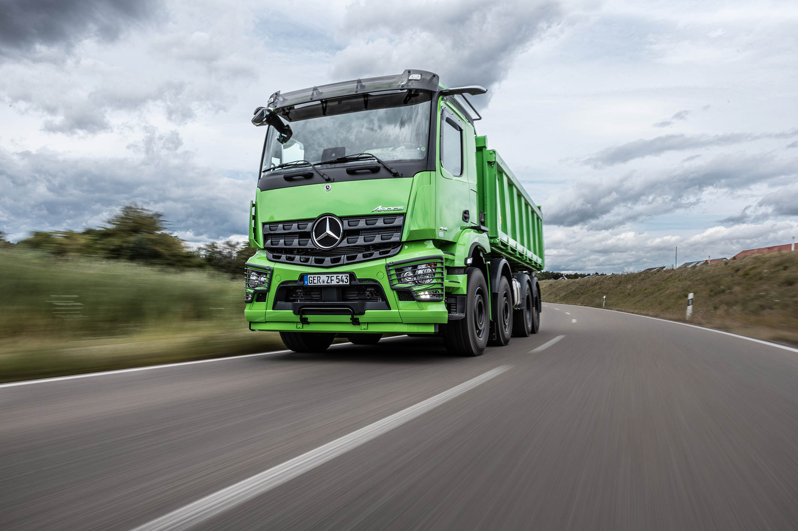

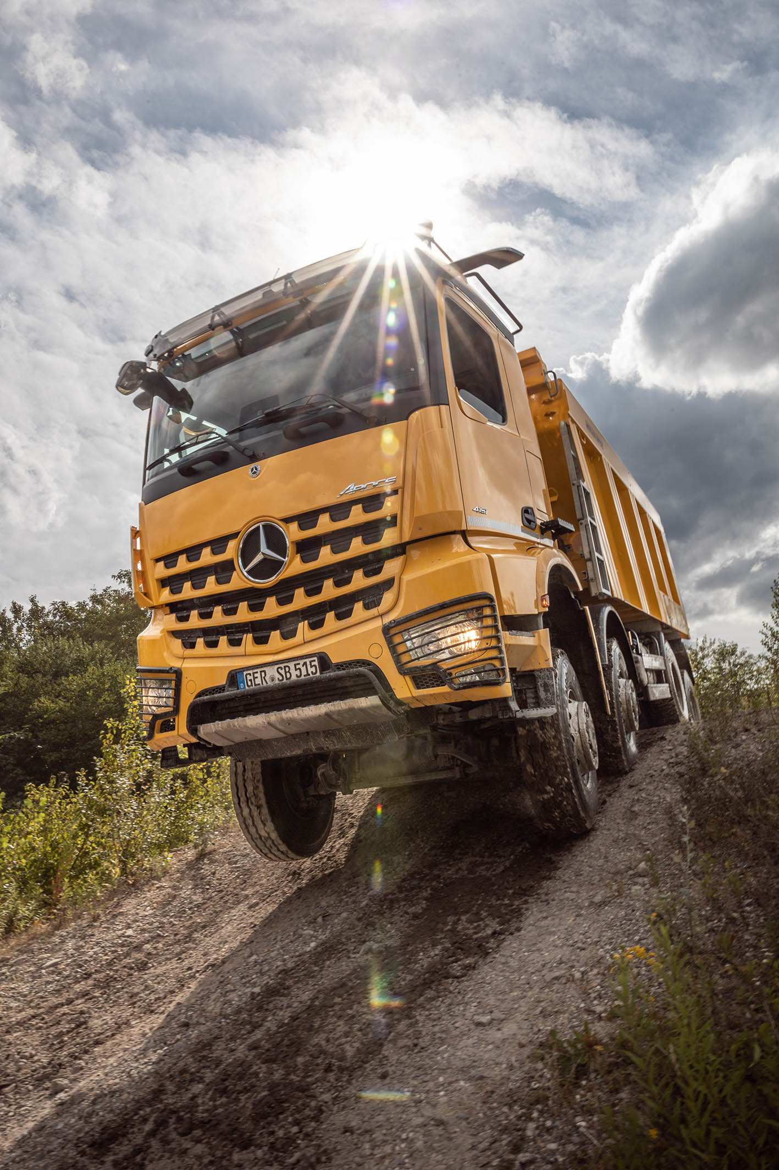

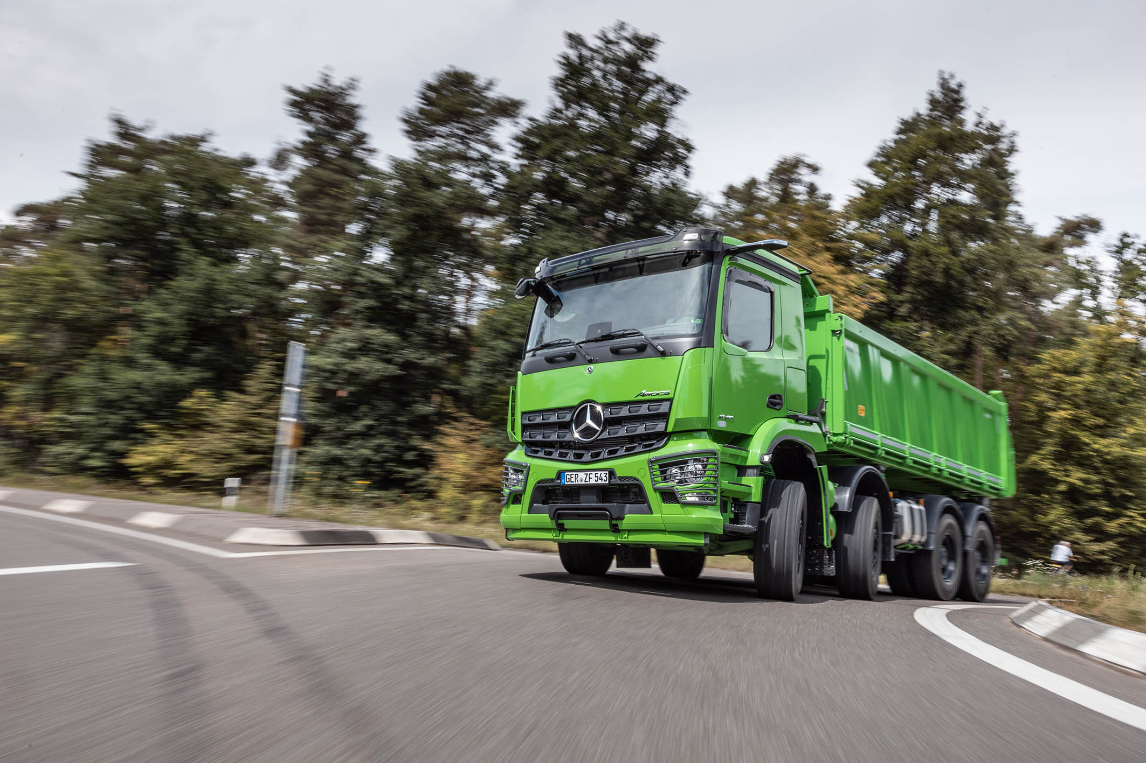

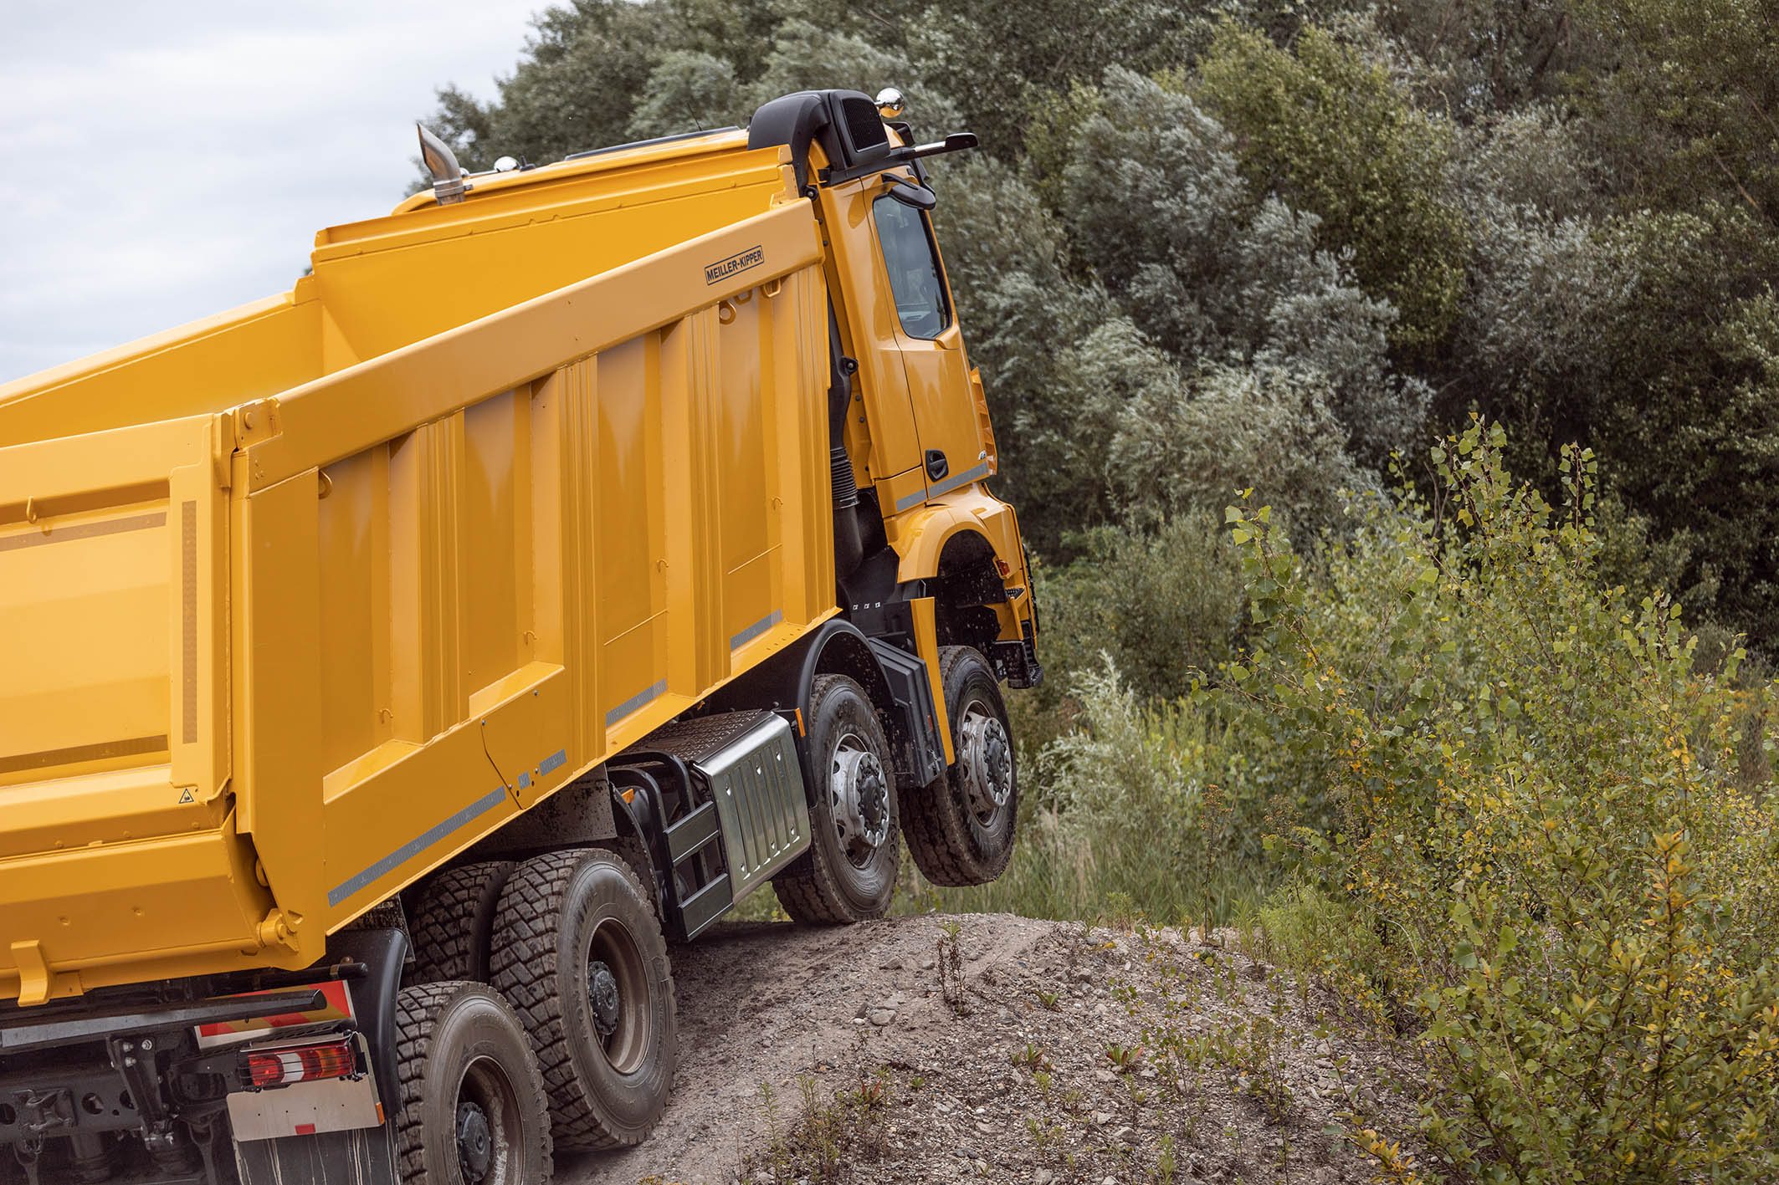

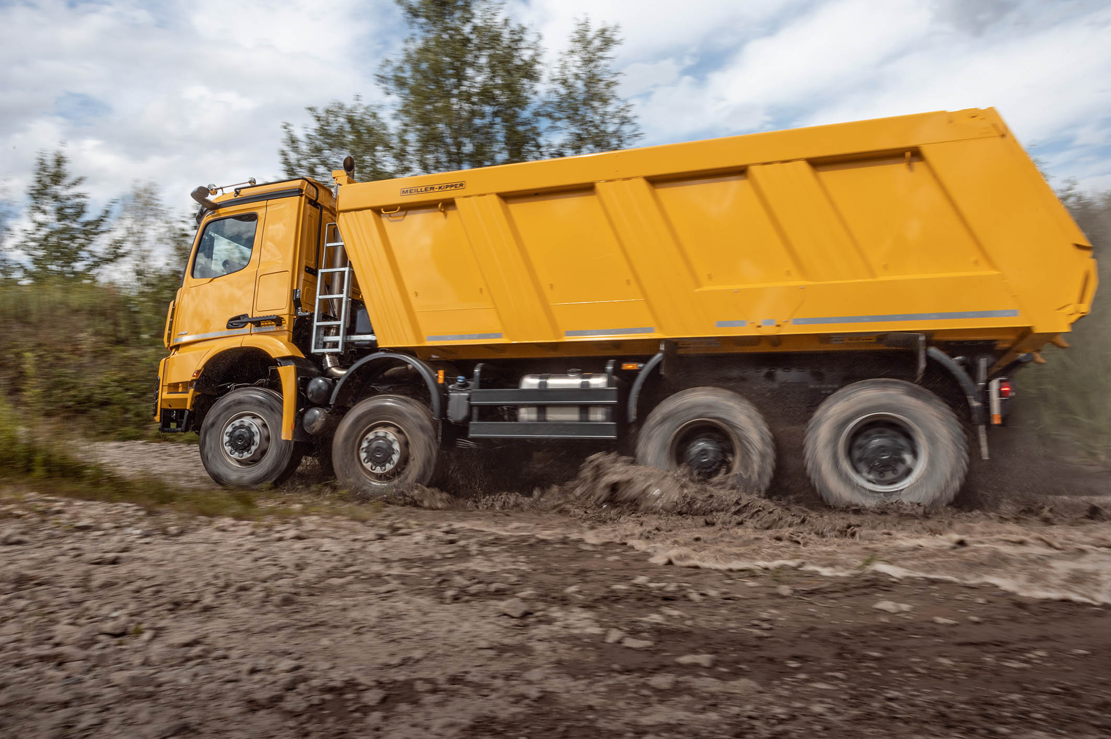

ends

For more information, please contact:

Carola Pfeifle, +49 (0) 711 17-5 35 51, carola.pfeifle@daimler.com
Ulrike Burkhart, +49 (0) 711 17-5 87 74, ulrike.burkhart@daimler.com

or

Jamie Fretwell at Mercedes-Benz Trucks UK Ltd
07712 519230, jamie.fretwell@daimler.com

Further information on Daimler Truck AG is available at:
www.media.daimler.com and www.daimler-truck.com

Gottlieb Daimler and Carl Benz laid the foundation for the modern transport industry more than 120 years ago. Over the past decades, Daimler's truck and bus divisions have consistently set standards for the entire transportation industry – in terms of safety, fuel efficiency and driver and passenger comfort. It is now time for the next evolutionary step: emission-free, automated and connected driving. Daimler Trucks & Buses is working to bring these important technologies to high-volume series production, across brands, divisions and regions. In this way the company intends to take a major step closer to realising its vision of CO₂-neutral transport and accident-free driving whilst also contributing to the sustainability of global goods and passenger transport.

This document contains forward-looking statements that reflect our current views about future events. The words “anticipate,” “assume,” “believe,” “estimate,” “expect,” “intend,” “may,” ”can,” “could,” “plan,” “project,” “should” and similar expressions are used to identify forward-looking statements. These statements are subject to many risks and uncertainties, including an adverse development of global economic conditions, in particular a decline of demand in our most important markets; a deterioration of our refinancing possibilities on the credit and financial markets; events of force majeure including natural disasters, pandemics, acts of terrorism, political unrest, armed conflicts, industrial accidents and their effects on our sales, purchasing, production or financial services activities; changes in currency exchange rates and tariff regulations; a shift in consumer preferences towards smaller, lower-margin vehicles; a possible lack of acceptance of our products or services which limits our ability to achieve prices and adequately utilize our production capacities; price increases for fuel or raw materials; disruption of production due to shortages of materials, labor strikes or supplier insolvencies; a decline in resale prices of used vehicles; the effective implementation of cost-reduction and efficiency-optimization measures; the business outlook for companies in which we hold a significant equity interest; the successful implementation of strategic cooperations and joint ventures; changes in laws, regulations and government policies, particularly those relating to vehicle emissions, fuel economy and safety; the resolution of pending government investigations or of investigations requested by governments and the conclusion of pending or threatened future legal proceedings; and other risks and uncertainties, some of which we describe under the heading “Risk and Opportunity Report” in the current Annual Report or the current Interim Report. If any of these risks and uncertainties materializes or if the assumptions underlying any of our forward-looking statements prove to be incorrect, the actual results may be materially different from those we express or imply by such statements. We do not intend or assume any obligation to update these forward-looking statements since they are based solely on the circumstances at the date of publication.
Daimler Trucks & Buses
Daimler Trucks & Buses is one of the world’s largest commercial vehicle manufacturers, with more than 35 primary locations around the world and approximately 100,000 employees. The company brings seven vehicle brands under one roof: Mercedes-Benz (light, medium and heavy trucks, city buses, overland buses and coaches) and Setra (overland, long-distance and premium coaches) are its European traditional brands; North American brands include Freightliner Trucks (in weight classes 5 to 8 serving a wide range of commercial vehicle applications), Western Star (heavy and long-haul heavy-duty trucks) and Thomas Built Buses (light to medium weight buses); and Asian brands BharatBenz, based in Chennai, India (9- to 55-ton trucks, medium- and heavy-duty buses) and FUSO, headquartered in Japan (trucks and buses for Asia, the Middle East, Africa, Europe and Latin America). Thus, Daimler Trucks & Buses offers its customers around the globe a broad portfolio of commercial vehicles, from minibuses to heavy trucks for specialized transport. In short: products and solutions for all who keep the world moving. More than 120 years ago, Gottlieb Daimler and Carl Benz laid the foundation for the modern transport industry. Over the past decades, Daimler’s Truck and Bus divisions have consistently set standards for the entire transportation industry - in terms of safety, fuel efficiency and driver and passenger comfort. Now it’s time for the next evolutionary step: emission-free, automated and connected driving. Daimler Trucks & Buses is working to bring these important technologies to volume series production, across brands, divisions and regions. The company aims to take its vision of CO2-neutral transport and accident-free driving a major step closer and contribute to the sustainability of global goods and passenger transport. In 2019 Daimler Trucks & Buses delivered a total of around one-half million trucks and buses to customers. In 2019 sales for individual business units amounted to €40.2 billion at Daimler Trucks and €4.7 billion at Daimler Buses. EBIT came to €2.5 billion for Daimler Trucks and €283 million for Daimler Buses.

