

Date: 20 January 2021

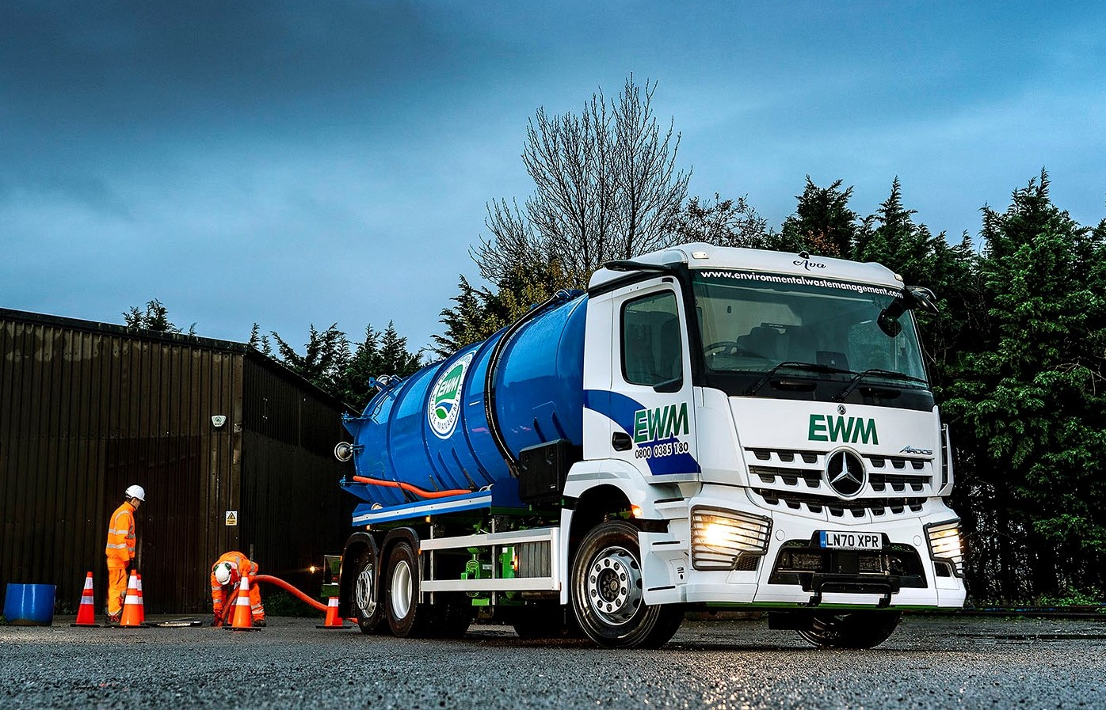

Ambitious liquid waste specialist brings five new Mercedes-Benz Arocs tankers on stream

Enforcement of new Direct Vision regulations governing the operation of trucks in Greater London begins on 1 March, but Mercedes-Benz operator Environmental Waste Management can rest easy – irrespective of aftermarket safety aids its latest 6x4 tankers are ‘good to go’ in the capital for the next 10 years.

The fast-growing Essex-based company has purchased five 26-tonne Arocs 2633s from S & B Commercials. Thanks to their ground-breaking MirrorCam technology and ClassicSpace M-cabs, the trucks have been awarded three-star Direct Vision ratings.

Transport for London’s Direct Vision regime recognises the contribution that MirrorCam’s cameras make to safety, by providing much improved rear visibility and eliminating the forward-facing blind spots caused by conventional door mirrors.

Seen through the driver’s eyes, the bottom edge of the window in a Mercedes-Benz Arocs or Actros is lower than in other makes of truck. At 2.3m the cabs of Environmental Waste Management’s six-wheelers are in the narrower of the two widths available, while their 320mm engine tunnels mean the floors are relatively low. All of these factors contribute to safety by enabling drivers to see more of what is going on around them.

Environmental Waste Management operates from a head office in Epping and has just celebrated a highly successful first year in business. Its skilled and experienced team specialises in the disposal of liquid waste, primarily from sewers and septic tanks, but also from industrial facilities, and including hazardous substances such as oils.

The new Arocs have 10.7-litre in-line six-cylinder engines that produce 240 kW (326 hp) and are paired with smooth and fuel-efficient 12-speed Mercedes PowerShift 3 automated manual transmissions.

Their comprehensive safety specifications also include Active Brake Assist 5 emergency braking technology, which employs a combination of radar and cameras, and provides dramatically improved responses at speeds of up to 50 kph. The system can apply full braking – as opposed to the 50% achieved previously – if it detects a pedestrian crossing the truck’s path.

The Arocs are fitted with split tank bodies by VJ Engineering, of Rugby, that can carry 13,000 litres of waste liquid and 3,500 litres of clean water. Each section has its own pump, which is operated via the truck engine’s PTO (power take-off).

Environmental Waste Management has been working primarily in London, the South-East and Midlands, but is pursuing an ambitious growth strategy and aspires to operate on a genuinely national basis as soon as possible.

Managing Director Steve Strudwick worked in senior positions with other waste management providers before taking up his latest role. He reported: “Our first year of trading could scarcely have gone any better, and the fact that we’re very adaptable means we can take advantage of different revenue streams.

“In the early months of 2020 we were heavily engaged in flood relief work, protecting vulnerable properties by removing waste-water from areas in which the sewage network was struggling to cope.

“Then, as the pandemic took hold, we were called upon to meet the surge in demand for non-potable water removal services from construction sites and other locations, arising directly from the increase in hand washing by workers. We also deliver non-potable water, as well as removing it.”

Every truck on the Environmental Waste Management fleet wears a three-pointed star. Mr Strudwick continued: “My shareholders were already operating Mercedes-Benz products in other businesses and are very well served by S & B Commercials. We’re now benefiting from that relationship too, as well as from the premium quality of the vehicles themselves.”

The subject of a five-year Mercedes-Benz Complete Service Contract, Environmental Waste Management’s new Arocs are being inspected and maintained on the operator’s own site by one of S & B Commercials’ mobile technicians; only when major work is required will a truck go into the workshop at the Dealer’s headquarters in Welham Green, near Hatfield.

Operations Manager Mitchell Dolan has been with Environmental Waste Management since day one. “Mercedes-Benz trucks are instrumental to our success,” he said. “The latest extensions to the fleet will enable us to increase our geographical footprint and further extend our customer base.”

Steve Strudwick added: “The new Arocs look fantastic, lead the field in terms of safety, and are perfectly tailored to the requirements of our business, while S & B Commercials’ Truck Sales Manager Sam Setterfield was exceptionally helpful.

“His detailed product knowledge meant he was able to answer all of my questions regarding specification, and he was very proactive in keeping me updated on progress during the build phase. The fixed-cost service contracts allow us to budget with confidence, knowing that there are no nasty surprises around the corner and that we’re in safe hands when it comes to 24-hour back-up.”

https://www.environmentalwastemanagement.com/

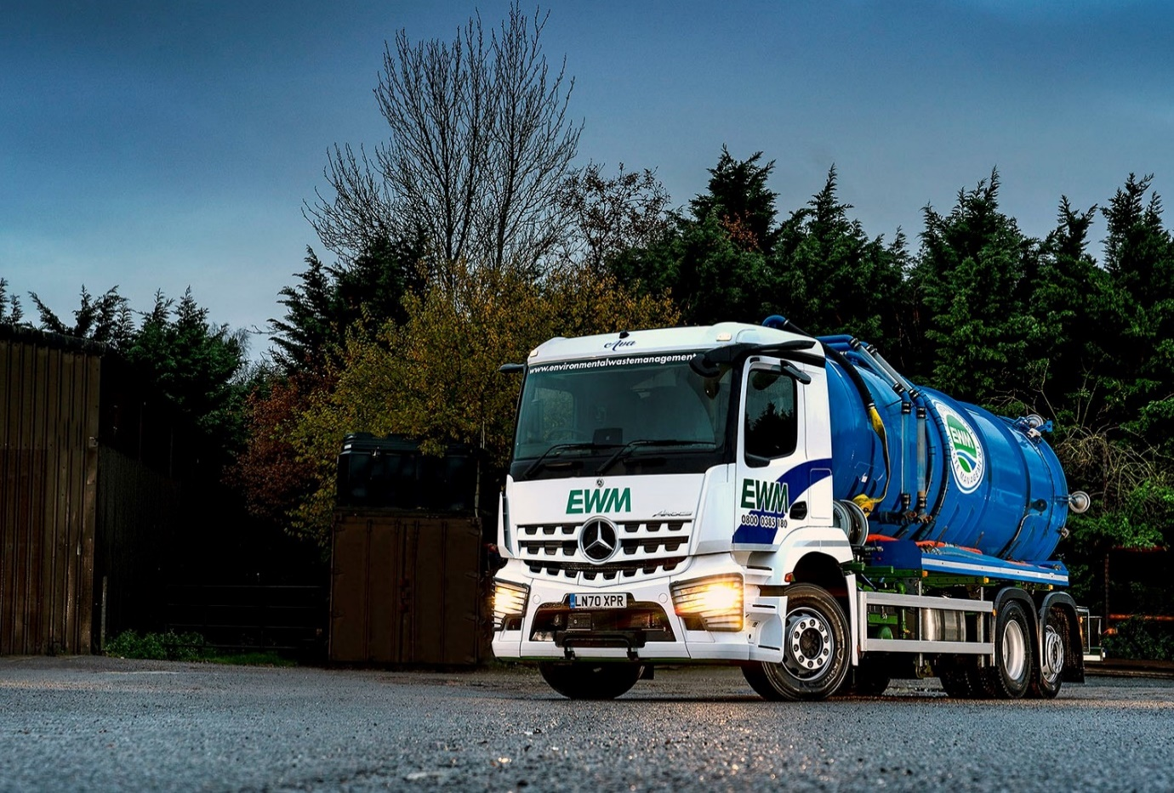

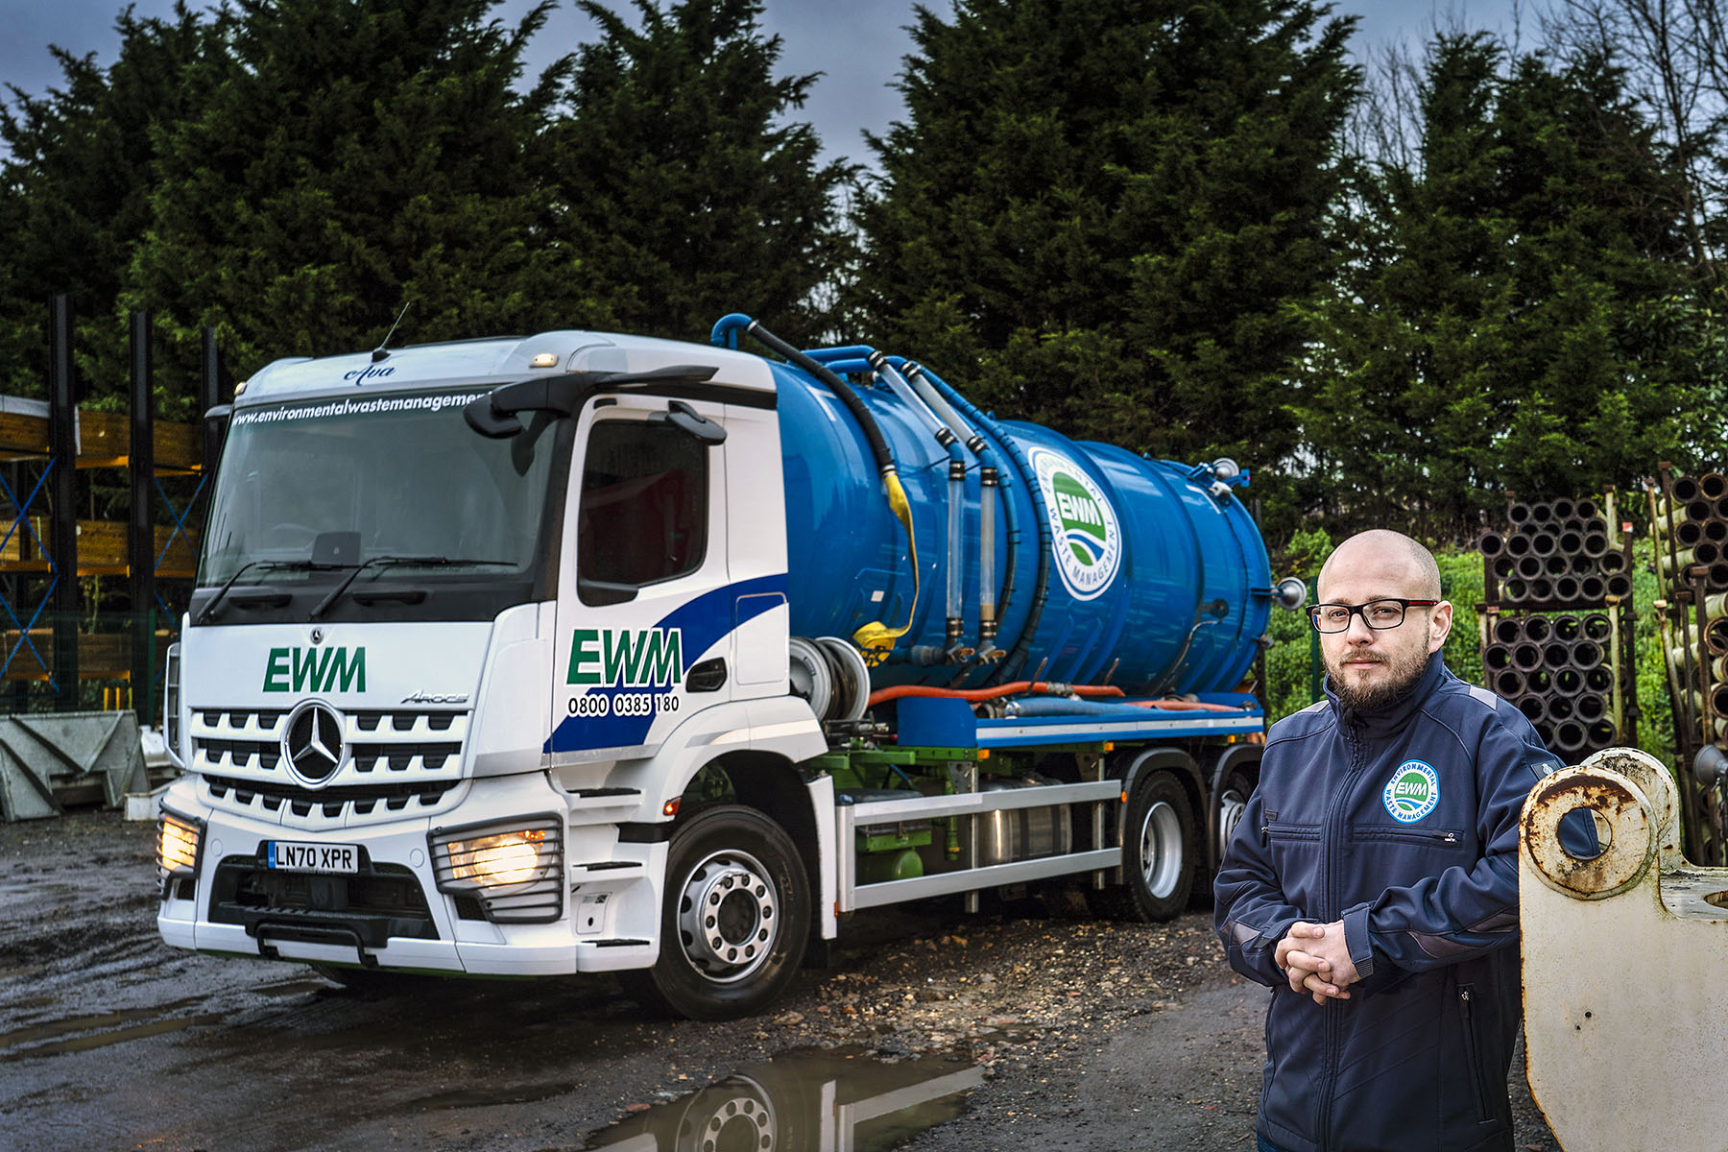

Going for growth: Operations Manager Mitchell Dolan said the investment in new Arocs would help Environmental Waste Management to extend its customer base

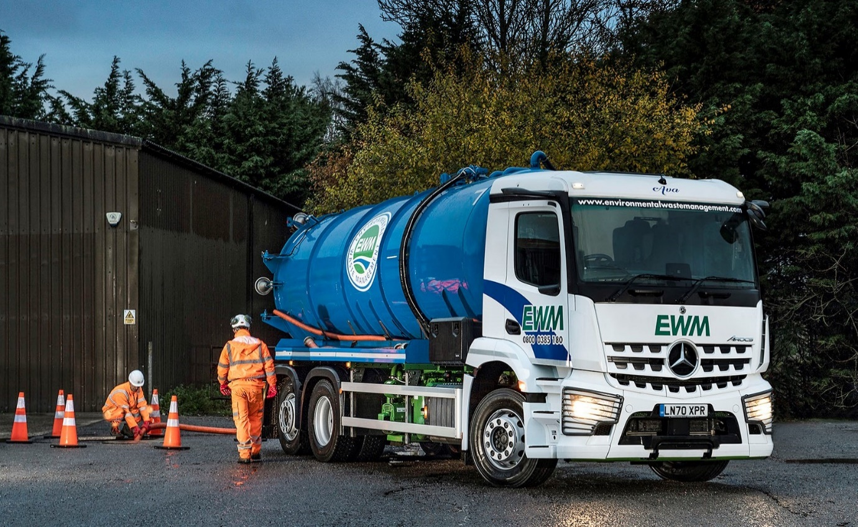
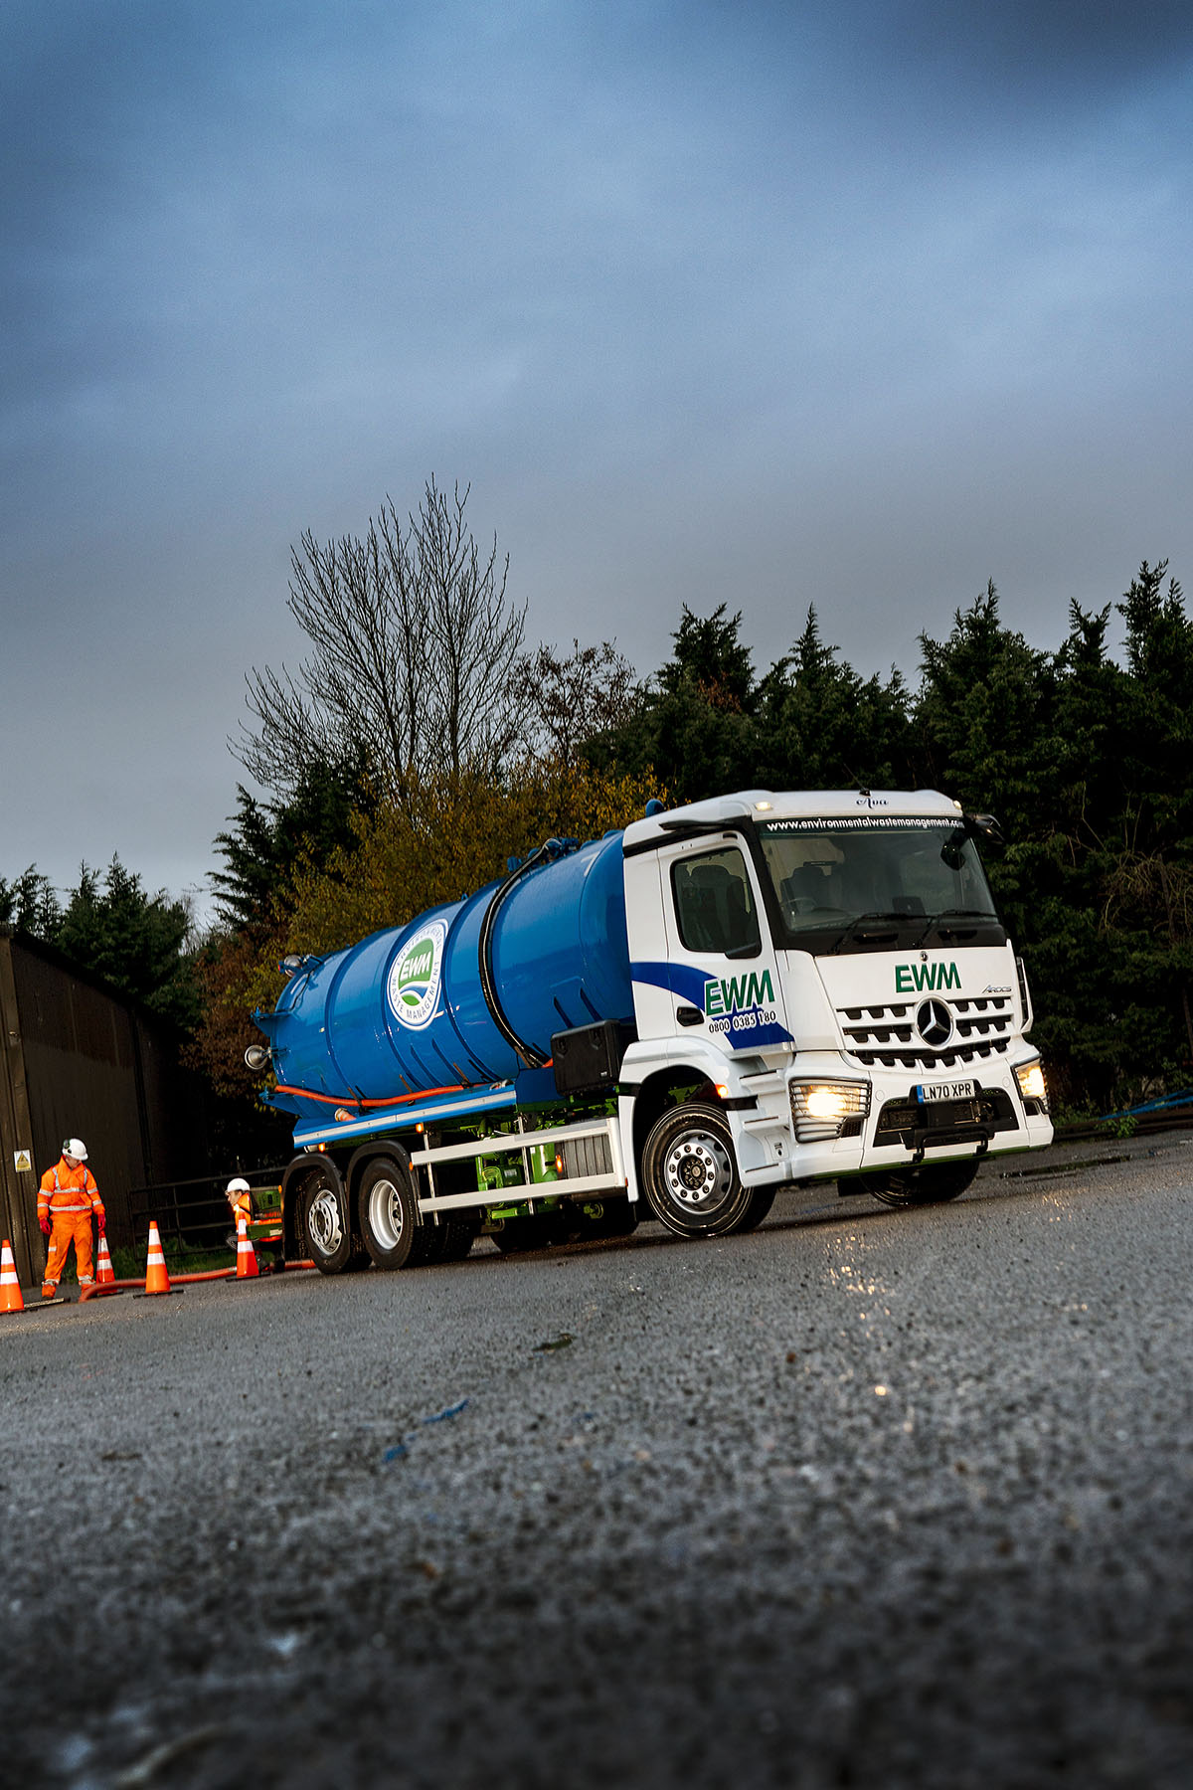

ends

For more information, or to request bigger/higher-res image files, please contact:
Steve Warren or John Ripley
Impact Communications, 01926 842126
Steve: 07770 470251, steve@impactcom.co.uk
John: 07771 484595, john@impactcom.co.uk

