

Date: 19 June 2019

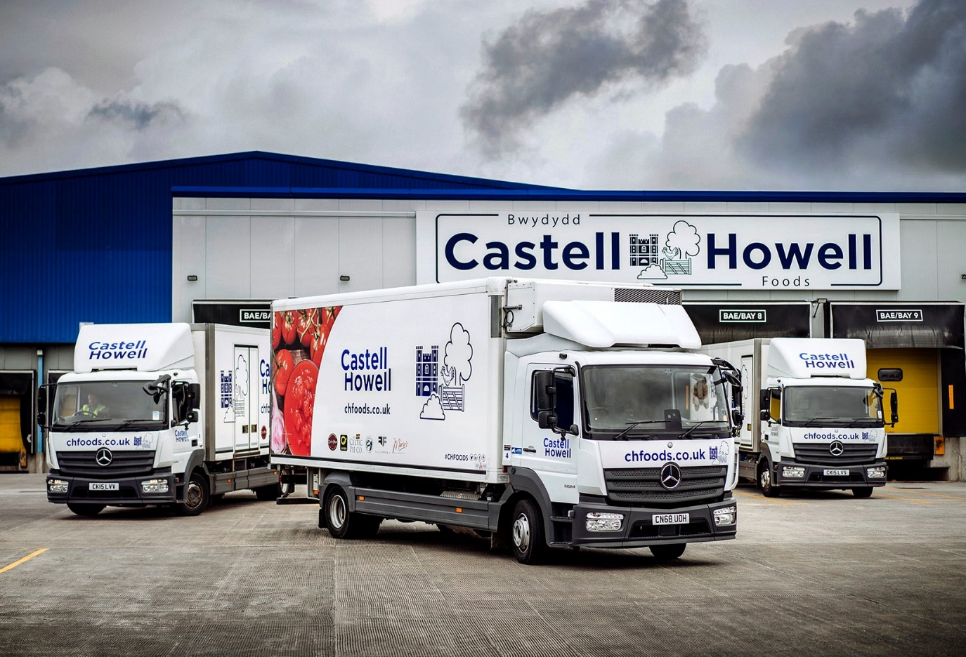

Castell Howell Foods banks on 16 tried and trusted Mercedes-Benz Atego rigids

Proven reliability and durability over a demanding working life led wholesaler Castell Howell Foods back to the Mercedes-Benz Atego range for the latest additions to its temperature-controlled fleet.

The Cross Hands-based company has taken delivery of 16 new Atego 12-tonners from South Wales Dealer Euro Commercials. All are 1224 LnR models with low-frame chassis, and S- ClassicSpace day cabs. Their 7.7-litre six-cylinder engines produce 175 kW (238 hp), and drive through Mercedes PowerShift 3 automated transmissions.

Castell Howell Foods’ fleet of more than 100 trucks and vans is dominated by mid-sized rigids, the majority of which wear three-pointed stars. Fitted with dual-compartment insulated bodies by Gray & Adams, and Frigoblock refrigeration units, the latest arrivals carry both chilled and frozen product.

“We’ve been running Atego rigids in a variety of sizes for 15 years or more,” said Martin Jones, the company’s Director of Transport Operations. “They’ve been an integral part of our ongoing success story, proving in service to be exceptionally tough and reliable, as well as highly competitive in terms of whole-life operating costs.

“With each model revision the level of refinement and driver appeal has gone up. The latest versions are as well engineered as ever, and drive very smoothly, while smart touches like LED daytime running lights mean they really look the part too.”

The new trucks are being used primarily on distribution routes into rural West Wales. Their lower frames allow for a reduced overall height, to minimise the risk of damage from overhanging trees, but the trucks retain a load volume comparable to a standard vehicle.

Urban deliveries are typically assigned to 15-tonne Atego rigids, while the flagships of the fleet are a pair of 375 kW (510 hp) Actros GigaSpace tractor units, which trunk between Cross Hands and satellite depots in Avonmouth, Blaenau Ffestiniog, Chirk, near Wrexham, and Merthyr Tydfil, as well as a cash and carry in Carmarthen.

Mr Jones continued: “This latest acquisition further cements our already excellent relationship with Euro Commercials. Sales Executive Steve Bastin knows our business very well and understands what we need – he always handles our orders efficiently and keeps us fully informed. We have also forged a strong working relationship with the Parts and Service teams at the Dealer’s Swansea branch.”

Castell Howell Foods celebrated its 30th anniversary last year. The company serves customers throughout Wales, the Welsh borders and the West Country, and prides itself on promoting and supplying premium quality regional produce. It stocks over 10,000 catering products and is best-known for its Celtic Pride Premium Beef Partnership, a supply chain initiative launched in 2003 which now has more than 80 farmer members, all of whom follow strict husbandry and management rules. Most recently it has launched Celtic Coast Fish Co., a specialist division which provides fresh fish and seafood from around the coast of the UK.

www.castellhowellfoods.co.uk

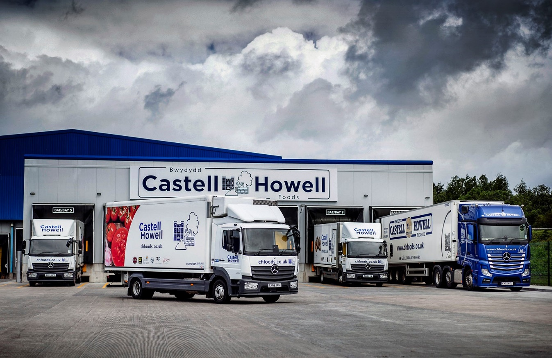

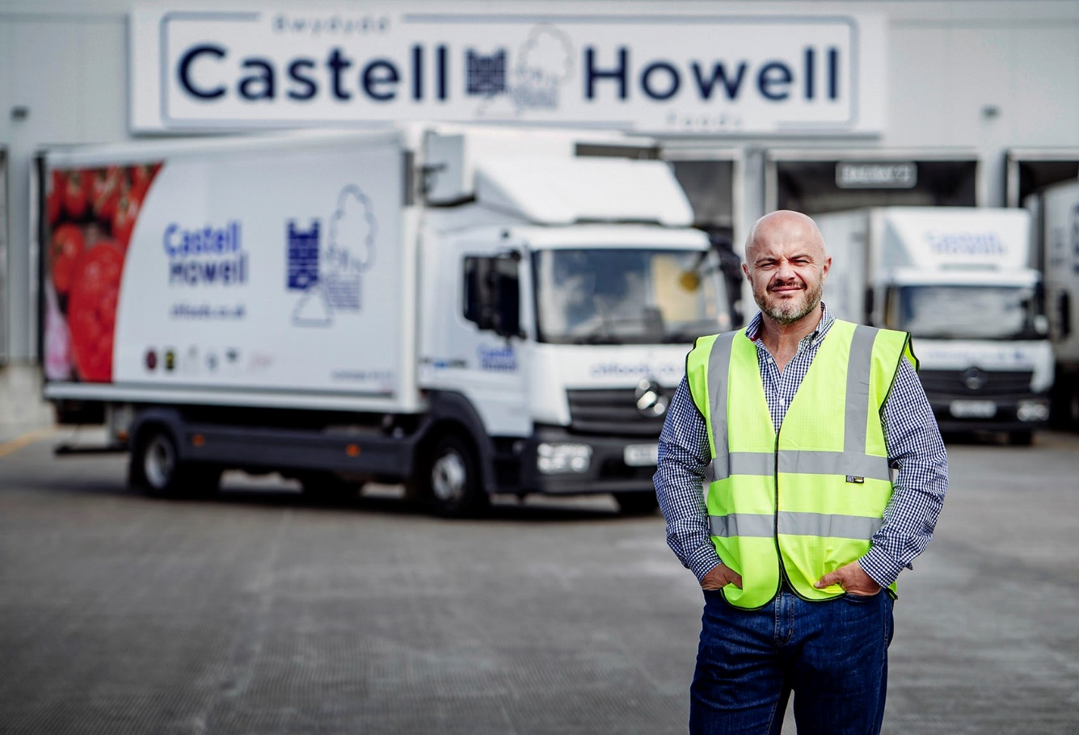

Trusted partner: Martin Jones of Castell Howell Foods knows he can rely on his
Mercedes-Benz Atego trucks

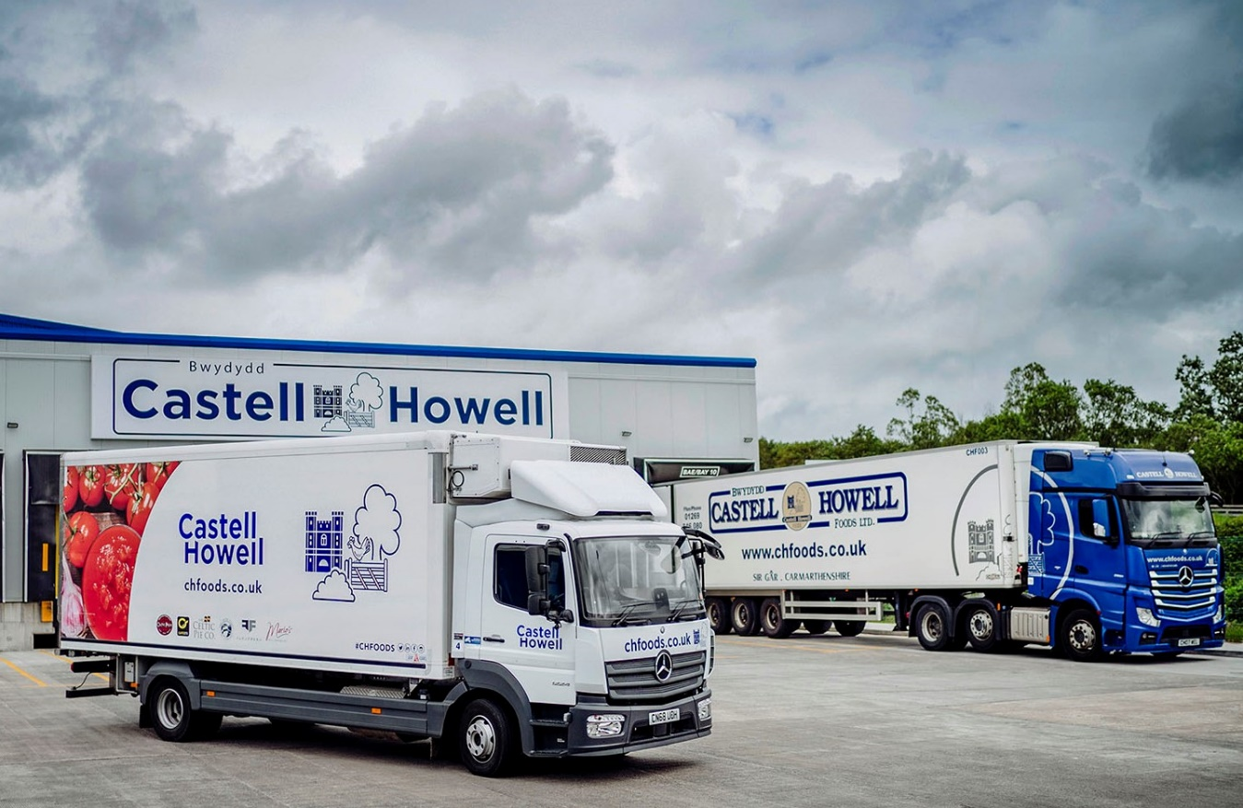

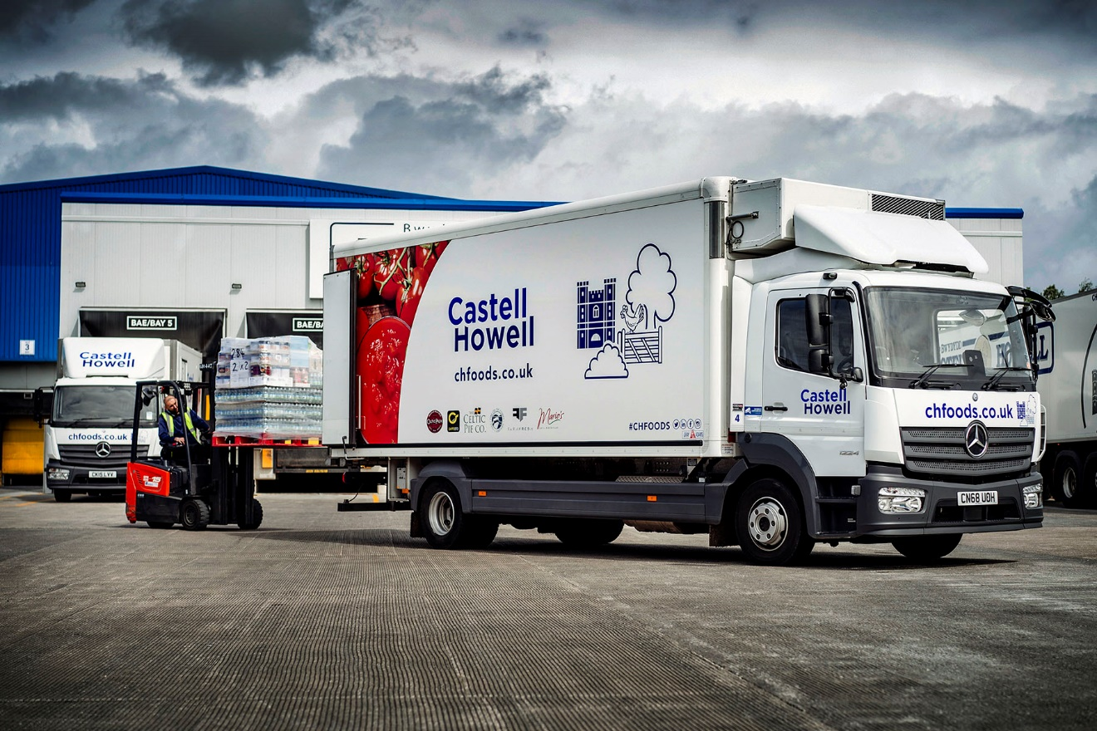

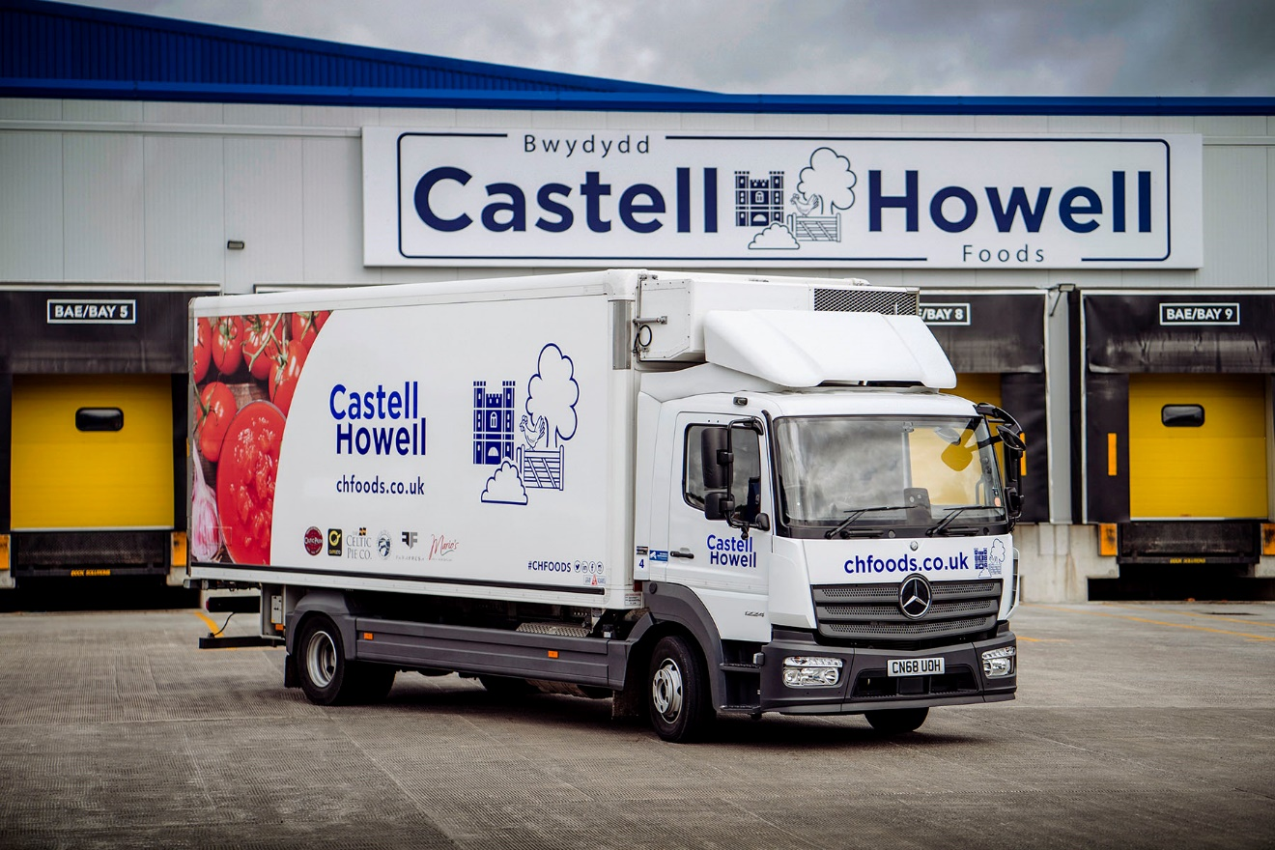

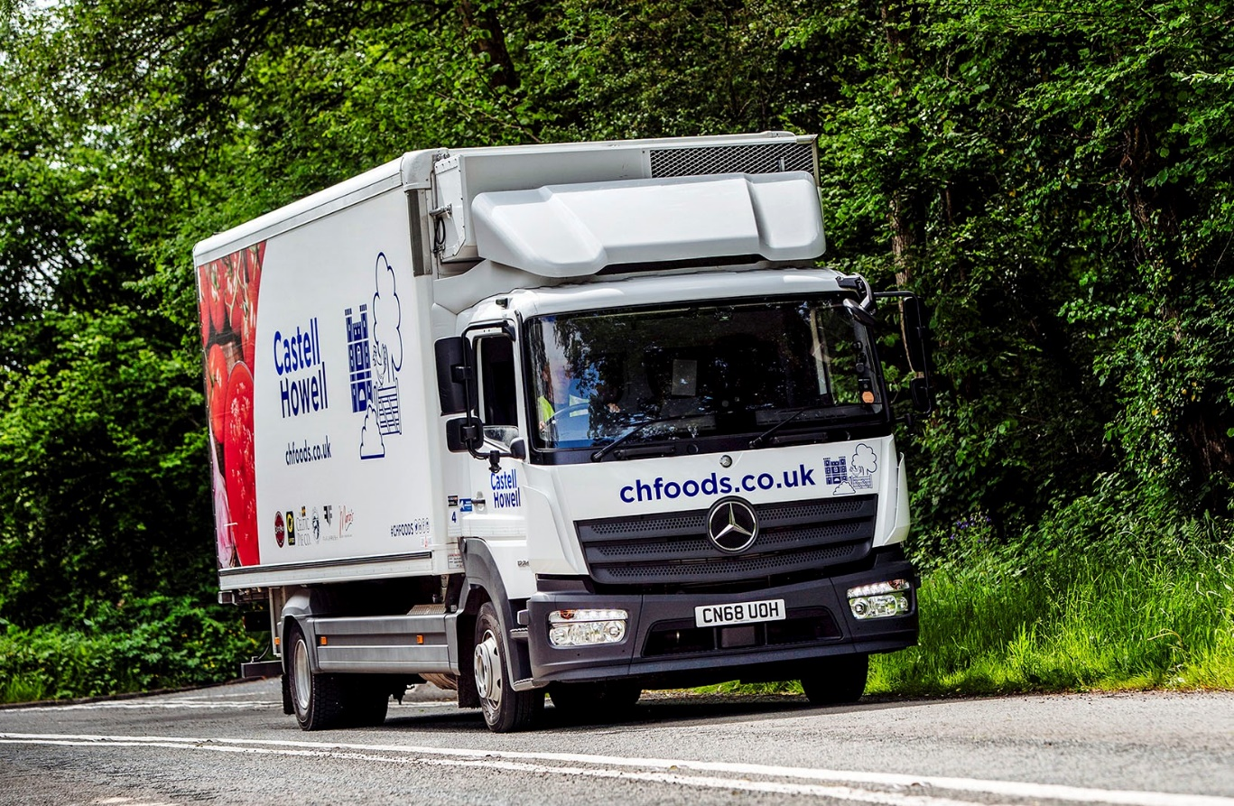

ends

For more information, or to request bigger/higher-res image files, please contact:
John Ripley or Steve Warren
Impact Communications, 01926 842126
John: 07771 484595, john@impactcom.co.uk
Steve: 07770 470251, steve@impactcom.co.uk

