

Date: 24 July 2020

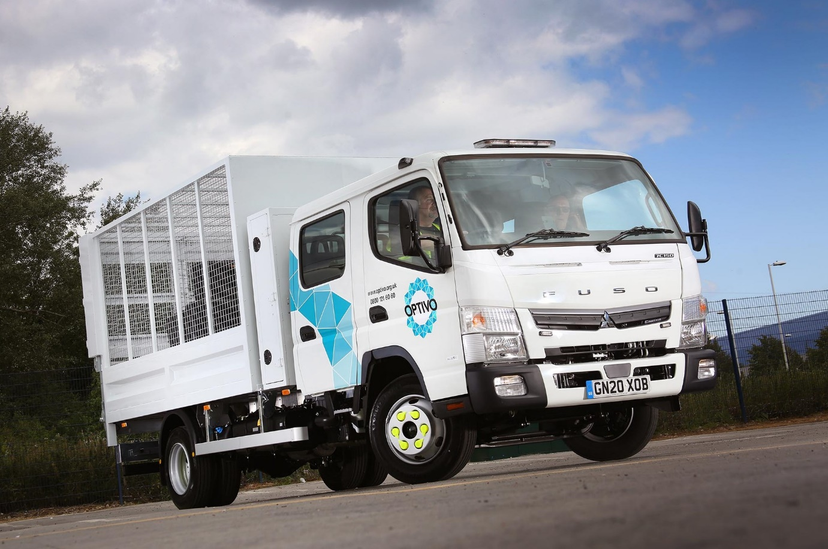

Seeing Double: Optivo’s second FUSO Canter has seating for a driver and six colleagues

Payload and agility lead Optivo back to Sparshatt Truck & Van for new FUSO Canter crew cab

Fast-growing housing provider Optivo has commissioned a second FUSO Canter, which is now being used to clear void properties in Kent of bulky waste items such as furniture, household appliances and flooring, as well as garden refuse.

Chosen for its market-leading carrying capacity and manoeuvrability, the 7.5-tonner arrived via the Sittingbourne headquarters of Sparshatt Truck & Van.

Sparshatt is best known as a dedicated Mercedes-Benz Trucks Dealer. However, as FUSO is part of the same Daimler family, the Mercedes-Benz franchised network also sells and supports the Canter light truck range in Great Britain.

The 7C15D model has a crew cab, and can seat a driver and six members of Optivo’s Kent Estates Services team. Tipmaster, of Leyton, East London, built its caged body and a lockable tool box immediately behind the cab, and fitted a 1,000 kg tail-lift.

The new truck is now working alongside a Canter 7C15 with day cab. Supplied by Sparshatt last December, that vehicle is used to clear up after fly tipping around estates, providing Optivo residents with a better service and cleaner communities.

Its body is also the work of Tipmaster and equipped with a tail-lift, but has solid sides. Both trucks are additionally fitted with low-profile, roof-mounted beacons, plus side marker lights.

Optivo, whose Grosvenor House head office is in Croydon, South London, was established as recently as 2017, following a merger of two housing associations. However, the company has a rich history that dates back to the early 20th Century.

One of the largest housing providers in the UK, and a member of the G15 group of London housing associations, Optivo has over 45,000 homes across the South East and Midlands, which provide 90,000 people with somewhere affordable to call their own.

Its two Canters are the subject of Mercedes-Benz Finance contract hire agreements, and powered by economical 3.0-litre common-rail diesel engines which generate high torque – 370 Nm is available over a broad engine speed range – and 110 kW (150 hp).

Their fuel-efficiency and Euro VI emissions credentials are also contributing towards Optivo’s target for the housing sector’s Sustainable Homes Index for Tomorrow (SHIFT) standard.

Kent Estate Services runs a fleet of more than 40 vans, but its trucks are the first vehicles it has needed an Operator’s Licence to run. Key to the Canter’s appeal is an exceptionally high carrying capacity that gives it an advantage over some competitors of more than one tonne.

Thanks in part to its light but tough ladder chassis, the Canter 7C15 offers a body and payload allowance of more than 5.0 tonnes, while the figure for the 7C15D crew cab variant is only marginally lower.

The Canter is also easy to drive, with a significantly more compact footprint than most vehicles in the same gross weight category, and a tight turning circle. Both are valuable attributes for Optivo, whose trucks spend much of their time on estate roads with restricted access.

Alex Magamedov, Optivo’s Waste Services & Fleet Officer, Property Services Kent & Sussex, confirmed: “We previously used 3.5-tonne vehicles to remove fly tipped waste from around our estates but some of the items the team collects are bulky and heavy. A high payload capacity was therefore the single most important criteria when we decided to move up to a 7.5-tonne truck. We’ve been very pleased with our first Canter. It’s highly manoeuvrable on residential streets and perfect for our operation. It also looks great and the team is proud to drive it.

“We’re confident our new truck will prove every bit as productive, if not more so,” she continued. “We’re now able to send a team of up to seven operatives to a void property, which they can then empty quickly and efficiently prior to refurbishment.”

Ms Magamedov added: “We’re also very happy with the working relationship we have developed with Sparshatt Truck & Van. Its dedicated Group Canter Specialist Dan Brunning provides an excellent, customer-focused service, while the Dealer’s local maintenance and repair support has resulted in significantly improved vehicle uptime.”
www.optivo.org.uk

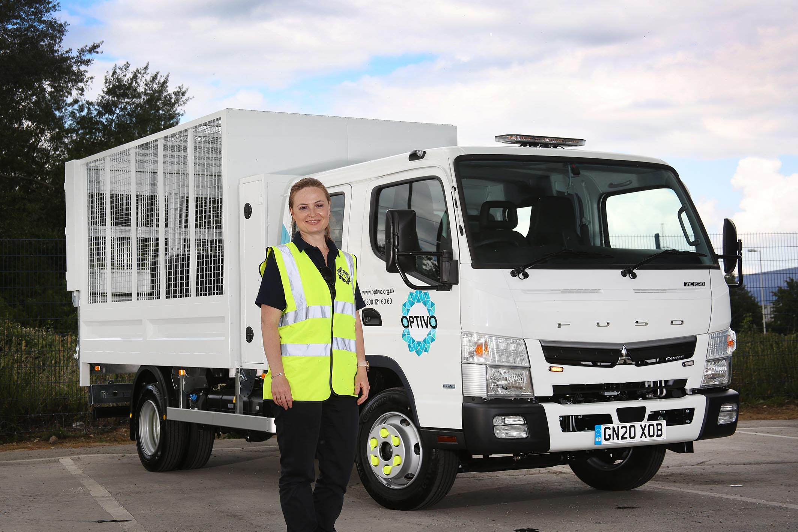

Productivity bonus: Optivo’s Waste Services & Fleet Officer, Property Services Alex Magamedov, is pictured with the new FUSO Canter which is now being used to empty void properties

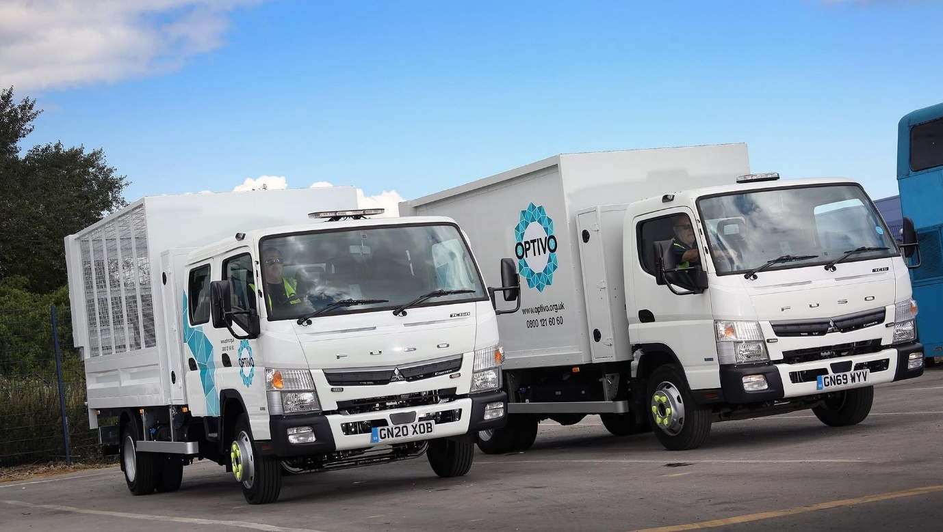

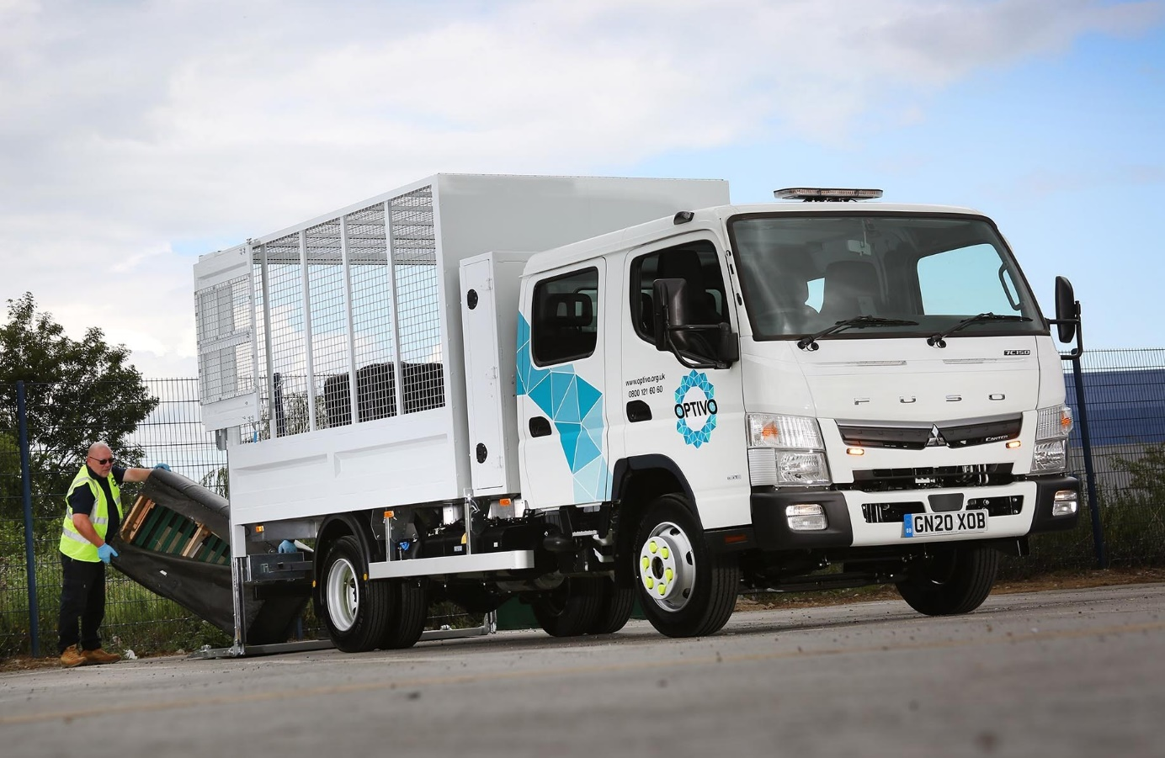

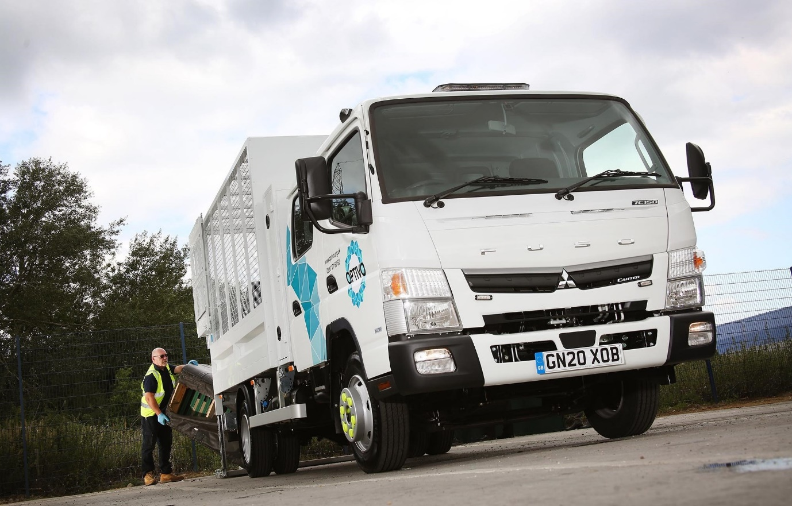

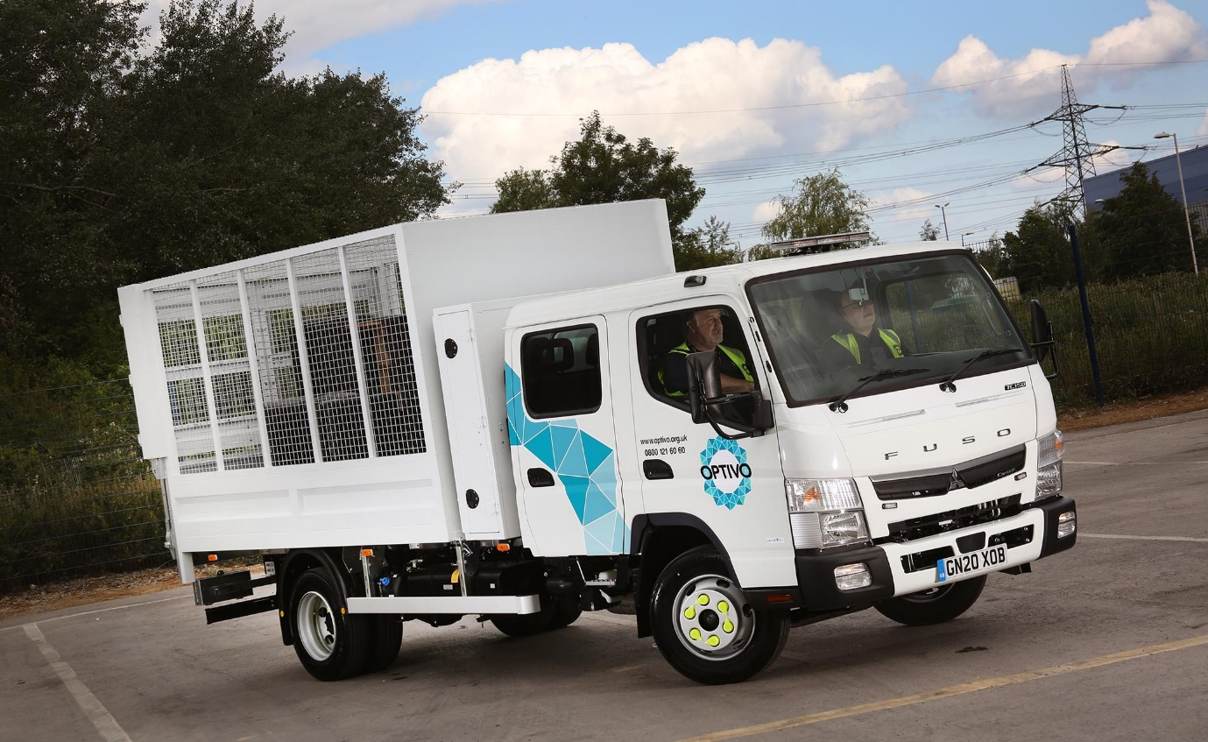

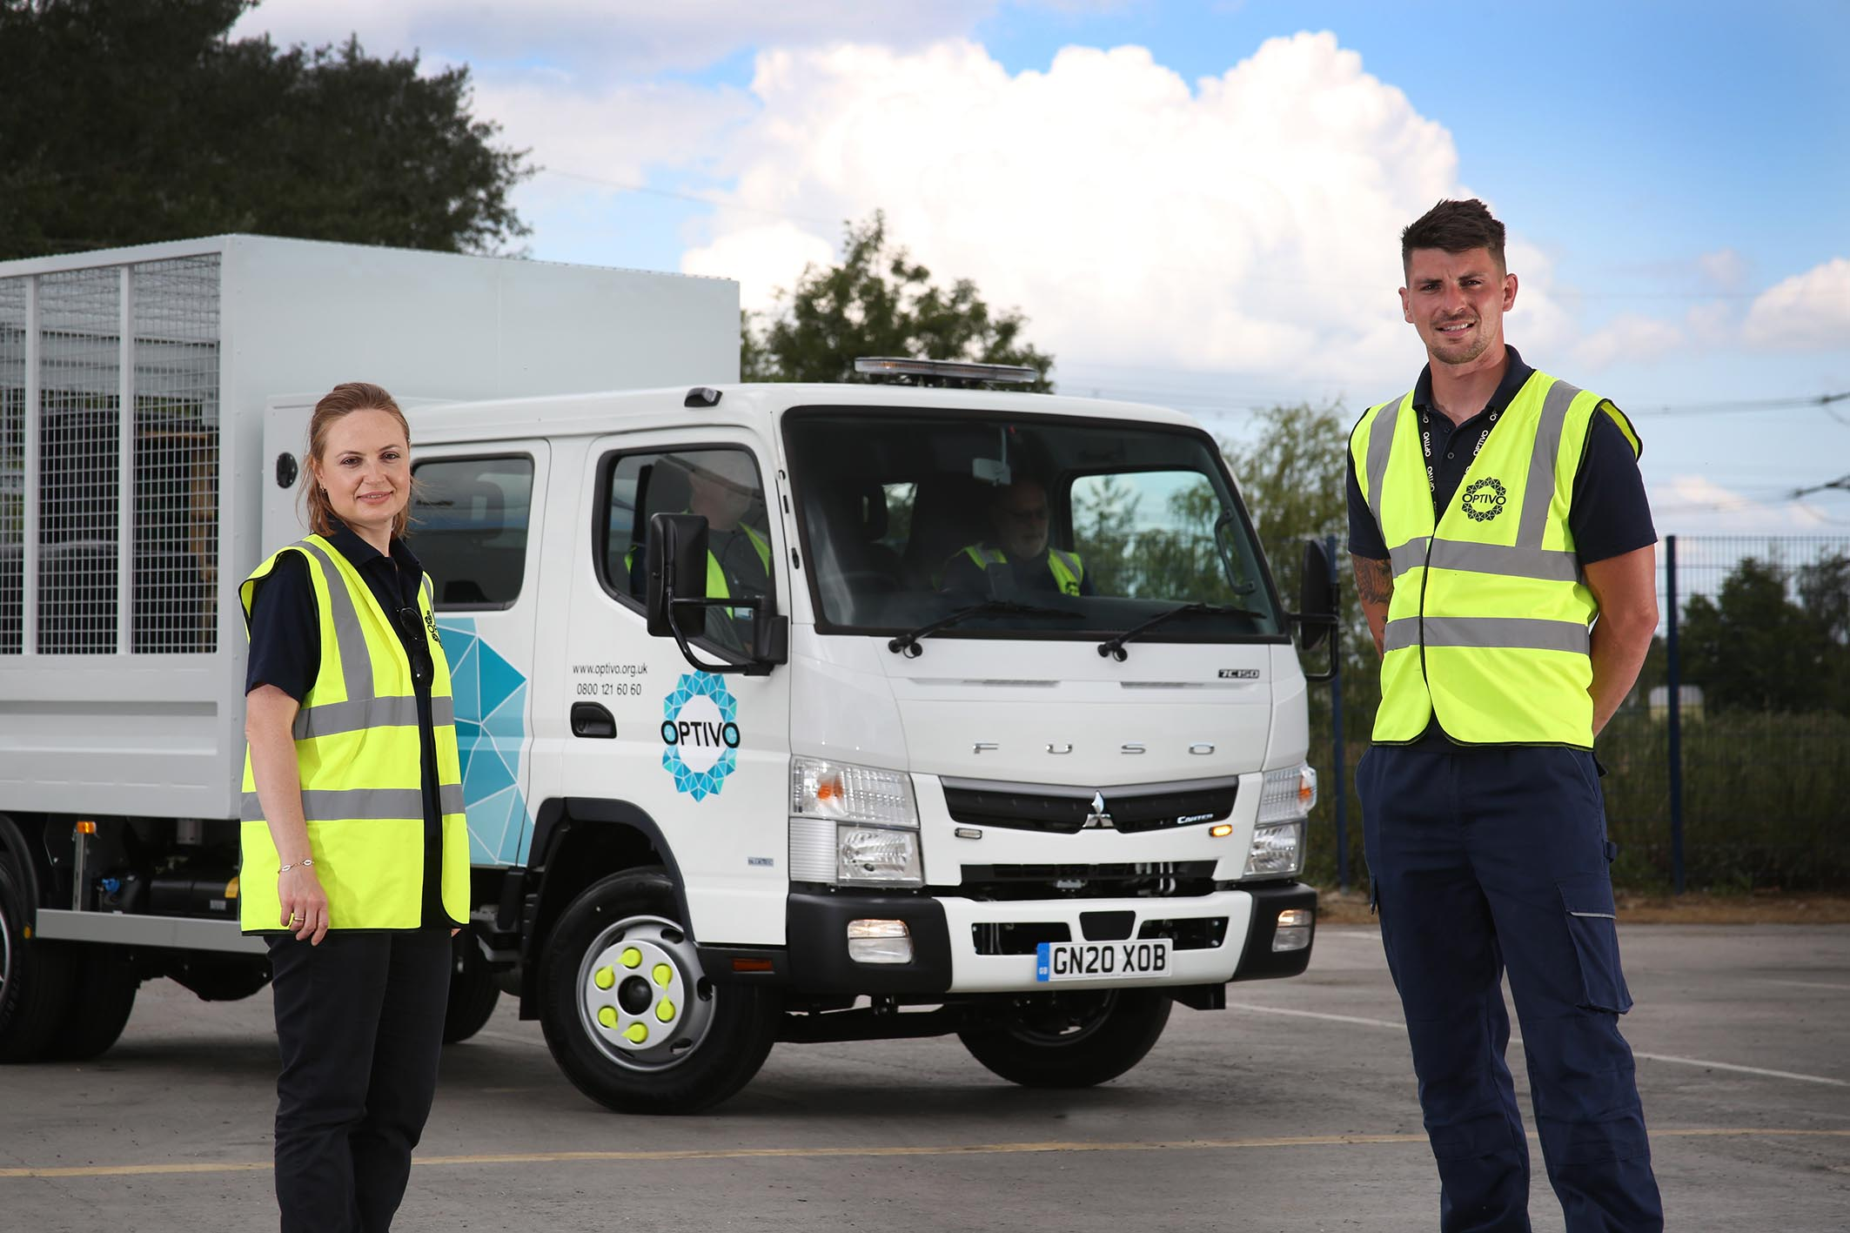

Canter can: Optivo’s Waste Services & Fleet Officer, Property Services Alex Magamedov, and Kent Estate Services Manager Niall Connett

For more information, or to request bigger/higher-res image files, please contact:
Steve Warren or John Ripley
Impact Communications, 01926 842126
Steve: 07770 470251, steve@impactcom.co.uk
John: 07771 484595, john@impactcom.co.uk

