

Date: 15 February 2023

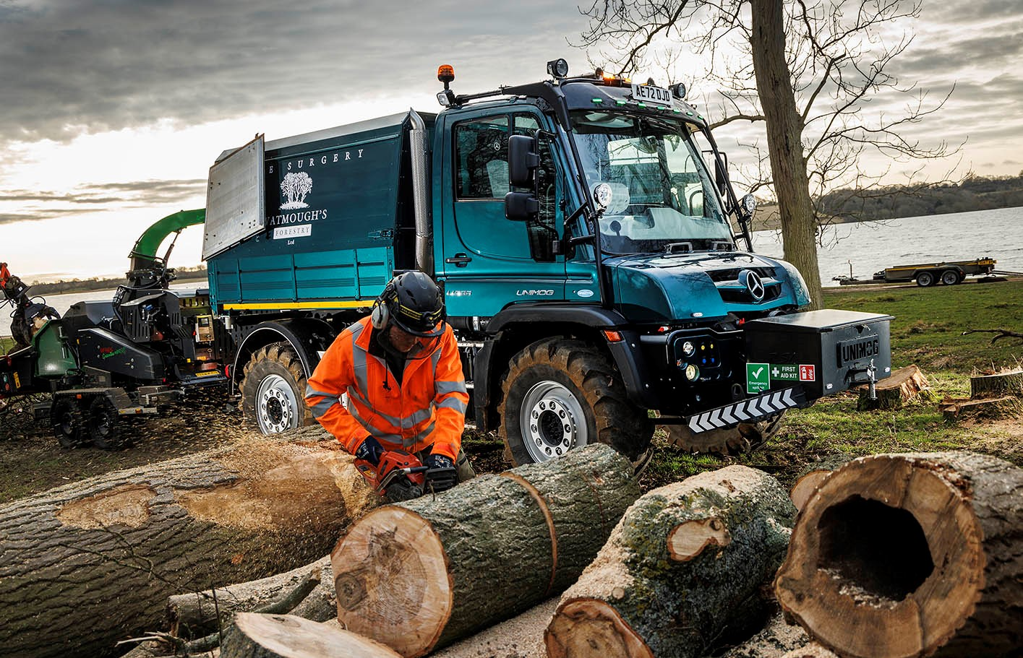

Watmough’s Forestry celebrates its 21st birthday with a second Mercedes-Benz Unimog

Adam Watmough called in at Mercedes-Benz Unimog Dealer Arthur Ibbett to collect a spare tyre for his 1996 off-roader – and came away intent on buying a new vehicle!

“It was the most expensive tyre I’d ever bought,” laughed the Melton Mowbray-based tree surgeon, who confirmed the order for his UGE implement carrier the following day.

Delivery of the new Unimog coincided with the 21st anniversary this month (February) of the company that bears his name. Watmough’s Forestry provides a comprehensive range of arboreal and hedge-cutting services to commercial and domestic customers located throughout Leicestershire and beyond.

A U535 variant, the vehicle employs a Euro VI Step E 7.7-litre in-line six-cylinder engine that produces 260 kW (354 hp) and maximum torque of 1,380 Nm. It is paired with the Opti-drive automated manual transmission purpose-designed by Daimler Truck engineers to manage the increased outputs from the most powerful Unimog engine, which was introduced in 2021.

An optional alternative to the standard-fit manual gearbox, the Opti-drive system offers improved gear change co-ordination and clutch control to produce the quicker shifts that translate into a smoother ride and improved fuel-efficiency.

Another new feature specified by Adam Watmough is Comfort steering, which makes it easier for drivers to turn the wheel at low, manoeuvring speeds, or when stationary, and is particularly helpful when the vehicle is fitted with large-volume tyres or heavy front implements. The electrohydraulic steering delivers a ‘feel’ that adapts to the driving situation.

Neither a truck, nor a tractor, the legendary Mercedes-Benz enjoys an unrivalled reputation as the ultimate off-roader, while also achieving impressive on-road speeds of up to 56 mph (where applicable). All Unimogs have 4x4 chassis with single rear wheels, while gross weights vary from 7.5 to 16.5 tonnes – Watmough’s Forestry’s new vehicle is rated at 12.7 tonnes GVW.

Mr Watmough already had experience of the Unimog’s strength and reliability, having purchased his first, pre-owned example, a U2150, nine years ago. “I’ve always sourced my parts from Arthur Ibbett as they’re not too far from me, and provide a fantastic service,” he said.

Recalling the day on which he resolved to buy his latest Unimog, Mr Watmough continued: “I’d been considering another secondhand example, and just put my head round the door of the sales office to say ‘Hello’ and see if anything was available.

“By the time I’d been through everything with Sales Executive Nick Suddes, though, I realised there wasn’t much of a financial incentive to buying used, and that I might as well order one straight from the factory.”

Key to the appeal of doing so for the image-conscious business owner was the fact that a new vehicle could be supplied in Mercedes-Benz Tourmaline Green, a near identical shade to his established corporate colour.

“I’ve saved a lot of money by not having to get a secondhand vehicle resprayed,” said Mr Watmough. “I could also tailor the specification precisely to my work and am benefiting from the peace of mind that comes with the manufacturer’s three-year warranty.

“Plus, I have to confess to a bit of an addiction with shiny new toys. The contrast between our two Unimogs in terms of comfort and the overall driving experience could not be more stark and illustrates how far the technology has moved on over the last quarter of a century. The older vehicle is pretty basic, whereas the new one has air-conditioning, heated seats, electric windows and electrically-adjusted door mirrors. It’s an absolute joy by comparison.”

The U535 is equipped with a front PTO (power take-off) and a hydraulics package, and arrived with a factory-built, three-way tipping body, onto which EH Hutton Coachbuilders, also of Melton Mowbray, mounted a ‘chip box’ body with side-hinged rear doors.

The Unimog also has a lockable, front-mounted toolbox, while Arthur Ibbett fitted the agricultural hydraulic pickup hitch that allows it to tow a wood chipper or a second chip box trailer.

“I was able to justify the investment in a second Unimog because demand from commercial, utility and domestic customers has been so strong and we’re looking forward to another very busy year,” explained Mr Watmough. “Having the two vehicles means we save on the cost of hiring in additional equipment and effectively gives us our own, rolling workforce.

“We spend a lot of time off road, of course, where the Unimog is in its element. But it’s also a lot more economical than a conventional tractor when we’re on the road. Our agricultural licence means that provided I’m satisfied they’re competent to do so, any of the guys can drive it as long as we stay off the motorway.”

Mr Watmough’s 20-year-old son Harry works alongside him in the family business and has just started driving the older Unimog. The new vehicle is also a hit with 13-year-old Toby and Angus, aged 11, especially when their Dad uses it for the ‘school run’.

“The Unimog creates a lot of interest when I pull up, beacons flashing and towering above the other parents’ cars,” added Mr Watmough. “I’ll give them a quick toot on the airhorn and the kids’ faces light up.”

watmoughsforestry.co.uk

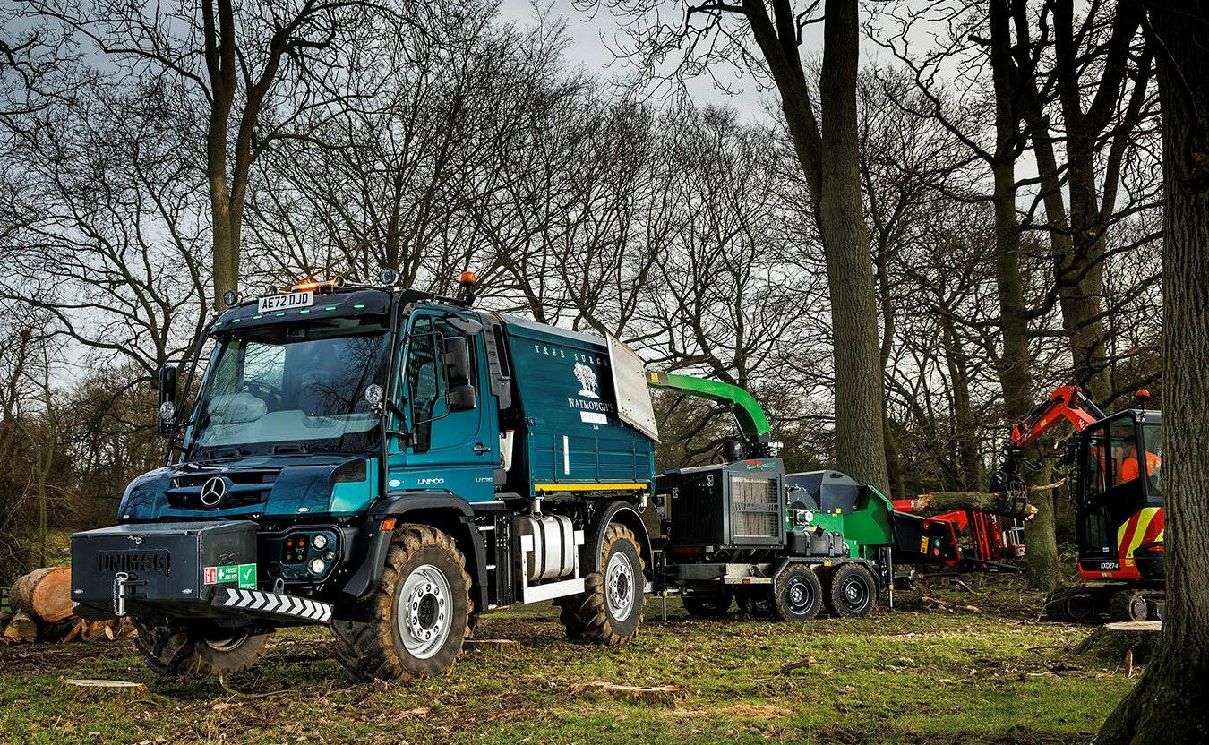
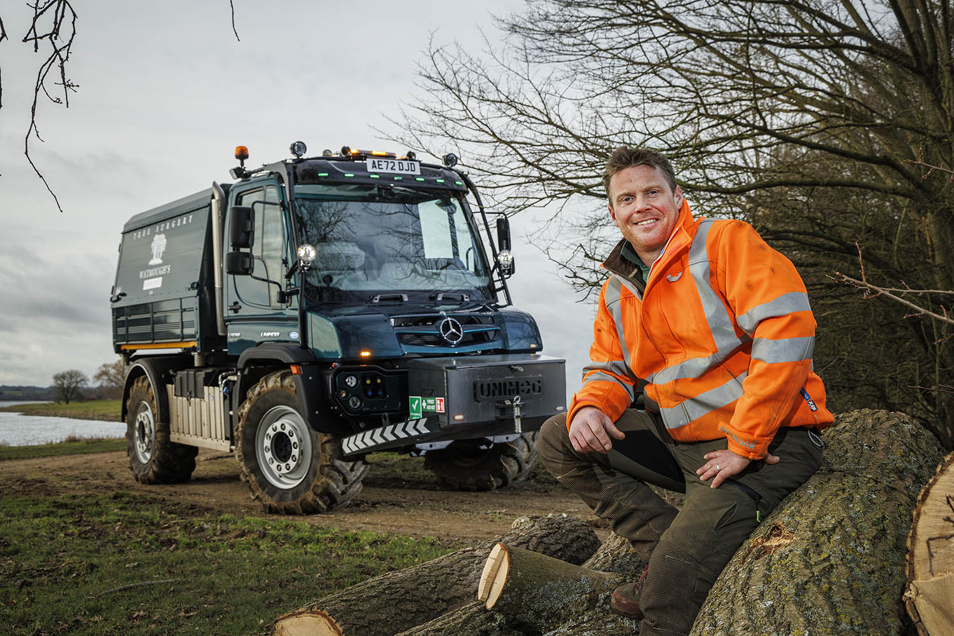

A cut above: Tree surgeon Adam Watmough with his smartly finished new Unimog

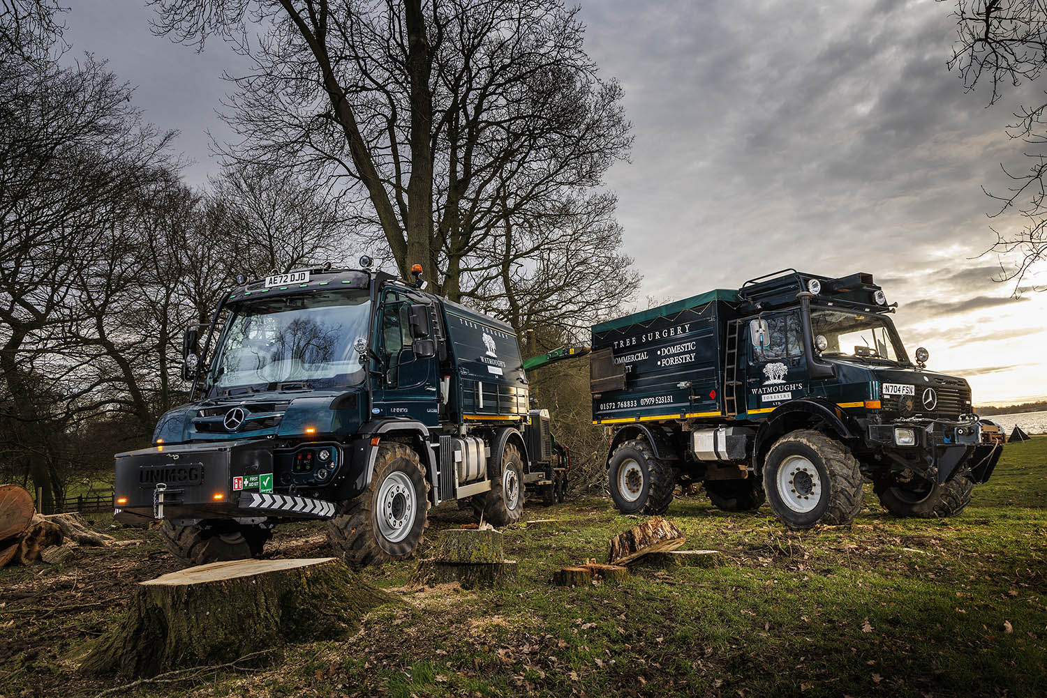

Line of descent: Watmough’s Forestry’s new Unimog, left, and its 26-year-old stablemate

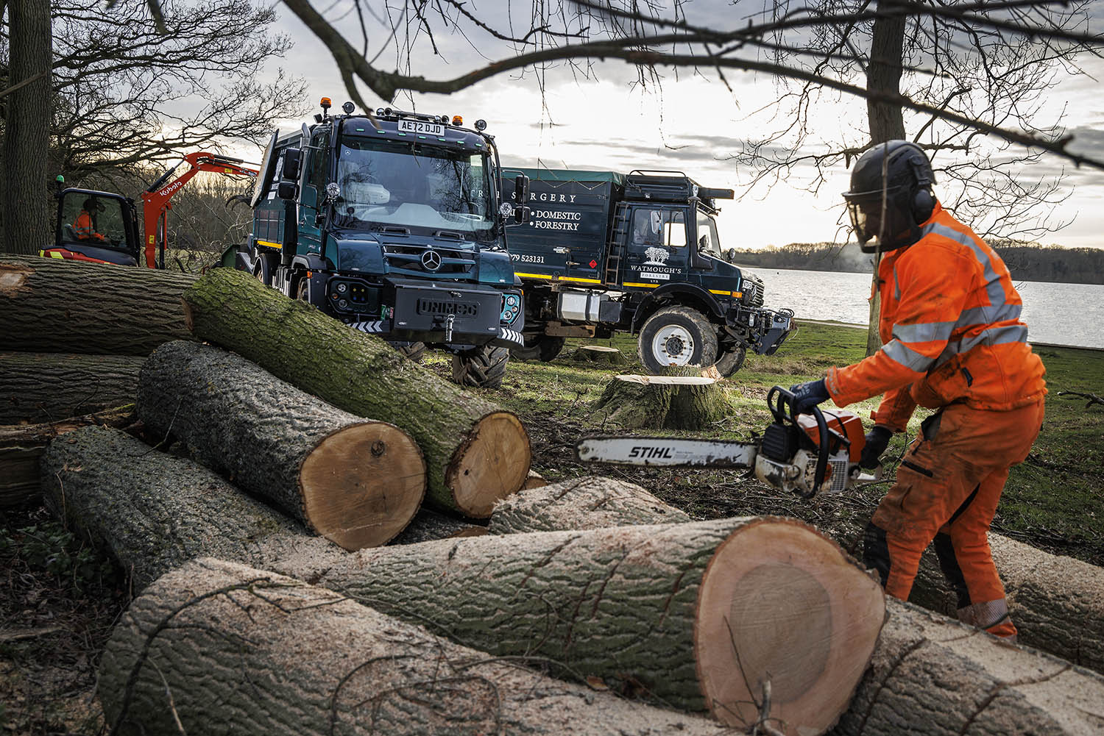

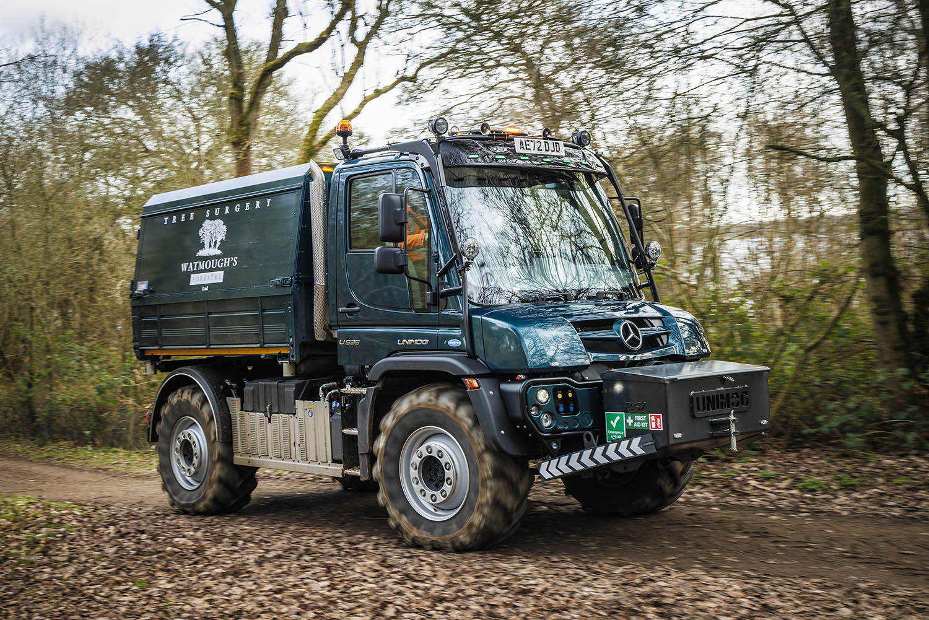

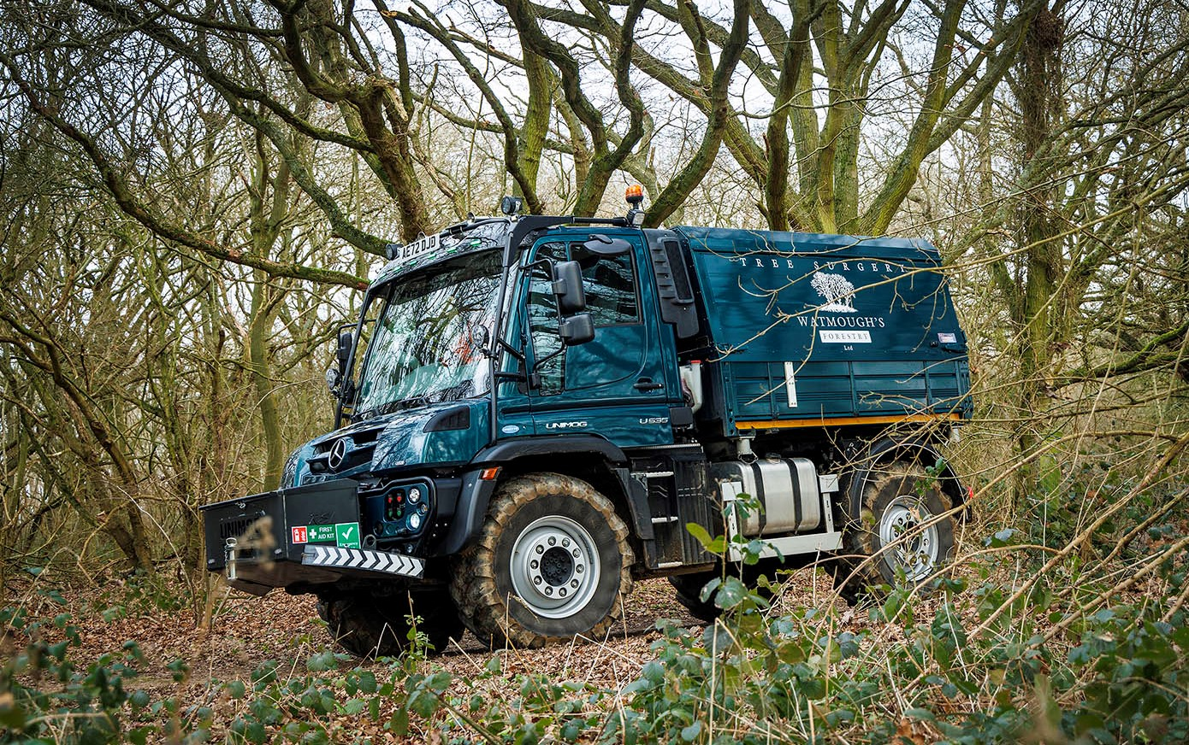

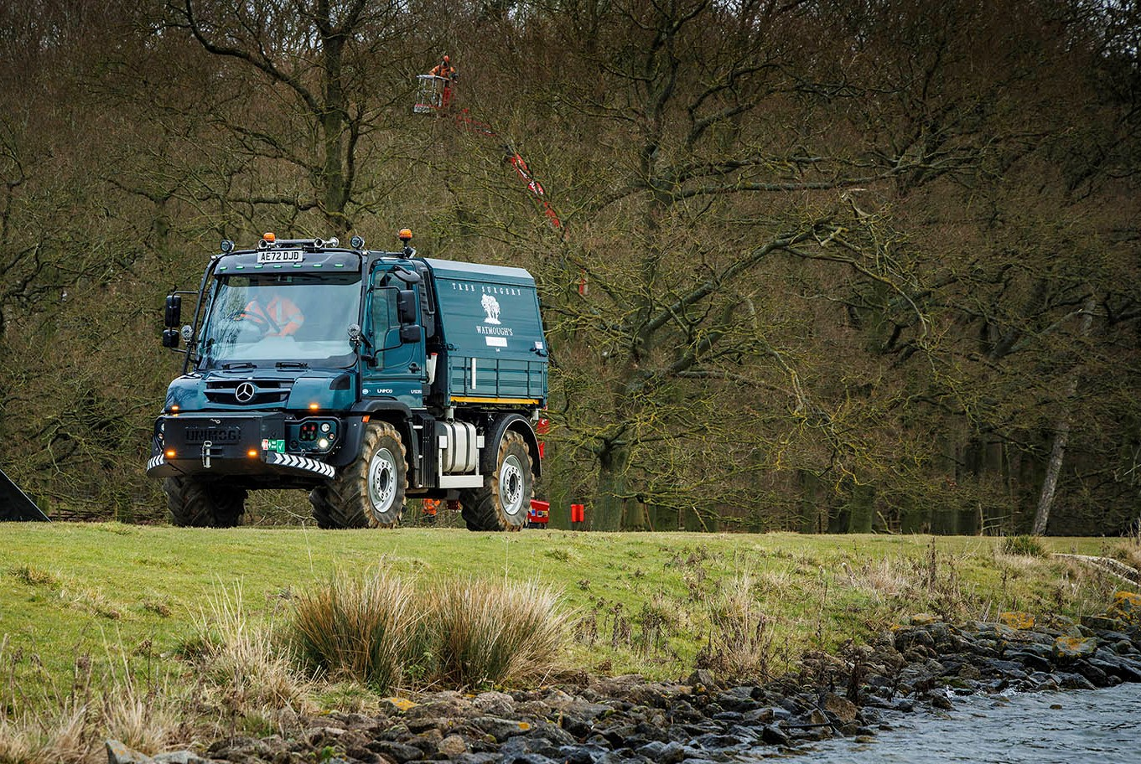

Ibbetts’ Nick Suddes can be contacted on 07739 091366 or nick.suddes@ibbetts.co.uk

ibbetts.co.uk

 facebook.com/ibbetts.unimog

 instagram.com/ibbetts_unimog

 linkedin.com/in/Arthur-ibbett-8186b019b

 www.twitter.com/ibbettsu

ends

For more information, or to request higher-res image files, please contact:

Jamie Fretwell at Mercedes-Benz Trucks UK Ltd
07712 519230, jamie.fretwell@daimler.com

or

Steve Warren or John Ripley
Impact Communications
Steve: 07770 470251, steve@impactcom.co.uk
John: 07771 484595, john@impactcom.co.uk

