

Date: 13 December 2024

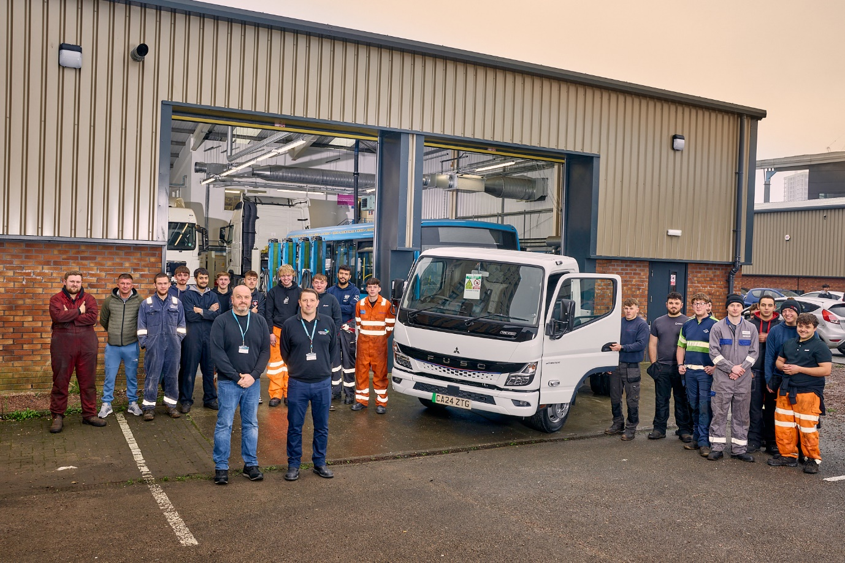

Bright future: Students at Cardiff and Vale College, with Lecturers Ben Young and Lee Whittaker (front left and right) and their FUSO eCanter electric truck

Tomorrow’s techs get their hands on Next Generation FUSO eCanter

Truck technicians of the future are getting real hands-on experience of working with electric vehicles, thanks to Cardiff and Vale College’s decision to buy its own 100% electric battery-powered FUSO eCanter.

Supplied by local Dealer Euro Commercials, the eCanter 4C15e has a gross weight of 4.18 tonnes and is fitted with a simple platform body – this reflects the fact that it is not intended for use in a transport application, but to help students prepare for life in workshops where electric vehicles are likely to be increasingly common.

The eCanter is used by the college’s level 2 and 3 heavy vehicle apprenticeship students – most are school leavers who have joined employers on schemes which see them spend four days per week in their workplace, and one on day-release in the classroom, over a period of two or three years.

Courses are taught by Heavy Vehicle Lecturers Lee Whittaker and Ben Young. “It’s no secret that there is a shortage of trained heavy vehicle technicians in the industry so these young people, and the skills they learn, are going to be vital to keep tomorrow’s trucks, buses and coaches running,” said Mr Young.

“We have over 100 students who are on apprenticeships with everyone from haulage operators to local authorities, bus and coach companies, main dealers and even emergency services. In all cases, as well as learning how to work on traditional combustion engines, knowledge of how to maintain electric vehicles safely and effectively is going to be crucial in their future careers.

“Having a vehicle of our own for them to work with on a daily a basis is invaluable to the teaching process. The FUSO eCanter is a model that’s in use in many real-world applications. It’s competitively priced and, importantly, its compact footprint means it doesn’t take up too much workshop space, so it’s ideal for this purpose.”

The College’s eCanter is a 4C15e model with three-seater Comfort cab and 129 kW motor. The S battery pack fitted provides a range of up to 70 km – larger M and L batteries are available, giving ranges of up to 140 and 200 km respectively.

Designed to offer versatility across a variety of applications, the FUSO eCanter is available with a range of flexible funding options through Daimler Truck Financial Services. Customers can choose between six wheelbase lengths and gross weights of 4.25, 7.49 or 8.55 tonnes, which means load capacity can be up to 5.0 tonnes.

The eCanter’s powerful electric motor generates 430 Nm of torque and maximum speed is electronically limited to 89 km/h. The batteries use lithium iron phosphate (LFP) cell technology, which ensures long service life and more usable energy.

The vehicle’s charging unit supports both alternating current (AC) and direct current (DC), at up to 104 kW. DC fast charging from 20 to 80% of capacity is possible in approximately 24 minutes with the S battery pack, or 26 and 39 minutes for M and L versions, respectively. AC charging (11 and 22 kW) takes approximately four to six hours, depending on the battery pack.

A standout feature of the eCanter is its impressively tight minimum turning circle of just 10.8 metres (wall-to-wall), ensuring unparalleled agility even in confined spaces. This precision handling enhances productivity and safety, making it the ideal choice for drivers who demand both performance and practicality.

Lee Whittaker added: “Having an electric truck that they can get their hands on is a huge benefit to our students, and to the qualified technicians who come in for course modules to boost the skills they already have.

“Euro Commercials came up with a vehicle that gives us everything we need, with nothing that we don’t, and Sales Consultant Nathan Notley handled the ordering and acquisition process very smoothly. We’re delighted with our FUSO eCanter.”

cavc.ac.uk

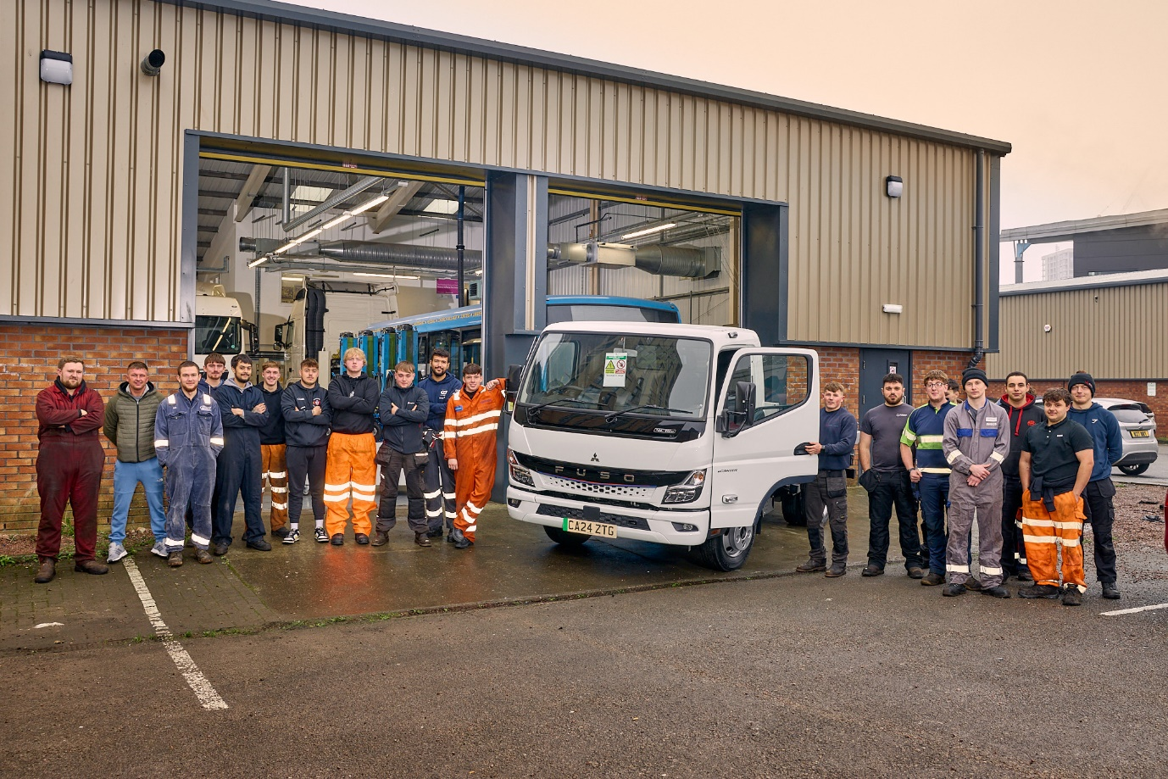

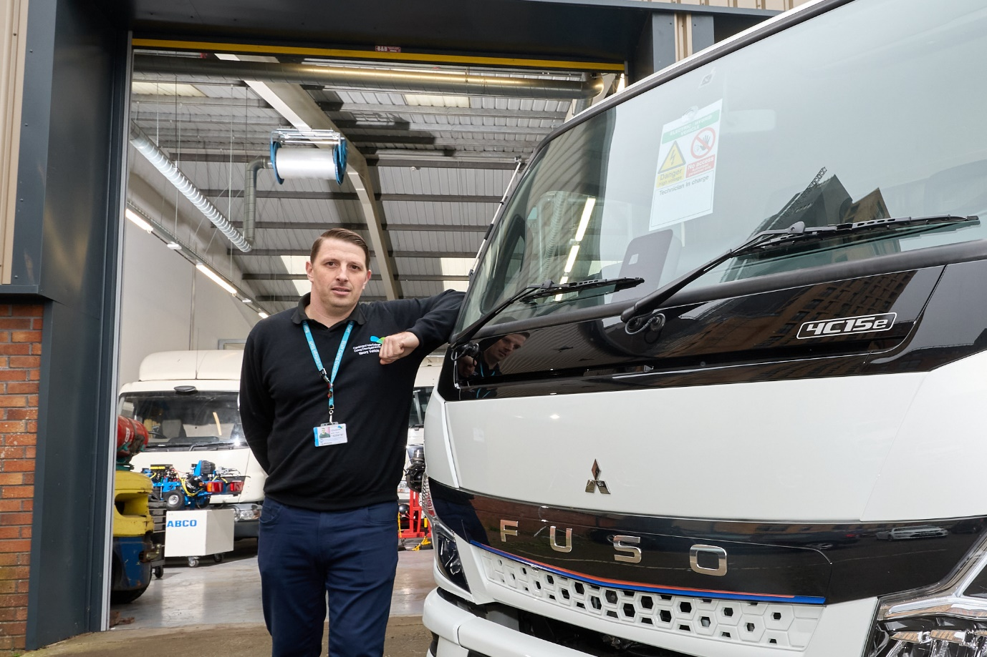

Heavy Vehicle Lecturer Lee Whittaker with the FUSO eCanter electric truck

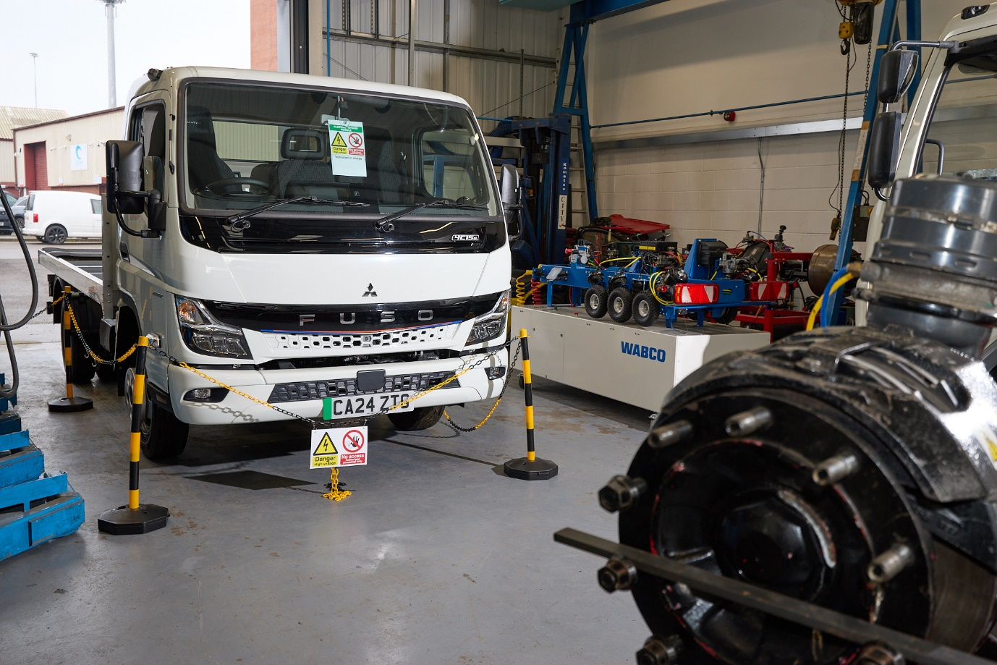

ends

For more information, or to request bigger/higher-res image files, please contact:
John Ripley: 07771 484595, john.ripley@loopagency.co.uk



