

Date: 11 May 2022

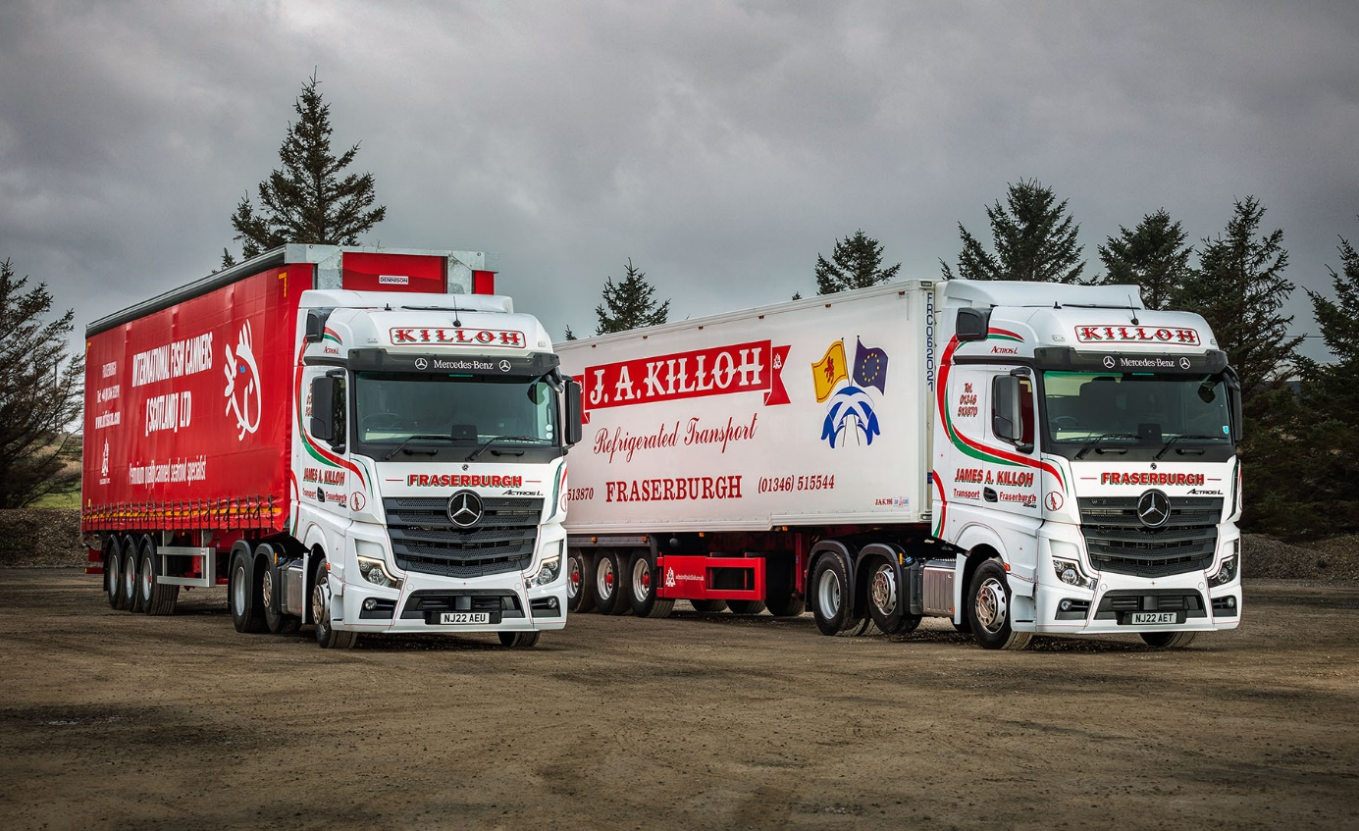

Seafood specialist shells out for a couple of new Actros L tractors from Mercedes-Benz Dealer BLS Truck & Van

Scotland’s first premium-specification Mercedes-Benz Actros Ls have taken to the road in the colours of Fraserburgh-based operator JA Killoh.

The two 2546 tractor units are also the first new vehicles supplied by Aberdeen Dealer BLS Truck & Van to a customer that has previously favoured pre-owned examples.

Actros L sets new standards in the segments for long-distance haulage and heavy-duty distribution. In addition to a full complement of well-proven Mercedes-Benz technology, it comes with a host of new features that deliver further improvements in efficiency, safety and comfort.

Highlights include sophisticated aerodynamics, quieter cabs with improved heat insulation, and a lower, more comfortable seating position that also provides improved visibility.

The Actros L badge now applies to all four- and six-wheeled tractor units with single or double drive axles, and 18- and 26-tonne rigid chassis, that have flat-floored GigaSpace, BigSpace – as chosen by JA Killoh – or Stream Space cabs in the wider (2.5m) of the two widths available.

As 2546 variants the operator’s latest trucks employ 10.7-litre in-line six-cylinder engines that produce 340 kW (460 hp).

Explaining the decision to purchase new vehicles on this occasion, rather than top-quality pre-owned examples, proprietor James Killoh said: “The used truck market is very strong at the moment and this is reflected in some of the prices.

“BLS Truck & Van’s Chris Dyer is a good salesman; he’s very professional and nothing is too much trouble for him. Chris told me about the Actros L and I liked the sound of it, so decided to order a couple, which we’ve also ‘specced’ with fridges and microwaves.

“These are still early days but first impressions are certainly positive. The drivers tell me they’re really quiet and comfortable, while in terms of fuel consumption the new trucks are already performing at the top end of our 9-9.5mpg fleet average. Obviously, I’m very happy with that.”

Mr Killoh established his business in 1974 and initially ran tippers to support the development of North Sea gas terminals. As time moved on, though, he moved into temperature-controlled and curtainside work.

Today, JA Killoh runs 20 tractor units from its head office and yard at Cairnsleed, on the outskirts of one of Europe’s largest fishing ports. All but two of these trucks wear three-pointed stars – a near-total transformation from the situation four years ago, when another manufacturer could lay claim to the entire fleet.

The operator maintains its vehicles in-house but relies on the team at BLS Truck & Van for parts supplies and technical assistance. The Dealer has been serving Mercedes-Benz and FUSO truck customers in the north of Scotland since its appointment by the manufacturer in 2018.

“We ran a lot of Mercedes-Benz trucks in the past, and they were always exceptionally reliable,” recalled Mr Killoh. “Aftersales support was the issue, though. We moved away from the brand because the service in this part of the world wasn’t always up to standard.

“Things are definitely back in shape now. Since BLS Truck & Van took over there’s been a marked improvement in performance. Any spares we need are always readily available and if ever we have an issue we just give them a ring; they’re very helpful and will do whatever it takes to resolve the problem for us.”

JA Killoh is heavily engaged in the delivery of seafood products – processed, rather than fresh – to supermarket RDCs nationwide. Most of this work is undertaken in temperature-controlled trailers built in Fraserburgh by Gray in Adams. While the ‘reefers’ are finished in JA Killoh’s own livery, some of its Dennison curtainside trailers bear the name of leading customer International Fish Canners (Scotland).

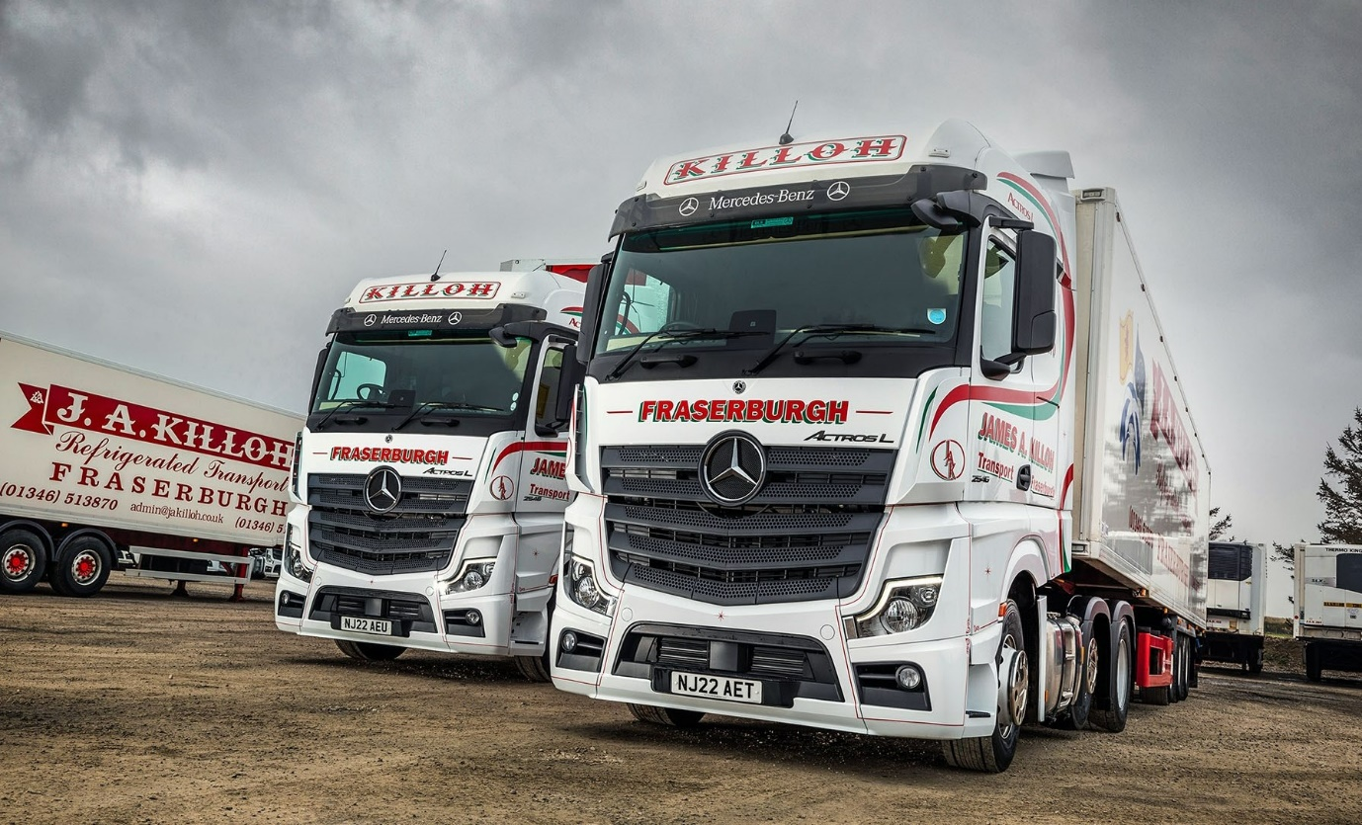

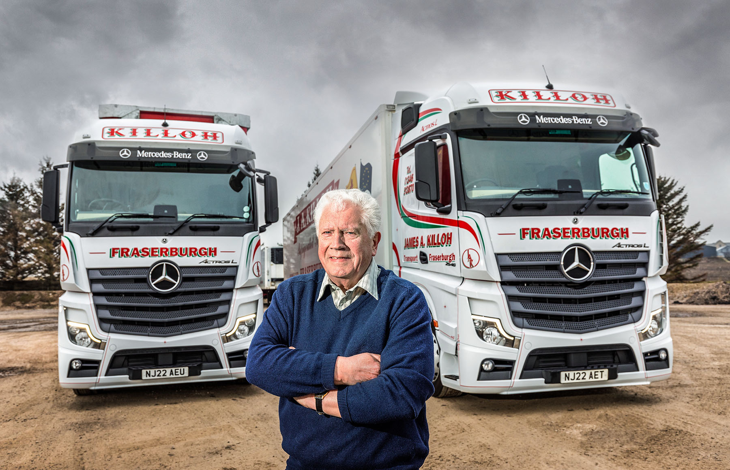

Double tops: Jim Killoh’s drivers tell him their Actros Ls are “really quiet and comfortable”

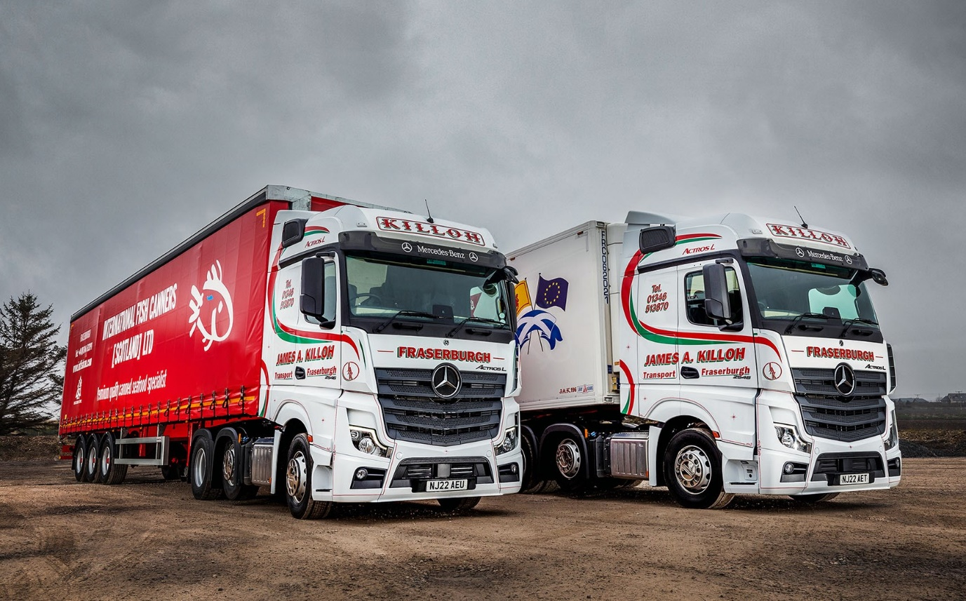

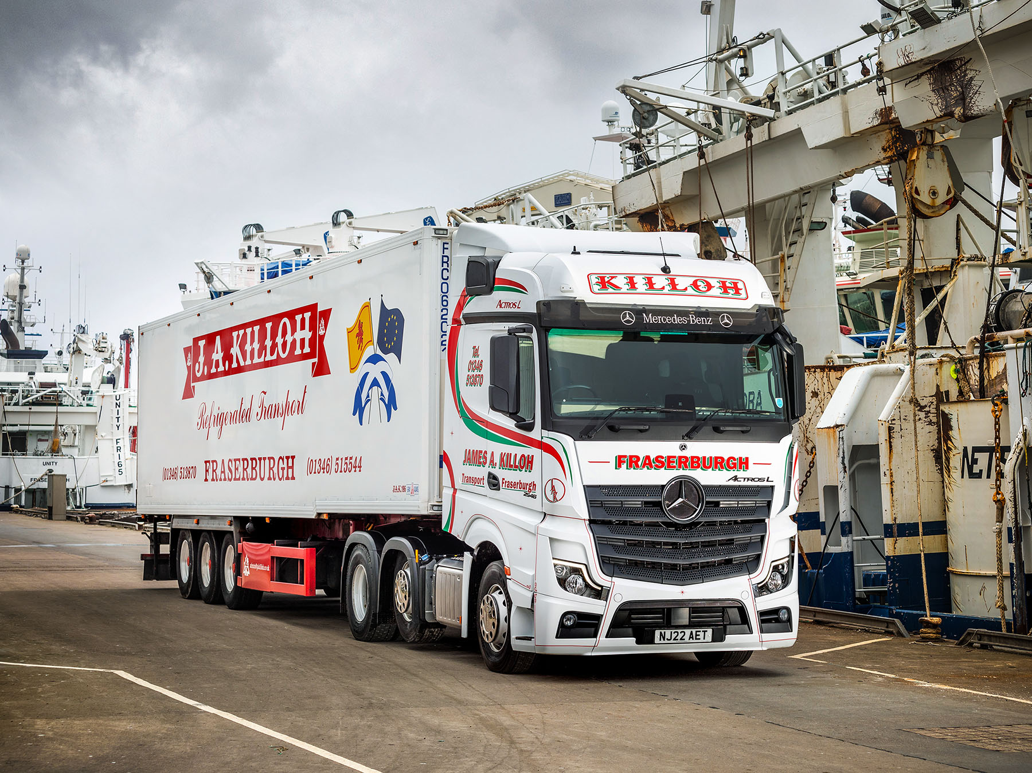
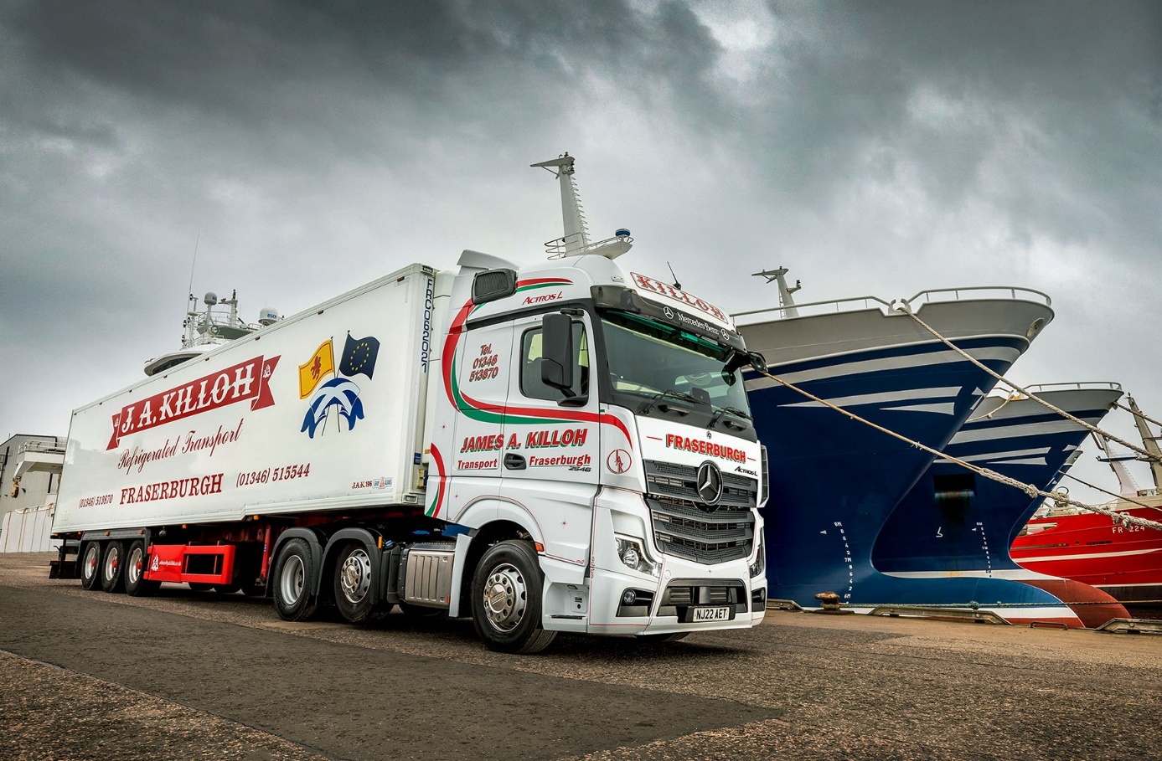

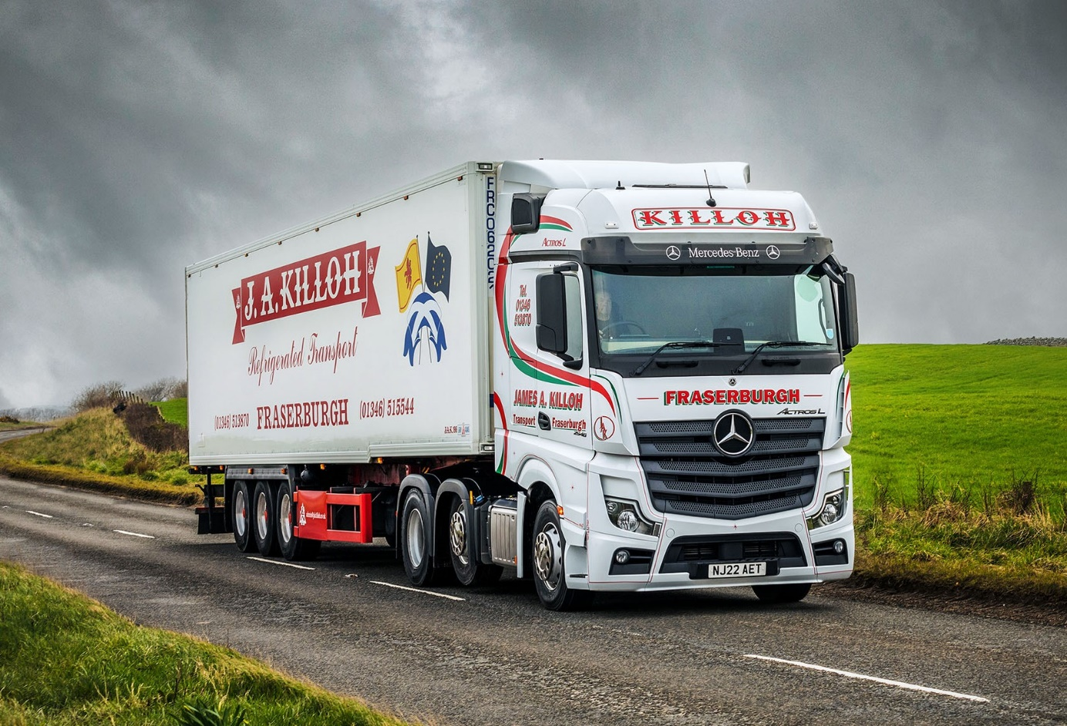

ends

For more information, or to request bigger versions of image files, please contact:
Steve Warren or John Ripley
Impact Communications
Steve: 07770 470251, steve@impactcom.co.uk
John: 07771 484595, john@impactcom.co.uk



