

03.08.2022

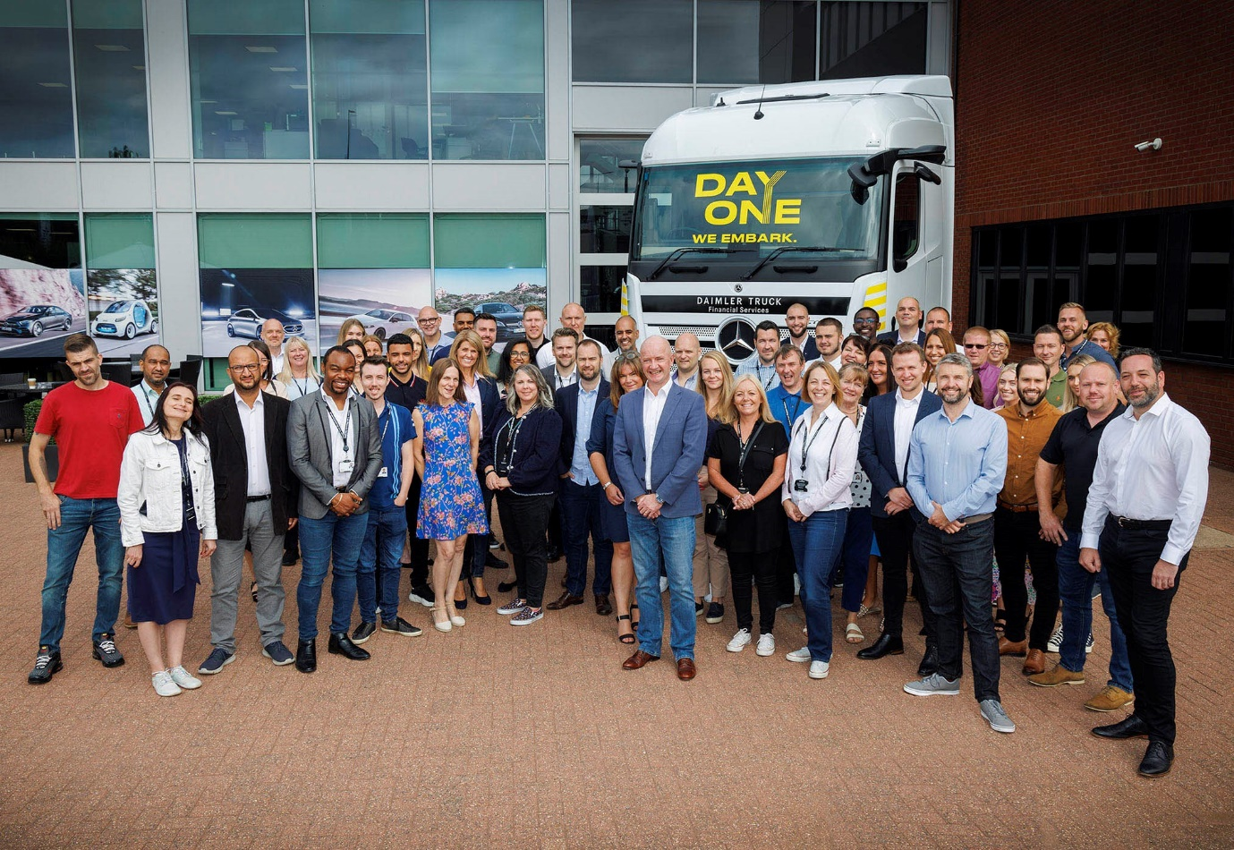

Starting out: Managing Director Nick Andrews is pictured, centre, with members of the Daimler Truck Financial Services UK team

New-start Daimler Truck Financial Services UK pledges to lead on zero-emission vehicle funding solutions

UK customers for Mercedes-Benz and FUSO trucks, and Mercedes-Benz buses and coaches, can now call on the support of a fully dedicated financial solutions partner, following the launch today (3 August) of Daimler Truck Financial Services UK.

By developing intelligent and sustainable solutions, the new business is set to play a key role in driving the take-up of alternatively-fuelled vehicles.

Dedication ensures that Daimler Truck Financial Services’ extensive range of purchase and leasing products, as well as the insurance packages it will be introducing next year in the UK, can all be perfectly tailored to meet the needs of commercial and passenger-carrying vehicle operators.

Daimler Truck Financial Services is a fully integrated part of the world’s biggest truck and bus manufacturer, Daimler Truck AG. Prior to the UK launch, Daimler Truck Financial Services was already doing business in 11 markets on six continents. Further expansion is planned this year in Turkey and Spain, and thereafter in Germany and France. With a global contract volume of 18 billion Euro, it is the road transport industry’s largest captive financial services company.

Stephan Unger, Member of the Board of Management of Daimler Truck AG for Financial Services, and CEO of Daimler Truck Financial Services, said: “We are very happy to welcome our new colleagues in the UK, which is an important market for us and plays a key role in our global strategy. All over the world we see growth opportunities for new finance products and service solutions to support the transfer to e-transportation or in connectivity services.”

Today’s launch follows the spin-off of Daimler Truck from its former parent company Daimler AG in December 2021, marking the dawn of a new era of entrepreneurial independence for the truck and bus business.

Operators of trucks, buses and coaches bearing the three-pointed star, and light trucks with the FUSO three diamonds badge, were previously served in the UK by Mercedes-Benz Financial Services, which continues to fund passenger cars and vans. Their agreements have now been transferred seamlessly to Daimler Truck Financial Services on exactly the same terms as before.

The DTFS team in the UK is led by Managing Director Nick Andrews and shares its headquarters in Milton Keynes with Mercedes-Benz Trucks UK. Customers for new and used vehicles are being welcomed aboard by their own, personal Finance Specialists.

“This is a tremendously exciting time to be launching our new business, not least because of the alternative fuels revolution now underway,” declared Nick Andrews. “UK operators can already choose battery-electric rigid trucks such as the FUSO eCanter and Mercedes-Benz eActros.

“Other vehicles that produce zero tailpipe emissions such as the low-entry eEconic and the eCitaro citybus are just around the corner, while customer testing of the eActros LongHaul tractor unit begins next year, and the first hydrogen fuel cell-powered Mercedes-Benz GenH2 Trucks will be on UK roads by the end of the decade.

“Transformative products like these require new and innovative approaches to the business of funding their acquisition and operation. We will support our customers on their journeys to a more sustainable, environmentally-friendly future, by offering leasing, financing and insurance products tailored to these new technologies.”

Nick said DTFS was fully-focused on serving B2B customers and had adopted a streamlined structure that would allow rapid responses to changing market needs.

DTFS UK has acquired existing truck and bus business from MBFS. “This is just the beginning, though, as our strategy is designed to deliver an integrated and sustainable solution for truck and bus operators across the UK,” he affirmed. “Like our colleagues at Mercedes-Benz Trucks UK and EvoBus UK, and those in their respective Dealer networks, we already have vast experience and expertise in the commercial vehicle sector.

“We’re committed to building lasting partnerships based on trust with customers, whether they be an owner-driver with a single vehicle or the CEO of a ‘blue chip’ fleet operator. And we’ll do that by providing flexible and customer-centric financing, leasing and insurance solutions and services with predictable costs over the entire lifecycle of a vehicle.”

He added: “Our customers know their businesses best. Our role is to tailor-make acquisition, insurance and other products that enable them to achieve their own financial and operational goals.”

Heiko Selzam, Managing Director, Mercedes-Benz Trucks UK, commented: “The launch of Daimler Truck Financial Services UK comes at precisely the right time, as we transition to zero-emission trucks and prove ourselves as an independent, modern, collaborative company with ambitious growth targets and a clear focus on customer satisfaction.

“I am excited that we are now fully integrated, offering our customers everything they need under one roof, while being united as one team, with one focus. We put truck operators first, by offering them not only the best trucks in the world, but also the best services and the best way to fund them.”

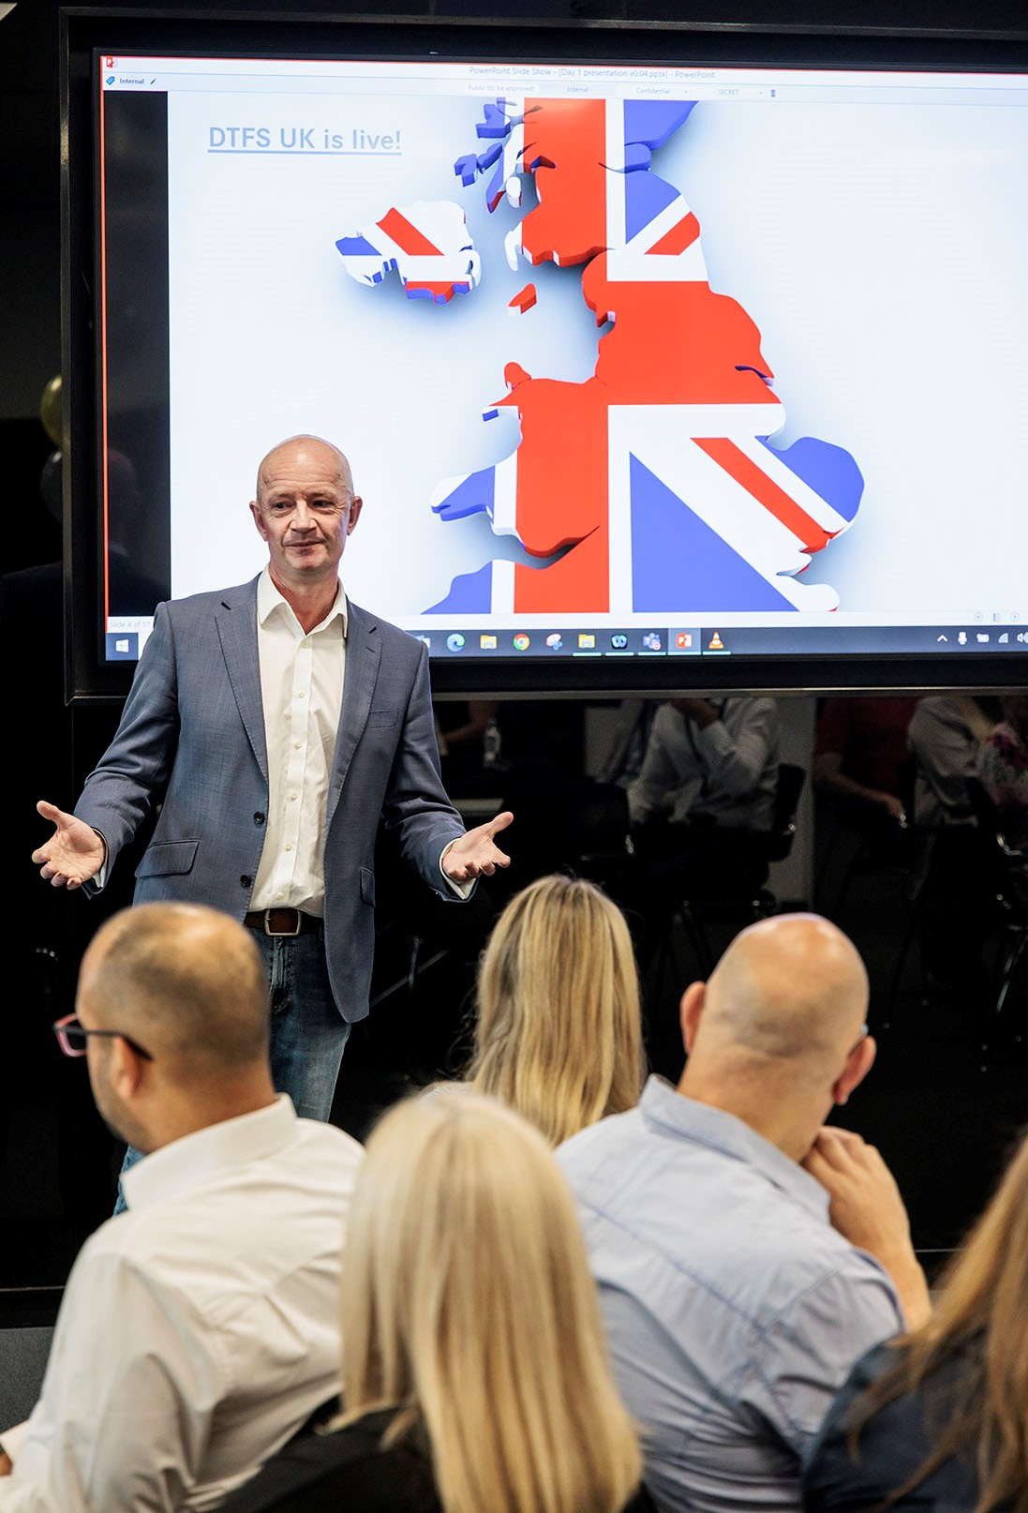

Committed to customers: Managing Director Nick Andrews outlined the new company’s plans to support operators in Britain and Northern Ireland, during a launch event for colleagues at the headquarters of Mercedes-Benz Truck UK in Milton Keynes
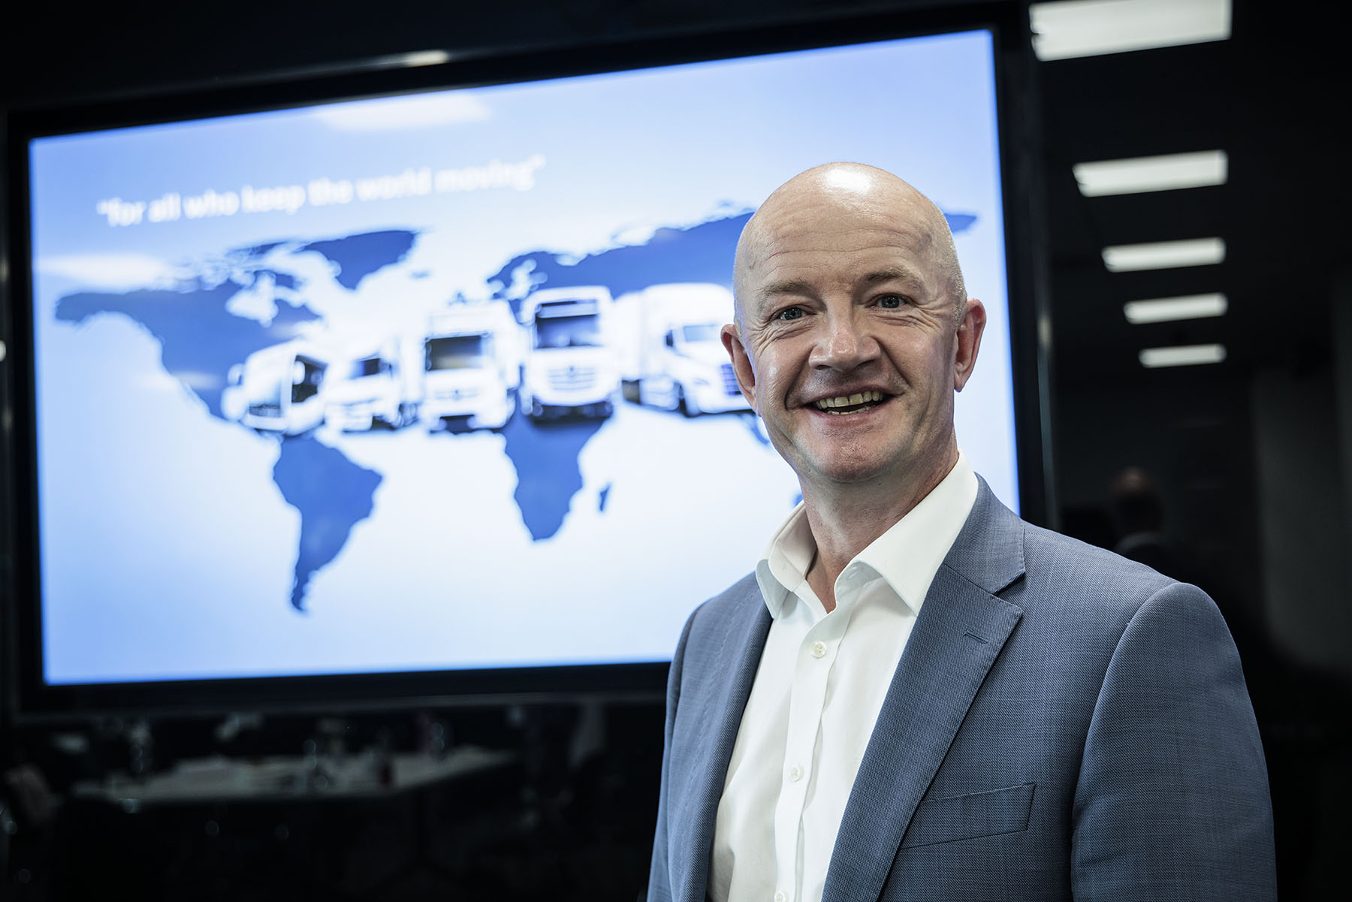

Leading the charge: Managing Director Nick Andrews said Daimler Truck Financial Services was perfectly placed to support UK operators as the transitioned to cleaner, ‘greener’ forms of fuel

ends

For more information on Daimler Truck Financial Services, or to request higher-res image files, please contact:

Gill Jockel, Marketing & Communications Manager, Daimler Truck Financial Services UK Ltd
07731 985771, gillian.jockel@daimlertruck.com

Oliver Wihofszki, Global Communications Daimler Truck Financial Services
+49 160 8613092, oliver.wihofszki@daimlertruck.com

or

Steve Warren or John Ripley
Impact Communications
Steve: 07770 470251, steve@impactcom.co.uk
John: 07771 484595, john@impactcom.co.uk

Forward-looking statements:
This document contains forward-looking statements that reflect our current views about future events. The words “aim”, “ambition”, “anticipate,” “assume,” “believe,” “estimate,” “expect,” “intend,” “may,” ”can,” “could,” “plan,” “project,” “should” and similar expressions are used to identify forward-looking statements. These statements are subject to many risks and uncertainties, including an adverse development of global economic conditions, in particular a decline of demand in our most important markets; a deterioration of our refinancing possibilities on the credit and financial markets; events of force majeure including natural disasters, pandemics, acts of terrorism, political unrest, armed conflicts, industrial accidents and their effects on our sales, purchasing, production or financial services activities; changes in currency exchange rates, customs and foreign trade provisions; a shift in consumer preferences; a possible lack of acceptance of our products or services which limits our ability to achieve prices and adequately utilise our production capacities; price increases for fuel or raw materials; disruption of production due to shortages of materials, labour strikes or supplier insolvencies; a decline in resale prices of used vehicles; the effective implementation of cost-reduction and efficiency-optimization measures; the business outlook for companies in which we hold a significant equity interest; the successful implementation of strategic cooperations and joint ventures; changes in laws, regulations and government policies, particularly those relating to vehicle emissions, fuel economy and safety; the resolution of pending government investigations or of investigations requested by governments and the conclusion of pending or threatened future legal proceedings; and other risks and uncertainties, some of which are described under the heading “Risk and Opportunity Report” in the current Annual Report. If any of these risks and uncertainties materializes, or if the assumptions underlying any of our forward-looking statements prove to be incorrect, the actual results may be materially different from those we express or imply by such statements. We do not intend or assume any obligation to update these forward-looking statements since they are based solely on the circumstances at the date of publication.

Daimler Truck at a glance
Daimler Truck Holding AG ("Daimler Truck") is one of the world's largest commercial vehicle manufacturers, with over 40 main locations and more than 100,000 employees around the globe. The founders of Daimler Truck have invented the modern transportation industry with their trucks and buses a good 125 years ago. Unchanged to this day, the company's aspirations are dedicated to one purpose: Daimler Truck works for all who keep the world moving. Its customers enable people to be mobile and get goods to their destinations reliably, on time, and safely. Daimler Truck provides the technologies, products, and services for them to do so. This also applies to the transformation to CO2-neutral driving. The company is striving to make sustainable transport a success, with profound technological knowledge and a clear view of its customers' needs. Daimler Truck's business activities are structured in five reporting segments: Trucks North America (TN) with the truck brands Freightliner and Western Star and the school bus brand Thomas Built Buses. Trucks Asia (TA) with the FUSO and BharatBenz commercial vehicle brands. Mercedes-Benz (MB) with the truck brand of the same name. Daimler Buses (DB) with the Mercedes-Benz and Setra bus brands. Daimler Truck's new Financial Services business (DTFS) constitutes the fifth segment, the product range in the truck segments includes light, medium and heavy trucks for long-distance, distribution and construction traffic and special-purpose vehicles used mainly in the municipal and vocational sector. The product range of the bus segment includes city buses, school buses and intercity buses, coaches and bus chassis. In addition to the sale of new and used commercial vehicles, the company also offers aftersales services and connectivity solutions.

Daimler Truck Financial Services at a glance
Daimler Truck Financial Services is one of the world’s largest captive financial services providers in the commercial vehicle sector. As part of the Daimler Truck Group, it supports the Group’s truck and bus brands with tailored financial services, which include leasing, financing, insurance and rental solutions. The clear objective of Daimler Truck Financial Services is to build and maintain the loyalty of the Group’s customer base as well as contributing to the Group’s financial success. Daimler Truck Financial Services will have around 1,900 employees by the beginning of 2023 and is expected to operate in 16 markets worldwide. Financial services play a vital role for the Daimler Truck Group’s customers, enabling them to use and maintain their vehicles on flexible and reasonable terms.

