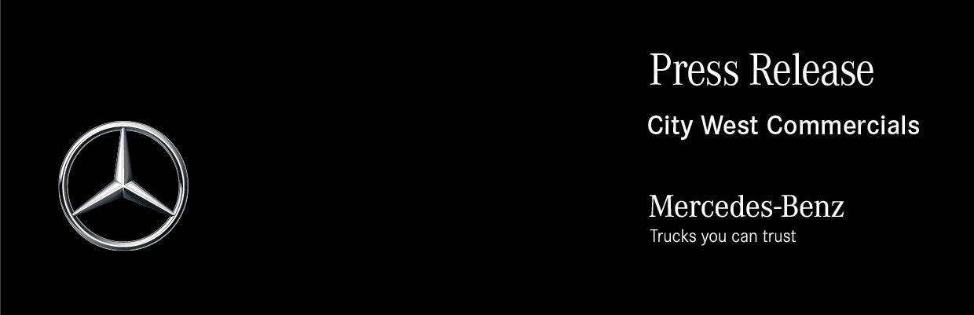

Date: 23 June 2020

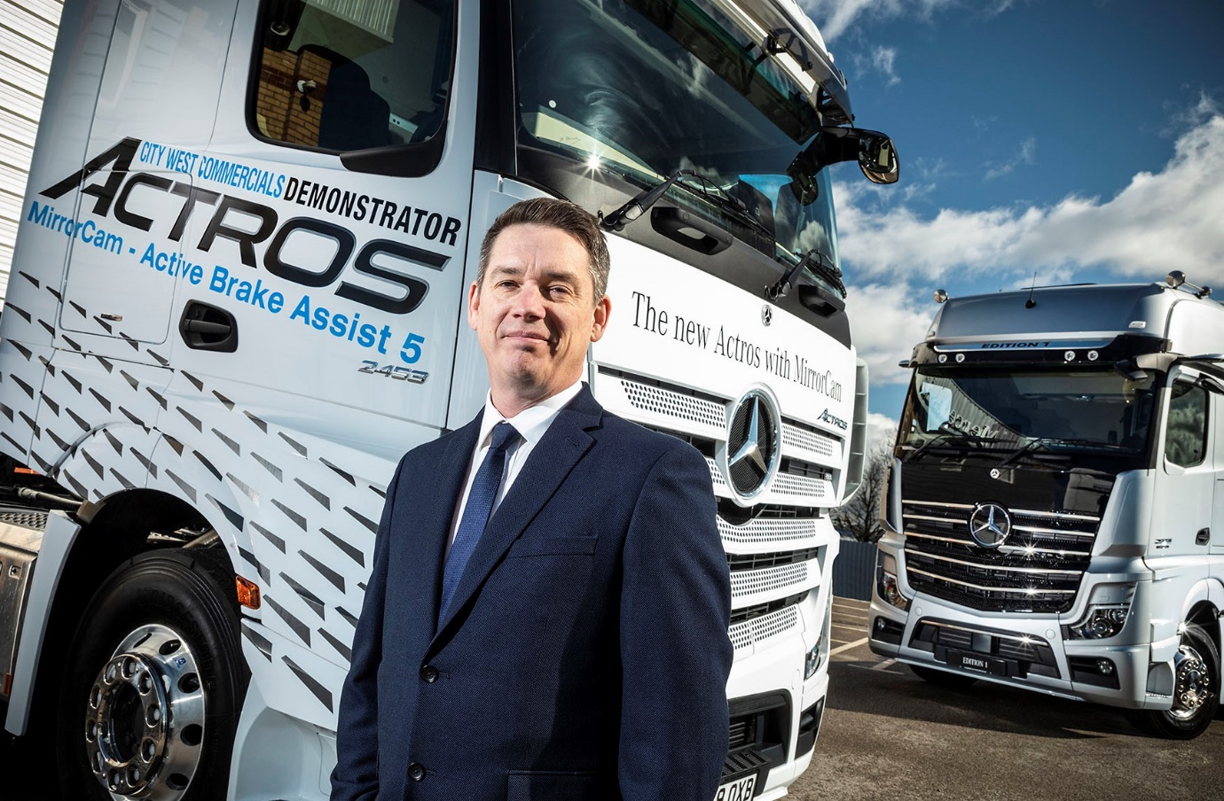

Sweet spot: City West Commercials’ new Dealer Principal is committed to the highest standards of customer service

Sweet takes the wheel at Mercedes-Benz Trucks Dealer City West Commercials

Operators in the south west will be hearing more from their local Mercedes-Benz Trucks Dealer – that’s the pledge from the man now steering City West Commercials into a new era.

Recently appointed Dealer Principal Darren Sweet joined City West Commercials three years ago as Group Aftersales Director, a move that represented a return to the three-pointed star. Darren’s 30-year career in the automotive industry includes stints with two former
Mercedes-Benz franchisees, between which he worked at senior levels for Northgate Vehicle Hire in the UK and Ireland.

Darren took up his new role shortly before the Covid-19 pandemic struck, so his first major challenge was to ensure that City West Commercials remained strategically robust. Crucially, all four of the Dealer’s depots have remained open to support the emergency services and front-line operators.

“It was certainly something of a ‘baptism of fire’,” acknowledged Darren. “The team have been fantastic in supporting our business, and this has allowed us to keep all departments, including Truck Sales, operational throughout the crisis.”

A dedicated truck sales specialist, City West Commercials serves customers for
Mercedes-Benz and FUSO vehicles from headquarters in Avonmouth, and three other branches. The company opened its purpose-built workshop in Exeter in 2018, while its facilities in Highbridge, Somerset, and Roche, Cornwall, have also benefited from significant investment in recent years.

“We have big plans to grow this business, and the consistent delivery of great customer service will be key to the achievement of our goals,” declared Darren. “Fortunately, the solid foundations from which we can build are already in place. I’ve inherited a first-class team of colleagues, while our branch infrastructure is among the best in the Mercedes-Benz Trucks network.

“In terms of aftersales, therefore, our strategy is one of evolution rather than revolution. We will continue to make incremental improvements in our service and parts offer, while simultaneously raising our profile, and ensuring that commercial vehicle operators across the region are fully aware of the timely, efficient support we can provide.”
From a sales perspective, meanwhile, Darren said City West Commercials would be focusing on growing its share of retail business on its ‘home turf’, while continuing to build upon an impressive track record of success in the national fleet sector.

“The local market is where we see the big opportunity,” he confirmed. “Today’s technologically advanced Mercedes-Benz trucks lead the field in terms of efficiency, safety and driver appeal. The FUSO Canter light truck range is also ideally suited to work across a wide variety of applications, particularly here in the south west where its compact dimensions and manoeuvrability can be a blessing for drivers who are up and down narrow lanes all day.

“To push on we need to be developing new relationships with local operators, and reassuring them that we’re best placed to provide the back-up they need. That’s how we’ll win new converts to the brands we represent.”
Darren said that following the recent recruitments of seasoned Mercedes-Benz and FUSO truck specialists Ian Carlisle and Rich Smith, City West Commercials’ Sales team now had “a perfect blend of youth and experience”.

Prior to his arrival in January Ian had worked for two other Mercedes-Benz Dealers since 2014. Rich, meanwhile, returned to the company this month (June), having spent exactly a year working for a Swedish manufacturer’s representative in the south west.

“I guess that having previously spent eight years with City West Commercials, the lure of the three-pointed star was too strong,” he laughed. “I’m a Mercedes-Benz man at heart, and have a lot of friends here, so I jumped at the opportunity to come back.”

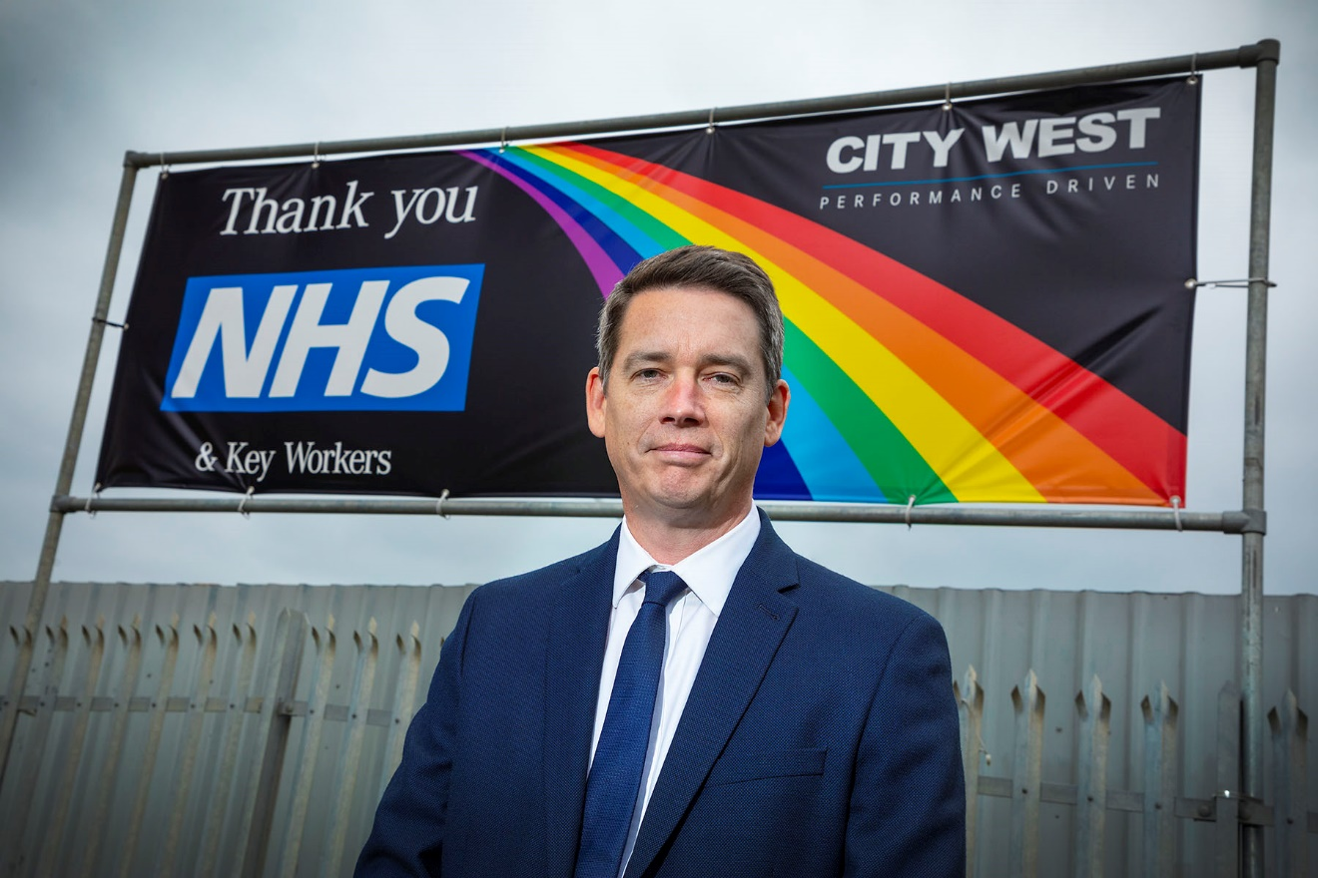

Sign of the times: City West Commercials’ new Dealer Principal Darren Sweet

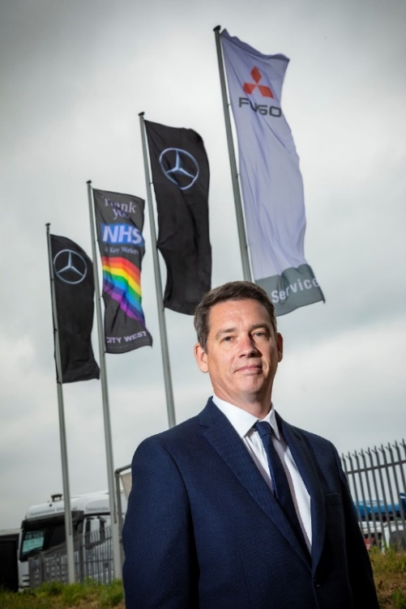

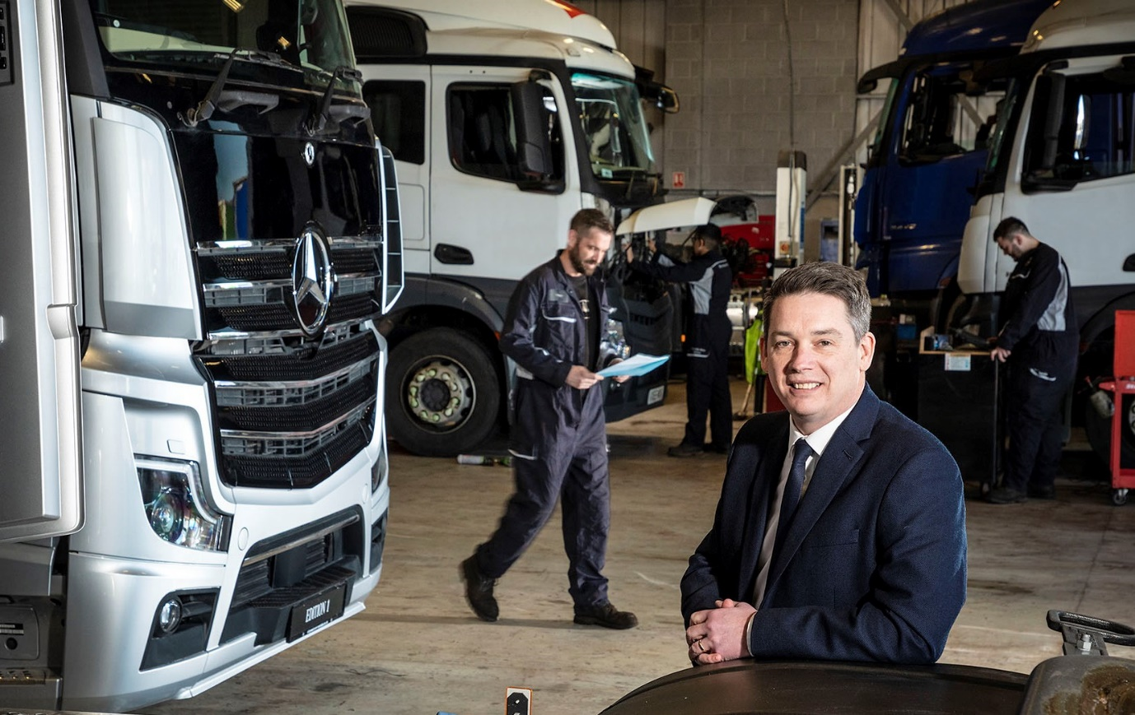

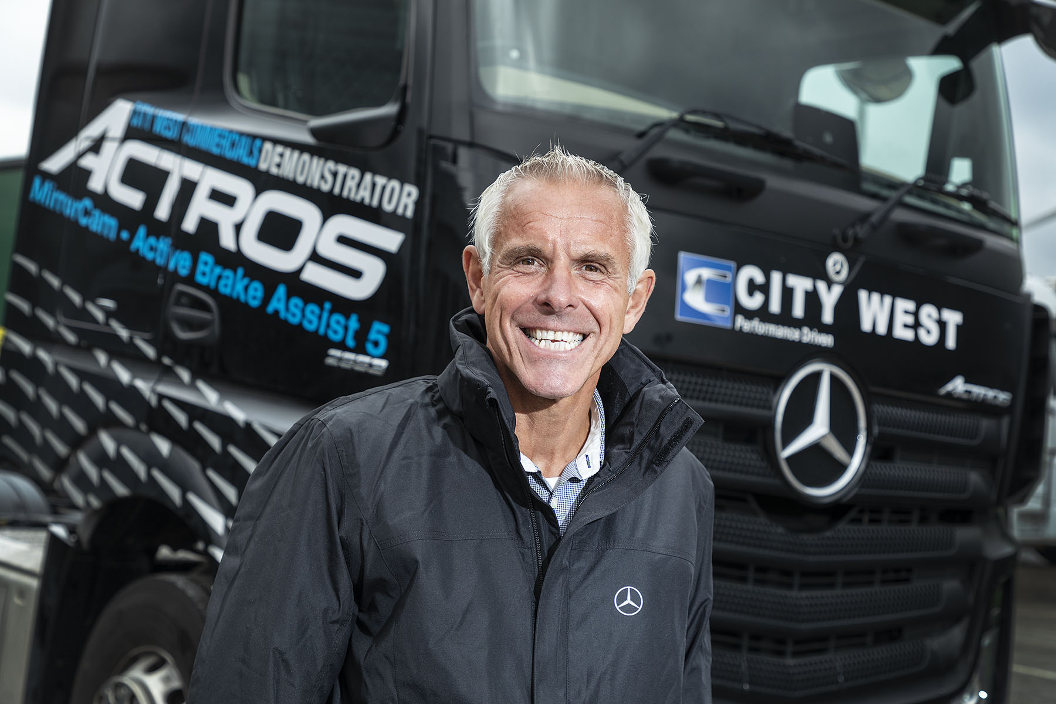

Back to the future: Rich Smith is delighted to be working again for City West Commercials

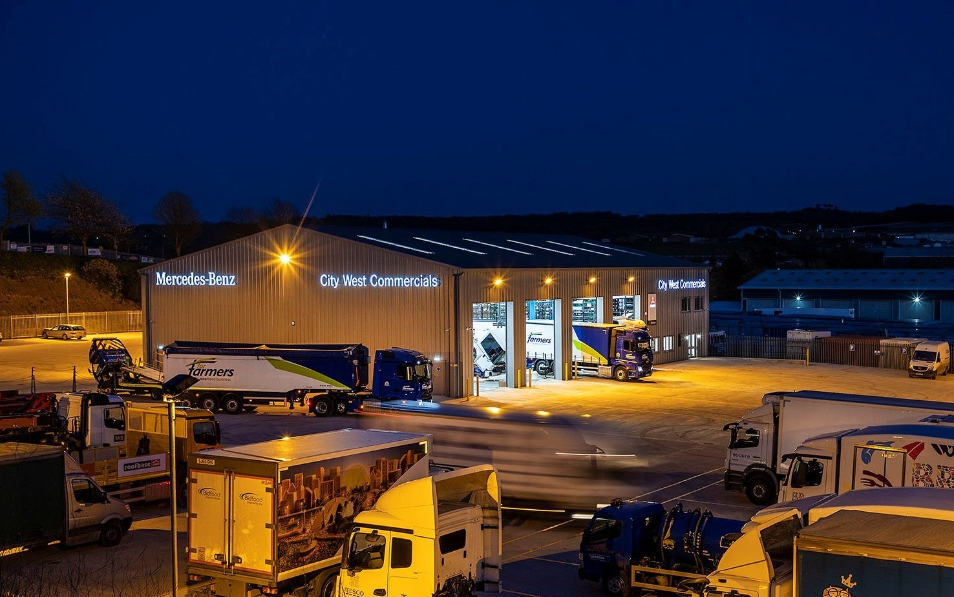

Service “at the speed of life”: City West Commercials’ facilities are among the best in the Mercedes-Benz Trucks Dealer network, and have remained open throughout the pandemic

ends

For more information, or to request bigger/higher-res image files, please contact:
Steve Warren or John Ripley
Impact Communications, 01926 842126
Steve: 07770 470251, steve@impactcom.co.uk
John: 07771 484595, john@impactcom.co.uk

