

Date: 3 November 2021

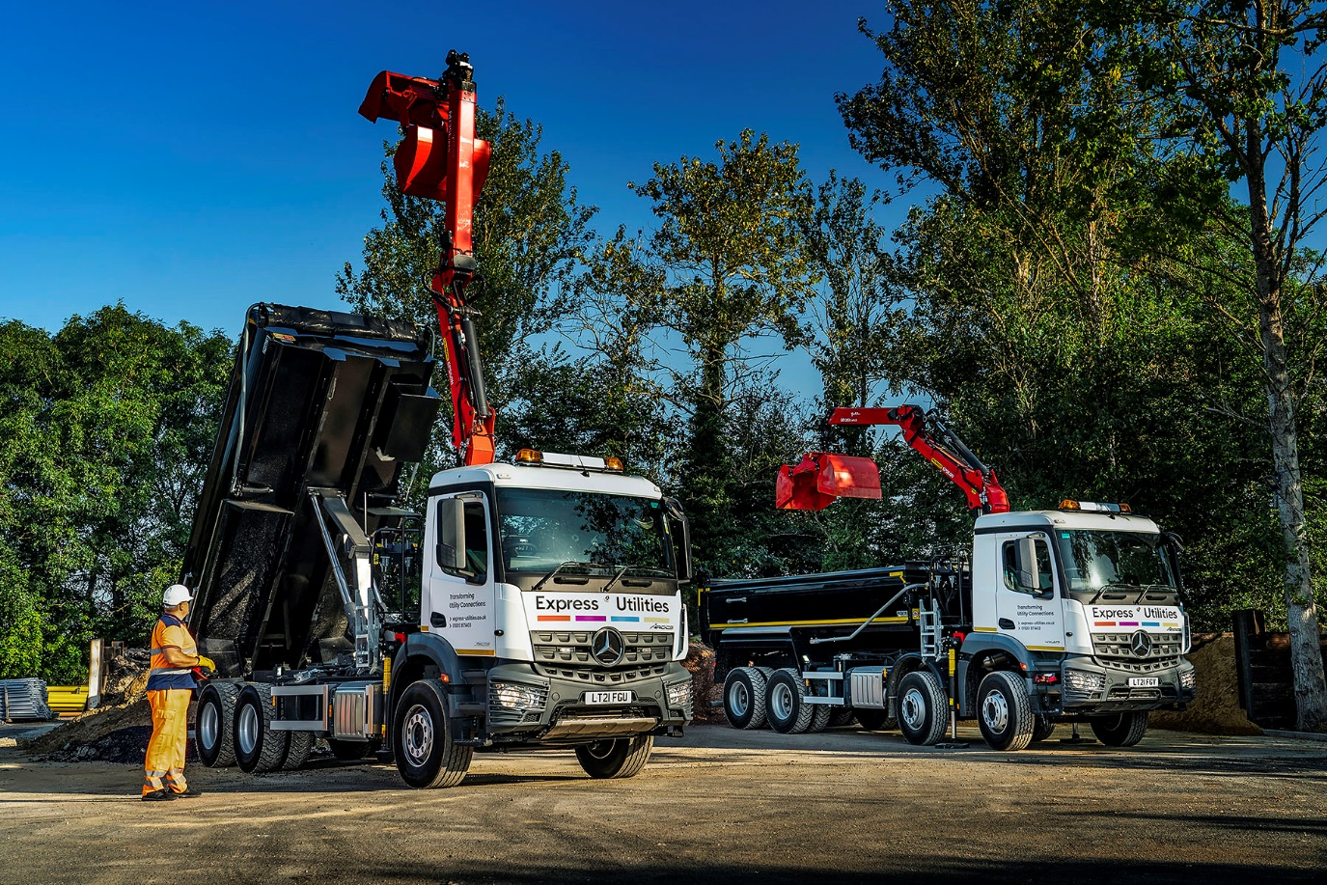

‘People power’ wins the day for Motus Truck & Van, as Express Utilities invests in four Mercedes-Benz Arocs

A fast-growing multi-utility connections provider turned to Mercedes-Benz for the four Arocs tipper-grabs that have become the first trucks to wear its new name.

The trucks – two eight-wheelers and a pair of six-wheelers – are smartly finished in the livery of Express Utilities, which operates from a head office in Harlow, Essex, and a number of locations nationwide.

Supplied by Motus Truck & Van, the Arocs are the subject of five-year Mercedes-Benz Complete Service Contracts. They have replaced a quartet of tipper-grabs from the same muscular model range that had been in service since 2018.

At that time both the supplying Dealer and its customer were trading under former names. Motus Truck & Van was established as recently as August, following the rebranding of two members of the Mercedes-Benz Trucks network that were already operating as a single franchise. Express Utilities, meanwhile, was launched in February; in its previous incarnation the business had been acquired the previous year by the BUUK Infrastructure Group, a leading provider of last‐mile multi-utility networks in the UK.

Having focused under its previous name and ownership solely on laying and maintaining gas pipework, Express Utilities now also installs, connects, owns and operates electricity, water and gigabit fibre networks for new-build housing developments across England, Scotland, and Wales. It is ideally placed as well, to help developers in the migration from gas to alternative sustainable solutions, to help meet future heat requirements in new homes.

In another break with the past, the operator has purchased its new Arocs rather than leasing them. All were fitted at Abba Commercials’ production facility in St Helen’s with steel Predator Ultimate tipping bodies and remote radio-controlled Palfinger Epsilon M135L cranes that work with Kinshofer clamshell buckets.

The 8x4 trucks are Arocs 3240 variants with ClassicSpace M-cabs, while the 6x4 Arocs 2633s have ClassicSpace S-cabs. All four were specified with uprated front axles and are powered by 10.7-litre in-line six-cylinder engines with outputs, respectively, of 290 kW (394 hp) and 240 kW (326 hp).

Two of the new tipper-grabs are operating from a depot in Roydon, Essex; the others are based in Peterborough and Rochester, Kent. They are used to collect and deliver stone and aggregates from quarries, and to remove spoil from sites.

The Arocs, each of which is also fitted with full set of Brigade safety cameras, represent a substantial investment by the new parent company and reflect its confidence in the future – Express Utilities has been forging ahead strongly since the acquisition and is opening more offices in various parts of the country.

In addition to its new Mercedes-Benz vehicles, the operator runs half a dozen smaller trucks, a combination of ‘hotboxes’ and tippers. It supplements this core fleet by renting equipment when necessary to meet demand.

The Dealer’s support was instrumental in convincing Express Utilities to replace its previous Mercedes-Benz tipper-grabs with four more. “Our last Arocs served us well,” reported Tony Lake, Project Manager for Backfill Reinstatement.

“The truck is fundamentally well suited to our requirements, not least because its excellent ground clearance is a big advantage when working in quarries and on rough sites. However, another manufacturer was also very competitive. Ultimately, it was Motus Truck & Van’s customer-focused service that swayed us towards Mercedes-Benz again.

“Truck Sales Manager Sam Setterfield has been out on the road with one of our vehicles, so he understands our operation and what we need. These trucks are highly bespoke and with Sam’s expert assistance we were able to refine the specifications and tailor them perfectly to meet our requirements.”

Tony Lake continued: “The Dealer’s aftersales back-up is first-class too. When inspections and routine maintenance are due on the Royston-based trucks we drop them off at its Welham Green workshop at the end of the day. The driver then goes home in a courtesy vehicle, and returns the following morning to collect the vehicle. It all works incredibly smoothly, and makes life very easy for us.

“Relatively minor tasks are undertaken on our own site by Motus Truck & Van’s highly professional mobile technician Jozsef Sohonyai, who we’ve come to know and trust over the last three years. We really can’t fault this guy. Not only is Jozsef a very good mechanic but he also has great people skills and is always on time; he’s a real asset to the Dealer’s business.”

Mr Lake added: “From both a sales and an aftersales perspective, Motus Truck & Van ticks all the boxes. That’s why we’ve committed once again to Mercedes-Benz.”

express-utilities.co.uk

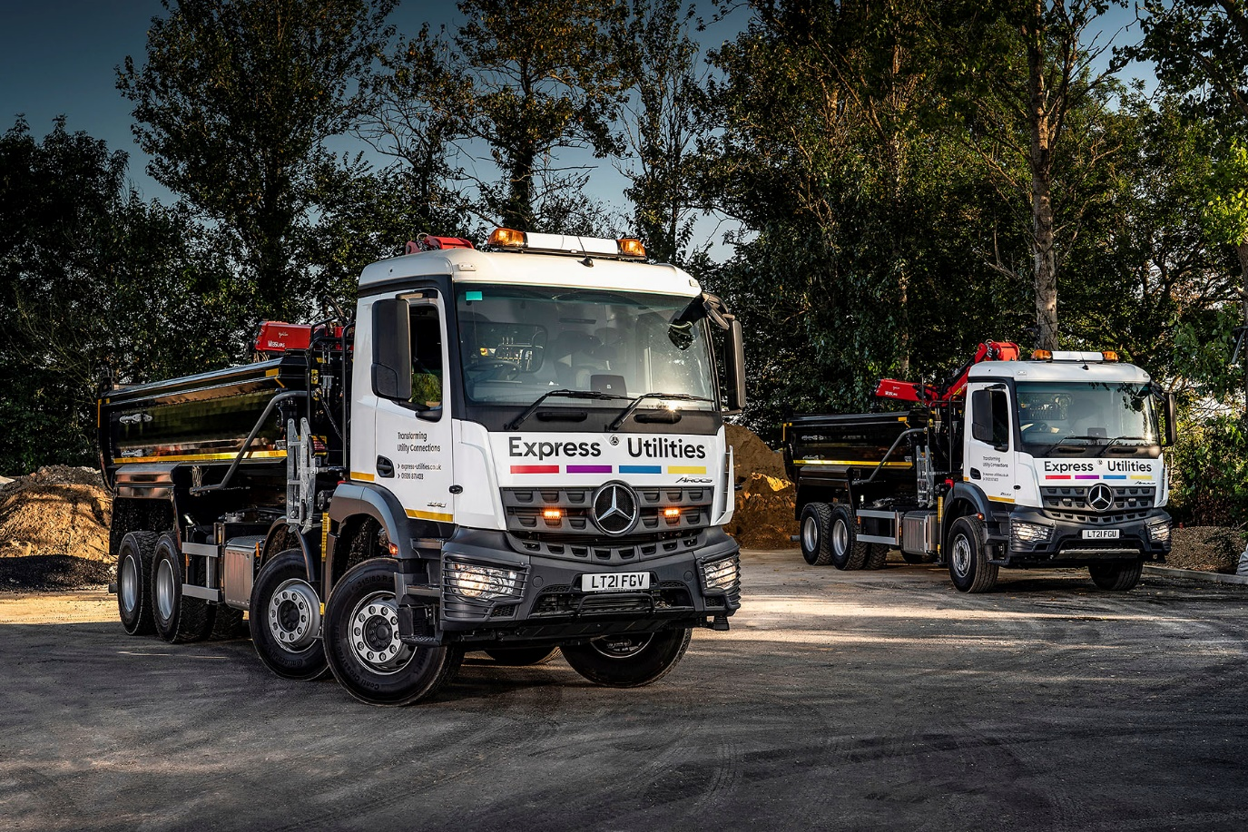

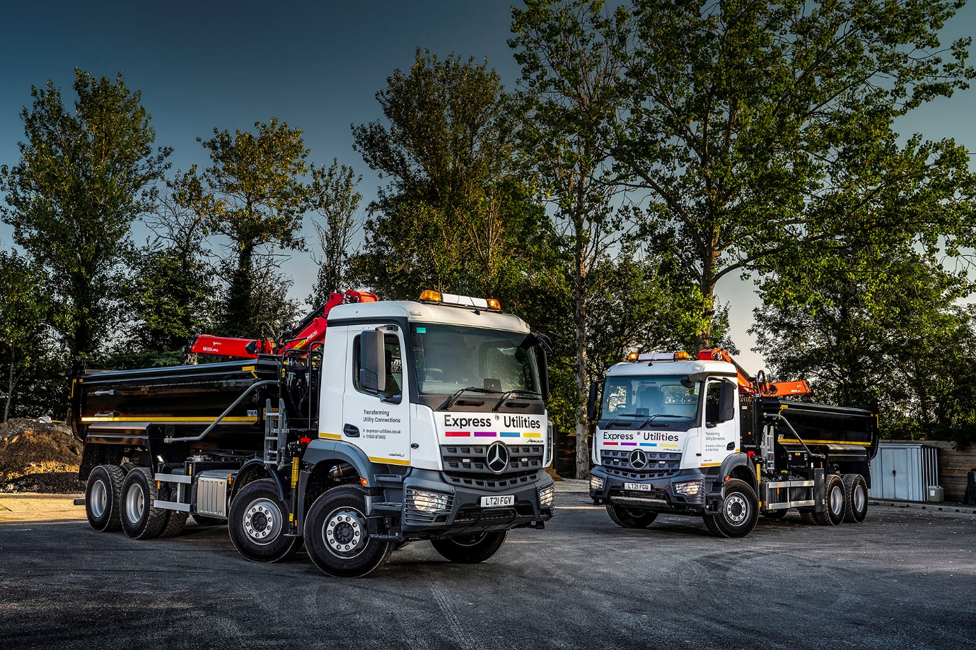

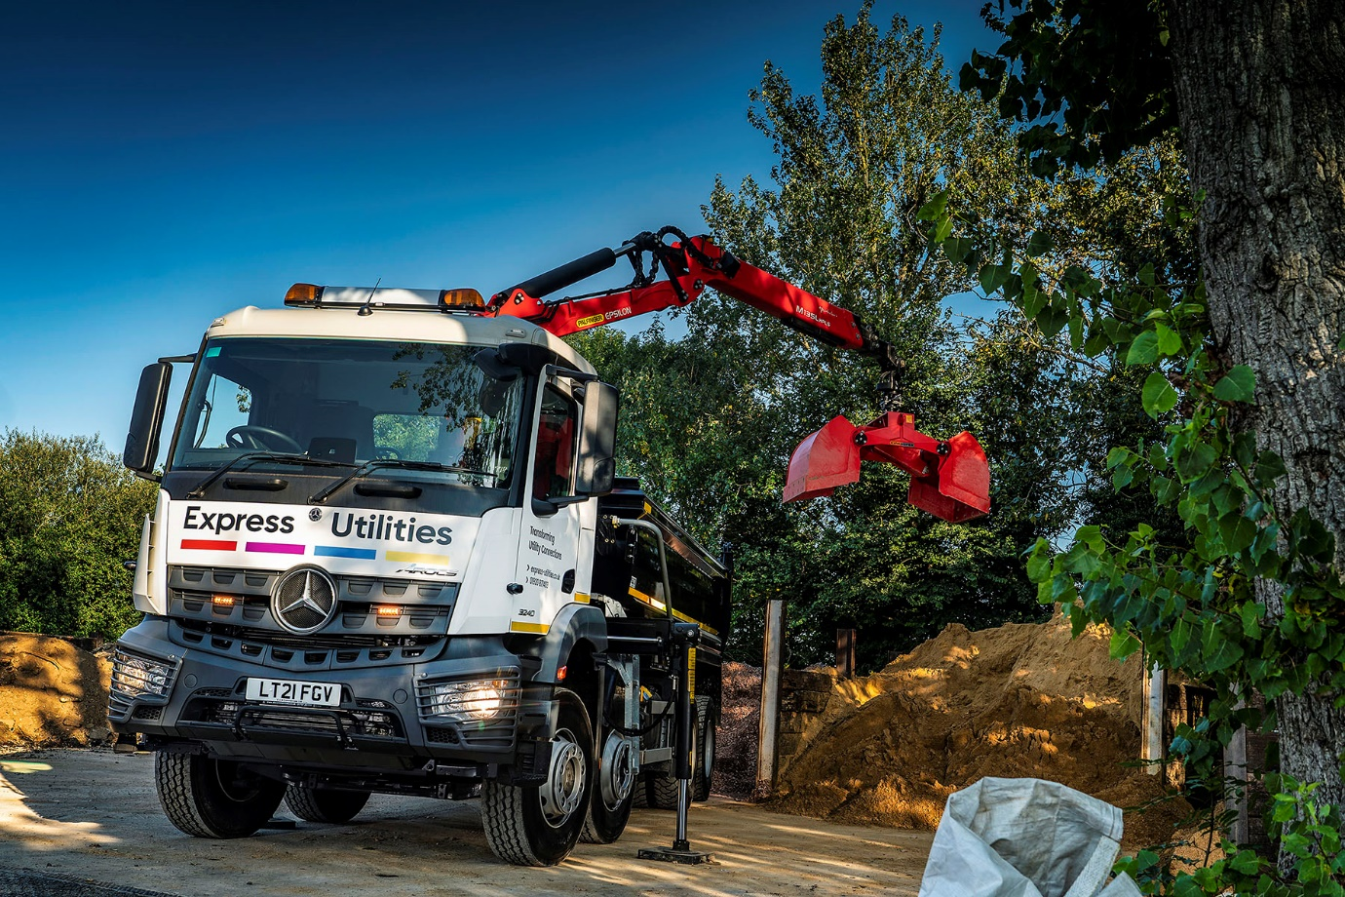

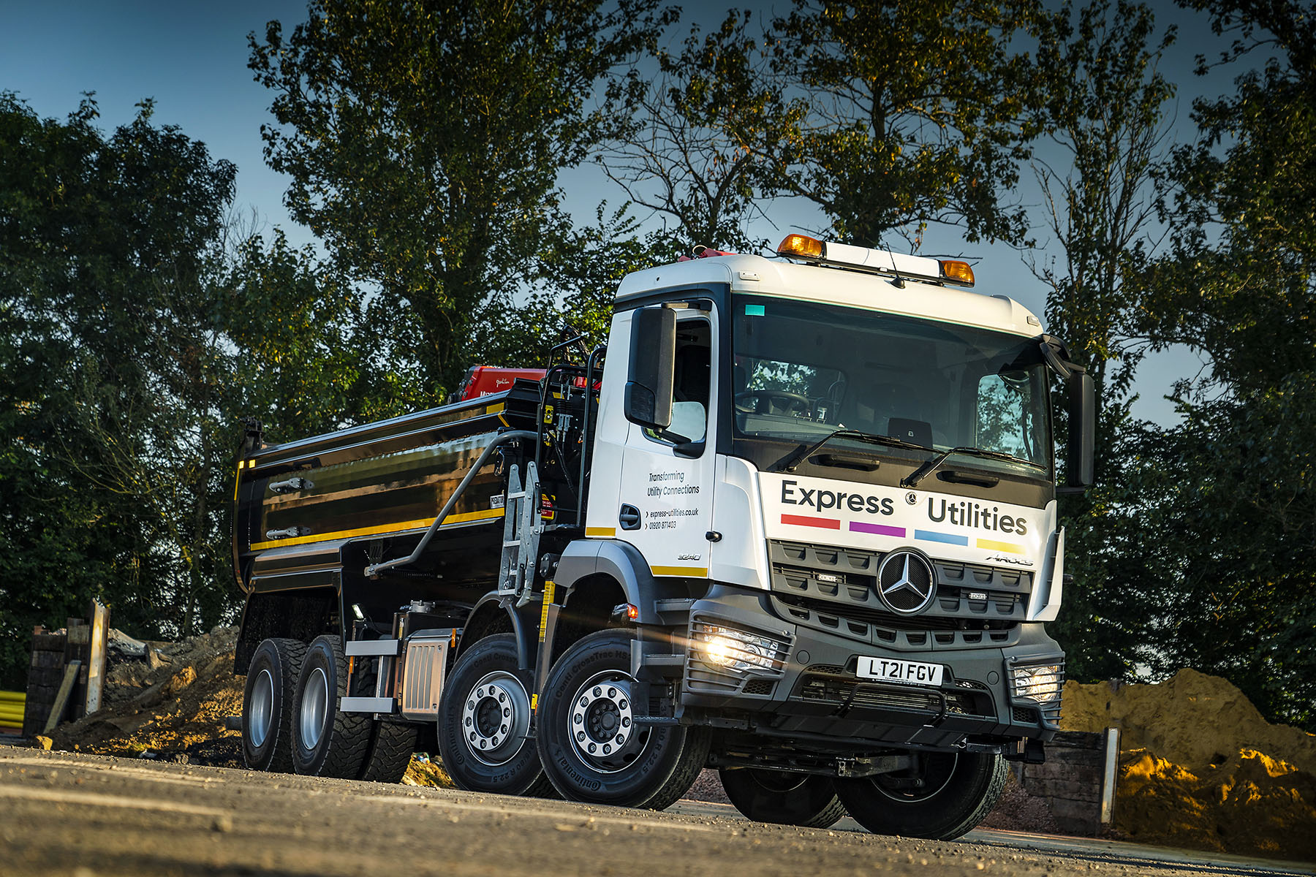

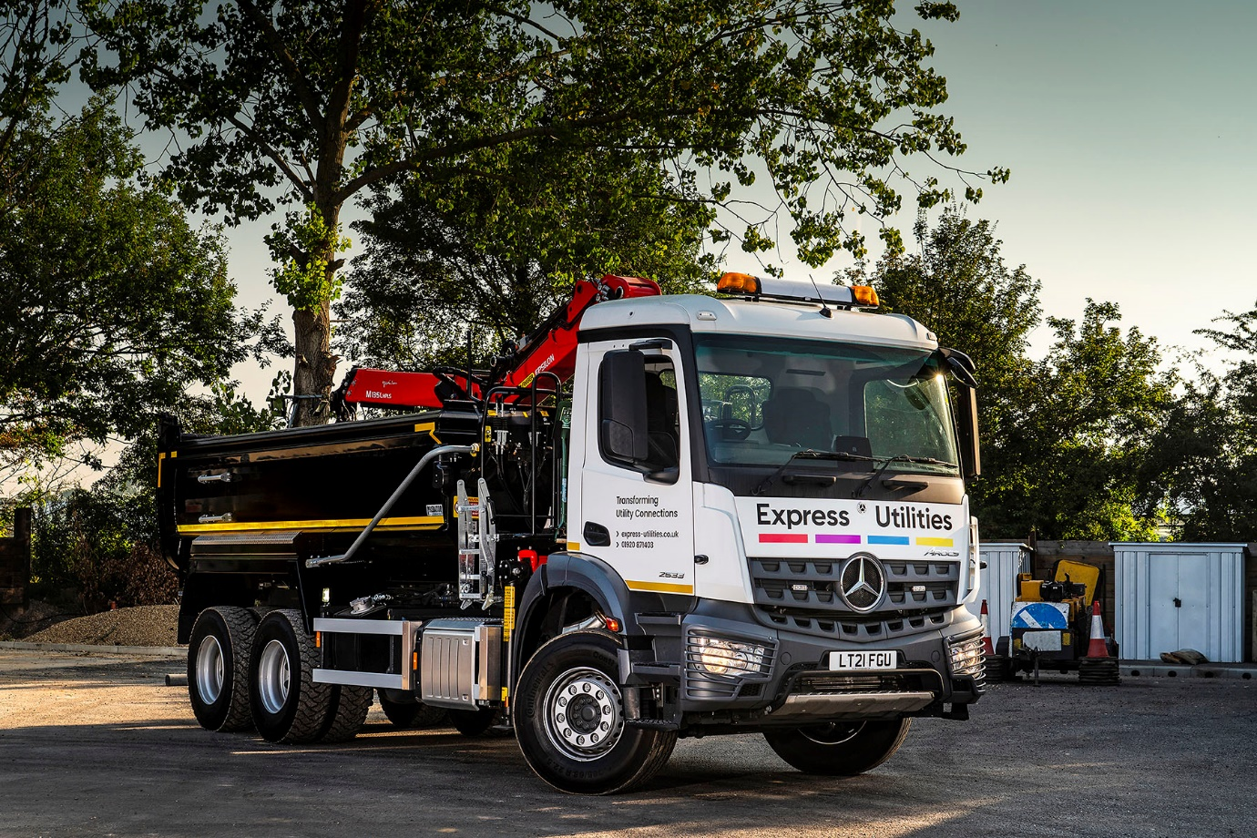

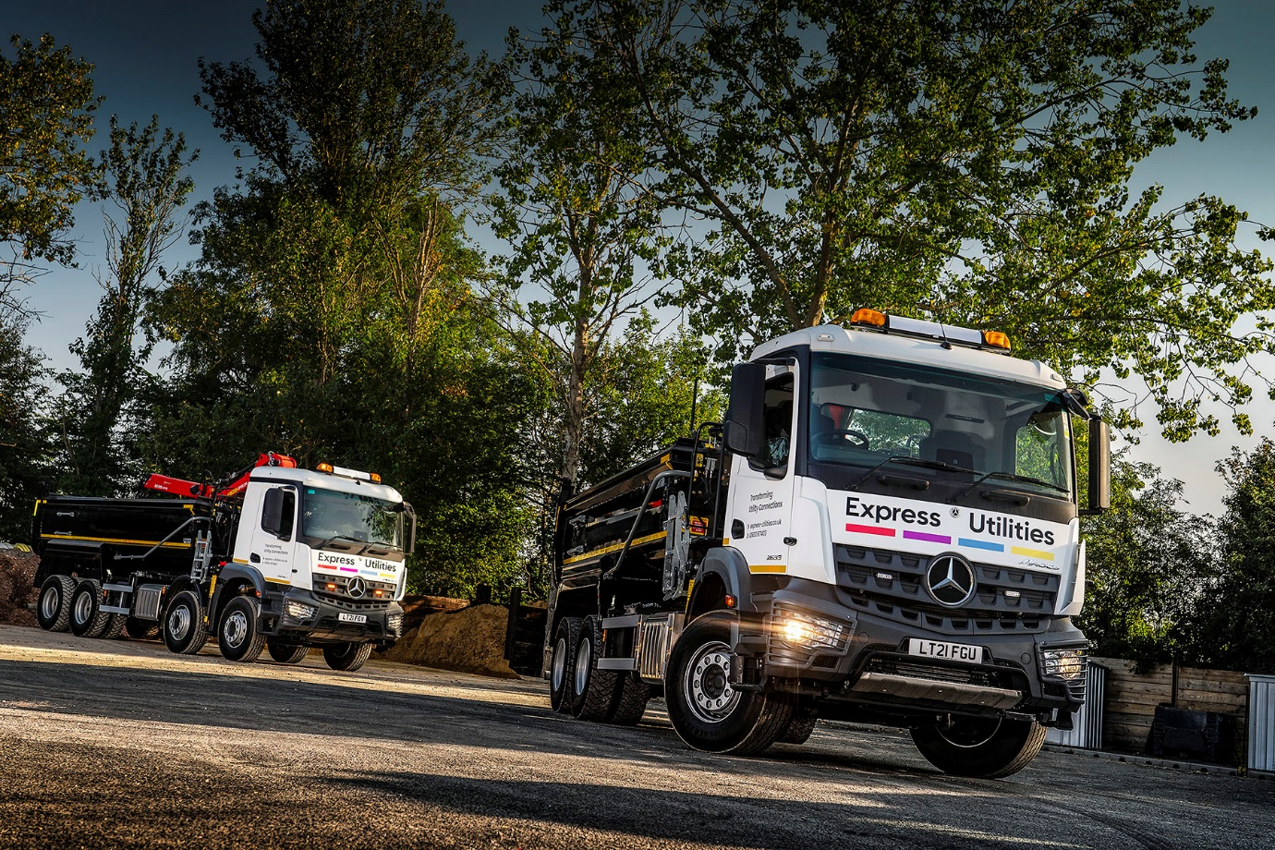

ends

For more information, or to request bigger/higher-res image files, please contact:
Steve Warren or John Ripley
Impact Communications
Steve: 07770 470251, steve@impactcom.co.uk
John: 07771 484595, john@impactcom.co.uk

