

Date: 26 October 2021

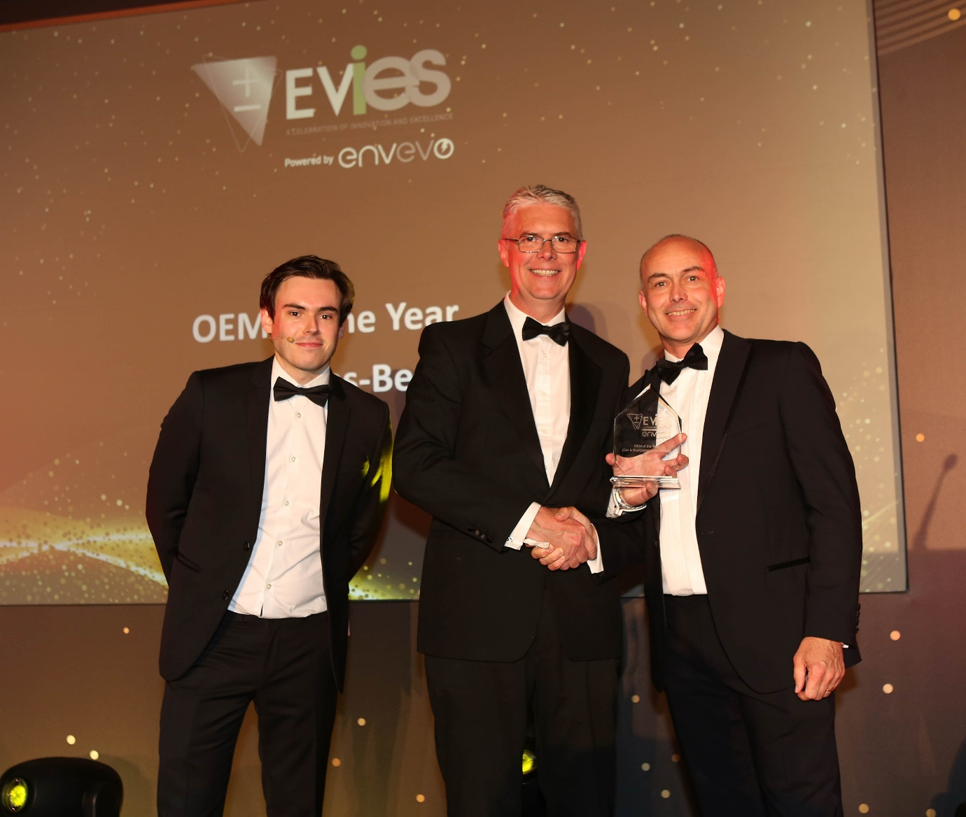

Winning ways: Ross Paterson, centre, accepts Mercedes-Benz Trucks UK’s EVIE Award from eSmart Networks Business Development Director Chris Doré, right, and event host, TV comedian Rhys James

Mercedes-Benz scoops electric trucks innovation prize

Mercedes-Benz Trucks UK has won a national award for its efforts to help the transport industry switch from fossil fuels to cleaner, ‘greener’ sources of power.

The company was the proud recipient of the OEM (Original Equipment Manufacturer) of the Year title at the 2021 Electrical Vehicle Innovation & Excellence Awards, staged by publishing and events group Solar Media.

Judges praised Mercedes-Benz Trucks not only for its current electric vehicles, but also for its comprehensive strategy to bring a diverse array of both battery and hydrogen fuel cell models to the market.

Panel member Liam Stoker, Editor-in-Chief of Current+ magazine, said: “Our Electric Vehicle Innovations and Excellence Awards 2021 highlighted just a few of the outstanding success stories the UK’s electric vehicle sector has produced in the past year, and it was Solar Media’s pleasure to reward our 14 winners on the evening.

“The OEM of the Year category was hotly contested, and our judging panel ultimately selected Mercedes-Benz Trucks as the winner due to its commendable commitment to providing vehicles to help electrify fleets in the UK; a critical factor in decarbonising transport.”

The awards were presented at a gala celebration evening held at the Bristol Harbour Hotel, to winners across a spectrum of industry, research and development sectors.

Accepting the trophy on behalf of Mercedes-Benz, Head of Special Trucks Ross Paterson said: “We were already extremely proud to be the only truck manufacturer on the shortlist. To win this accolade is a very gratifying recognition of our determination to offer customers the practical, viable solutions they need to remove diesel vehicles from our roads.”

Widely acknowledged as a world leader in eMobility, parent company Daimler has been working towards providing sustainable, carbon-neutral transport options for many years. Its aim is for all new vehicles on sale across Europe, North America and Japan to be fully ‘tank-to-wheel’ CO₂-neutral by 2039.

“To achieve this, we’ve outlined a two-pronged strategy,” continued Ross. “By focusing on both battery power and hydrogen fuel cells, we’ll be able to offer the best possible options for a wide range of applications. Batteries are best suited to lower cargo weights, shorter distances and fixed routes; those hauling heavier loads over longer, or less predictable routes will prefer the flexibility that hydrogen fuel cells provide.”

Mercedes-Benz Trucks UK sells and supports vehicles bearing the famed three-pointed star badge, as well as the FUSO range.

The FUSO eCanter – the world’s first fully-electric light truck – was launched to British customers in 2018. The 7.5-tonne truck’s four-tonne payload and 100km range made it an immediately attractive proposition and eCanter models have since found homes in the fleets of a string of blue-chip operators.

This year has also seen the global premiere of the first fully electric, series-produced Mercedes-Benz truck – the eActros 4x2 or 6x2 rigid. With up to 400km of range, the eActros offers a genuine, no-compromise alternative to a conventional diesel truck for many customers.

Next in line is the Mercedes-Benz eEconic, a battery-electric version of the acclaimed low-entry chassis which is a popular choice for refuse collection fleets and across other applications in the urban environment.

Ross said: “We recognise, though, that electric distribution and municipal trucks don’t suit everyone – so we’ve announced the Mercedes-Benz eActros LongHaul. This battery-powered tractor unit should be ready for series production in 2024, with a range of 500 kilometres on a single charge, more than meeting the needs of most nationwide hauliers.

“Looking further ahead we have our fuel-cell concept, Mercedes-Benz GenH2 Truck, which will have an operational range of up to 1,000 kilometres on a single tank of liquid hydrogen when it comes to market in the second half of the decade.”

Meanwhile, Daimler Truck AG has its eyes on the bigger picture too. In partnership with Volvo Group, it recently formed cellcentric GmbH, a joint venture committed to accelerating the development of hydrogen fuel cells. An agreement has also been signed with global industrial gas and engineering leader Linde, to jointly develop the next generation of liquid-hydrogen refuelling technology for fuel-cell-powered trucks.

“With the era of the internal combustion engine now entering its phase-out period, our focus is firmly on the future and the introduction of new and innovative products that will ensure the sustainability of the road transport sector for generations to come,” said Ross Paterson.

ends

For more information on Mercedes-Benz Trucks, or to request higher-res image files, please contact:

Jamie Fretwell, Mercedes-Benz Trucks UK Ltd
07712 519230, jamie.fretwell@daimler.com

or

Steve Warren or John Ripley
Impact Communications, 01926 842126
Steve: 07770 470251, steve@impactcom.co.uk
John: 07771 484595, john@impactcom.co.uk

About Mercedes-Benz Trucks UK Ltd
Mercedes-Benz Trucks UK Ltd is the sales and marketing organisation responsible for all Daimler truck products in the UK, including FUSO Canter.

The flagship new Mercedes-Benz Actros which won the 2020 International Truck of the Year award, features seven core innovations including MirrorCam, Multimedia Cockpit and Active Brake Assist 5. Our premium range of innovative trucks – Actros, Arocs, Atego, Econic and Unimog – draw upon more than 125 years of exceptionally high standards of quality, backed up by our promise of Trucks You Can Trust.

www.mbtrucks.co.uk

