

Date: 1 April 2021

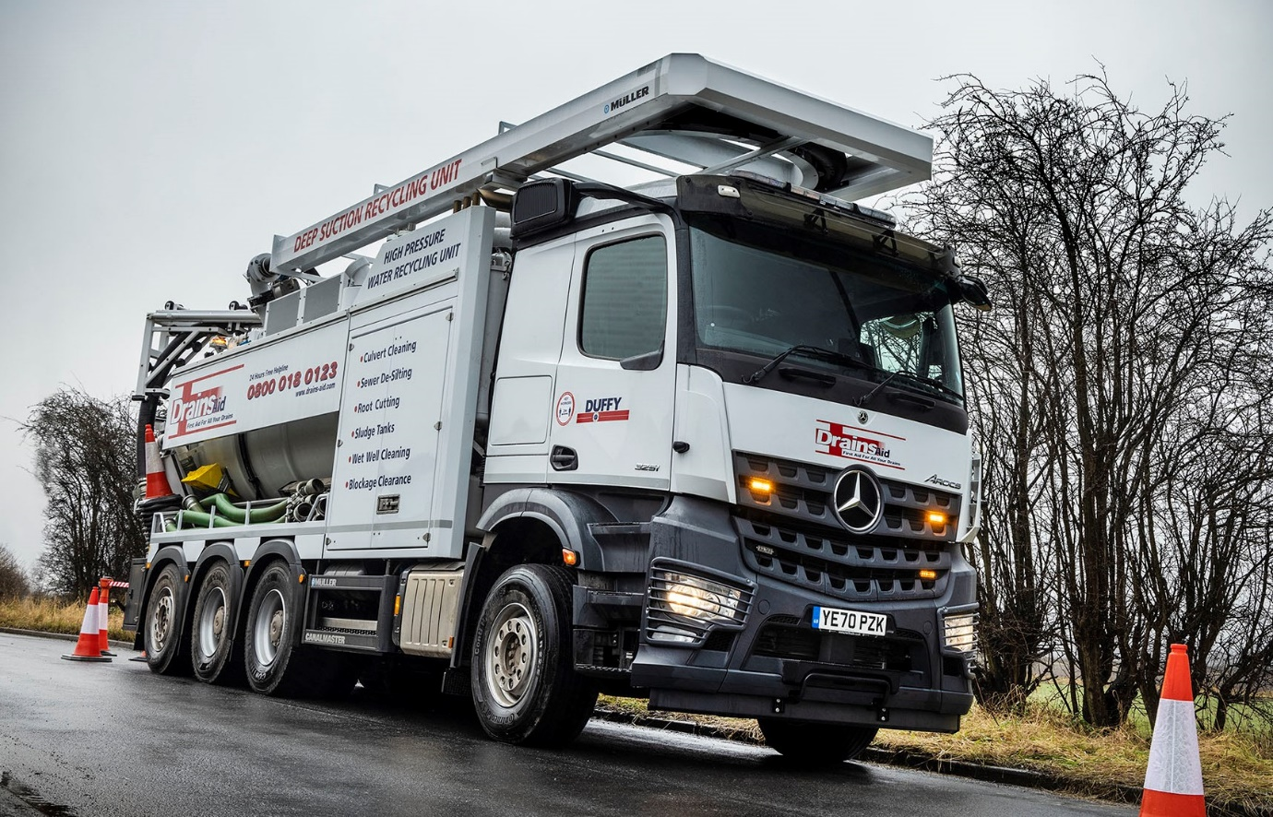

DrainsAid delivers eco-friendly ‘deep cleans’ with Müller-equipped Mercedes-Benz Arocs from Northside

The new Mercedes-Benz sewer-cleaning vehicle that has just entered service with Yorkshire-based DrainsAid combines high-performance jetting and suction capabilities with impeccable environmental credentials.

Equipped to clean large diameter sewers and deep wells, the vehicle is based on an Arocs 3251 chassis supplied by local Dealer Northside Truck & Van. Its Canalmaster Super Recycler bodywork was built and fitted in Germany by specialist manufacturer Müller, and works with a liquid ring vacuum pump by CVS Engineering and jetting pump by URACA.

Key to the appeal of Müller’s system is the fact that the dirty water it sucks up is then filtered, with silt and sludge being separated, then fed back to the high-pressure jetting nozzles for re-use in the cleaning process. The recycling of water in this way negates the need for the truck to leave the site to refill a tank with clean water, thereby enabling the operator to save on fuel costs and reduce its carbon footprint.

DrainsAid provides a ‘Total Drainage Management’ service that includes preventative maintenance and reactive repairs, to a customer base that includes utilities and rail companies, brewers and chemical plants.

It is part of the privately-owned Peter Duffy Limited civil engineering, utilities and construction group, which operates from headquarters in Wakefield and celebrates its 50th anniversary next year. The new truck was acquired by the group’s Plant & Fleet Services division, which sources vehicles and equipment for other parts of the business.

The 8x4 Arocs employs a 12.8-litre in-line six-cylinder engine that produces 375 kW (510 hp) and is paired with a smooth and fuel-efficient 16-speed Mercedes PowerShift automated manual transmission. As an ENA variant, it has a single front axle – uprated to 9.0 tonnes – a double-drive bogie and a steered rear axle. This configuration affords the truck a level of manoeuvrability comparable to a six-wheeler, an important attribute given that access to some of the locations at which DrainsAid works is tight.

The ClassicSpace L-cab with 170mm engine tunnel offers the low roof height needed to accommodate Müller’s bodywork. It features Mercedes-Benz Trucks’ ground-breaking MirrorCam technology, as well as the optionally upgraded interactive version of the stylish and intuitive twin-screen Multimedia Cockpit, and a fridge.

Although the operator’s fleet includes a 32-tonne Mercedes-Benz vacuum tanker that has provided impressively reliable service, the decision to mount its latest machine on another chassis bearing the three-pointed star was based primarily on the firm recommendation of the bodybuilder.

Director Neil Duffy is from the second generation of the founder’s family, and leads the Plant & Fleet Services arm. He explained: “We believe Müller’s equipment to be the best on the market for deep suction work. Although it also builds on other makes of truck the bodybuilder’s strong preference was for the Arocs.

“Given our previous experience with Mercedes-Benz vehicles, which have always proved exceptionally reliable and cost-effective to run, we had no reservations about accepting that recommendation.”

An approved Mercedes-Benz bodybuilder for many years, Müller is represented in the UK and Ireland by sole distributor Roadvac, of Alfreton. Roadvac Sales Director Donal Kearney commented: “Mercedes-Benz chassis offer an ideal base for Müller’s bodywork in terms of weight distribution. Müller also favours them for the high performance of the engine PTOs, and because Mercedes-Benz Trucks’ bodybuilder module works seamlessly with its own equipment.

“For example, the recycler is fully radio remote-controlled for ease of use and safety. The enhanced connectivity provided by the bodybuilder module means the operative can also stop or start the truck engine and PTO directly from the Müller control panel.”

The operator will be inspecting and maintaining the new truck in its own workshop, with parts back-up from Northside Truck & Van. “The Dealer’s service has been excellent throughout,” confirmed Neil Duffy.

“Its Sales Executive Steve Cusworth has liaised closely with the bodybuilder and we received regular progress updates throughout the year, from confirmation of our order to delivery of the finished vehicle. Northside also arranged a full day of driver training, immediately prior to the three days we then received on operation of Muller’s Super Recycler.”

He added: “The DrainsAid team are delighted with their new Mercedes-Benz. It’s already very busy and demand is such that they are confident it will remain fully utilised in the service of customers throughout the country. As well as being perfectly specified to fulfil its demanding role, the Arocs looks the part and is an impressive flagship for our business.”

www.drainsaid.com

www.peterduffyltd.com

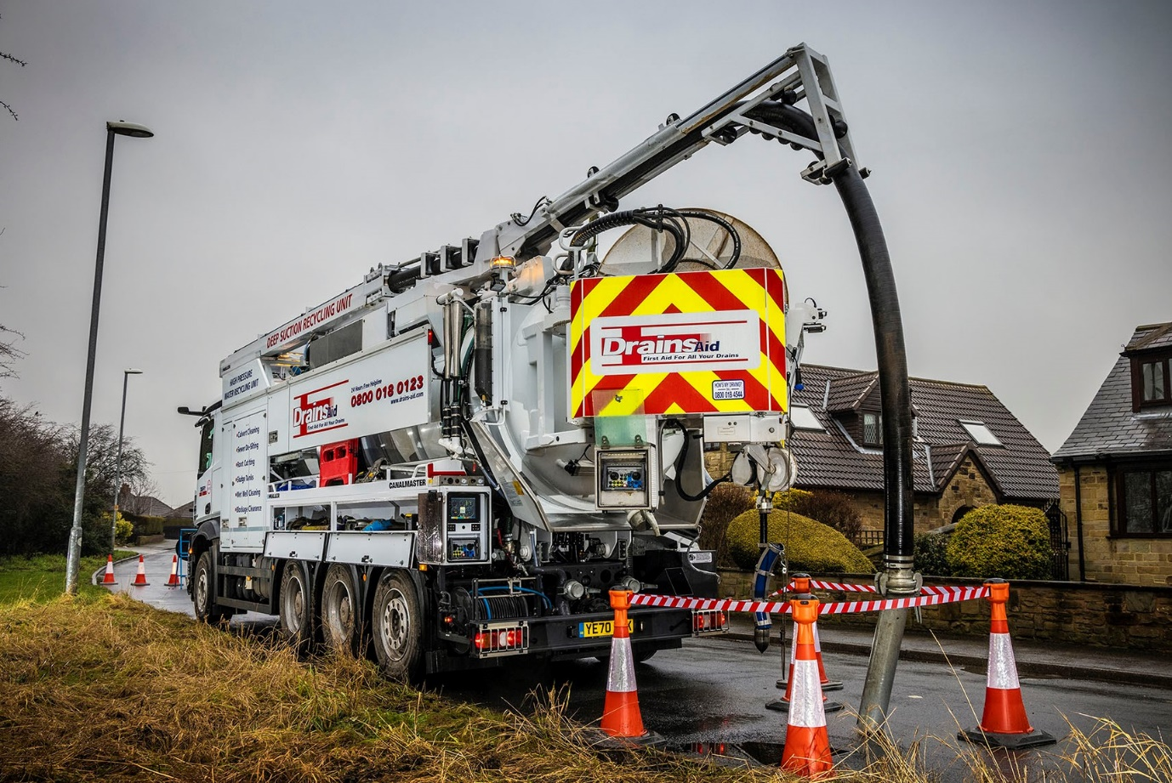

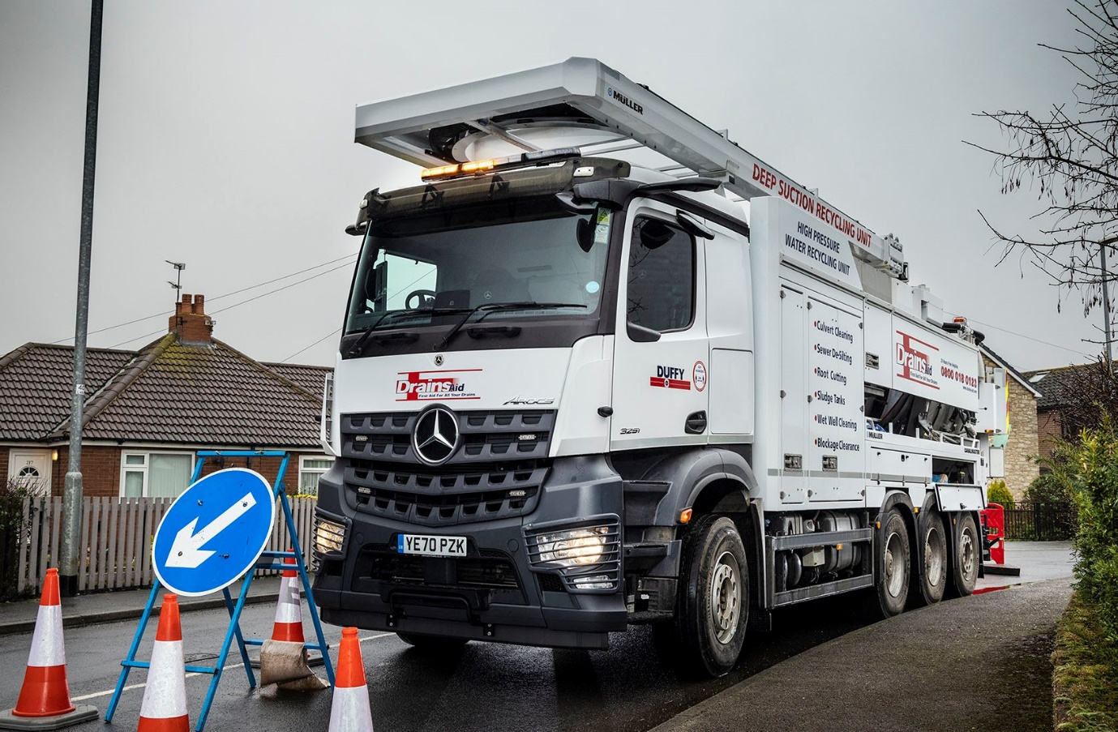

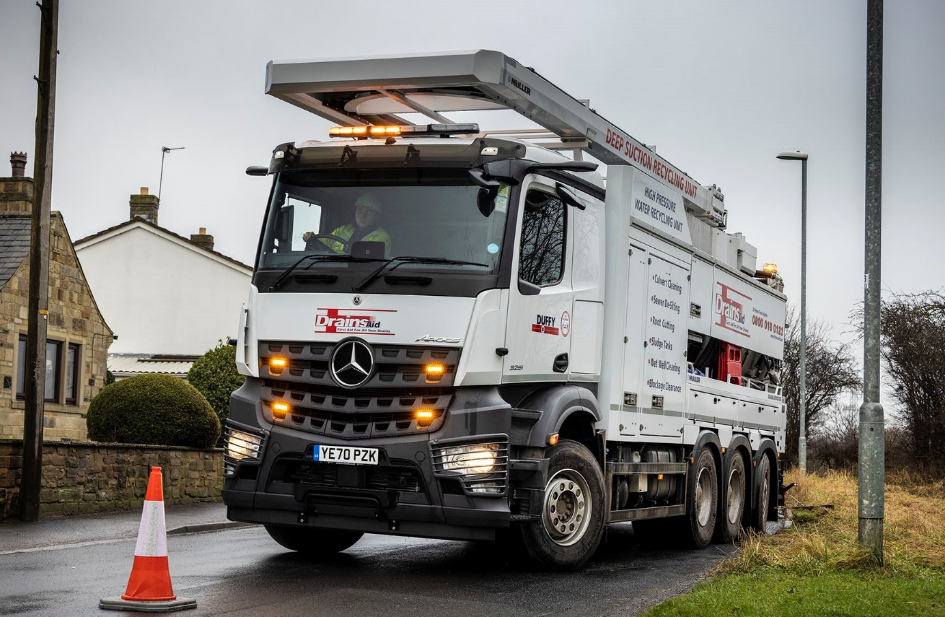

ends

For more information, or to request higher-res image files, please contact:

Jamie Fretwell at Mercedes-Benz Trucks UK Ltd
07712 519230, jamie.fretwell@daimler.com

or

Steve Warren or John Ripley
Impact Communications, 01926 842126
Steve: 07770 470251, steve@impactcom.co.uk
John: 07771 484595, john@impactcom.co.uk

About Mercedes-Benz Trucks UK Ltd
Mercedes-Benz Trucks UK Ltd is the sales and marketing organisation responsible for all Daimler truck products in the UK, including FUSO Canter. In 2019, the company registered 6,963 new trucks. Mercedes-Benz accounted for 6,188 new trucks registered in 2019, making it the third-biggest truck brand in the UK. Meanwhile, FUSO registrations hit 775 – including 580 new trucks over 6.0-tonnes. The flagship new Mercedes-Benz Actros which won the 2020 International Truck of the Year award, features seven core innovations including MirrorCam, Multimedia Cockpit and Active Brake Assist 5. Our premium range of innovative trucks – Actros, Arocs, Atego, Econic and Unimog – draw upon more than 125 years of exceptionally high standards of quality, backed up by our promise of Trucks You Can Trust.
www.mbtrucks.co.uk

