

Date: 15 September 2022

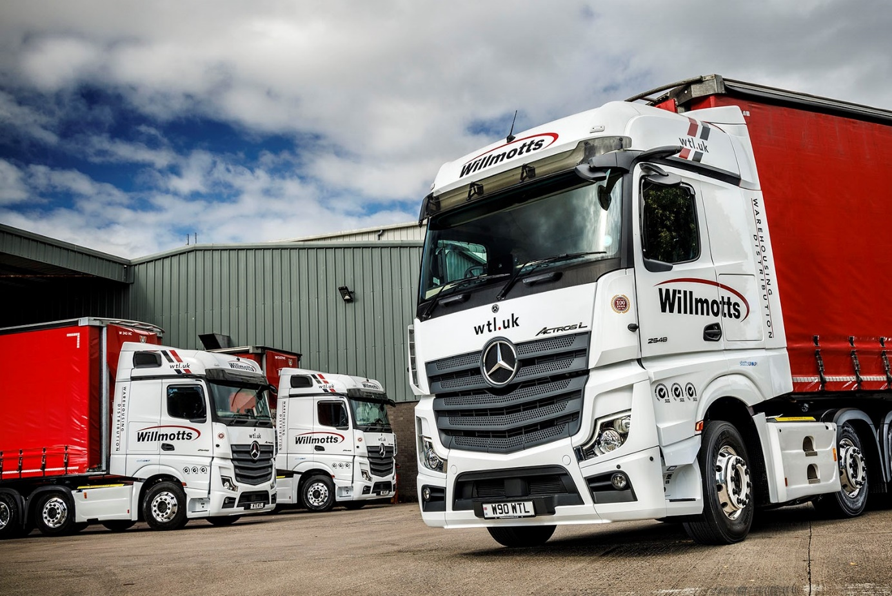

Willmotts sharpens the focus on safety with five new Mercedes-Benz Actros from City West Commercials

West Country haulier Willmotts Transport has become one of the first UK customers for Mercedes-Benz trucks equipped with new, improved MirrorCam technology.

The Shepton Mallet-based operator has purchased five Actros L BigSpace tractor units from City West Commercials, one of which was showcased on the Dealer’s stand at Truckfest South West earlier this month (September).

Willmotts Transport is part of the Stotts Group and runs more than 100 trucks, the overwhelming majority of them tractor units. Established more than a century ago, it has long been a provider of general freight services. However, in recent years the company has forged ahead strongly through expansion in ambient food and drinks distribution, and British Retail Consortium-certified warehousing services.

Several brands are represented on the Willmotts fleet – the new Actros are its first from the fifth-generation range launched in 2019. Acquired with funding support from Daimler Truck Financial Services, they are 2548 variants and powered by 12.8-litre in-line six-cylinder engines with outputs of 350 kW (476 hp).

MirrorCam was the first camera-based alternative to conventional mirrors, and over the last three years has won widespread acclaim from operators, drivers and industry pundits, for the major contribution it makes to safety.

The system delivers significant benefits when cornering or reversing, especially with an articulated rig. The images relayed by the roof-mounted cameras to screens mounted inside the cab, on the A-pillars, adapts automatically to provide the driver with a clear view – not possible with mirrors – of the full length of the semi-trailer. A guidance line in the display that shows where the end of the trailer is, assists with precision reversing.

What’s more, drivers whose trucks are equipped with MirrorCam no longer have to contend with the substantial, forward-facing blind spots caused by mirror housings, a particular advantage at approaches to roundabouts.

The second-generation version of MirrorCam announced in May by Mercedes-Benz Trucks, and now starting to appear on right-hand drive, UK-registered vehicles, provides even better support for drivers.

The camera arms are 10cm shorter on both sides, so less vulnerable to damage, while the enhanced housing design reduces the possibility of debris accumulating on the lenses. Technical developments, meanwhile, have further improved image quality and clarity.

“We’ll never put all of our eggs in one basket when it comes to vehicle suppliers,” confirmed Andy Tuck, Willmotts’ Transport & Compliance Director. “City West Commercials’ Truck Sales Executive Richard Smith was admirably persistent in extolling the virtues both of the latest Actros and of the aftersales support we could expect to receive.

“We also had drivers on the fleet who’ve been in Mercedes-Benz trucks for a while, and kept asking when we were going to get some more. We decided, therefore, that the time was right to give the Actros another try.”

In addition to MirrorCam, Willmotts’ new trucks came with Multimedia Cockpits. Stylish and intuitive, these employ twin screens – one with ‘touch’ functionality – in place of traditional switchgear.

“The latest Actros is so very different,” observed Mr Tuck, “and that’s not only down to MirrorCam; the Multimedia Cockpit is also a radical departure. There was some initial apprehension about the new trucks from a couple of drivers, but that reticence didn’t last long – they were soon enthusing about the new and easy-to-use dashboard, and how much more they can see with MirrorCam.”

Mr Tuck continued: “As well as enhancing safety, we’re told the system can reduce diesel consumption, because the compact cameras offer less wind resistance than mirrors. Any fuel savings will be very welcome, as will the expected reductions in AdBlue consumption.

“As a business we’ll embrace new technology at every opportunity. I’ve no doubt that features like MirrorCam and the Multimedia Cockpit will be commonplace in our industry before very long, because of all the benefits they offer. It was Mercedes-Benz, though, that got there first.”

Willmotts Transport’s new Actros are the subject of Mercedes-Benz Complete Service Contracts, under which they are now being inspected and maintained by the workshop teams at City West Commercials’ Avonmouth headquarters and Highbridge depot.

Managing Director Dan Gray said: “Assuming the driver feedback remains as positive, and the trucks continue to live up to their early promise, there’s a real opportunity here for Mercedes-Benz to increase its share of our fleet. We’re now looking forward to receiving from the Dealer, the timely and efficient aftersales back-up that we need.”

Truckfest South West was staged at the Royal Bath & West Showground on 3-4 September.
Commenting on the opportunity to present its own Actros alongside an impressive line-up of Mercedes-Benz trucks that also included H&C Haulage’s stunning, all-black 8x4 Arocs 3253 tipper, Mr Gray added: “City West Commercials put on a really impressive display and we were delighted to see how many people flocked to its stand all weekend.”

wtl.uk

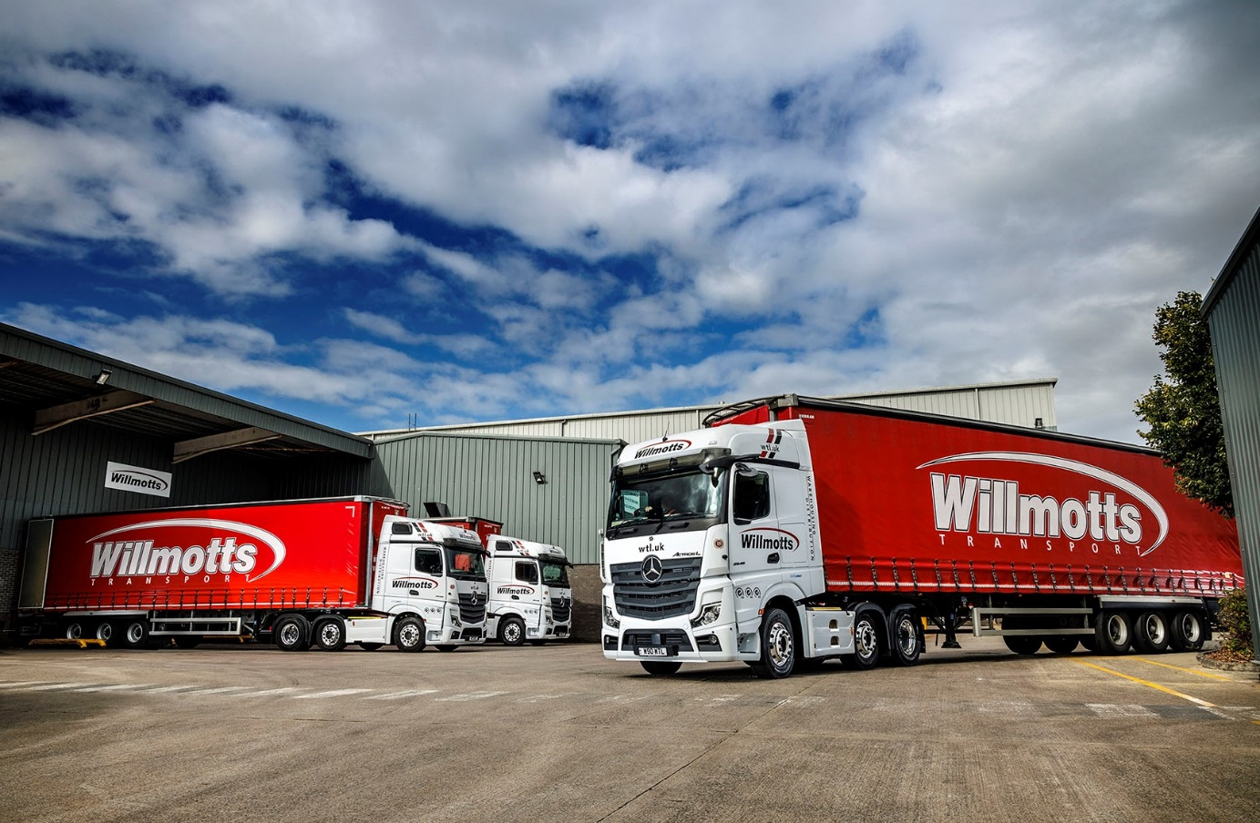
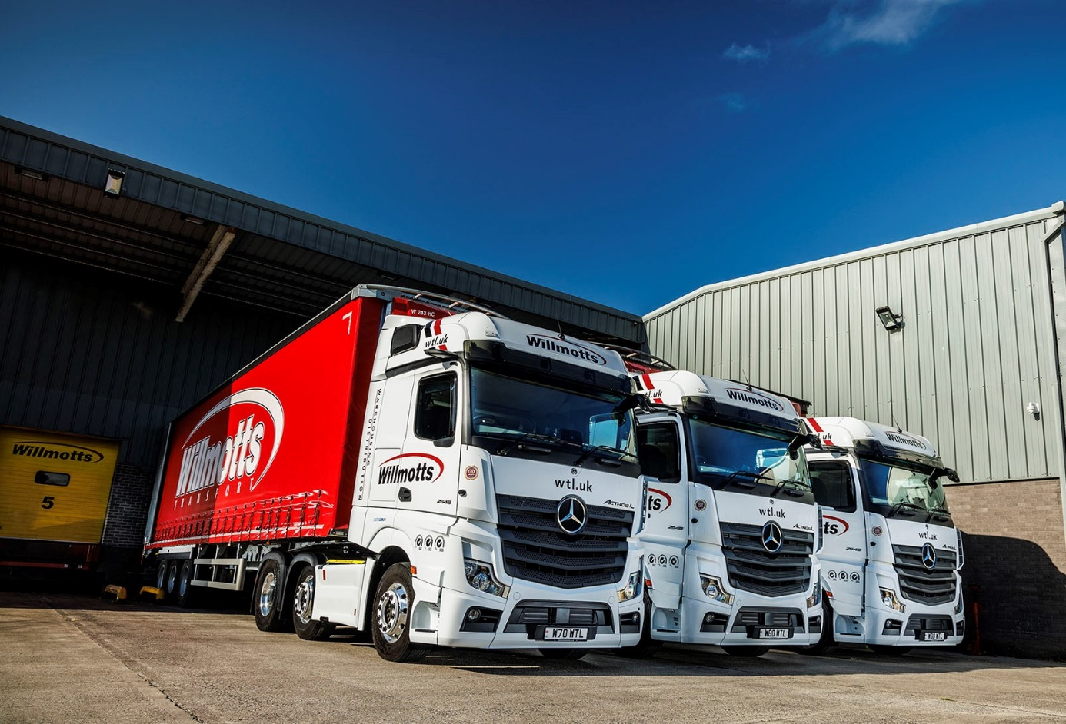

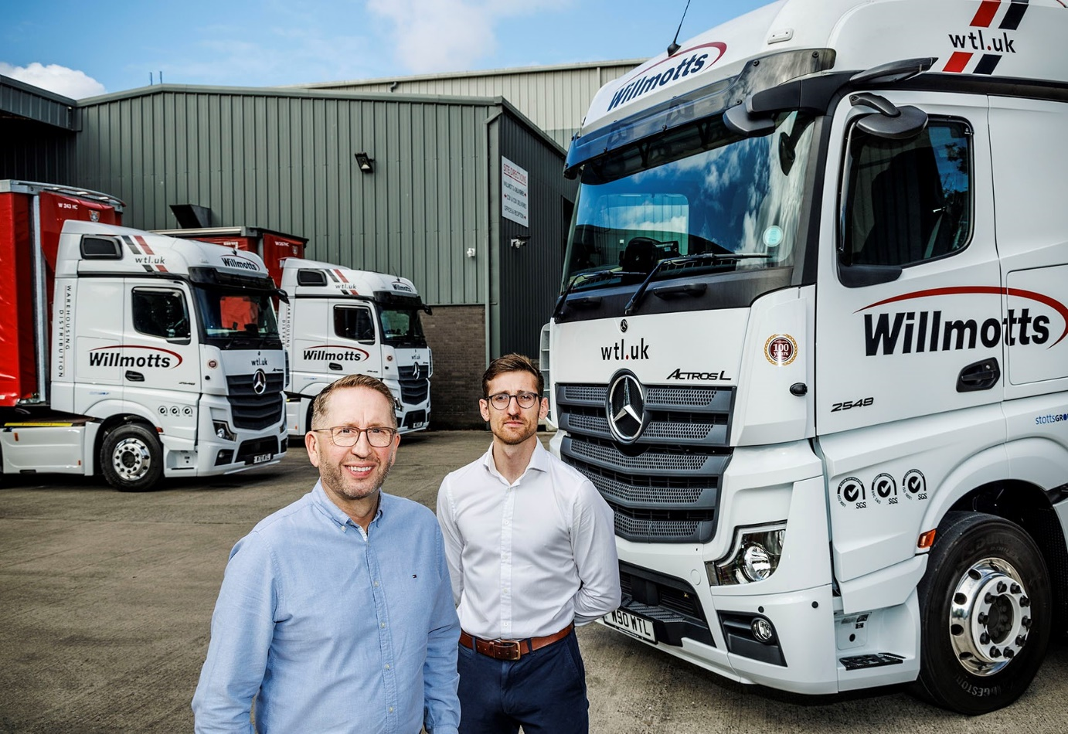

Out in front: Willmotts Transport Chairman and owner Andy Stott is pictured, left, with Managing Director Dan Gray, and three of their new Mercedes-Benz Actros; Transport & Compliance Director Andy Tuck was unavailable on the day the photographs were taken

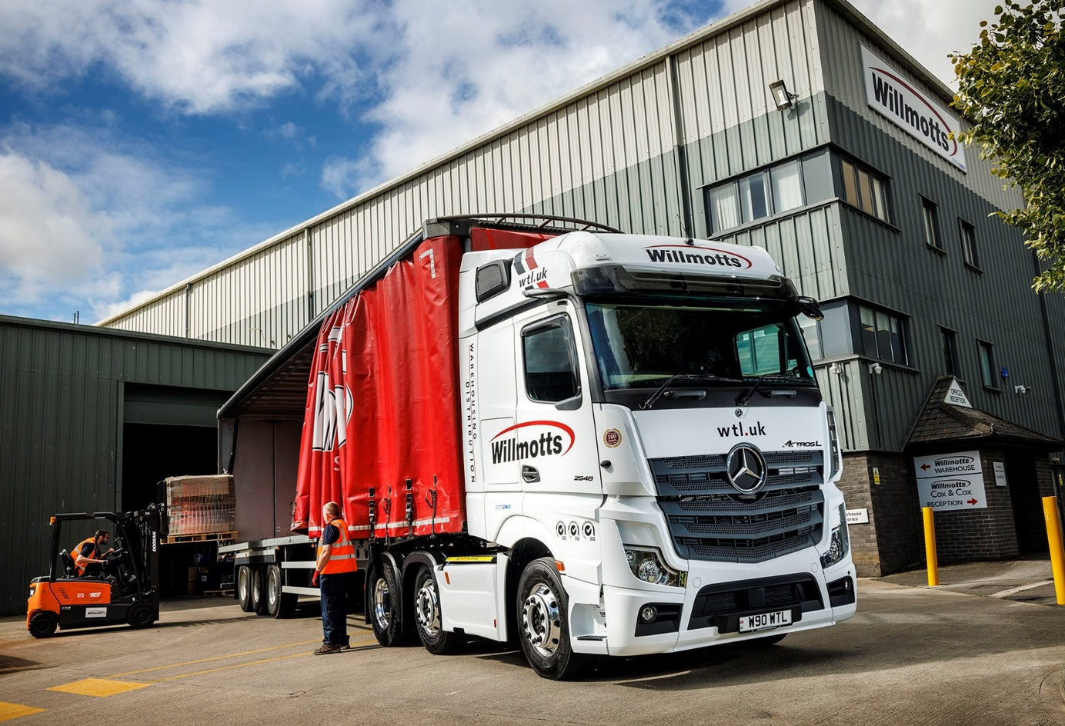

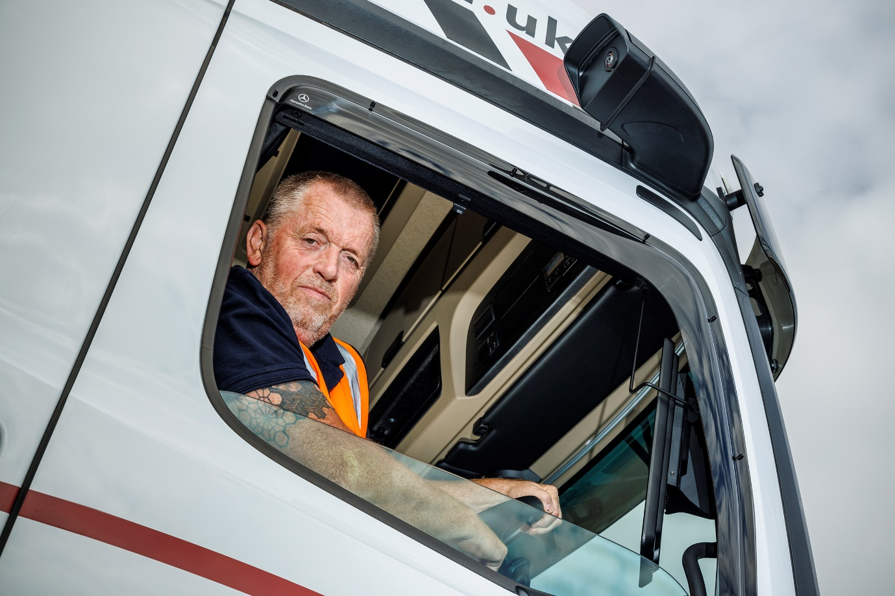

Innovation in action: Willmotts Transport driver Jon Payne is benefiting from the enhanced performance of his new truck’s second-generation MirrorCam technology

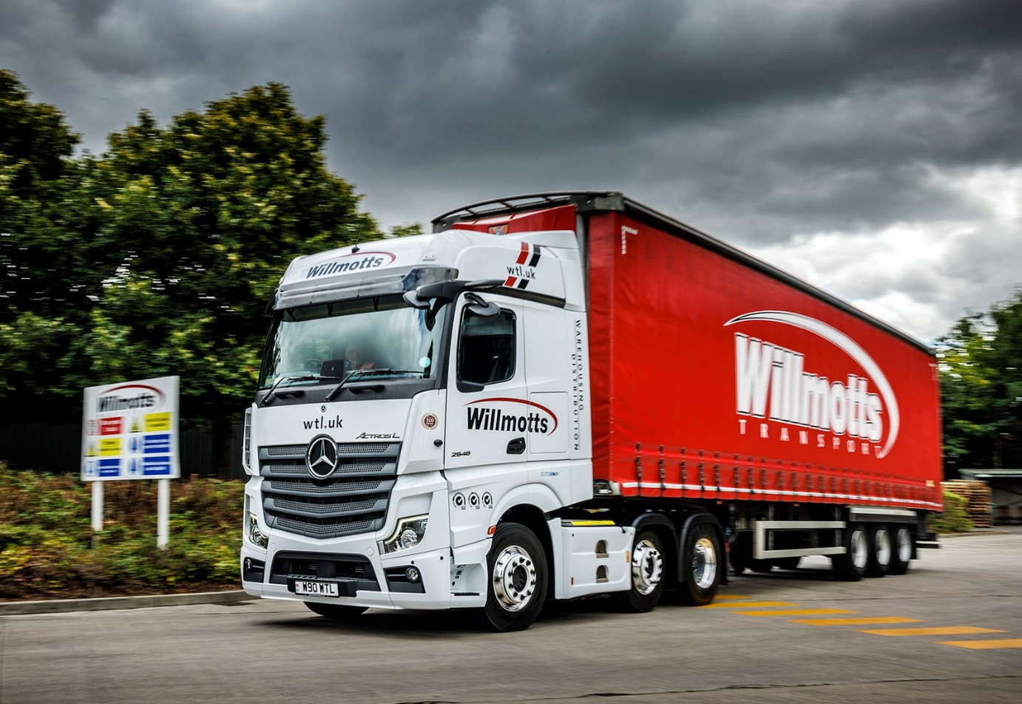

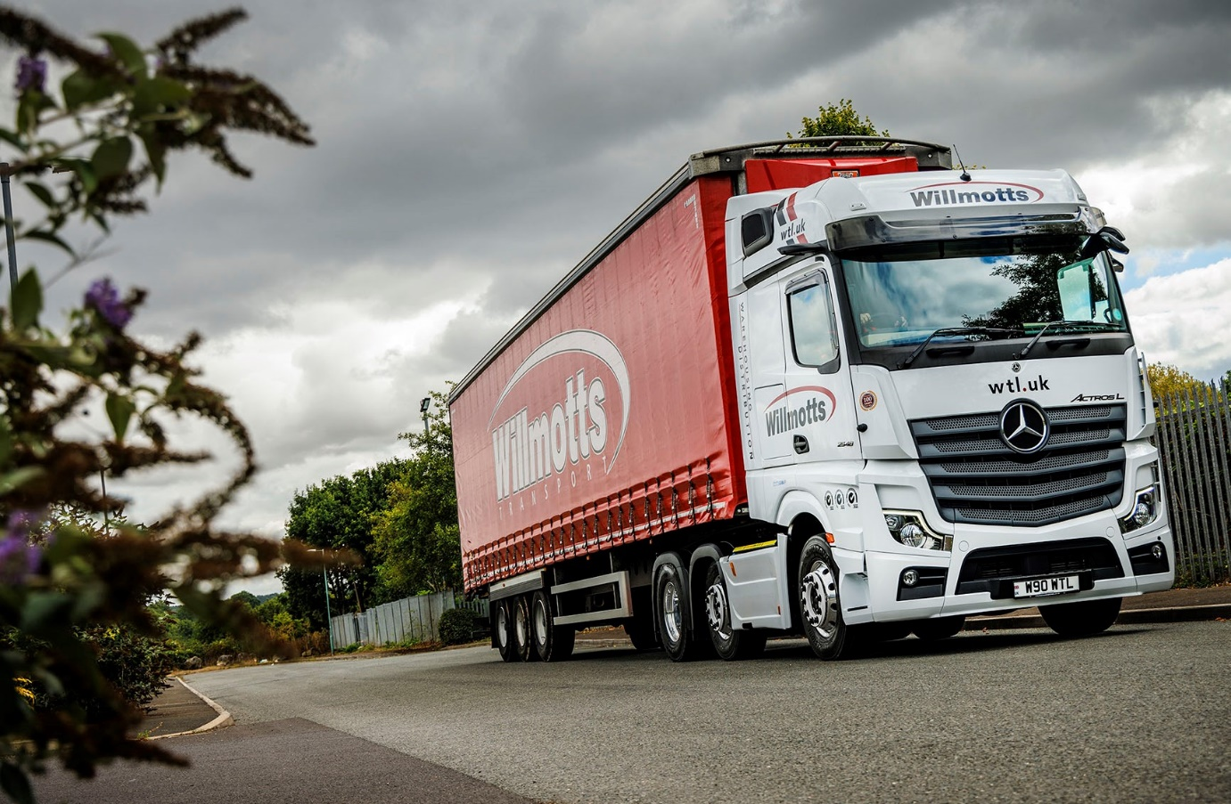

ends

For more information, or to request bigger/higher-res image files, please contact:
Steve Warren or John Ripley
Impact Communications
Steve: 07770 470251, steve@impactcom.co.uk
John: 07771 484595, john@impactcom.co.uk

