

Date: 13 May 2025

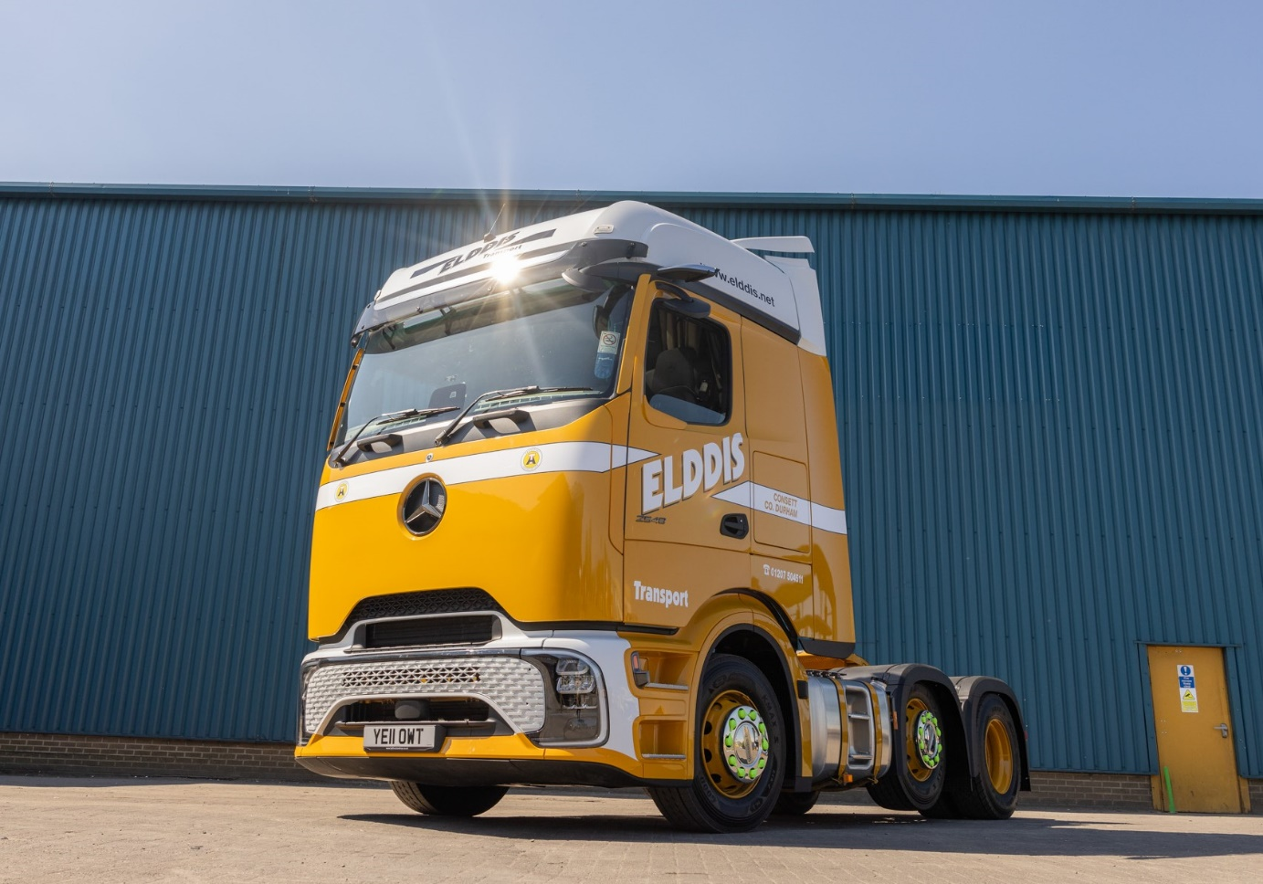

Elddis goes flat out for North East’s first Mercedes-Benz Actros L ProCabin

High-profile haulier Elddis Transport has continued its tradition of investing early in the latest Mercedes-Benz truck technology – taking delivery of the first Actros L ProCabin to hit the roads in the North East.

The Actros L 2548 is the first of a batch of eight ProCabins, all to be supplied to Consett-based Elddis by Dealer Bell Truck and Van over the next four weeks.

The Actros L ProCabin’s innovative design makes it already the most distinctive truck on the road, but in unmistakable Elddis livery and with the registration YE11 OWT (Yellow Truck) this vehicle is sure to be noticed wherever it goes.

“The Actros L ProCabin has been described as a ‘Marmite’ truck, but we love it,” said Elddis Executive Chairman Nigel Cook. “It's different, but that is what state of the art often is.
“In fact the truck was already attracting attention before we even took delivery – I put an early photograph of it on our Facebook page and it was viewed 320,000 times in just a few days!

“These trucks make a bold statement but investing in the Actros L ProCabin is no leap in the dark,” he continued. “We know we can trust the vehicle because behind that futuristic face it has the same high-quality Mercedes-Benz engineering that we’ve been relying on for years.”

The ProCabin owes its unique appearance to the smooth front panel – but this is not just a visual gimmick, as the cab’s improved aerodynamics also bring a fuel efficiency improvement of up to three percent.

The Elddis trucks are powered by 350 kW (476 hp), 12.8-litre in-line six-cylinder engines from the third-generation OM 471 family, which is engineered for optimum driving dynamics and efficiency. Their Big ProCabins feature premium bunks and heated seats, fridges and luxury touches such as ambient lighting and extra USB-C sockets in the side walls.

The fresh design is much more than skin-deep too – Actros L ProCabin trucks all boast a full suite of technological enhancements to boost both efficiency and safety. These include the latest version of Mercedes-Benz Active Brake Assist, now in its sixth generation, as well as Active Sideguard Assist and Front Guard Assist. Together these and other standard systems help the vehicle meet or exceed the latest General Safety Regulations.

Meanwhile driver comfort and efficiency are enhanced by Predictive Powertrain, and the My TruckPoint platform provides a range of over-the-air services direct to the cab.

The new truck’s first assignment was an appearance at the Transport Association’s 70th anniversary celebration event, held at the Silverstone racetrack – after which it went off to be fitted with a bespoke air management kit to maximise aerodynamic efficiency when working with Elddis’s high-cube trailers, before starting work in earnest.

Elddis Transport has been an enthusiastic supporter of the Actros, and early adopter of its many technological innovations, since day one – and has also set a succession of specially-finished Actros on the road to mark various milestones, charity initiatives or customer associations. Its fleet of more than 160 trucks is heavily dominated by the three-pointed star.

The operator has forged close links with Bell Truck and Van too – the Dealer runs a vehicle maintenance unit on the Elddis headquarters site where all its Actros tractors are maintained.
“We’ve been very well served over the years by our Mercedes-Benz trucks, while the support we’ve received from Bells has been first class,” said Mr Cook.

Elddis Transport in its present form has been a well-known name in UK haulage since the 1970s but the family’s roots in the industry stretch back much further. Mr Cook’s great-grandfather Thomas Cook set up in business with a single horse and cart in the late 1800s, while his son Siddle C. Cook famously ran one of the country’s best-known heavy haulage firms in the 1950s and ’60s. Nigel Cook’s father Geoffrey established the current business.

Elddis has built on its family ethos and retains a high level of loyalty from customers and long-serving staff. Today, while working across a broad range of sectors, it is highly regarded for its expertise in the demanding FMCG market, providing transport, warehousing and distribution services across the UK.

www.elddis.net

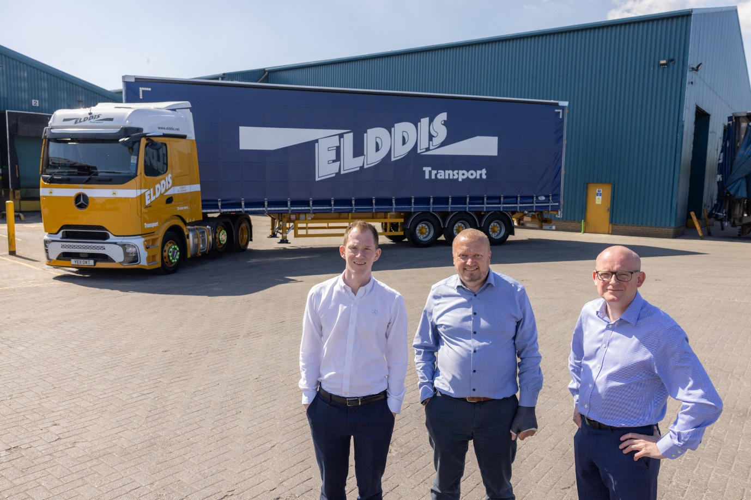

Productive partnership: Elddis Transport Executive Chairman Nigel Cook is flanked by Group Truck Sales Manager Alex Wordsworth of Dealer Bell Truck and Van, left, and Daimler Truck UK Key Account Manager Matt Lee.

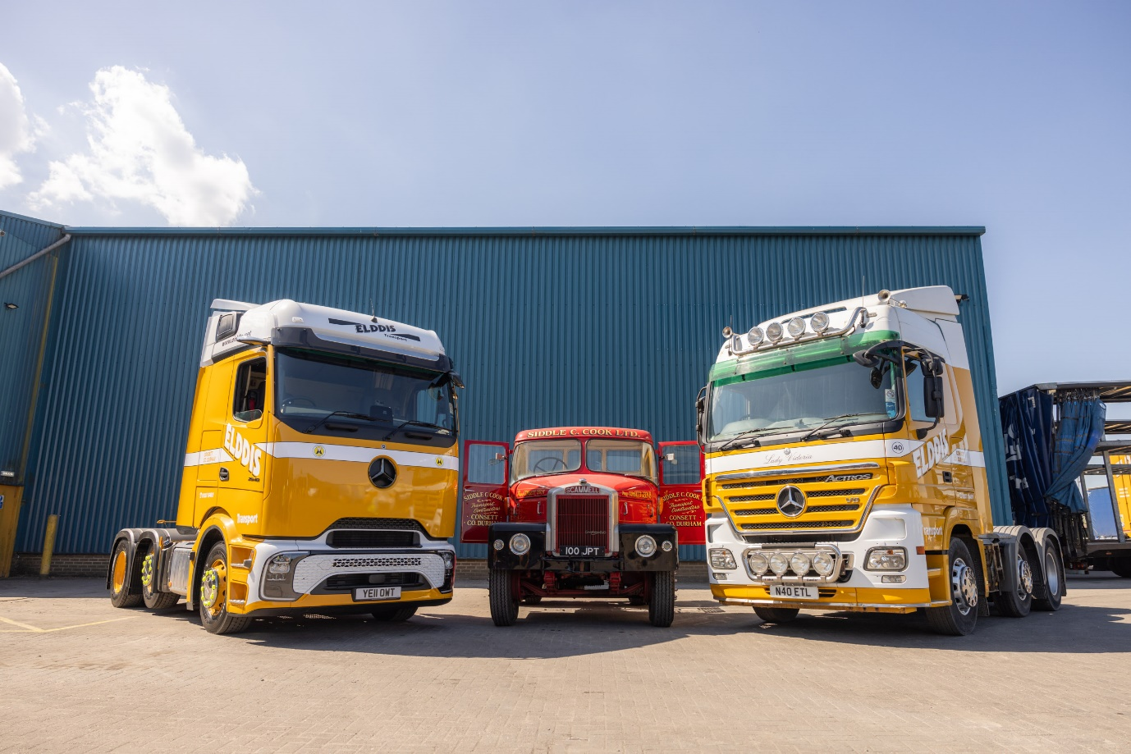

Family values: Elddis Transport’s new Actros L ProCabin with the fleet’s V8-powered Actros that bears the name ‘Lady Victoria’, after Chairman Nigel Cook’s wife, and a Scammell heavy hauler in the livery of Nigel’s grandfather Siddle C Cook.

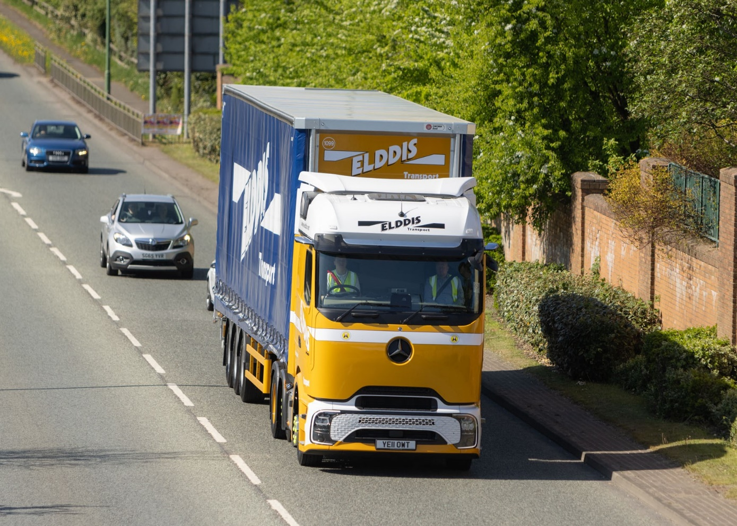

ends

For more information, or to request bigger/higher-res image files, please contact:
John Ripley: 07771 484595, john.ripley@loopagency.co.uk

