

Date: 2 August 2023

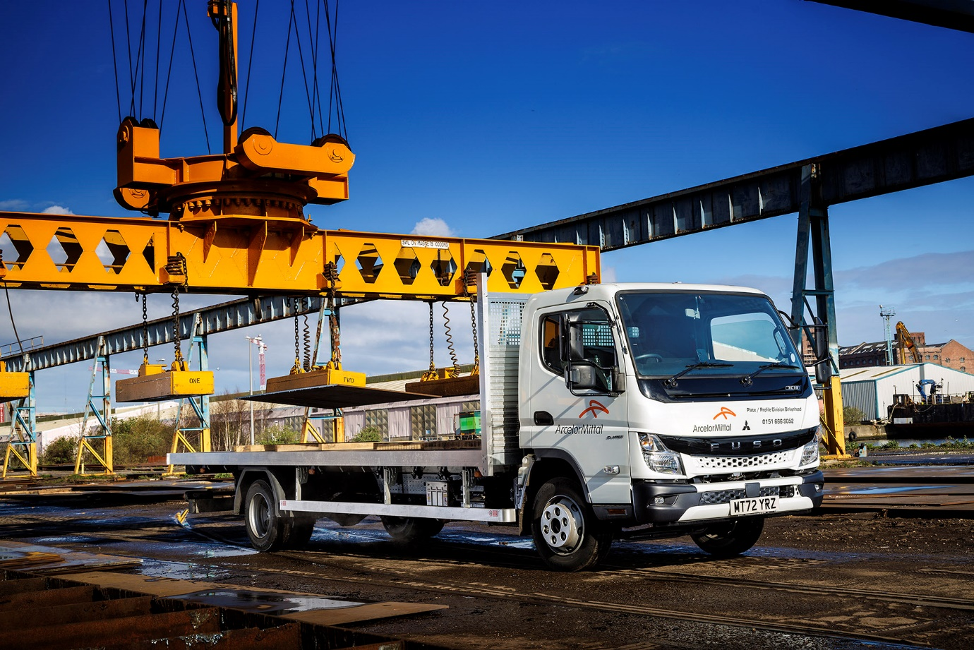

FUSO Canter steps up to the plate for ArcelorMittal

Global steel manufacturer ArcelorMittal needed a tough little truck with a big appetite for payload, to handle deliveries from Merseyside to customers across the North of England.

Maximum load-carrying ability in a compact package was the prime requirement – which meant a 7.5-tonne FUSO Canter fitted the profile exactly.

ArcelorMittal’s Canter, from the all-new range introduced last year, was supplied by Dealer eStar Truck & Van.

The operator’s depot at Birkenhead supplies a wide variety of steel plates and profiles. Much of this goes to large manufacturing customers including the famous Cammell Laird shipyard, just over a mile away, where it is used in the construction of ships and submarines.

“These consignments include profiles cut from plate to exacting measurements, and the deliveries are handled by third-party hauliers. Most of the vehicles leaving the yard are in the 28 to 44-tonne GVW range,” said Transport Production Co-ordinator Elliott Taylor.

“We also receive a significant number of orders from smaller-scale customers, though. They don’t need such heavy items and, very often, their premises are quite tricky to get a truck into. When we decided to invest in a vehicle of our own to handle this work, it was clear we needed something that would give us the biggest ‘bang for our buck’ on payload but also be compact and manoeuvrable enough to get in and out of sites where access is tight.”

He continued: “We looked at several alternatives but there was nothing available that could match the 7.5-tonne FUSO Canter. With its aluminium platform body ours can easily carry over four tonnes, which is far ahead of anything else we looked at in the same gross weight category. The compact footprint and tight turning circle make it very agile, so for the sort of deliveries we ask it to perform, the Canter really is extremely well suited.

“The service from eStar Truck & Van was excellent too. They understood our needs completely and also handled all liaison with the bodybuilder. The service contract package they put together for us means we can budget forwards with confidence, knowing exactly what our running costs for the vehicle will be.”

As a 7C18 model, the Canter is powered a 3.0-litre common-rail powerplant that generates a range-topping 129 kW (175 hp) and up to 430 Nm of torque, and is paired with a smooth-shifting DUONIC dual-clutch automated manual transmission with Eco Mode, Parking and Creep functions. A compact exhaust system means the model meets the EURO VI – STEP E emission standard. Its 20ft platform is by Commercial Body Specialists, also of Stoke-on-Trent. Like all new Canters, it also came with a three-year, unlimited mileage warranty.

The vehicle is now working across the North-West, and as far afield as Yorkshire and the West Midlands, on a daily basis.

“It’s performing very well, is well liked by our driver and, with eStar’s support package, has proved to be an excellent choice. We’re delighted with our FUSO Canter,” Mr Taylor asserted.

distribution.arcelormittal.com/en-UK

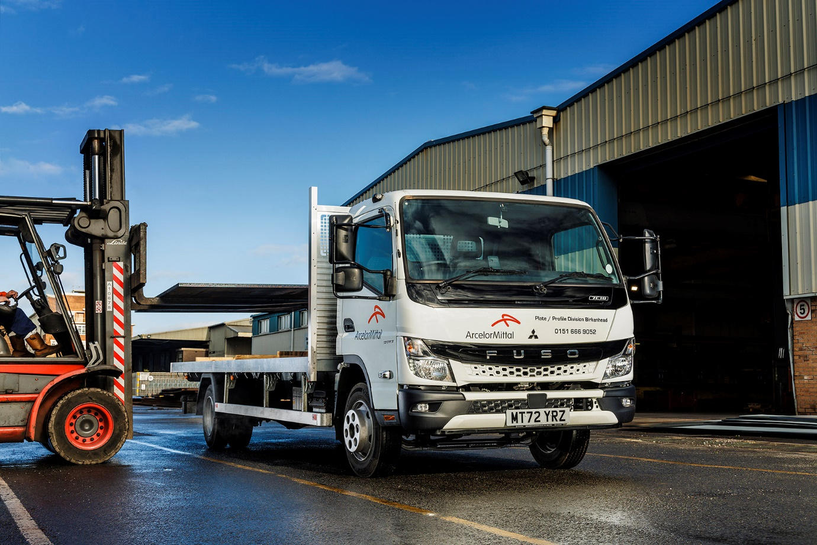

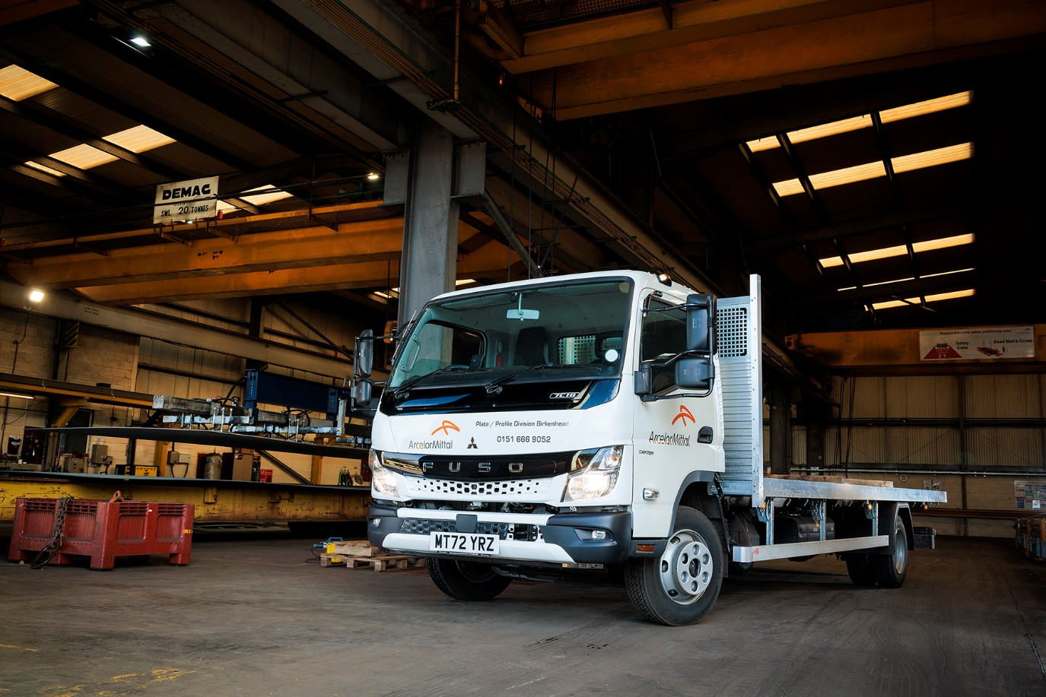

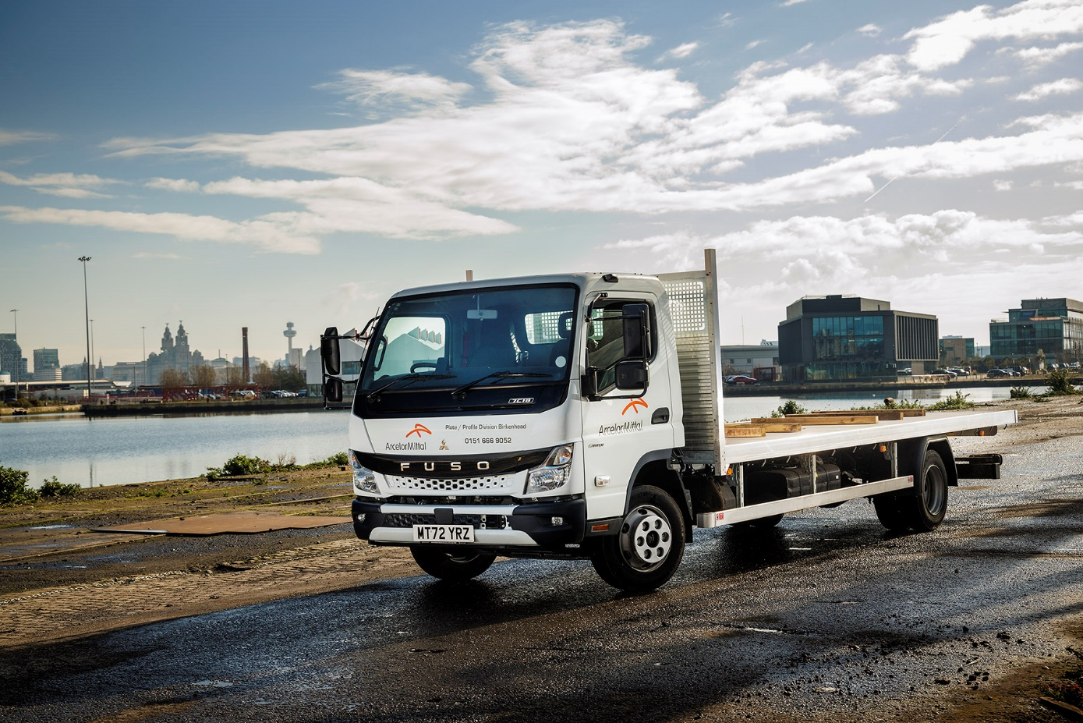

ends

For more information, or to request bigger/higher-res image files, please contact:
John Ripley: 07771 484595, john.ripley@loopagency.co.uk

