

Date: 6 July 2022

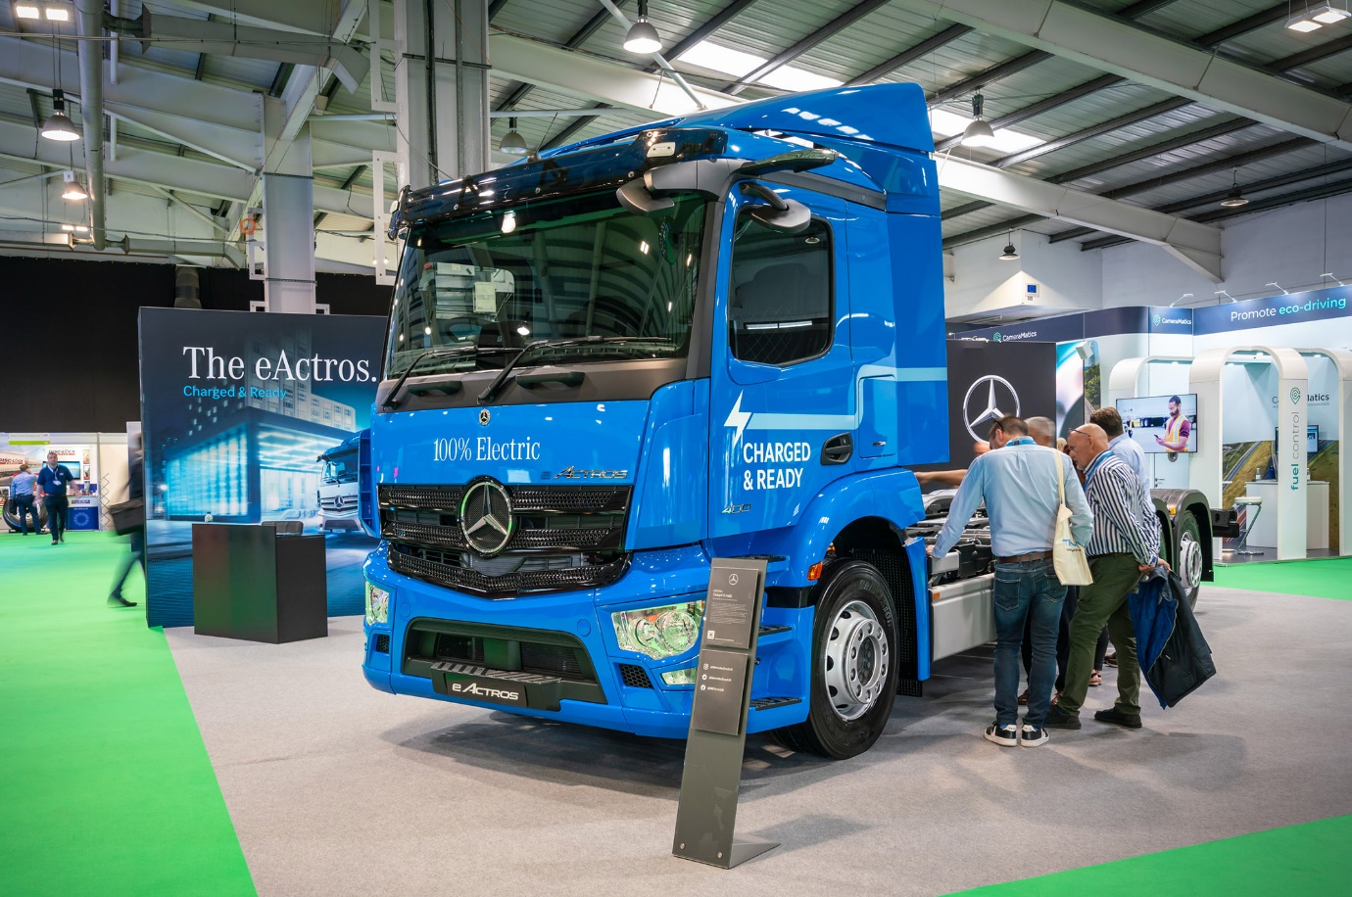

Mercedes-Benz Trucks leads the Road Transport Expo charge with eActros UK debut

Operators, drivers and other sector professionals made a bee-line for the Mercedes-Benz Trucks presentation at the inaugural Road Transport Expo, where the fully electric eActros and new FUSO Canter were being shown for the first time in Britain.

The ground-breaking eActros, which produces zero tailpipe emissions, is aimed at those engaged in heavy-duty, short-haul distribution roles and heralds the dawn of a new age of sustainable road transport. Having already excelled in a comprehensive programme of ‘real world’ testing, it is now on sale to UK operators as a 4x2 or 6x2 rigid.

The 27-tonne eActros 400 took pride of place on Mercedes-Benz Trucks’ stand at last week’s event, which was staged at the NAEC Stoneleigh. The vehicle is powered by four 112 kWh lithium-ion batteries and provides a maximum range of 249 miles (400km). It offers a maximum body and payload allowance of 16.6 tonnes.

The eActros 300, meanwhile, employs three batteries and will cover up to 186 miles (300km) between charges. It is also available in three-axled form, or as a two-axled chassis with 19-tonne gross weight. The combined body and load carrying capacity of the 19-tonne variant is 10.6 tonnes, a figure that rises to 17.7 tonnes for the 27-tonner.

Mercedes-Benz Trucks and its official Dealer network are also responsible for sales and support of the FUSO Canter light truck range in Britain. The new FUSO Canter unveiled at Road Transport Expo incorporates an eye-catching, redesigned cabin, while also offering improvements in safety and comfort.

The Canter still comes in four weight classes (3.5-8.55 tonnes), eight wheelbases (2,500 mm to 4,750 mm), and with three engine output variants (130 hp to 175 hp). In a new departure, however, 3.5-tonne Canters are now available for first time in right-hand drive form with a 1.7m-wide S (standard) cabin, which can be specified as an alternative to the 2.0m width of the established C (comfort) cab. Crewcab variants continue to be offered in several weight classes.

Customers for Canters with the S-cab can also choose a new, bodybuilder-friendly wheelbase of 3,400mm.

The 3S13 displayed at Road Transport Expo allowed visitors to see the narrow cab for the first time. Powered by a 96 kW (130 hp) 3.0-litre turbodiesel engine, the show vehicle was fitted with a dropside body.

Further highlights of the Mercedes-Benz Trucks presentation at Stoneleigh included a 6x2 Econic 2630 refuse collection vehicle, with the renowned low-entry cab and fully glazed passenger door that allows it to achieve a five-star Direct Vision Standard rating; an all-terrain Unimog U319 implement carrier; a pair of stunning silver tractor units in the shape of a mighty Arocs 3363 and luxuriously equipped Actros L 2553 – both with the new, improved version of MirrorCam which features even more streamlined camera housings; and another Actros tractor unit promoting the Mercedes-Benz Certified Used Trucks programme.

Others – including a fully electric FUSO eCanter – were among the biggest draws at the events Ride & Drive, while Mercedes-Benz Trucks UK eConsultancy Manager James Venables gave one of the first day’s keynote speeches, on the latest urban vehicle technology and the strides manufacturers are making to help operators keep pace with evolving safety and emissions regulations.

Elsewhere, examples of Mercedes-Benz and FUSO vehicles were on display in the colours of various operators and ancillary suppliers, across the exhibition site.

Kathryn Mitchell, Head of Marketing Communications, PR and Events at Mercedes-Benz Trucks, declared: “We were delighted to play our part in supporting the first Road Transport Expo, to showcase our comprehensive range of vehicles and to meet so many operators, drivers and enthusiasts. The launch of the eActros is a major milestone in the history of Mercedes-Benz Trucks and it was very exciting to be able to display this ground-breaking vehicle to a UK audience for the first time.”

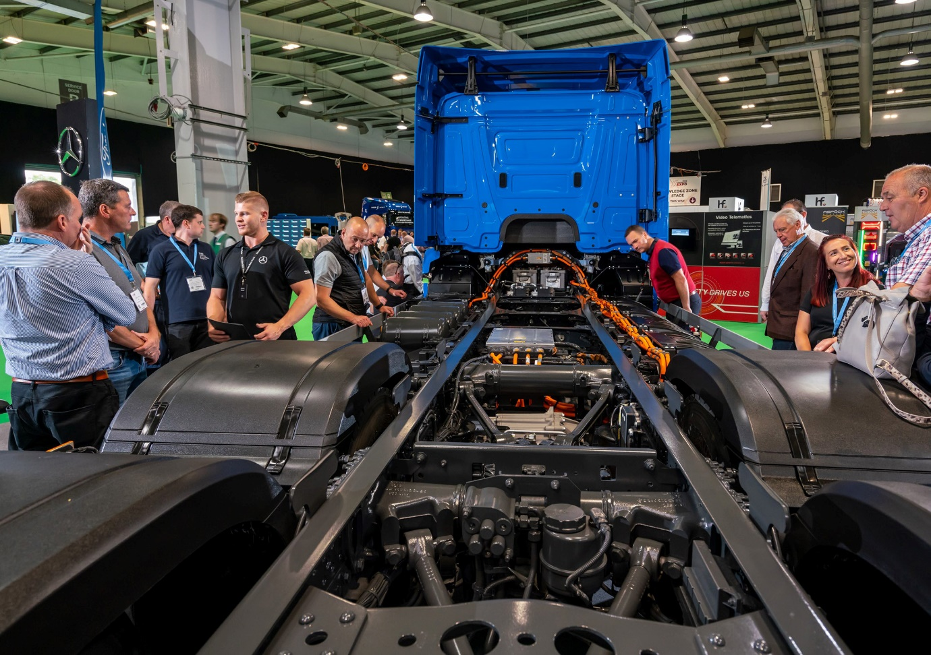

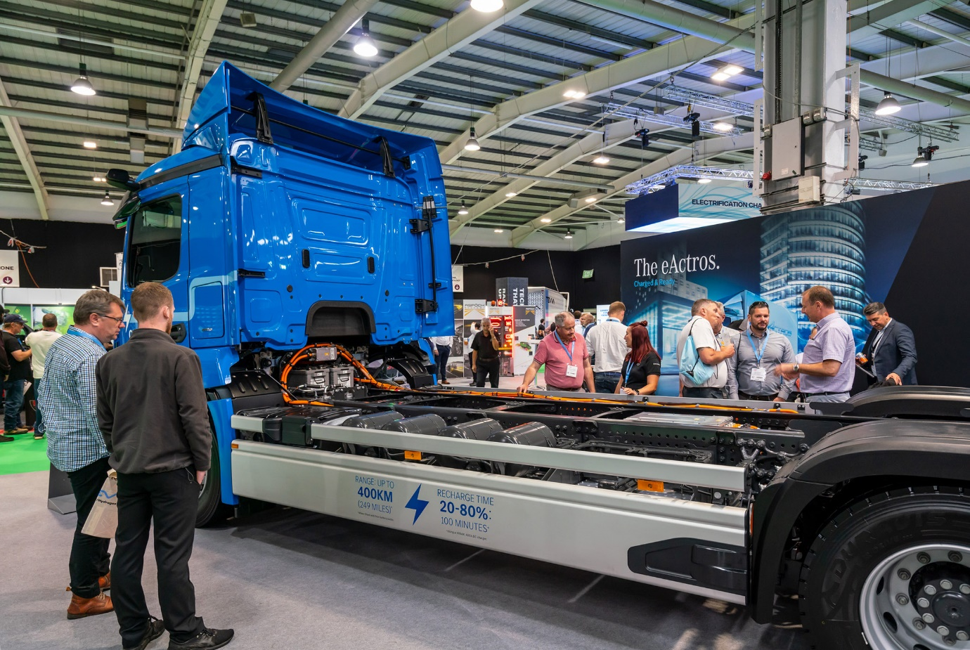

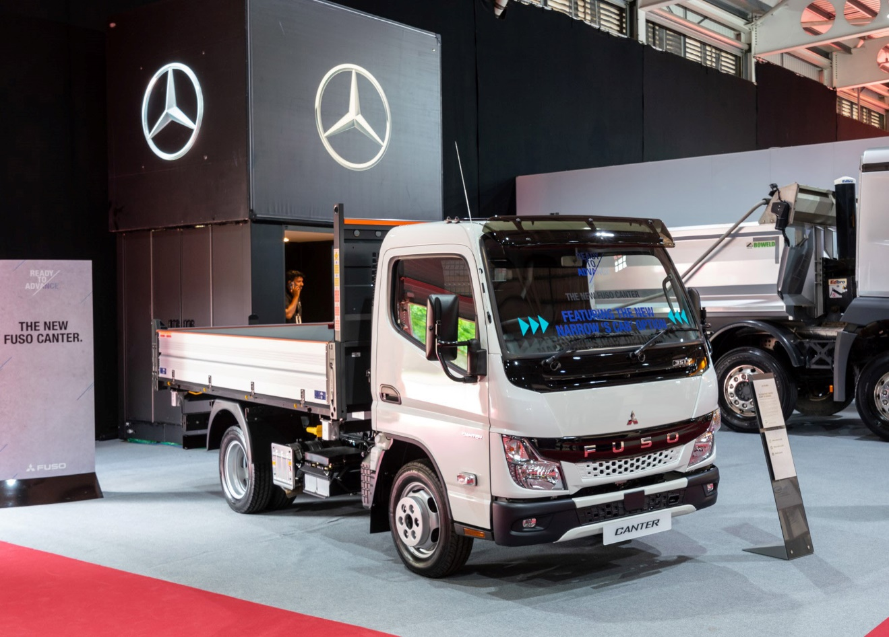

Compact contender: Seen here in 2,500mm wheelbase form, the FUSO Canter with 1.7m-wide S Cab is likely to be a hit with operators working in locations where access is tight

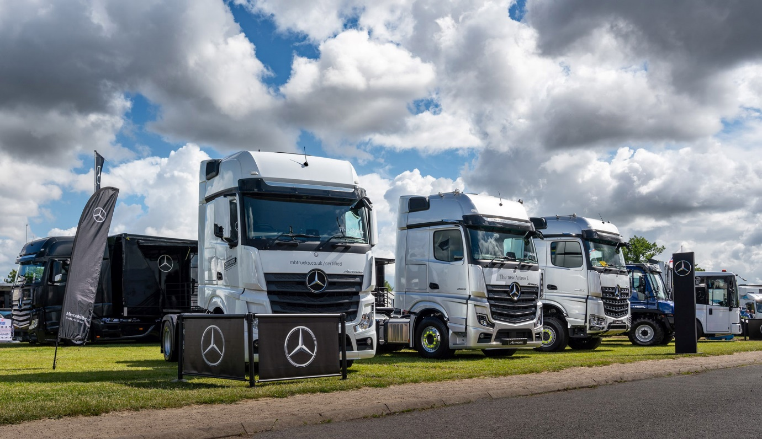

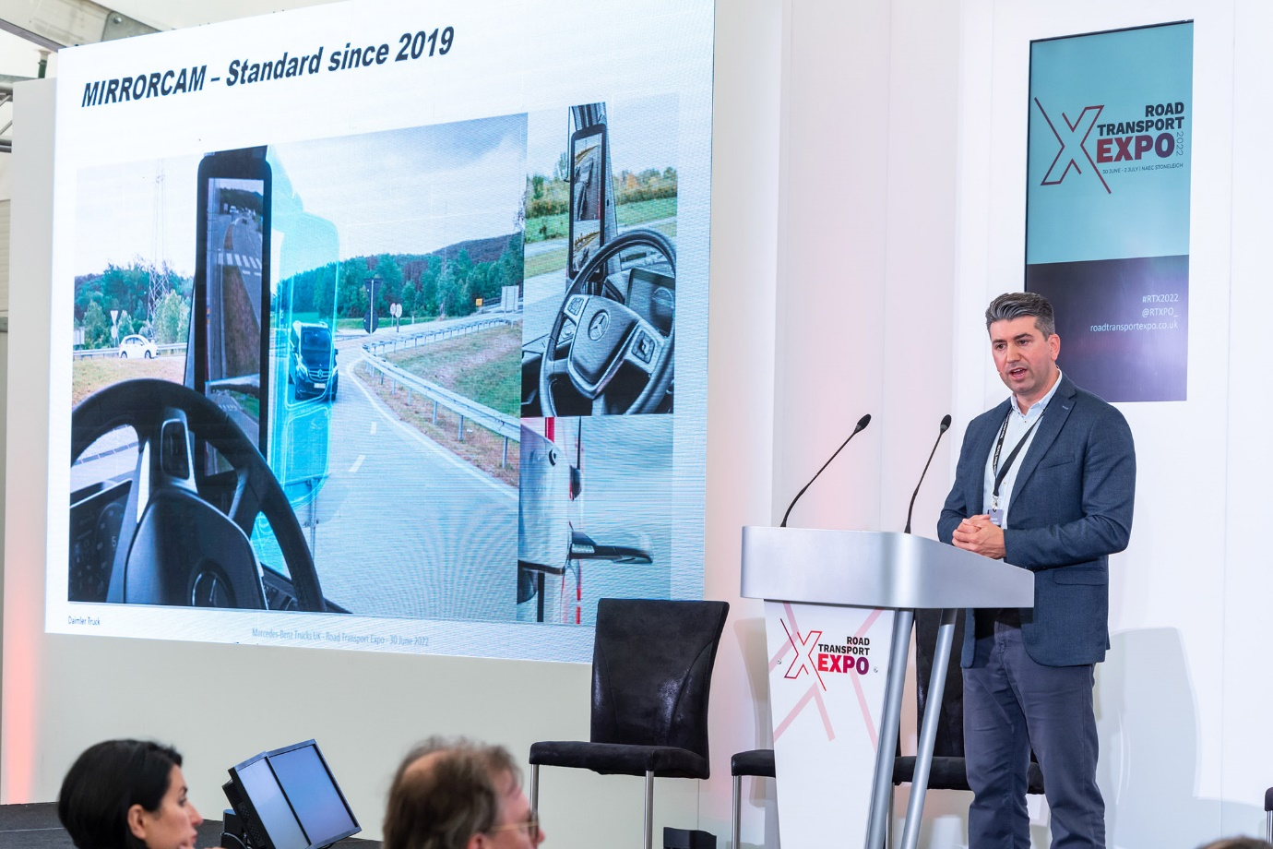

Keynote speaker: Mercedes-Benz Trucks eConsultancy Manager James Venables

ends

For more information, or to request higher-res image files, please contact:

Jamie Fretwell at Mercedes-Benz Trucks UK Ltd
07712 519230, jamie.fretwell@daimler.com

or

John Ripley, Impact Communications
John: 07771 484595, john@impactcom.co.uk

