

Date: 15 July 2021
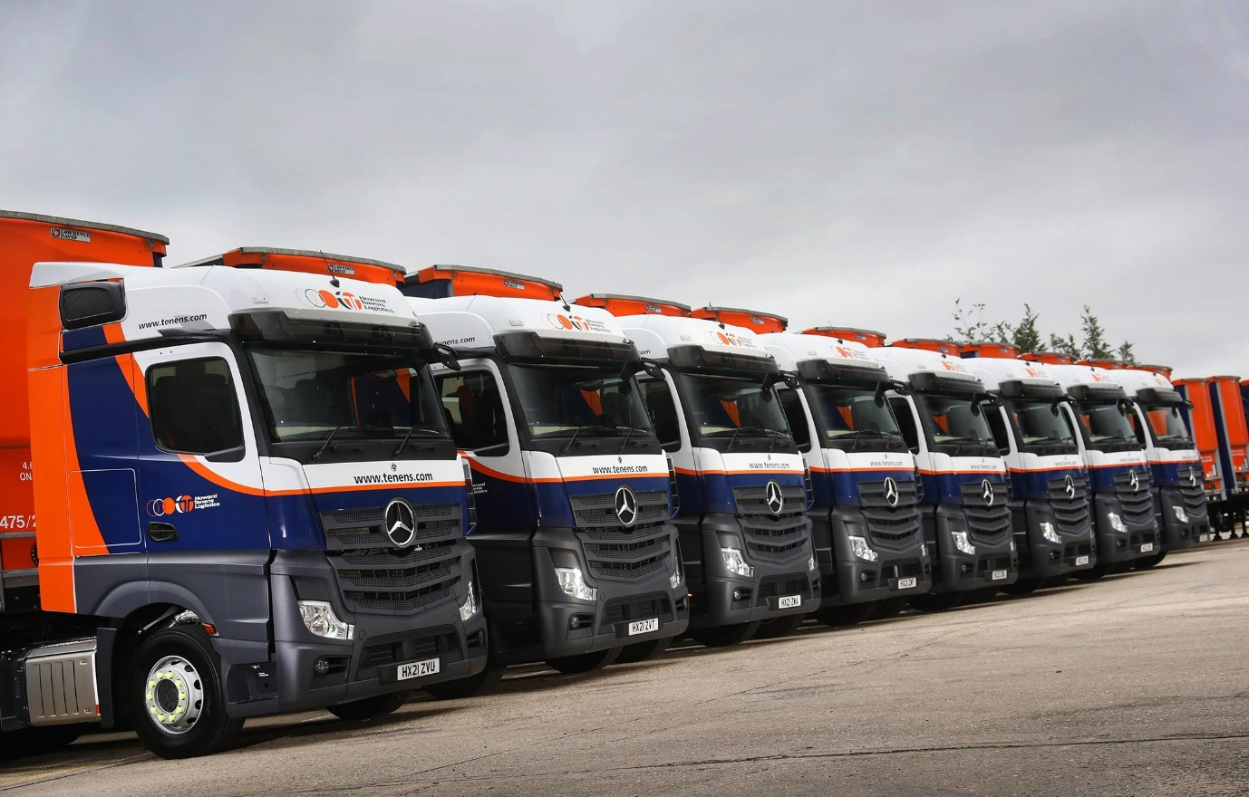
Top trucks with back-up to match – Howard Tenens Logistics updates its Andover fleet with 16 new Mercedes-Benz Actros

Outstanding aftersales support was every bit as important as the safety and fuel-efficiency of the trucks themselves in convincing Howard Tenens Logistics to purchase its first new-generation Mercedes-Benz Actros.

The 16 tractor units were supplied by Marshall Truck & Van and work from the family-owned operator’s Andover branch. The subject of a Mercedes-Benz Complete Service Contract, they are now being inspected and maintained at the Dealer’s workshop in the Hampshire town – Marshall’s team also looked after the leased units from the last Actros model range, that have been replaced.

The new trucks have flat-floored BigSpace cabs and, as 2545 variants, are powered by 12.8-litre, ‘straight-six’ engines in 330 kW (450 hp) trim. They are easily distinguished from their predecessors due to the absence of conventional mirrors; instead, they are equipped with roof-mounted MirrorCam cameras.

By providing much enhanced rear visibility and eliminating forward-facing blind spots, MirrorCam represents a major leap forward in terms of safety. So, too, does the latest Active Braking Assist 5 emergency braking technology, which now employs a camera as well as radar, and is even more responsive – at speeds of up to 50 kph, the system can apply full braking automatically when encountering a pedestrian crossing its path.

Both are standard-fit Mercedes-Benz features. Underlining Howard Tenens’ commitment to the protection of its drivers, their colleagues and other road users, it has also added a full suite of safety cameras and sliding fifth wheels with sensors that issue alerts if trailers are not coupled correctly.

Howard Tenens Logistics operates from headquarters in Stroud, Gloucestershire, and a network of 20 locations with premium warehousing nationwide. The company owns a fleet of 100 trucks, 60 of them tractor units, that includes Mercedes-Benz vehicles based at Birstall, in West Yorkshire, and Swindon. It supplements this core fleet with substantial numbers of rented vehicles.

Howard Tenens’ decision to buy outright the 16 new tractor units that work from Andover, rather than to lease again, followed confirmation that the biggest customer served by this depot was renewing and extending its contract.

One of Marshall Truck & Van’s Actros demonstration units underwent week-long trials, first at Andover, and then at two other Howard Tenens locations, with instruction provided at each by the Dealer’s Key Account Manager Bill Kingsmill and TRUCKTrainer Andy Parker. The feedback was resoundingly positive.

Alan Pellow, the operator’s National Fleet & Compliance Manager, recalled: “The demo went very well. After a little bit of familiarisation everybody liked the MirrorCam, while the new-generation model was also about half a mile per gallon better on fuel, which holds out the promise of some very welcome savings.”

MirrorCam contributes to economy, as well as safety and driver comfort – Mercedes-Benz estimates an improvement of up to 1.5% – because the compact and streamlined camera housings offer significantly less wind resistance than mirrors. The Actros also benefits from enhanced aerodynamics and updates to the well-proven Predictive Powertrain Control system, which manages gear changes for optimum efficiency.

Howard Tenens Logistics also specified the optionally upgraded version of Mercedes-Benz Trucks’ radical new dashboard, which replaces traditional switchgear with stylish and intuitive twin screens. Multimedia Cockpit, interactive, comes with a larger, 12in instrument panel and extra functionality, including satellite navigation.

Mr Pellow continued: “The truck looks great, but aftersales support is just as important. The experience of working with Marshall Truck & Van on the leased vehicles over the last three years was a key factor in our decision to place this order with Mercedes-Benz. The Dealer’s back-up is superb – General Manager David Collard and his workshop team are very helpful and can always be relied upon to get a truck in when we need them to do so.”

Alan Pellow’s comments were echoed by Howard Tenens Logistics Executive Director Ben Morris, who attended the international launch of the fifth-generation Actros in Barcelona, and by Kevin Witts, who manages the company’s Andover depot.

Mr Morris commented: “Marshall Truck & Van have done a really good job of ensuring the seamless changeover of the fleet, and have also helped us to extend the maintenance contracts on some of the leased vehicles, which are now working elsewhere within the group.

“The Dealer provides an excellent service, while I love all of the new technology on the Actros. From a safety perspective in particular, MirrorCam is a big step forward and definitely puts Mercedes-Benz ahead of its competitors.”

Kevin Witts added: “I’ve been in this industry for years and Marshall is the best main Dealer I’ve ever worked with. They are honest and up front, where a lot aren’t, and if I’m struggling to get a vehicle into the workshop they will always move things around to accommodate me. That’s all any transport manager can ask for.”

Established in 1953 and now one of the UK’s largest independently-owned and operated logistics companies, Howard Tenens prides itself on its proactive and flexible approach, commitment to innovation, and ability to provide finely-tailored solutions. It serves a broad portfolio of customers working across multiple sectors, including automotive, retail and FMCG, packaging and renewable energies.

tenens.com

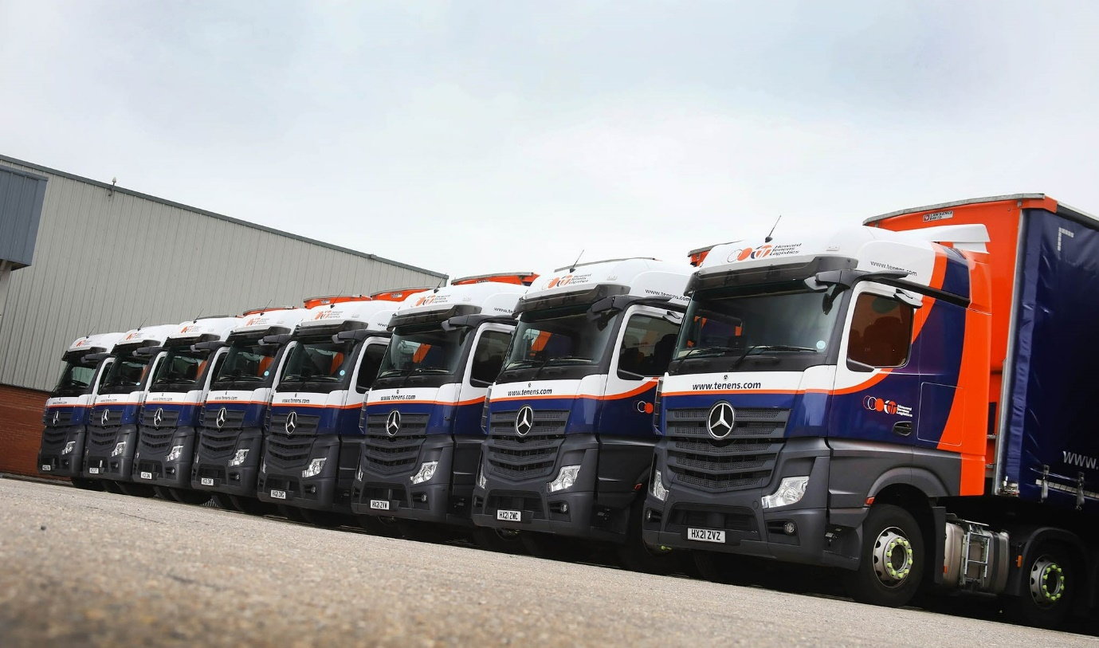
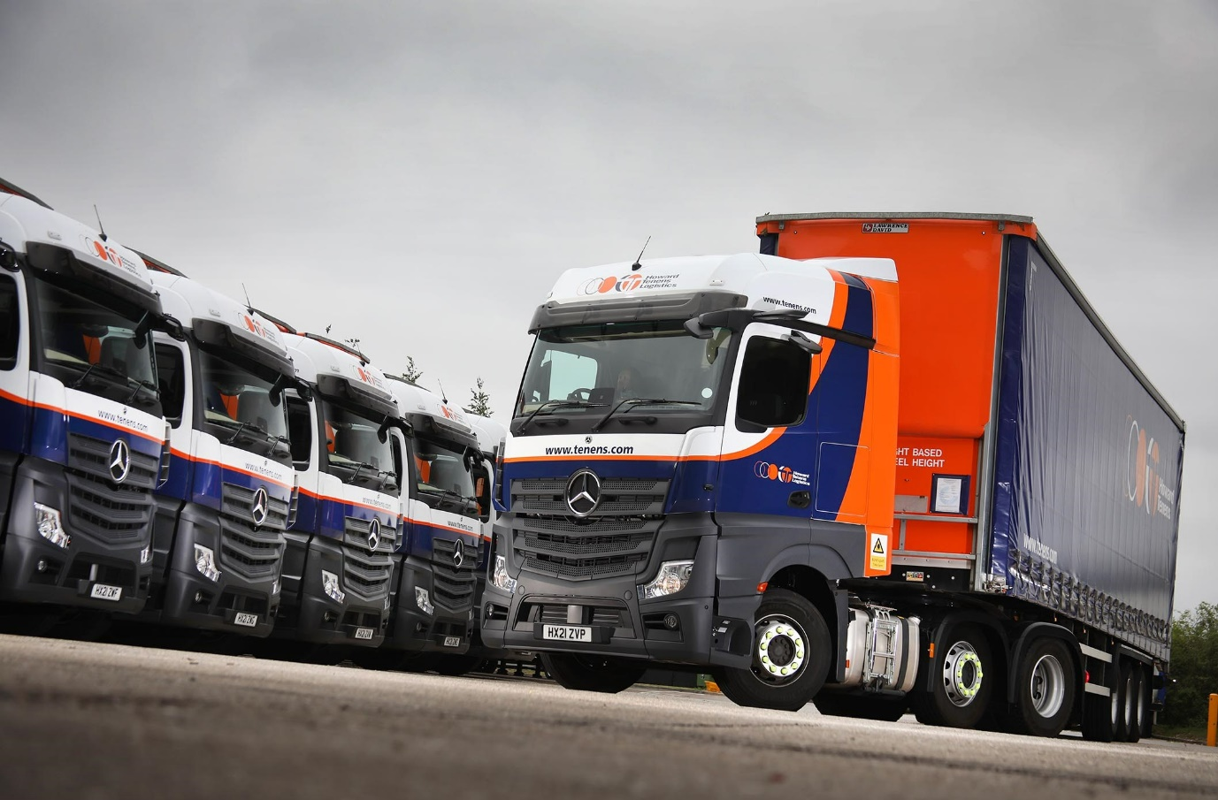

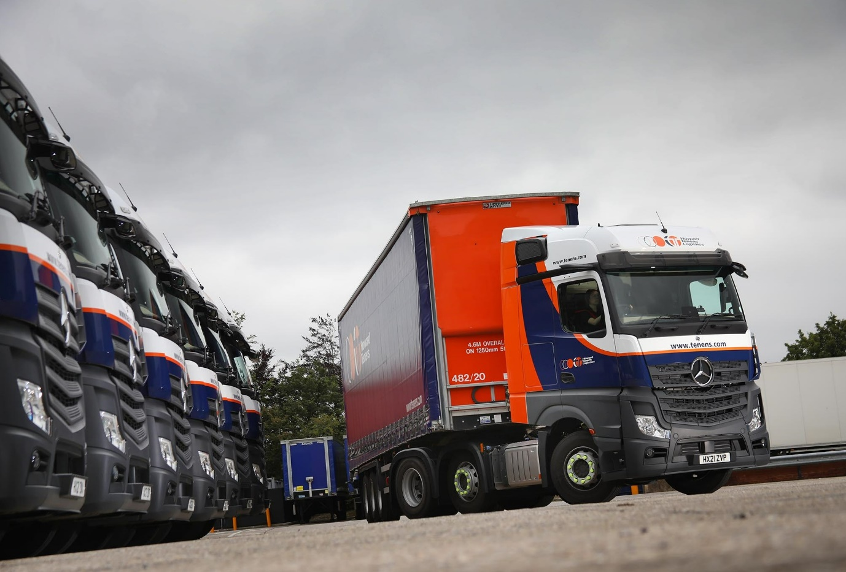

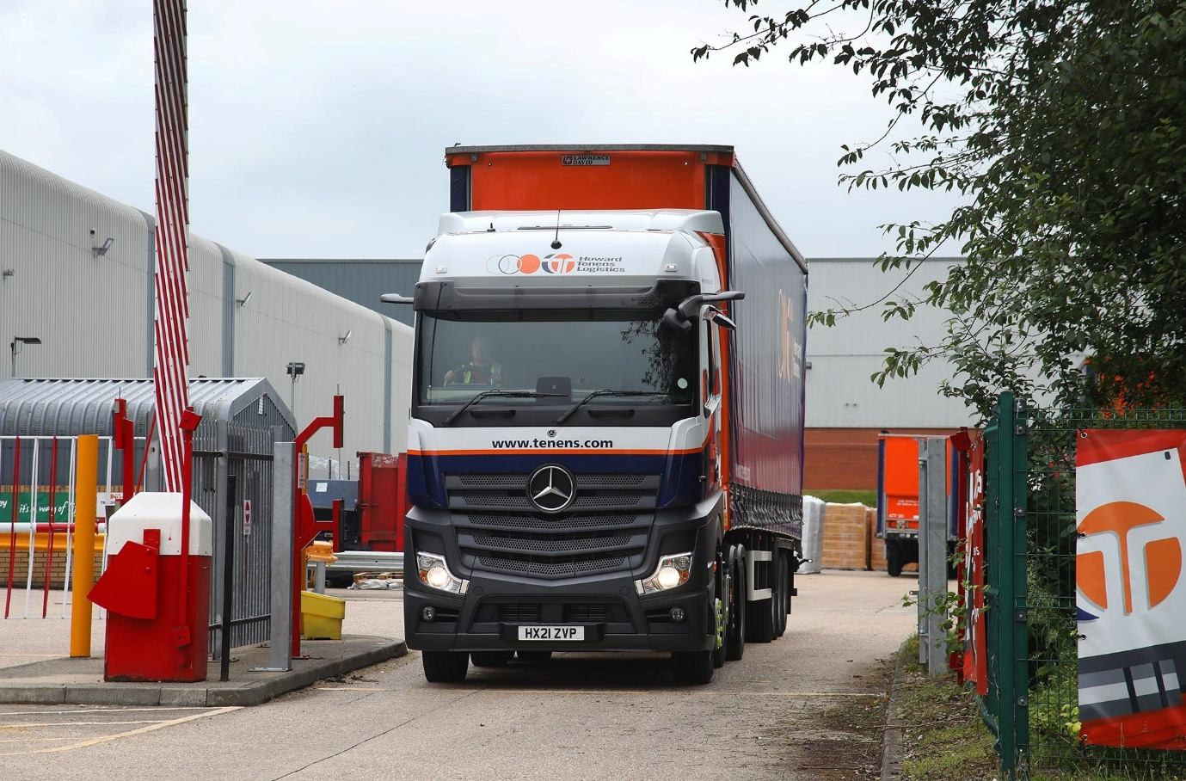

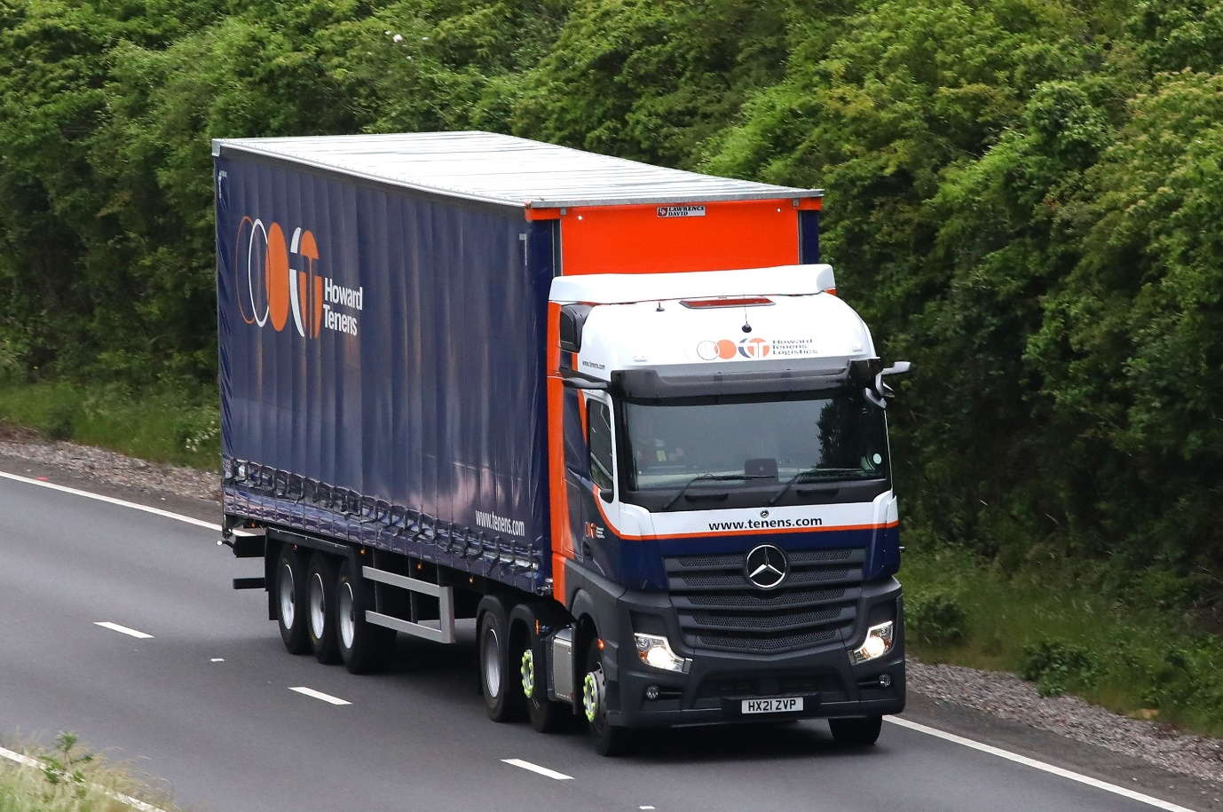

ends

For more information, or to request higher-res image files, please contact:

Jamie Fretwell at Mercedes-Benz Trucks UK Ltd
07712 519230, jamie.fretwell@daimler.com

or

Steve Warren or John Ripley
Impact Communications, 01926 842126
Steve: 07770 470251, steve@impactcom.co.uk
John: 07771 484595, john@impactcom.co.uk

About Mercedes-Benz Trucks UK Ltd
Mercedes-Benz Trucks UK Ltd is the sales and marketing organisation responsible for all Daimler truck products in the UK, including FUSO Canter.

In 2019, the company registered 6,963 new trucks. Mercedes-Benz accounted for 6,188 new trucks registered in 2019, making it the third-biggest truck brand in the UK. Meanwhile, FUSO registrations hit 775 – including 580 new trucks over 6.0-tonnes.

The flagship new Mercedes-Benz Actros which won the 2020 International Truck of the Year award, features seven core innovations including MirrorCam, Multimedia Cockpit and Active Brake Assist 5. Our premium range of innovative trucks – Actros, Arocs, Atego, Econic and Unimog – draw upon more than 125 years of exceptionally high standards of quality, backed up by our promise of Trucks You Can Trust.

www.mbtrucks.co.uk

