

Date: 4 February 2025

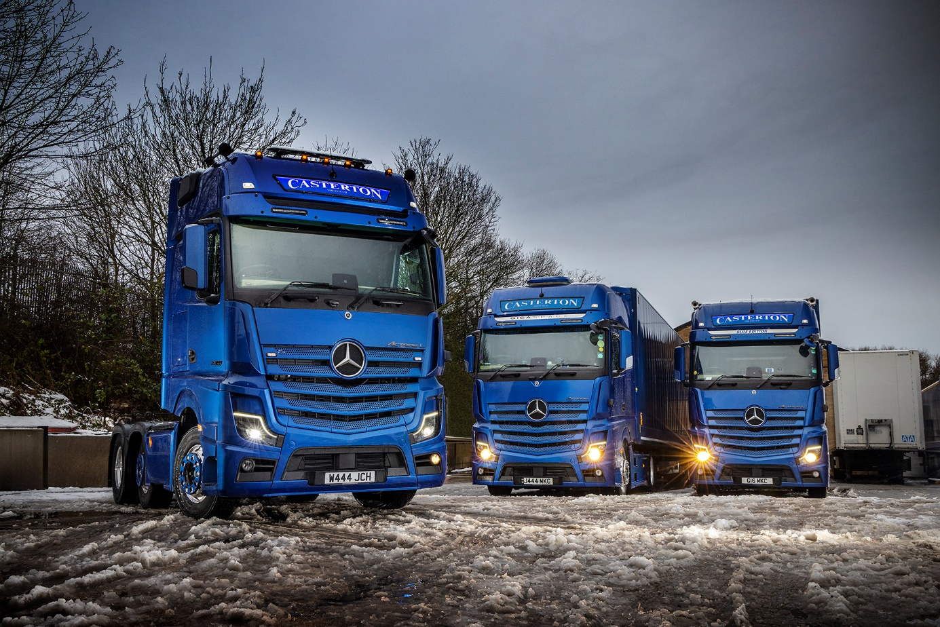

Three and easy: Casterton’s new Actros L 2558 lines up alongside the operator’s previous pair of Mercedes-Benz tractor units

Mercedes-Benz Actros L from Bell Truck & Van is a winner at the pumps for Casterton Haulage

A drastic improvement in fuel performance from its first two Mercedes-Benz Actros tractor units brought Casterton Haulage to the inevitable decision to invest in a third.

Sheffield based Casterton took its first pair of Actros from Dealer Bell Truck and Van last year – both are highly specified 4x2 units for work across Europe.

Managing Director Mark Casterton recalled: “Up to that point we had vehicles from two other brands on our fleet. When I needed a new truck urgently, though, neither could quote us a delivery time that was anywhere near quick enough.

“I know Carl Belch, Bell Truck and Van’s Sales Director, so I gave him a call and explained the situation. Straight away he said he could get me what I needed, when I needed it. That first truck had an unusual specification – a high-spec 4x2 tractor with a powerful engine – but Bells made the delivery process even smoother than they had promised.”

The truck was an Actros L 1853 with 12.8-litre, in-line six-cylinder engine generating a muscular 390 kW (530 hp). Delivery was handled by Sales Executive James Walsh, who soon found himself taking Casterton’s order for a second vehicle – this time with a 375 kW (510hp) version of the same powerplant. Both are 4x2 units with Low-liner reduced frame height, for work across Europe including event and concert logistics.

“Again James was able to source and deliver the vehicle to a tight timeframe, with the specification exactly as we wanted including extras like alloy wheels,” said Mr Casterton.

“I drive the 530 hp Actros myself, and it’s a great truck,” he continued. “But as well as being lovely to drive with a beautifully equipped cab, it’s also proved to be impressively fuel-efficient.

“Its first long-distance trip was a run to Portugal, alongside one of our older units. There’s a big difference in ages, with the other truck being seven years old, so it’s not really a fair comparison, but the Actros was a full two miles per gallon better. The 510 hp vehicle has been similarly economical, so between them they’re delivering a significant saving.”

All of which explains why Casterton returned to Bells for a third Mercedes-Benz – this time an Actros L 2558, with 425 kW (580 hp) 15.6-litre engine, in more conventional 6x2 format.

“We’ve developed a specialism in event logistics but I still class us a general haulier,” said Mr Casterton. “We do a bit of everything, including a lot of steel transport. The 4x2 units are intended mainly for event work and the new 580 is specced for hauling steel, but all our vehicles are able to turn their hand to whatever is required.

“Their overall excellence, and the top-quality back-up from Bells, means Mercedes-Benz is now the dominant brand in our fleet. The trucks were acquired with competitive funding support from Daimler Truck Financial Services and are covered by their ServiceContracts – I usually drive them to the Team Valley depot for maintenance, and Bells either lend me a vehicle or give me some office space to work in. It’s developing into a great partnership.”

Casterton Haulage was established in 1998 and remains very much a family firm – Mark Casterton drives the Actros 1853, his brother Jason the 1851 and the keys to the newest truck were handed to son James. Meanwhile wife Gillian runs the office and the couple’s daughter, Raechel, runs her own RAE Transport operation.

www.castertons.co.uk

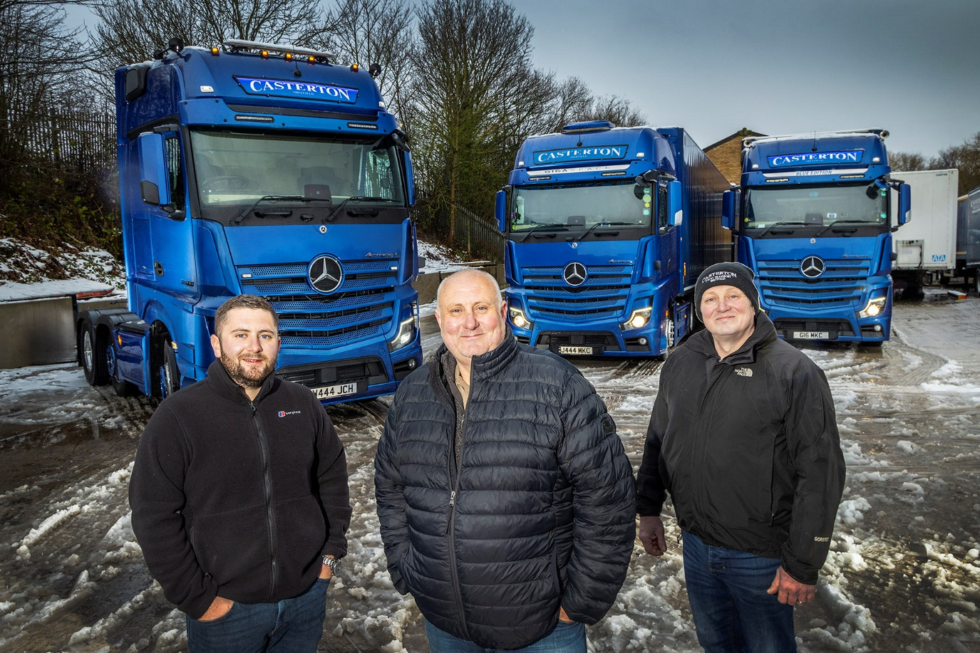

Family values: Managing Director Mark Casterton is flanked by son James, left, and brother Jason

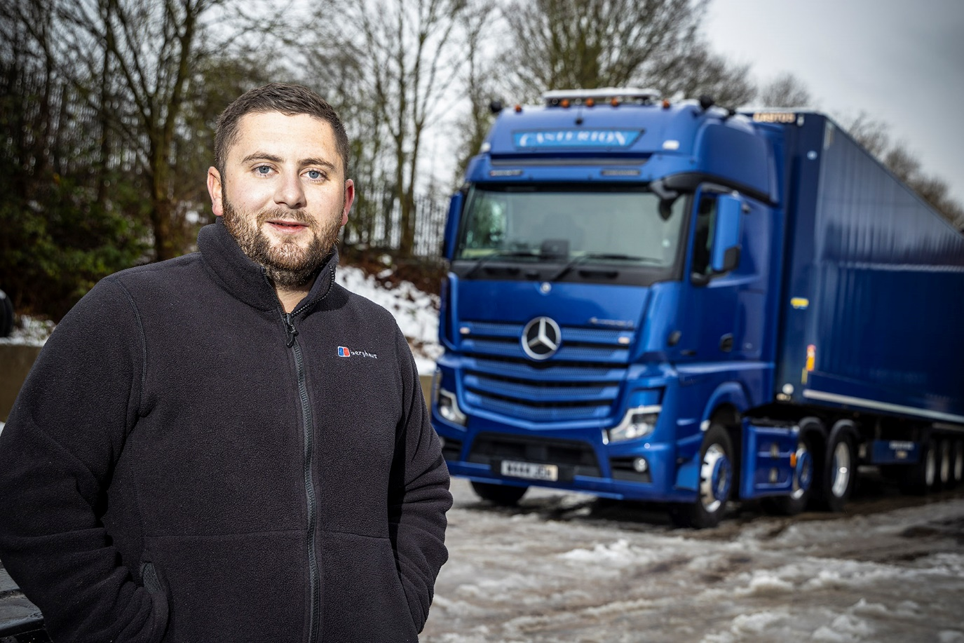

Blue leader: James Casterton with his stunning Actros L 2558

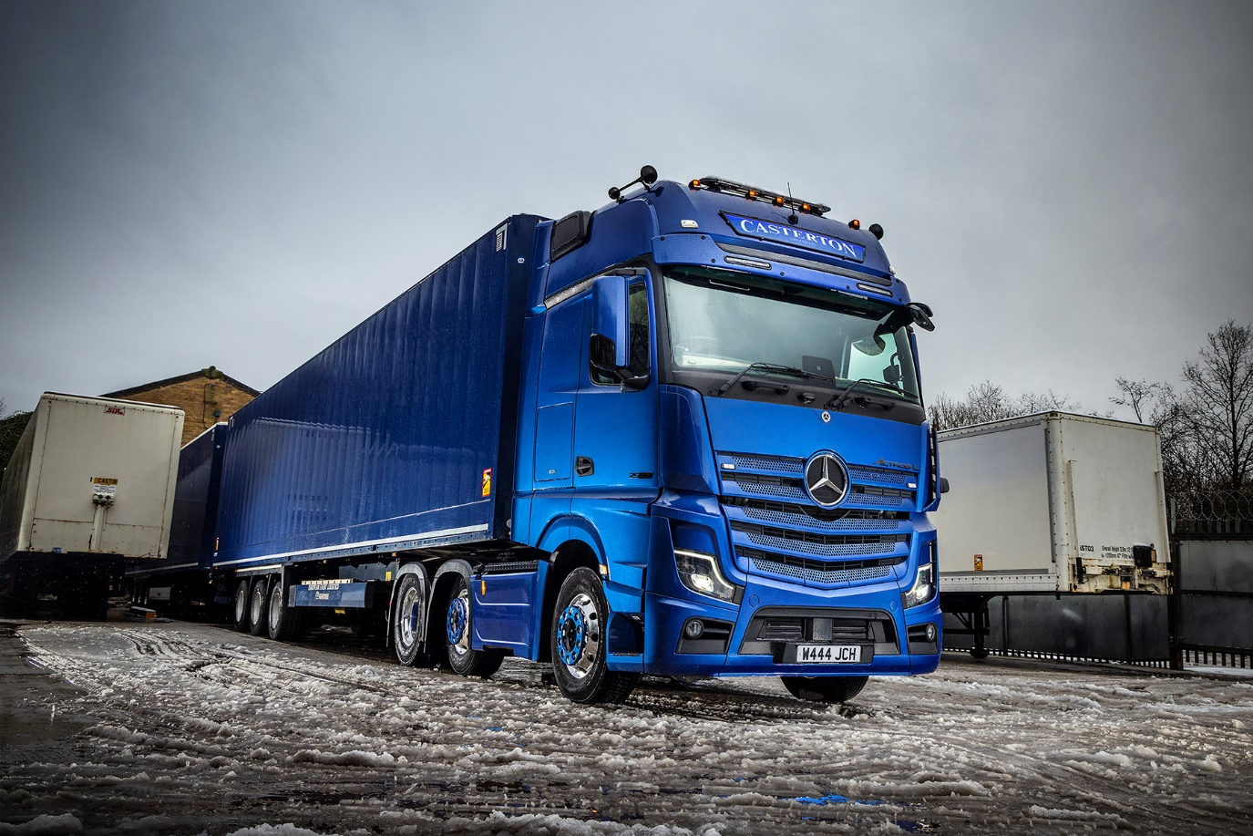

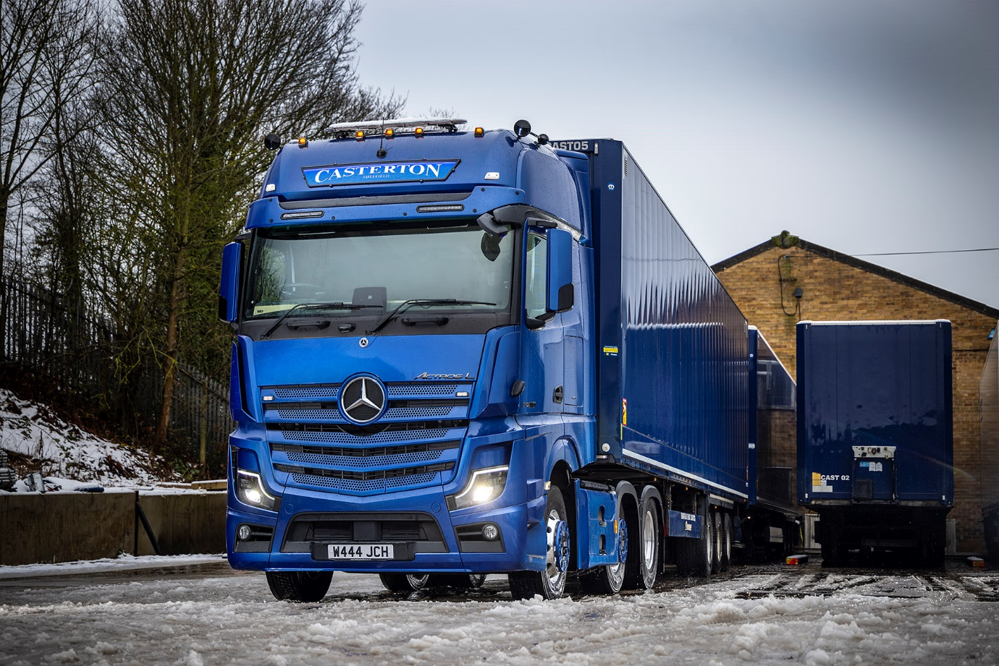

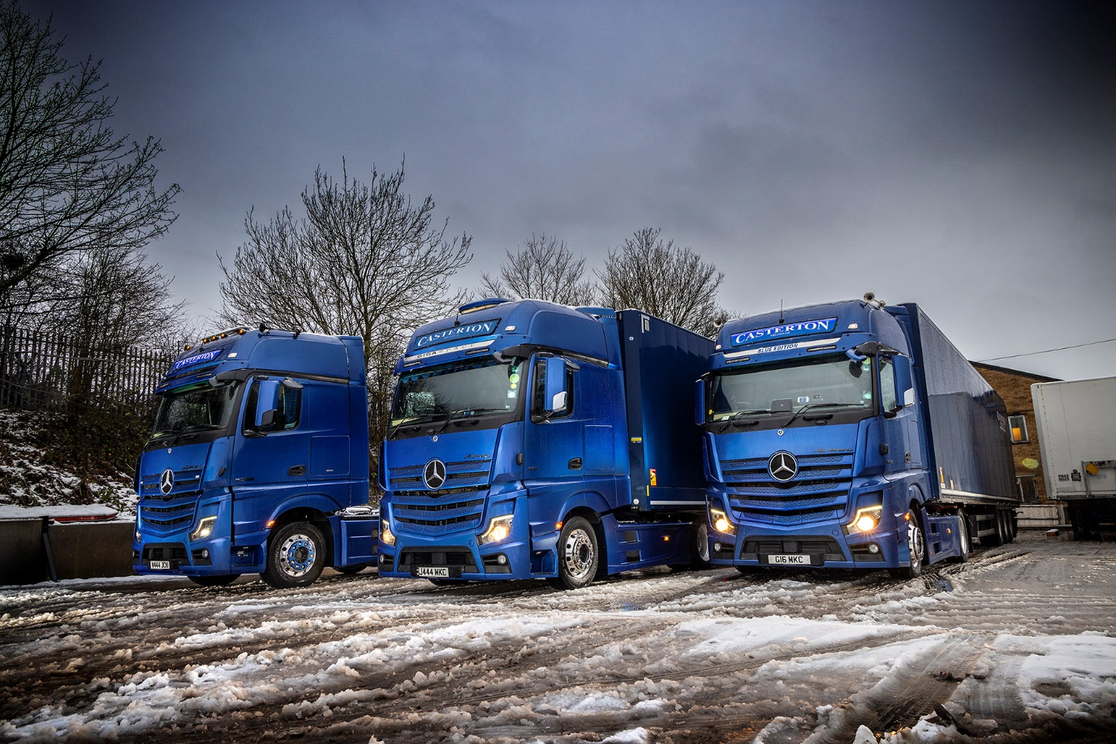

ends

For more information, or to request bigger/higher-res image files, please contact:
John Ripley: 07771 484595, john.ripley@loopagency.co.uk

