

Date: 29 March 2022

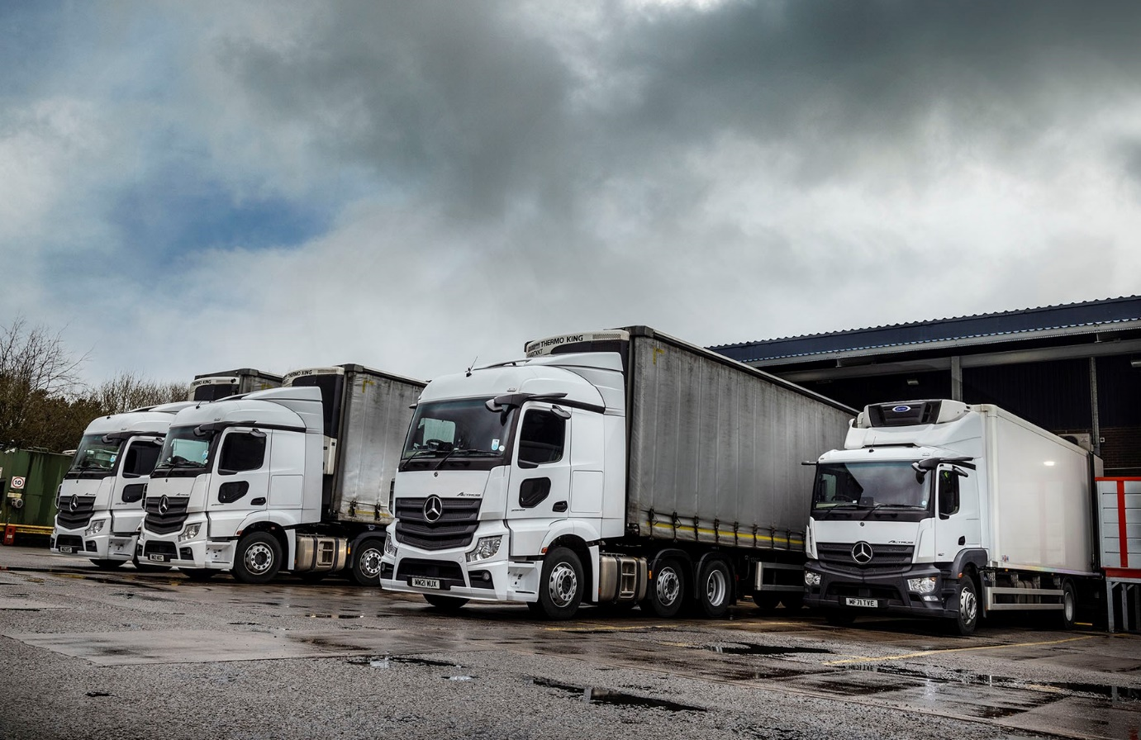

National Veterinary Services future-proofs its fleet with 11 Mercedes-Benz Actros StreamSpace tractor units from eStar Truck & Van

The UK’s largest wholesale supplier to the veterinary industry has ensured compliance for operation in London and other cities by switching from tractor units with big, flat-floored cabs, to narrower, lower variants. What has not changed, though, is that like the vehicles they have replaced, its latest trucks wear Mercedes-Benz three-pointed stars.

Working from National Veterinary Services’ headquarters in Stoke-on-Trent, the 11 new Actros pull temperature-controlled semi-trailers and service a network of 11 hubs which, in turn, deliver to some 2,700 veterinary practices nationwide. The company has been supplying and distributing products to animal health practices and other approved outlets since 1989 and stocks more than 15,000 lines, including pharmaceuticals, instrumentation, pet products and accessories.

Supplied by eStar Truck & Van, the new Actros are all 2545 models. Their StreamSpace cabs are 2.3m wide – the narrower of the two widths available – and have 170mm engine tunnels. This combination, together with the Mercedes-Benz MirrorCam technology that has replaced conventional mirrors, and the additional windows fitted in the lower half of the nearside doors by Astra Vehicle Technologies, of Ellesmere Port, means the trucks attract an impressive three Direct Vision stars from Transport for London. They are therefore permitted to continue operating in the capital from 2024 onwards.

The Actros are powered by 12.8-litre in-line six-cylinder engines that produce 330 kW (450 hp) and are now being maintained under Mercedes-Benz Finance contract hire agreements by the workshop team at eStar Truck & Van’s Stoke branch.

National Veterinary Services (NVS) trialled one of the Dealer’s demonstration units with a 320mm tunnel and correspondingly lower floor. However, it felt that the specification of the vehicles as ordered represented the best compromise between enhanced visibility and driver comfort.

To further enhance the driving experience it opted for the upgraded, interactive version of Mercedes-Benz Trucks’ radical, twin-screen Multimedia Cockpit, which boasts a larger, 12in instrument panel and comes with extra functionality, including satellite navigation. The cabs are equipped with fridges, while reflecting the fact that they are often double-manned for runs to Scotland and the South-West the co-driver also gets a suspension seat.

The latest Actros generation comes as standard with the ground-breaking Active Brake Assist 5 emergency braking system, which employs a camera as well as radar, and is even more responsive to pedestrians crossing the truck’s path. The operator has also added an optional Safety Package comprising a bundle of additional features, among them a driver’s airbag and Proximity Control Assist.

Fitted with air management systems and Jost sliding fifth wheels, the Actros will each cover 150,000 km per year. They begin leaving the company’s main warehouse before midnight, bound for the hubs, with final deliveries made to customers by its fleet of 140 Mercedes-Benz Sprinter vans.

Transport Operations Manager Phil Bate observed: “It’s all about recognising and responding to the direction of travel in the industry. Unsurprisingly, our drivers loved the spacious, flat-floored units they were in previously. But they also understand the rationale behind our decision to move to smaller cabs that offer better direct visibility.

“We’ve embraced Mercedes-Benz Trucks’ MirrorCam and other technology because of the tangible benefits it offers in terms of compliance, not only for London but for other towns and cities too. By moving to three star-rated vehicles we’ve effectively future-proofed our fleet.

“We’ve also done everything we can to ensure the safety of our driving colleagues and of the public in general, particularly vulnerable road users, while at the same time specifying a few additional features to make what can be a very tough job that bit more comfortable.”

In addition to its 11 tractor units, NVS operates a single fridge-bodied Actros 18-tonner. Mr Bate continued: “We’ve been running Mercedes-Benz trucks for a number of years and enjoy very good relationships with the manufacturer and its local representative.

“The 10 Actros units we stood down to make way for the new ones did a very good job, while eStar Truck & Van understands our business and what we need in terms of back-up. Inspections and routine services are carried out at times that suit us, and if ever we have an issue we know the Dealer will do everything it can to get the vehicle back on the road as quickly as possible. Communication is all-important at such times and eStar’s is excellent.”

nvsweb.co.uk

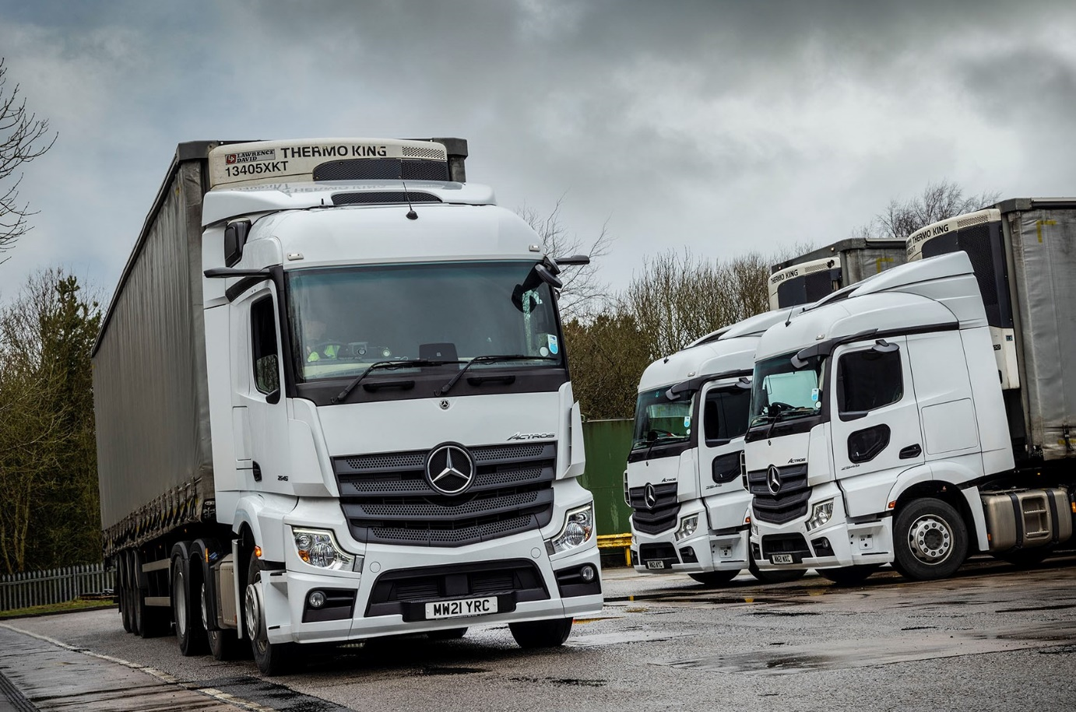

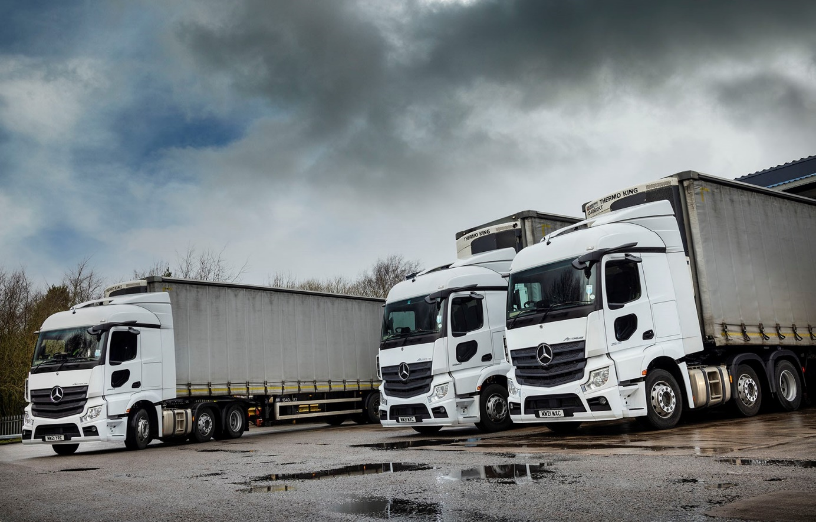

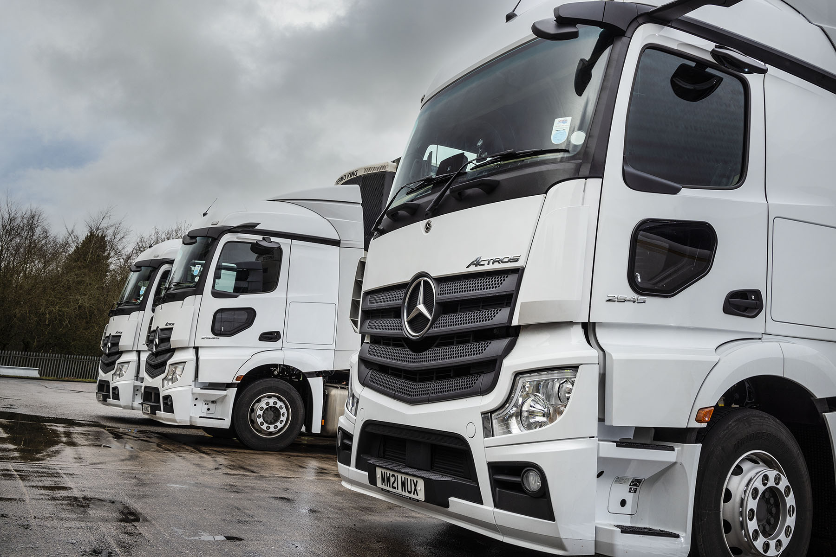

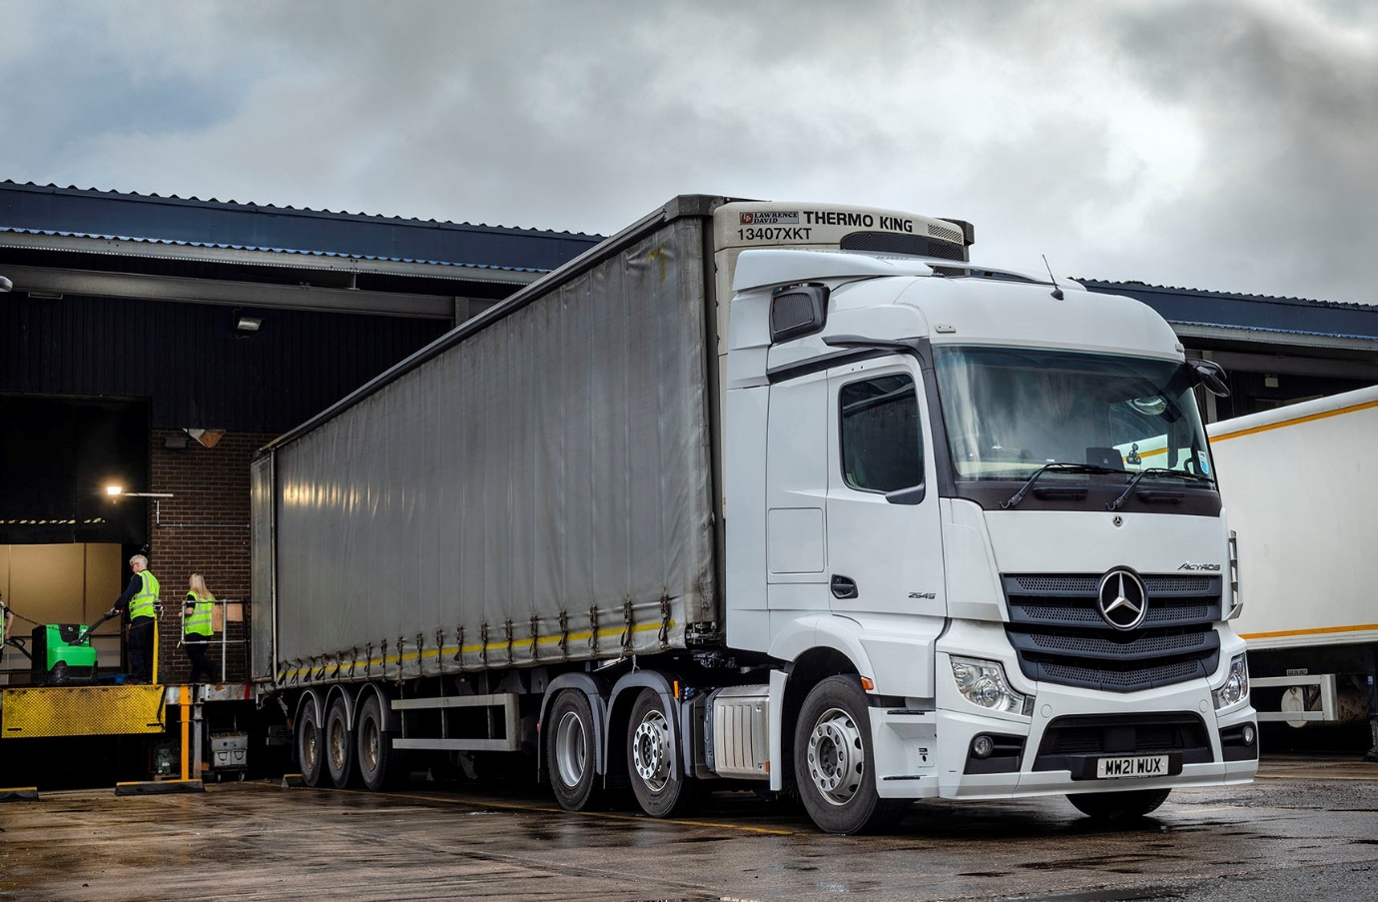

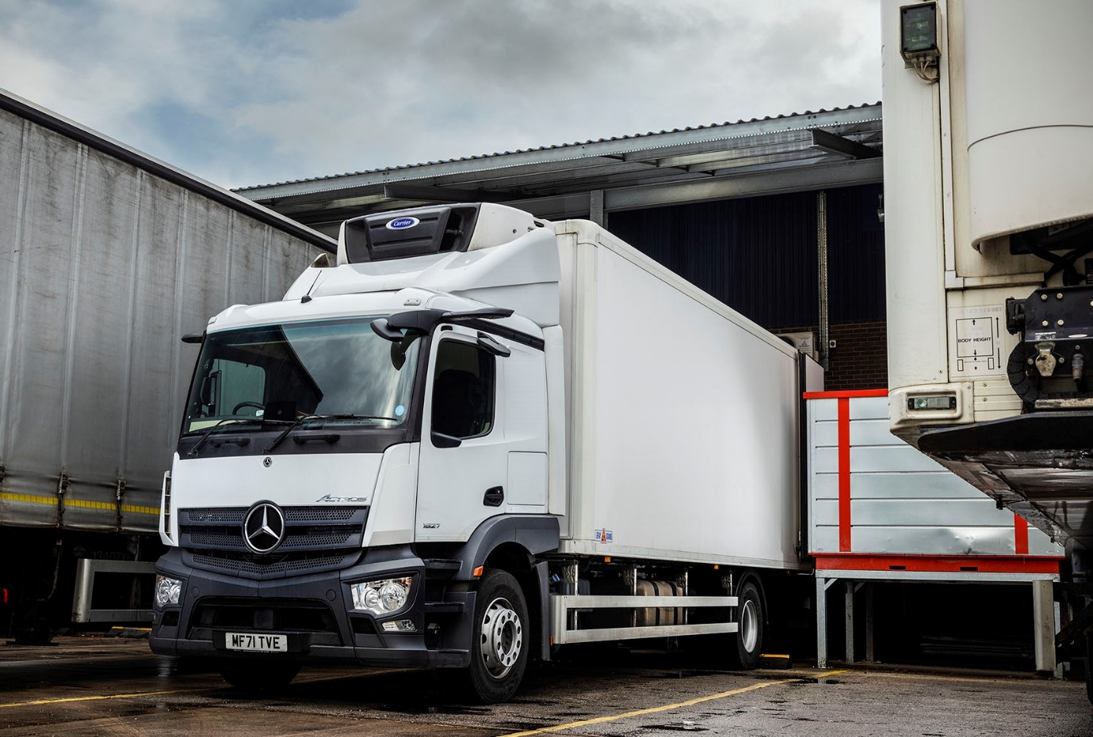

ends

For more information, or to request higher-resolution image files, please contact:
Steve Warren or John Ripley
Impact Communications
Steve: 07770 470251, steve@impactcom.co.uk
John: 07771 484595, john@impactcom.co.uk

