

Date: 3 June 2021

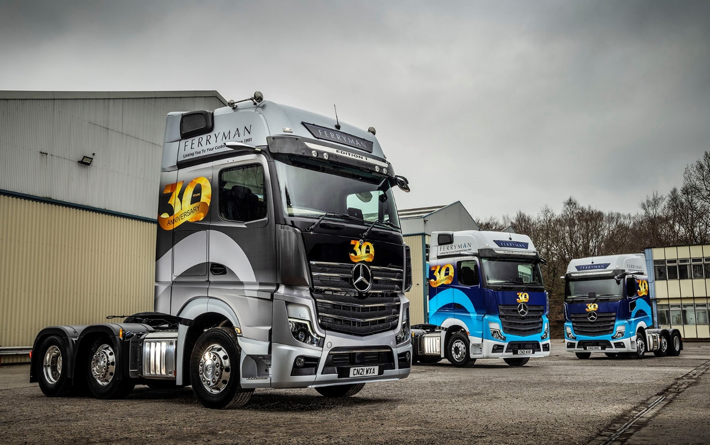

‘Trucker Jenko’ leads the Mercedes-Benz line for Ferryman with stunning Actros Edition 1

Ferryman’s awesome Mercedes-Benz Actros Edition 1 flagship is guaranteed the exposure it deserves – as ‘Trucker Jenko’ its driver Martyn Jenkins is a YouTube vlogger with more than 1.8 million video views, and he can’t stop talking about his exclusive new tractor unit.

The top-of-the-range model was supplied to the South Wales haulier, together with two other, highly specified Actros by local Dealer Euro Commercials. They are Ferryman’s first Mercedes-Benz trucks, and all three wear eye-catching liveries that highlight its 30th anniversary.

Martyn, who also posts regularly on other social media channels, declared: “I’m 52 and this is my first top-of-the-range truck. There’s so much to be excited about that I feel like a kid at Christmas, really lucky, and incredibly grateful.

“The Edition 1 is unbelievable. I love the way it looks, even at night when the grille-mounted three-pointed star is illuminated. It’s also great to drive, with an amazingly spacious and comfortable cab – the top bunk is huge! – in which to spend nights away. Whichever way you look at it, this truck is lush.”

Family-owned and run, Ferryman is based in Pontllanfaith, Blackwood, Gwent, and offers a comprehensive range of warehousing, distribution and transport services covering anything from a single pallet to a full load.

The company is a proud member of TPN – THE Pallet Network, and of the Road Haulage Association. It operates a modern fleet of 26 trucks, all but five of them tractor units, in which another manufacturer has previously held sway.

PopIn Vehicle Graphics, of Cardiff, applied the striking vinyl wraps in which the Actros are now turning heads wherever they go. It was also responsible for the design on the back doors of the Edition 1’s curtainsided trailer, which highlights Ferryman’s long-standing fund-raising support for the Welsh charity, Tenovus Cancer Care.

The operator ordered its Mercedes-Benz trucks after two-week trials of a pair of demonstration units last year. Transport Manager Richard Morris recalled: “Euro Commercials’ driver-trainer came in and gave us a thorough overview of what the Actros could do, particularly with regard to the benefits of all the new technology.

“We then sent them out on long-distance work and the feedback from the drivers was first class. MirrorCam (Mercedes-Benz Trucks’ revolutionary, camera-based alternative to conventional mirrors) took a little getting used to, but having done so both said they preferred it, because the visibility is much better, particularly on the blind side when reversing.

“The same was true when they were driving in the rain or freezing fog, as the images from the cameras are relayed to screens mounted inside the cab, on the A-pillars. We’re hoping, too, that MirrorCam will save on repair costs – standard mirrors get quite a few knocks here in the Welsh Valleys, but the fact that they’re higher and more compact means the cameras should be less vulnerable to damage.”

Richard Morris continued: “Our drivers liked everything about the Actros cab, especially the new dashboard with its twin screens. The Predictive Powertrain Control system really impressed too. As long as you let the truck do what it wants to do, you’ll get the best out of it, and this was reflected in the fuel figures – none of our tractors is more than three-years-old and the fleet average is 9.7 mpg, but the demonstrators returned 10.9. A difference of more than a mile per gallon represents a huge saving, not only in cost but also in terms of emissions.”

Ferryman’s Actros are the subject of Mercedes-Benz Finance contract hire agreements under which each will cover 140,000 km per year. They are now being inspected and serviced by the workshop team at Euro Commercials’ Cardiff headquarters.

Just 400 Actros Edition 1s have been built and of these only 35 were made available to UK customers. A stunning showcase for the fifth-generation Actros range, it is based on the imposing GigaSpace cab and instantly recognisable thanks to its gloss black grille, darkened headlamp covers and rims, and branded sun visor incorporating four extra LED main-beam headlamps.

Like most examples, Ferryman’s Edition 1 employs a top-of-the-range 15.6-litre in-line six-cylinder engine that delivers a potent 460 kW (625 hp). The upgraded Multimedia Cockpit, interactive incorporates a larger, 12in primary colour display, and offers extra functionality. The black leather-trimmed cab interior – which includes door handles with contrasting topstitching – features a polished and brushed aluminium dashboard badge that confirms the truck as ‘One of 400’, while driver Martyn can also choose from no fewer than eight colours of ambient ceiling lighting.
As 2551 variants Ferryman’s two other Actros are powered by 12.8-litre ‘straight sixes’ producing 375 kW (510 hp). They also have GigaSpace cabs and came with a full complement of advanced technology – in addition to MirrorCam, the Multimedia Cockpit and the latest version of Predictive Powertrain Control, which ‘reads’ the topography ahead and manages the driveline for optimum efficiency, standard Actros specification includes the Active Brake Assist 5 emergency braking system, offering improved pedestrian recognition capability through the use of a camera as well as radar.

Richard Morris added: “Time will tell, of course, but our early impressions of Euro Commercials are entirely positive. Its Sales Executive Darren Hobbs has done everything we could have asked, and while the Actros weren’t the cheapest trucks we considered the contract hire package is certainly very competitive.”

He said the tractor units tended to be away all week, so most inspections and maintenance would be undertaken on Friday nights or Saturday mornings. “The Dealer’s offered to provide our drivers with courtesy vehicles in which to go home after dropping their trucks at the workshop, or to collect and deliver should we need it. Service like that makes all the difference, so I’m very optimistic that Euro will deliver on its promises and we’ll get the back-up we need.”

See: bit.ly/FerrymanVideo

www.ferryman.org.uk

www.tenovuscancercare.org.uk/

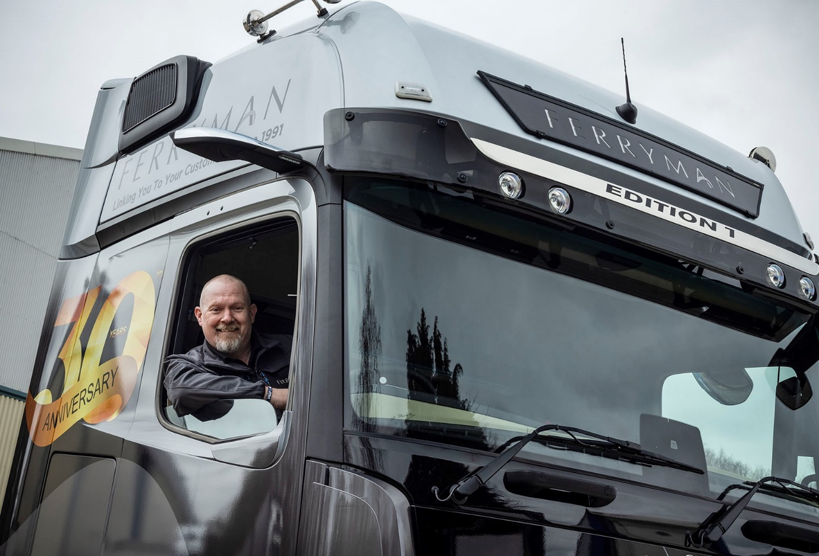

Spreading the word: Actros Edition 1 driver Martyn Jenkins launched his ‘Trucker Jenko’ YouTube channel in 2018 and now has nearly 13,000 subscribers

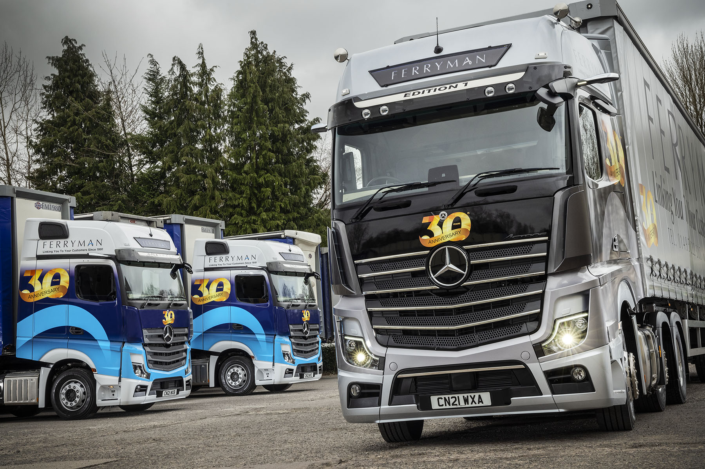
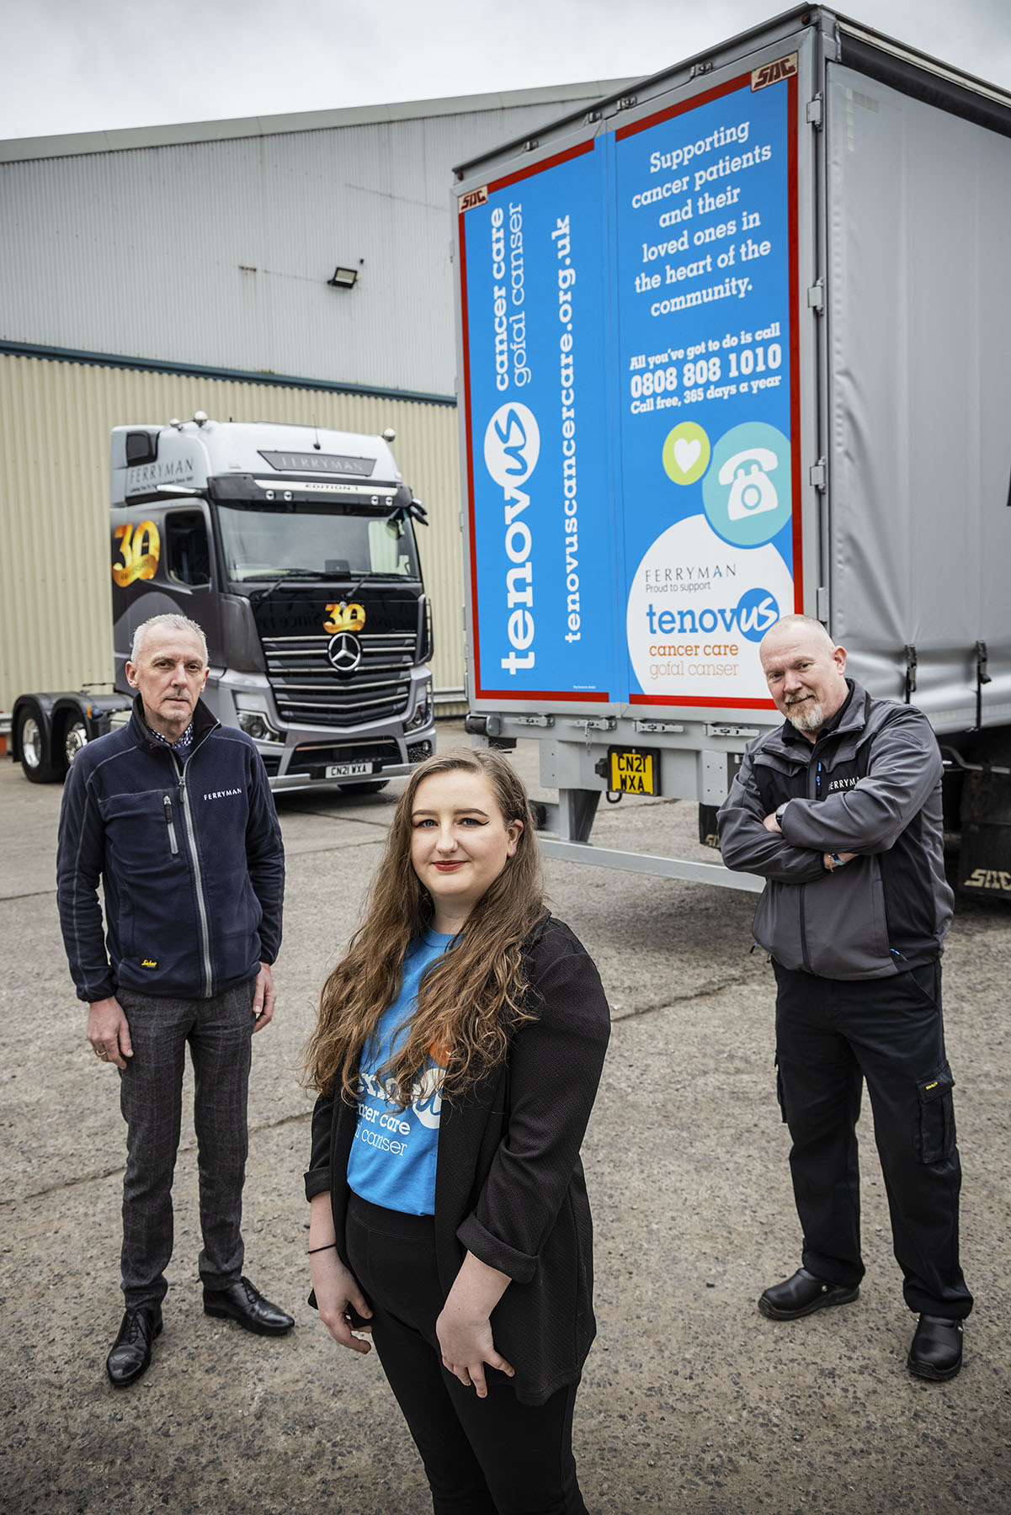

Charity champions: Tenovus Cancer Care Philanthropy & Special Events Manager Rebecca Edmunds is pictured with Ferryman Transport Manager Richard Morris, left, and driver Martyn Jenkins
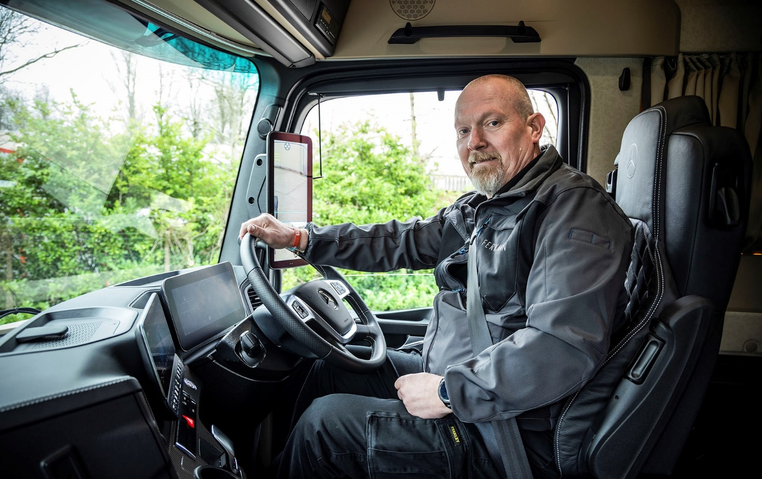

Power to please: With 460 kW (625 hp) on tap, Martyn Jenkins’ new Actros Edition 1 is easily the most powerful truck he’s ever driven

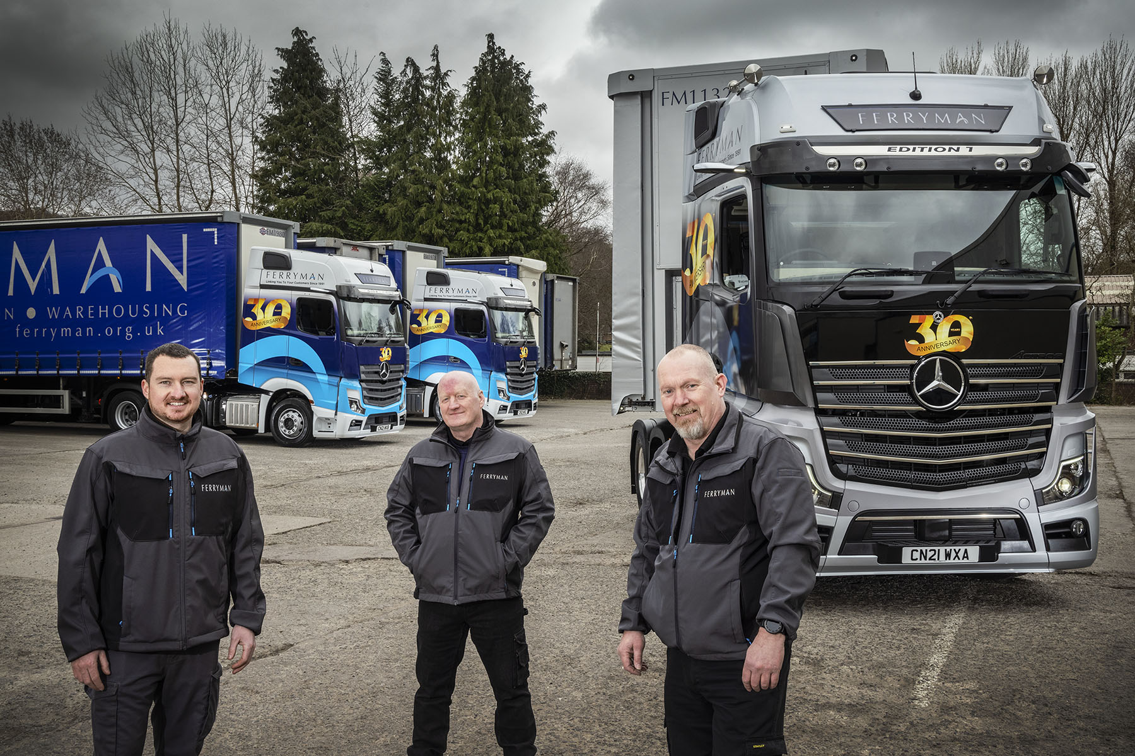

Driving force: Martyn Jenkins, right, and his Ferryman colleagues Chris Newell, left, and Wayne Jones are delighted with their new Mercedes-Benz Actros
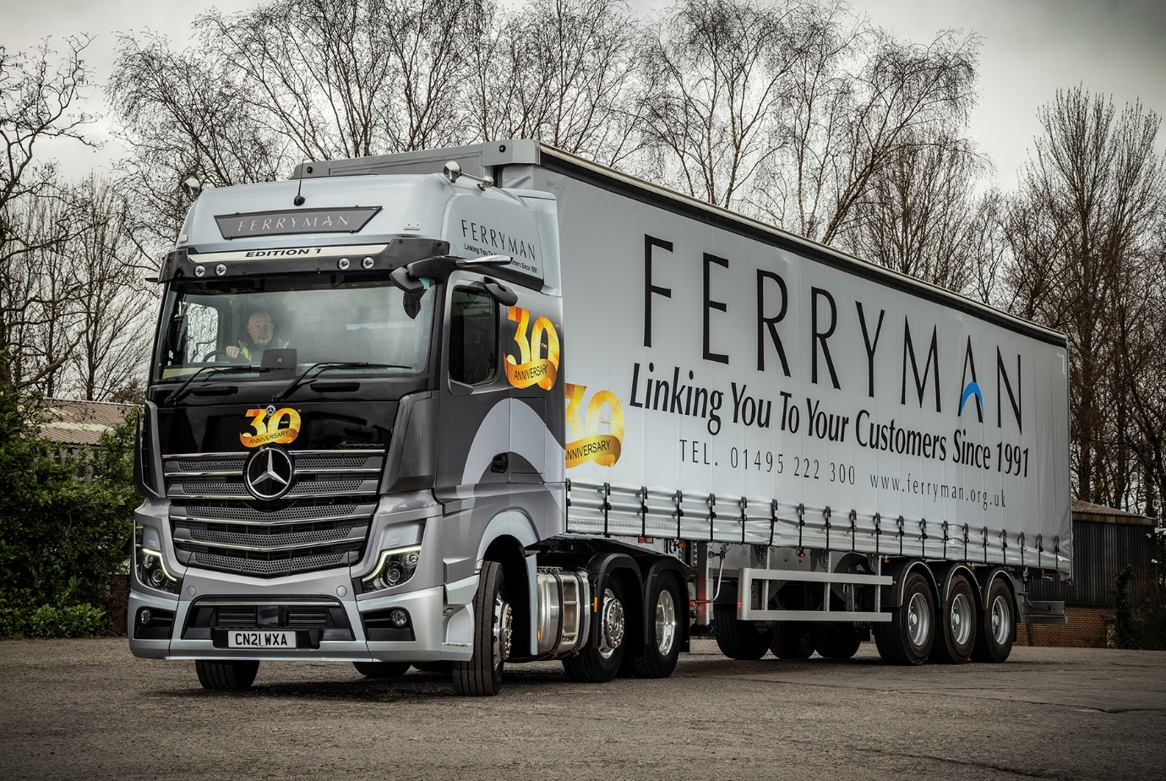

ends

For more information, or to request bigger/higher-res image files, please contact:
Steve Warren or John Ripley
Impact Communications, 01926 842126
Steve: 07770 470251, steve@impactcom.co.uk
John: 07771 484595, john@impactcom.co.uk

