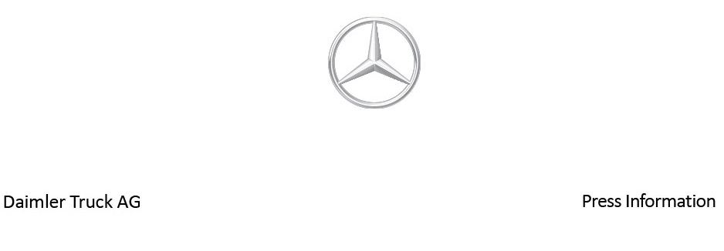

Date: 20 September 2022

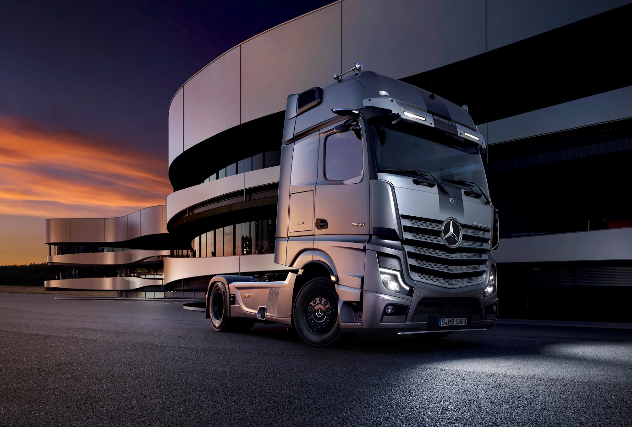

Exclusivity assured: Unveiled at IAA Hanover, the stunning Mercedes-Benz Actros Edition 3 will be limited to a production run of just 400 units

Functionality, fuel efficiency, driving comfort and exclusivity: Mercedes-Benz Trucks showcases its latest diesel-powered trucks at the IAA Transportation 2022 trade fair in Hanover

- Actros L offers a wide range of features for relaxed driving, comfortable living and efficient working.

- Actros L Edition 3, limited to 400 units, is also distinguished by around 30 exclusive, special features.

- Third generation of the OM 471 engine for heavy commercial vehicles makes the Actros even more dynamic and reduces fuel consumption by up to 4%.

Second generation MirrorCam can provide the driver with even better assistance in many traffic situations.

- Driver assistance systems such as Active Sideguard Assist, Active Drive Assist 2 and Active Brake Assist 5 with its pedestrian detection can ensure even greater safety in road traffic.

- Service contracts such as Mercedes-Benz Complete, in combination with Mercedes-Benz Uptime and the Fleetboard portal, can all contribute towards optimising the total cost of ownership.

- Stina Fagerman, Head of Marketing, Sales and Services at Mercedes-Benz Trucks: “The transition to CO₂-neutral road transport is in full swing. For the transitional phase, we aim to further optimise our premium trucks with conventional diesel engines, not only in the interest of our customers, not only to sustainably reduce the total cost of ownership, but also the CO₂ footprint.”

Stuttgart/Hanover – With pioneering innovations, Mercedes-Benz Trucks has, over recent years, elevated the various models of the Actros series to a very high level in terms of their efficiency, comfort and safety for all road users. However, the commercial vehicle industry cannot and must not stand still, especially as transport companies and truck manufacturers are facing major challenges in a highly competitive environment, including the absolutely necessary decarbonisation of road freight transport. It is therefore all the more important to make use of all options – also within the context of tried-and-tested diesel trucks – to optimise the vehicles. At the IAA Transportation 2022 trade fair in Hanover, Mercedes-Benz Trucks is showing which innovative solutions it intends to use to further expand its strong market position in this segment with the help of the Actros L and the Actros L Edition 3. Stina Fagerman, Head of Marketing, Sales and Services at Mercedes-Benz Trucks: “The transition to CO₂-neutral road transport is in full swing. For the transitional phase, we aim to further optimise our premium trucks with conventional diesel engines, not only in the interest of our customers, not only to sustainably reduce the total cost of ownership, but also the CO₂ footprint.”

Actros L: Established flagship for traditional long-distance haulage with even higher fuel efficiency and more dynamics thanks its improved drivetrain

Mercedes-Benz Trucks has once again set new standards in the traditional diesel trucks premium segment with the Actros L presented at this year’s IAA Transportation trade fair in Hanover. The top-of-the-range model of the successful Actros series produced since November 2021 once again underlines the claim of Mercedes-Benz Trucks to always focus on the needs of its customers and their drivers. The fact that the Actros L caters for a high level of driver comfort is also emphasised by the driver’s cab with its width of 2.50 metres, available as StreamSpace, BigSpace and GigaSpace variants. The flat floor in the cab creates a cozy ambience. The improved sound and heat insulation reduces the noise level and makes the time spent in the cab even more pleasant – both when driving and during rest stops.

The third-generation 12.8-litre OM 471 engine for heavy-duty commercial vehicles is an example of further optimised fuel efficiency. The new engine available in the Mercedes-Benz Actros L from October 2022 features a vast range of technical innovations that are consistently aimed at reducing the total cost of ownership (TCO) with regard to fuel-saving driving, reduced CO₂ emissions, lower operating costs, and higher margins, without affecting performance, vehicle dynamics or driving comfort. On the contrary: As one example of many, the third generation of the OM 471 engine introduces a consumption-optimised turbocharger, which, together with the revised exhaust gas aftertreatment system, enables maximum fuel savings of up to 4% compared with the previous generation. Another highlight of the third-generation OM 471 engine is the extended Top Torque program, providing more performance exactly when it’s really needed – for example when driving onto a motorway or when overtaking. For enhanced vehicle dynamics, Mercedes-Benz Trucks has also focused on the whole drivetrain: For example, the new PowerShift Advanced automated transmission control enables faster and smoother moving off and acceleration in many scenarios thanks to its precision gear selection.

The new drivetrain is available for all heavy-duty Mercedes-Benz truck series: from the Actros to the Actros L and the Arocs.

Supporting driver assistance systems and a second generation MirrorCam¹

In addition, safety assistance systems such as the fifth-generation Active Brake Assist with pedestrian detection (ABA 5), Lane Keeping Assist and the second-generation MirrorCam, or the equipment options of the second-generation Active Drive Assist (ADA 2) for partially automated driving to Level 2, or Active Sideguard Assist (ASGA), also make important contributions to safety.

Under certain circumstances, ADA 2 can actively support the driver with longitudinal and lateral guidance of the vehicle, and automatically maintain a distance, accelerate, and steer if the necessary system conditions, such as an adequate curve radius or clearly visible roadway markings, are in place. In addition, the Emergency Stop Assist sub-function included in ADA 2 is capable of initiating an emergency stop (within system limits) if, despite visual and audible warnings, the steering wheel is no longer being held by the driver.

ASGA, which is currently available for left-hand-drive trucks, is not only able to warn the driver of moving cyclists or pedestrians on the front passenger side, but can also initiate automated braking up to its own turning speed of 20 km/h until the vehicle comes to a standstill if the driver fails to react in time.

Active Sideguard Assist uses the MirrorCam display on the front passenger side to provide visual warnings. The second generation of the mirror camera system has been in use since April 2022, and it can now provide the driver with even better support in many situations in road traffic thanks to camera arms that are ten centimetres shorter and new imaging parameters. One of the benefits of shortening the camera arms is that the drivers can now reverse in a straight line more easily than with the first generation. This is mainly due to the fact that the perspective of the MirrorCam is now even more similar to that of the usual glass mirror.

The evolution in the colour and brightness coordination of the camera system, which was originally designed to be very bright, means that the displays, for example when reversing into a dark or poorly lit warehouse, depict the area relevant to the driving situation even more precisely. Thanks to its supportive effect, the enhanced MirrorCam system can now assist in managing situations such as overtaking, manoeuvring, driving in poor visibility and darkness, cornering, and passing narrow spaces even more safely and without stress.

The optionally available LED headlights offer additional safety – especially in darkness or poor visibility – thanks to their higher light intensity compared with xenon headlights and very good illumination of the roadway.

Actros Edition 3: Unique design and superior comfort

As a limited special model of the Actros L with a “Wow!” effect, Edition 3 is also being showcased at the IAA Transportation 2022 trade fair in Hanover. Up to 30 additional interior and exterior features as well as design elements stemming from Edition 1 and Edition 2 give the 400 production run truck an unmistakable character. The luxury of the Edition 3 is marked by a whole range of equipment features. In its stylish interior, these include the instrument panel and door handles in nappa leather, various interior parts with a carbon fibre look, and the roof hatch with its ambient lighting. The Edition 3 badge on the front passenger side and the illuminated “Edition 3” entry badge on the driver and front passenger sides are also eye-catching. The top bunk comes with bedding and is 900 millimeters wide. An all-round curtain – almond beige on the inside, black on the outside – ensures stylish privacy. The same applies to the curtain with the Mercedes-Benz star in front of the bunk.

Highlights on the exterior include the exclusive decals on the side wall, the “Edition 3” lettering in the white aluminum sun visor with two additional LED headlights, the Actros emblem at the front in dark chrome, and the Actros lettering on the upper rear cab wall. The stainless steel entry steps are striking features on the side of the vehicle. The front and rear axle caps are also made of stainless steel. The scope of delivery also includes the illuminated Mercedes-Benz star in dark chrome, several painted decorative grille applications made of stainless steel, and the aluminum steps in the side trim.

Edition 3 is available for all two- and three-axled models of the latest Actros L generation with GigaSpace and BigSpace cabs in left- and right-hand drive versions. The cab paint finish is freely selectable and can be adapted to customers’ liveries, while the front of the vehicle is always painted in white aluminium metallic to guarantee a high recognition value. Whether it’s high-end power with the 15.6 litre OM 473 engine or further reduced consumption with the new OM 471 engine in its third generation, thanks to improved gearshift performance by PowerShift Advanced for all available drivetrains the Actros L Edition 3 offers all drivers impressive performance and a high level of driving pleasure.

Smart digital solutions for even more efficient use

In order to maximise the use of all Actros models and save time and administrative effort, Mercedes-Benz Trucks provides its customers with a whole range of digital solutions on the Fleetboard portal. Another digital solution is provided by the mapping tool, which enables back office employees in transportation companies to react quickly to the current vehicle status wherever necessary. This is because the tool shows where a vehicle is currently located and whether it is moving or stationary in real time. Another tool is a logbook with detailed information on driving times and non-operational times, total weight, mileage covered, route progress and topography. This allows fleet managers to subsequently track each individual Actros in the company so that use can be optimised when parlaying with the driver or dispatcher.

The HABBL logistics application stands out because it steers drivers step-by-step through their work orders. The app can be used in parallel on the Actros Multimedia Cockpit and any Android mobile device for tasks outside the vehicle. All those involved in a transport process – drivers, dispatchers and customers – can always obtain the available information they need. This increases process quality and at the same time creates a high degree of transparency.

Mercedes-Benz Uptime: Improved vehicle availability for the Actros

Mercedes-Benz Uptime combines intelligent vehicle networking with intensive customer support and thus offers Mercedes-Benz Trucks customers an innovative service product. The aim is to support customers in reliably fulfilling their transport orders by making sure the truck spends as much time as possible on the road. Workshop visits must be minimised and planned more efficiently. In order to reduce breakdowns, repair requirements can be identified as early as possible and customers can be supported in organising the necessary work at short notice – always taking into account their deployment planning. The results: Improved planning of workshop visits, increased vehicle availability, and a higher level of road safety.

Truck Data Centre is at the heart of Mercedes-Benz Uptime and also the basis for other vehicle connectivity solutions. The networking module receives data from the sensors, cameras, and control units in the truck and evaluates it for different applications. The Truck Data Centre not only forms the basis for the numerous services of Mercedes-Benz Uptime, but also for Fleetboard, the service for sustainably increasing vehicle availability.

Mercedes-Benz Trucks also offers its customers various repair and maintenance contracts at monthly predictable costs to ensure the highest possible vehicle availability and the lowest possible number of breakdowns. Mercedes-Benz Complete provides peace of mind as a comprehensive service package covering all workshop tasks, including replacement of wear parts.

Mercedes-Benz Uptime is available as standard in the Mercedes-Benz Complete service contracts. The comprehensive service package covers all workshop work, including maintenance and wear parts. It starts with the coordination of appointments and extends to invoice verification. This means that you can rely on the comprehensive additional protection for your vehicle – for maximum value retention and mobility.

¹ With all these assistance systems, Mercedes-Benz Trucks aims to provide drivers with the best possible support when driving the vehicle within the system limits. However, the driver remains fully responsible for driving the vehicle safely at all times, as is also required to do so by law.

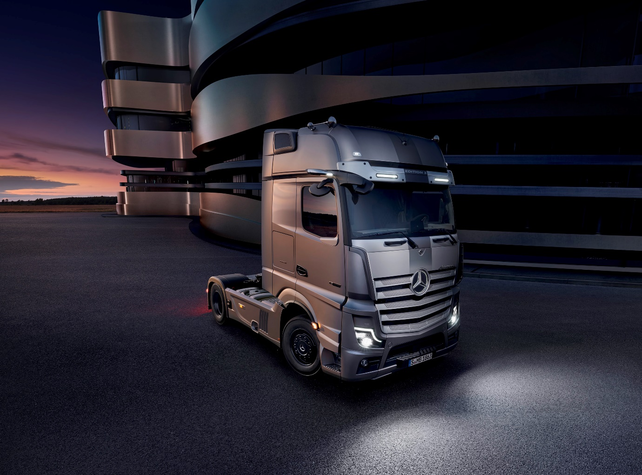

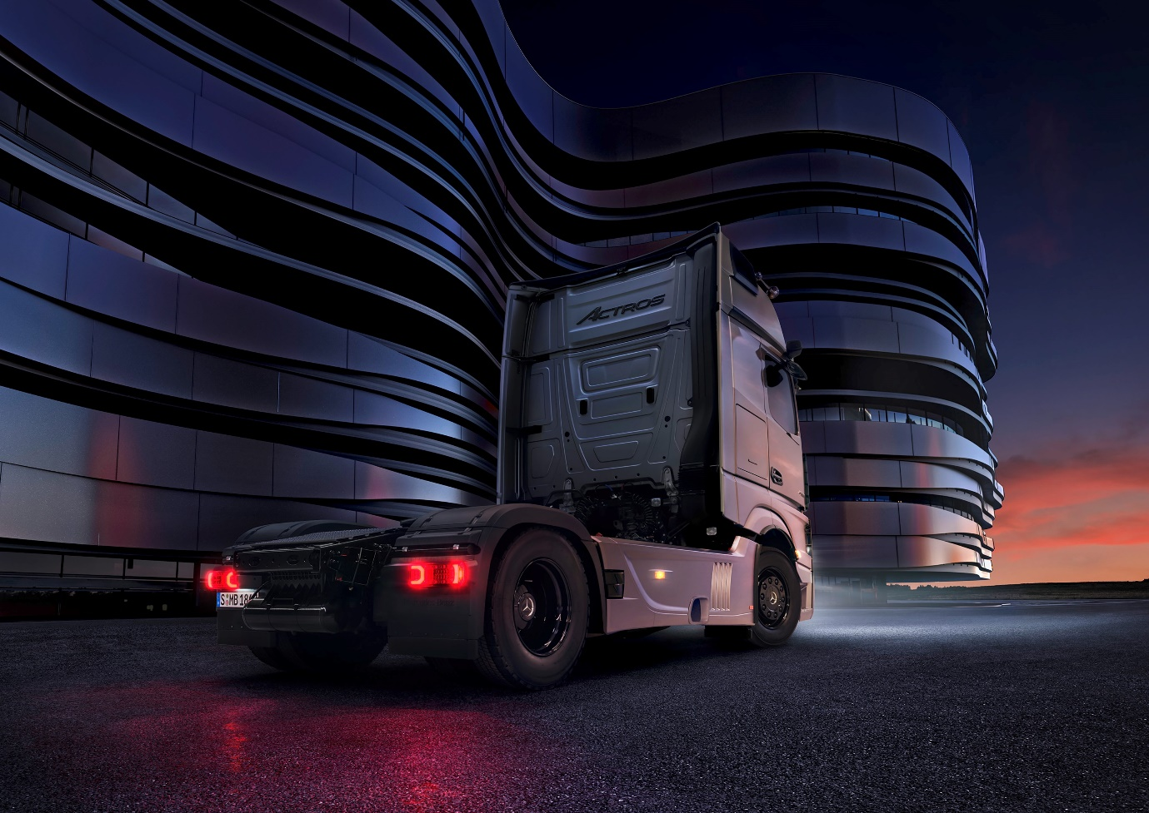

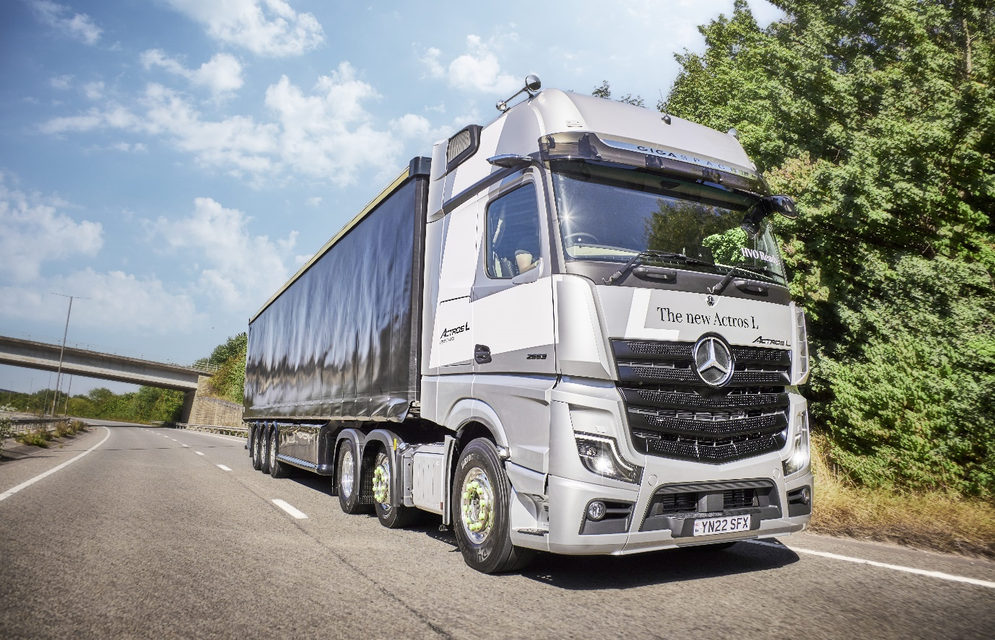

Raising the bar: Aimed at long-distance hauliers and those engaged in heavy-duty distribution, Actros L features even more sophisticated aerodynamics, quieter cabs with improved heat insulation, and a lower, more comfortable seating position that also provides improved visibility
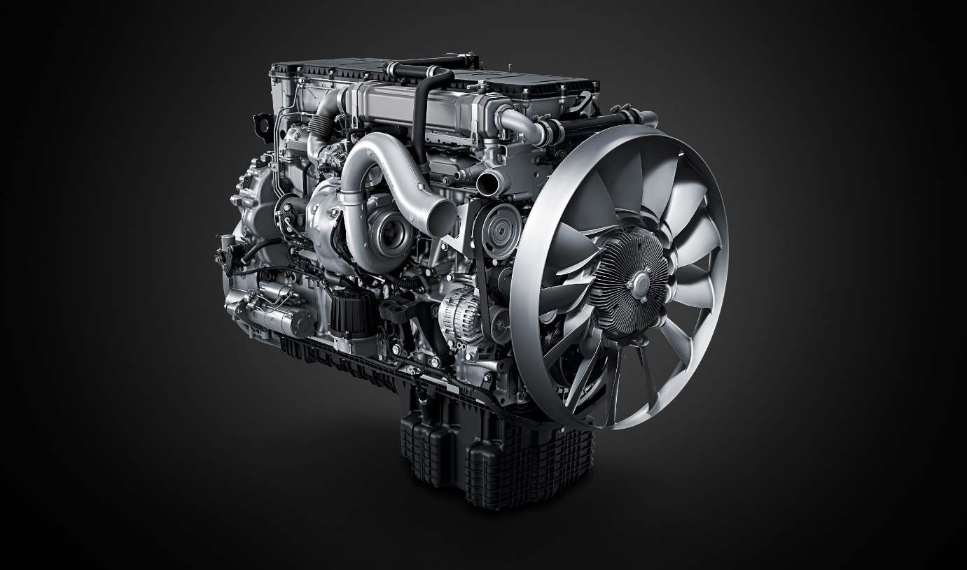

Highly reliable and impressively fuel-efficient: The third-generation OM 471 engine benefits the environment while also contributing to operator profitability

ends

For more information, or to request higher-resolution images, please contact:

Jamie Fretwell at Mercedes-Benz Trucks UK Ltd
07712 519230, jamie.fretwell@daimler.com

or

Steve Warren or John Ripley
Impact Communications
Steve: 07770 470251, steve@impactcom.co.uk
John: 07771 484595, john@impactcom.co.uk

or

Carola Pfeifle, +49 (0) 160 8612423, carola.pfeifle@daimlertruck.com
Ulrike Burkhart, +49 (0) 160 8613757, ulrike.burkhart@daimlertruck.com

Further information on Daimler Truck is available at:
www.media.daimlertruck.com and www.daimlertruck.com

Forward-looking statements:
This document contains forward-looking statements that reflect our current views about future events. The words “aim”, “ambition”, “anticipate,” “assume,” “believe,” “estimate,” “expect,” “intend,” “may,” ”can,” “could,” “plan,” “project,” “should” and similar expressions are used to identify forward-looking statements. These statements are subject to many risks and uncertainties, including an adverse development of global economic conditions, in particular a decline of demand in our most important markets; a deterioration of our refinancing possibilities on the credit and financial markets; events of force majeure including natural disasters, pandemics, acts of terrorism, political unrest, armed conflicts, industrial accidents and their effects on our sales, purchasing, production or financial services activities; changes in currency exchange rates, customs and foreign trade provisions; a shift in consumer preferences; a possible lack of acceptance of our products or services which limits our ability to achieve prices and adequately utilise our production capacities; price increases for fuel or raw materials; disruption of production due to shortages of materials, labour strikes or supplier insolvencies; a decline in resale prices of used vehicles; the effective implementation of cost-reduction and efficiency-optimization measures; the business outlook for companies in which we hold a significant equity interest; the successful implementation of strategic cooperations and joint ventures; changes in laws, regulations and government policies, particularly those relating to vehicle emissions, fuel economy and safety; the resolution of pending government investigations or of investigations requested by governments and the conclusion of pending or threatened future legal proceedings; and other risks and uncertainties, some of which are described under the heading “Risk and Opportunity Report” in the current Annual Report. If any of these risks and uncertainties materializes, or if the assumptions underlying any of our forward-looking statements prove to be incorrect, the actual results may be materially different from those we express or imply by such statements. We do not intend or assume any obligation to update these forward-looking statements since they are based solely on the circumstances at the date of publication.

Daimler Truck at a glance
Daimler Truck Holding AG ("Daimler Truck") is one of the world's largest commercial vehicle manufacturers, with over 40 main locations and more than 100,000 employees around the globe. The founders of Daimler Truck have invented the modern transportation industry with their trucks and buses a good 125 years ago. Unchanged to this day, the company's aspirations are dedicated to one purpose: Daimler Truck works for all who keep the world moving. Its customers enable people to be mobile and get goods to their destinations reliably, on time, and safely. Daimler Truck provides the technologies, products, and services for them to do so. This also applies to the transformation to CO2-neutral driving. The company is striving to make sustainable transport a success, with profound technological knowledge and a clear view of its customers' needs. Daimler Truck's business activities are structured in five reporting segments: Trucks North America (TN) with the truck brands Freightliner and Western Star and the school bus brand Thomas Built Buses. Trucks Asia (TA) with the FUSO and BharatBenz commercial vehicle brands. Mercedes-Benz (MB) with the truck brand of the same name. Daimler Buses (DB) with the Mercedes-Benz and Setra bus brands. Daimler Truck's new Financial Services business (DTFS) constitutes the fifth segment, the product range in the truck segments includes light, medium and heavy trucks for long-distance, distribution and construction traffic and special-purpose vehicles used mainly in the municipal and vocational sector. The product range of the bus segment includes city buses, school buses and intercity buses, coaches and bus chassis. In addition to the sale of new and used commercial vehicles, the company also offers aftersales services and connectivity solutions.

