

Date: 24 October 2023

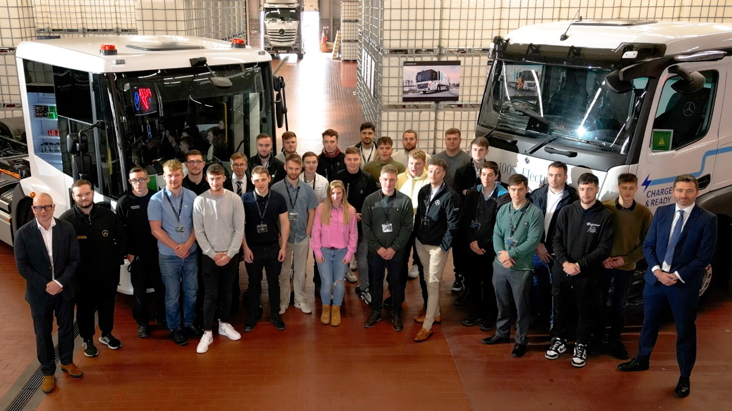

Rising stars: Mercedes-Benz Trucks UK Managing Director Heiko Selzam, left, and Director, Customer Service & Parts Richard Skidmore, right, with this year’s graduation class

Mercedes-Benz Trucks ‘grows its own’ with a new crop of qualified heavy vehicle technicians

Mercedes-Benz Trucks welcomed a new cohort of qualified Mercedes-Benz truck technicians to its UK Dealer Network – and gave them the ultimate inspiration for their future careers.

If the 55 attendees at this year’s graduation day celebration were in any doubt about how high they could potentially fly, Mercedes-Benz Trucks UK Managing Director Heiko Selzam presented the ideal example.

Addressing the group, at an event held at the brand’s Commercial Vehicle Centre at Wentworth Park in Yorkshire, Heiko told the new graduates he had once been in their shoes – having started his own career on the ground floor with an internship at parent company Daimler Benz AG, 27 years ago.

“You are the future of this company,” he told them. “This is a people business. We rely on you to take us forward, and to help deliver the services that our customers depend on.”

Director, Customer Service & Parts Richard Skidmore added: “As heavy vehicle specialists you are already highly qualified – more so than a car or van technician – but we hope your learning doesn’t stop here. We will support you throughout your careers to develop your technical skills and personal attributes, so that we can grow and be even more successful together.”

The event, held last month (27 September), was the first mass gathering of graduating technicians held by Mercedes-Benz Trucks since the Covid pandemic. As well as receiving their certificates and the congratulations of the company’s senior executives, attendees were treated to a day of activities that were intended to both entertain and inform.

Driving challenges in a Mercedes-Benz Atego and a battery-electric FUSO eCanter, and rides in an Actros tractor unit and mud-busting Unimog off-road truck, were interspersed with fault-finding puzzles and games aimed at challenging the young delegates to think creatively about problem solving and pooling resources.

For 22-year-old Jessica Heppenstall, of Yorkshire-based Dealer Northside Truck & Van, her graduation was the latest stage of an obsession with engines and vehicles that started when she was just eight years old, and took up the sport of go-kart racing – eventually achieving a top-ten national ranking.

“After leaving college I took a job in a local independent garage but joining the Mercedes-Benz Apprenticeship programme opened up a path to a career with better qualifications, higher earning potential and support for continued development,” she said.

Lee Lousvet, who works at Intercounty Truck & Van in Bedfordshire, is another motorsport enthusiast – having been involved in ‘banger’ racing since childhood.

“From a very young age, I always wanted to be a mechanic,” he recalled. “So I was delighted to win a place as a Mercedes-Benz apprentice straight from school, at 16 years old.”

Now aged 20, Lee certainly has no regrets. “I much prefer working on trucks – compared to a cramped car engine bay there’s so much more room to manoeuvre! Now I’ve reached this stage I definitely want to stay with Mercedes-Benz. My next goal is to increase my knowledge and experience so I can gain the higher qualifications to become a Diagnostic Technician, then to keep learning and developing to go as far as I can.”

Archie Terrell, meanwhile, had completed a college course in plumbing before making a sudden change of career direction. “I’d always had an interest in vehicles, and heard of an opening at Rossetts Commercials, in Aldershot,” he said. “I looked into the apprenticeship scheme and was impressed by the emphasis on continual learning and support for development of skills and knowledge.

“I sometimes look back and wonder where I’d be if I’d carried on as a plumber, but I know I made the right choice. I’m really enjoying my job and feel like it has much more to offer as I progress.”

At the end of a day that also included a lunch of hand-made, wood-fired pizzas – and before the new technicians returned home with ‘goodie bags’ full of Mercedes-Benz branded treats – Head of Training Ian Acey told them: “You’ve seen and heard a lot today about the cutting-edge technology on our vehicles, but all innovations are driven by people.

“Mercedes-Benz Trucks has invested in helping you reach this milestone but our commitment to your professional and personal development does not end here. We hope you will go back to your Dealerships and grow to become our leaders of the future.”

In addition to on-the-job learning at their Dealerships, apprentices undertake block release study at the Mercedes-Benz Apprenticeship Academy in Milton Keynes. Staff take great pride in not only providing them with the product knowledge and practical skills they will need to excel in their roles, but also in supporting them with exemplary pastoral care.

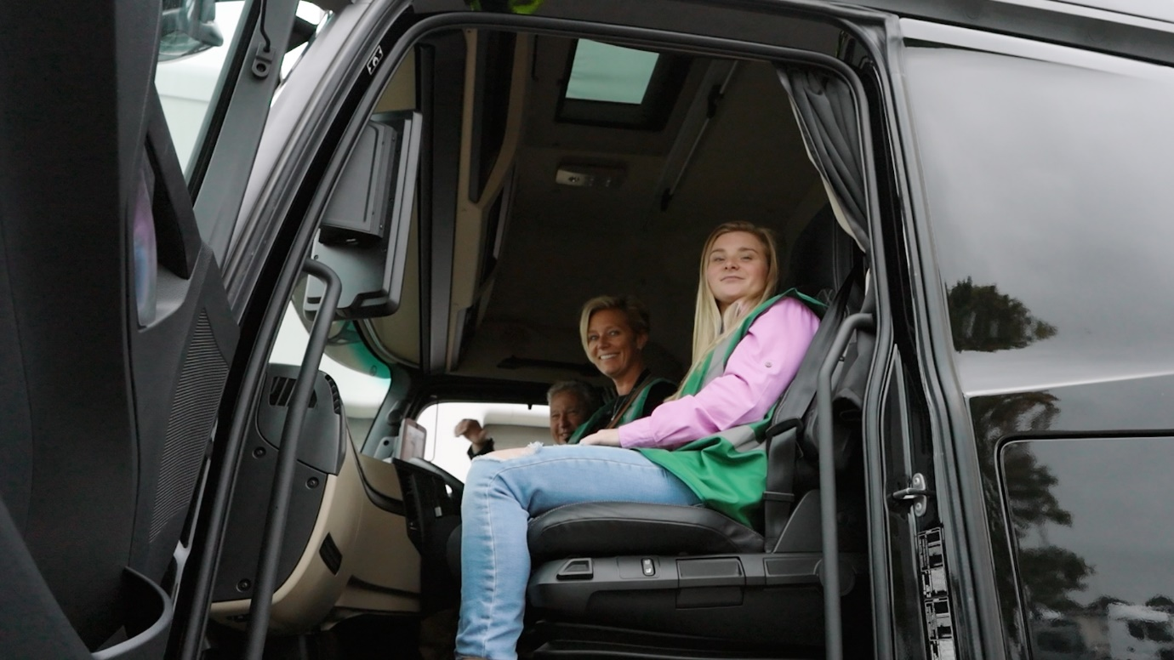

Riding high: Technician Jessica Heppenstall, right, enjoys the view from the cab of a Mercedes-Benz Actros tractor unit

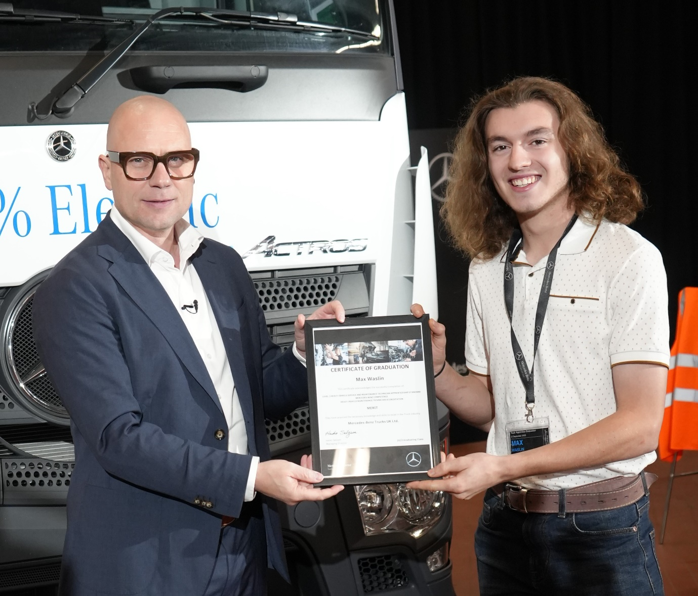

Certified success: Mercedes-Benz Trucks UK Managing Director Heiko Selzam presents newly qualified technician Maz Waslin, of specialist Unimog Dealer South Cave Tractors, with his certificate of graduation

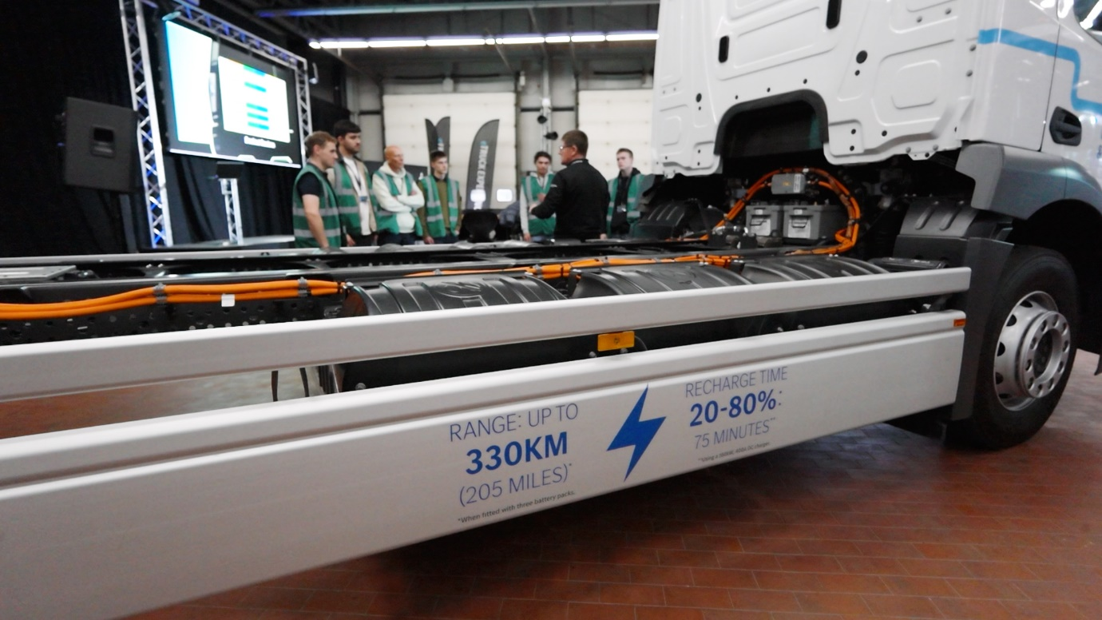

Sparking interest: Attendees were given a detailed introduction to the all-electric Mercedes-Benz eActros – a vehicle they’re likely to see in their home workshops much more often in the coming years

ends

For more information, or to request higher-res image files, please contact:

Jamie Fretwell at Mercedes-Benz Trucks UK Ltd
07712 519230, jamie.fretwell@daimler.com

or

John Ripley: 07771 484595, john.ripley@loopagency.co.uk

