

Date: 24 February 2022

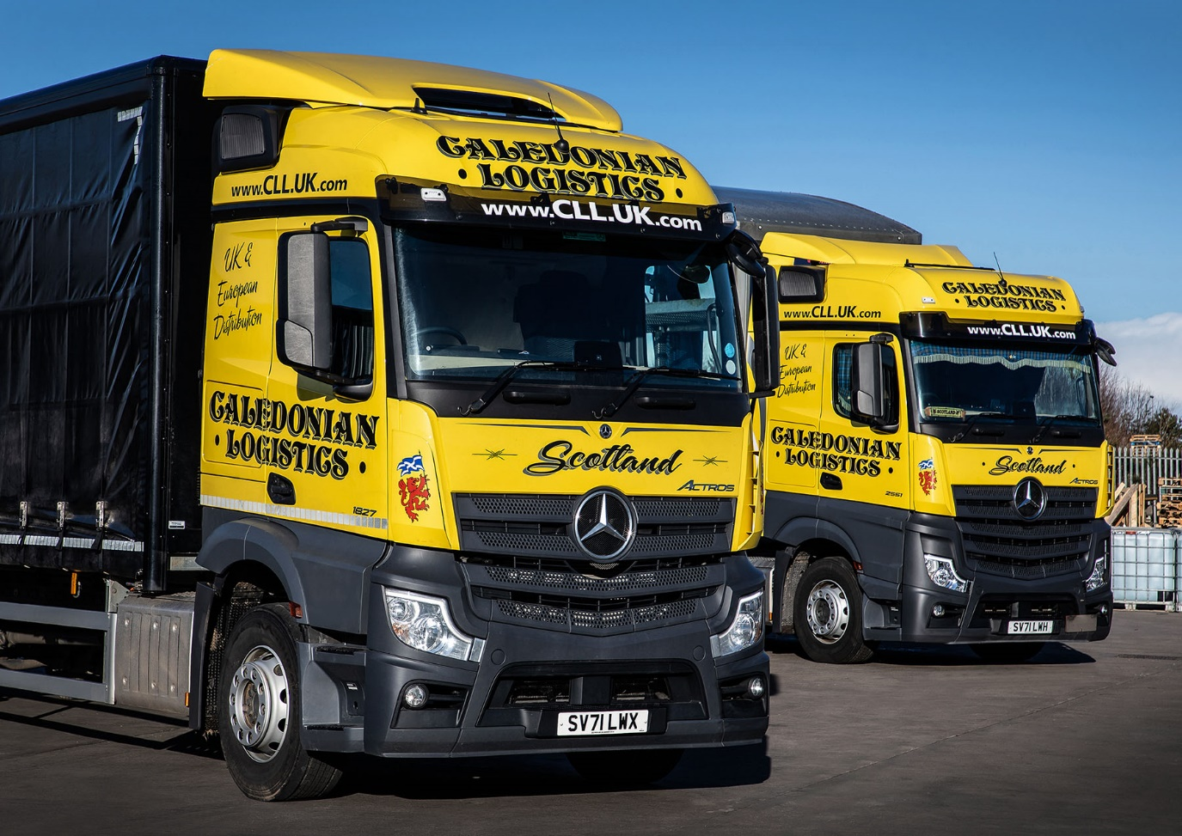

Caledonian Logistics turns to BLS Truck & Van for 35 new Mercedes-Benz Actros

Caledonian Logistics opted for the best of both worlds with its latest fleet order, choosing Mercedes-Benz Actros trucks in rigid and tractor unit form.

The Aberdeenshire-based company’s 35 new vehicles are being supplied by local Dealer BLS Truck & Van and are the subject of contract hire agreements with Mercedes-Benz Finance.

Most are replacing trucks by two other manufacturers that have reached the ends of their contract hire terms. However, Caledonian Logistics is also increasing its total fleet strength by a couple of vehicles, to 80.

The 16 tractor units are now in service. All are 2551 models with flat-floored BigSpace cabs. Their 12.8-litre in-line six-cylinder engines generate 375 kW (510 hp) and drive through smooth and fuel-efficient 12-speed Mercedes PowerShift automated manual transmissions.

Based at the operator’s headquarters in Kintore, and at depots in Inverness and Cumbernauld, these vehicles are making nightly trucking runs to the Palletways hub in Lichfield, Staffordshire – Caledonian Logistics has been a member of the national delivery network for more than 20 years. This high-mileage application that will see each truck average around 320,000 km per year.

The rigids, meanwhile, have been earmarked for local collections and deliveries. The first two to be delivered are both 18-tonne 1827 models with curtainside bodies by Truckcraft, of Stalybridge, Cheshire. They have 7.7-litre engines, rated at 200 kW (272 hp), and 2.3-metre StreamSpace sleeper cabs.

They will be joined over the coming weeks by another 12 identical vehicles, and four 26-tonne Actros 2536 variants with 10.7-litre, six-cylinder engines that produce 265 kW (360 hp).

“We’ve had Mercedes-Benz trucks on the fleet before – indeed we’re running some Atego 7.5-tonners at the moment,” revealed Managing Director Derek Mitchell. “But it’s been four or five years since we last acquired an Actros.

“We’ve returned to Mercedes-Benz with this order in part because we were offered shorter lead times than rival brands could quote, but also because Dealer BLS Truck & Van has made great strides since taking over the franchise for the north of Scotland.

“The Dealer offers a high level of customer service. Sales Executive Chris Dyer handled this order very professionally and we’ve been given all the promises we were seeking in terms of back-up.”

He explained: “Our trucks are on timed runs. This means any work needs to be completed to a tight schedule, so they’re back on the road exactly when we expect. We have every confidence that the BLS team will keep the fleet on the road, where it belongs.”

Mr Mitchell continued: “The Actros has always been a fine vehicle and that remains the case – I’ve ridden in one of the new units as a passenger on a run down to Cumbernauld and found it very comfortable.

“The 510 hp engines we specified mean they are never short of power, and while we have yet to measure their economy figures accurately the early signs on both diesel and AdBlue consumption appear promising.

“The drivers are certainly pleased with their new trucks, which look very smart out on the road in our colours. Overall, therefore, we’re delighted with our choice of Actros.”

Founded in 1999, Caledonian Logistics has grown into a business that employs 142 people but is still family-run – Mr Mitchell’s son, Scott, is now a Director. Over the last couple of decades as a member of the Palletways network, the operator has gone from handling 600 pallets per month, to well over 13,000 today.

“Recent years have seen a lot of uncertainty across all sectors of the economy, with first Brexit and then the Covid-19 pandemic,” continued Mr Mitchell. “But goods must be kept moving and the haulage industry has had to play its part.

“Demand for our services has remained strong, which is why we continue to invest in more new trucks. These latest vehicles will help us maintain the efficient service on which Caledonian Logistics prides itself.”

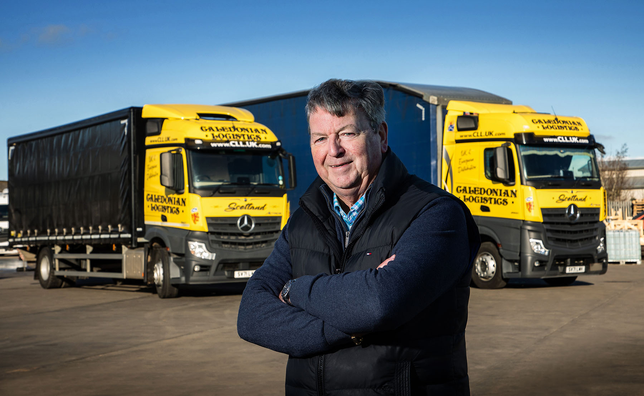

Actros advantage: Derek Mitchell is delighted with his new Mercedes-Benz rigids and tractors

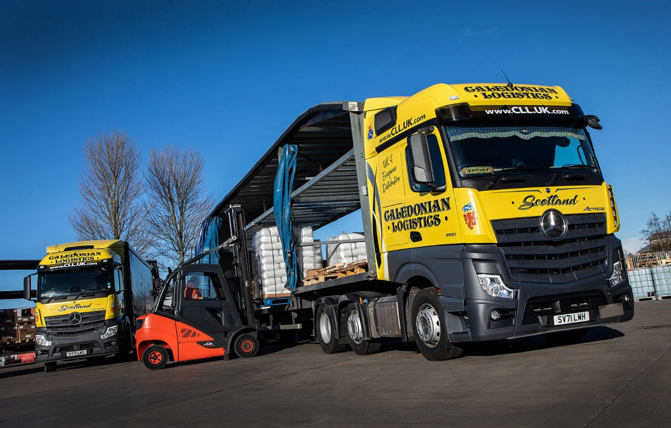

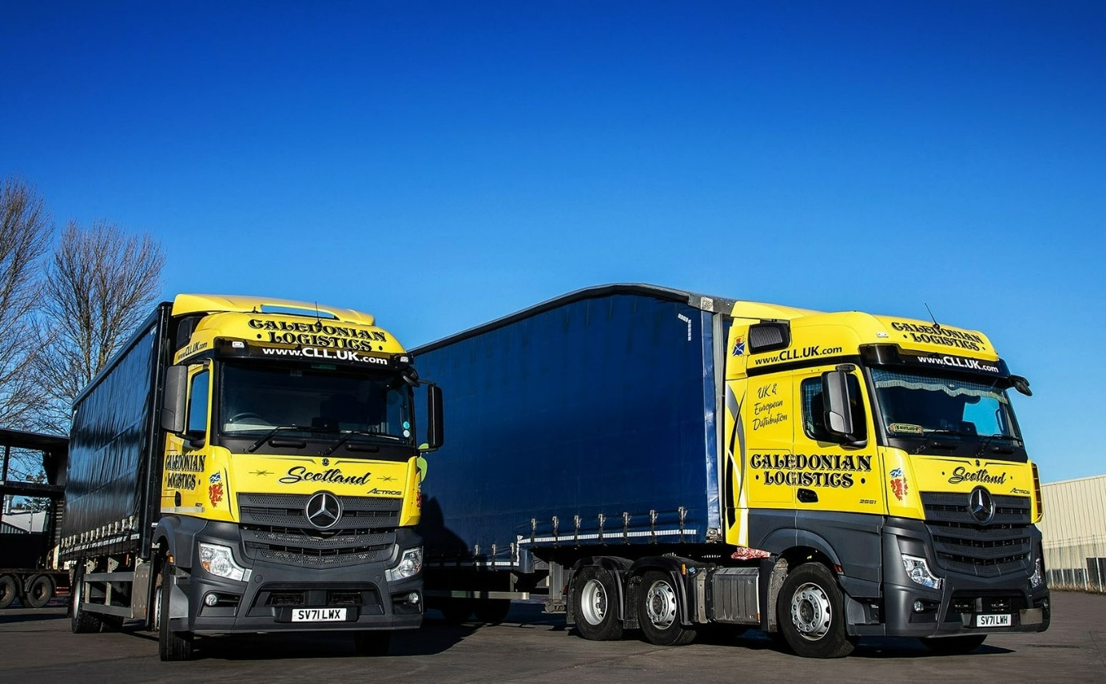

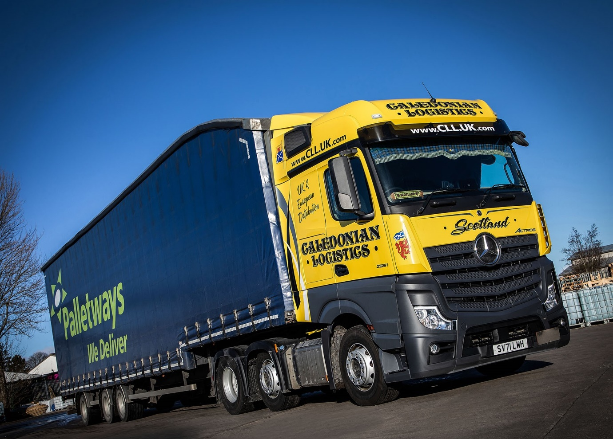

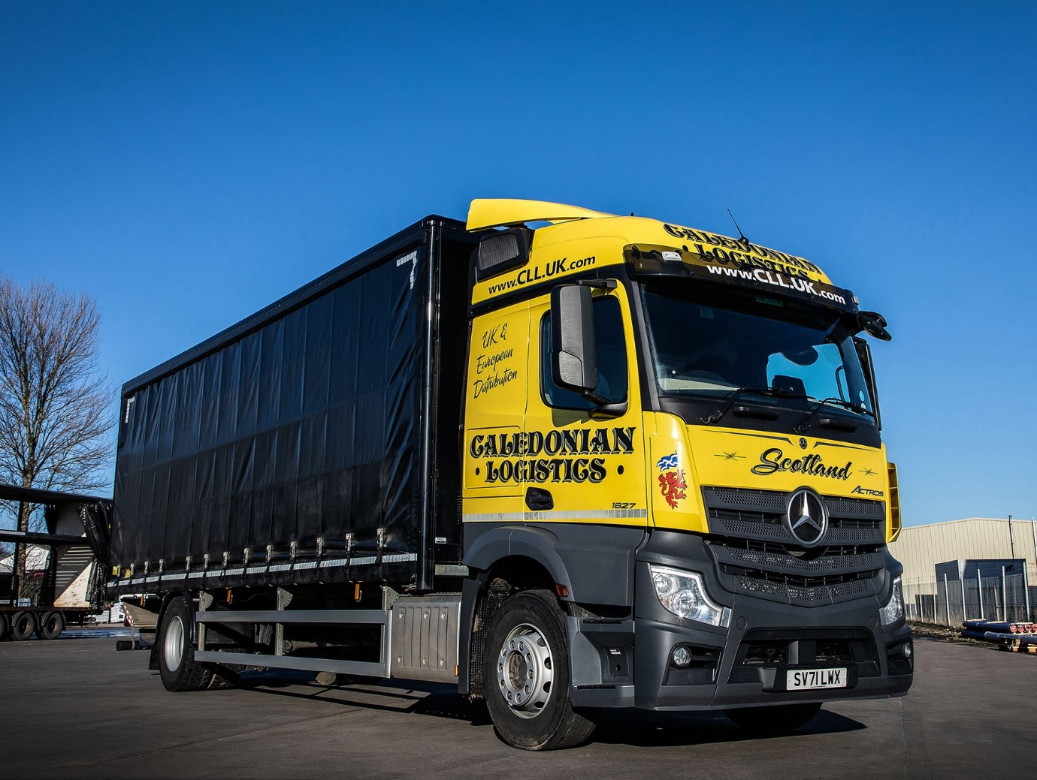

ends

For more information, or to request bigger versions of image files, please contact:
John Ripley or Steve Warren
Impact Communications
John: 07771 484595, john@impactcom.co.uk
Steve: 07770 470251, steve@impactcom.co.uk



