

Date: 4 August 2020

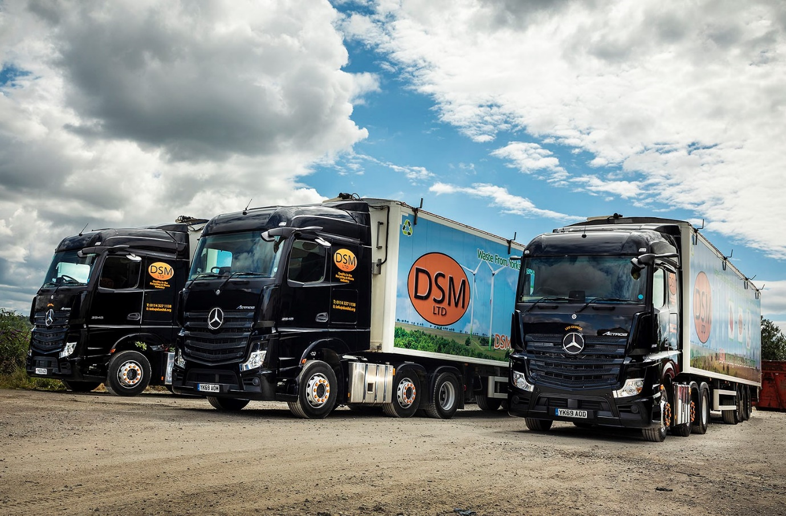

DSM takes a leap forward on safety with
Mercedes-Benz MirrorCam from Northside

One look was all it took to convince Scott Reynolds that radical MirrorCam technology from Mercedes-Benz represents a major safety breakthrough.

The Managing Director of Sheffield-based waste management specialist DSM was a guest of local Dealer Northside Truck & Van at an open day event that provided operators with the chance to take turns at the wheels of various Actros models equipped with the new system.

Staged at the Mercedes-Benz Trucks Customer Experience Centre on Wentworth Park, near Barnsley, the presentation certainly impressed Mr Reynolds, which helps to explain why his company has just taken delivery of its first three tractor units with MirrorCam.

The subject of a Mercedes-Benz Finance contract hire agreement, all are 2548 models with aerodynamic, flat-floored StreamSpace cabs, and 350 kW (476 hp) 12.8-litre in-line six-cylinder engines. They have replaced three 330 kW (450 hp) units from the previous Actros range.

Mr Reynolds recalled: “I knew the latest-generation Actros was loaded with advanced technology, so jumped at the opportunity to try it for myself. I was particularly keen to see MirrorCam in action, and the benefits were obvious from the outset.”

MirrorCam replaces conventional mirrors. The images relayed by its rear-facing cameras to screens mounted inside the cab, on the A-pillars, provide drivers with significantly better visibility. Just as importantly, the absence of conventional wing mirrors contributes to increased safety for vulnerable road users, by eliminating the large blind spots they cause.

“I’d heard that Mirrorcam takes a bit of getting used to, but I was entirely comfortable with it from the ‘off’,” reported Mr Reynolds. “The system is very easy to use, and thanks in part to some clever technology the view to the rear is much improved.

“Just as importantly, though, the absence of bulky mirror housings means those big, forward-facing blind spots are a thing of the past. Drivers can see so much more of what’s going on around them, and that can only make the roads safer for everyone, but particularly vulnerable cyclists and pedestrians.”

DSM has a “zero waste to landfill” policy. Its sorting and transfer station processes waste produced by commercial and industrial customers located throughout South Yorkshire. Recyclables such as glass, paper and plastics are separated, and its trucks then transport the remaining waste in Knapen moving floor trailers to waste-to-energy plants across the UK, where it is used as refuse-derived fuel.

“We know from experience that the Actros is reliable, cost-effective to operate, and popular with our drivers,” continued Mr Reynolds. “Our previous fleet of three Actros, which these trucks have replaced, performed very well over the last three years. By adding innovations like MirrorCam Mercedes-Benz has made a great truck even more efficient, easier to use, and safer.”

New Actros is a technological tour-de-force. Other highlights include the futuristic Multimedia Cockpit with twin screens in place of switchgear, and an enhanced version of the fuel-saving Predictive Powertrain Control system. Active Brake Assist 5, meanwhile, employs cameras, as well as radar, and delivers dramatically improved responses at speeds of up to 50 kph. It can apply full braking – as opposed to the 50% achieved previously – if it detects a pedestrian crossing the truck’s path.

“Our drivers love their new trucks,” continued Mr Reynolds. “MirrorCam has been very well received and they appreciate the extra bit of ‘oomph’ the bigger engine offers. We’re not obsessive about measuring fuel returns, but the guys tell me they’re doing well at the pumps too.”

He added: “Northside’s Truck Sales Executive Vicki Light worked extremely hard to put together a competitively priced package that meets all of our requirements. She kept us fully informed throughout the acquisition process and was able to deliver our new Actros four weeks early, which was a bonus. I can’t praise her highly enough.

“That superb quality of customer care extends to the workshop team at the Dealer’s Sheffield branch. They collect our trucks when inspections and maintenance are due, carry out the work at nights or over weekends so we don’t incur any downtime, then return them to us afterwards. It’s a first-class service.”

www.dsmltd.org



Embracing progress: Scott Reynolds of DSM says Mercedes-Benz has made a great truck even better

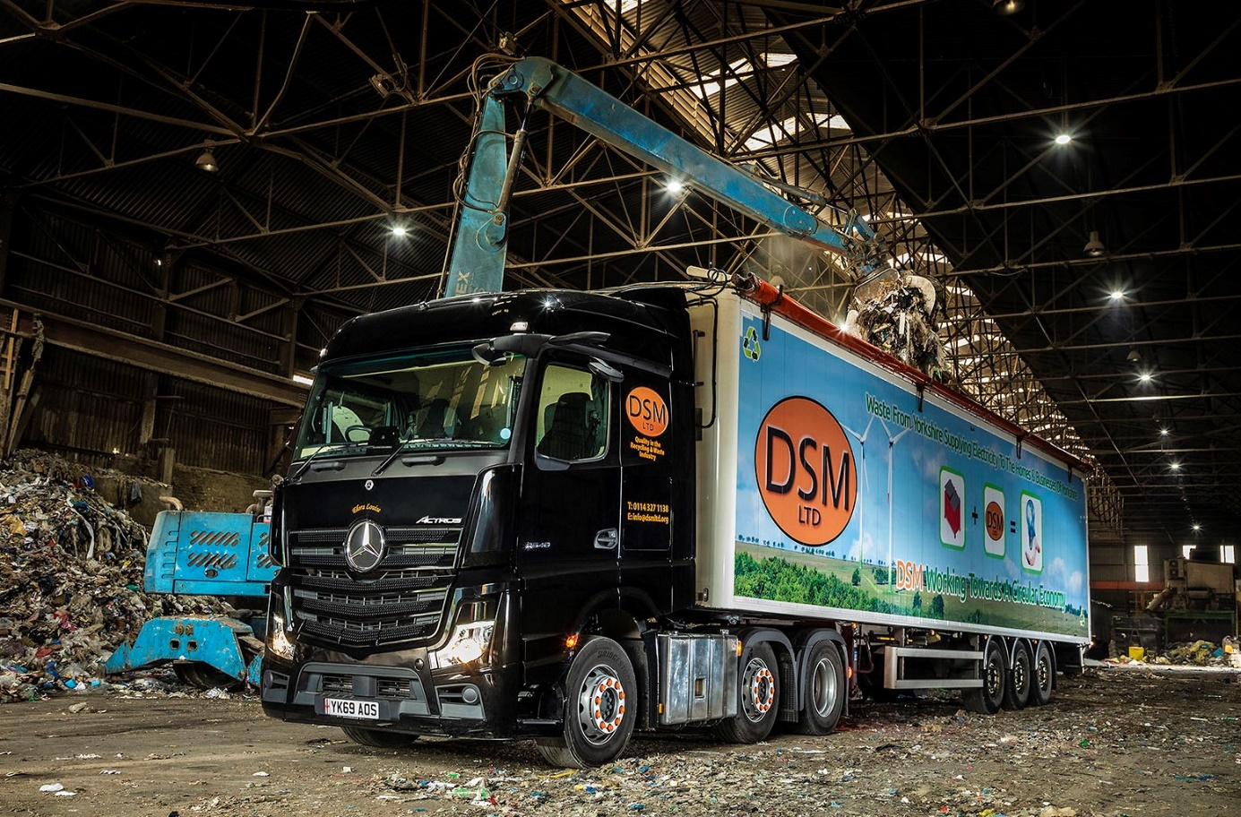

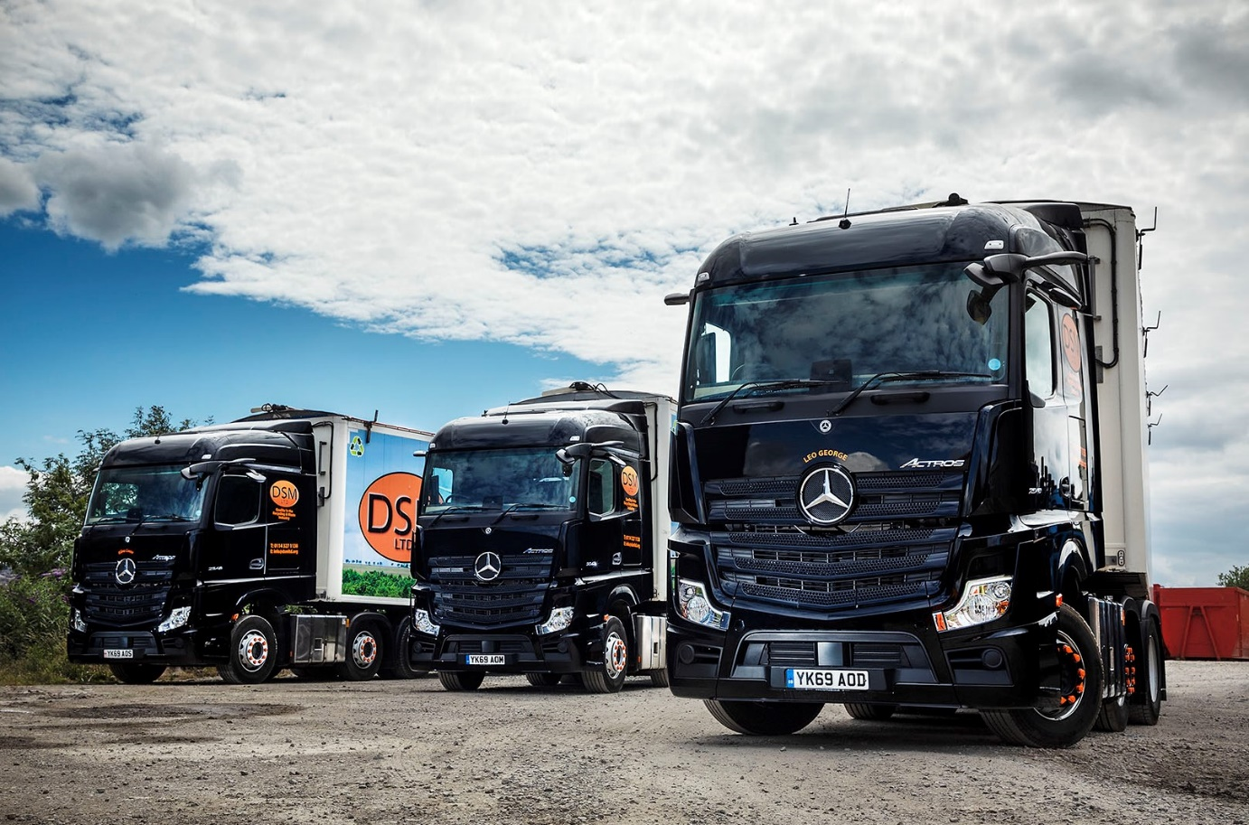

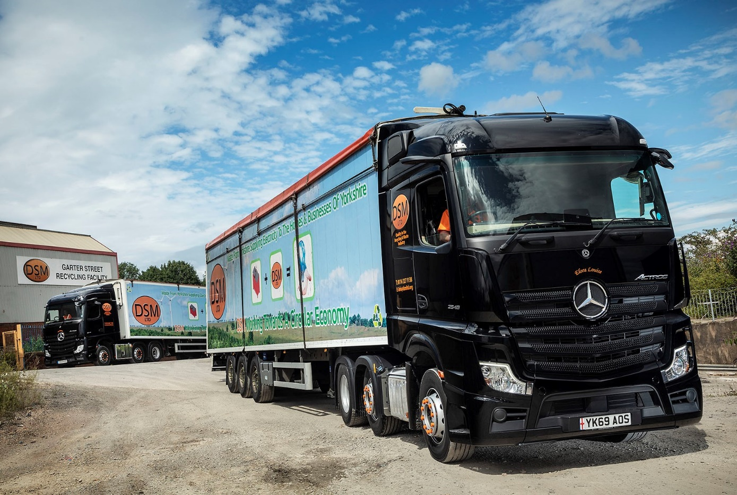

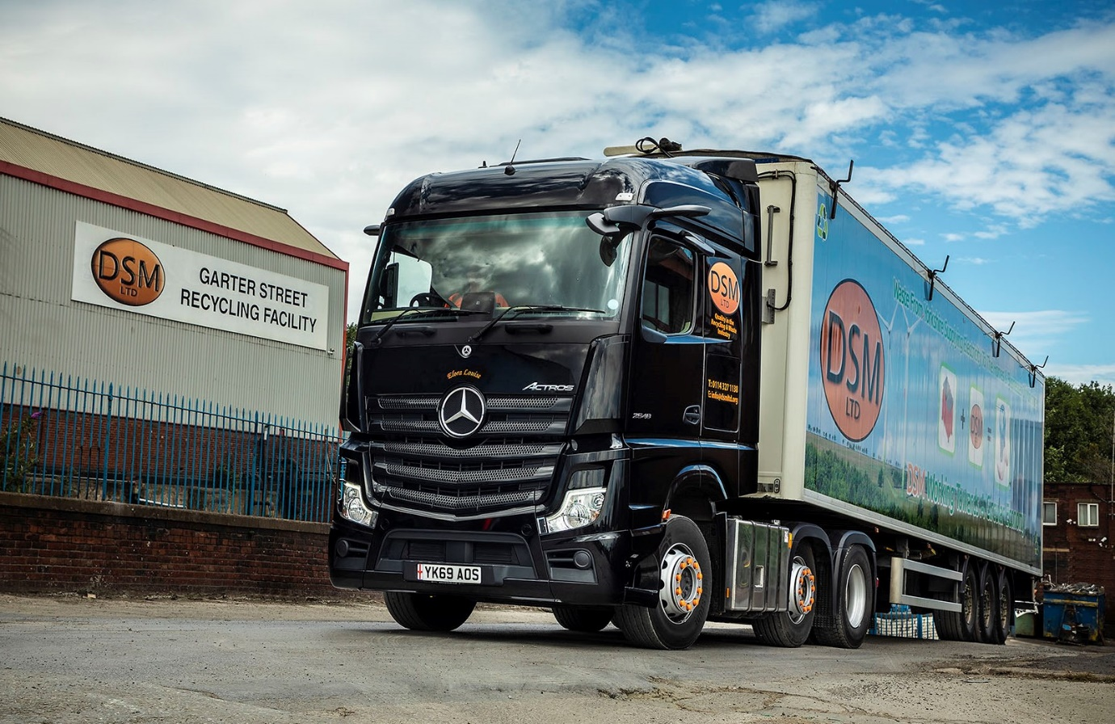

ends

For more information, or to request bigger/higher-res image files, please contact:
John Ripley or Steve Warren
Impact Communications, 01926 842126
John: 07771 484595, john@impactcom.co.uk
Steve: 07770 470251, steve@impactcom.co.uk

