

Date: 2 June 2020

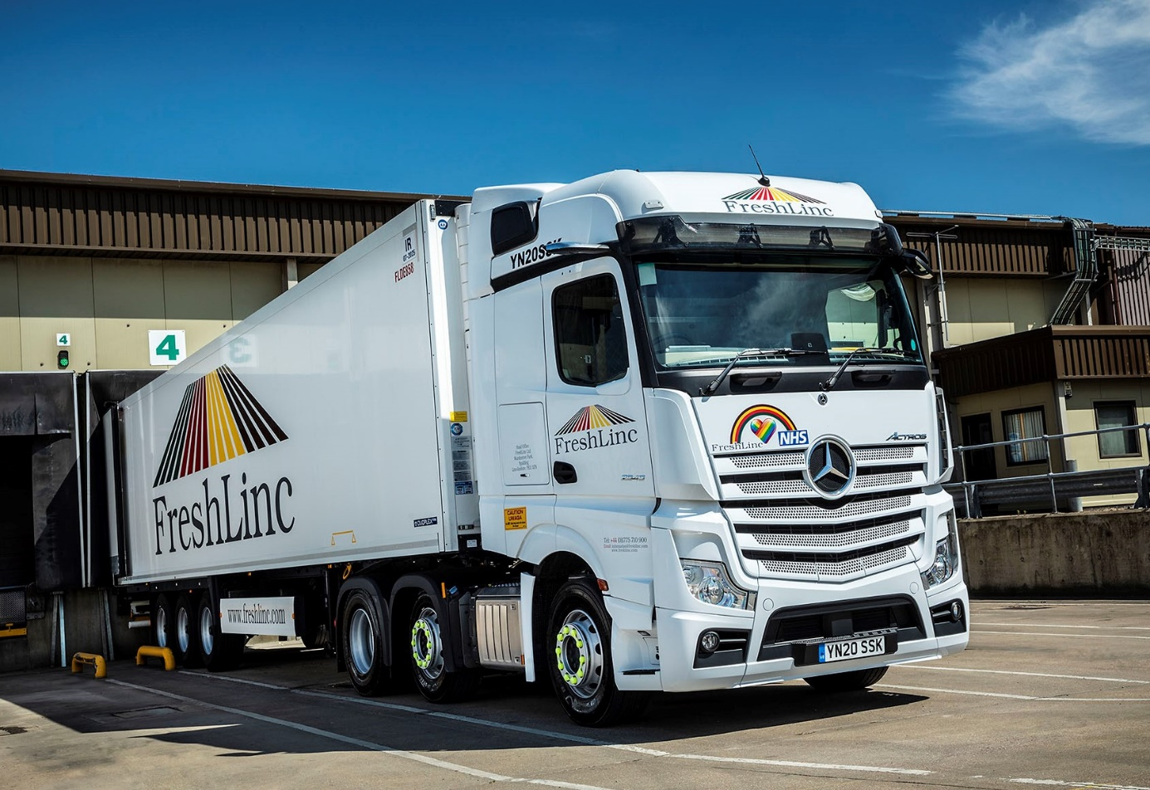

FreshLinc “excited” about its first Mercedes-Benz trucks after videocall handover of demonstrator

So impressed was FreshLinc Group with the fuel-efficient performance and technical specification of a Mercedes-Benz Actros demonstrator that within just four weeks of setting the tractor unit on the road it had followed-up with an order for 14 identical trucks.

The refrigerated distribution specialist’s first Mercedes-Benz vehicles will join a 400-strong, mixed-marque fleet, and work from its headquarters in Spalding, Lincolnshire.

Their scheduled introduction in October heralds the beginning of a “new and exciting chapter”, according to FreshLinc Fleet Engineer Andy Marchant.

The subject of a Mercedes-Benz Finance contract hire agreement, all will be 6x2 Actros 2545 models with flat-floored BigSpace cabs and 12.8-litre, in-line six-cylinder engines producing 330 kW (450 hp). Inspections and maintenance will be entrusted to the workshop team at the spacious and comprehensively equipped branch in Boston which was opened in 2015 by supplying Dealer Intercounty Truck & Van.

FreshLinc handles more than 6,000 loads each week, on its diverse chilled and ambient food and drink, container, crane, bulk transport horticultural operations. The company trialled an Actros for six months last year, an exercise that provided a wealth of encouraging data and gave it the confidence to take on the second demonstrator in April.

After a ‘virtual handover’ in which a Mercedes-Benz Trucks specialist delivered a videocall presentation then followed up with documentation and a question and answer session, this vehicle was assigned to supermarket deliveries.

It has since been double-shifted, and runs fully loaded in both directions. “We were keen to utilise the new truck’s full potential and very quickly established that its mpg returns were in line with our expectations, which sealed the deal,” recalled Andy Marchant.

“The Actros has also been well accepted by our drivers. They appreciate its general comfort, while the early feedback on features such as MirrorCam and the new dashboard is entirely positive.”

Complementing FreshLinc’s familiar livery, the demonstration unit wears NHS rainbow and heart motifs, which underscore the operator’s appreciation of the front-line doctors, nurses and other health workers who have so endeared themselves to the nation during the Covid-19 pandemic.

Winner of the coveted International Truck of the Year 2020 trophy, the fifth-generation Mercedes-Benz Actros has raised the bar in terms of technological innovation.

MirrorCam, the much-publicised replacement for conventional mirrors, enhances safety by providing significantly enhanced visibility when cornering or reversing, especially with an articulated rig. It also cuts fuel consumption by up to 1.5%, thanks to the compact, streamlined profile of the camera housings.

A potential life-saver in the form of Active Brake Assist 5 is also standard equipment. Whereas the previous version of Mercedes-Benz Trucks’ emergency braking system relied solely on radar, its successor employs a combination of radar and cameras. The result, at speeds of up to 50 kph, is a dramatically improved response to moving pedestrians. Active Brake Assist 5 employs full braking – as opposed to the 50% achieved previously – when encountering pedestrians crossing its path.

Other developments include an enhanced version of the well proven Predictive Powertrain Control system, which now makes a more substantial contribution to economy, while also ensuring that life at the wheel is easier for drivers, and the twin screen Multimedia Cockpit, which brings connectivity and intuitive operation to the fore. Like the 14 trucks Freshlinc has ordered, the demonstrator features the upgraded Multimedia Cockpit, interactive which comes with a larger 12in instrument panel and extra functionality.

Andy Marchant and his colleagues have held video conferences with Mercedes-Benz Trucks Key Account Manager James Venables and members of the Intercounty Truck & Van team. “Good communication will be crucial to the success of our new relationship, and I’m pleased to say that we’ve made a very good start,” confirmed Mr Marchant. “The Dealer knows it will have to perform to keep me happy, and I’m optimistic it will do so.”

www.freshlinc.com

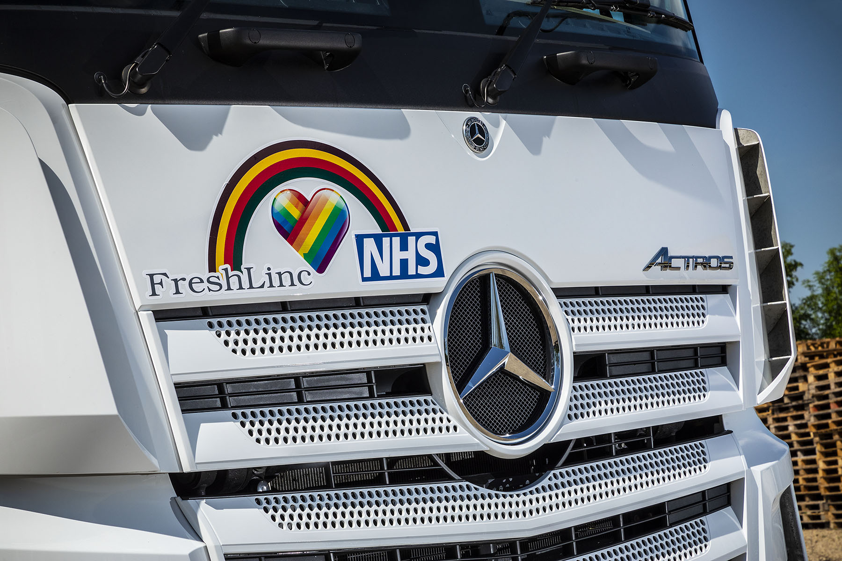

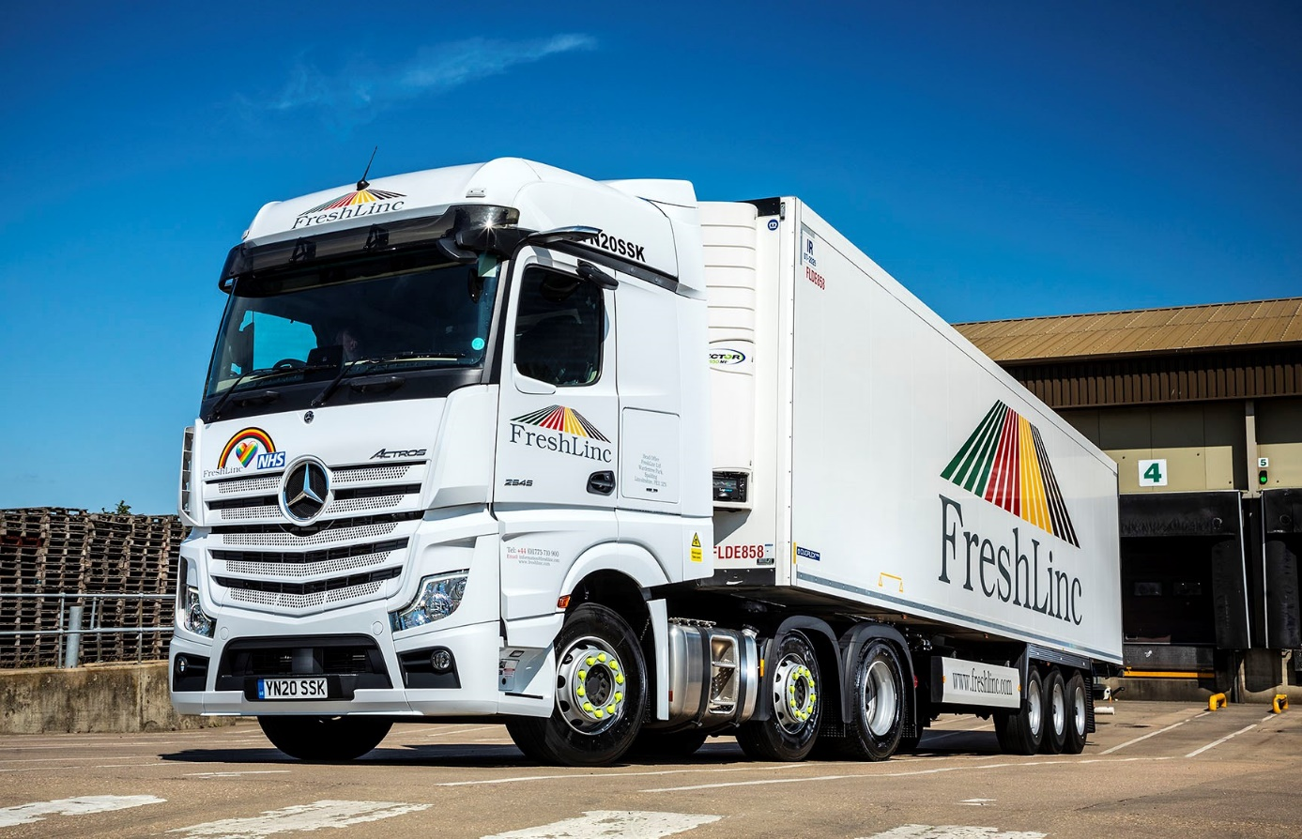

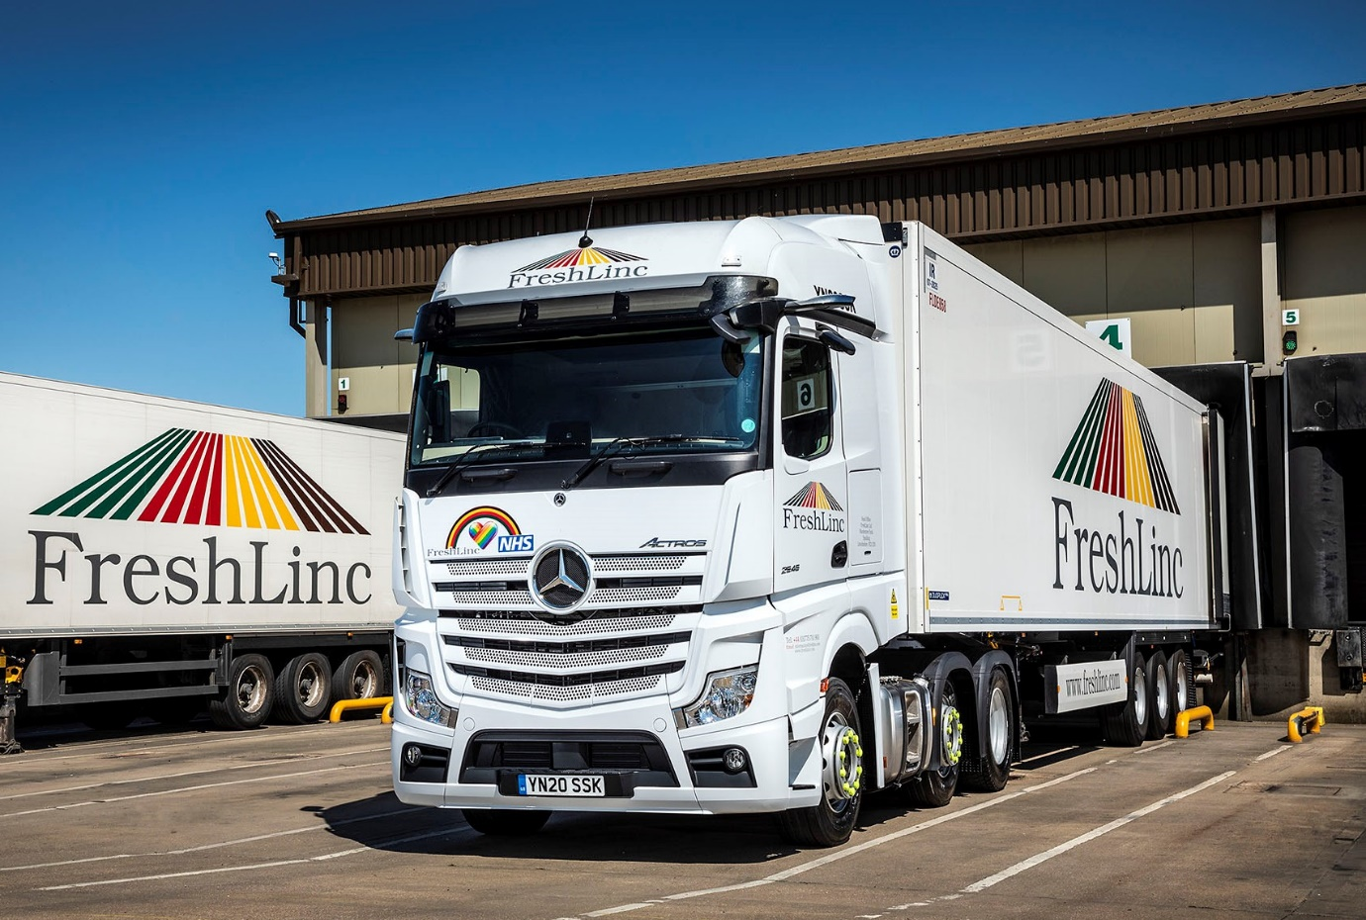

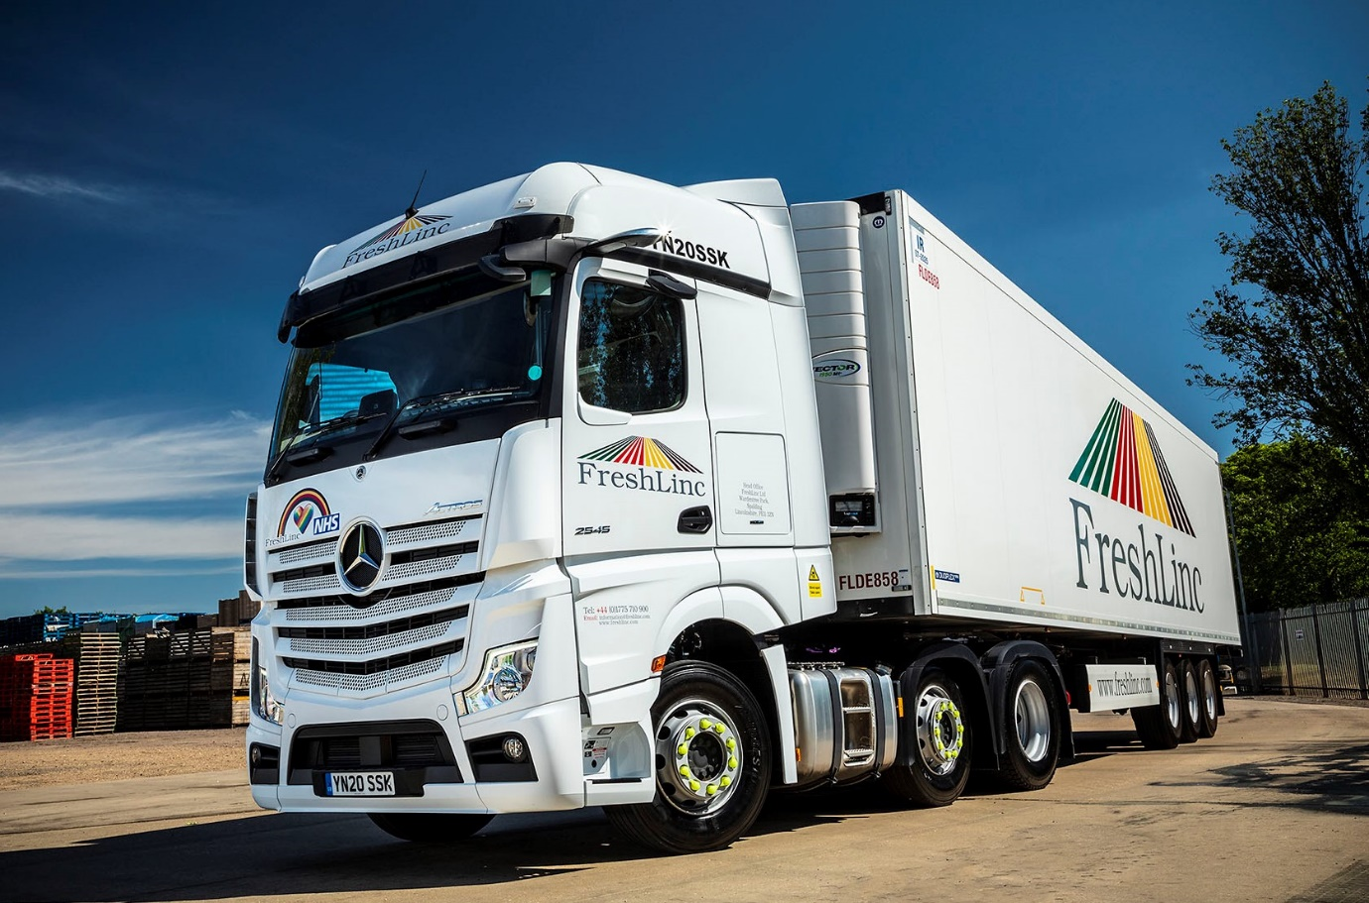

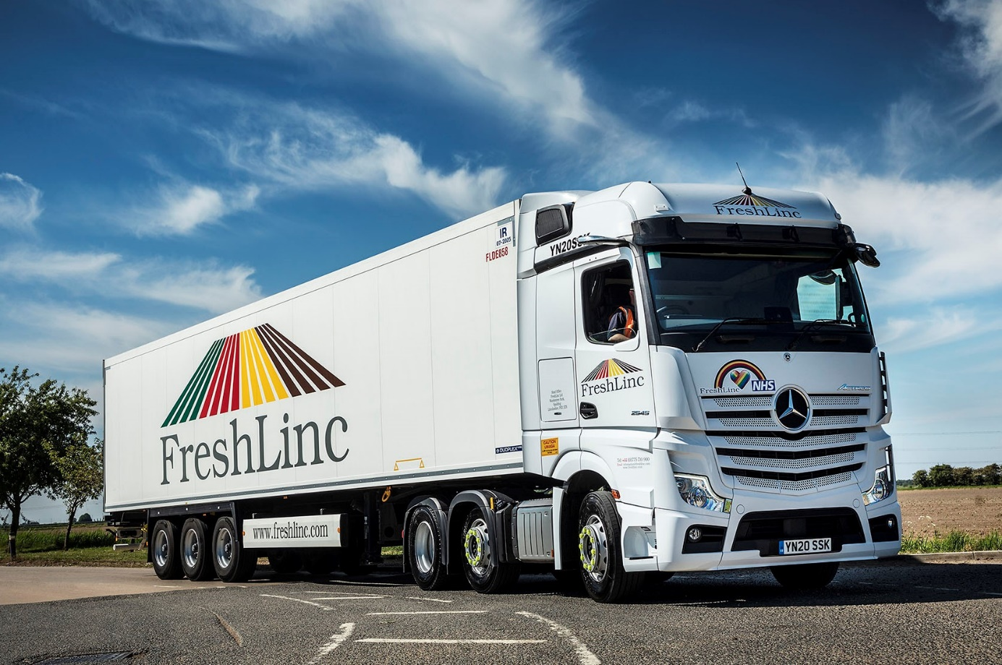

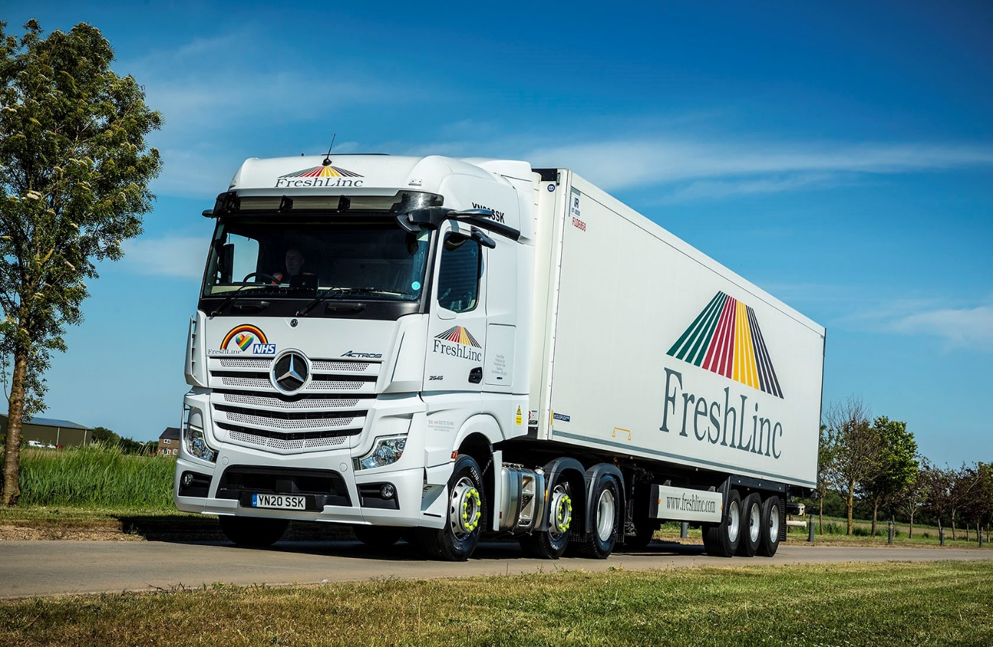

ends

For more information, or to request higher-res image files, please contact:

Jamie Fretwell at Mercedes-Benz Trucks UK Ltd
07712 519230, jamie.fretwell@daimler.com

or

Steve Warren or John Ripley
Impact Communications, 01926 842126
Steve: 07770 470251, steve@impactcom.co.uk
John: 07771 484595, john@impactcom.co.uk

About Mercedes-Benz Trucks UK Ltd
Mercedes-Benz Trucks UK Ltd is the sales and marketing organisation responsible for all Daimler truck products in the UK, including FUSO Canter. In 2019, the company registered 6,963 new trucks.

Mercedes-Benz accounted for 6,188 new trucks registered in 2019, making it the third-biggest truck brand in the UK. Meanwhile, FUSO registrations hit 775 – including 580 new trucks over 6.0-tonnes.

The flagship new Mercedes-Benz Actros which won the 2020 International Truck of the Year award, features seven core innovations including MirrorCam, Multimedia Cockpit and Active Brake Assist 5.

Our premium range of innovative trucks – Actros, Arocs, Atego, Econic and Unimog – draw upon more than 125 years of exceptionally high standards of quality, backed up by our promise of Trucks You Can Trust.

www.mbtrucks.co.uk

