

Date: 26 July 2023

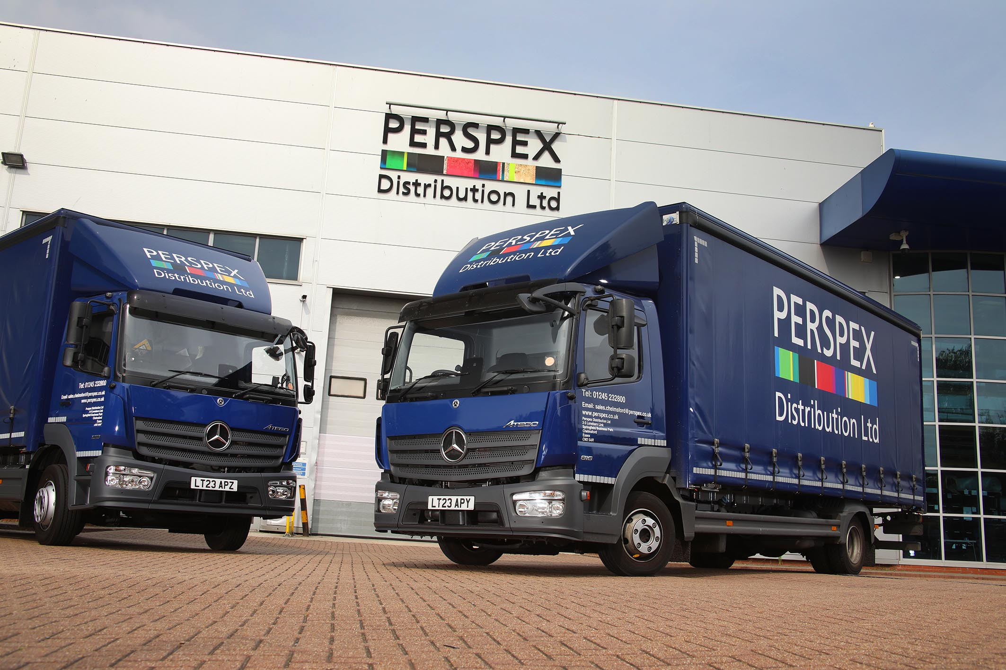

Mercedes-Benz Atego makes its case to Perspex Distribution

Premium-brand build quality at a competitive price made the Mercedes-Benz Atego a clear winner for Perspex Distribution Ltd.

A leading distributor of Perspex® cast acrylic and thermoplastic sheet, rod and tube, the company is now running its first trucks to wear the famous three-pointed star badge.

The five new vehicles were delivered by Dealer Motus Truck & Van and are working from Perspex Distribution’s five sites at Blackburn, Chelmsford, Leeds, Tamworth and Weybridge.

All are from the Mercedes-Benz Atego light-duty distribution range that is designed to offer precise handling with exceptional ride comfort, and is renowned for its reliability and durability. Four are 12-tonne 1218 models with 5.1-litre engines that produce 130 kW (177 hp) and drive through six-speed Mercedes PowerShift 3 automated manual transmissions. The fifth is a smaller 816 model, at 7.5 tonnes GVW and with a 115 kW (156 hp) version of the same engine. All have ClassicSpace S-cabs and curtainside bodies by Northamptonshire-based Kurt Hobbs Coachworks.

They join a fleet of 24 trucks which provide deliveries of sheet materials, either at standard sizes of up 3x2-metre or cut to order, as well as other profiles, to customers across a broad range of industries all over the UK. All are replacements for vehicles stood down, the only difference being that one of the 12-tonners replaced a 7.5-tonne chassis.

Warehouse Manager Keith Seymour said: “When choosing these vehicles we researched a number of options as part of our decision-making process. Our final choice was down to a combination of shorter delivery times from Motus Truck & Van than many competitors could quote, the highly competitive whole-life cost of the Atego, and the fact that Mercedes-Benz is widely acknowledged as one of the leading brands in the market.

“The Atego is clearly very well put together and has a great reputation for toughness so with the backing of an attractively priced Service Contract from Motus Truck & Van, and a support package that includes full roadside assistance from factory technicians, we’re looking forward to years of reliable and cost-effective service from our new vehicles.”

Perspex Distribution offers a fast delivery turnaround across a wide range of cast and extruded materials, and LED lighting, from its large stock holdings. Offering an unrivallec range of UK-manufactured materials, the company serves key industrial sectors including visual communications, signage, retail point of sale, construction and general fabrication.

Perspex Distribution forms part of the UK manufacturing group for Perspex® acrylic. Manufactured in Lancashire since 1934, Perspex® acrylic is recognised as a market leader in the plastics sector.

www.perspex.co.uk

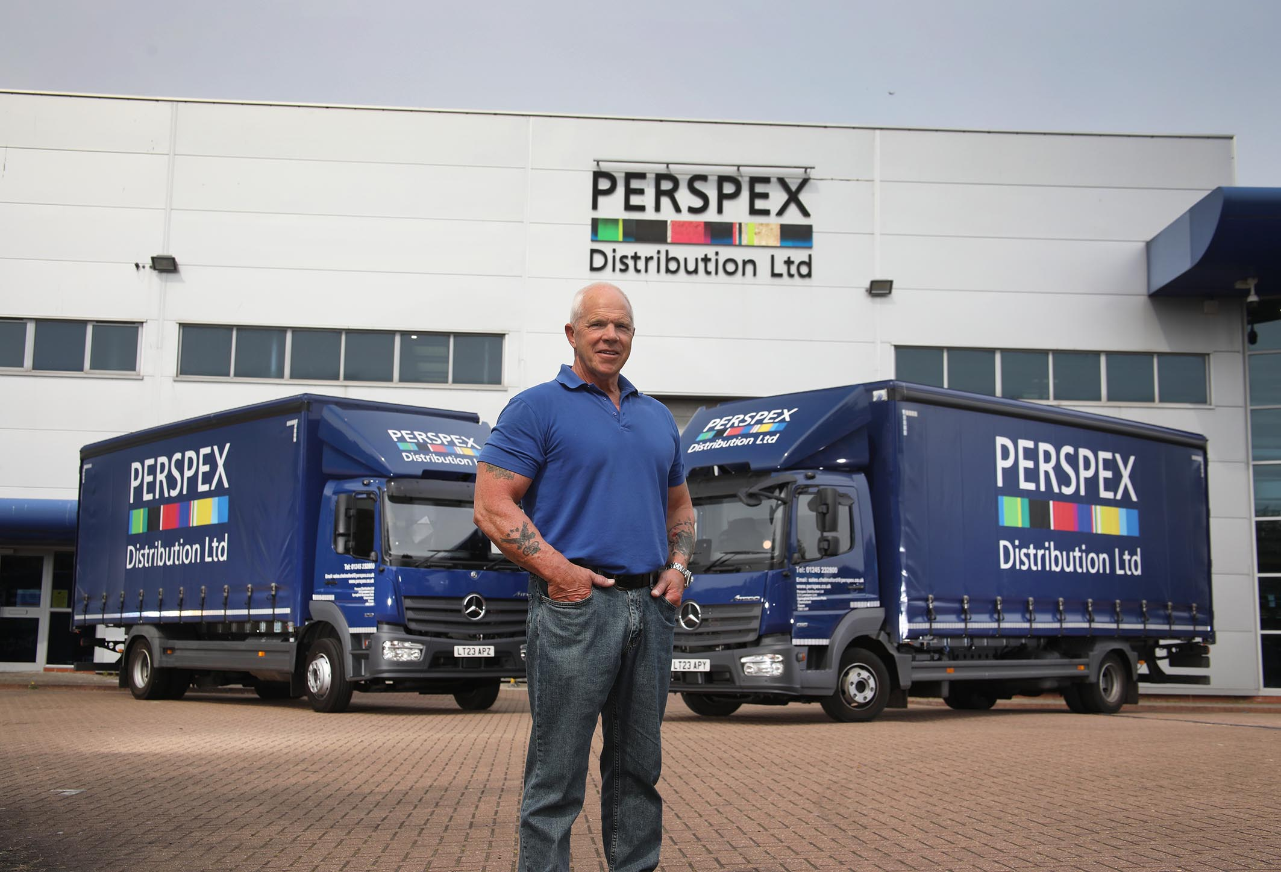

Winning combination: The Mercedes-Benz Atego displays an ideal package of attributes for Perspex Distribution’s Keith Seymour

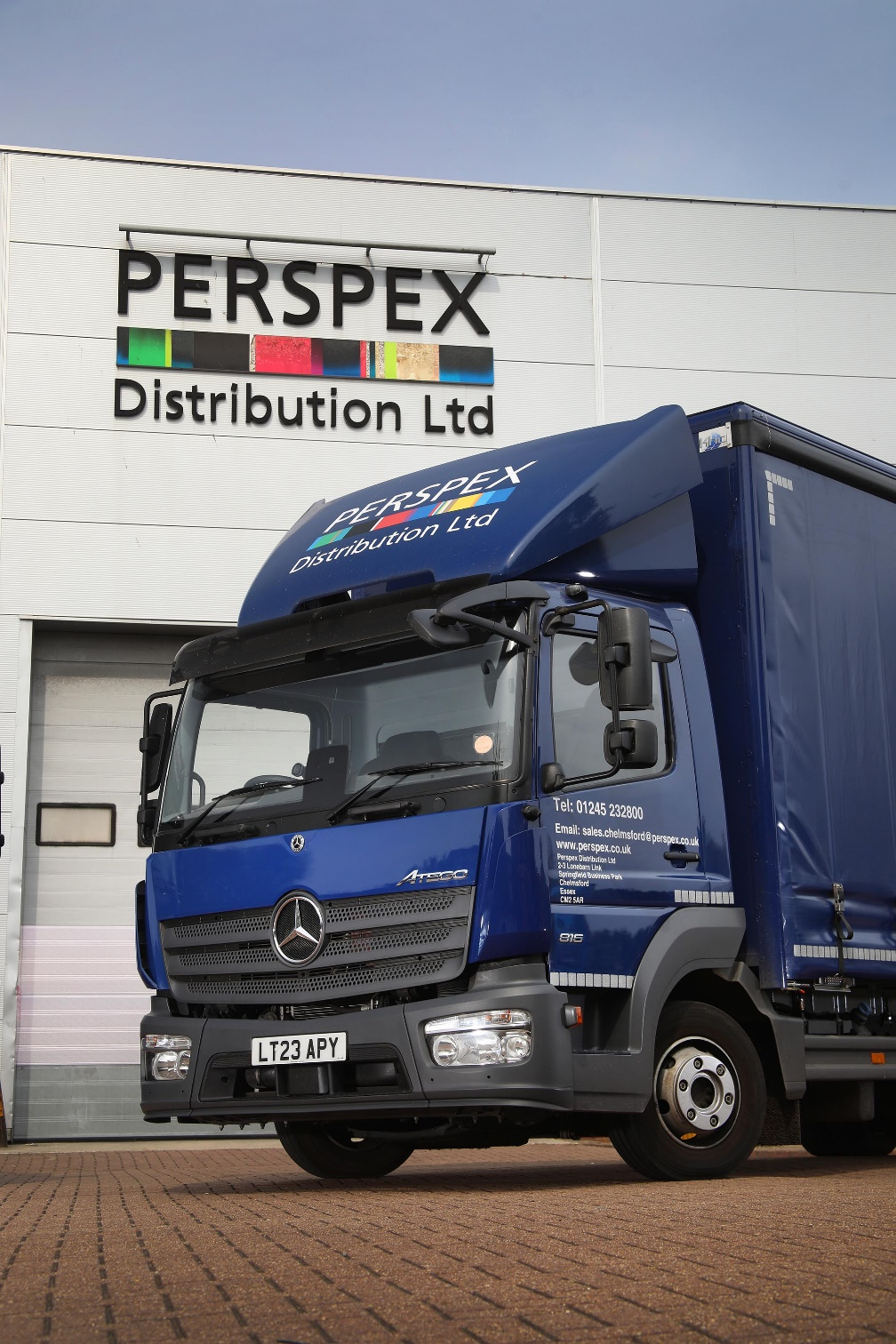

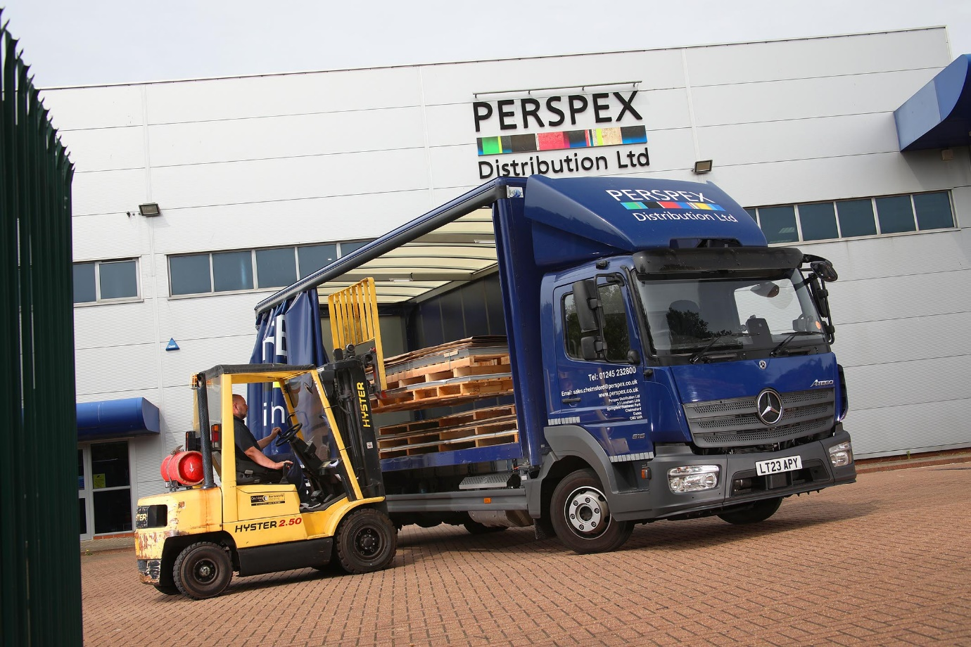

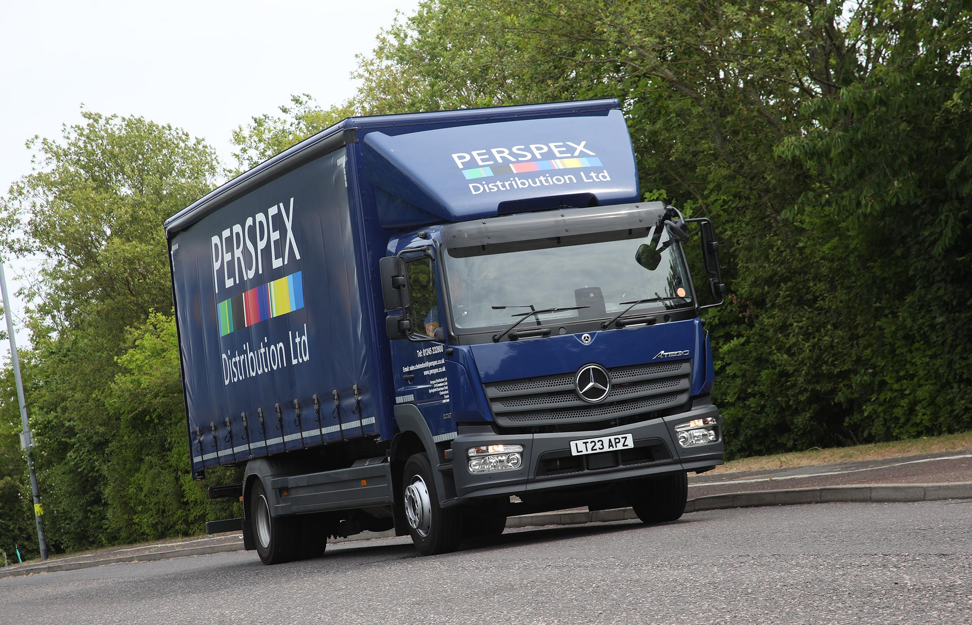

ends

For more information, or to request bigger/higher-res image files, please contact:
John Ripley: 07771 484595, john.ripley@loopagency.co.uk

