

Date: 18 March 2025

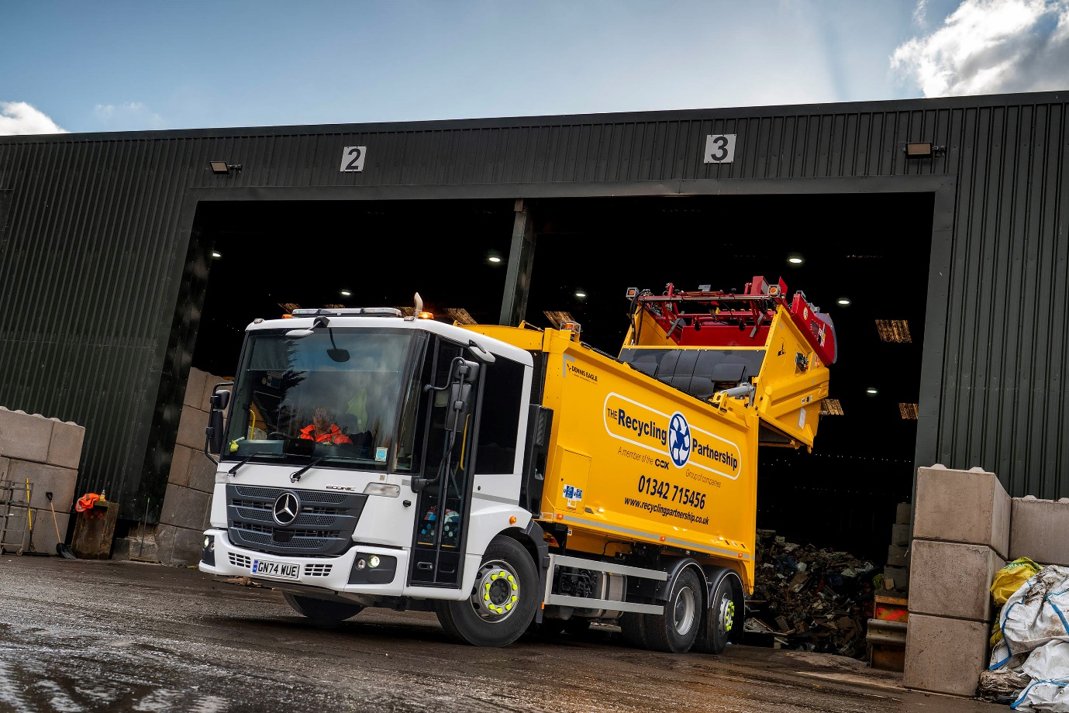

Recycling Partnership fleet comes of age with 21st Mercedes-Benz Econic

Sussex-based waste management specialist The Recycling Partnership has completed its transformation to an all-Mercedes-Benz Econic fleet of 21 refuse collection vehicles, with the arrival of two new chassis from Dealer SAGA Truck & Van.

Transport Manager Andrew Burgess said: “We’ve run Mercedes-Benz vehicles for some years but they came from several different sources and other manufacturers were represented in the line-up too. When I took on this role a year ago, I wanted to standardise – not just on one vehicle, but also one supplier.

“This simplifies the job of fleet management but also allows us to develop a relationship with a trusted partner, both for vehicle acquisition and ongoing support. We reached out to several potential suppliers but the response from SAGA and Sales Executive Shaun O’Hara stood out as by far the best.”

The two new trucks are 6x2 Econic 2530 models, their rear-steer chassis fitted with Dennis Eagle compactor bodies and Terberg bin lifters. Each is powered by a 7.7-litre engine generating 220 kw (300 hp) and driving through a fully automatic Allison six-speed gearbox.

“Since starting to work with Shaun I’ve been really impressed by the depth of his understanding of our industry,” continued Mr Burgess. “He’s an expert on his own product, but he’s also extremely knowledgeable about the ancillary equipment we operate and the way it interfaces with the Mercedes-Benz base vehicle.

“His professionalism and customer care are exemplary too. The acquisition of these new Econics was handled very smoothly and we were kept fully informed throughout the process, so we are entirely satisfied that we’ve made the right choice.”

Routine maintenance on the trucks will be carried out at The Recycling Partnership’s own workshop on its headquarters site at Turners Hill, near Crawley.

“The fact that we maintain the trucks in-house was another reason for wanting to standardise the fleet – it makes life easier for our technicians,” continued Mr Burgess. “As SAGA customers we also know that technical advice or support with any more serious issues is just a phonecall away, if we should need it – not that we ever have.”

The new trucks have joined a fleet which runs from The Recycling Partnership’s headquarters and a second depot in Brighton. They collect commercial waste from customers across East and West Sussex, as well as parts of Surrey and Kent. Loads are brought back to the operator’s own processing centre where they are sorted for either recycling or energy generation. The company also offers specialist services including the collection and recycling of items such as food waste, confidential documents and electrical and electronic equipment, as well as commercial and domestic skip hire.

Econic drivers benefit from an unrivalled view of the conditions around them, thanks to the vehicle’s deep, wraparound windscreen and low seating position. The Econic attracts a top, five-star Direct Vision rating from Transport for London, when fitted with the optional fully glazed, bus-style folding side door as specified by The Recycling Partnership. This allows the individual at the wheel to make direct eye contact with cyclists or pedestrians at junctions and in traffic, a key advantage in helping each to understand the other’s intentions.

The new Econic is also equipped with Active Brake Assist 5 emergency braking technology, which boasts an industry-leading pedestrian recognition capability, and an Electronic Parking Brake that is applied automatically when the engine is switched off.

“We’re looking forward to developing an increasingly close partnership with SAGA as we move forward, and are already tapping into Shaun O’Hara’s impressive knowledge of the battery-powered eEconic as we begin to make plans for a possible move to electric transport,” Mr Burgess concluded.

recyclingpartnership.co.uk

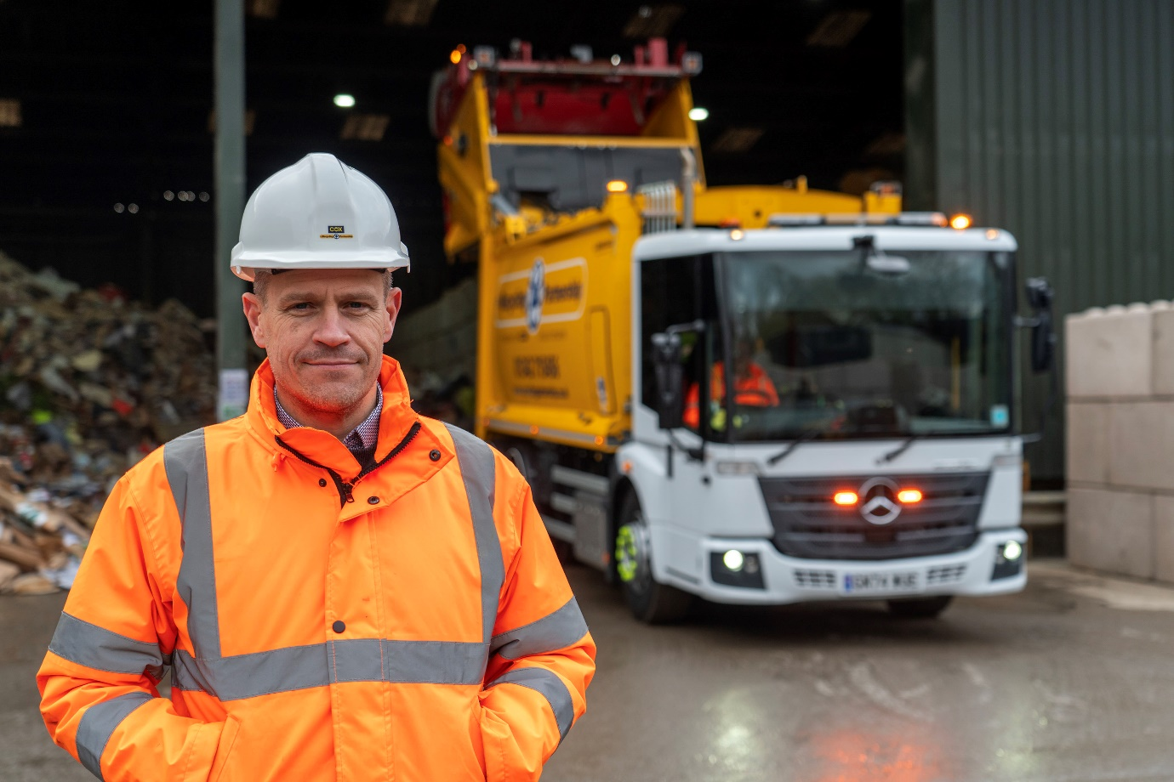

Raising standards: The Recycling Partnership’s Andrew Burgess with one of his latest Mercedes-Benz Econic refuse collection trucks

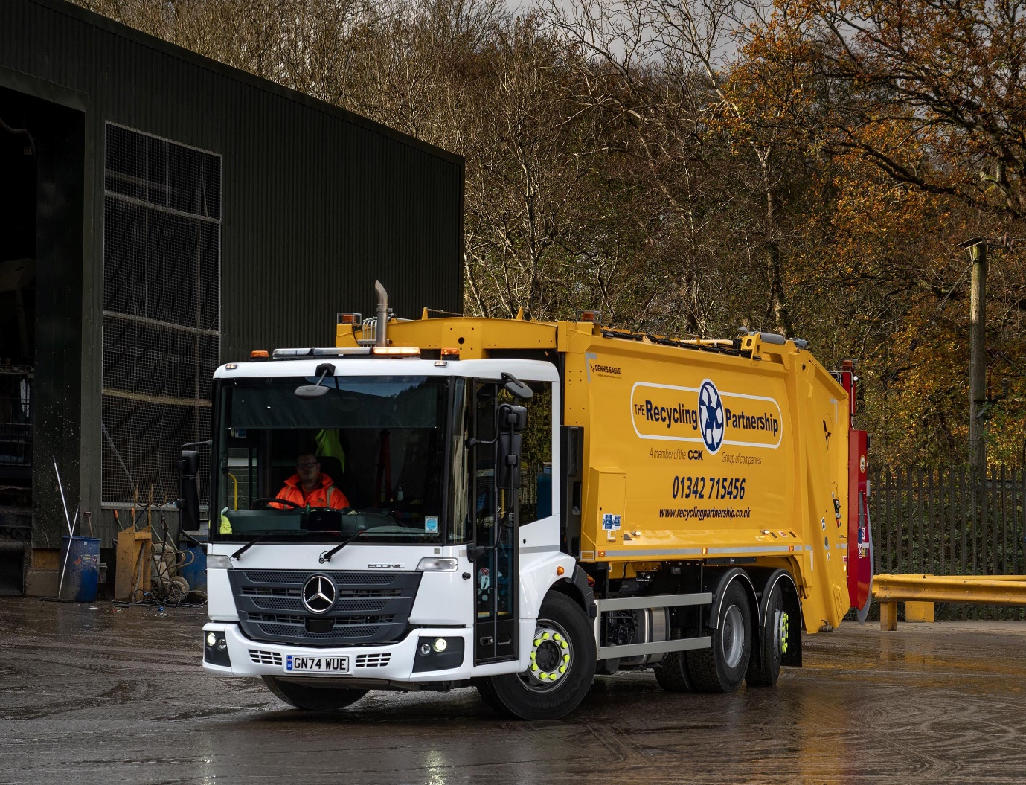

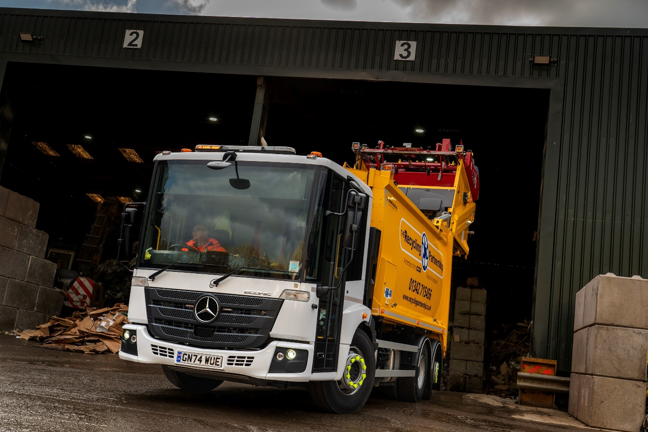

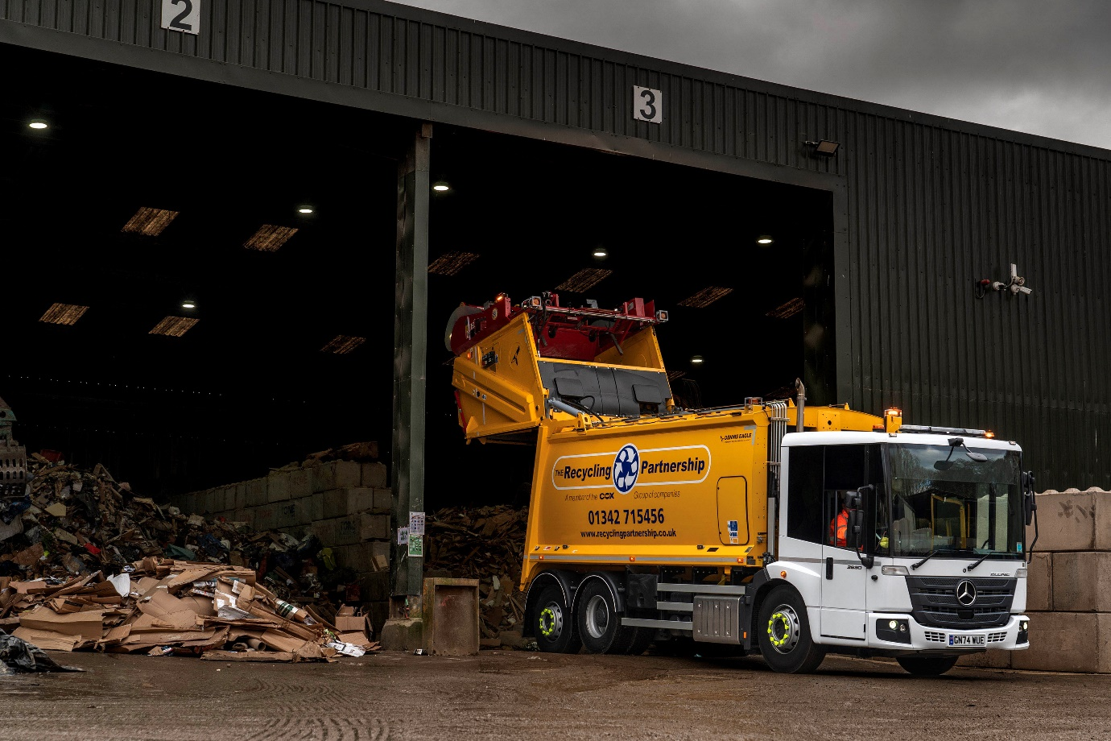

ends

For more information, or to request bigger/higher-res image files, please contact:
John Ripley: john@loopagency.co.uk 07771 484595

