

Date: 22 April 2022

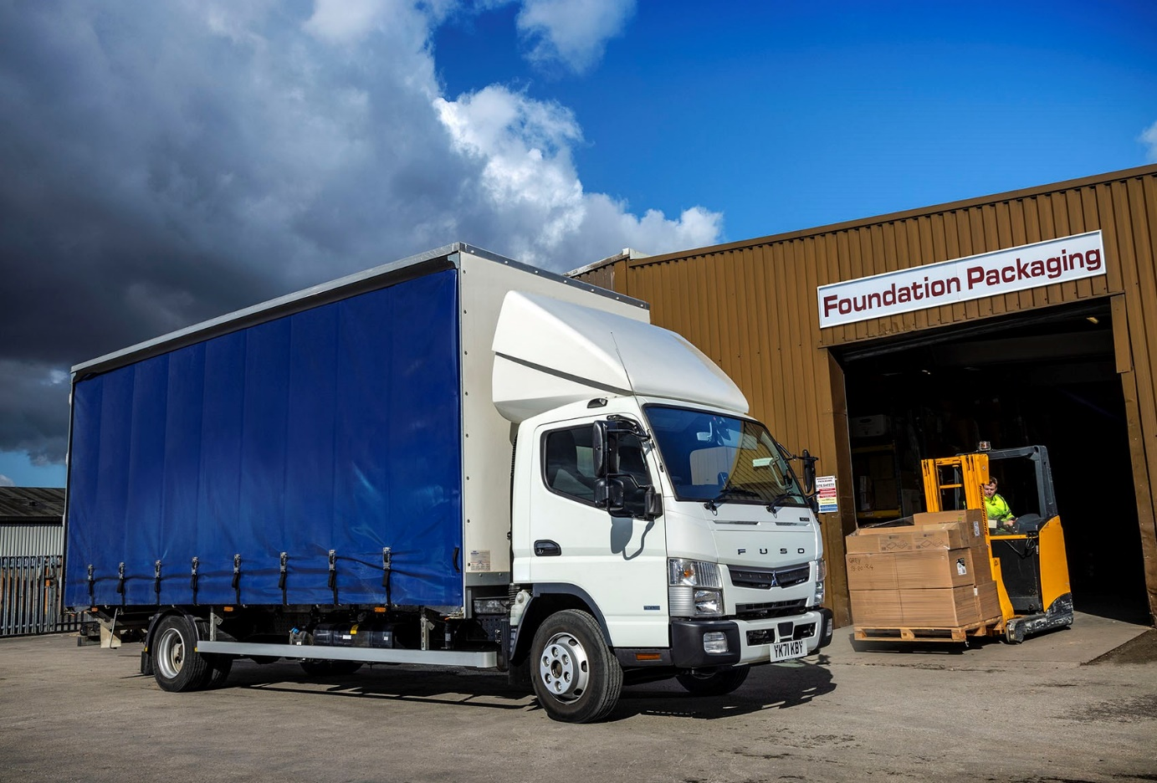

Packaging firm lays foundations for future success with FUSO Canter from Northside Truck & Van

Doncaster-based Foundation Packaging contacted its local Mercedes-Benz Dealer to enquire about its next FUSO Canter – and was delighted to be told a new curtainside-bodied vehicle could be delivered the following week!

Northside Truck & Van had commissioned the 7.5-tonner for its own demonstration fleet, but was happy to let the vehicle go to its new customer instead. Like other members of the Mercedes-Benz Dealer network in Britain, Northside also sells and supports the Canter light truck range, as FUSO is also part of the global Daimler Truck family.

Established in 1999, Foundation Packaging is currently in the process of moving into a new warehouse at Flixborough, near Scunthorpe. This development will add another 26,000 sq ft of storage space to support its continued growth.

The firm runs three Canters, as well as a couple of vans, which it uses to supply foodservice manufacturers and resellers located throughout the North of England with a comprehensive range of solutions, including takeaway containers, wrappings and storage products.

The subject of a tax-efficient finance lease from Mercedes-Benz Finance, the latest truck is the first that Foundation Packaging has acquired from new. The Canter 7C15 employs a 3.0-litre common-rail turbodiesel that produces 110 kW (150 hp) and an impressive 370 Nm of torque.

Its 20ft curtainside body, which can accommodate 10 pallets, was built in Manchester by Alloy Bodies – like Northside Truck & Van, the bodybuilder is owned by the Anderson Group of transport-related businesses.

Foundation Packaging operates two other 7.5-tonne Canters, one a 2018 example, the other a year older, both of which it acquired from private sources. The company’s first Canter, a 64-registered model which it purchased from Northside with 140,000 miles ‘on the clock’ three years ago, was taken back by the Dealer in part-exchange against the new one.

Warehouse & Logistics Manager Lee Arthur reported: “We’ve remained very busy throughout the pandemic and had put another 130,000 miles on the original Canter. It had always been exceptionally reliable and certainly didn’t owe us anything.

“But the time was right for us to stand down that vehicle, and the fact that Northside was prepared to provide us with a new and competitively priced replacement at such short notice, was a real bonus.”

Key to the 7.5-tonne Canter’s appeal for Foundation Packaging are its compact footprint and agility, and its market-leading carrying capacity – thanks in part to its light but sturdy ladder-frame chassis, the vehicle offers a combined body and payload allowance of around 5.0 tonnes, which is approximately one tonne more than some of its more traditional competitors.

“I love our FUSO trucks and so do my colleagues, who find them very easy to drive,” enthused Mr Arthur. “Some of our palletised products – brown paper bags, for example – are pretty heavy, so the vehicle’s high payload is a big advantage in terms of productivity.

“We make a high proportion of our deliveries to customers on inner city industrial estates and other urban locations. The Canter is not as physically big as most other 7.5-tonners, and is highly manoeuvrable with a very tight turning circle. This is another important ‘plus’ when it comes to getting in and out of tight spots.”

Mr Arthur was quick to praise the service he had received from Northside Truck & Van’s FUSO Canter Sales Specialist Ian Gaunt. “Ian’s customer service has been absolutely brilliant; I really can’t fault him. He was patient, flexible and accommodating, particularly when it came to arranging the finance.

“Given his commitment to delivering the best package I’d certainly use Ian again, and would have no hesitation in recommending him to other prospective customers.”

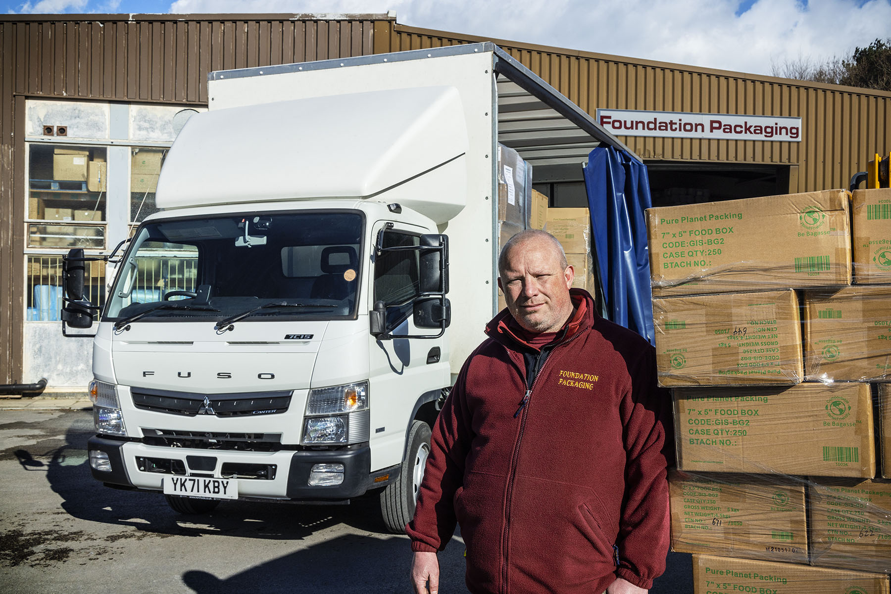

Lee Arthur: “I love our FUSO trucks and so do my colleagues, who find them very easy to drive”

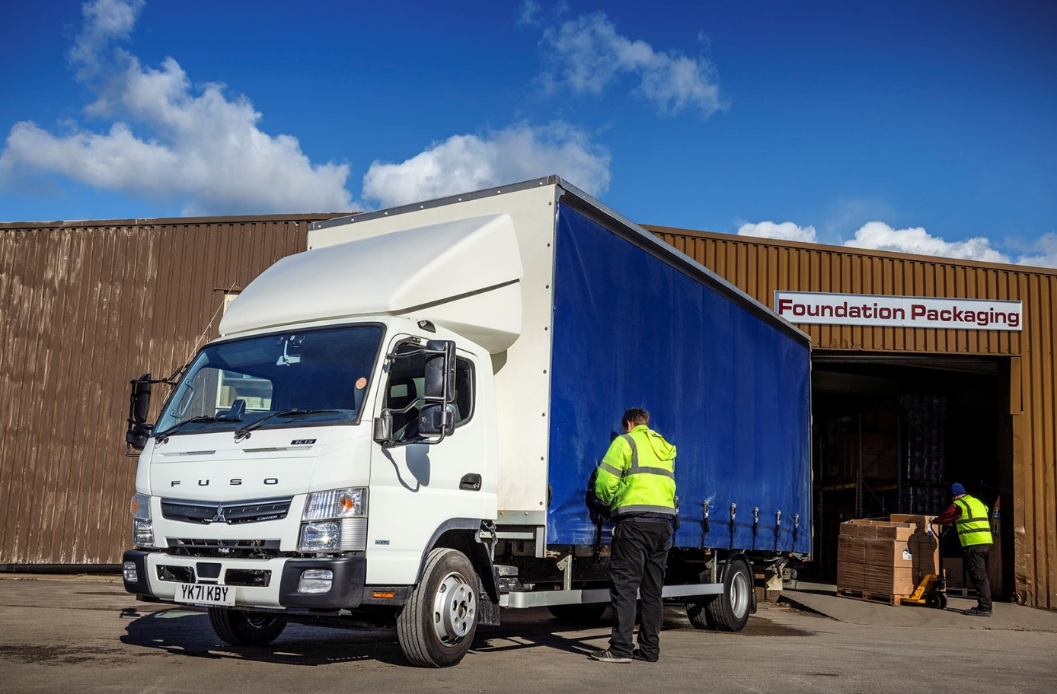

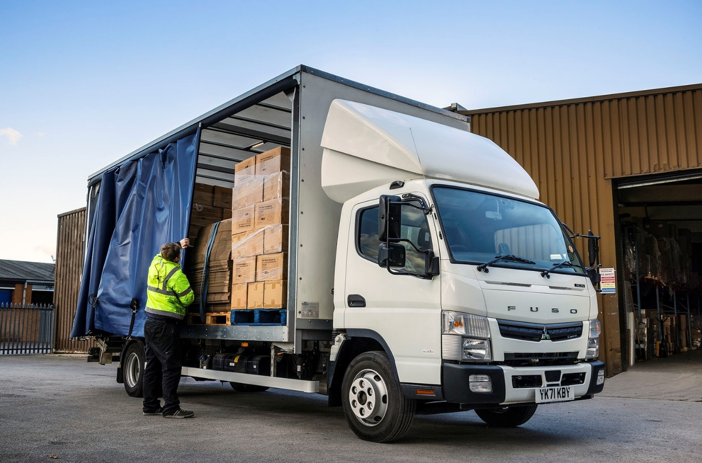

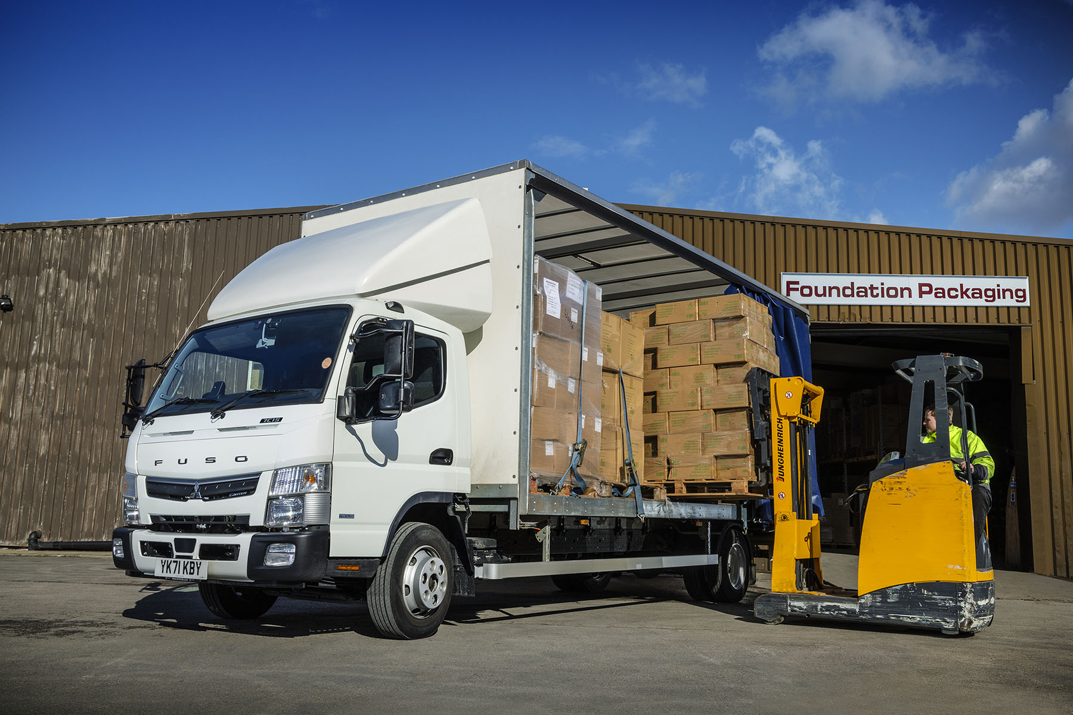

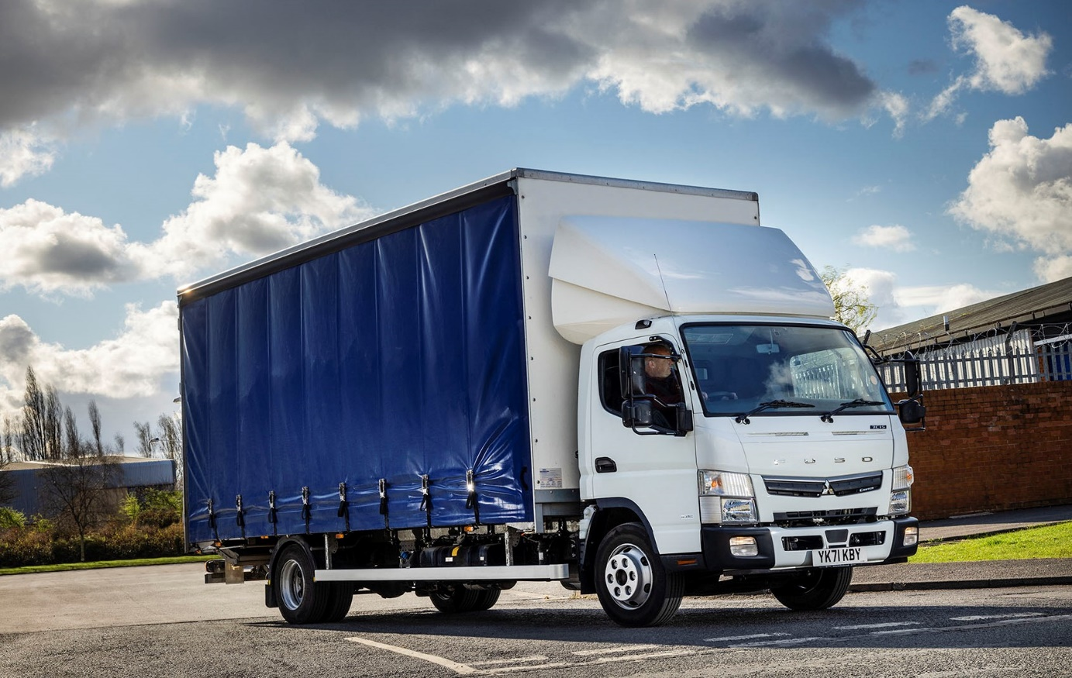

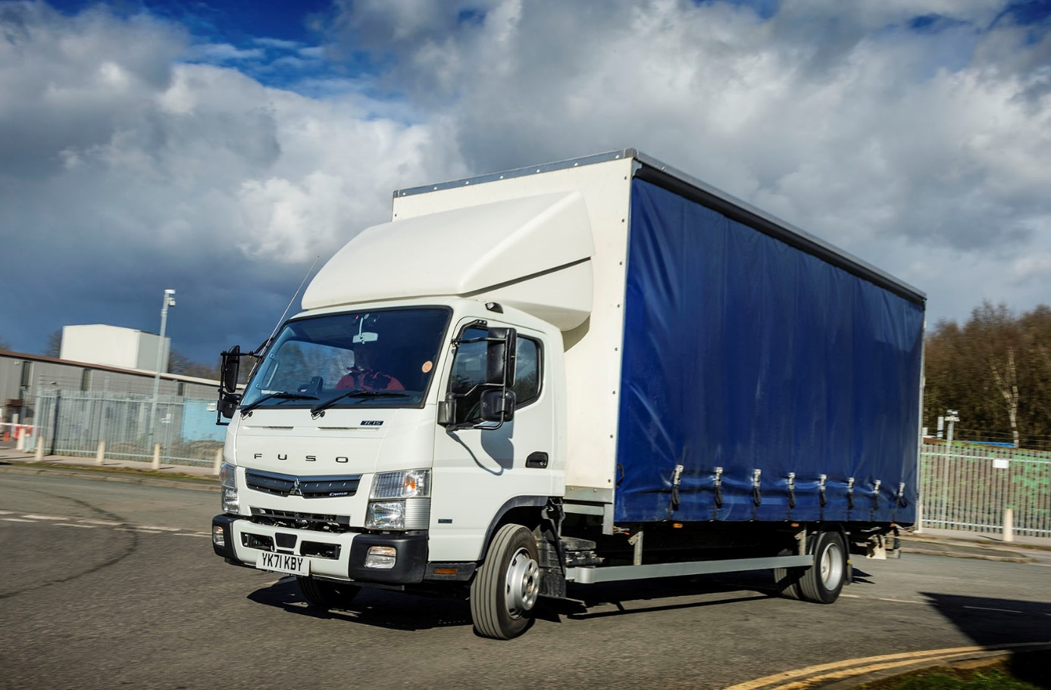

ends

For more information, or to request bigger/higher-res image files, please contact:
Steve Warren or John Ripley
Impact Communications
Steve: 07770 470251, steve@impactcom.co.uk
John: 07771 484595, john@impactcom.co.uk

