

Date: 17 July 2019

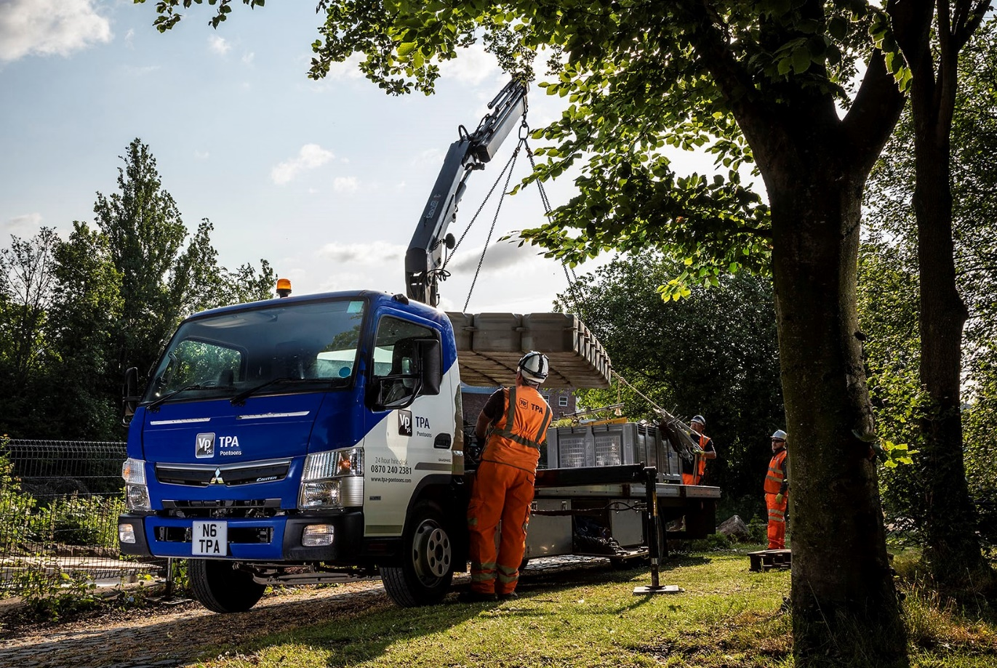

New 7.5-tonne FUSO Canter floats TPA’s boat

Temporary access solutions provider TPA is achieving faster, safer, and more efficient deliveries of its specialised pontoon systems after replacing a combination of spot-hired and subcontracted vehicles with its first FUSO Canter.

TPA’s new 7.5-tonner with crane was supplied by Mertrux Truck & Van, which, like other FUSO Canter Dealers in Britain, is also a member of the franchised Mercedes-Benz Trucks network.

Part of the Vp plc group, TPA operates from headquarters in Worksop. The company’s portable roadways division runs a large fleet of specialised articulated trucks but it relied previously on rented vehicles or third-party providers to deliver the modular floating pontoons which are employed in a wide range of applications where access across water is required – from temporary bridges and marinas, to platforms for engineers to repair sluice gates.

“We were using 3.5-tonne van-based vehicles for smaller deliveries, or calling in subcontractors for anything larger,” explained Operations Manager Neil Crosby. “However, to cope with growing demand for our pontoon equipment, and to ensure that we have more control over our deliveries, we decided it was time to invest in our own truck.”

TPA required a vehicle compact and manoeuvrable enough to get in and out of sites with restricted access. It would be fitted with a crane to facilitate safe, speedy loading and unloading, and a platform body capable of carrying as many pontoon modules as possible.

“It quickly became apparent that the Canter was going to be the best tool for the job,” Mr Crosby continued. “It offered exactly the set of attributes we were looking for.”

TPA’s new Canter 7C18 is powered by a 3.0-litre common-rail turbo-diesel which offers high-torque characteristics – 430 Nm is available over a broad engine speed range. Its range-topping 129 kW (175 hp) output is transmitted to the road via a DUONIC dual-clutch automated gearbox. An engine brake is included as standard.

Mr Crosby recalled: “Mertrux Sales Executive Alex Stamp worked closely with us to ensure the Canter was correctly specified for the job. Once we’d made our decision he was able to source a vehicle extremely quickly, and also handled all of the liaison with our bodybuilder.”

The Canter was fitted by Alfreton-based Plant Equipment with a 6.2-metre platform body and Cayvol crane capable of lifting 380 kg at a distance of 9.8 metres, yet retains a payload of over 2.5 tonnes and is capable of towing a further 3.5 tonnes. It can carry up to 80 square metres of the company’s most popular pontoon product. TPA has also commissioned a trailer which can accommodate a further 64 square metres of pontoon.

“The combined capacity of the truck and trailer is equivalent to that of a 13.6-metre semi-trailer,” Mr Crosby reported: “This represents a six-fold increase, by volume, over what we were getting on a 3.5-tonne van, while the crane significantly reduces the amount of manual handling required. We have also invested in C+E licence training for two operatives, who now share the driving duties on the new truck.

“These are still early days but the Canter hasn’t missed a beat – we’ve had no niggles or problems of any kind. Our colleagues appreciate the excellent visibility afforded by the driving position, while the Duonic gearbox leaves them free to concentrate on what’s going on around them. It’s a great truck and we couldn’t be happier with it.”

www.vp-tpa.com

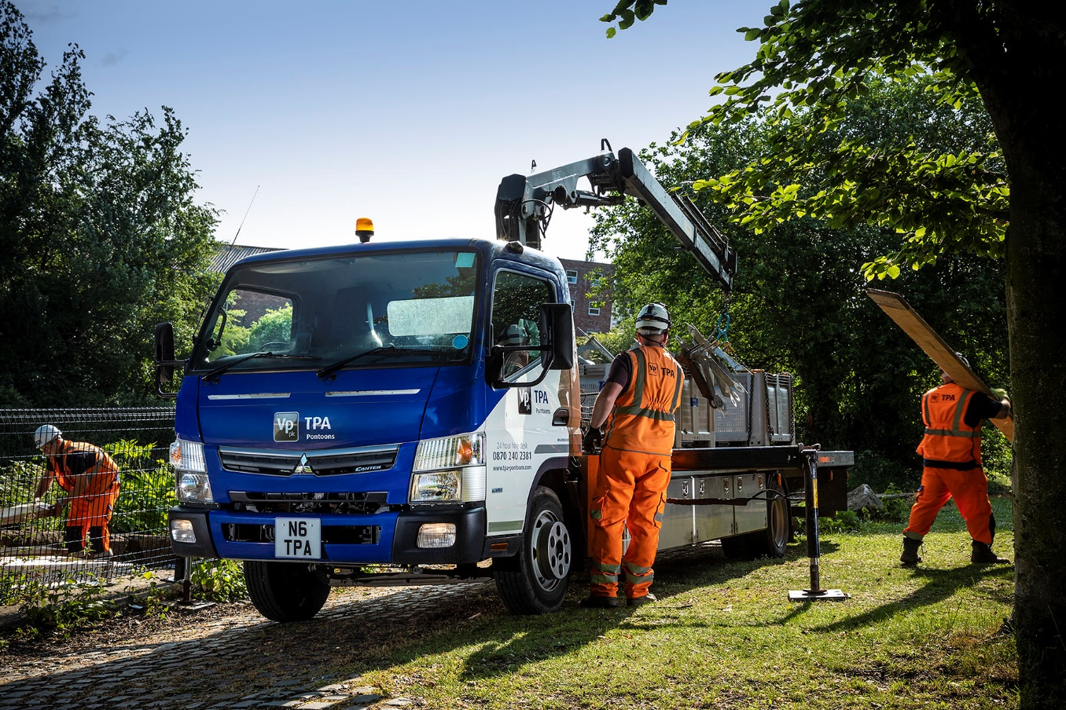

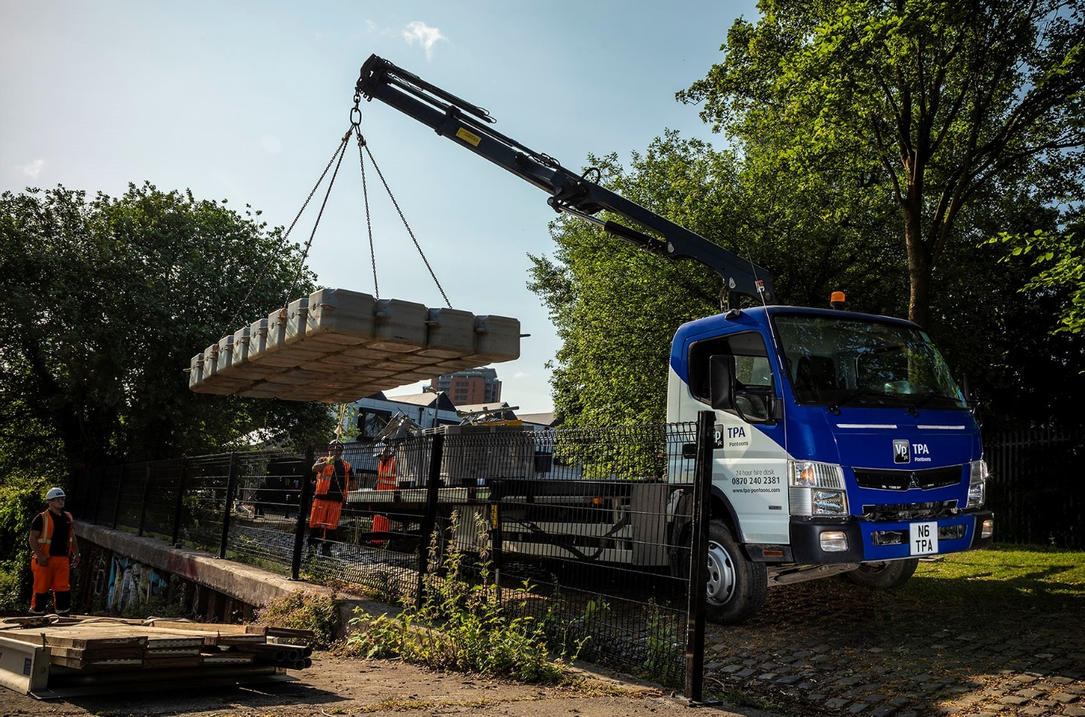

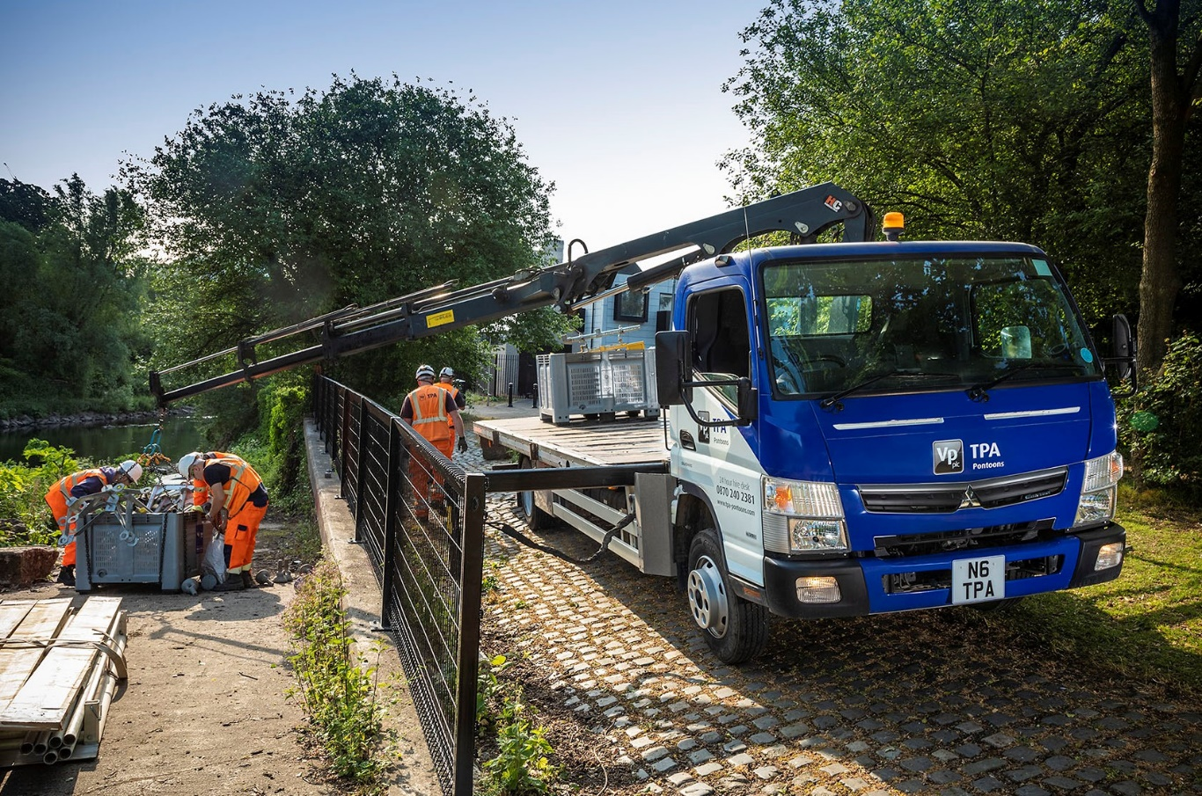

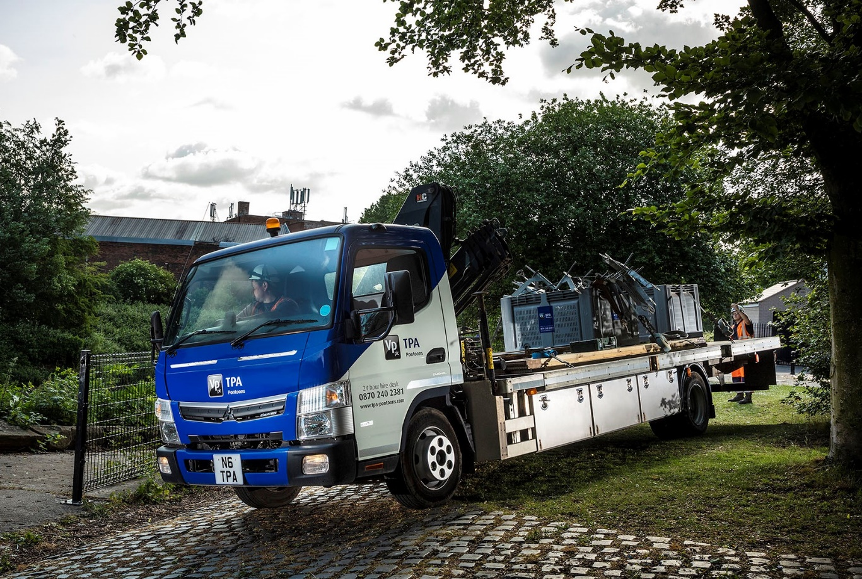

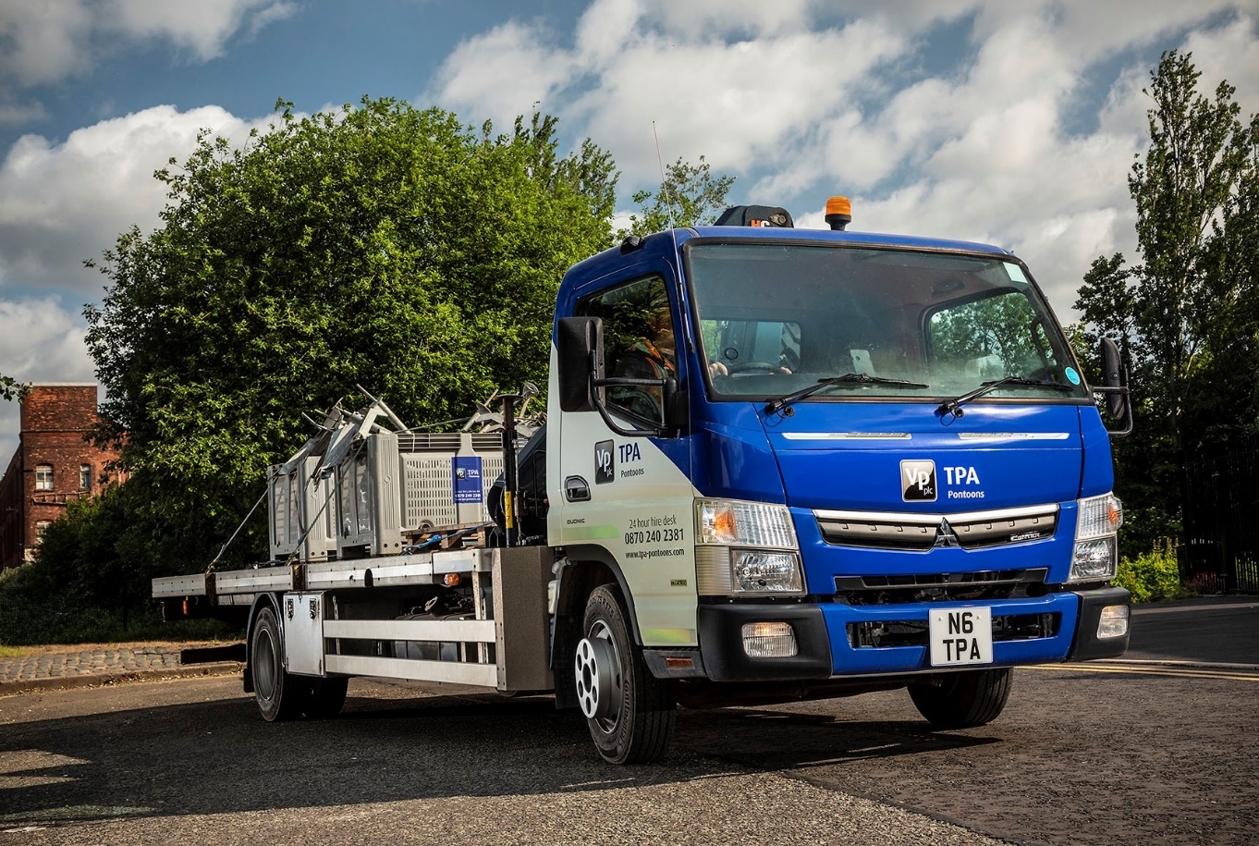

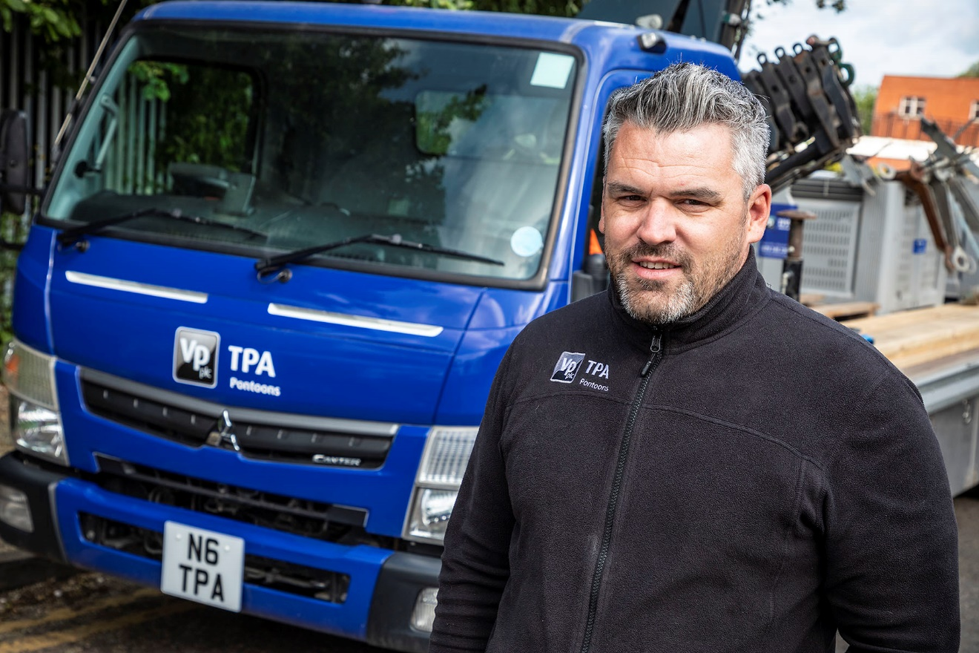

Platform for growth: Neil Crosby is delighted with the new FUSO Canter

ends

For more information, or to request bigger/higher-res image files, please contact:
John Ripley or Steve Warren
Impact Communications, 01926 842126
John: 07771 484595, john@impactcom.co.uk
Steve: 07770 470251, steve@impactcom.co.uk



