

Date: 15 October 2020

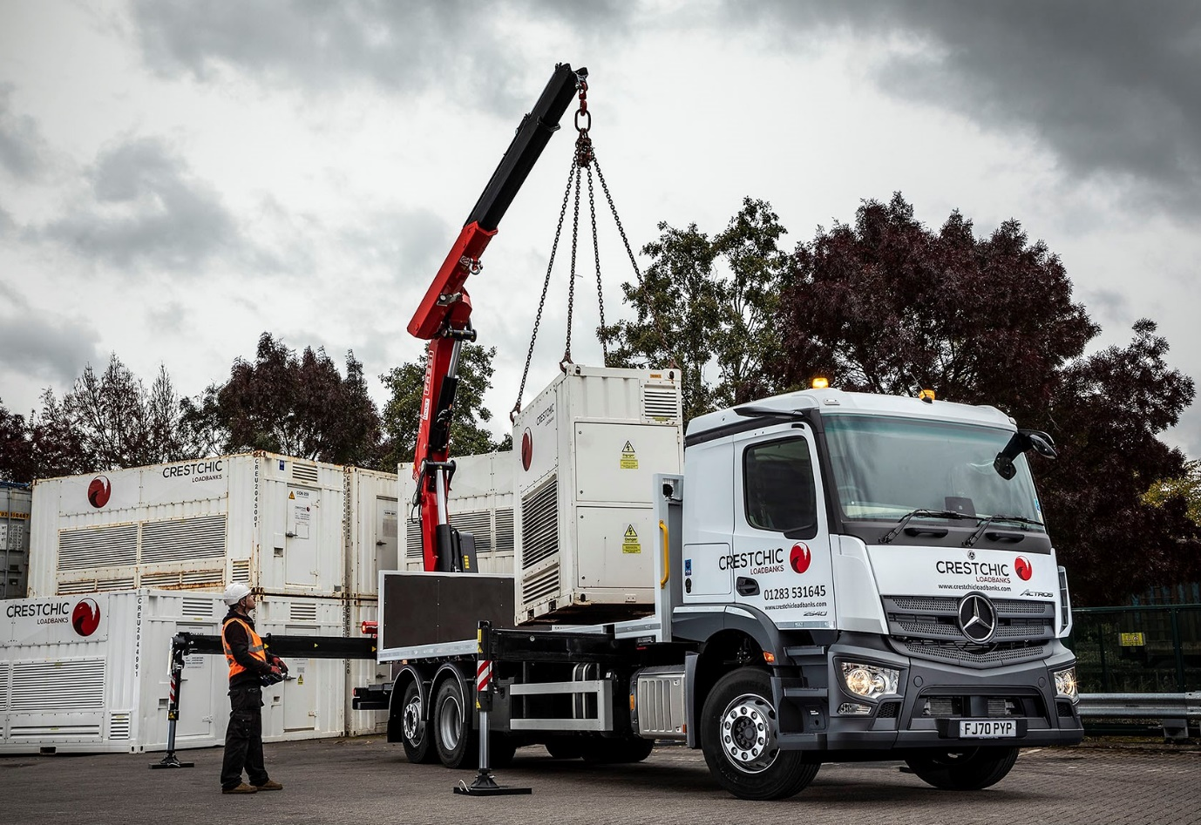

Crestchic banks on ‘high vision’ Mercedes-Benz Actros from Mertrux Truck & Van

Crestchic’s latest Mercedes-Benz 26-tonner is a clear winner when it comes to safety – and has an impressive four-star Direct Vision Standard rating to prove it.

The 6x2 Actros 2540 has joined the Burton-on-Trent-based operator’s fleet of 10 trucks, all but one of which are by Mercedes-Benz and arrived via Derby Dealer Mertrux Truck & Van. Other recent additions to the line-up include three Atego 7.5-tonners and an Actros tractor unit, as well as a Sprinter van.

Crestchic manufactures and supplies load banks, crucial pieces of electrical testing equipment for customers like the Ministry of Defence, hospitals, banks and dockyards, requiring highly reliable power sources. Based at its headquarters in Burton and a second depot in Rochester, the trucks are used to deliver these installations nationwide.

The new Actros has a 10.7-litre straight-six engine that produces 290 kW (394 hp), and is fitted with a platform body, by Central Crane Technicians, of Chesterfield. A rear-mounted 34 tonne/metre Fassi F365 crane mounted is used to offload Crestchic’s products.

Thanks to its ClassicSpace L-cab with 320mm engine tunnel, and 70-series low-profile tyres, the truck has a relatively low floor and driving position that translate into excellent direct visibility. Drivers also benefit from Mercedes-Benz Trucks’ innovative MirrorCam system, a standard feature on all new-generation Actros and Arocs models.

MirrorCam’s cameras relay a clear and broad field of vision to a pair of 15-inch screens on the cab’s A-pillars. Crucially, the streamlined camera housings are compact and mounted at roof height, so they also eliminate the forward-facing blind spots caused by conventional mirrors that drivers of other trucks have to contend with.

Transport for London’s Direct Vision Standard employs a star ratings system – from zero to five – which is based on how much drivers of goods vehicles over 12 tonnes GVW can see in relation to other users. Regulations that would have left trucks in the lowest category requiring additional safety systems in order to operate legally in London were due to be enforced from this month, but due to the intense demands placed on operators by the pandemic this has been put back to March 2021. By 2024, the minimum requirement increases to three stars.

Star ratings are calculated according to how the vehicle left the production line, and do not take account of any aftermarket camera systems. With its panoramic windscreen the low-entry Mercedes-Benz Econic has secured a five-star rating, but other models bearing the three-pointed star also score relatively highly thanks to their cab design. This advantage over competitors is extended by MirrorCam.

By opting for Actros vehicles that already meet the second-highest level of vision, Crestchic has effectively ‘future-proofed’ itself against any further tightening of the regulations in years to come. It has also underscored its commitments to safety and compliance.

“We had the Direct Vision regulations very much in mind when specifying this truck, but we were looking at the bigger picture too,” said Transport Supervisor Paul Howlett. “Safety is much more than just a box-ticking exercise for us, so the impressive contribution made by the vehicle’s Active Brake Assist 5 system was another key attraction.”

The previous version of Mercedes-Benz Trucks’ emergency braking system relied solely on radar, but the latest adds cameras to the mix. The result, at speeds of up to 50 kph, is a dramatically improved response to moving pedestrians. Active Brake Assist 5 can now employ full braking – as opposed to the 50% achieved previously – when encountering pedestrians crossing its path.

“We put in a lot of work with Mertrux and Mercedes-Benz Trucks to get the specification of this Actros absolutely right, and the result is a vehicle that’s perfectly suited to our requirement for working in busy urban areas,” continued Mr Howlett. “As ever, our order was handled very professionally by Mertrux. Its Sales Executive Alex Stamp liaised with our chosen bodybuilder, and the truck was delivered in perfect condition.

“We also know from experience that it will be reliable and cost-effective to operate. Mercedes-Benz trucks have proved themselves to be dependable performers on our fleet for more than a decade and are also well liked by our drivers.

“The MirrorCam system, which also features on our latest Actros tractor unit, has been particularly well received. The drivers initially expressed some concerns about how they’d get on with it, but after just a few minutes behind the wheel they were all converted. They now tell me it’s a huge improvement over a traditional mirror arrangement.”

Established in 1983, the company aggressively marketed its products overseas, as well as on the home market, from its earliest days, and now has offices in France, Germany, Dubai, Singapore and the USA.

crestchicloadbanks.com
facebook.com/CrestchicLimited
linkedin.com/company/crestchic-loadbanks

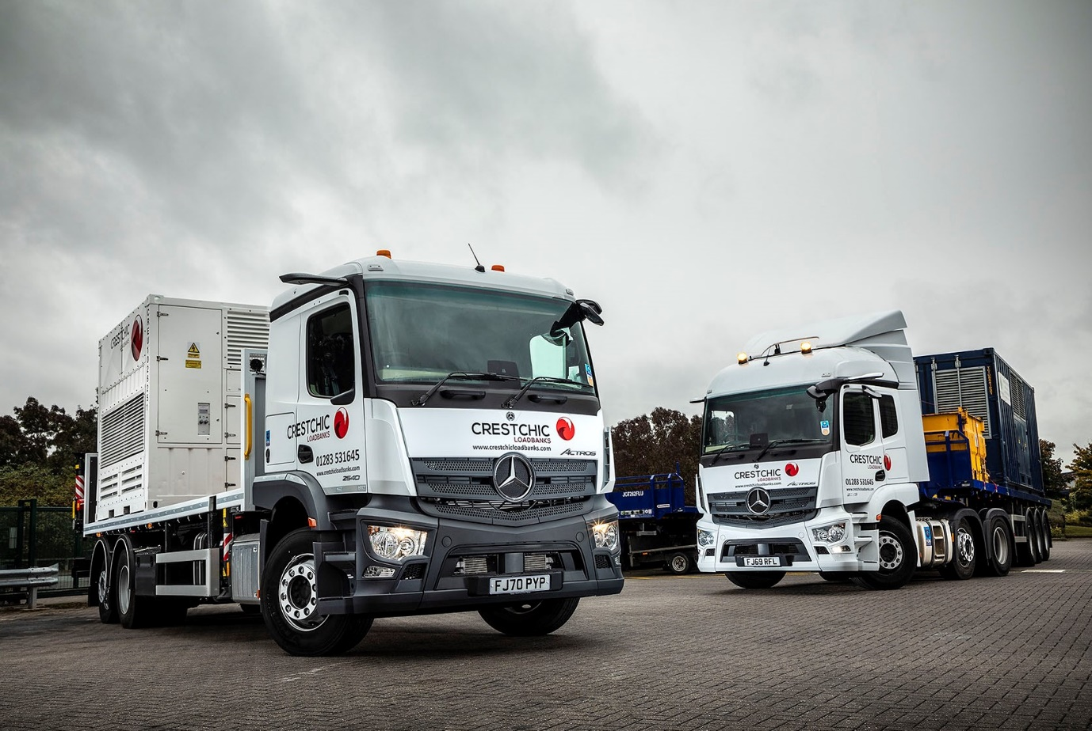

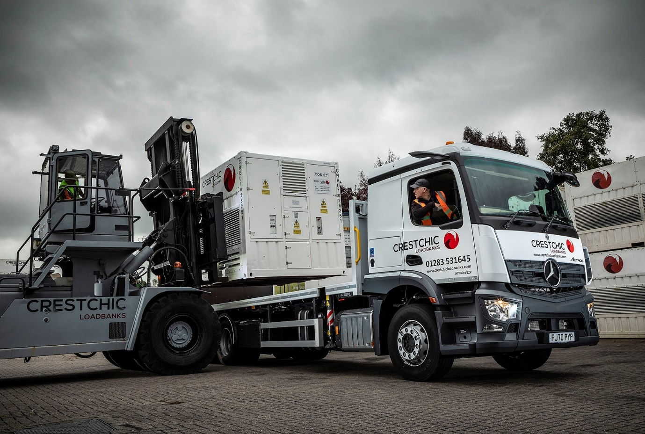

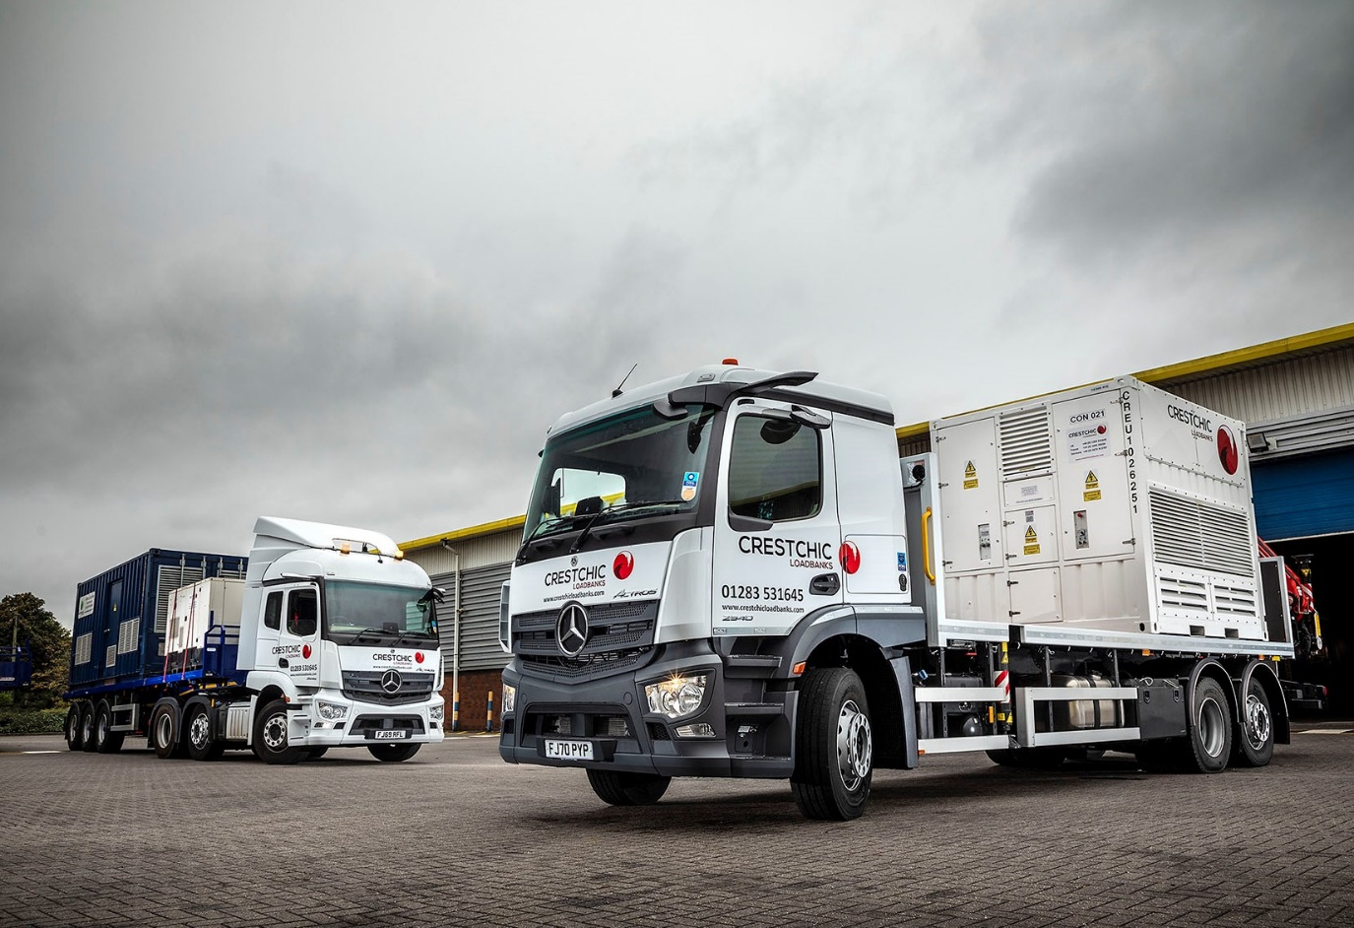

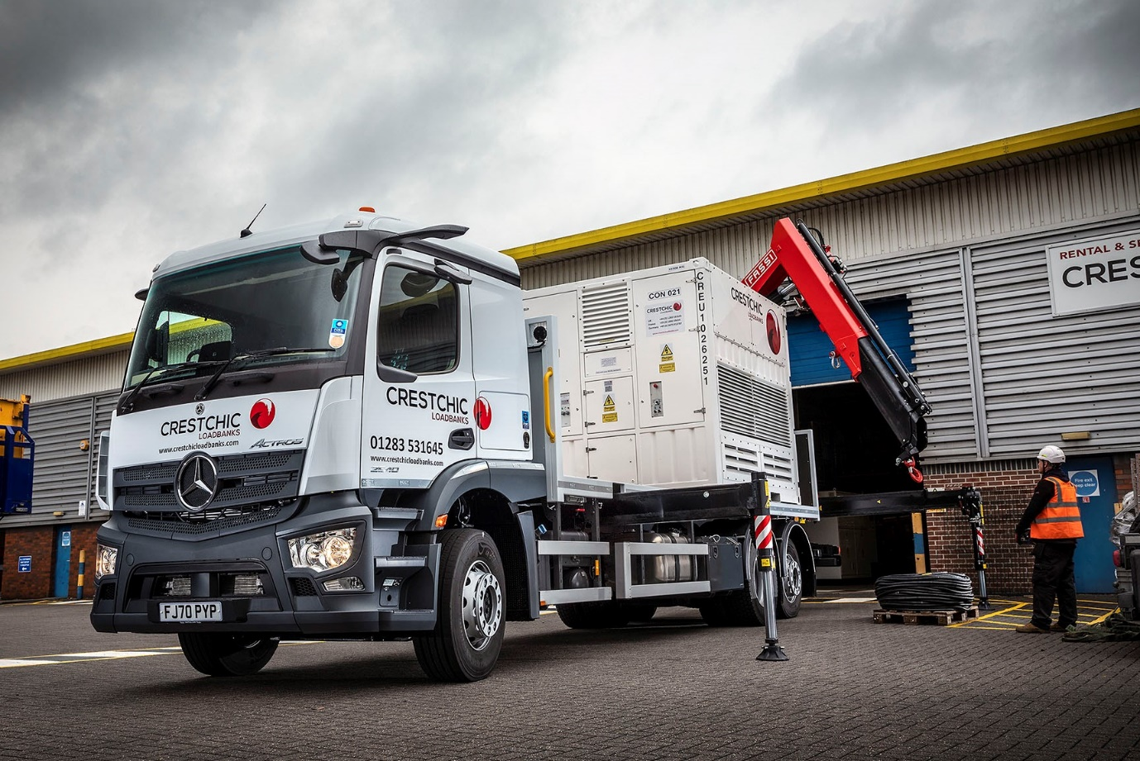

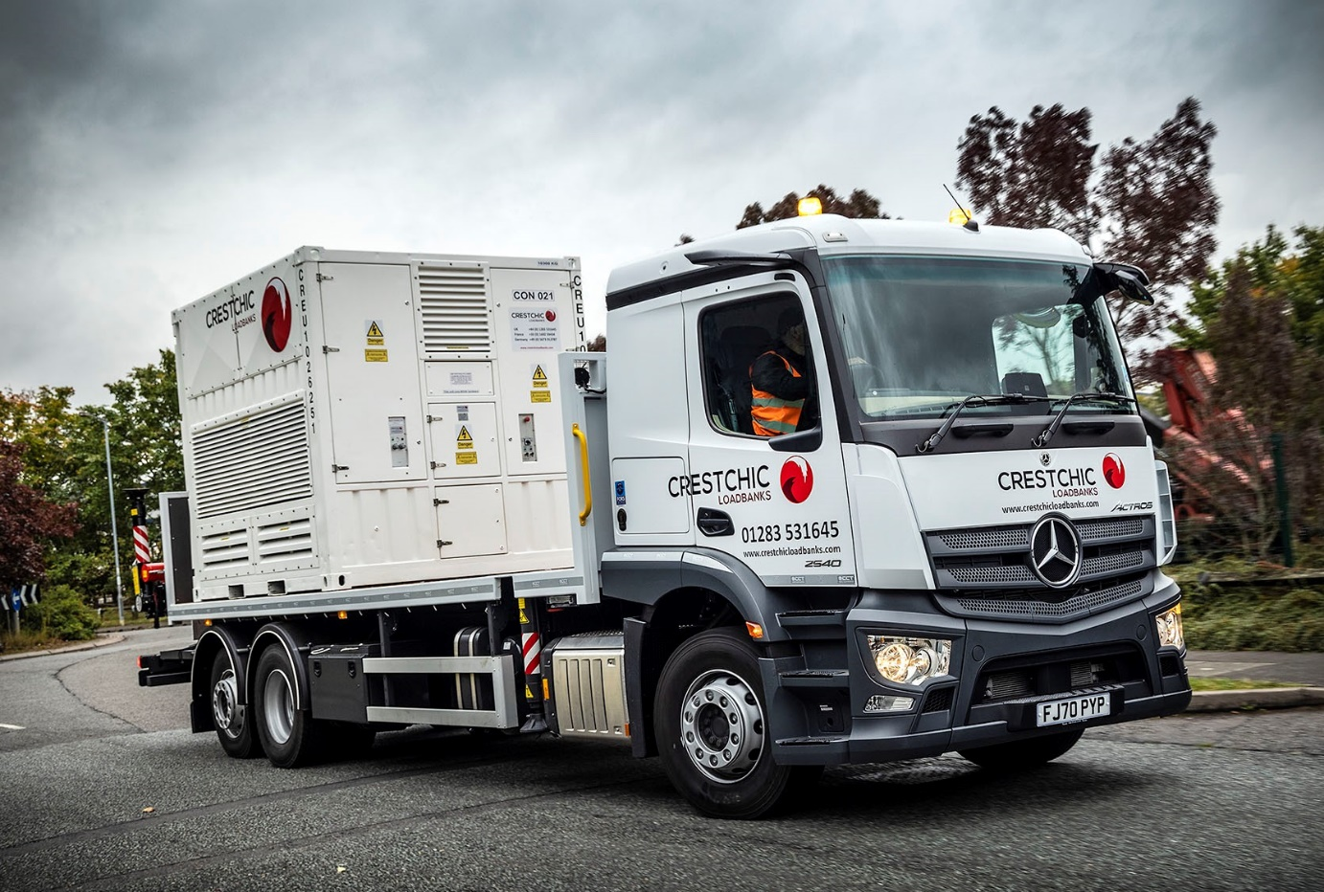

ends

For more information, or to request bigger/higher-res image files, please contact:
John Ripley or Steve Warren
Impact Communications, 01926 842126
John: 07771 484595, john@impactcom.co.uk
Steve: 07770 470251, steve@impactcom.co.uk



