

Date: 22 May 2019

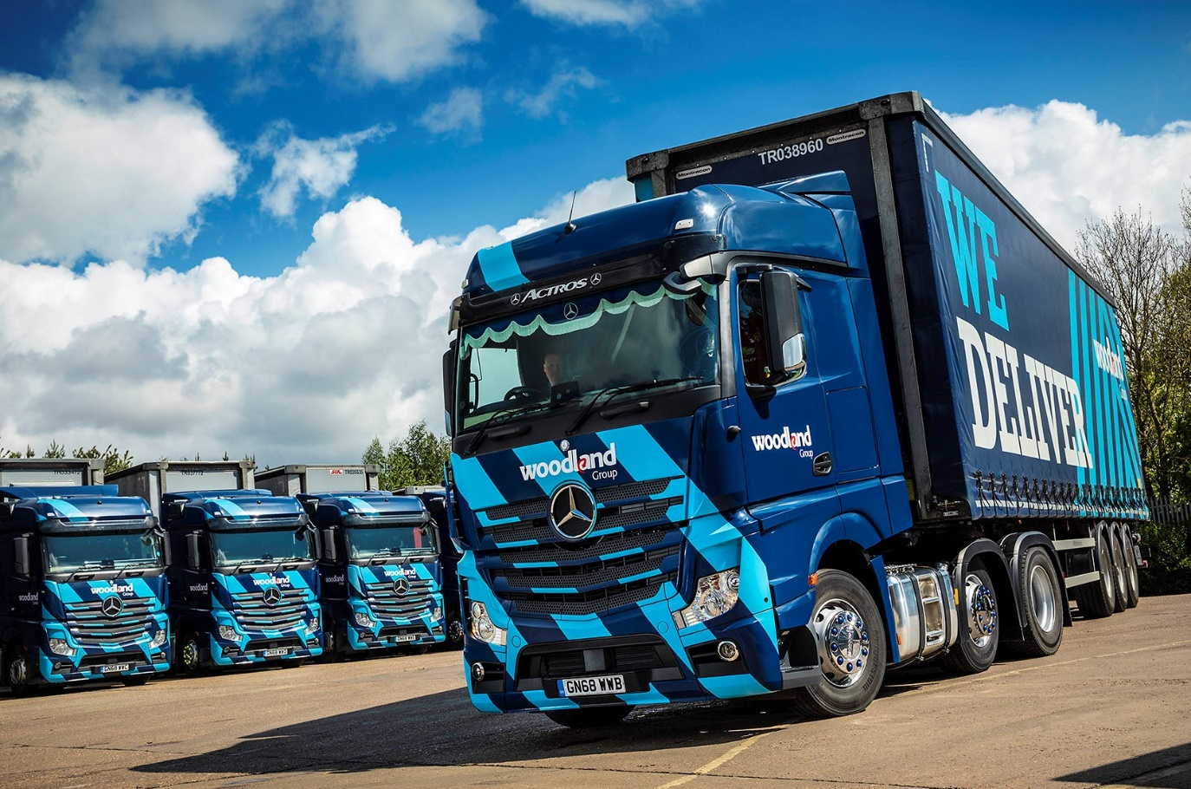

Woodland trusts its 138 Mercedes-Benz trucks to deliver on reliability, economy and safety

Woodland Logistics reports a 10% improvement in fuel economy since it began equipping its Mercedes-Benz trucks with Predictive Powertrain Control (PPC) systems and embarked on a major programme of driver training delivered by Dealer Sparshatt Truck & Van.

The UK distribution and warehousing arm of Woodland Group, one of the country’s biggest privately-owned global logistics businesses, Woodland Logistics operates a fleet of 138 trucks, all of which are by Mercedes-Benz. Most are tractor units, although the line-up includes 34 rigids, a combination of 18- and 26-tonners.

Last year alone Sparshatt Truck & Van supplied its high-profile customer with 40 new Actros tractors for work on a variety of contracts. All 2545 models with BigSpace cabs and second-generation 330 kW (450 hp) 12.8-litre OM 471 straight-six engines, they also came with Safety Packs, Fleetboard telematics and ground-breaking Uptime predictive maintenance technology.

Woodland Logistics operates from headquarters in Chelmsford, and other hubs in Coventry and Hayes. The company has been providing innovative logistics, e-commerce and supply chain management services since 1988. Strikingly finished in the operator’s distinctive two-tone blue livery, its trucks are maintained within the manufacturer’s franchised Dealer network under five-year Mercedes-Benz Complete Service Contracts – the tractor units typically cover 150,000 km per year.

Woodland Logistics Managing Director Sean Kirby confirmed: “We choose Mercedes-Benz trucks for their outstanding reliability and fuel efficiency, which ensure that we are best-placed to succeed in a highly competitive environment.

“We also enjoy exceptionally healthy relationships not only with Mercedes-Benz – I’ve worked with the brand in various capacities since the mid-1980s – but also with Sparshatt Truck & Van. The Dealer has been supplying our trucks for the last five or six years, and provides an excellent service. We’ve grown our own business by listening to our customers, then either responding to their requests or proactively suggesting solutions. That’s exactly what Director Paul Rooney, Sales Executive Martin Kemsley and their colleagues at Sparshatt do for us.”

Woodland Logistics decided to put Mercedes-Benz Trucks’ Predictive Powertrain Control system to the test 18 months ago, while simultaneously committing additional resources to its driver training programme.

PPC employs 3D GPS mapping to read three kilometres of topography ahead then responds by managing speed, braking and the transmission to maximise fuel efficiency. The system really comes into its own when the vehicle is travelling up or down hills, by applying carefully judged gear shifts at an early stage, and making full use of the EcoRoll function.

“As a direct result of these initiatives we’ve seen typical improvements in economy of up to 10%, which clearly represents a very substantial cost saving,” said Mr Kirby. “Our Actros tractors now typically return in excess of 10 mpg. That’s a very good figure, but what’s most pleasing is that rather than only being achieved by the very best drivers, we’re seeing it consistently, across the fleet as a whole.”

Standard equipment on all roadgoing Actros tractor units, the Mercedes-Benz Safety Pack incorporates the remarkable Active Brake Assist 4 emergency braking system with pedestrian recognition, as well as Proximity Control Assist, and a driver’s airbag.

The Uptime maintenance system, meanwhile, employs sensors, which monitor the condition of the vehicle constantly. As a result, the Dealer knows precisely what is required before the truck reaches the workshop. It can then order parts in advance, while allocating sufficient time during a single visit to complete all tasks.

“Safety is our number one priority and it’s reassuring to know that our trucks are so highly specified when it comes to accident prevention technology,” continued Mr Kirby. “It’s also crucial in terms of the delivery commitments we make to our customers, that we keep our trucks operational at all times. Uptime complements the inherent reliability that we’ve come to expect of Mercedes-Benz, and ensures that our vehicles are maintained in as smooth and efficient a manner as possible.”

www.woodlandgroup.com

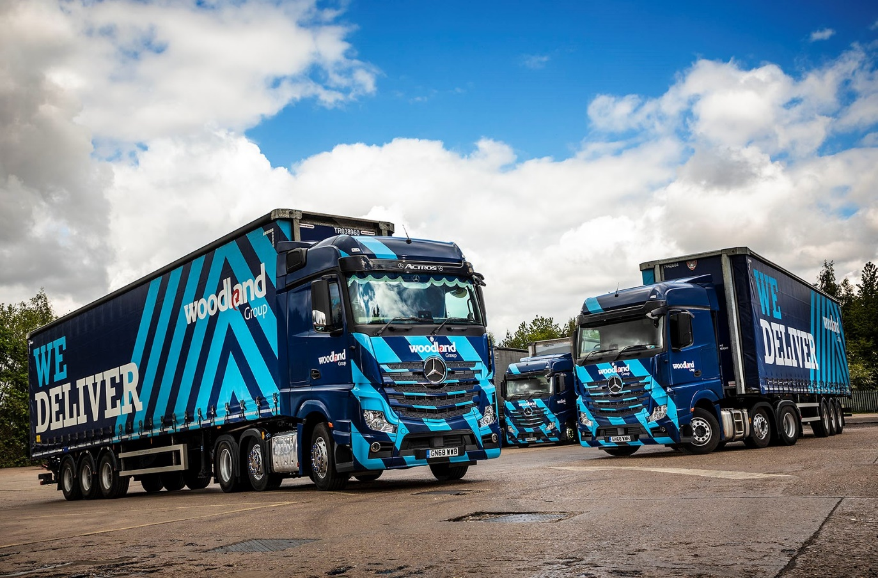

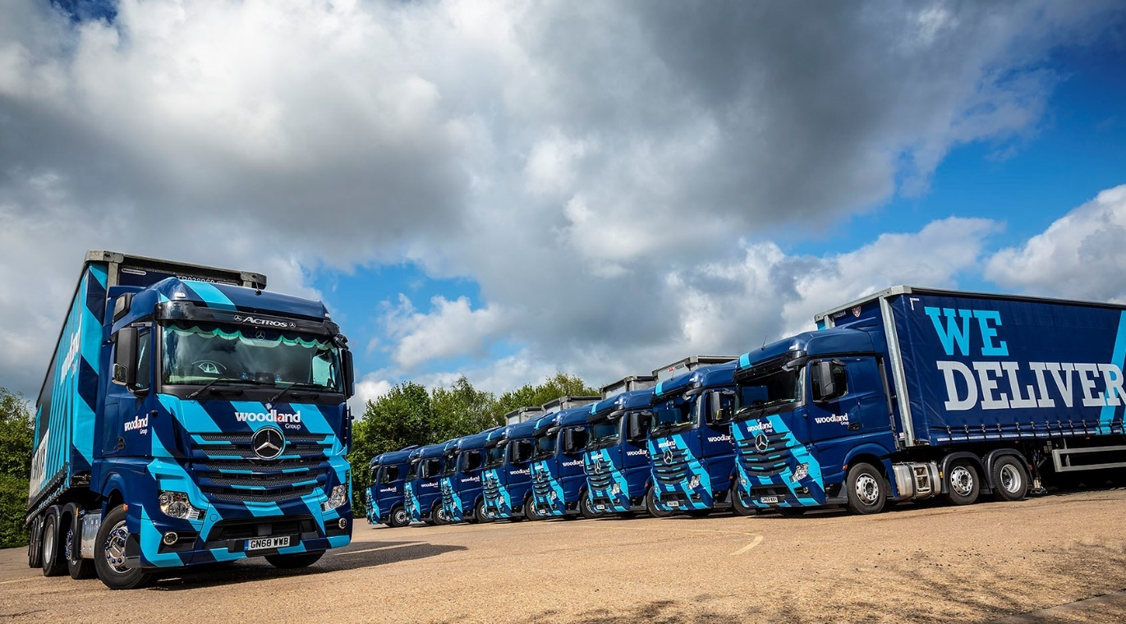
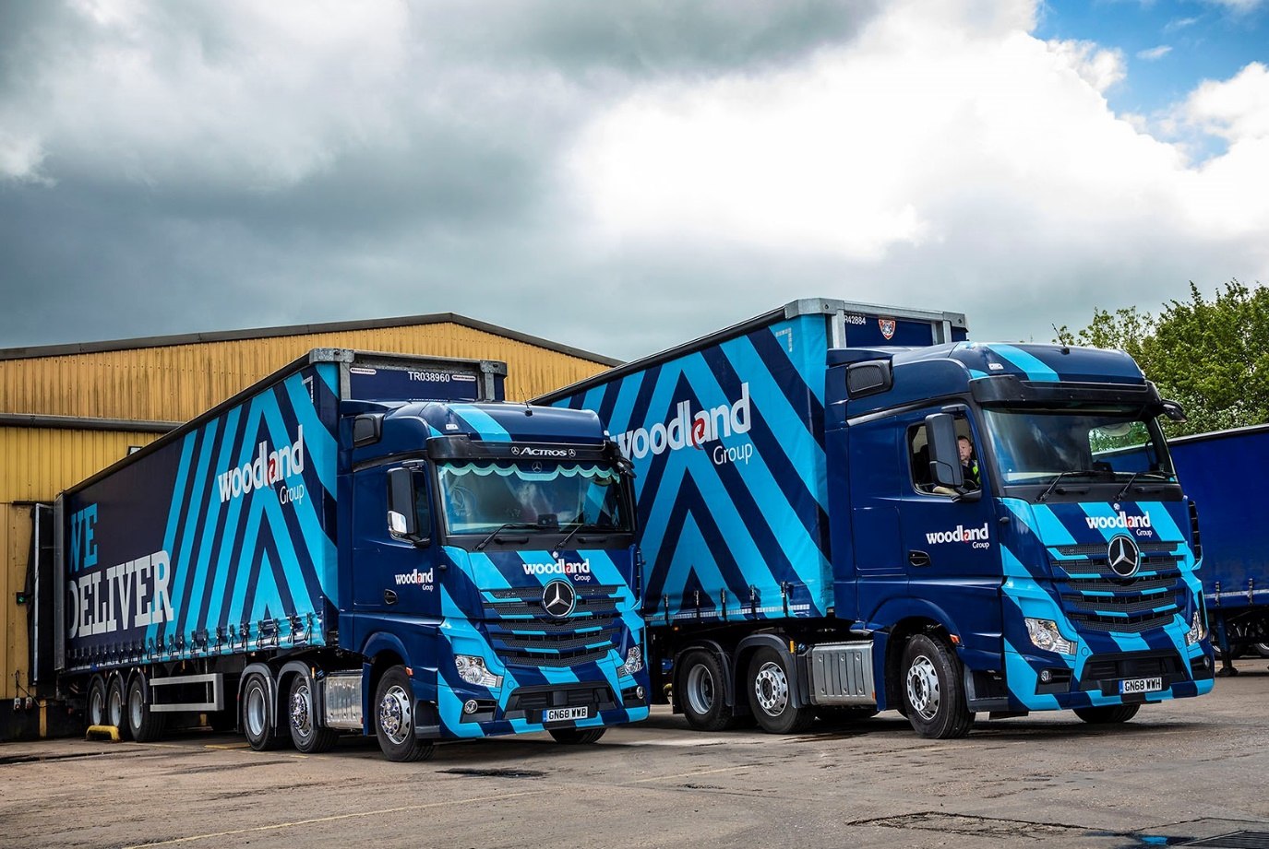

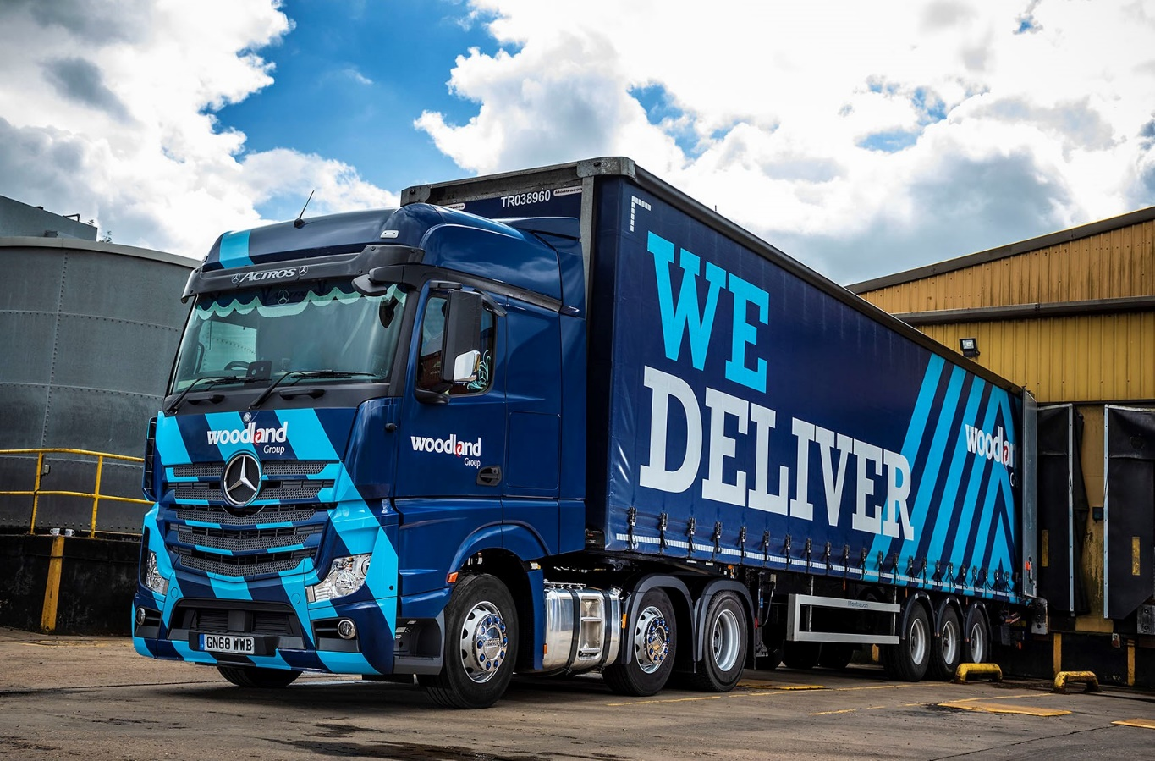

Note to Editors
Please be advised that having previously done so as Sparshatts Truck & Van, from March 2019 the Mercedes-Benz Trucks Dealer for South-East London and Kent has been trading as Sparshatt (without the final ‘s’) Truck & Van. This very minor change to the company’s name was a legal stipulation, arising from the acquisition of the business completed a year earlier.

For more information, or to request bigger/higher-res image files, please contact:
Steve Warren or John Ripley
Impact Communications, 01926 842126
Steve: 07770 470251, steve@impactcom.co.uk
John: 07771 484595, john@impactcom.co.uk

