

Date: 12 August 2020

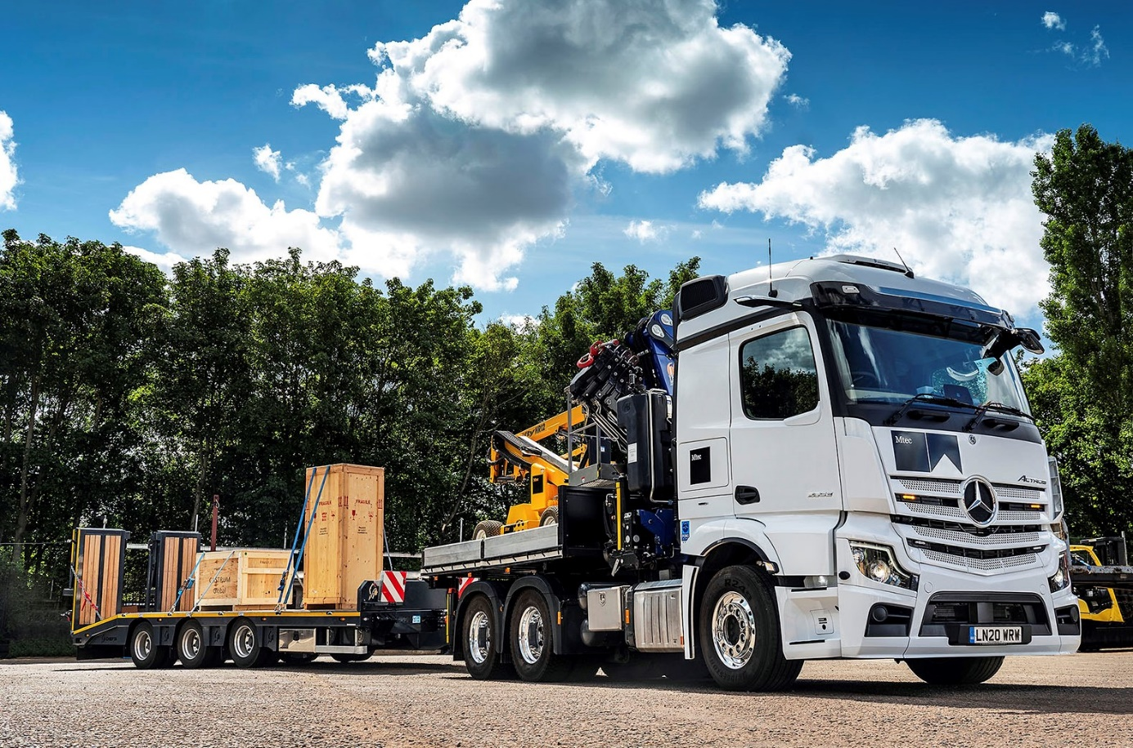

Mtec commissions a multi-purpose Mercedes-Benz masterpiece from S & B Commercials

International fine art logistics specialist Mtec is using a cleverly designed Mercedes-Benz heavy haulage tractor unit to deliver monumental sculptures for artists, galleries and museums, as well as private collectors.

Plated for operation at a gross combination weight of 80 tonnes, the Hertfordshire-based operator’s first new-generation Actros arrived via long standing supplier S & B Commercials.

The 6x4 Actros 2653 is powered by a 12.8-litre in-line six-cylinder engine which produces 390 kW (530 hp), and fitted, immediately behind its aerodynamic StreamSpace cab, with a 50 tonne/metre PM 50.26 crane

Mtec Managing Director David Williams specified his latest unit to undertake a broad variety of assignments. So as well as working in conventional fashion with a low-loading semi-trailer, it can also be fitted with a demountable body and pull a drawbar trailer.

Built by Central Hydraulic Loaders, of Tamworth, the dropside body sits over the fifth wheel. The same company also installed the crane and the VBG drawbar coupling employed when the truck pulls its tri-axle Chieftain beavertail trailer.

As Mr Williams explained, this solution provides Mtec with the flexibility to make deliveries at tight locations. “Manoeuvring a tractor and trailer can be a challenge at places like Kew Gardens, and some of the stately homes we visit,” he said.

“It’s obviously not an option for the heaviest sculptures, which can often weigh in excess of 50 tonnes. But for smaller pieces the demountable body and drawbar configuration allows us to crane the item off the trailer and then take it in on the truck itself. It’s a highly practical solution that’s already working very well.”

Mtec was established by Mr Williams in 1993. In addition to its headquarters in Ware, and other depots in Cambridge, and Larkfield, Kent, the company has a secure storage facility in Venice, and another in Antwerp, which it opened shortly after the Brexit vote in 2016. Trucks are regularly sent as far afield as Russia, Ukraine and Turkey.

Mtec’s fleet of 20 trucks is dominated by Mercedes-Benz. Most are tractors, and the new Actros is its fourth heavy haulage unit. The remaining fully air-suspended rigids have gross weights of between 15 and 26 tonnes, among them a box-bodied Atego 15-tonner supplied by S & B Commercials last year.

The latest arrival is smartly finished with colour-coded bumpers and optional Xenon headlamps. The Extra Line pack includes LED position lamps and indicators, and a three-pointed star welcome light, while Alcoa Durabrite alloy wheels add a further flourish. The Actros also benefits from a factory-option water retarder, and an auxiliary air-conditioning unit fitted by SB Components, of Wisbech.

The truck is instantly recognisable as a new-generation Actros thanks to its camera-based MirrorCam technology. Much improved rear vision and the elimination of forward-facing blind spots caused by conventional mirrors translate into a major safety advance. The compact size and streamlined profile of the camera housings offer fuel savings of around 1.5%.

The International Truck of the Year 2020 also features the futuristic Multimedia Cockpit, which replaces traditional switchgear with twin screens – Mtec specified the upgraded interactive version with bigger, 12in instrument panel and extra functionality. Other highlights include enhanced versions of the Active Brake Assist emergency braking, and fuel-saving Predictive Powertrain Control systems, and ground-breaking Uptime predictive maintenance technology.

“We’ve always chosen Mercedes-Benz trucks for their cutting-edge design and features, as well as their outstanding reliability and the manufacturer’s unrivalled back-up on the Continent,” continued Mr Williams.

“I drove one of S & B’s Actros demonstrators before ordering our new truck, and was hugely impressed with MirrorCam, particularly the way the camera pans to keep the rear of the trailer in view at all times, including on roundabouts and tight bends.”

As with previous acquisitions, Mtec has signed-up to an eight-year Mercedes-Benz Complete Service Contract, under which its new Actros is now being inspected and maintained at S & B Commercials’ workshop in Hatfield.

“I’m super happy with the aftercare support we receive from S & B,” confirmed Mr Williams. “They know our fleet well and will do whatever it takes to keep us on the road. The Dealer’s Truck Sales Manager Sam Setterfield also provides a first-class service. I really cannot fault S & B.”

www.mtecfreightgroup.com/

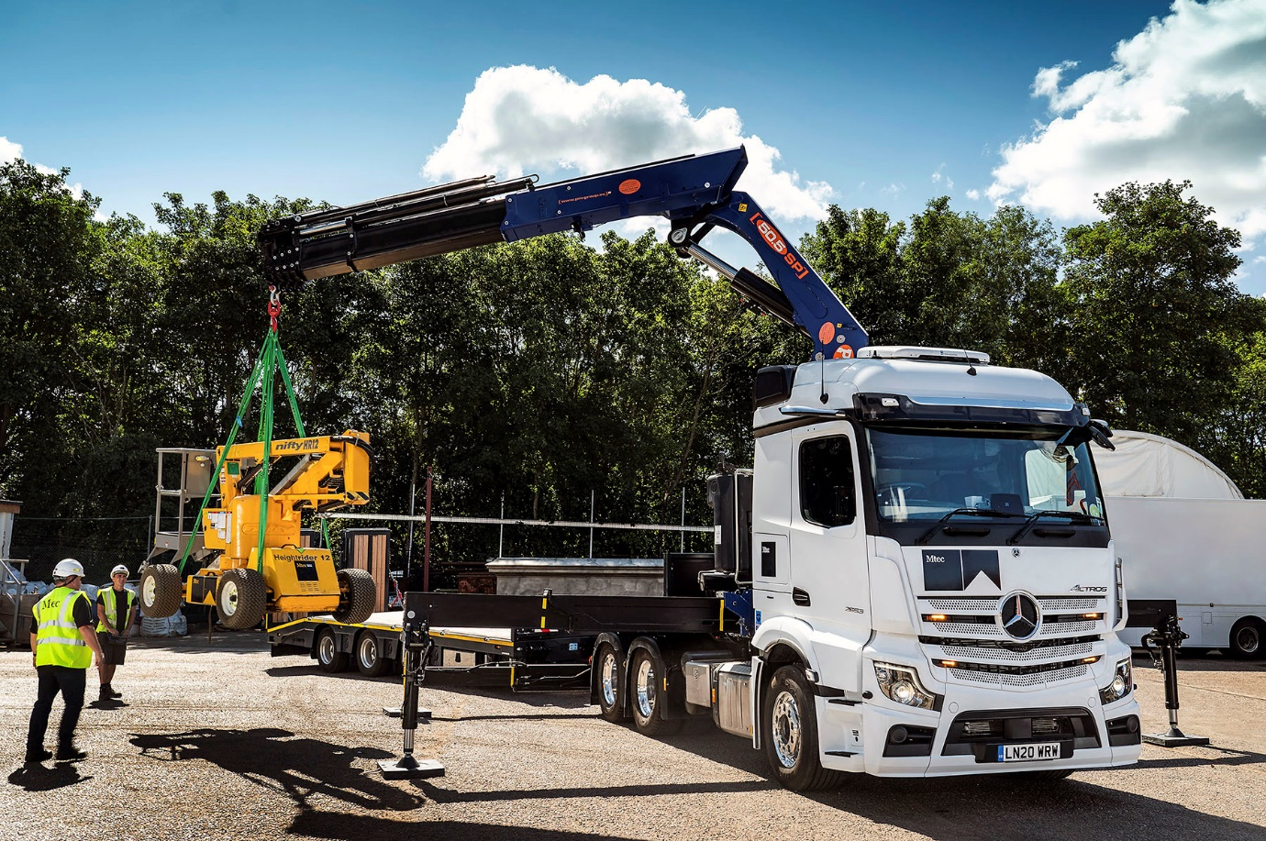

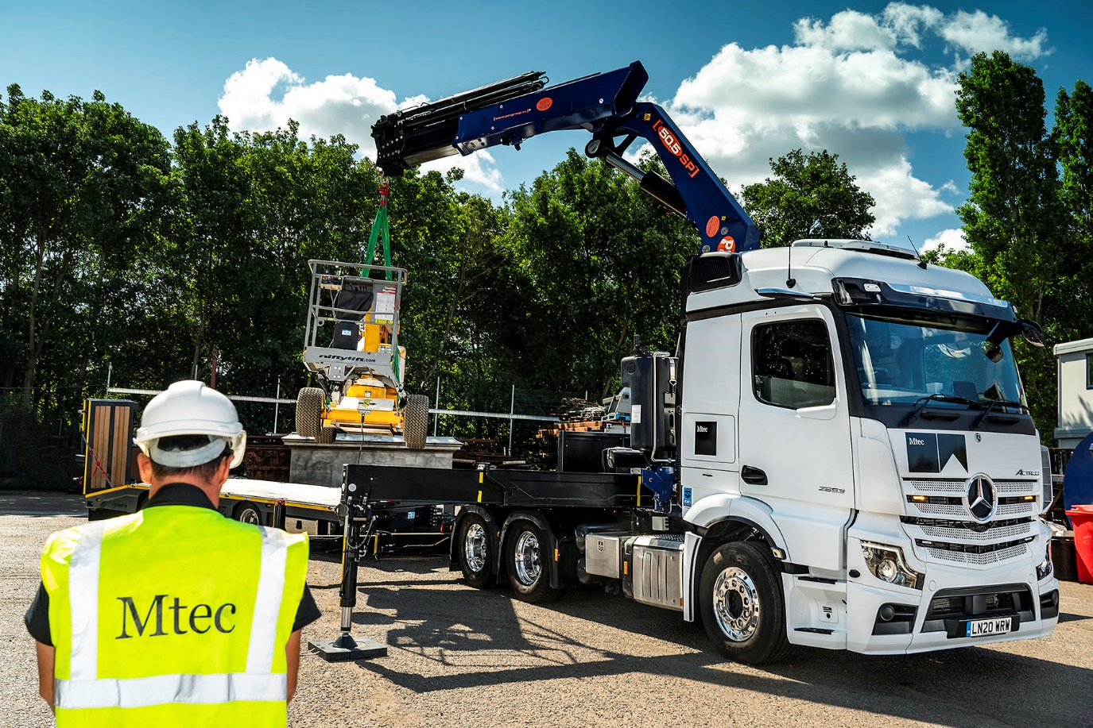

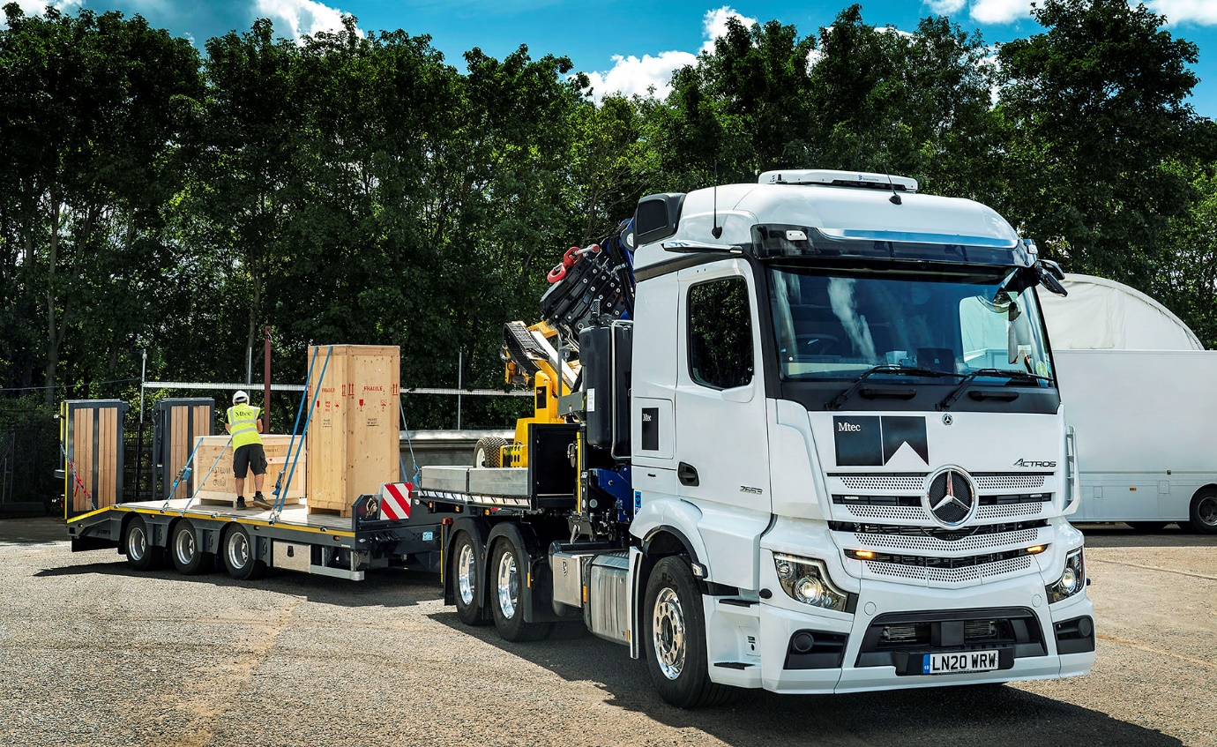

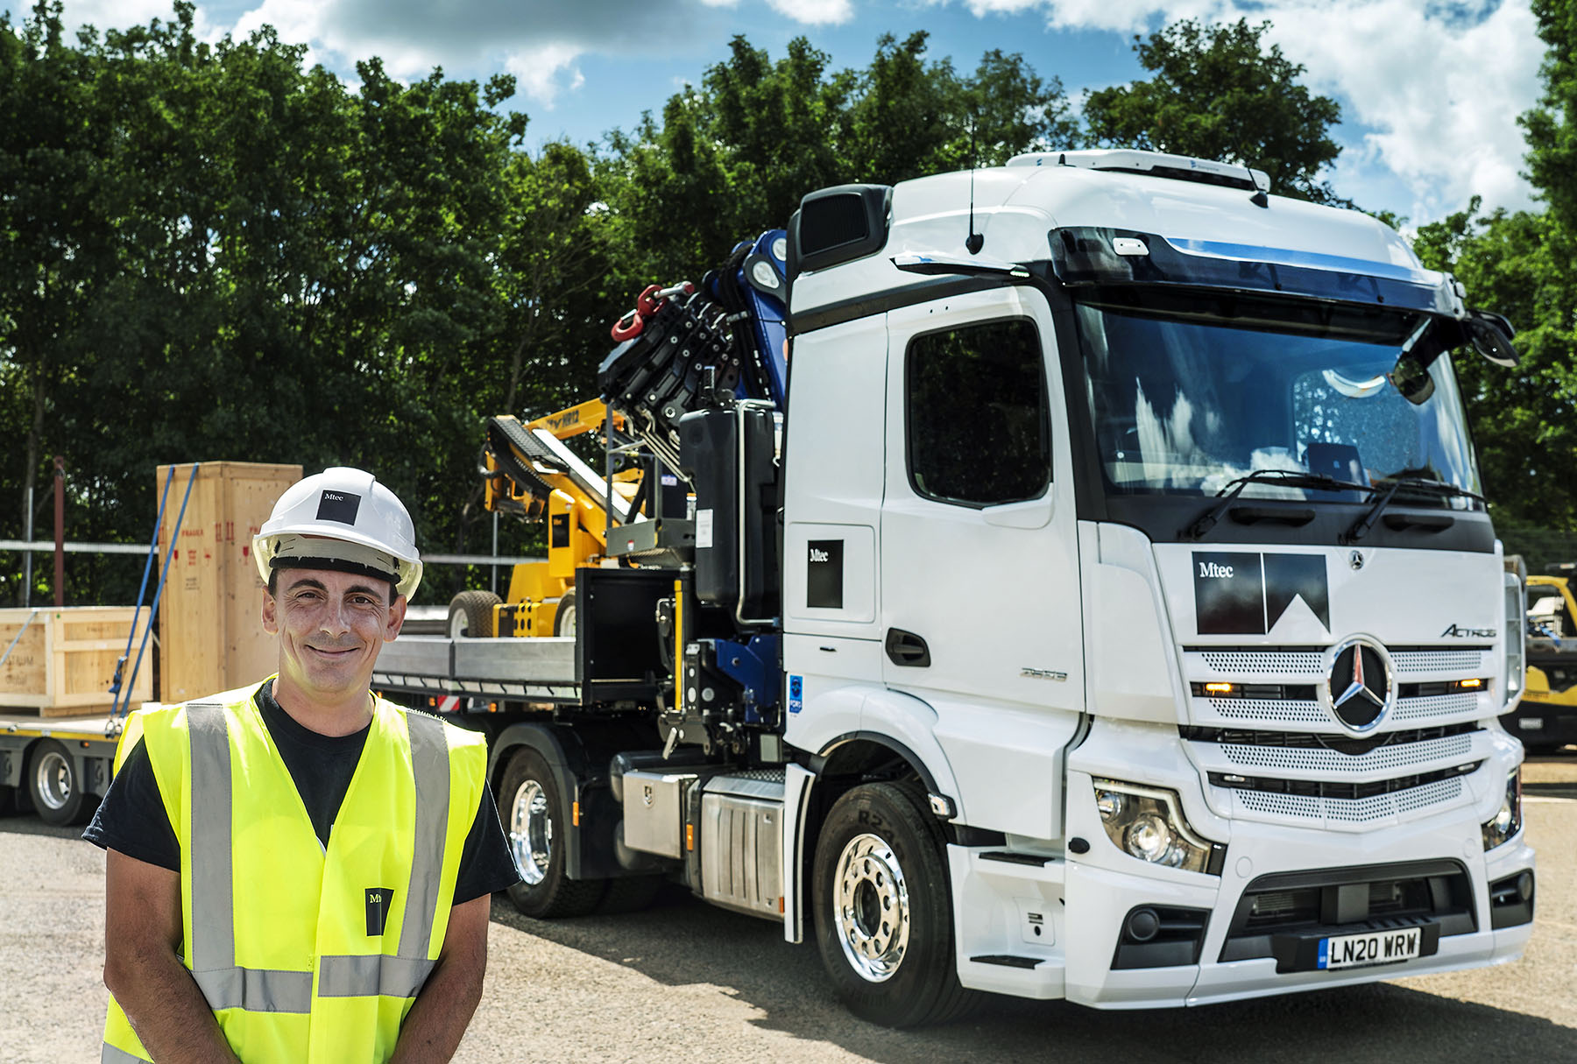

More Mercedes-Benz muscle: Mtec driver Craig Gibbons is delighted with his new Actros

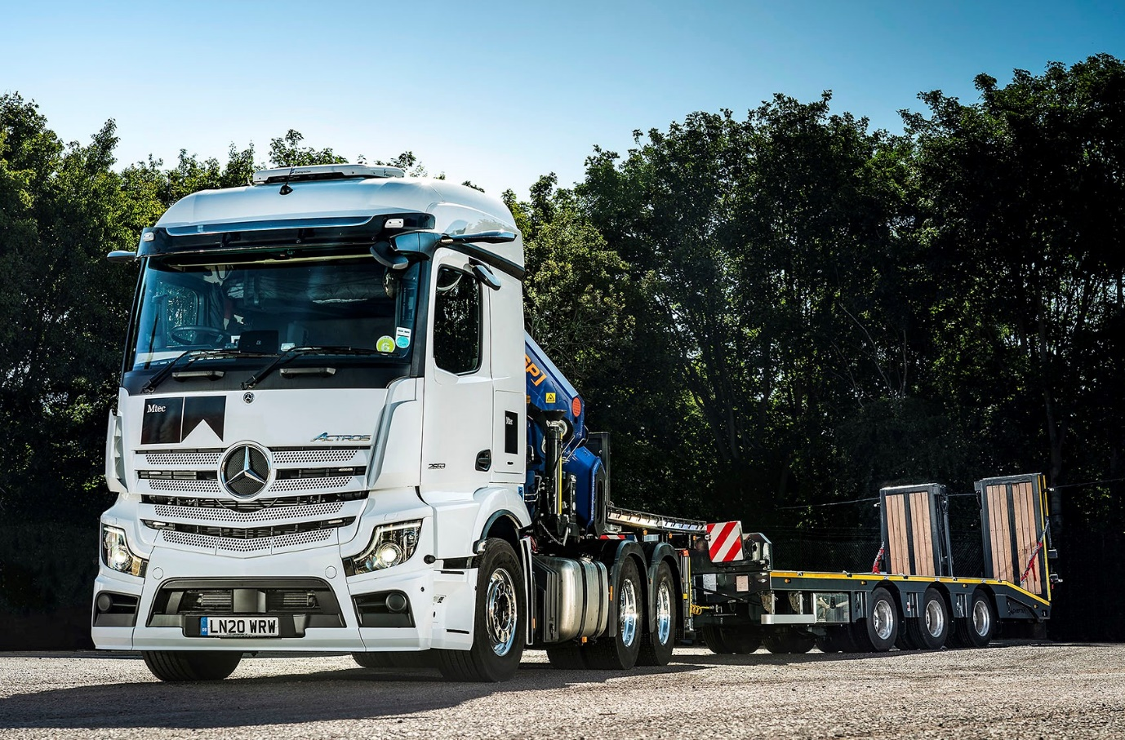

ends

For more information, or to request bigger/higher-res image files, please contact:
Steve Warren or John Ripley
Impact Communications, 01926 842126
Steve: 07770 470251, steve@impactcom.co.uk
John: 07771 484595, john@impactcom.co.uk



