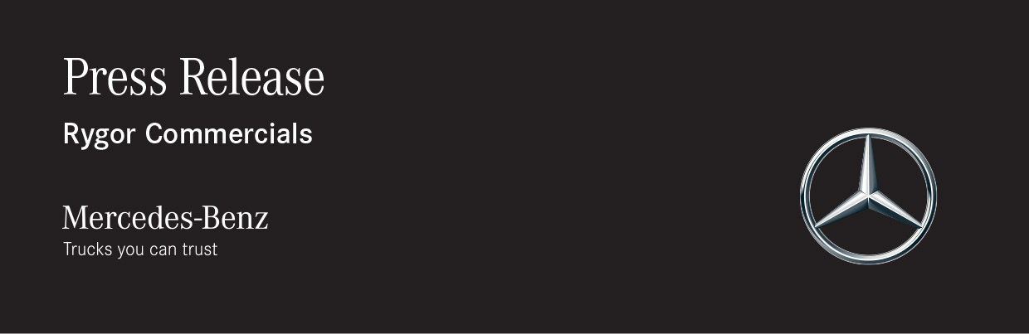

Date: 2 December 2019

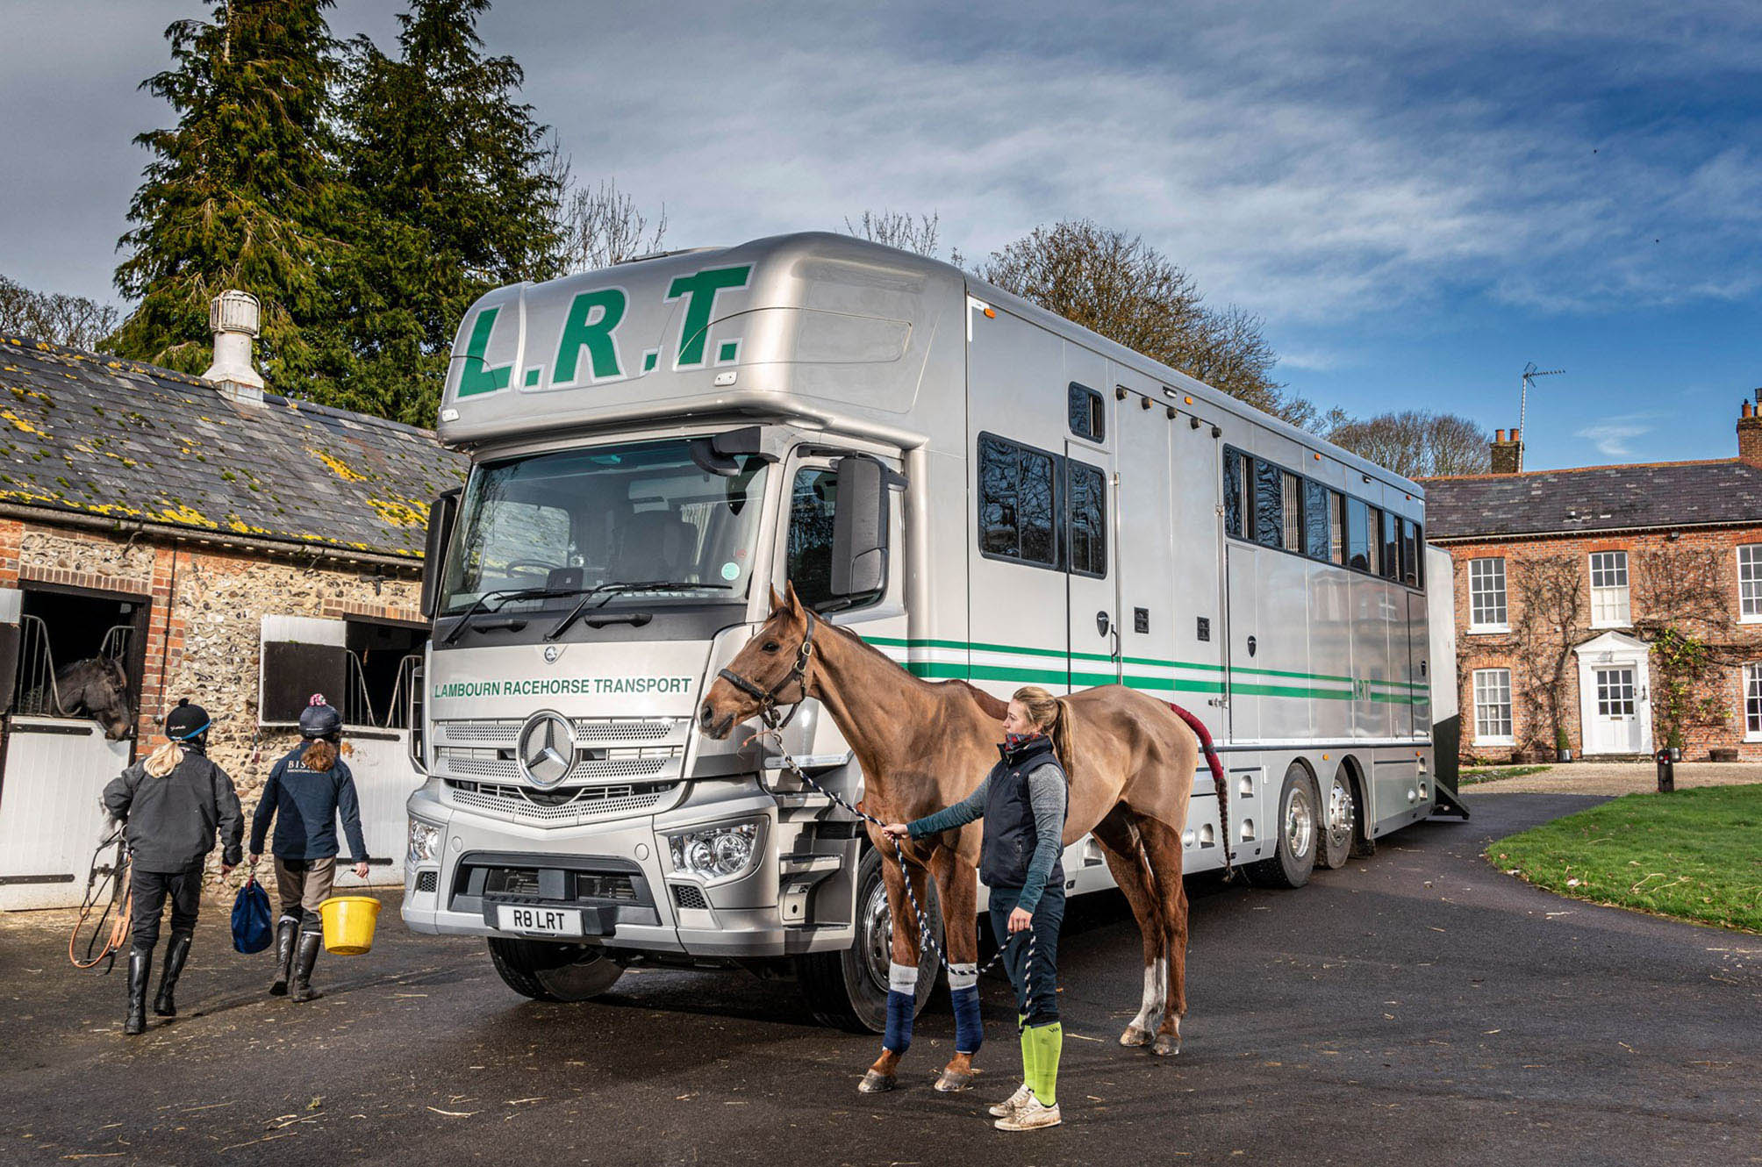

Lambourn Racehorse Transport backs another Mercedes-Benz winner from Rygor Commercials

As the proud holder of a royal warrant from Her Majesty Queen Elizabeth II, Lambourn Racehorse Transport has long experience of working with some of the finest thoroughbreds – which helps to explain why its truck fleet is dominated by Mercedes-Benz.

The Berkshire-based company has been trusted by professionals for more than 85 years to transport everything from Cheltenham Festival and Royal Ascot winners, to maiden two-year-olds and yearlings. As well as moving racehorses between stables and courses, and to and from auction sales, it carries mares and foals during the breeding season.

Lambourn Racehorse Transport (LRT) runs a fleet of 16 bespoke horseboxes of varying sizes from 3.5 to 26 tonnes GVW, which is dominated by vehicles bearing the Mercedes-Benz three-pointed star.

The latest, six-wheeled addition to the line-up is based on a low frame height, fully-air-suspended Actros 2536 ENA chassis supplied by Dealer Group Rygor Commercials.

Specialist manufacturer Oakley Coachbuilders, of Ware, Hertfordshire, built the pod above its ClassicSpace S-cab, and the 10-metre body which is capable of transporting up to 11 yearling flat racers, or nine much heavier National Hunt horses.

The truck’s second-generation 10.7-litre in-line six-cylinder engine produces 265 kW (360 hp) and is paired with a Mercedes PowerShift 3 automated manual transmission. Reflecting the fact that many of the animals it transports are extremely valuable, LRT has enhanced safety by specifying an optional high-performance engine brake.

The hand-built body meets the four-metre maximum height restriction which applies in Europe. There are two beds, one in the pod and the other behind the seats, as well as living accommodation, and 11 stalls with fully padded partitions which can be widened or narrowed according to the size of the individual animal.

Both long-established suppliers to their high-profile customer, Rygor Commercials and Oakley Coachbuilders also teamed up earlier this year to deliver a 13-tonne Mercedes-Benz Atego 1324 with eight-metre body for up to seven horses.

LRT was established in 1930 to provide a transport service to the racehorse trainers of the Lambourn Valley and surrounding villages. The company began buying Mercedes-Benz trucks following its acquisition in 1992 by Merrick Francis, who remains at the helm as Managing Director. Mr Francis is the son of Dick Francis, a former Champion Jockey who went on to become a best-selling author of crime thrillers set against racing backdrops, and was famously known as the Queen Mother’s favourite novelist.

LRT has offices in Newmarket and Doncaster, and at Fairyhouse and Goffs in Ireland, which are open during auction sales. It typically sends a couple of trucks onto the Continent each week, with the majority of assignments carried out in France, the Netherlands and Belgium.

Explaining the rationale behind his enduring commitment to Mercedes-Benz trucks, Merrick Francis said: “Come rain or shine, we undertake to deliver our clients’ horses safe and sound, on time, every time. A reliable fleet is therefore of paramount importance, and that’s what Mercedes-Benz has always given us.

“We cannot afford to have a truck laid up at the side of the road with valuable racehorses on board. We’re seldom let down by a Mercedes-Benz. If issues do arise, they’re invariably minor, and the manufacturer’s 24-hour roadside assistance service has quickly set us back on the road. The fact that this support is available throughout Europe is very reassuring.

“Our trucks are also cost-effective to operate, and well-liked by our drivers and grooms. They don’t cover huge mileages, so we run them for anything up to 12 years before selling them on, and they always command strong residual values.”

The new 26-tonner is driven by William Stewart, who was already working for LRT when Mr Francis took over 27 years ago. The Irish-born former apprentice jockey known to all as ‘Murphy’ said: “I drove our first 26-tonne 11-horse transporter in 2011, and I’ve driven every one we’ve had since.

“This new Actros is definitely the best yet. It’s very comfortable, and more powerful than previous models, so whereas before I might have been dropping down the gears to get up a hill, she flies up no problem.”

Merrick Francis added: “I bought my first horsebox from Simon Harrison of Oakley Coachbuilders in the mid-1980s, and he’s been a trusted supplier ever since. We’ve also been relying for the last 27 years on Rygor Commercials’ Swindon branch to maintain our Mercedes-Benz trucks, and get them through their MoTs. My General Manager has a very good relationship with the Dealer’s workshop team, and we know that if ever we need something urgently they will always help us out.”
Fleet Sales Specialist Chris Carter has managed Rygor Commercials’ account with LRT since 1995. He commented: “Lambourn Racehorse Transport is a genuine flag-bearer for the racing industry, and its immaculately turned out Mercedes-Benz horseboxes are a familiar sight at courses, sales and stables across the UK and beyond. I’m delighted that in partnership with Simon and the team at Oakley Coachbuilders, Rygor Commercials continues to meet this prestigious operator’s every need.”

www.lambourntransport.com

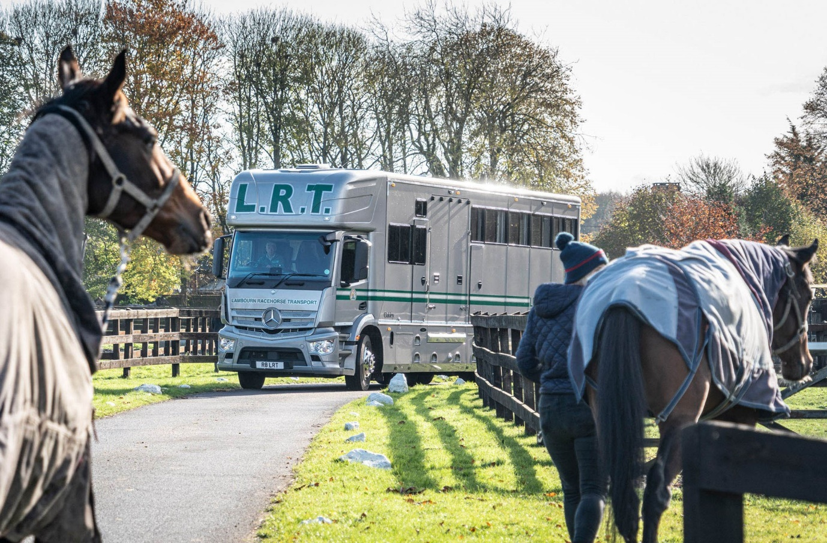

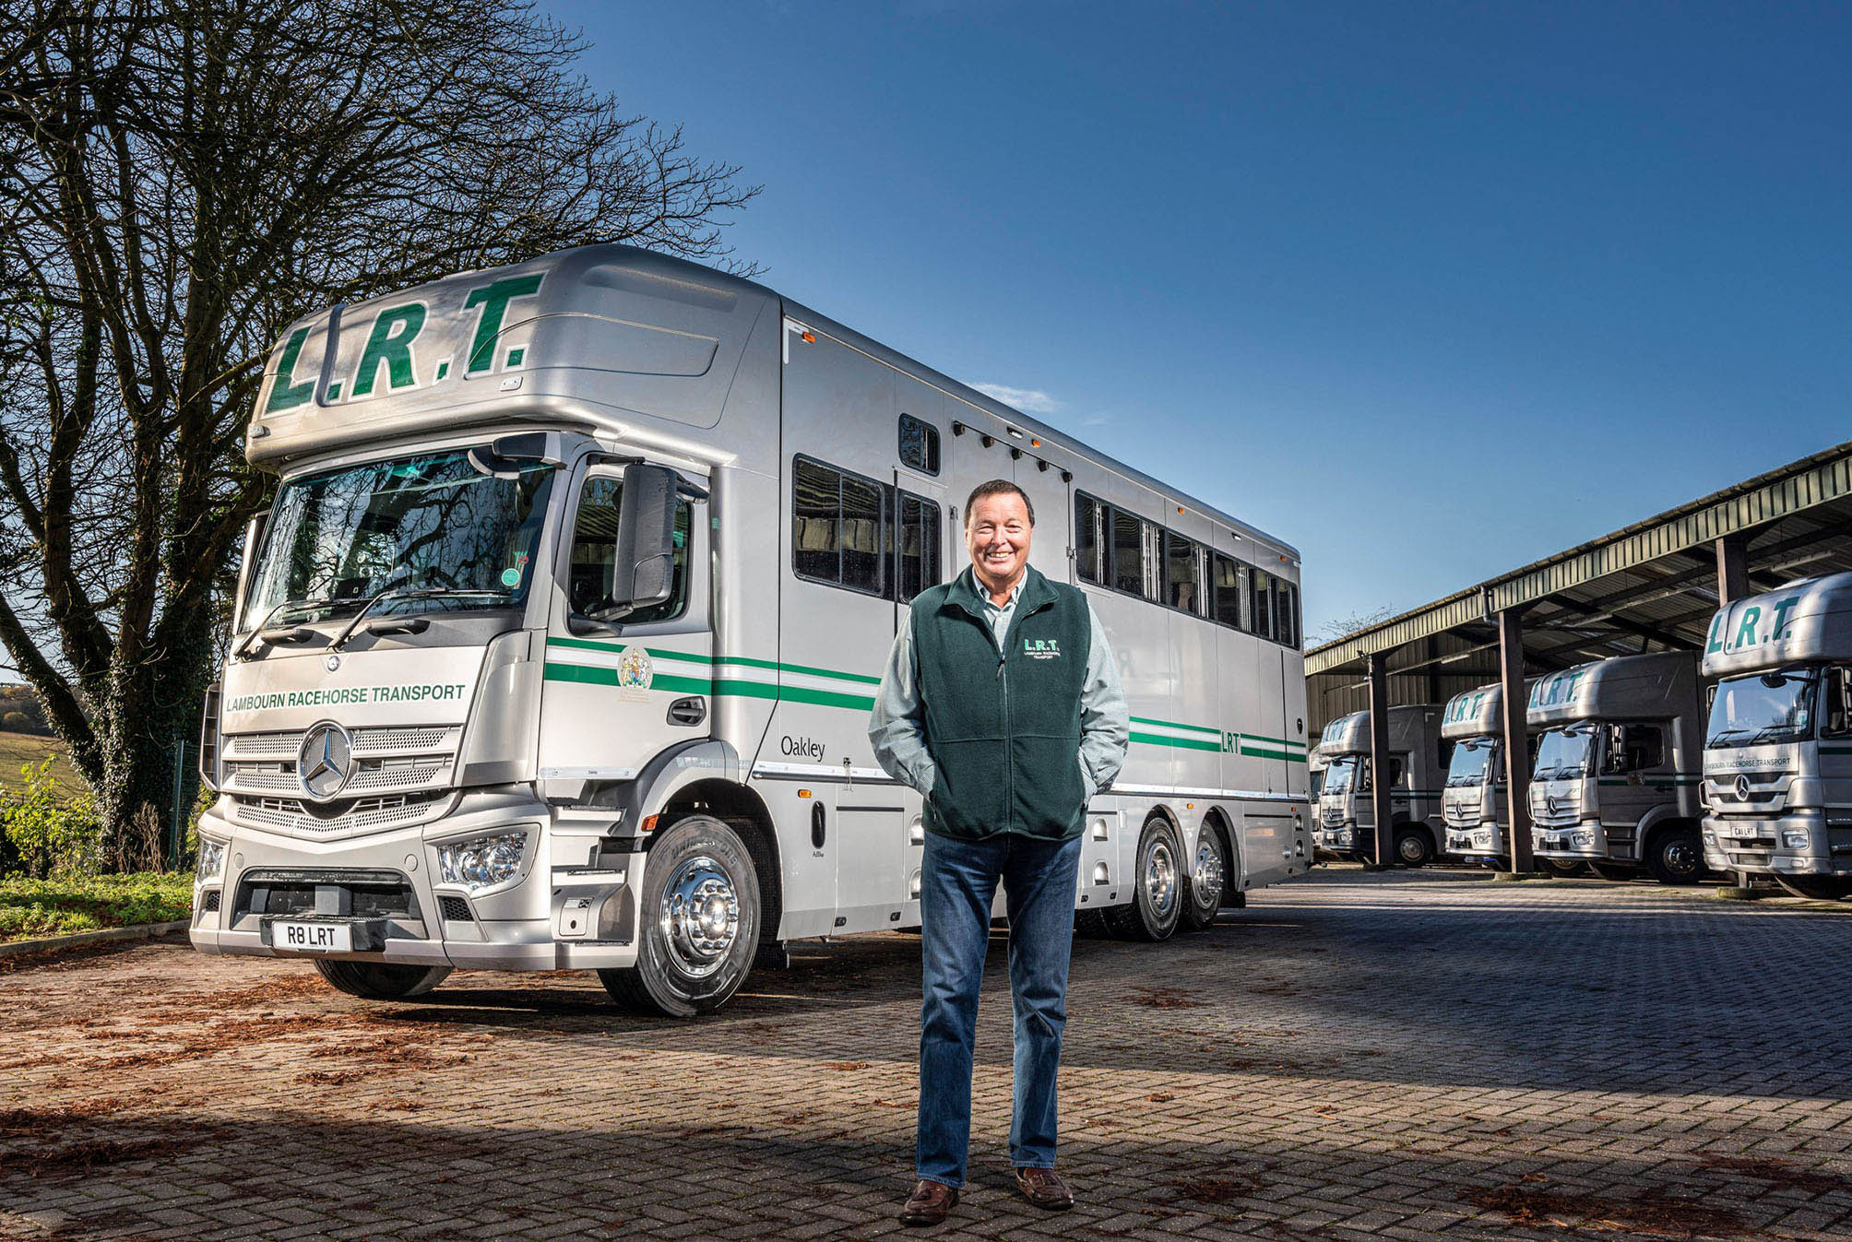

Leading the field: Lambourn Racehorse Transport’s Merrick Francis, with his latest Mercedes-Benz

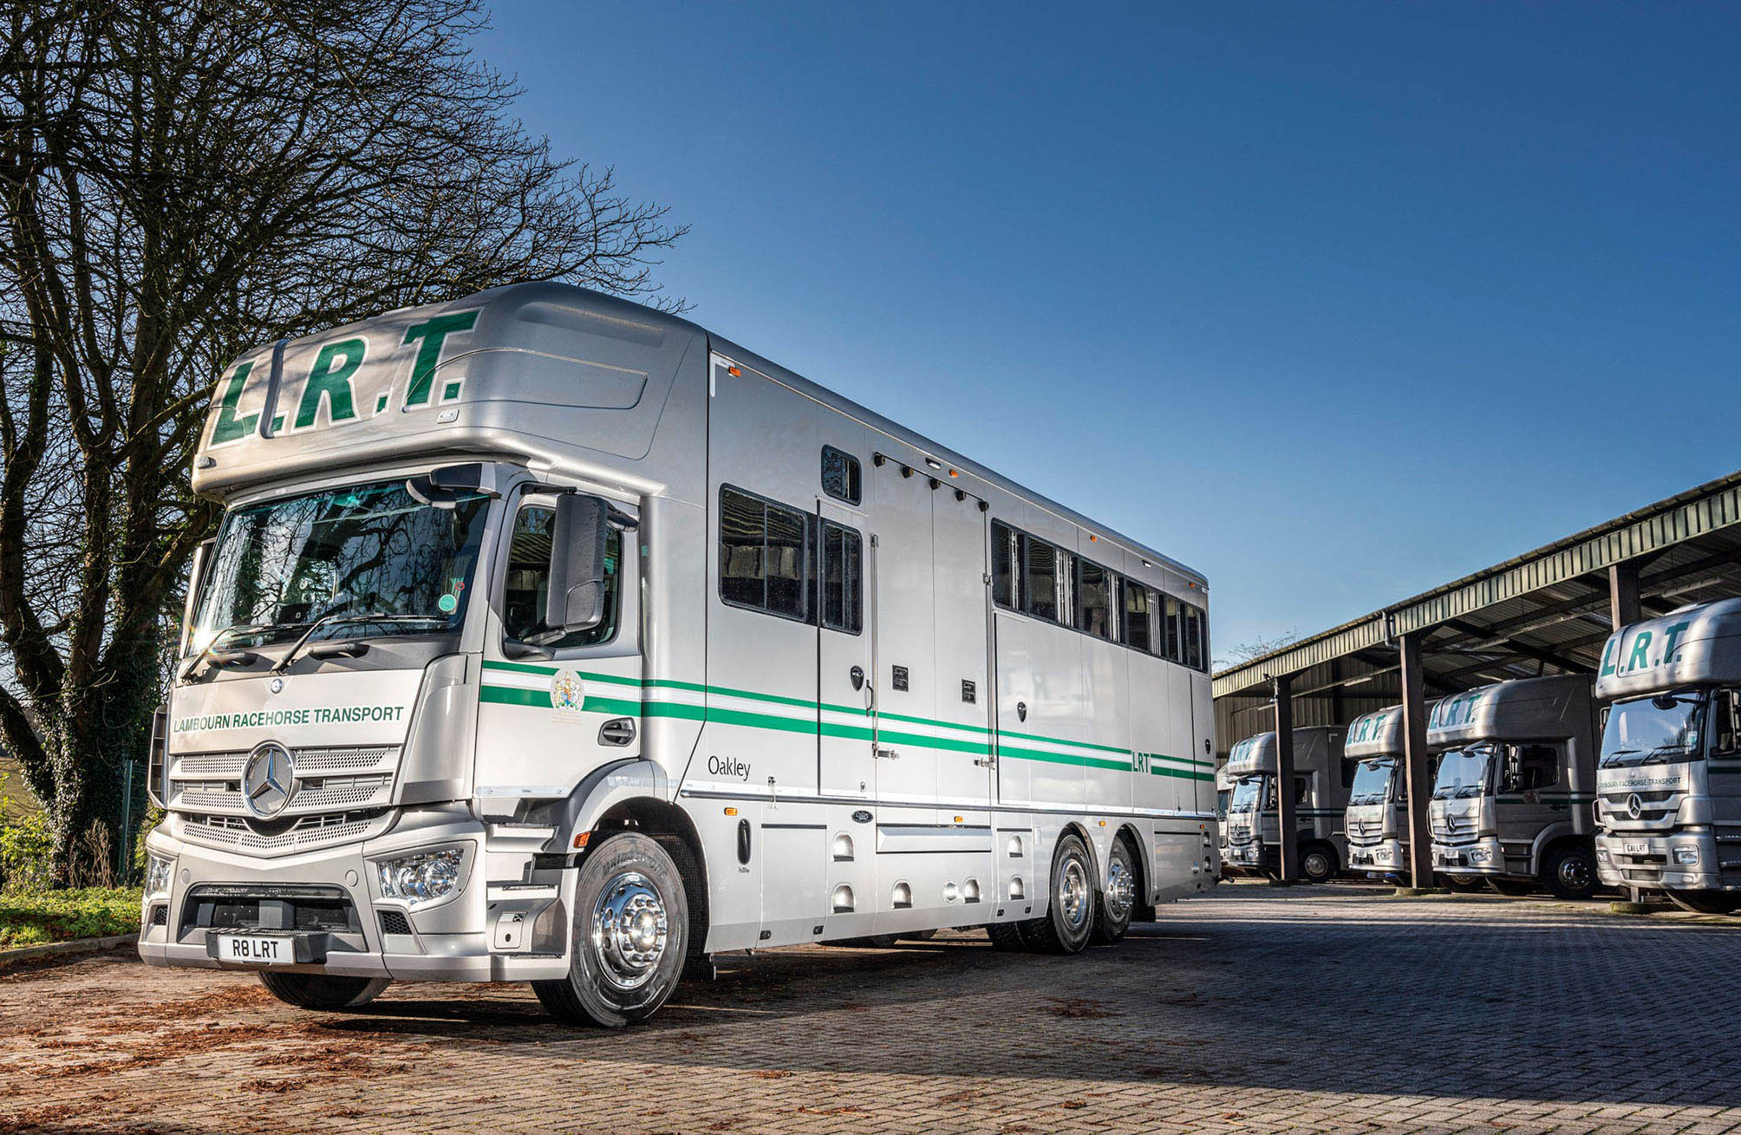

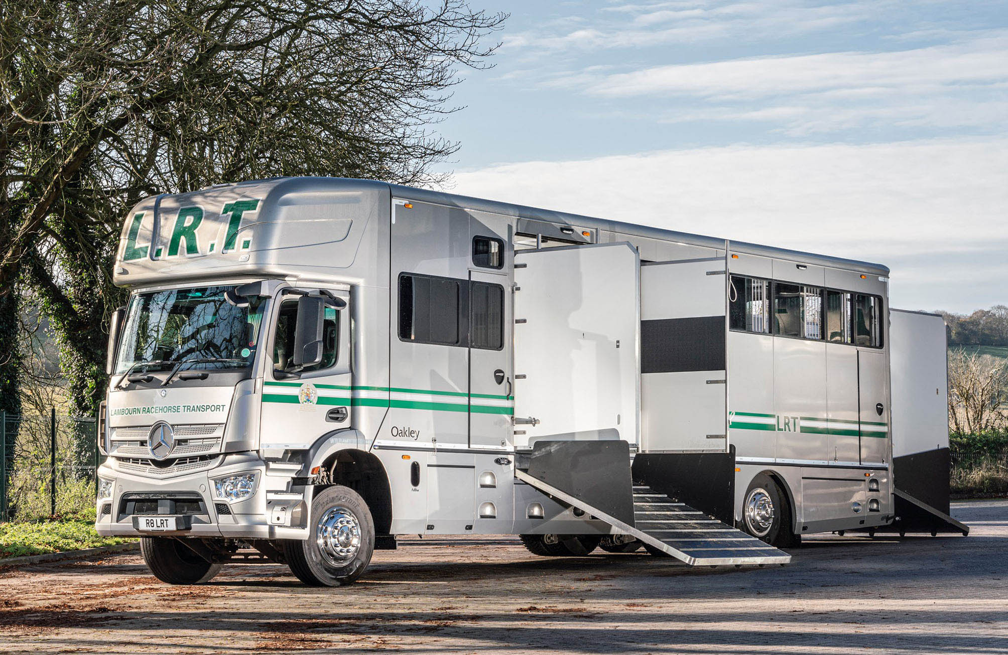

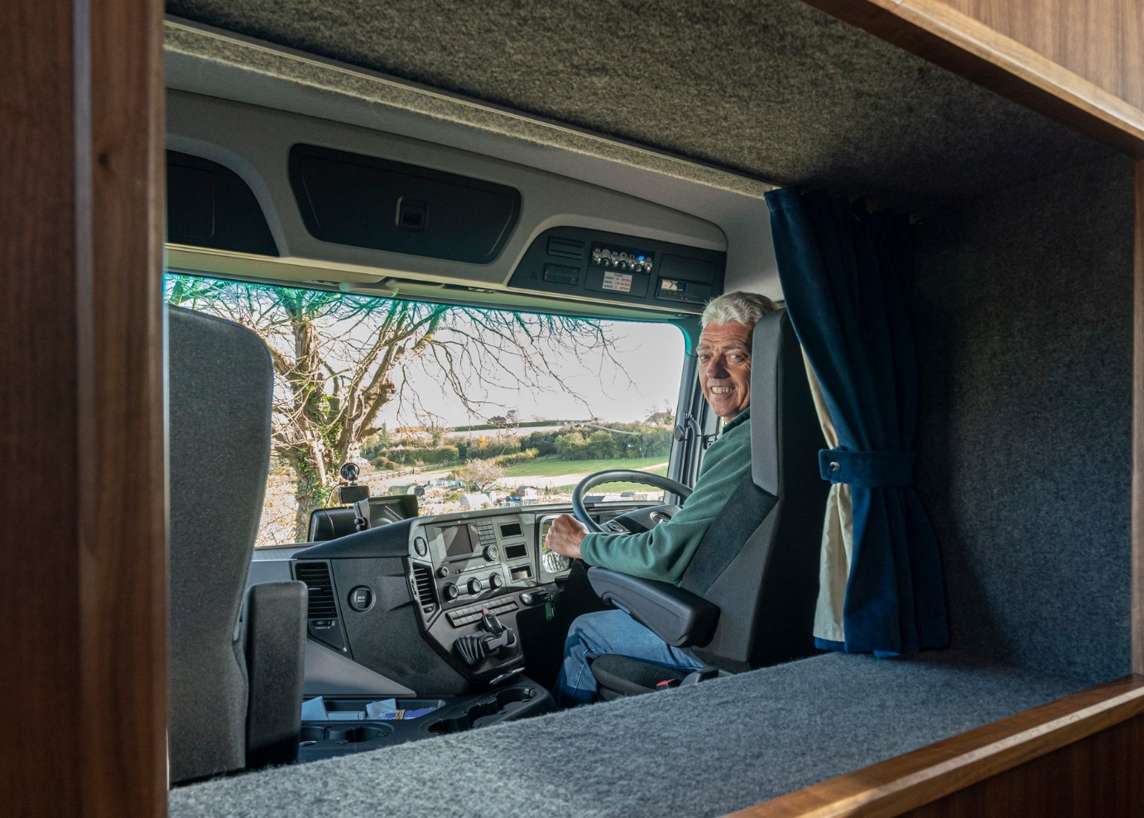

Seat of power: Long-serving William ‘Murphy’ Stewart has driven every one of LRT’s Mercedes-Benz six-wheelers and reckons his new Actros is “definitely the best yet”

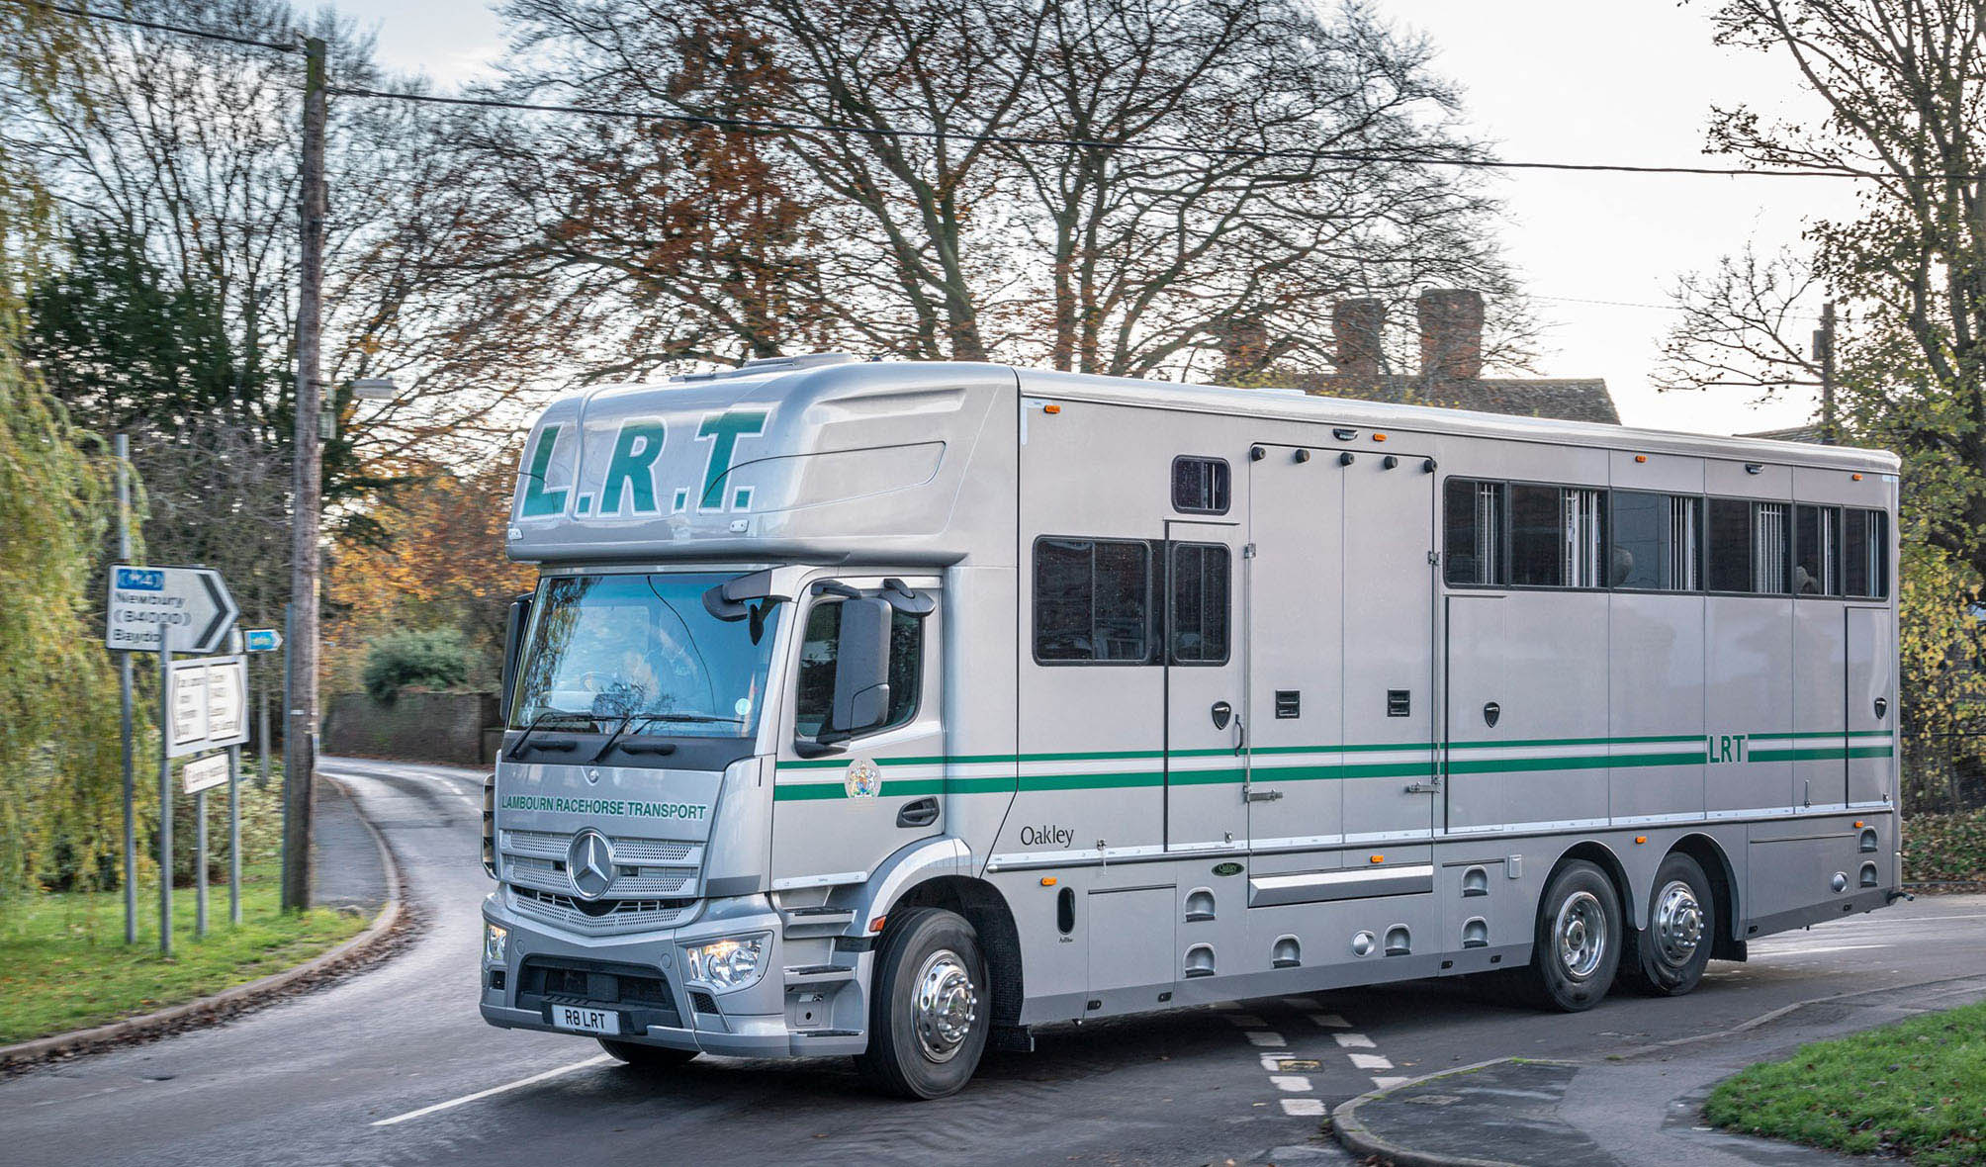

ends

For more information, or to request bigger/higher-res image files, please contact:
Steve Warren or John Ripley
Impact Communications, 01926 842126
Steve: 07770 470251, steve@impactcom.co.uk
John: 07771 484595, john@impactcom.co.uk

Notes to Editors: Rygor Commercials

Award-winning Mercedes-Benz Commercial Vehicle Dealer group, Rygor, has branches throughout Berkshire, Gloucestershire, Oxfordshire, Somerset, West London, Warwickshire, Wiltshire and Worcestershire, offering extensive coverage for customers throughout the M5, M4 and M42 corridors.

The Rygor business has expanded and gone from strength to strength in recent years, launching its flagship Gloucester branch in late 2016 (which won Showroom of the Year at the 2018 Commercial Motor Awards) and undergoing a significant refurbishment of its Oxford branch in 2018. Rygor was delighted to be announced as winner of the ‘Best Sales Team’ award at the 2019 AM Awards, demonstrating our continued commitment to our customers and dedication to providing exceptional customer service.

With a proven track record, Rygor is proud to be selling and supporting the most prestigious name in commercial vehicles.

For more information, in the first instance please contact Kate Ruberry-Shoemack, Head of People and Communications at Rygor – kateruberry-shoemack@rygor.co.uk

