

Date: 7 June 2022

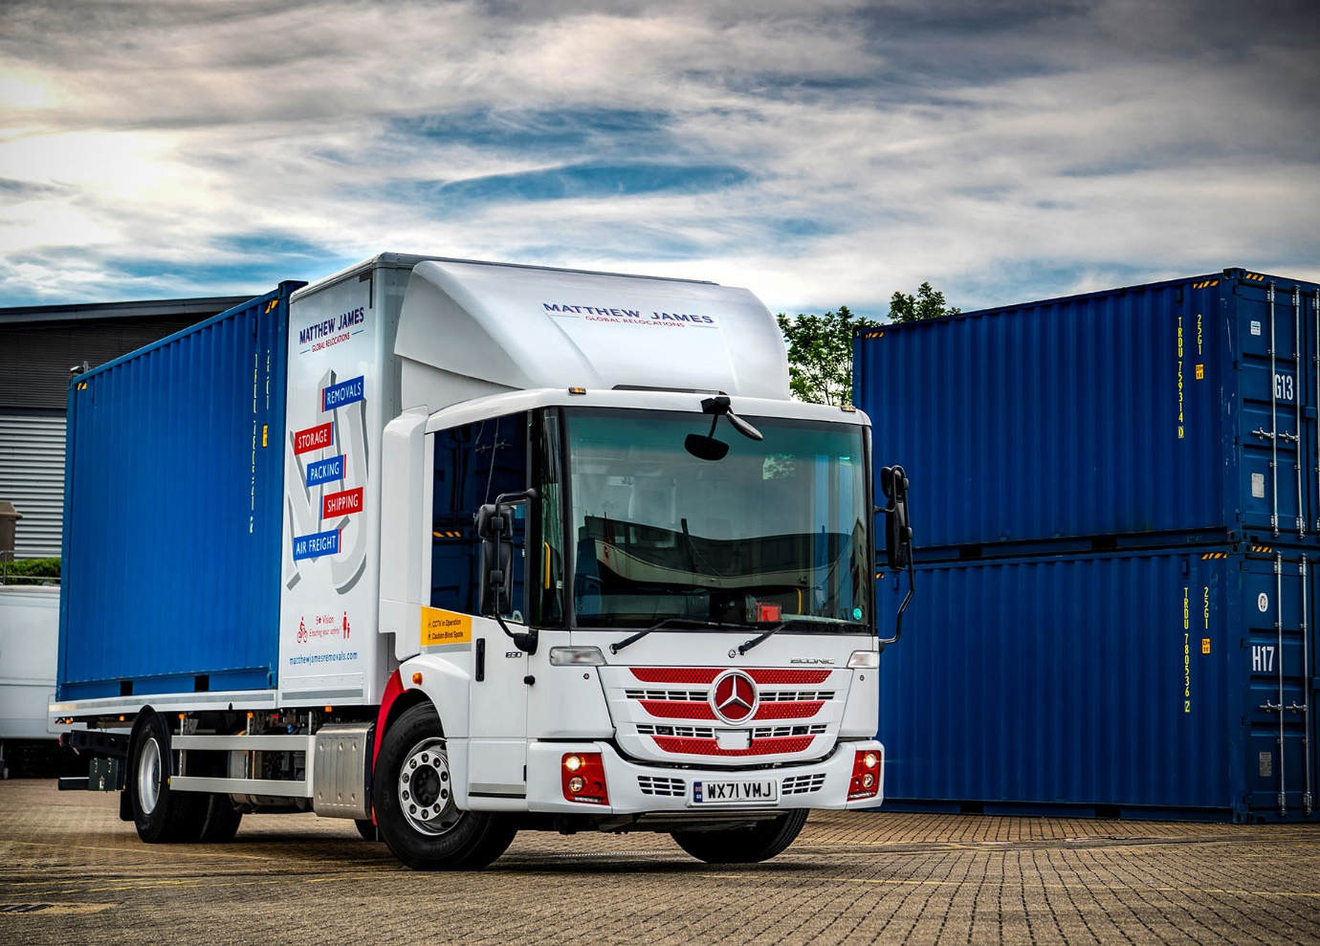

Matthew James thinks ‘outside the box’ for safer city removals with Mercedes-Benz Econic from Rygor

Global relocations specialist Matthew James has commissioned a low-entry Mercedes-Benz Econic with unrivalled direct visibility credentials that make it ideally suited to removals work in and around London.

The compliance-focused company, which operates from head offices in Dartford, Kent, and the Spanish resort of Malaga, purchased the latest addition to its fleet from established supplier Rygor Commercials.

The 4x2 Mercedes-Benz Econic boasts a deep, panoramic windscreen. As specified by Matthew James, with a fully glazed, folding passenger door, the vehicle attracts a maximum five-star rating from Transport for London’s Direct Vision Standard scheme.

As an 1830 L variant the air-suspended chassis is powered by a 7.7-litre in-line six-cylinder engine that produces 220 kW (300 hp) and is paired with a fully automatic six-speed Allison gearbox.

Preston-based SBR Specialist Coachbuilders fitted a large storage box immediately behind the cab and a platform incorporating twists locks, for securing the 20ft ISO shipping containers it is designed to carry. Matthew James’ porters access the container via a ramp system.

Easily entered and exited via a single step, the Econic accommodates a driver and up to three passengers in air-conditioned comfort and safety. The individual at the wheel sits much lower than in a conventional truck. This, coupled with the bus-style nearside door, allows them to make direct eye contact with vulnerable road users – particularly cyclists and pedestrians – at junctions and in traffic, a key advantage in helping each to understand the other’s intentions.

The Mercedes-Benz Econic has long been the refuse chassis of choice for many local authorities and waste and recycling specialists. However, the significantly enhanced visibility it affords drivers, together with its market-leading, factory-fit safety systems, mean that over recent years the vehicle has also become increasingly attractive to safety-conscious companies working across other sectors, most notably construction and distribution.

Matthew James’ new truck, which is also fitted with a 360º camera system by Hall’s Electrical, is one of the first Econics to be used in a removals application.

A third-generation family business that provides national and international relocation services, and specialises in moving UK citizens throughout Europe, Matthew James runs weekly road train services to and from France, Spain and Portugal.

It runs a mixed-marque fleet of 40 trucks, of which 15 are by Mercedes-Benz. These include five 26-tonne Actros LnR models with low frames and pantechnicon bodies, all of which arrived via Rygor Commercials.

Managing Director Matthew de-Machen commented: “We were quiet for a single month during the pandemic but this apart there’s been no let-up in demand, as customers have adjusted their domestic arrangements in line with new working regimes and lifestyle aspirations.

“Our business is still booming and the Econic adds another, important string to our bow. Matthew James’ investment in this vehicle reflects our strong commitments to compliance and to the safety, not only of colleagues, but also of other, vulnerable road users.

“It’s easy to make a compelling business case for operation of the Econic in and around London. As well as leading the field in terms of direct visibility, its big, airy cab can accommodate a team of porters, which means we don’t have to send them out in a second vehicle.”

Mr de-Machen continued: “We bought our first Mercedes-Benz Actros in 2016 with the intention of keeping them for 10 years. Those trucks have been all over the Continent, yet they’ve never let us down, and the same is true of those we’ve purchased since. That fantastic reliability is crucial to the smooth running of our business, as these are highly specialised vehicles so we can’t just hire a replacement in the event of a breakdown.”

Matthew James maintains the fleet in its own workshop. As with all new Econics supplied through the official Mercedes-Benz Trucks Dealer network, its new truck came with a comprehensive manufacturer’s warranty extending to three years/160,000 km.

As previously, Matthew James’ latest order was managed by Rygor Commercials Truck Sales Executive Marcus Cahalin. “I’ve known Marcus for years and he always provides a first-rate service,” confirmed Matthew de-Machen.

Marcus Cahalin added: “Matthew James’ impressive track record of fleet innovation owes much to Matt de-Machen’s passion for vehicles and machinery. We have a great working relationship, and I am always delighted to be able to support such an influential and highly respected operator in the development of a new removals concept.

“Matthew James’ ambition, when it comes to its fleet, aligns very much with our own company values in being rewarding, reliable and respectful. As a company, it offers a reliable service and is courteous to other road users, and I have every confidence its new Econic will prove both efficient and cost-effective for work in and around London.”

www.matthewjamesremovals.com

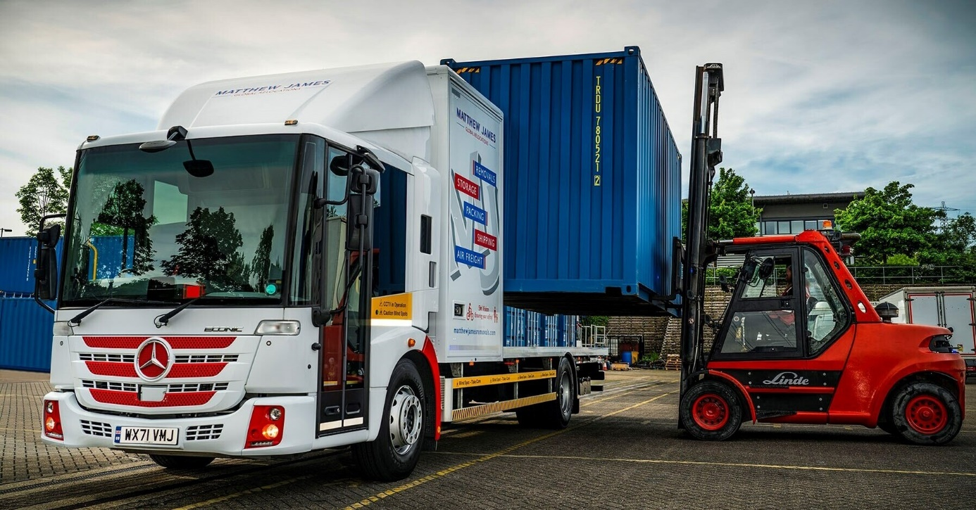

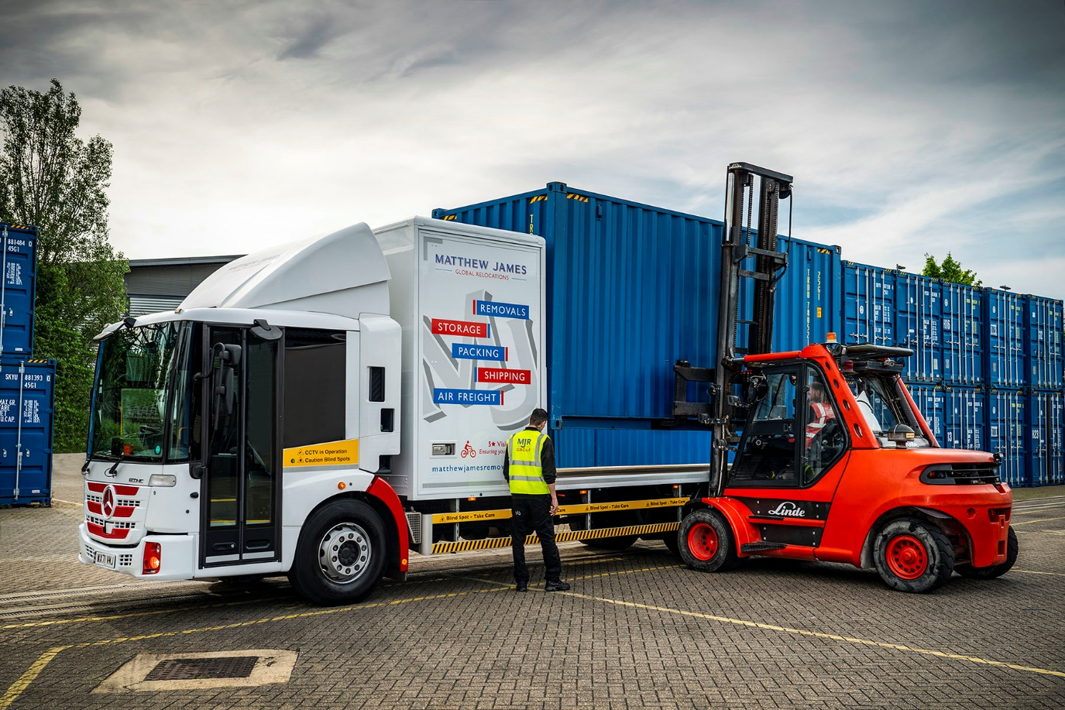

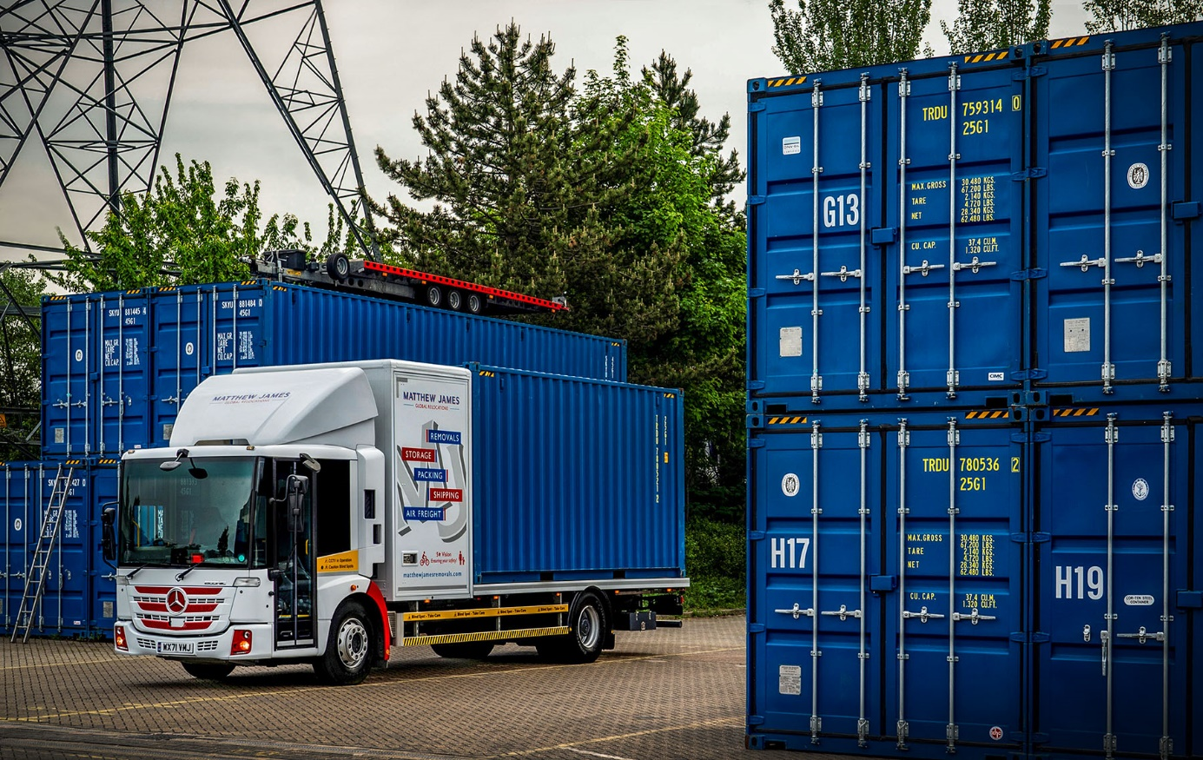

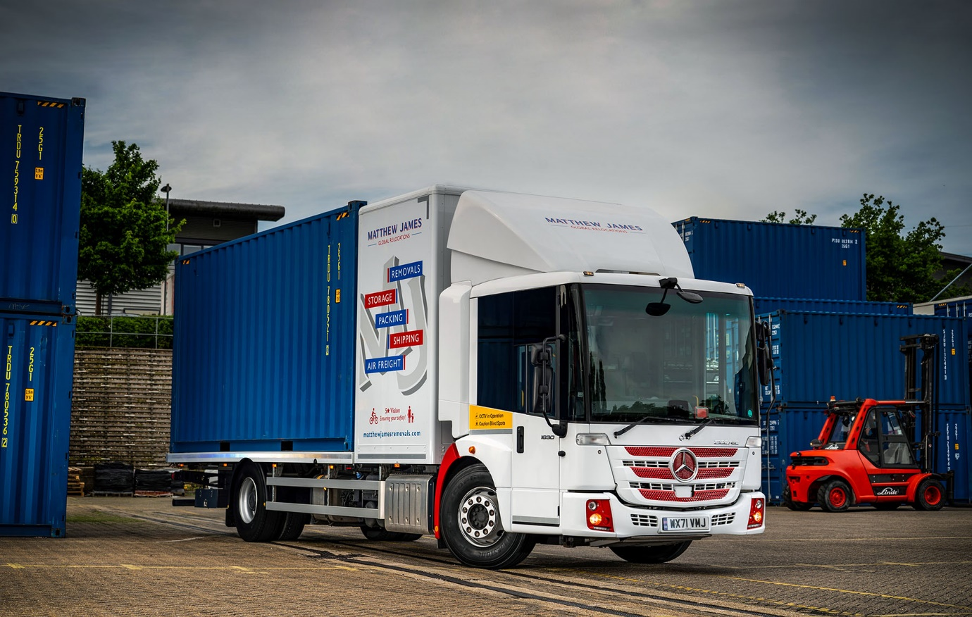

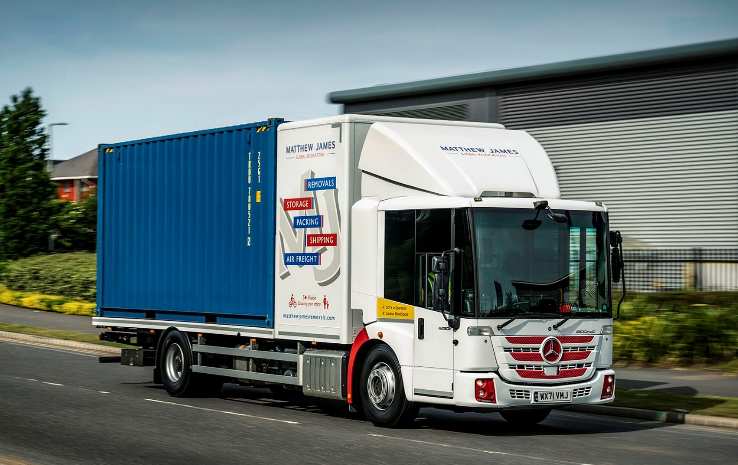

ends

For more information, or to request bigger/higher-res image files, please contact:
Steve Warren or John Ripley
Impact Communications
Steve: 07770 470251, steve@impactcom.co.uk
John: 07771 484595, john@impactcom.co.uk

Notes to Editors: Rygor Commercials

Award-winning Mercedes-Benz Commercial Vehicle Dealer group, Rygor Commercials, has branches in Berkshire, Gloucestershire, Oxfordshire, Somerset, West London, Warwickshire, Wiltshire, and Worcestershire, offering extensive coverage for customers throughout the M5, M4 and M42 corridors.

The Rygor business has developed and gone from strength to strength in recent years, investing in extensive renovations of its sites across the country as well as a brand-new, dedicated Heathrow Truck Centre which opened in 2020. With six industry and network awards under its belt in the past 24 months, Rygor continues to be dedicated to providing exceptional customer service, which Sets Standards. The Dealer was delighted to be announced as winner in the ‘Franchised Dealer of the Year’ category at the 2019 Commercial Motor Awards and ‘Van Dealer of The Year 2021’ at the What Van? Awards, accolades which not only demonstrate the company’s focus on customer satisfaction, but also its commitment to the development, training, and wellbeing of its team members.

With a proven track record, Rygor is proud to be selling, maintaining and supporting the most prestigious name in commercial vehicles.

For more information, in the first instance please contact Kate Ruberry-Shoemack, Head of People and Communications at Rygor – kateruberry-shoemack@rygor.co.uk, or, in her absence, Communications Assistant, Talitha Scott – talithascott@rygor.co.uk.

