

Date: 20 November 2019

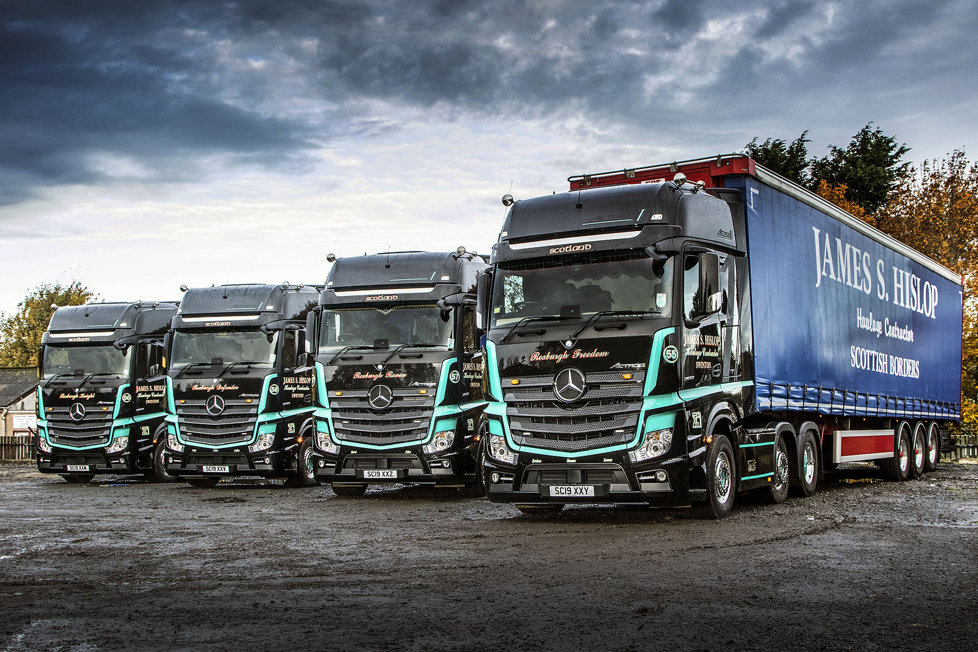

James S Hislop opens a new Mercedes-Benz chapter with four high-spec Actros1s

Scottish Borders-based haulier James S Hislop has rewarded four of its best drivers with beautifully finished and exceptionally well equipped Actros1 tractor units from
Mercedes-Benz Dealer Western Commercial.

The family business placed its order after being impressed by the economical performance of a 390 kW (530 hp) demonstrator. The new trucks employ the same 12.8-litre straight-six engine, and are already living up to the operator’s high expectations.

“They’re doing absolutely fine,” confirmed Managing Director Alan Hislop. “Average returns are around the 9 mpg mark. That may not sound a lot to some, but it’s very good for us, though, given that we’re almost two hours from the nearest motorway. Our trucks also pull high-sided trailers, and are invariably fully freighted.

“The drivers are more than happy with their Actros1s,” he continued. “That’s hardly surprising, because as well as being striking in appearance, it’s also a lovely truck to drive, and very well specified.

“They’re all good guys and have been with us for a long time, so it’s nice to be able to thank them for their loyal service by putting them behind the wheels of such stylish, spacious and comfortable vehicles.”

James S Hislop operates from headquarters in Kelso, and a second depot 15 miles away at Swinton, near Duns. The new Mercedes-Benz units have taken their places in a mixed-marque fleet of 26 tractor units that also includes three 375 kW (510hp) Actros which are on short-term hire. The company is maintaining them in its own workshop, but relies on Western Commercial for timely and efficient parts back-up, as well as technical support and any warranty work.

The Actros1 is a highlight of the fourth-generation model range and an impressive showcase for Mercedes-Benz Trucks’ technical excellence. In terms of driver appeal, meanwhile, few trucks come close to its comprehensively equipped GigaSpace cab.

Real head-turners in their distinctive black and high-visibility green colours, Hislop’s trucks also feature Alcoa Dura-Bright alloy wheels, roof-mounted air horns, Bi-xenon headlamps, LED tail lights, and illuminated grille-mounted three-pointed stars.

The luxurious Style Line interior design is complemented by a leather-trimmed steering wheel and Comfort leather massage seats for driver and co-driver, an uprated multimedia entertainment system and a Premium Comfort mattress. Practical features such as automatic climate control, an electric sunroof and sunblind, a microwave and pull-out refrigerator, and rear overhead lockers also contribute to the ‘feel-good factor’ for drivers.

Technical enhancements, meanwhile, include Safety Packs with Active Brake Assist 4 emergency and Proximity Control Assist systems, fuel-saving Predictive Powertrain Control and Fleetboard telematics hardware, and Mercedes-Benz Uptime technology.

Alan Hislop’s father James established the business in 1988 and, although now retired, continues to take an active interest. Representing the third generation of the family, Alan’s 21-year-old son Angus holds a Class 1 licence and has just completed his workshop apprenticeship. Ruari, aged 12, and Gregor, 11, are also ‘truck mad’, and set on following in their older brother’s footsteps when they leave school.

Alan Hislop attended a dinner hosted by Rory Allen, Western Commercial’s dedicated Truck Sales Director, at which Mercedes-Benz Trucks UK Managing Director Mike Belk outlined his plans for the future strategy of the brand, with particular focus on customer service and support.

“It all sounded very promising,” recalled Mr Hislop. “These are still early days in our relationship with Mercedes-Benz, but we’ve certainly made a very good start. We’re getting on very well with the team at Western Commercial, whose operation looks very professional.

“Of course, vehicle uptime will be crucial. We’ve not had any issues with our Actros1s, and will be looking closely to see how the Dealer performs if and when one does crop up. On the evidence of what I’ve seen so far, though, I’m optimistic that the back-up will be there when we need it.”

jamesshislop.co.uk

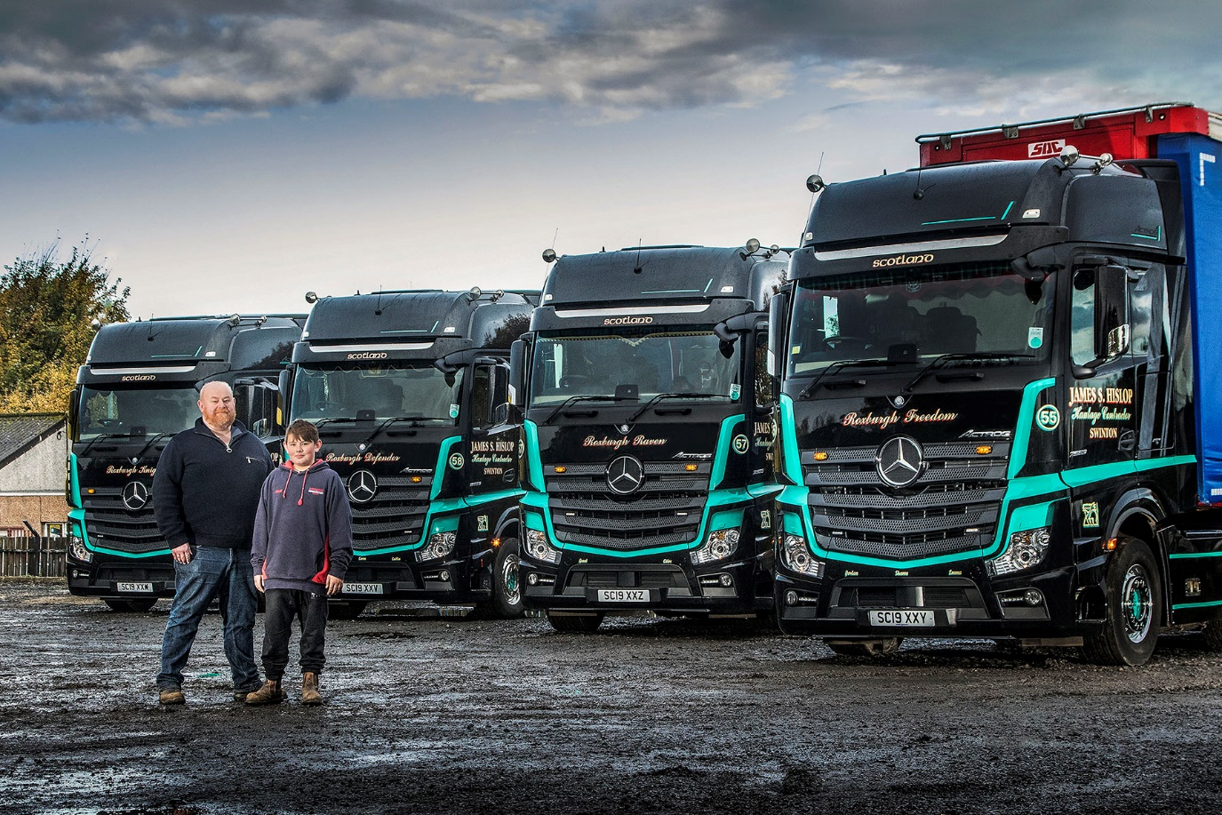

Family values: Eleven-year-old Gregor Hislop’s heart is set on following father Alan into the business founded by his grandfather

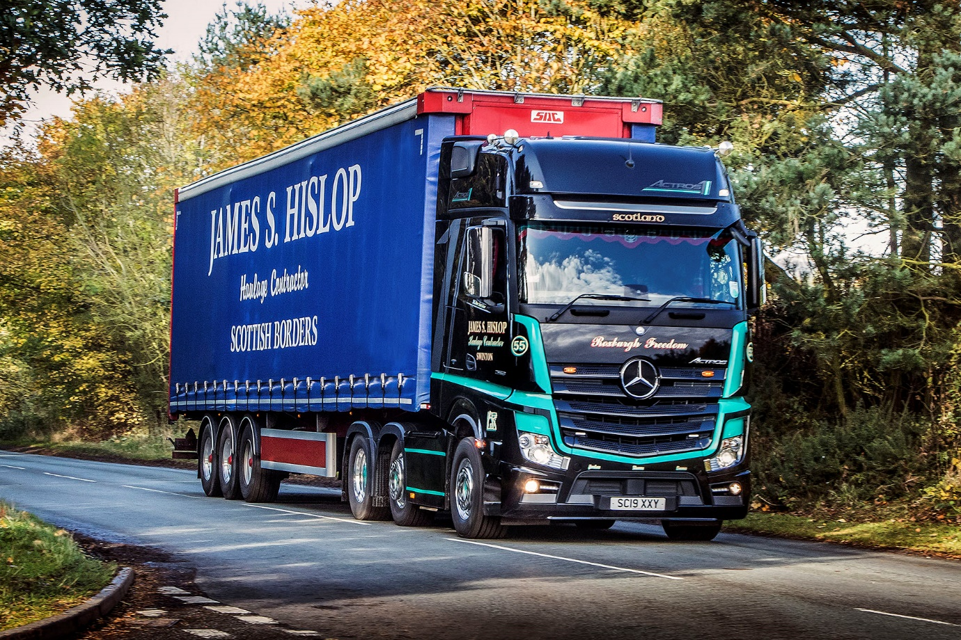

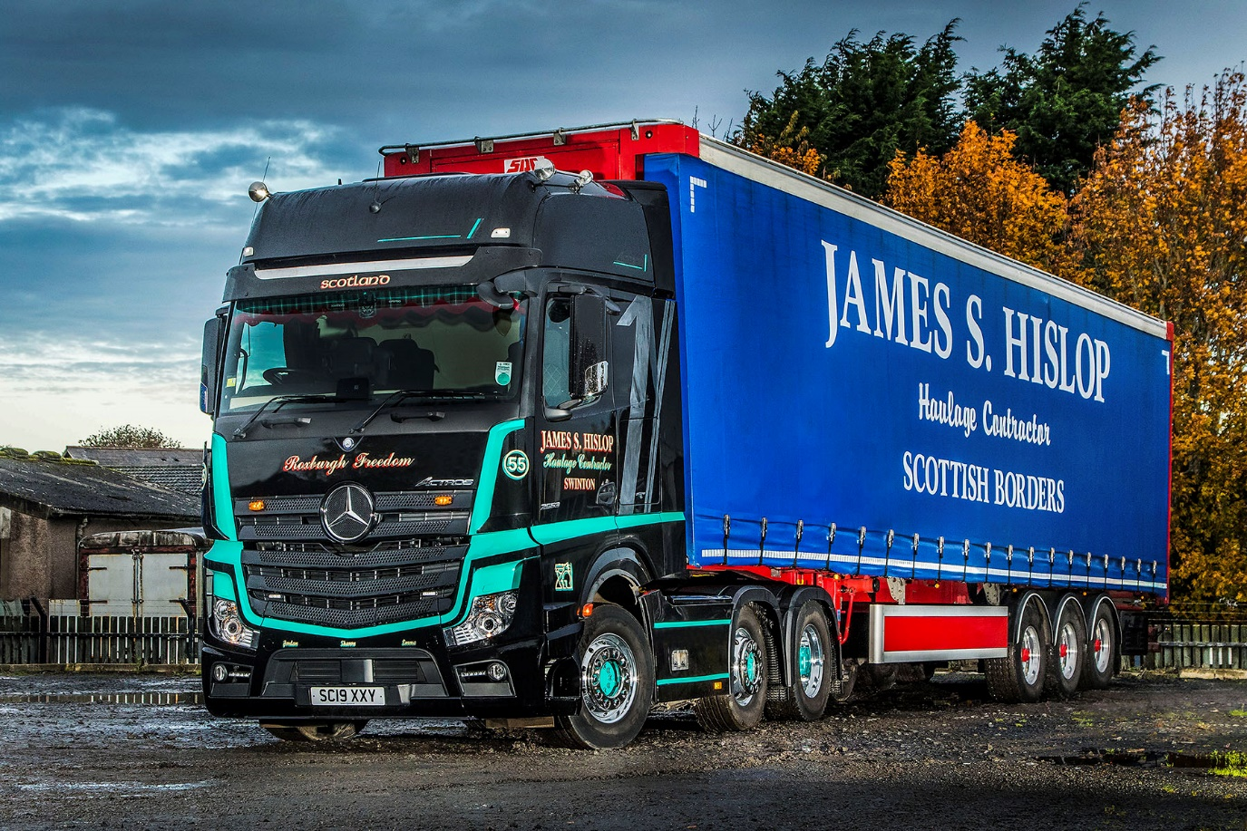

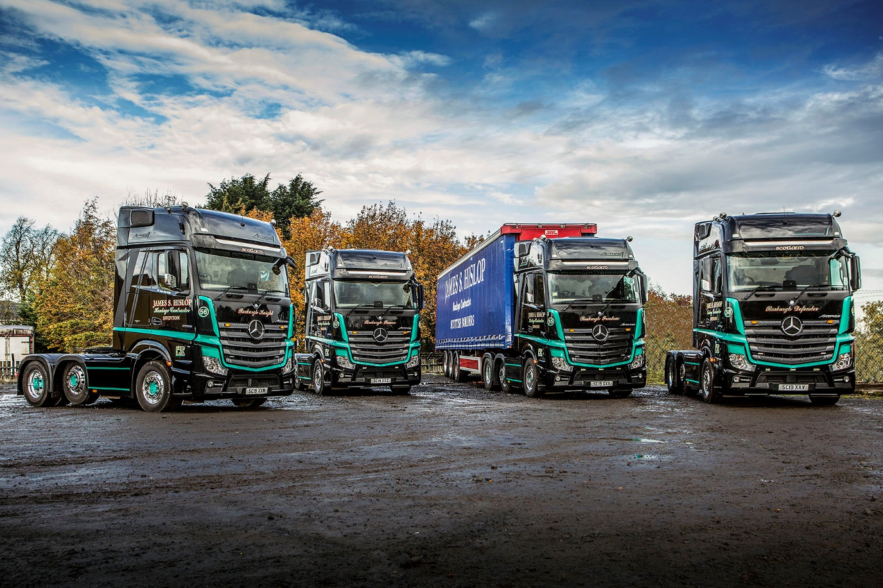

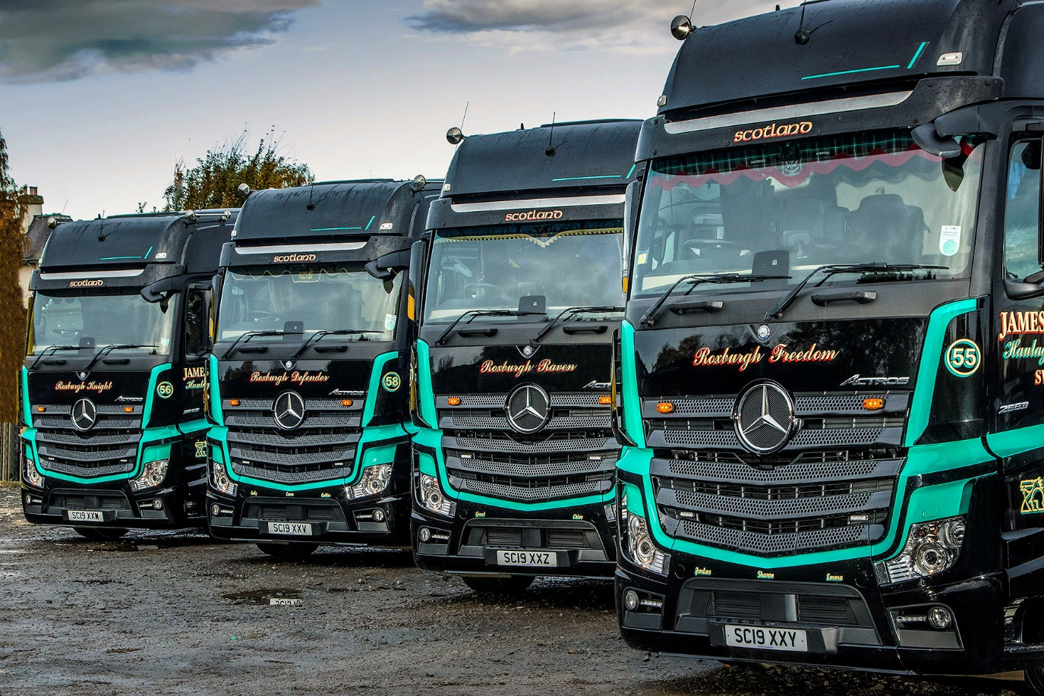

ends

For more information, or to request bigger/higher-res image files, please contact:
Steve Warren or John Ripley
Impact Communications, 01926 842126
John: 07771 484595, john@impactcom.co.uk
Steve: 07770 470251, steve@impactcom.co.uk



