

Date: 25 July 2019

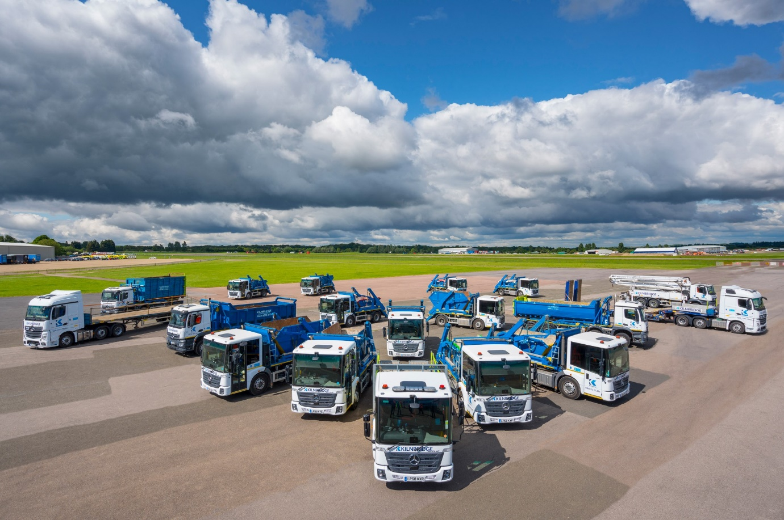

Kilnbridge raises the safety bar with 22 low-height Mercedes-Benz trucks from S & B Commercials

Safety-focused construction and engineering contractor Kilnbridge has underscored its commitment to the protection of vulnerable road users and its own drivers by replacing its entire fleet with 22 trucks from three Mercedes-Benz model lines.

Kilnbridge operates from headquarters in east London, and its vehicles are now being maintained under five-year Mercedes-Benz Complete Service Contracts by supplying Dealer S & B Commercials.

Most are based on 18-tonne versions of the low-entry Econic, which has been awarded a five-star Direct Vision rating by Transport for London, thanks to its deep, panoramic windscreen, full-height glazed passenger door, and a seating position that allows drivers to make eye contact with cyclists and pedestrians at junctions and in traffic.

All 1827L variants with 200 kW (272 hp) six-cylinder engines and Mercedes PowerShift 3 automated transmissions, the Econics are already delivering fuel savings and emissions reductions of 2-3% compared to their predecessors.

Fourteen are fitted with Hyva skip-loading equipment, while Kilnbridge has also commissioned a single vehicle with cheese-wedge plant body by Sterling GP. Presented at the Freight in the City Expo, this is one of the first Econics to be specified for the transportation of plant.

Completing the operator’s new fleet are a pair of 330 kW (450 hp) Actros 2545 StreamSpace tractor units plated for operation at up to 68 tonnes GCW, and five 32-tonne rigid vehicles, all from the muscular Arocs construction range and powered by 290 kW (394 hp) straight-sixes. Four of these are 8x4 Arocs 3240Ks with Hyva hook-loading gear; the fifth is a low frame-height 8x2 Arocs 3240 L ENA model which also has a Sterling GP cheese-wedge plant body, as well as a HIAB crane supplied and fitted by Walker Cranes.

Kilnbridge works predominantly in London and the South-East. It is a CLOCS (Construction Logistics and Cyclist Safety) Champion, accredited to Gold standard by FORS (Fleet Operator Recognition Scheme), and an ardent supporter of both.

The skip-loaders and hook-loaders are now being used by its Waste Management division, which provides collection, recycling and ancillary services to commercial and industrial clients, particularly those involved in construction and demolition.

The tractor units and beavertail-bodied vehicles, meanwhile, are in operation with K-PLANT, Kilnbridge’s plant and equipment services business, which provides a comprehensive range of plant and equipment to support its ongoing construction and infrastructure projects.

K-PLANT Director Thomas Barrett explained: “Kilnbridge operates to the highest safety standards. We opted for the Mercedes-Benz Econic because it represents the benchmark in terms of ergonomics, and offers terrific visibility, with a generously sized windscreen and glazed folding door on the co-driver’s side.

“As well as ensuring that our drivers are at the same eye-level as pedestrians and cyclists, the low-floor cab with its wide-opening driver’s door scores very highly thanks to its outstanding ease of entry. This reduces the risk of drivers sustaining injuries, particularly by slipping while frequently getting in and out of the cab on construction sites.”

The skip- and hook-loading bodywork on Kilbridge’s Econics and Arocs is also remote radio-controlled, making the job less hazardous for drivers, who can stand well clear while changing bins.
Mr Barrett said Kilnbridge initially intended to replace only four skip vehicles with Econics. However, a major fleet management review, which invited stakeholder contributions from across the business, and took account of Transport for London’s Direct Vision Standard, concluded that a wholesale investment in new Mercedes-Benz vehicles represented the best way forward.

Though safety was certainly crucial, it was not the only factor behind this decision. “We had initial discussions with several manufacturers,” continued Mr Barrett. “Cost-effectiveness, particularly an analysis of fuel economy, was also a key priority. We trialled Econic and Arocs demonstrators before committing to Mercedes-Benz, and I’m delighted to report that despite some initial scepticism our drivers have now embraced their new trucks.”

Mr Barrett recalled: “Steve Thurbon, Commercial Sales Manager at S & B Commercials, provided exemplary support during the delivery process, working hard to co-ordinate the various bodybuilders and ensure our tight deadlines were met. Having spent time with Steve, I was impressed with his fantastic product knowledge.

“We’re also very happy with the aftersales arrangements, not least because the Dealer’s West Thurrock workshop is ideally located for our Canning Town headquarters, and materials recycling facility in Rainham.”

Established in 1992, and still privately-owned, Kilnbridge specialises in the delivery of ‘turnkey’ structures contracts. The company also has offices in Belfast and Northampton, and major projects undertaken for clients from the aviation, energy, rail, commercial and retail sectors feature prominently within its portfolio.

www.kilnbridge.com

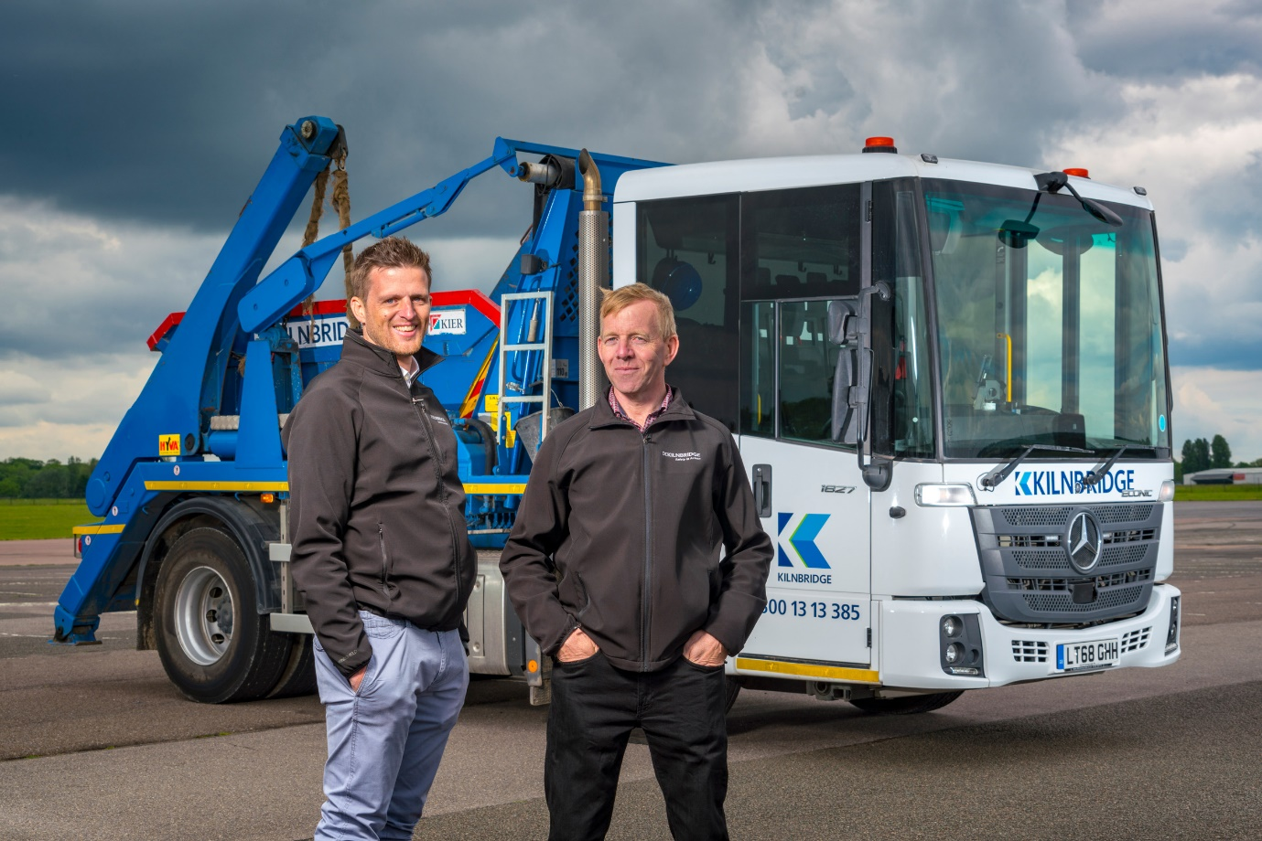

Reaching for the three-pointed stars: Kilnbridge’s K-PLANT Director Thomas Barrett, left, and Operations Director – Waste Management Al Keaney

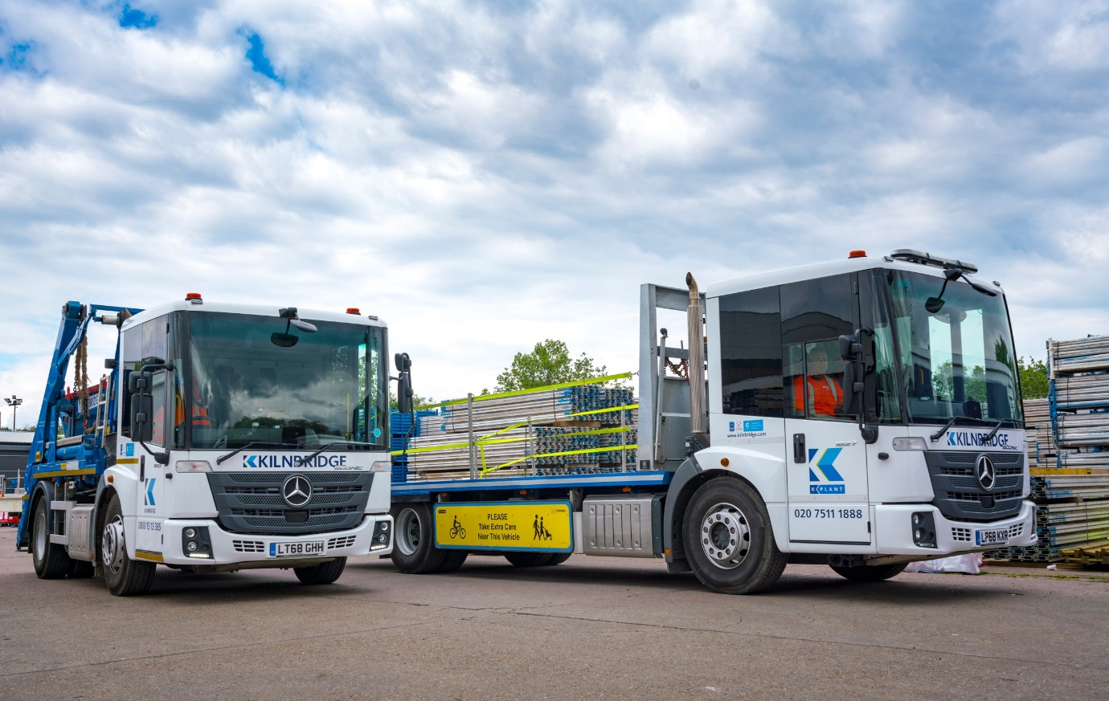

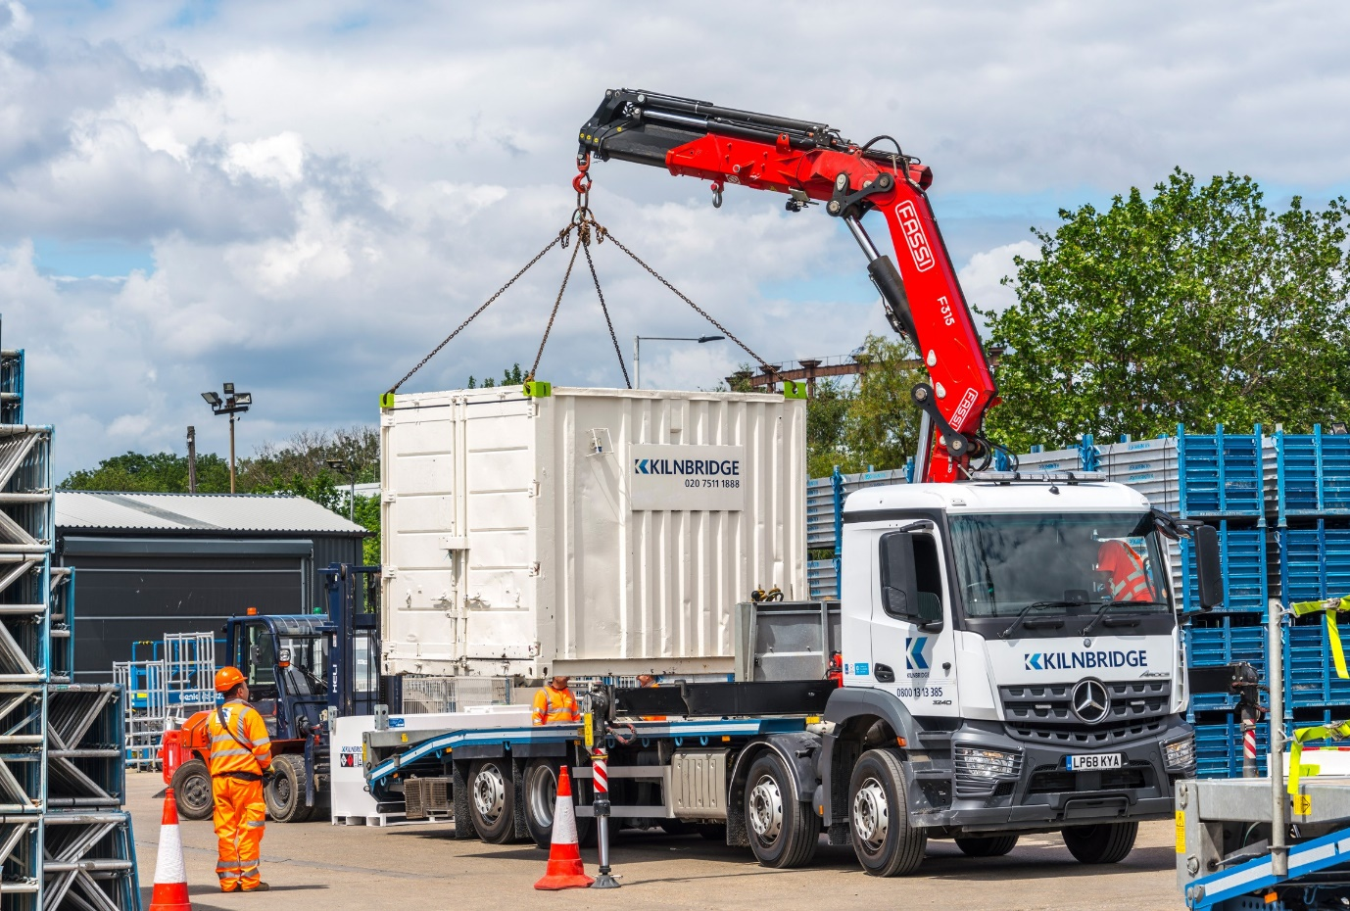

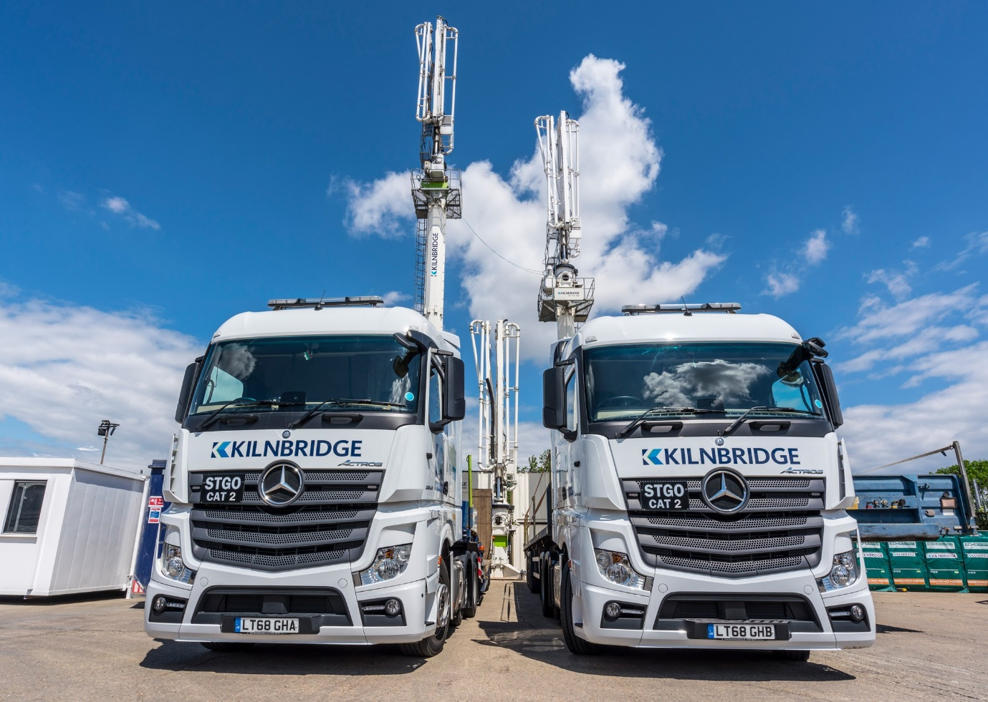

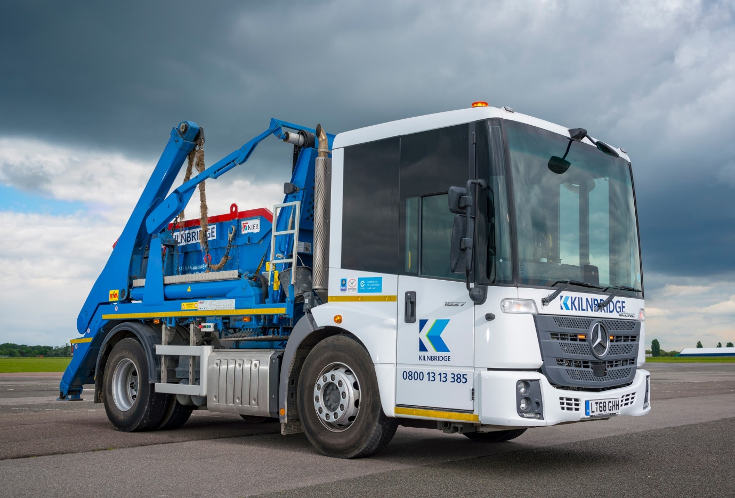
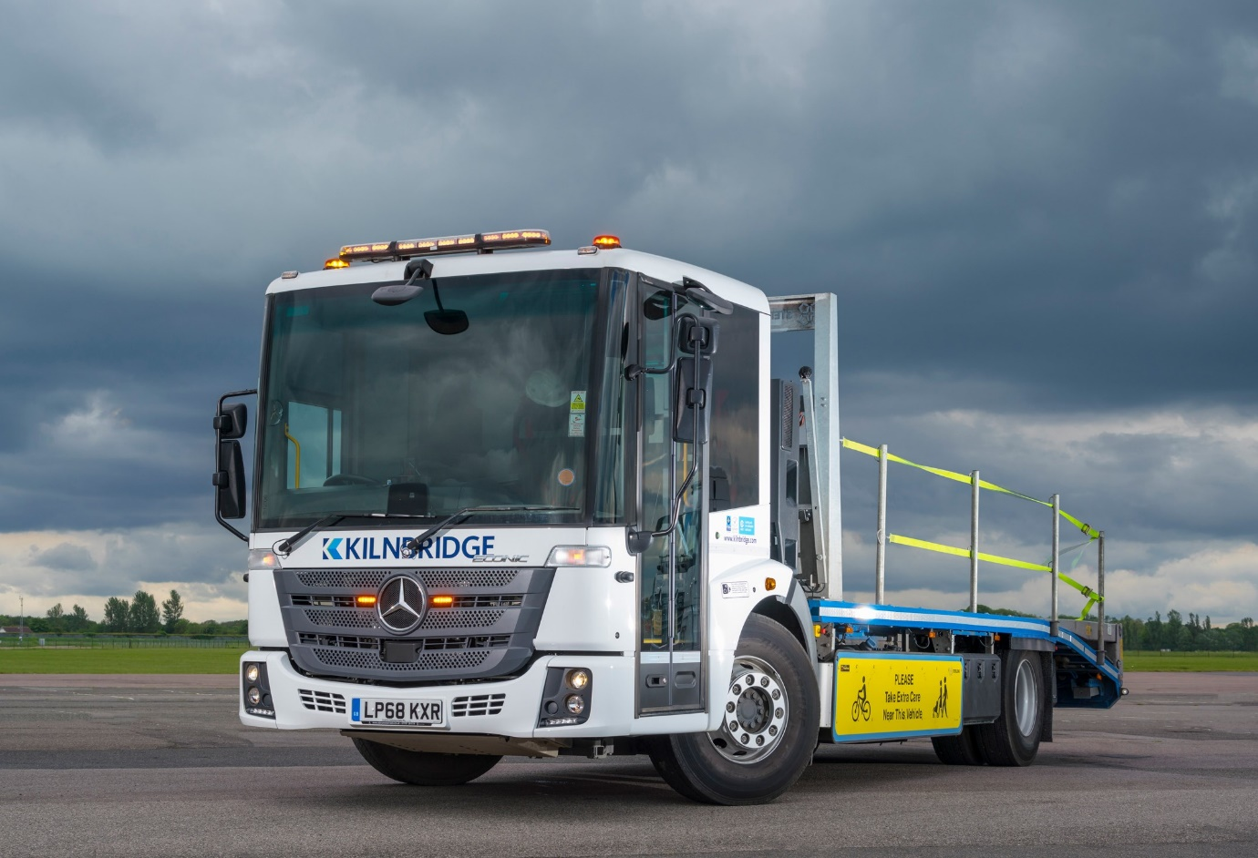

ends

For more information, or to request bigger/higher-res image files, please contact:
Steve Warren or John Ripley
Impact Communications, 01926 842126
Steve: 07770 470251, steve@impactcom.co.uk
John: 07771 484595, john@impactcom.co.uk

