

Date: 26 February 2020

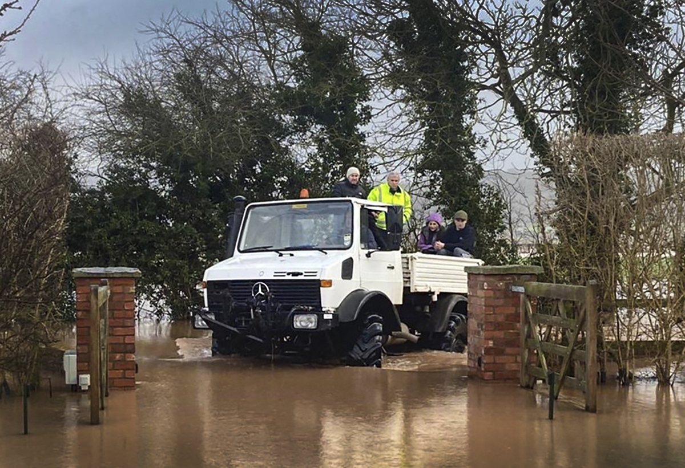

Heroes both: Kier Rogers and his Mercedes-Benz Unimog keep locals moving in Hampton Bishop

Kier wades in with his Mercedes-Benz Unimog as Storm Dennis floods hit Herefordshire

Apple grower and cider maker Kier Rogers has been hailed a hero of flooded Hampton Bishop after using his all-terrain Mercedes-Benz Unimog to ferry neighbours to and from their cut-off homes and businesses.

The proprietor of premium cider brand Colcombe House also delivered much-needed food and other supplies in his 28-year-old U1700 over three long and hectic days as Storm Dennis battered the Herefordshire village.

Hampton Bishop is situated between the River Lugg and the River Wye, which meet nearby. ‘Danger to life’ warnings were issued as both peaked at record levels – flood waters more than three-and-a-half feet deep rendered roads impassable and left residents stranded.

Its plight made national headlines and Kier was also kept busy on two evenings, transporting villagers to meet and be interviewed by the TV crews and other media who descended on their local pub, the Bunch of Carrots.

A long-term fan of the Mercedes-Benz brand, Kier bought his first Unimog 15 months ago. The truck undertakes a variety of tasks on his 400-acre holding on the banks of the Wye. He also plans to acquire a trailer next summer so he can use it to haul a proportion of his apples at the peak of their ripeness to a local pressing farm.

The legendary Unimog combines outstanding cross-country capability with high road speeds compared to the conventional tractors that other local farmers deployed during the flood relief effort. Riding on 28in wheel rims shod with agricultural tyres for maximum traction off-road, Kier’s truck took all in its stride, fording stretches of deep water that even drivers of 4x4 SUVs dared not risk unless their vehicles were fitted with snorkels.

“Wading would have been very scary in places,” recalled Kier. “But nothing stops a Unimog and mine performed brilliantly throughout. I was able to carry up to 10 people at a time, with hay bales in the back for them to sit on, and they were all very grateful.

“I took one person to hospital, collected and delivered their thyroid tablets for another, and gave a lift to a gas fitter because the central heating had gone off at the home of a disabled child in the village.

“I was out for 11 hours on each of the first two days of the floods, and it just went on and on. But I’m lucky enough to own a vehicle with exceptionally high clearance so was only too happy to pitch in and help my neighbours in their time of need.”

Kier is a visionary horticulturalist who challenges conventional fruit growing practices and techniques. Customers for Colcombe House artisan ciders, which he launched in 2015, include some of the country’s best-known Michelin-starred chefs and restaurants.

Residents took to social media to thank him for his heroic contribution. “Many many thanks to Kier and his fellow tractor drivers,” wrote one. “I can honestly say I don’t know how all of us in the village would have managed.”

Meanwhile, mobile security specialist Serbus, which is based in Hampton Bishop, presented Kier with a ‘thank you’ hamper for ferrying members of its team to and from their place of work. “He really put himself out for us,” acknowledged Co-founder and Director Russ Ticehurst.

“The offices were cut off but it was ‘mission critical’ that we reach them in order to manage and maintain our servers, so there was no interruption of service to our customers. Someone gave me Kier’s number and he picked us up and took us in. The hamper was just a small token of our gratitude.”

He added: “We’re now reviewing our flood management arrangements and seriously contemplating buying our own Unimog.”
www.colcombehouse.co.uk

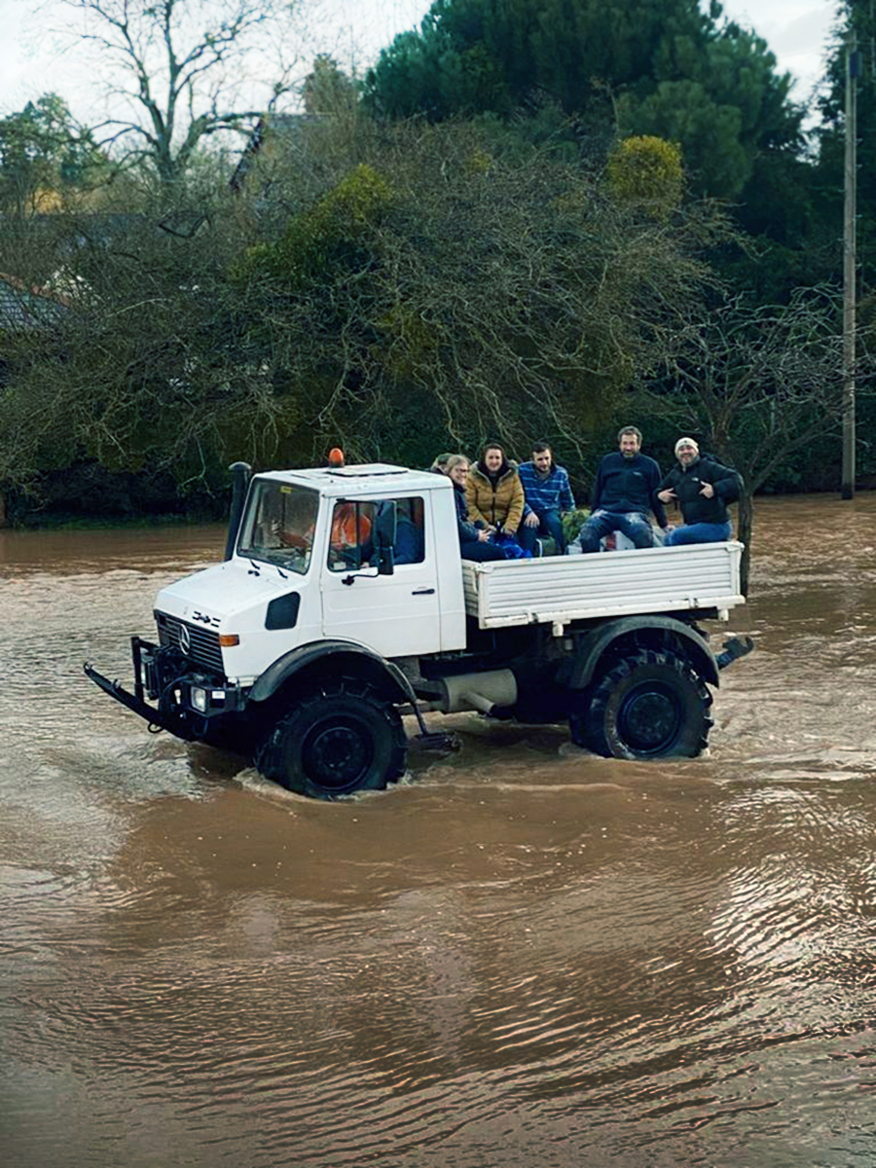

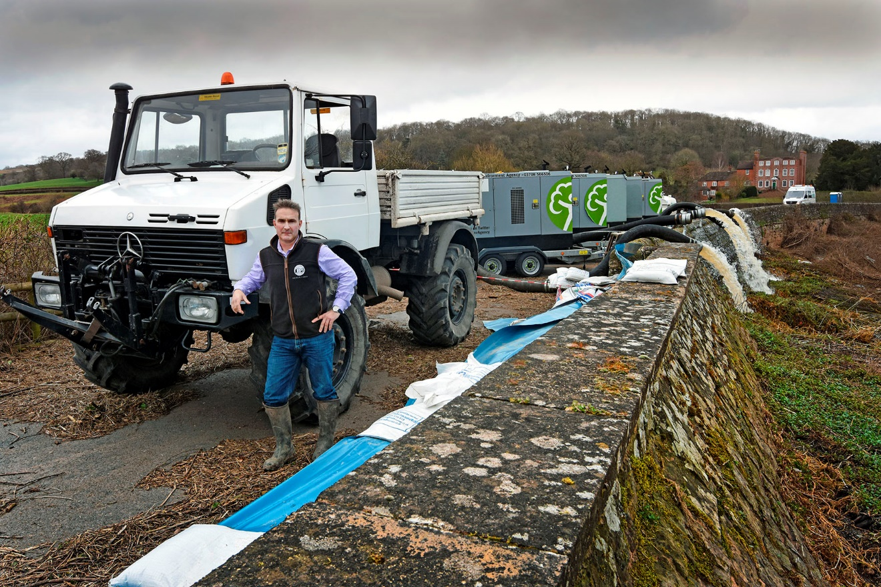

Pump action: Kier Rogers and his Mercedes-Benz Unimog

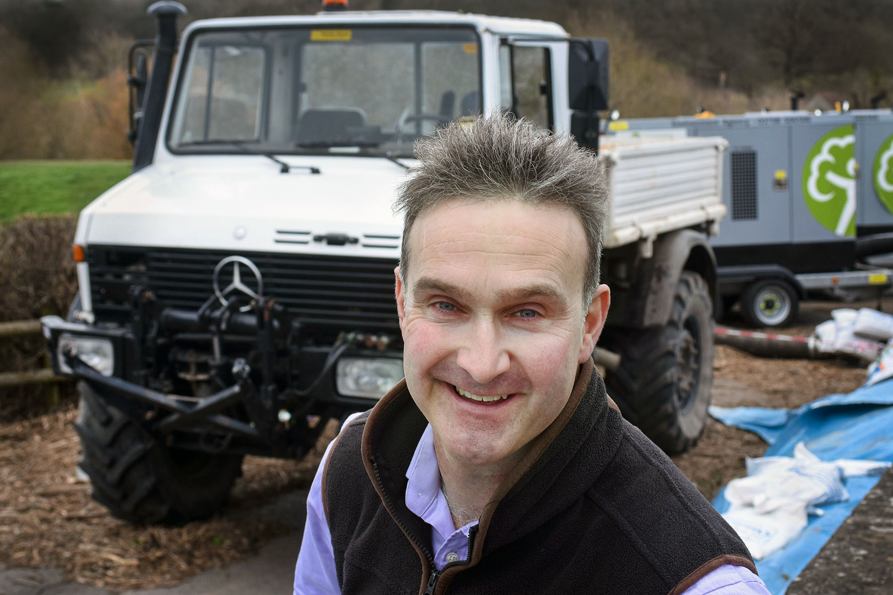

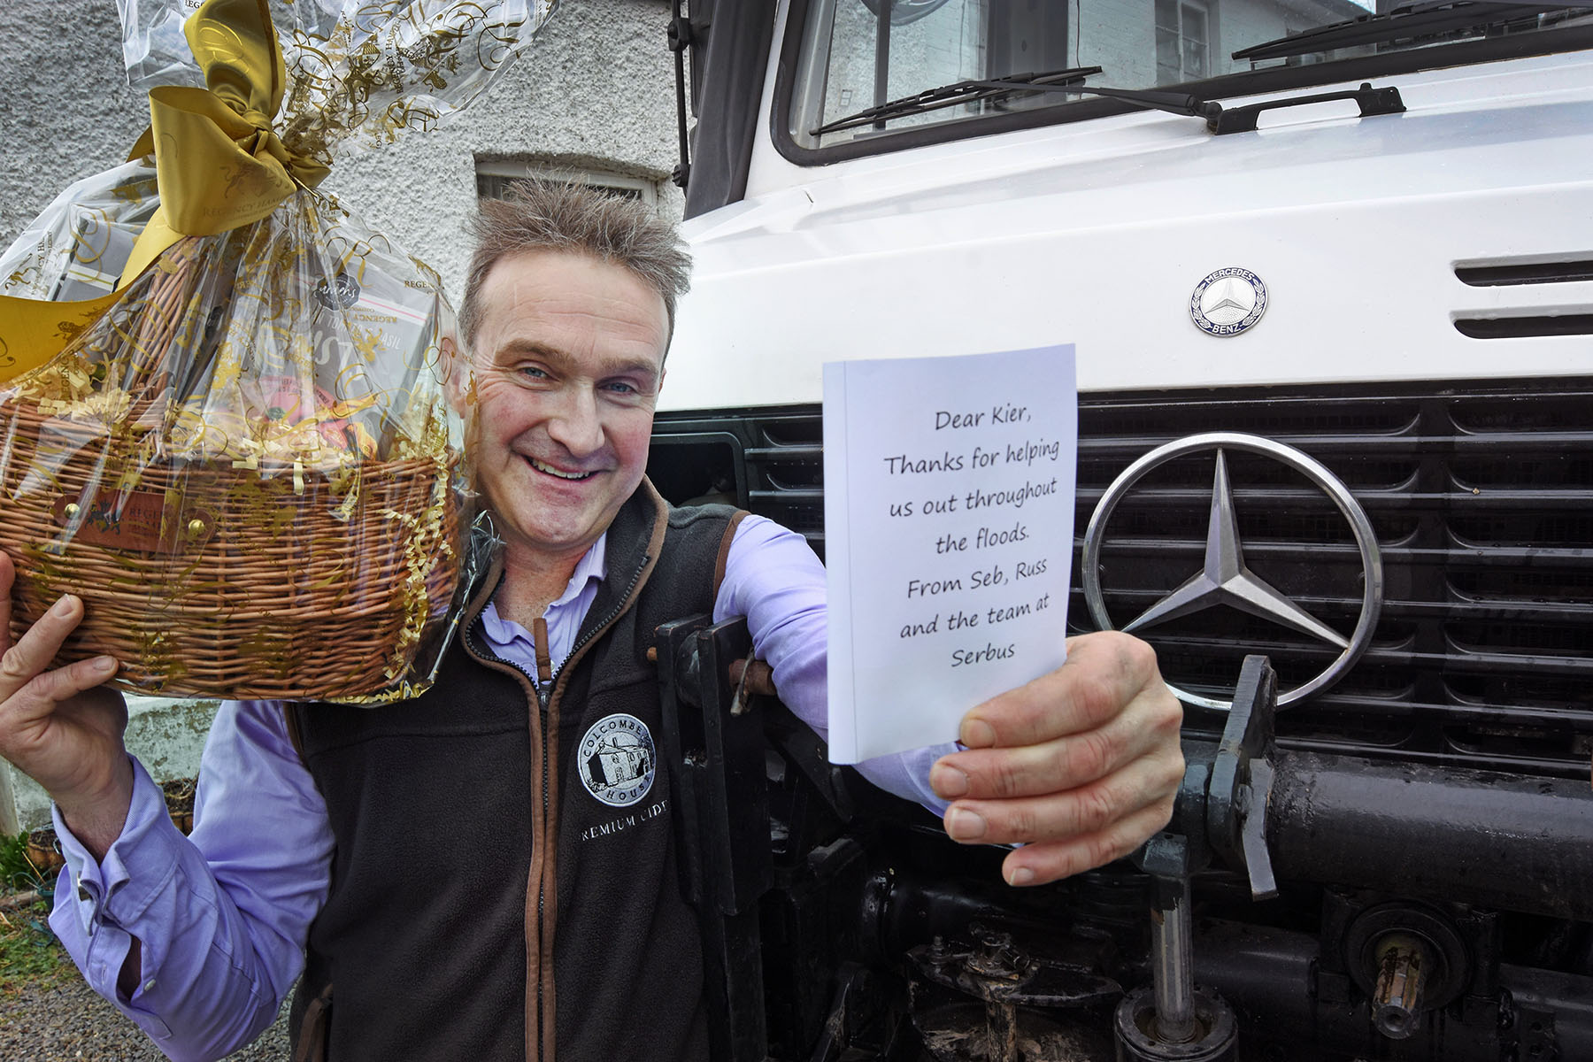

A big thank you: Kier Rogers and his Mercedes-Benz Unimog, with the hamper he received from one grateful local company

ends

For more information, or to request higher-res image files, please contact:

Jamie Fretwell at Mercedes-Benz Trucks UK
07712 519230, jamie.fretwell@daimler.com

or

Steve Warren or John Ripley
Impact Communications, 01926 842126
Steve: 07770 470251, steve@impactcom.co.uk
John: 07771 484595, john@impactcom.co.uk

About Mercedes-Benz Trucks UK Ltd
Mercedes-Benz Trucks UK Ltd is the sales and marketing organisation responsible for all Daimler truck products in the UK, including FUSO Canter.

In 2019, the company registered 6,963 new trucks. Mercedes-Benz accounted for 6,188 new trucks registered in 2019, making it the third-biggest truck brand in the UK. Meanwhile, FUSO registrations hit 775 – including 580 new trucks over 6.0-tonnes.

The flagship new Mercedes-Benz Actros which won the 2020 International Truck of the Year award, features seven core innovations including MirrorCam, Multimedia Cockpit and Active Brake Assist 5. Our premium range of innovative trucks – Actros, Arocs, Atego, Econic and Unimog – draw upon more than 125 years of exceptionally high standards of quality, backed up by our promise of Trucks You Can Trust.

www.mbtrucks.co.uk

