

Date: 10 June 2020

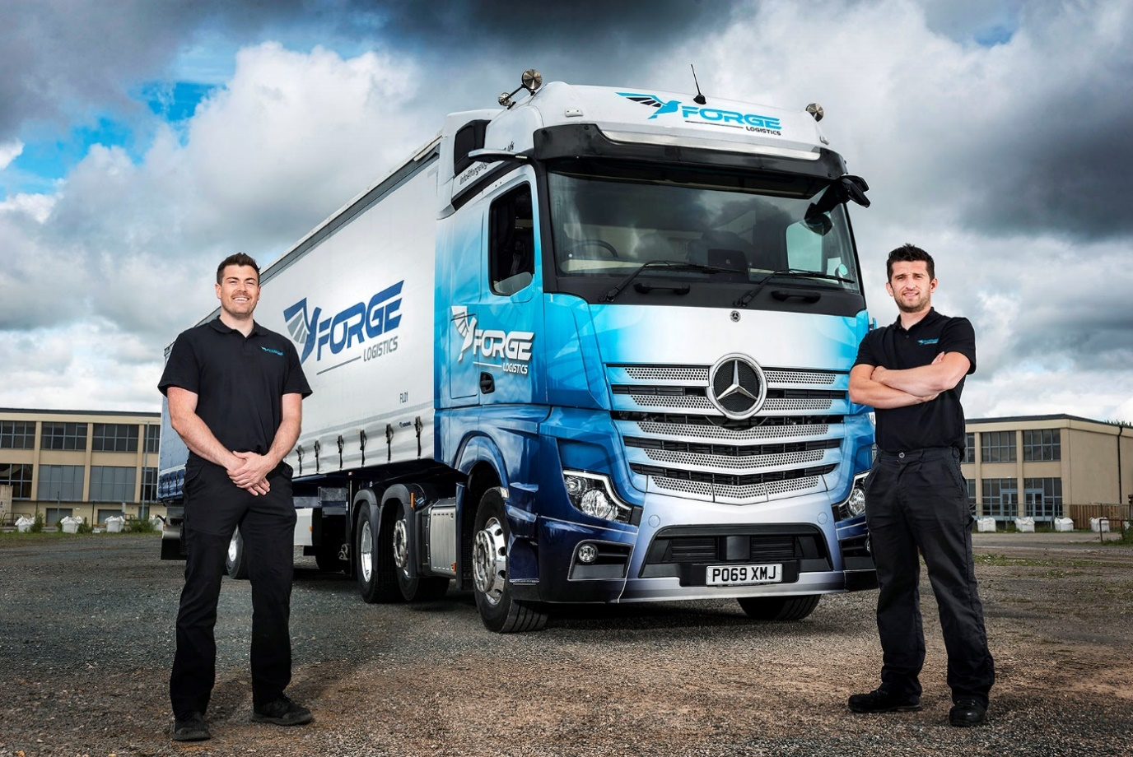

Precious metal: Forge Logistics partners Jamie Keen, left, and James Rose-Shaw with their first Mercedes-Benz Actros

Military men Forge a new future with Mercedes-Benz Actros from Ciceley Commercials

Ex-servicemen Jamie Keen and James Rose-Shaw have recruited their first truck, a striking Mercedes-Benz tractor unit, and look forward to putting nine more into action.

The former brothers-in-arms’ Actros 2548 BigSpace tractor unit wears the colours of Forge Logistics, the Preston-based firm they established 18 months ago.

Supplied by local Dealer Ciceley Commercials, the truck is powered by a 12.8-litre, in-line six-cylinder engine that generates 350 kW (476 hp). Its flat-floored cab, meanwhile, boasts a TrendLine interior with leather trim, as well as the optional twin-screen Multimedia Cockpit, interactive, which comes with a larger 12in instrument panel and extra functionality.

Like all new-generation Actros it also features the ground-breaking MirrorCam system, with streamlined rear-facing cameras in place of traditional side mirrors, and a market-leading suite of other safety and efficiency technology.

The subject of a Mercedes-Benz Finance contract hire agreement, the vehicle will be inspected and maintained in the 24-hour workshop at Ciceley Commercials’ Blackburn dealership, just off junction 4 of the M65.

Jamie Keen and James Rose-Shaw launched their business after serving together in the Army Air Corps, providing ground support services for Apache attack helicopters. Both completed multiple tours of duty in Afghanistan, and on board the Royal Navy amphibious assault ship HMS Ocean.

They left the forces determined to put their experience, determination and ‘can-do’ attitudes to good use in civilian life. Forge Logistics began working for one of the home shopping sector’s leading names with five Mercedes-Benz Sprinter vans. Fast forward a year-and-a-half, and the company is running a fleet of 40 Sprinters. The new tractor unit, meanwhile, will be followed shortly by another nine Actros, which are currently on order.

All work full-time for Forge’s sole customer. The vans make local deliveries while the truck transports consignments from a sorting centre near Haydock to distribution depots across the North of England.

“We chose Sprinters originally because of the very favourable terms available through our customer’s arrangement with Mercedes-Benz,” recalled James Rose-Shaw. “They have been great workhorses, while we were also impressed from the outset by the care and attention we received from Ciceley Commercials.

“The Dealer showed a genuine interest in understanding and supporting our business, and its flexibility in arranging services to fit in with our shift patterns has been a great help to our time-critical work.”

Jamie Keen added: “Truck Sales Executive Matt Riley and his colleagues were very helpful when we decided to take the plunge and apply for our Operator’s Licence. Having also attended the Dealer’s open day and seen the fantastic new Actros close up, there was never any doubt that our first truck would be a Mercedes-Benz. We’re still on the phone to Matt most days, with questions about all sorts of things – he’s become a firm friend and we consider him to be an integral part of our success.”

Winner of the coveted International Truck of the Year 2020 trophy, the fifth-generation Mercedes-Benz Actros has raised the bar in terms of technological innovation.

MirrorCam enhances safety by providing significantly improved visibility when cornering or reversing, especially with an articulated trailer. It also cuts fuel consumption by up to 1.5%, thanks to the compact, aerodynamic profile of the camera housings.

Previous versions of Mercedes-Benz Trucks’ emergency braking system relied solely on radar, but its successor – Active Brake Assist 5 – uses a combination of radar and cameras. The result, at speeds of up to 50 kph, is a dramatically improved response to moving pedestrians. Active Brake Assist 5 employs full braking – as opposed to the 50% achieved previously – when encountering pedestrians crossing its path.

Other developments include an enhanced version of the well proven Predictive Powertrain Control system, which now makes a greater contribution to economy, while also ensuring that life at the wheel is easier for drivers. Mercedes-Benz Uptime, meanwhile, enables the vehicle to monitor its own ‘health’ and alert Ciceley’s Service Department in advance if attention is likely to be required – this means parts can be picked and an appropriate time slot booked before the truck arrives, keeping downtime to a minimum.

“Our first 18 months in business have been something of a whirlwind,” recalled James Rose-Shaw. “We were already working long hours to get things up and running when Covid-19 hit. While many sectors saw an immediate slow-down, home shopping really took off – Jamie and I have been flat-out seven days a week, for up to 18 hours a day, to cope with the soaring demand.

“Ciceley Commercials have been fantastic throughout, despite having to contend with the social distancing and other implications of the pandemic. Now we can’t wait to get our next nine Actros units out on the road.”

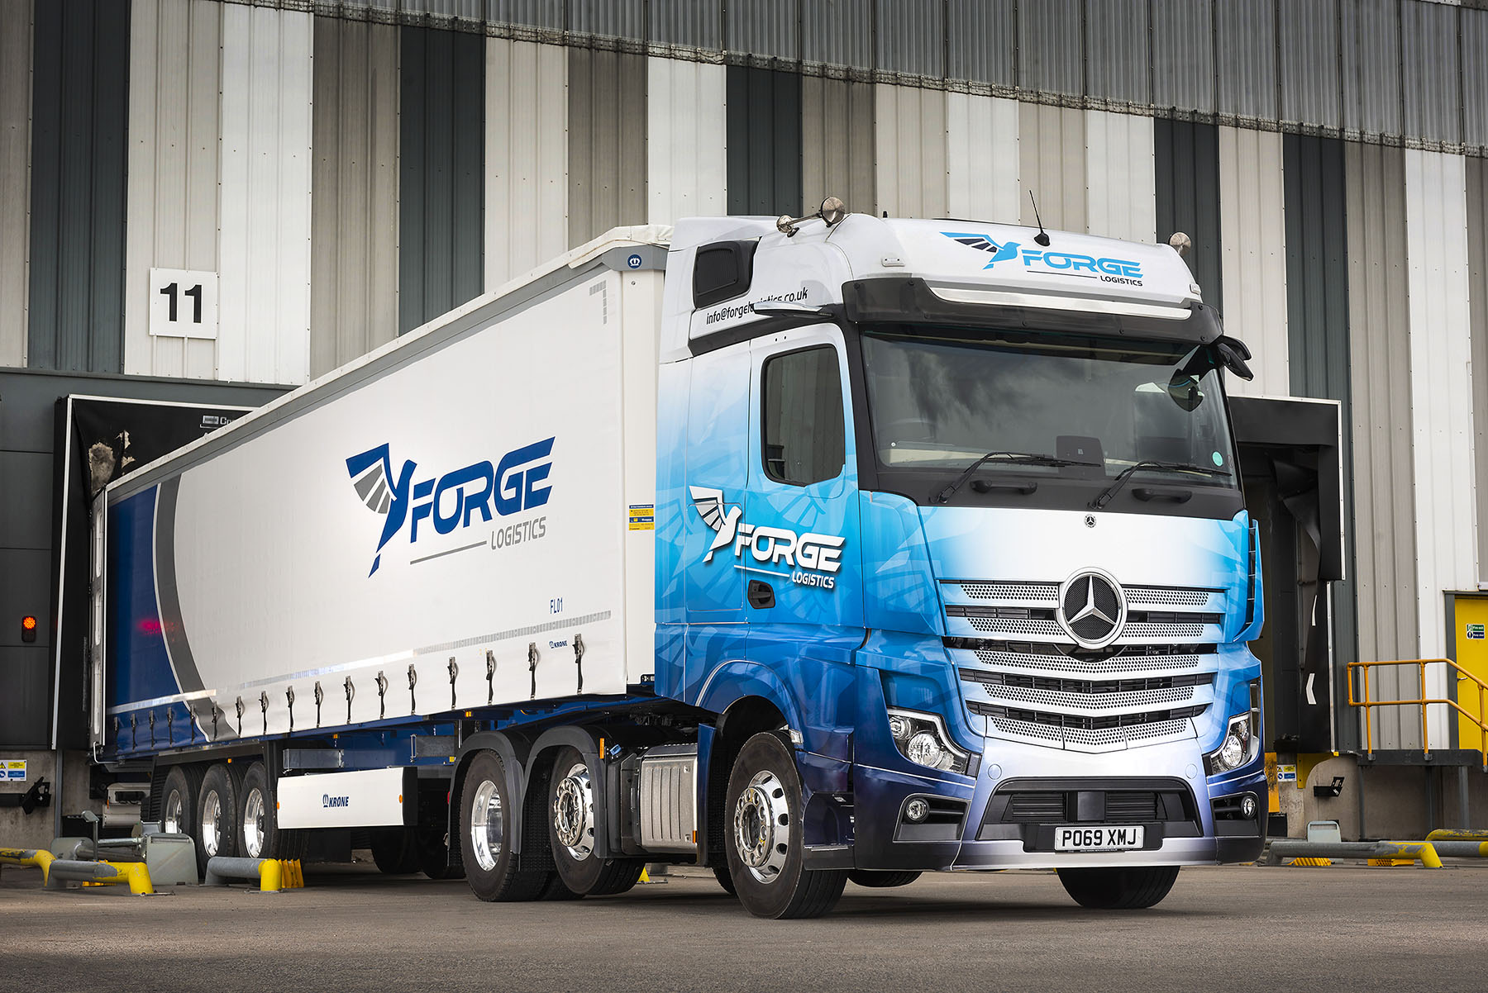

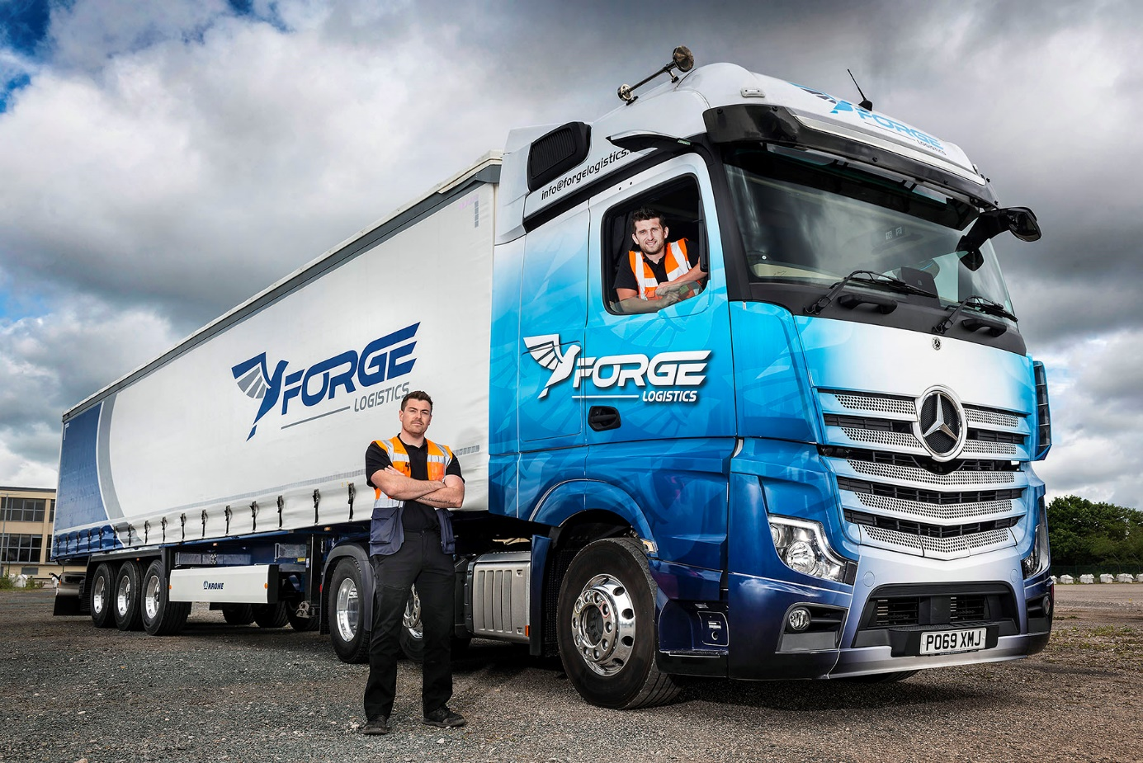

On the march: Ex-soldiers Jamie Keen, left, and James Rose-Shaw, with the first of their 10 Mercedes-Benz Actros

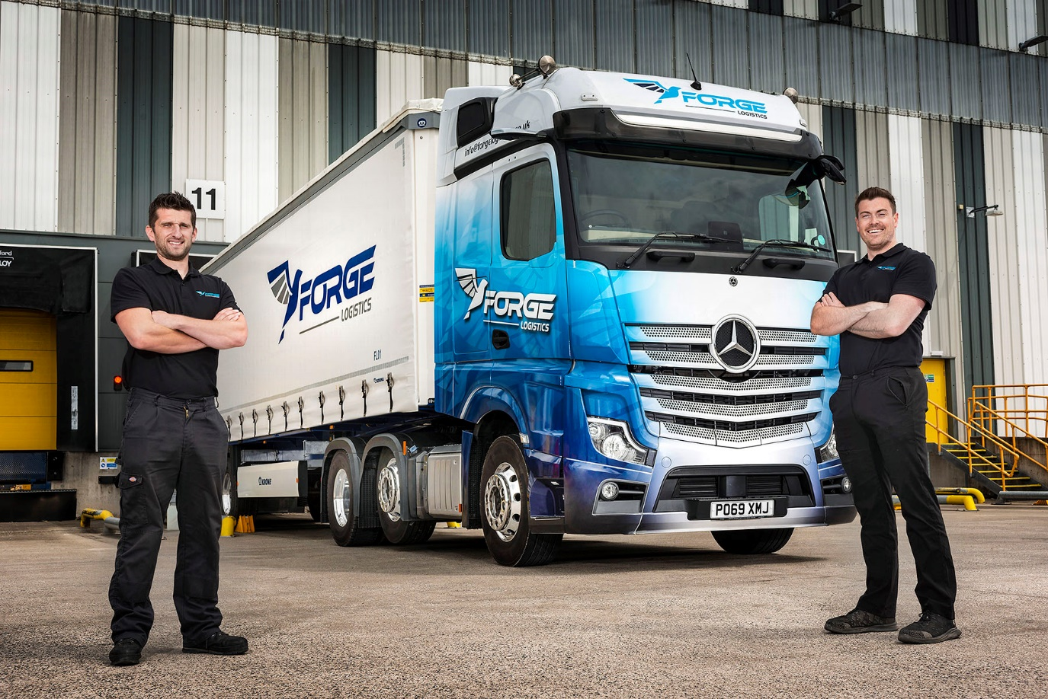

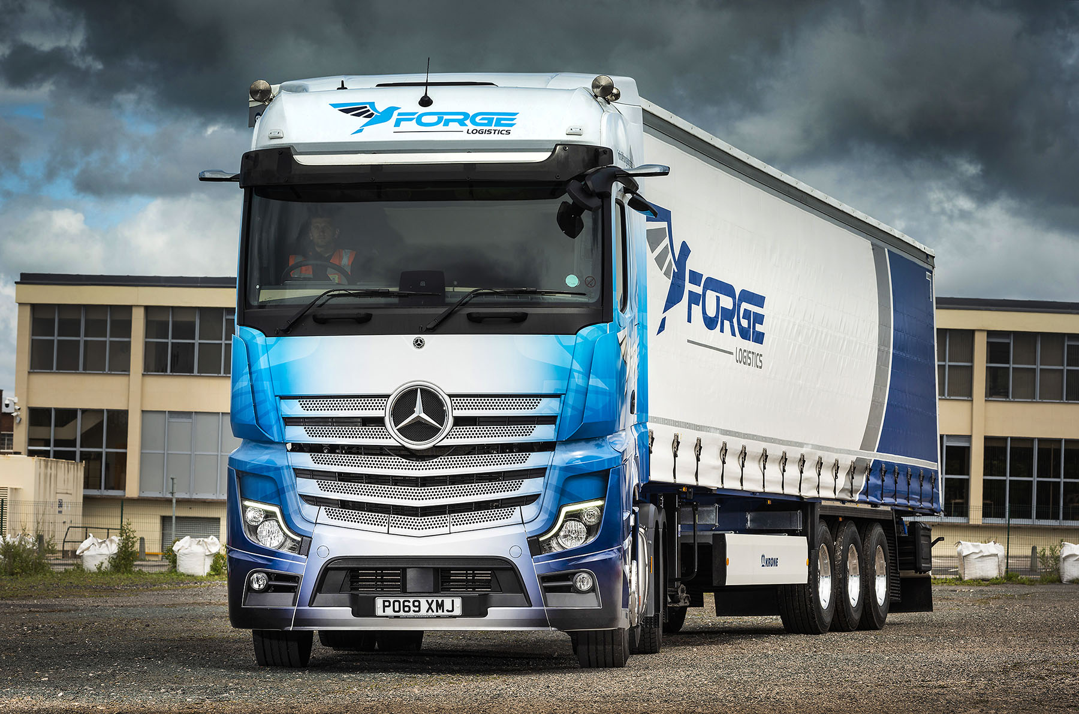

ends

For more information, or to request bigger/higher-res image files, please contact:
John Ripley or Steve Warren
Impact Communications, 01926 842126
John: 07771 484595, john@impactcom.co.uk
Steve: 07770 470251, steve@impactcom.co.uk

