

Date: 20 September 2022

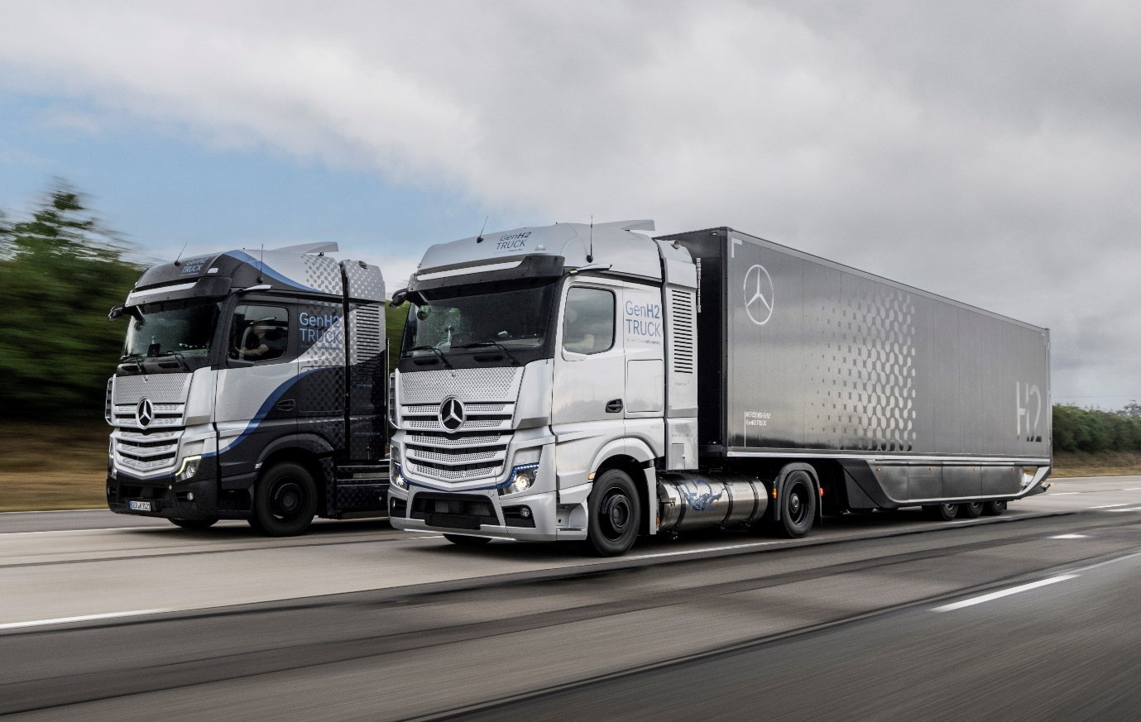

Heavy-duty hero: Now undergoing intensive testing, the remarkable GenH2 Truck reflects Mercedes-Benz Trucks’ commitment to the development of hydrogen fuel-cell technology

Mercedes-Benz Trucks provides outlook on hydrogen-based GenH2 Truck at IAA Transportation 2022 in Hanover

- In the second half of this decade, Mercedes-Benz Trucks intends to expand its range of vehicles to include series-produced trucks with hydrogen-based fuel-cell drives.

- The first prototypes of the Mercedes-Benz GenH2 Truck are already undergoing rigorous testing – both on the in-house test track and on public roads.

The development goal is a range of 1,000 kilometres and more. This makes the truck suitable for particularly flexible and demanding operations, especially in the important segment of heavy long-distance transport.

Stuttgart/Hanover – On the road to sustainable transport, Mercedes-Benz Trucks intends to expand its range of vehicles to include series-produced trucks with hydrogen-based fuel-cell drives in the second half of the decade. The background here is in the widely different applications and tasks for trucks. Hydrogen-based drives can be the better solution especially for flexible and demanding applications in the important segment of heavy-duty transport and long-haul applications. For electric trucks, the same as for conventional trucks applies. When choosing their vehicles, transport companies make rational purchasing decisions based on total cost of ownership. They are unwilling to compromise on their trucks’ suitability for everyday use, tonnage and range. Mercedes-Benz Trucks will continue to offer its customers optimal vehicle solutions for the full range of applications.

Further reasons to rely on a second zero-emission drive technology are the availability of a corresponding infrastructure and the availability of sufficient green energy. Mercedes-Benz Trucks is convinced that this energy requirement can only be covered quickly and cost-effectively with green electricity and green hydrogen. Hardly any country in the world will be able to supply itself with green energy alone at competitive prices in the future. Consequently, there will have to be global trade with CO₂-neutral energy sources. Green hydrogen will play a central role here. Mercedes-Benz Trucks assumes it will be traded at very attractive prices in the future. In addition, the truck manufacturer sees advantages in terms of the costs and technical feasibility of the hydrogen infrastructure, as well as longer ranges, flexibility and shorter refueling times for customers. Therefore, hydrogen trucks can be a viable option for our customers, especially in tough long-haul operations and notably in terms of total cost of ownership.

Development in full swing

The first Mercedes-Benz GenH2 Truck fuel-cell prototypes have been undergoing rigorous testing programmes since last year – both on the in-house test track and on public roads. In the development of hydrogen-based drives, Mercedes-Benz Trucks prefers liquid hydrogen. In this aggregate state the energy carrier has a significantly higher energy density in relation to volume compared to gaseous hydrogen. As a result, more hydrogen can be carried, which significantly increases the range and enables comparable performance of the vehicle with that of a conventional diesel truck. The development objective of the series-ready GenH2 Truck is a range of 1,000 kilometres and more. This makes the truck suitable for particularly flexible and demanding applications, especially in the important segment of heavy-duty long-haul transport. The start of series production for hydrogen-based trucks is planned for the second half of the decade.

Key figures of the GenH2 Truck comparable with conventional long-haul trucks

The development engineers of Daimler Truck have based the GenH2 Truck on the characteristics of the conventional Mercedes-Benz Actros long-haul truck in terms of payload, range and performance. The aim is to offer the series-produced variant of the GenH2 Truck with a payload of 25 tonnes at a gross weight of 40 tonnes. Two special liquid hydrogen tanks and a particularly powerful fuel-cell system will enable this high payload and long range. They represent the heart of the GenH2 Truck. The two stainless-steel liquid-hydrogen tanks intended for the series version of the GenH2 Truck will have a particularly high storage capacity of 80 kg (40 kg each) for covering long distances. The stainless-steel tank system consists of two tubes, one within the other, that are connected to each other and vacuum-insulated.

In the series version of the GenH2 Truck, the fuel-cell system is to supply 2 x150 kilowatts and the battery is to provide an additional 400 kW temporarily. At 70 kWh, the storage capacity of the battery is relatively low, as it is not intended to meet energy needs, but mainly to be switched on to provide situational power support for the fuel-cell, for example during peak loads while accelerating or while driving uphill fully loaded. At the same time, the relatively light battery allows a higher payload. It is to be recharged in series-production vehicles with braking energy and excess fuel-cell energy. A core element of the sophisticated operating strategy of the fuel-cell and battery system is a cooling and heating system that keeps all components at the ideal operating temperature, thus ensuring maximum durability. In a pre-series version, the two electric motors are designed for a total of 2 x 230 kW continuous power and 2 x 330 kW maximum power. Torque is 2 x 1577 Nm and 2 x 2071 Nm respectively.

Comprehensive commitment to hydrogen

At the same time, Daimler Truck is working together with Linde on the development of a new process for handling liquid hydrogen (“subcooled” liquid hydrogen, “sLH2 technology”). Among other things, this innovative approach enables even higher storage density and easier refuelling compared to LH2. The companies plan for the first refuelling of a prototype vehicle at a pilot station in Germany in 2023. Mercedes-Benz Trucks and its partners are planning for a high level of transparency and openness around the relevant interfaces of the jointly developed sLH2 technology. The goal is to collaborate with other companies and associations as possible to develop their own refuelling and vehicle technologies that apply the new liquid-hydrogen standard and thereby establish a global mass market for the new process.

When it comes to infrastructure for hydrogen filling stations along important transport routes in Europe, Daimler Truck is planning to work together with the companies Shell, BP and TotalEnergies. Daimler Truck is also a shareholder in hydrogen filling station operator H2 MOBILITY Deutschland. In addition, Daimler Truck, IVECO, Linde, OMV, Shell, TotalEnergies and the Volvo Group have committed to work together to help create the conditions for the mass-market roll-out of hydrogen trucks in Europe as part of the H2Accelerate (H2A) interest group.

Fuel-cell joint venture cellcentric with Volvo Group

Together with the Volvo Group, Daimler Truck is committed to hydrogen-based fuel-cells. Both companies founded their joint venture cellcentric in 2021. Cellcentric’s goal is to become one of the world’s leading manufacturers of fuel-cell systems. To this end, the company plans to set up one of the largest series production facilities in Europe starting in 2025.

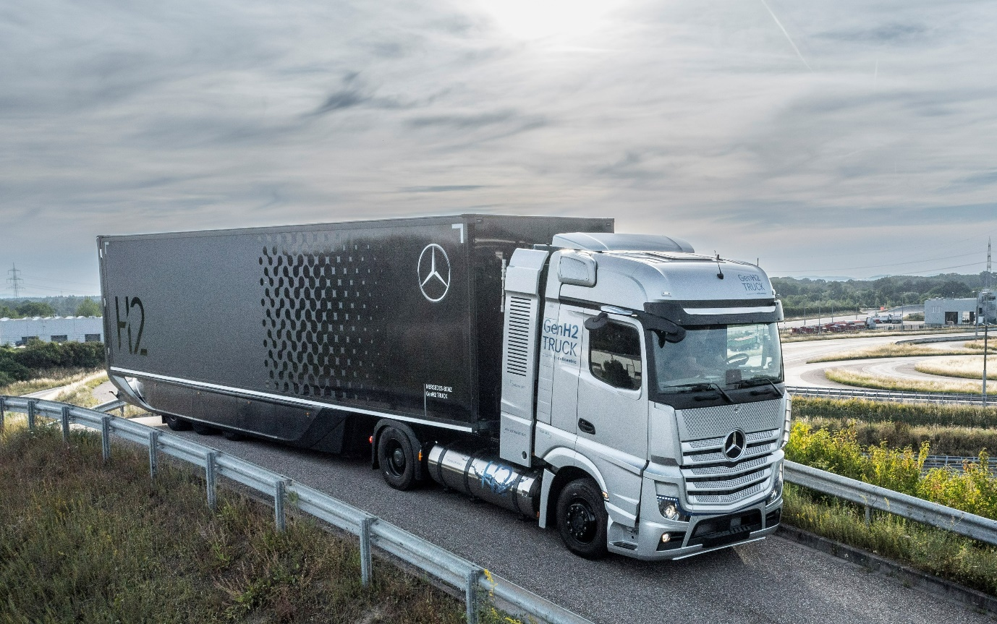

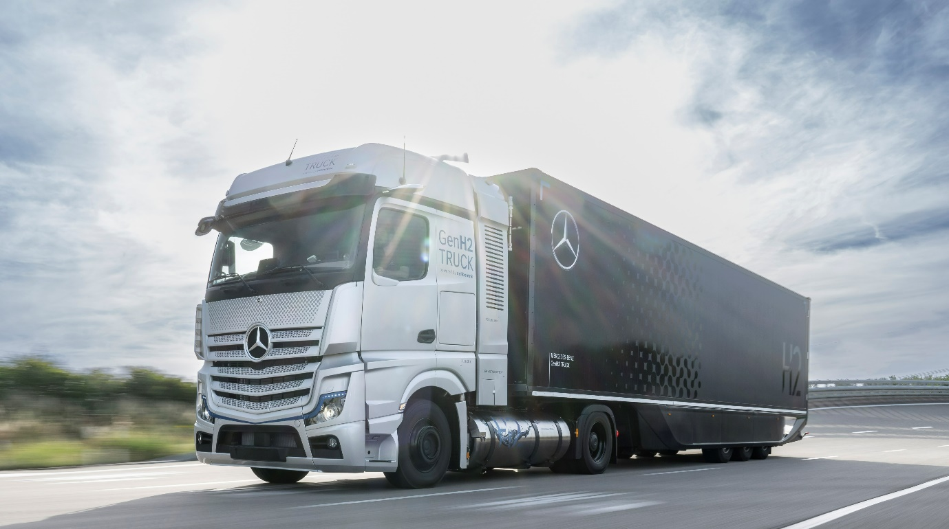

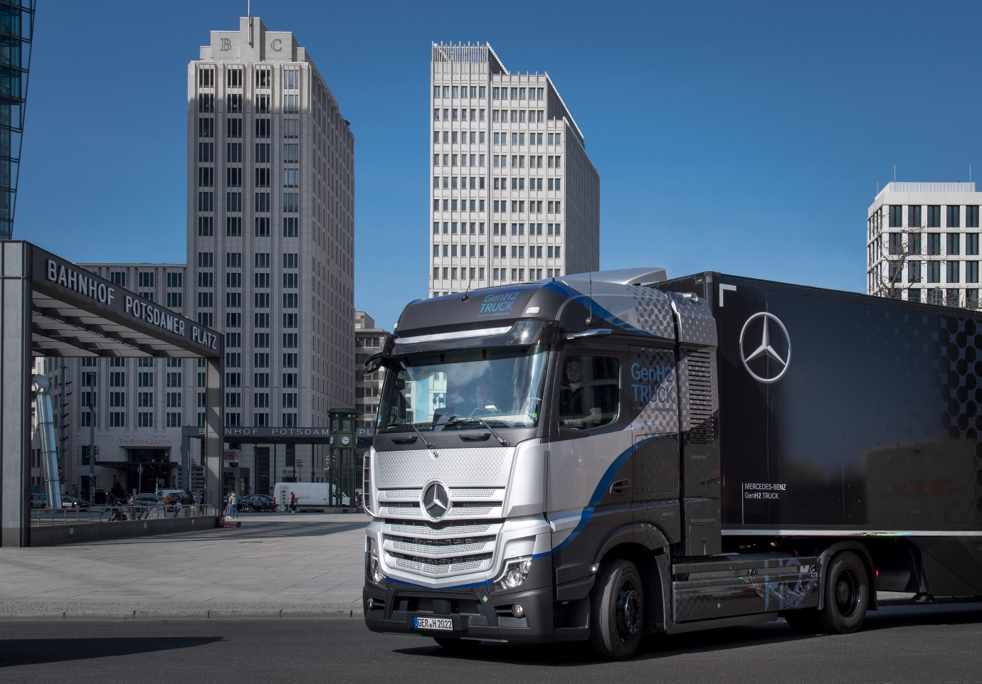

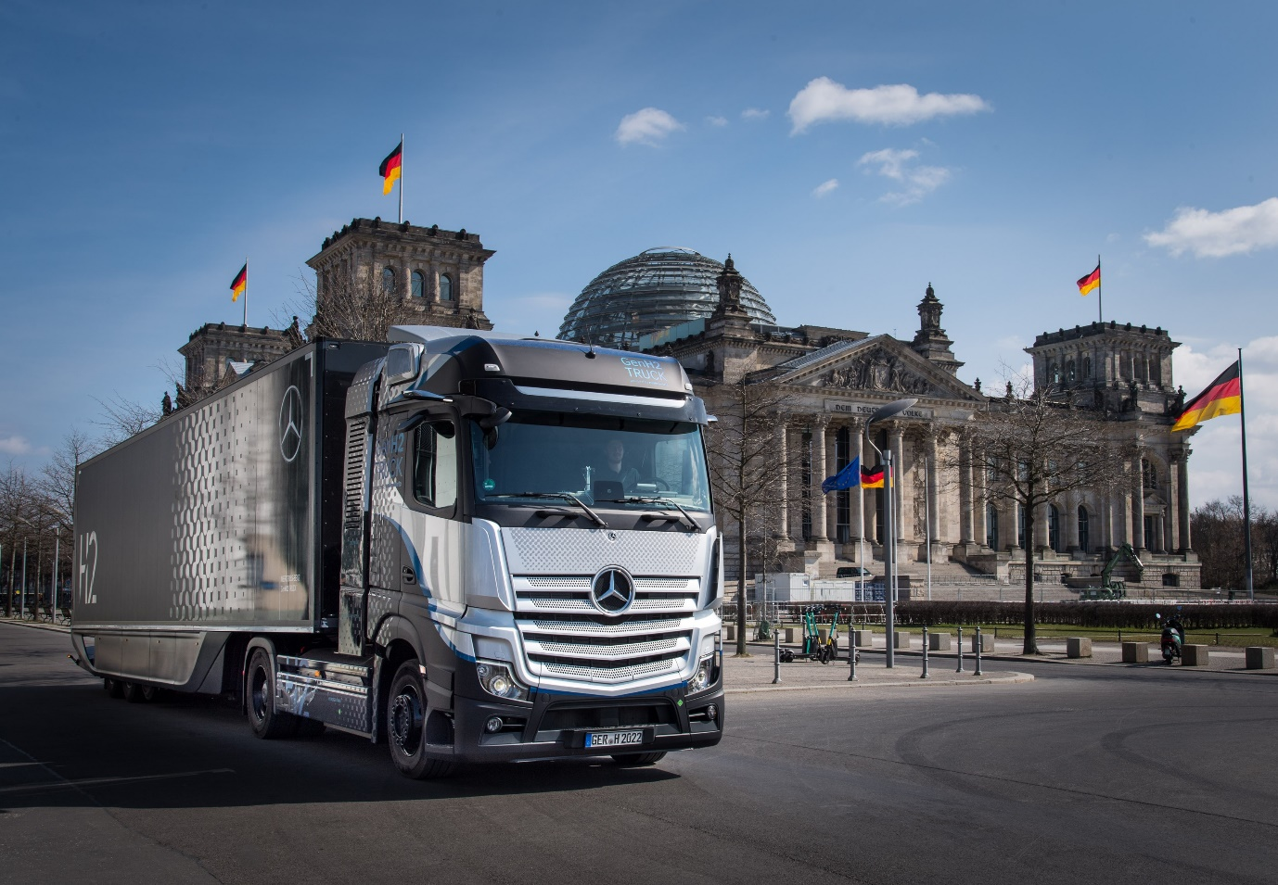

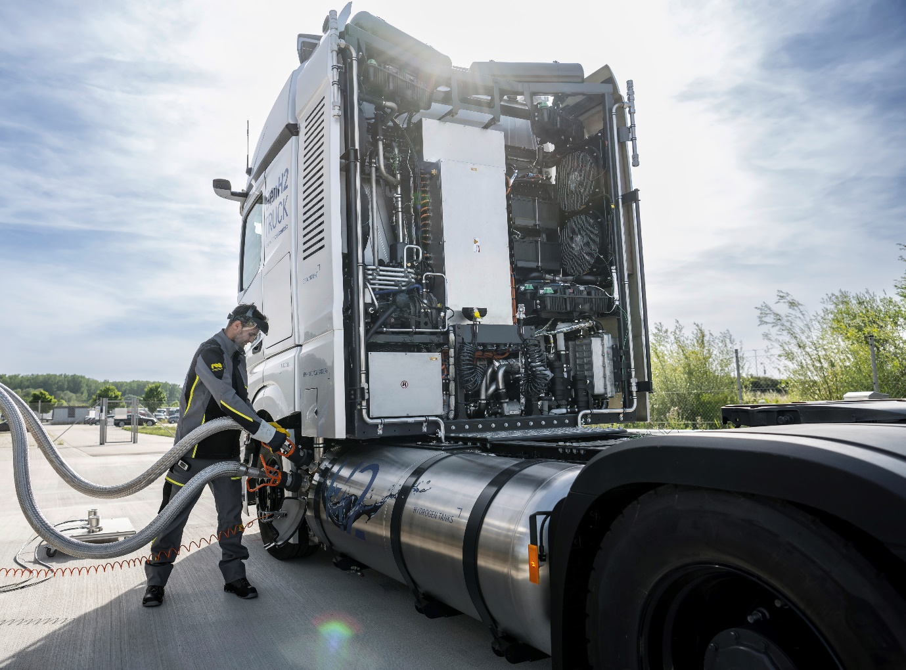

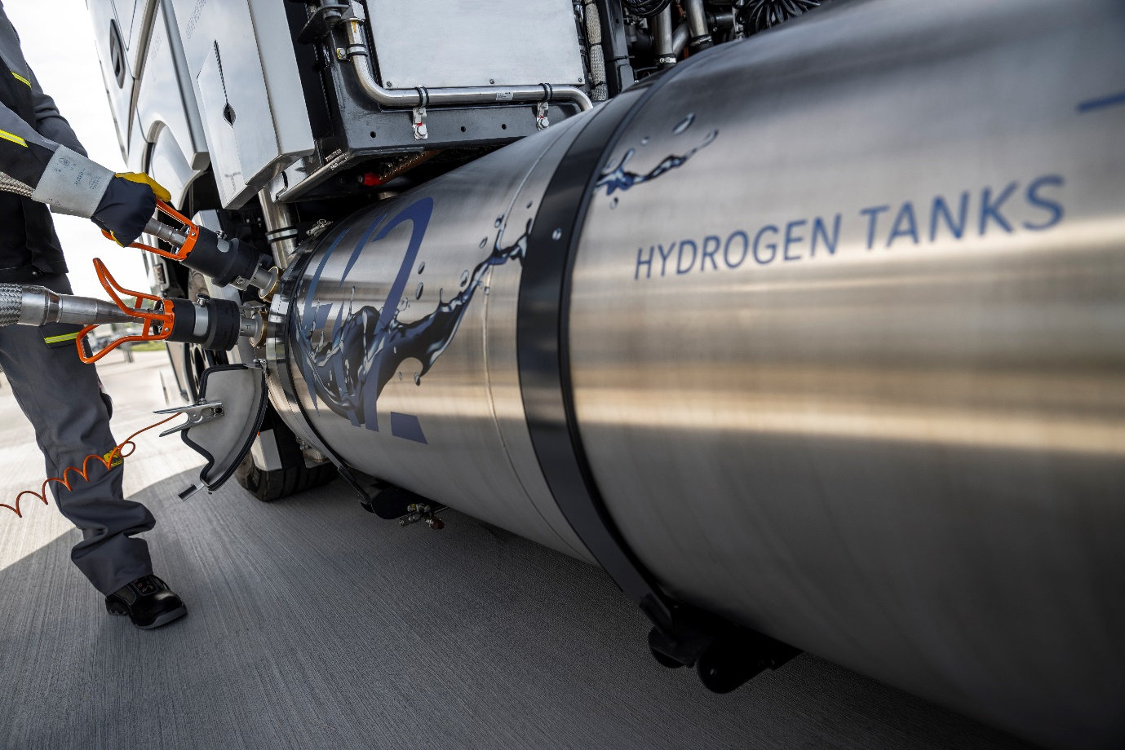

ends

For more information, or to request higher-resolution images, please contact:

Jamie Fretwell at Mercedes-Benz Trucks UK Ltd
07712 519230, jamie.fretwell@daimler.com

or

Steve Warren or John Ripley
Impact Communications
Steve: 07770 470251, steve@impactcom.co.uk
John: 07771 484595, john@impactcom.co.uk

or

Paul Mandaiker, +49 (0) 176 30999267, paul.mandaiker@daimlertruck.com

Further information on Daimler Truck is available at:
www.media.daimlertruck.com and www.daimlertruck.com

Forward-looking statements:
This document contains forward-looking statements that reflect our current views about future events. The words “aim”, “ambition”, “anticipate,” “assume,” “believe,” “estimate,” “expect,” “intend,” “may,” ”can,” “could,” “plan,” “project,” “should” and similar expressions are used to identify forward-looking statements. These statements are subject to many risks and uncertainties, including an adverse development of global economic conditions, in particular a decline of demand in our most important markets; a deterioration of our refinancing possibilities on the credit and financial markets; events of force majeure including natural disasters, pandemics, acts of terrorism, political unrest, armed conflicts, industrial accidents and their effects on our sales, purchasing, production or financial services activities; changes in currency exchange rates, customs and foreign trade provisions; a shift in consumer preferences; a possible lack of acceptance of our products or services which limits our ability to achieve prices and adequately utilise our production capacities; price increases for fuel or raw materials; disruption of production due to shortages of materials, labour strikes or supplier insolvencies; a decline in resale prices of used vehicles; the effective implementation of cost-reduction and efficiency-optimization measures; the business outlook for companies in which we hold a significant equity interest; the successful implementation of strategic cooperations and joint ventures; changes in laws, regulations and government policies, particularly those relating to vehicle emissions, fuel economy and safety; the resolution of pending government investigations or of investigations requested by governments and the conclusion of pending or threatened future legal proceedings; and other risks and uncertainties, some of which are described under the heading “Risk and Opportunity Report” in the current Annual Report. If any of these risks and uncertainties materializes, or if the assumptions underlying any of our forward-looking statements prove to be incorrect, the actual results may be materially different from those we express or imply by such statements. We do not intend or assume any obligation to update these forward-looking statements since they are based solely on the circumstances at the date of publication.

Daimler Truck at a glance
Daimler Truck Holding AG ("Daimler Truck") is one of the world's largest commercial vehicle manufacturers, with over 40 main locations and more than 100,000 employees around the globe. The founders of Daimler Truck have invented the modern transportation industry with their trucks and buses a good 125 years ago. Unchanged to this day, the company's aspirations are dedicated to one purpose: Daimler Truck works for all who keep the world moving. Its customers enable people to be mobile and get goods to their destinations reliably, on time, and safely. Daimler Truck provides the technologies, products, and services for them to do so. This also applies to the transformation to CO2-neutral driving. The company is striving to make sustainable transport a success, with profound technological knowledge and a clear view of its customers' needs. Daimler Truck's business activities are structured in five reporting segments: Trucks North America (TN) with the truck brands Freightliner and Western Star and the school bus brand Thomas Built Buses. Trucks Asia (TA) with the FUSO and BharatBenz commercial vehicle brands. Mercedes-Benz (MB) with the truck brand of the same name. Daimler Buses (DB) with the Mercedes-Benz and Setra bus brands. Daimler Truck's new Financial Services business (DTFS) constitutes the fifth segment, the product range in the truck segments includes light, medium and heavy trucks for long-distance, distribution and construction traffic and special-purpose vehicles used mainly in the municipal and vocational sector. The product range of the bus segment includes city buses, school buses and intercity buses, coaches and bus chassis. In addition to the sale of new and used commercial vehicles, the company also offers aftersales services and connectivity solutions.

