

Date: 4 December 2019

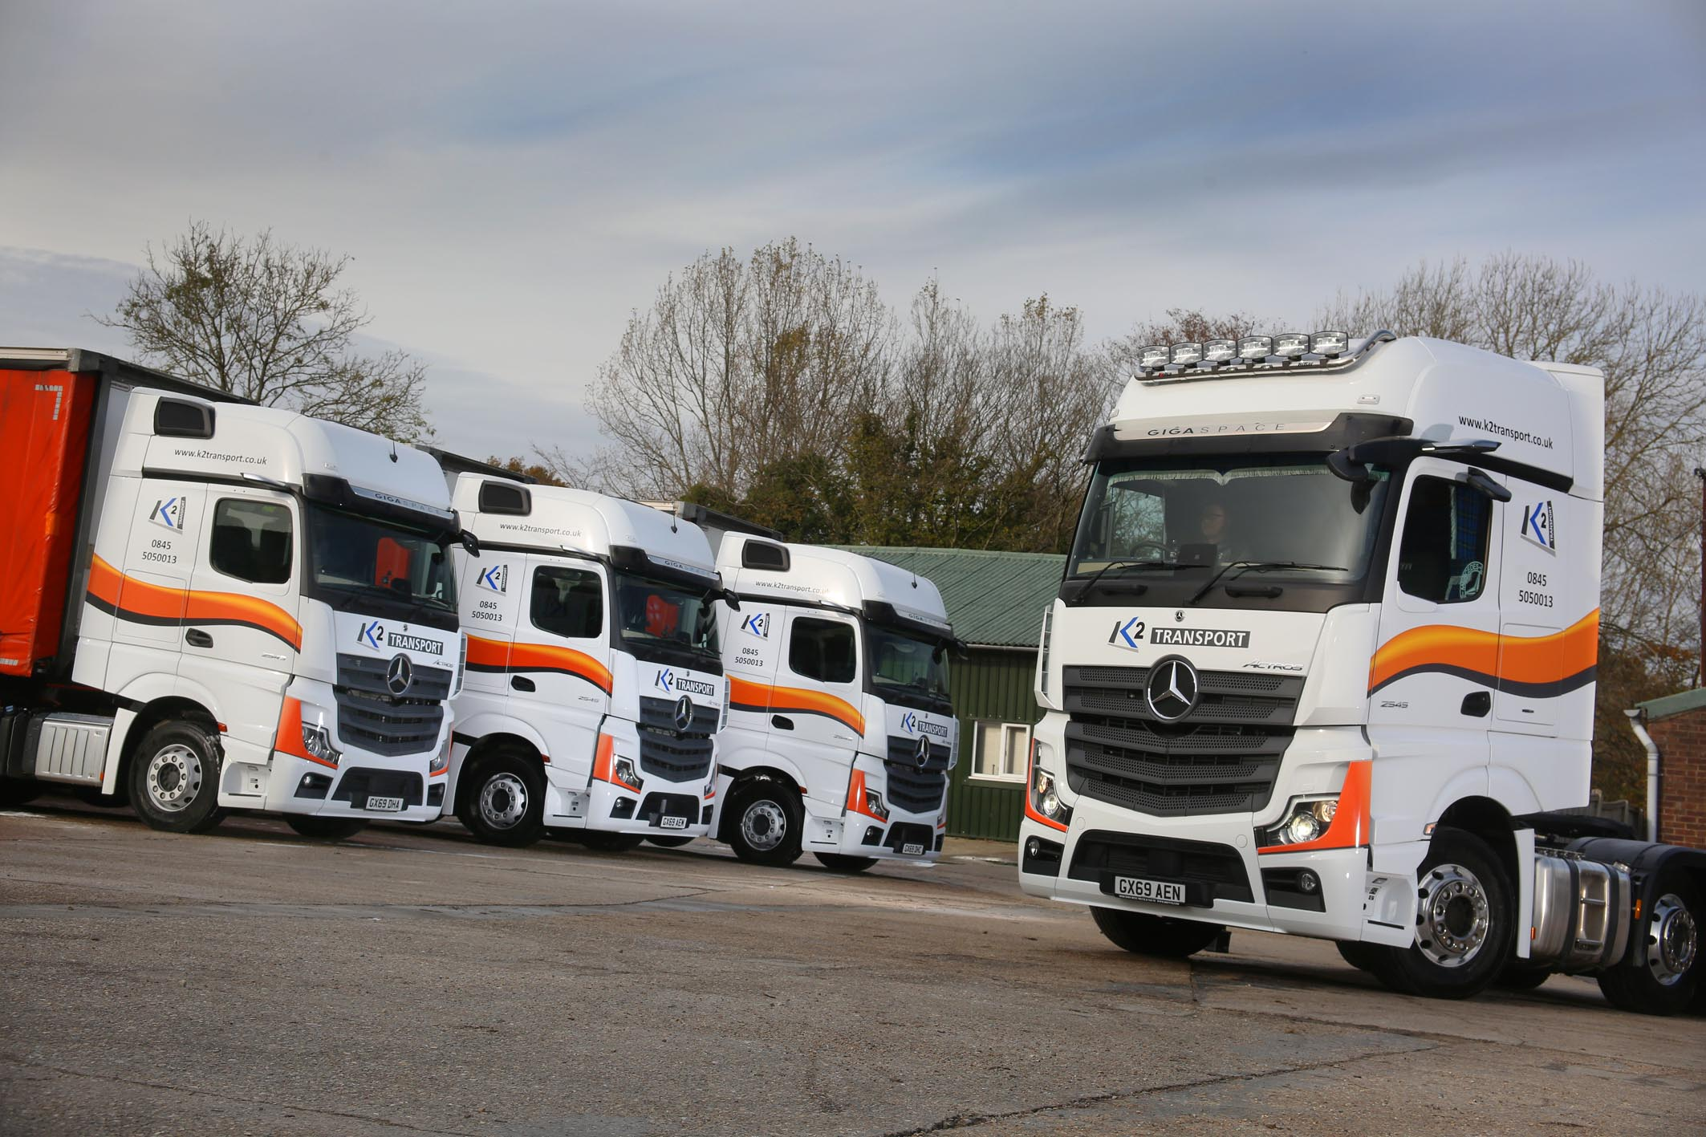

Mercedes-Benz trucks are peak performers for K2 Transport

K2 Transport’s joint owners spent little time reflecting on their options when they needed another eight trucks – brand new Mercedes-Benz Actros tractor units with the revolutionary MirrorCam system were the obvious choice.

Six of the new trucks have replaced Actros models acquired three years ago. The other two, however, represent extensions to the Sussex-based operator’s growing fleet.

K2 Transport was established in Uckfield by Kim Brand and Nick Pearce as recently as 2013. Having started out with a single truck, they now run 19 Mercedes-Benz vehicles.

Supplied by Dealer MBNI Truck & Van, the operator’s new Actros 2545s have range-topping GigaSpace cabs. Their second-generation, 12.8-litre, in-line six-cylinder engines produce 330 kW (450 hp) and drive through Mercedes PowerShift automated manual transmissions.

All but one of the trucks are on general haulage duties, with the sole exception assigned to K2’s Pallex contract. Pulling a double-deck trailer, it trunks nightly to a hub in Leicestershire, and returns with consignments for onward delivery to customers in local postcode areas.

Like the trucks they replaced, the Actros are the subjects of RentaMerc contract hire agreements. They are now being inspected and maintained in the Eastbourne workshop of Rossetts Commercials. All three companies – MBNI Truck & Van, RentaMerc and Rossetts – are members of the Northern Ireland-based Inspired Business Investments Group.

Kim Brand and Nick Pearce are confirmed fans of Mercedes-Benz, having enjoyed reliable, cost-effective performance from their Actros, as well as timely, customer-focused back-up, since the early days of their business.

The new vehicles are their first from the latest model generation – recently crowned International Truck of the Year – but the owners had already driven the new Actros and experienced its ground-breaking technology at first hand.

“We both attended the truck’s European launch in Barcelona, so had a chance to see for ourselves what all the fuss was about,” recalled Mr Brand. “We’d heard a lot about the various features, but I didn’t appreciate just how good the whole package is until I got behind the wheel.”

The most visible change, MirrorCam replaces conventional mirrors with a rear-facing camera system. As well as increasing safety and reducing the chances of accident damage by providing much improved visibility, this ground-breaking technology offers fuel savings of up to 1.3% in long-haul operations, thanks to the compact, streamlined profile of the camera housings.

Stylishly designed and beautifully finished, the state-of-the-art Multimedia Cockpit brings connectivity and intuitive operation to the fore, and is particularly noteworthy for its two digital dislays. K2’s new trucks were specified with Multimedia Cockpit Interactive, which includes satellite navigation and a 12-inch driver display.

The new Actros also features enhanced versions of the Active Brake Assist emergency braking system, and well-proven Predictive Powertrain Control system, which scans the road ahead then manages the vehicle’s driveline to restrict diesel consumption and cut emissions.

A standard feature across the entire new Actros range, PPC now offers much extended functionality, covering virtually all A roads and many B roads, while also taking account not only of topography, but also of corners, roundabouts, junctions and road signs.

Kim Brand continued: “MirrorCam seems to be grabbing most of the headlines, and rightly so because it’s great. However, other advances in safety, efficiency and overall ease of use are hugely beneficial too. Mercedes-Benz has made a fantastic truck even better.”

He added: “They might be loaded with new technology but these new trucks are very user-friendly and have quickly been embraced by our drivers. The customer service has been excellent too.

“We’ve built a strong professional relationship with team at MBNI Truck & Van, and with Norman McBride and his staff at RentaMerc – they’re all great people to do business with. Rossetts Commercials also looks after our vehicles very efficiently.”

Driver and truck enthusiast Stuart Bell joined K2 Transport shortly after its launch. “Stuart’s always kept his vehicles in pristine condition and has been telling us for a while that he’d like to exhibit his Actros at shows,” added Mr Brand. “We were happy to indulge him, and have therefore spent a little more to equip his new unit with extras such as alloy wheels and light bars, so it really stands out from the crowd.”

www.k2transport.co.uk

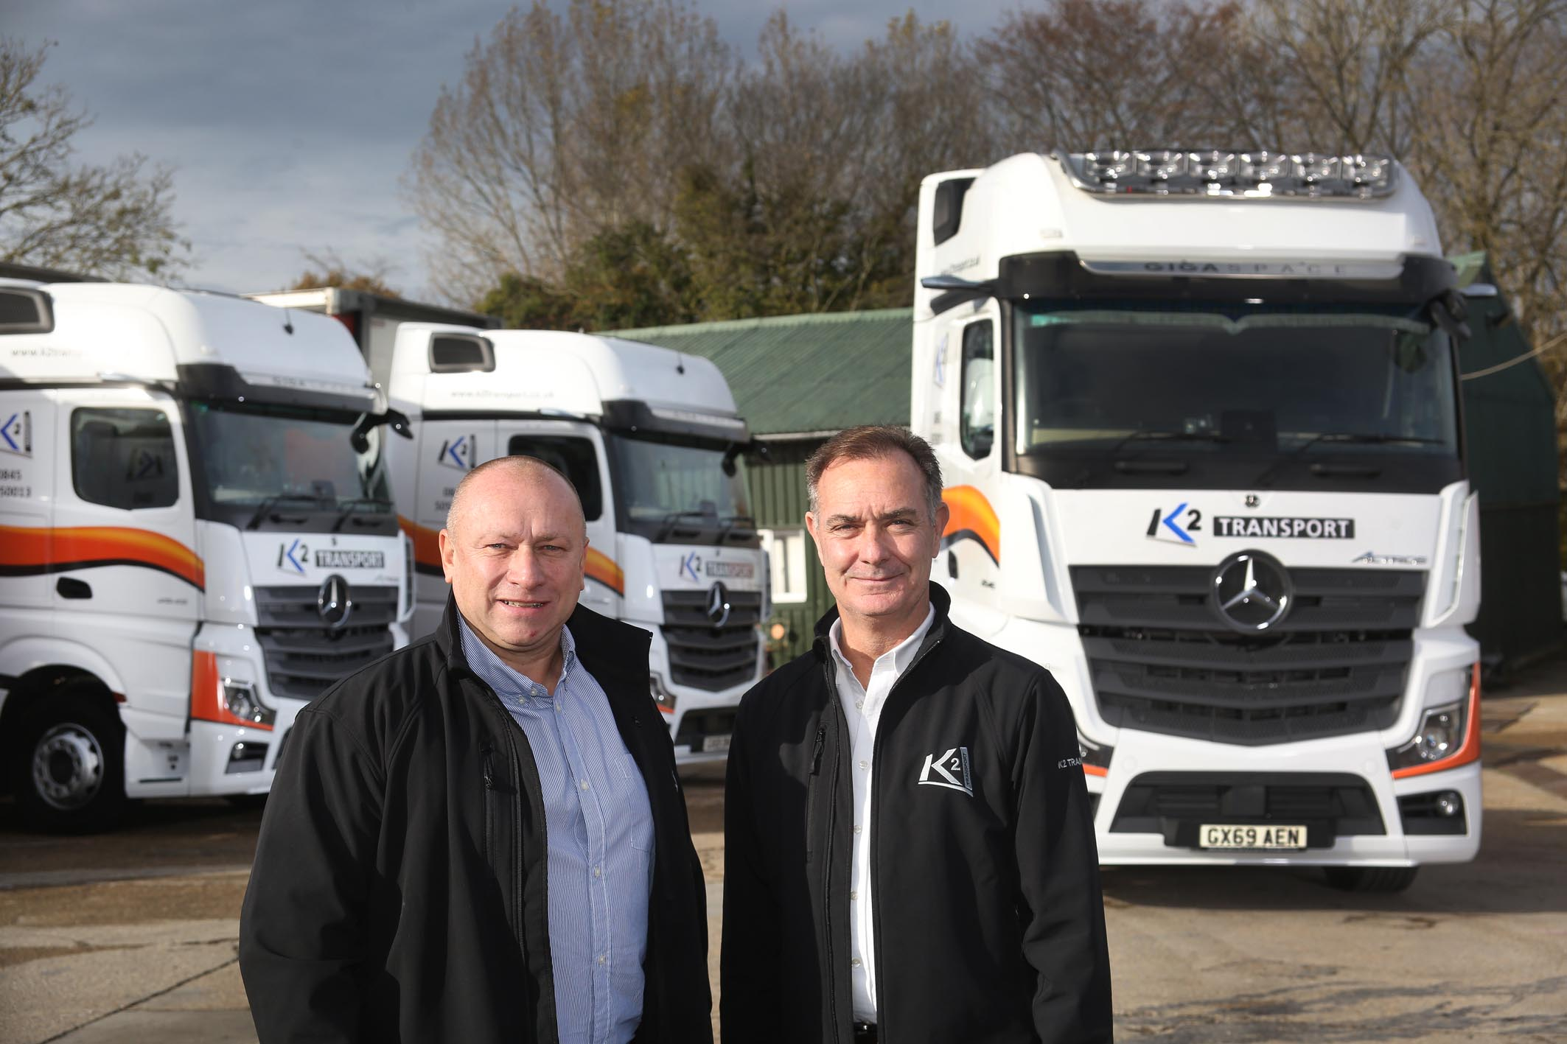

On the up: Nick Pearce, left, and Kim Brand, are growing their fleet of Mercedes-Benz trucks

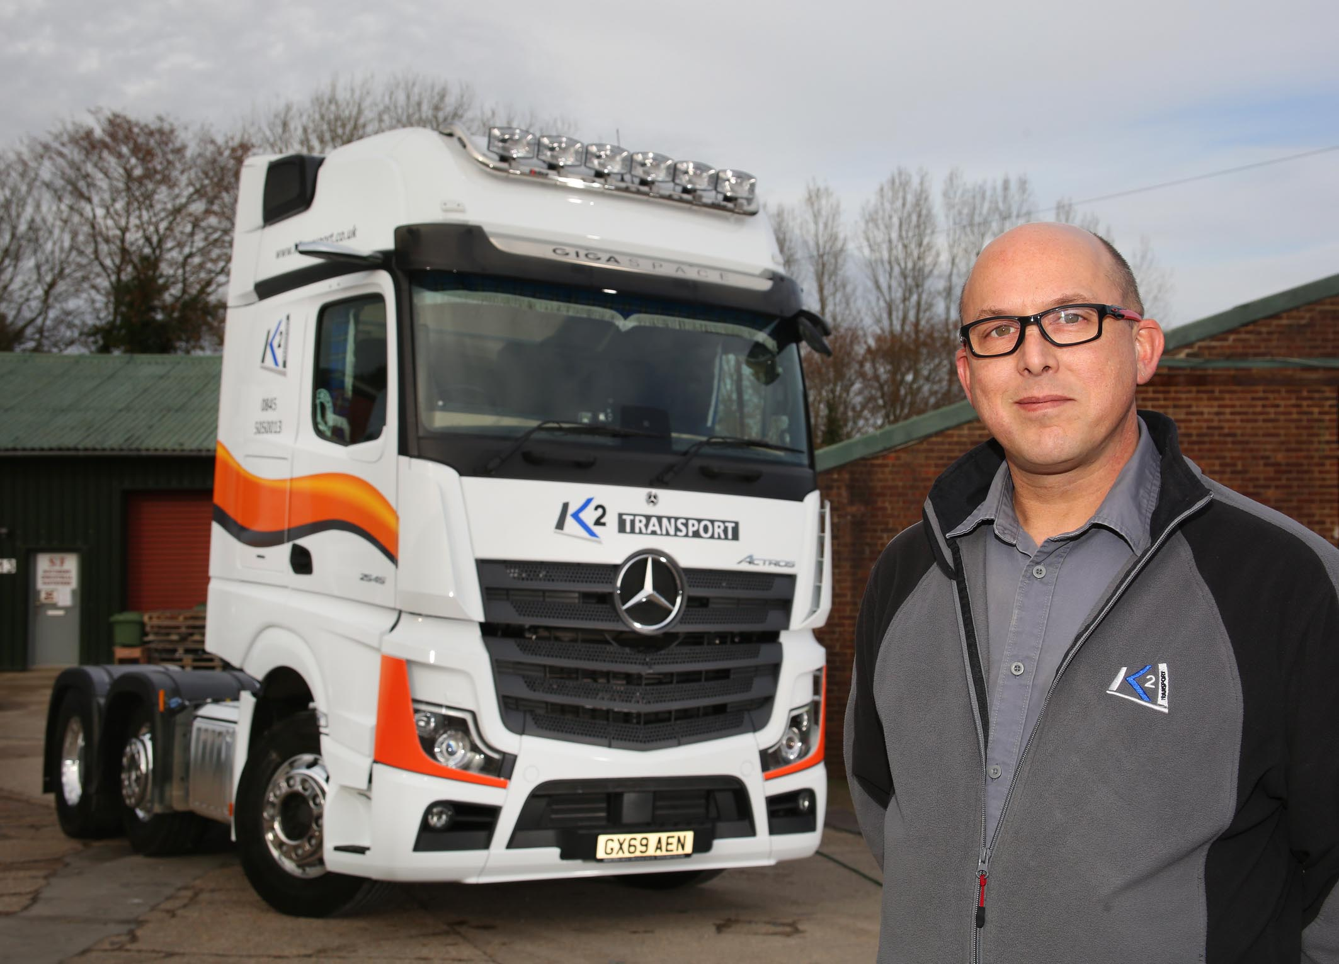

Showing the way: Stuart Bell is delighted with his smart new Actros

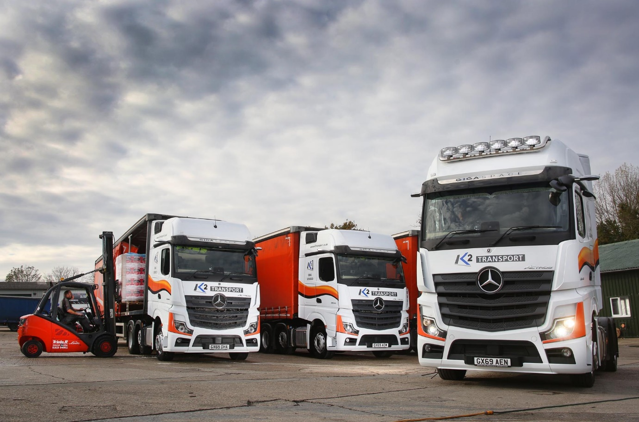

ends

For more information, or to request bigger/higher-res image files, please contact:
John Ripley or Steve Warren
Impact Communications, 01926 842126
John: 07771 484595, john@impactcom.co.uk
Steve: 07770 470251, steve@impactcom.co.uk



