

Date: 11 January 2021

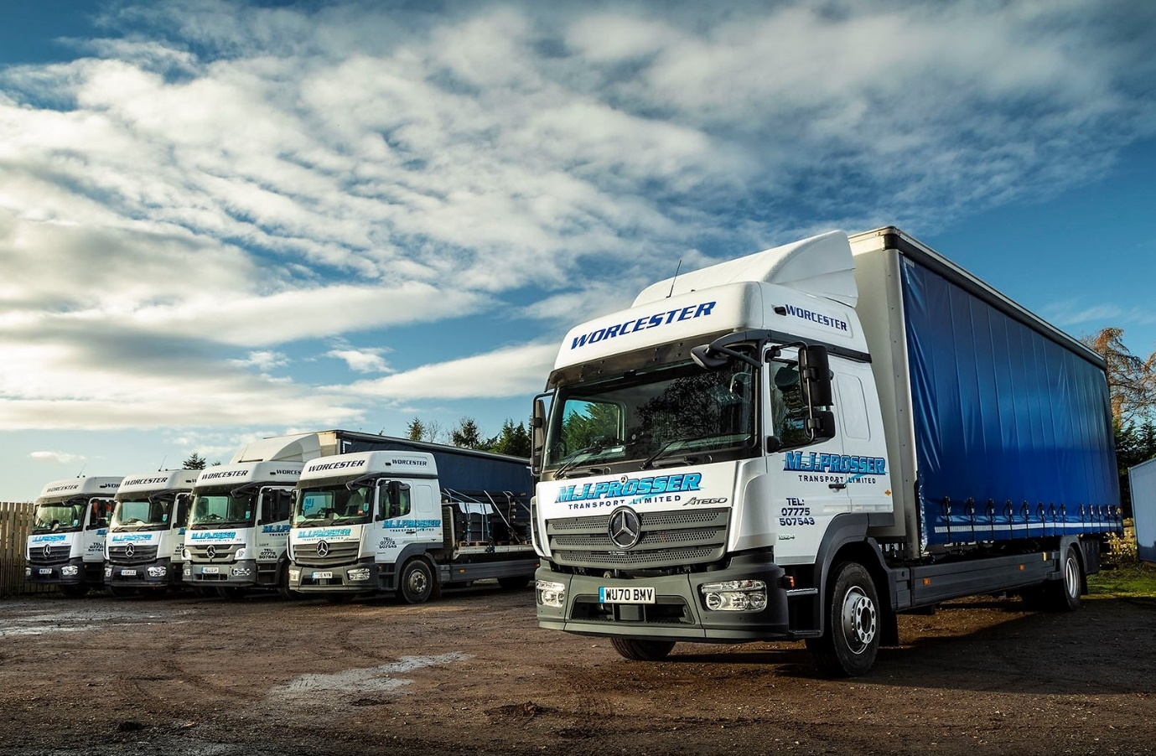

Mercedes-Benz Atego stands the test of time for Rygor Commercials customer MJ Prosser

The number 13 may be unlucky for some, but certainly not for Mercedes-Benz operator MJ Prosser. The Worcester-based general haulier relies solely on Atego 13-tonners, the oldest of which is on a 13-plate and has clocked-up more than 600,000 trouble-free kilometres.

Proprietor Mark Prosser established his business in 1983, and every truck he has bought since 2000 has worn a three-pointed star. For the last 16 years they have all been supplied by Jeremy Price, Fleet Sales Manager at Dealer Rygor Commercials.

Like the four vehicles already in service, the latest arrival is a 1324 L model with high-roofed BigSpace L-cab, 175 kW (238 hp) 7.7-litre in-line six-cylinder engine, and rear air suspension.

The boss’s 19-year-old son has recently established his own business, Luke Prosser Light Haulage, with a 3.5-tonne Mercedes-Benz Sprinter curtainsider that was also supplied by Rygor’s Jeremy Price.

The Mercedes-Benz Atego is purpose-designed for light- and medium-duty distribution work, as well as construction applications. MJ Prosser’s rigids are fitted with either curtainside or platform bodies, all of which are 8.5 metres long – to accommodate these, the chassis are extended at the Mercedes-Benz Custom Tailored Trucks (CTT) plant in Molsheim, France.

The new truck is a curtainsider by Fred Smith & Sons, of West Bromwich. In addition to its double-bunk sleeper cab, which is relatively unusual for a vehicle in this weight class, it boasts an extensive optional specification that includes a dashboard with walnut finish, as well as air-conditioning, a night heater, and a long-range combination of 180- and 100-litre fuel tanks – replacing the single standard item, which has a capacity of 120 litres.

MJ Prosser primarily serves customers from the construction sector, for which it transports a broad range of products and materials but particularly steelwork, roofing sheets and cladding to building sites throughout the UK.

“We’ve remained loyal to the Mercedes-Benz Atego over the last 20 years because it’s such a reliable and durable truck,” confirmed Mark Prosser. “I typically swap them out after seven or eight years, but I know that if I need to run them for longer I can safely do so, because they’ll just keep going for as long as it takes.”

The last two vehicles to be replaced had covered 1.2 million and 1.3 million kilometres. “Neither owed me a penny,” said Mr Prosser.

The operator maintains the trucks in its own workshop but relies on Rygor Commercials for parts and technical support. “We probably over-service them if I’m honest,” he continued. “I’m happy to continue doing so, though, as they don’t cost us a lot and are so rarely off the road.

“We’ve had the occasional breakdown over the years, of course, as you’re always going to get with any operation such as ours. When they have happened, though, Mercedes-Benz Trucks’ Service24h emergency assistance has always performed and had us up and running again very quickly. I can’t fault the manufacturer’s back-up.”

The vehicles are also popular with MJ Prosser’s drivers, some of whom regularly spend nights out in their cabs. “We spec them nicely and there’s plenty of space, while I reckon the driving experience is as good as you’ll get in a truck of this size,” said Mr Prosser, who still takes the wheel himself to provide holiday and relief cover from time to time.

He recalled: “Our new Atego is the eighth that Jeremy has delivered, and they’ve all been ‘spot on’. He understands my business and knows what I want in terms of options, which makes life so much easier for me.

“I’ll just send him a text to let him know I need another truck and I trust him implicitly to manage the entire process, including liaison with the bodybuilder. It’s a great service.”

Jeremy Price added: “We’re committed at Rygor to building long-term relationships with operators, and I take great personal pride in having retained the business of many loyal customers. MJ Prosser is a great case in point.

“Mark knows exactly what he wants from a truck, and has found it in the Atego, so sees no reason to change. He is a great, and highly valued, ambassador for our Dealership, and for the Mercedes-Benz Trucks brand.”

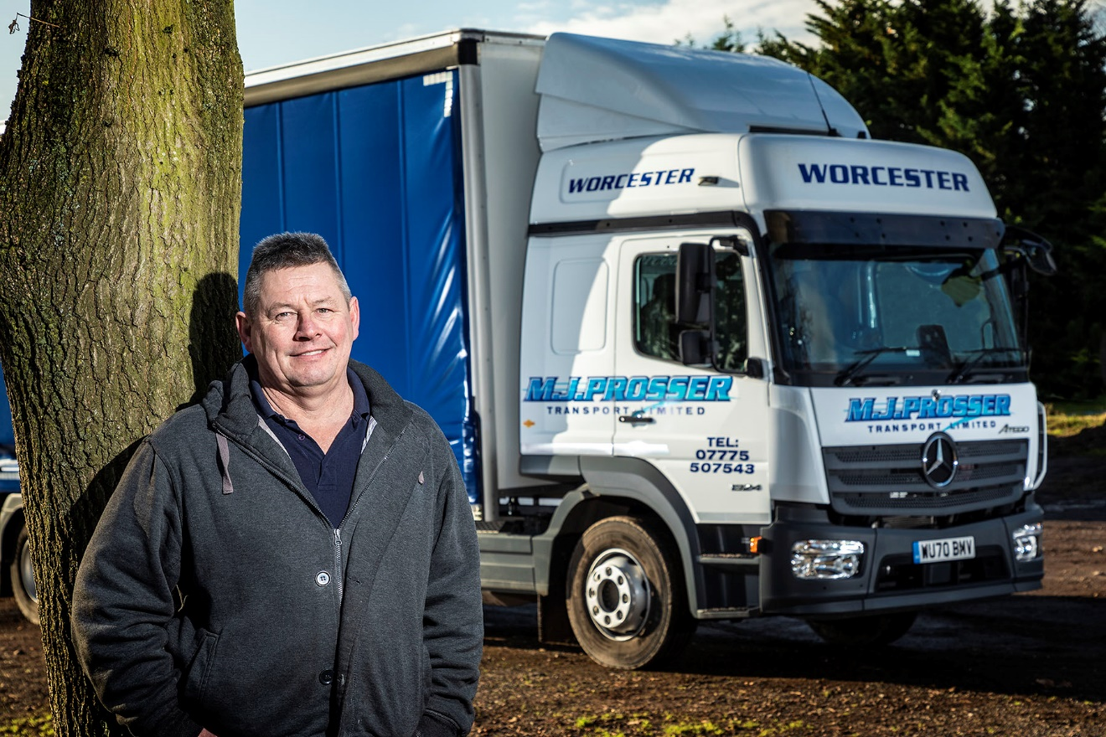

Loyalty rewarded: Mark Prosser has been running reliable, durable Mercedes-Benz Atego trucks for two decades

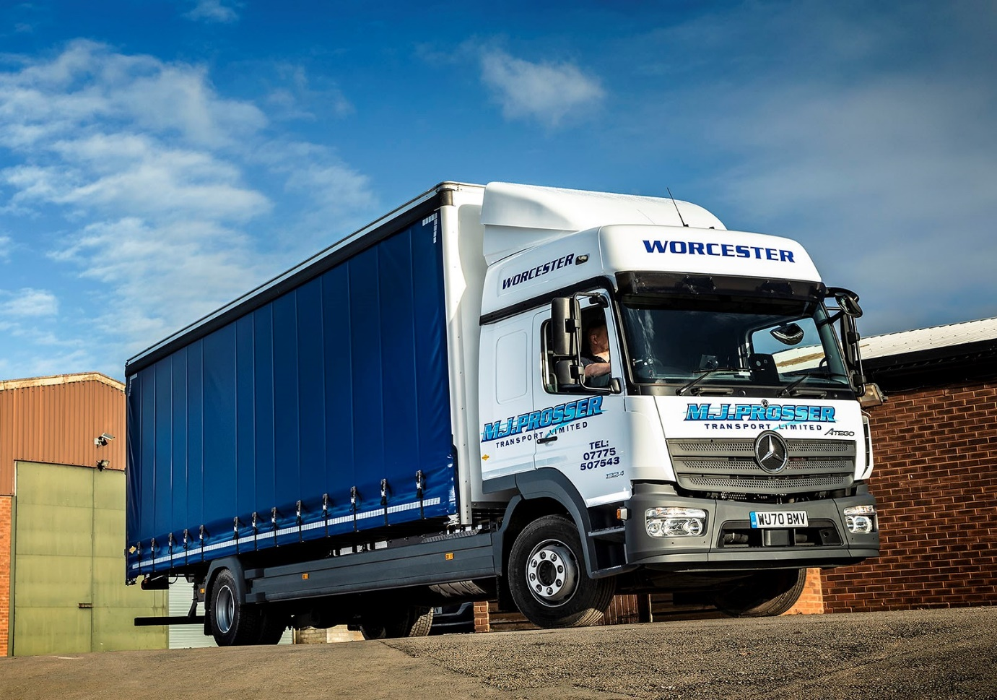

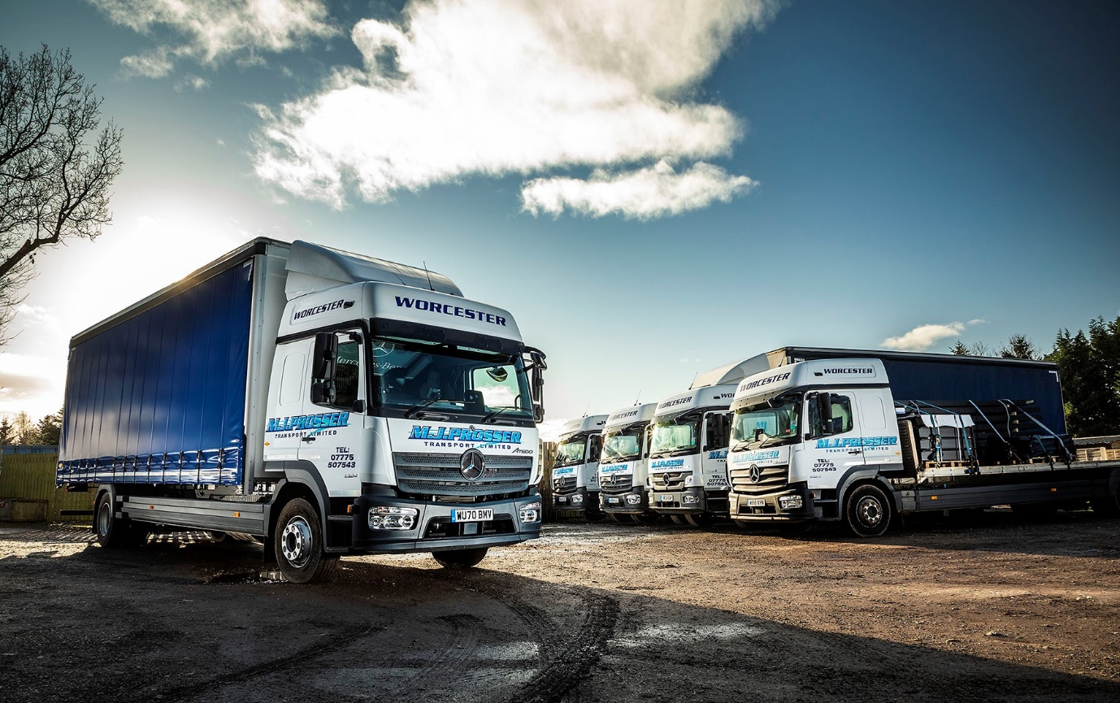

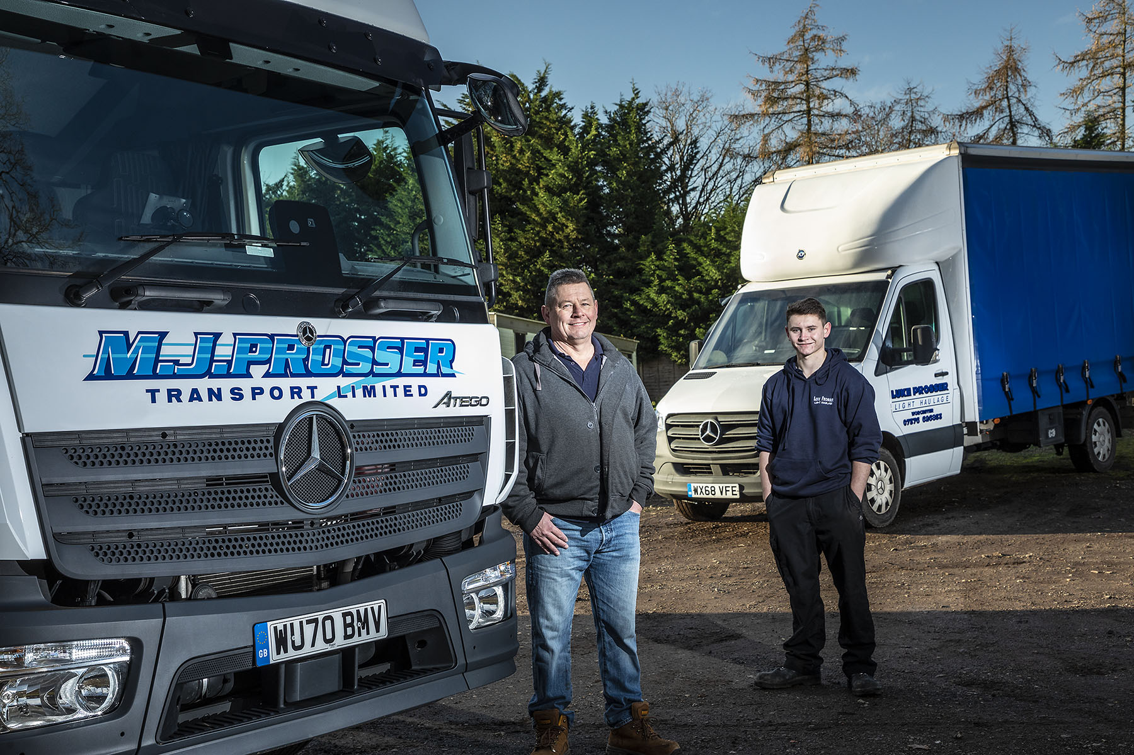

Like father like son: Mark and Luke Prosser, who is just starting out on his own career in the transport industry

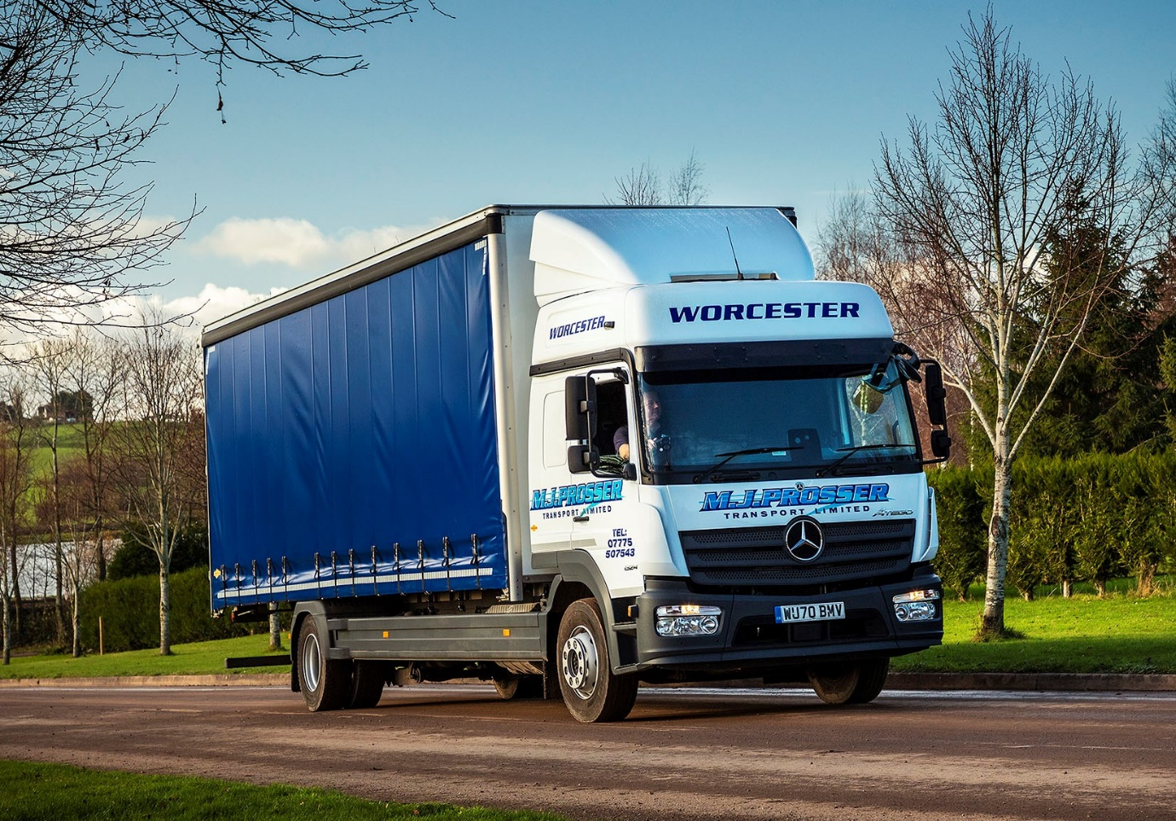

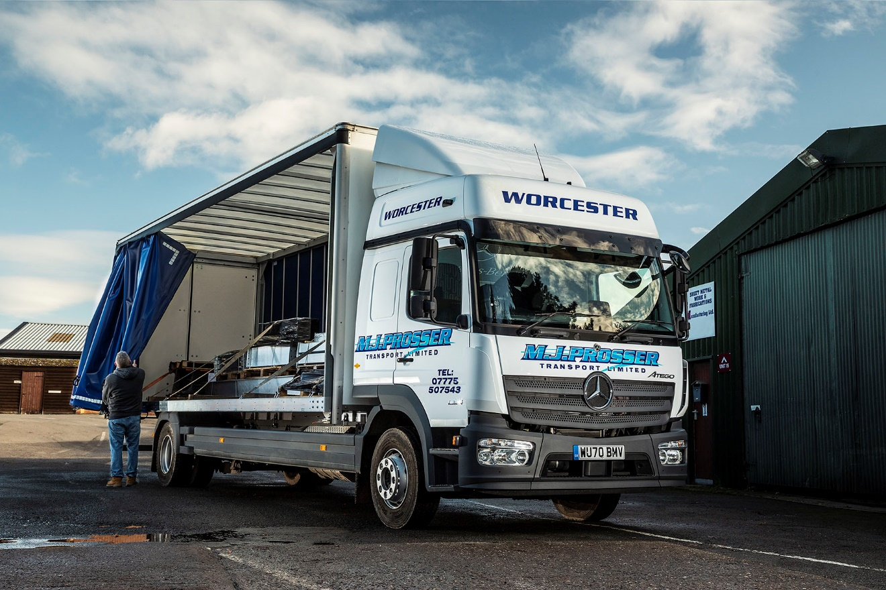

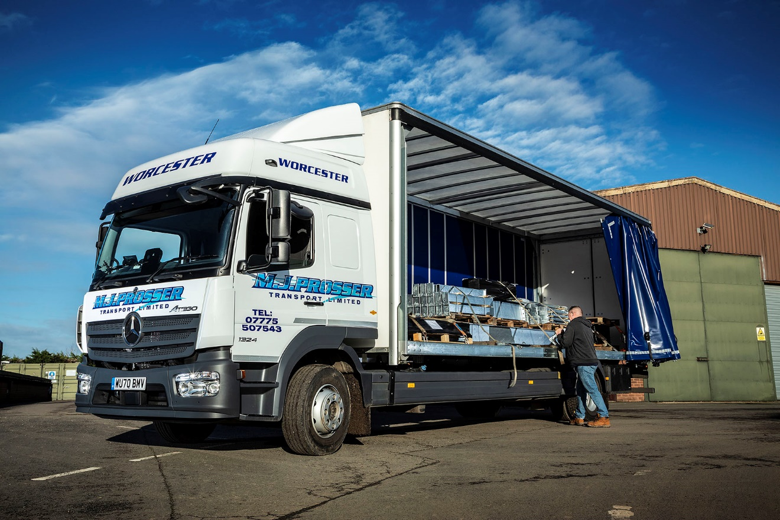

ends

For more information, or to request bigger/higher-res image files, please contact:
Steve Warren or John Ripley
Impact Communications, 01926 842126
Steve: 07770 470251, steve@impactcom.co.uk
John: 07771 484595, john@impactcom.co.uk

Notes to Editors: Rygor Commercials

Award-winning Mercedes-Benz Commercial Vehicle Dealer group, Rygor, has branches throughout Berkshire, Gloucestershire, Oxfordshire, Somerset, West London, Warwickshire, Wiltshire and Worcestershire, offering extensive coverage for customers throughout the M5, M4 and M42 corridors.

The Rygor business has expanded and gone from strength to strength in recent years, launching its flagship Gloucester branch in late 2016 (which won Showroom of the Year at the 2018 Commercial Motor Awards) and undergoing a significant refurbishment of its Oxford branch in 2018. Rygor was delighted to be announced as winner of the ‘Best Sales Team’ award at the 2019 AM Awards, demonstrating our continued commitment to our customers and dedication to providing exceptional customer service.

With a proven track record, Rygor is proud to be selling and supporting the most prestigious name in commercial vehicles.

For more information, in the first instance please contact Kate Ruberry-Shoemack, Head of People and Communications at Rygor – kateruberry-shoemack@rygor.co.uk

